R/V Paragon Hydraulic Power Unit Upgrades
Chad Kecy 03-14-2022

This document covers the proposed upgrades to the hydraulic power unit onboard the R/V Paragon. This entails replacing the gas powered motor with an electric motor and rechargeable batteries.

Related Documents

Z:\901700 Acoustical Ocean Ecology\Paragon Head Stabilization\Electrical\Documents\Paragon Battery Review Materials\Drawings

Paragon DC Motor HPU System RevA
Paragon Battery Charge Path
Paragon Battery Discharge Path

Z:\901700 Acoustical Ocean Ecology\Paragon Head Stabilization\Electrical\Documents\Paragon Battery Review Materials\Datasheets

All datasheets/manuals/references are located in this folder

Motor Replacement

ECPC 1004 DC Motor

This 11HP motor is a direct replacement for the gas powered Honda GX-390 motor which is currently used in the R/V Paragon. It is meant to operate at 48Vdc, but lower voltages simply cause the motor to run at lower RPM’s. We will be running our system from a 36V bus. This was determined by referring to the motor’s performance curve and matching the voltage with the desired RPM of the HPU.

A custom “box” and mount will be needed for this motor; a spider coupling allows it to directly attach to the existing pump for the hydraulic fluid. An appropriately sized flyback diode will be wired into the motor and mounted on the new base.

Batteries

Dakota LiFePO4 36V 63AH Single Battery

We intend on using marine batteries from Dakota Lithium; these are both manufactured and shipped from the continental United States. They have been developed to operate in marine environments and are used, primarily, for operating trawling motors in fishing boats.

To achieve our required capacity, four will be wired in parallel. Our capacity was derived from a typical at-sea day by the Bio-Acoustics lab, which is typically four hours of continuous usage of the HPU. Andy Hamilton calculated that approximately 1500 watts would be needed for a half day of hydrophone pole stabilization.

1500W x 4.5 hours = 6.75 kWh

6750 Wh / 36 V = 188Ah ; We rounded up to a minimum of 200Ah

63Ah x 4 = 252Ah

Battery Charger

Dakota LiFePO4 36V 18 Amp Charger

Dakota offers two chargers for its 36V batteries, an 8 amp and a “fast” 18 amp version. We will be incorporating the 18 amp version into our system. However, we will be charging four batteries in parallel.

Our proposed system will use shore power when charging our batteries. It would take 14 hours to charge our system, if it is fully discharged. However, we will rarely, if ever deplete our batteries this far. Thus, overnight charging via shore power is within limits of normal operation.

Safety Housing
This will be a watertight enclosure which will hold the contactors, fuse, shunt, and battery charger. See schematic for complete wiring details. The discharge path has been designed to support a nominal 200 amp steady state load, with short (~300 msec) peaks up to 350 amps. The contactors are opposite operation (NO and NC) which only allow charging while the HPU motor is disengaged. The current shunt is wired to indicate a negative current while charging, and a positive current while charging.

There will be four interface connections to/from the safety housing.
- Battery Input
- Motor Output
- Battery Charger Input Power (110VAC)
- A 6 (or 12) pin connection to the cabin

The details of the type/size of the enclosure have not been decided upon yet.
Requirements:
- Must be watertight (IP66-68)
- Easy access (i.e. hinged door or lid)
- The four IO connections must maintain the IP rating
- Proper heat dissipation must be taken into consideration w/r to the charger.

Panel Meter
The ECPC404 panel meter can display four values (one at a time): battery voltage, battery current (charging and discharging), Ah remaining, and an elapsed time indicator. The 404 also has two built-in low power relays; these can be used for LED indicators, or additional safety circuitry. We currently are not using them, but I may run wires to them to ease future functionality.

System Placement
Per the wiring diagram, the components of the battery system will be housed in three locations: the cabin, the aft hold, and the aft compartment.

Aft Hold
The four parallel batteries will be mounted on a common base plate and stored in the aft hold. Care will be taken to mount them such that the weight distribution minimizes any changes to the stability of the R/V Paragon.

The aft hold is considered a wet area, so any electrical connections such as the battery terminals will be covered with appropriate rubber covers and/or heat shrink tubing. The physical wiring will be such that there are only two output 2/0 AWG wires. These two wires will be terminated into an Anderson 350 amp connector. This connection will run through a wire pass through to the aft compartment.

Aft Compartment
The new DC motor and the safety housing will both be installed in the aft compartment. The motor will be physically placed where the old gasoline engine had been; the mechanical connection to the pump will remain the same. The exact location of the safety housing is TBD, but discussions with Jared are ongoing. Some ancillary equipment related to the gasoline engine will also be removed and that opens up more general space in the aft compartment.

Cabin
Full control and monitoring of the battery-powered hydraulic system is available from the cabin. The HPU On/Off switch applies 12Vdc (from the primary Paragon bus) to the panel meter and to the HPU Start switch. Separate power to the meter allows voltage and current monitoring during charge cycles. The HPU Start switch will engage the motor, and hence, the HPU. This switch also controls the two contactors in the safety housing, disabling charging during HPU operation.

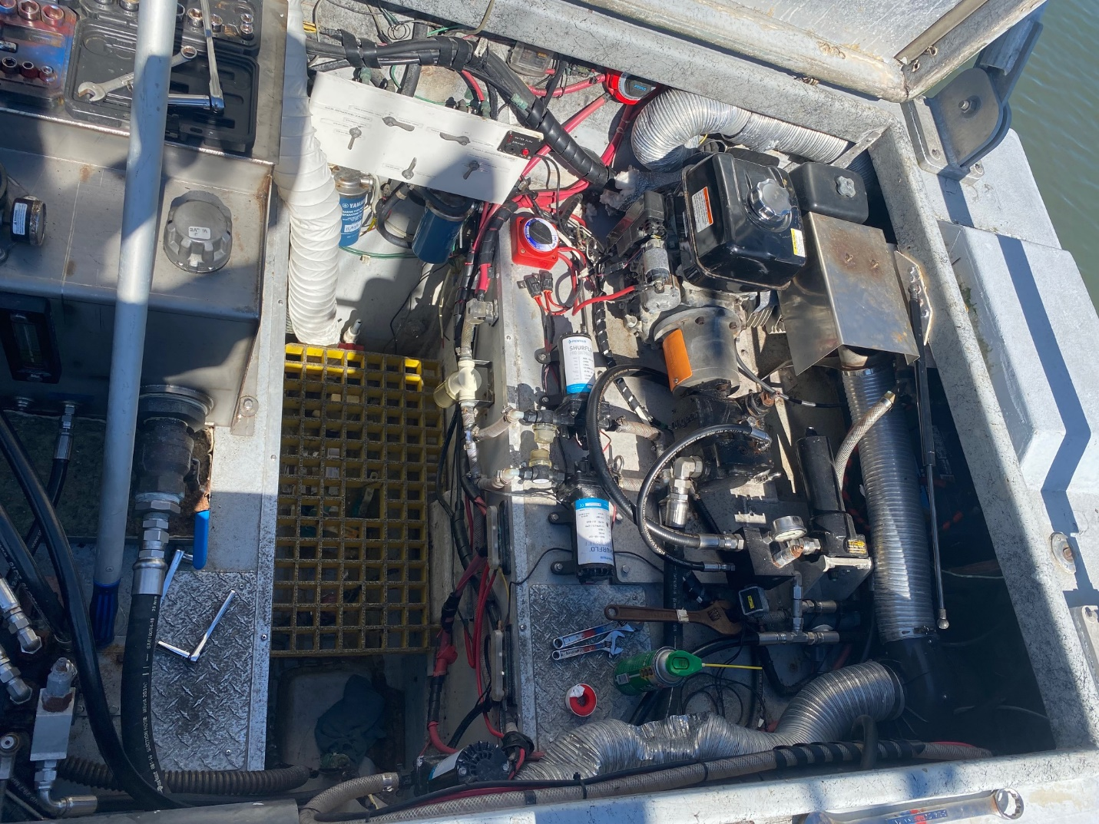
Figure One: Aft compartment on R/V Paragon

