Taiwan Straits Expedition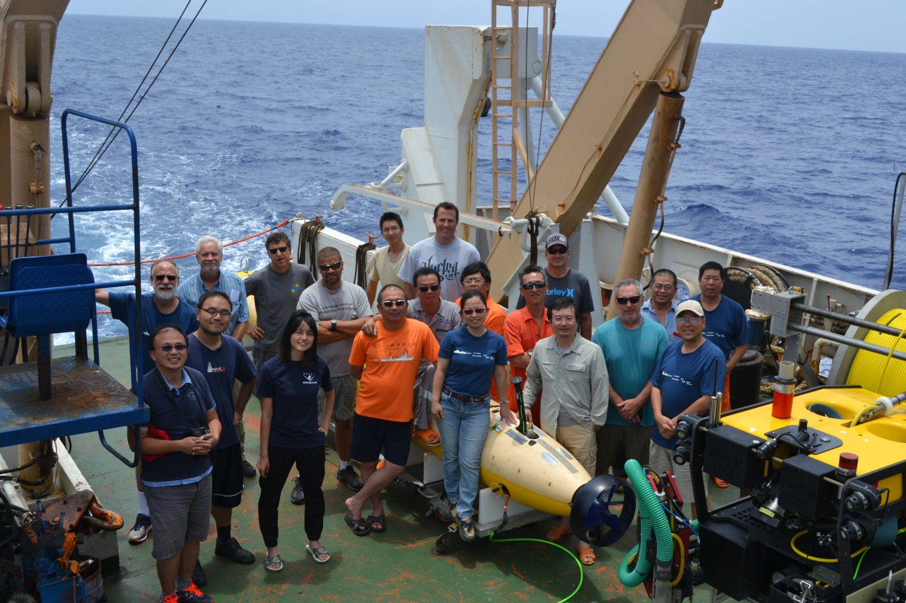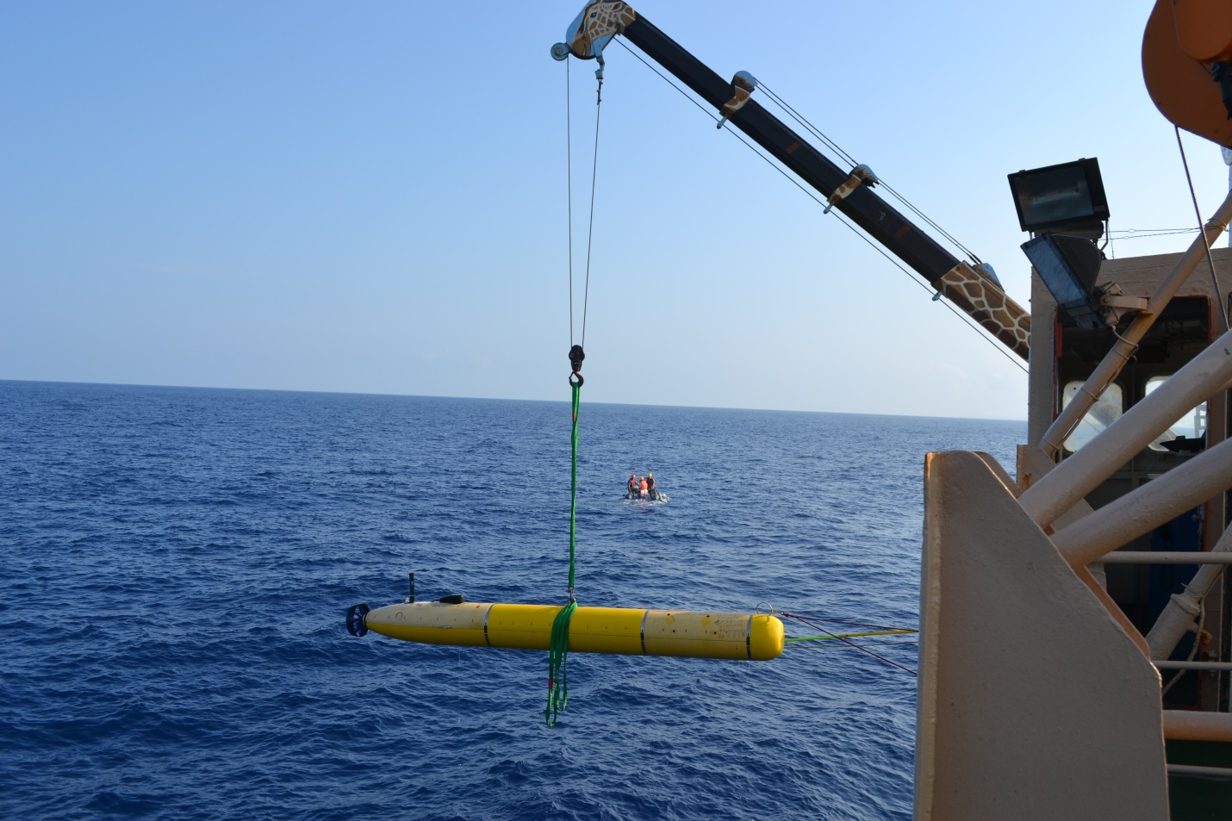
- Mobilized Dorado Mapping AUV and Mini-ROV onto R/V Ocean Research 1, operated by National Technical University of Taiwan
- Performed 11 mapping AUV surveys of near-shore and deepwater canyon features
- Longest survey was ~23 hours in duration utilizing high capacity battery packs

Greenland Expedition
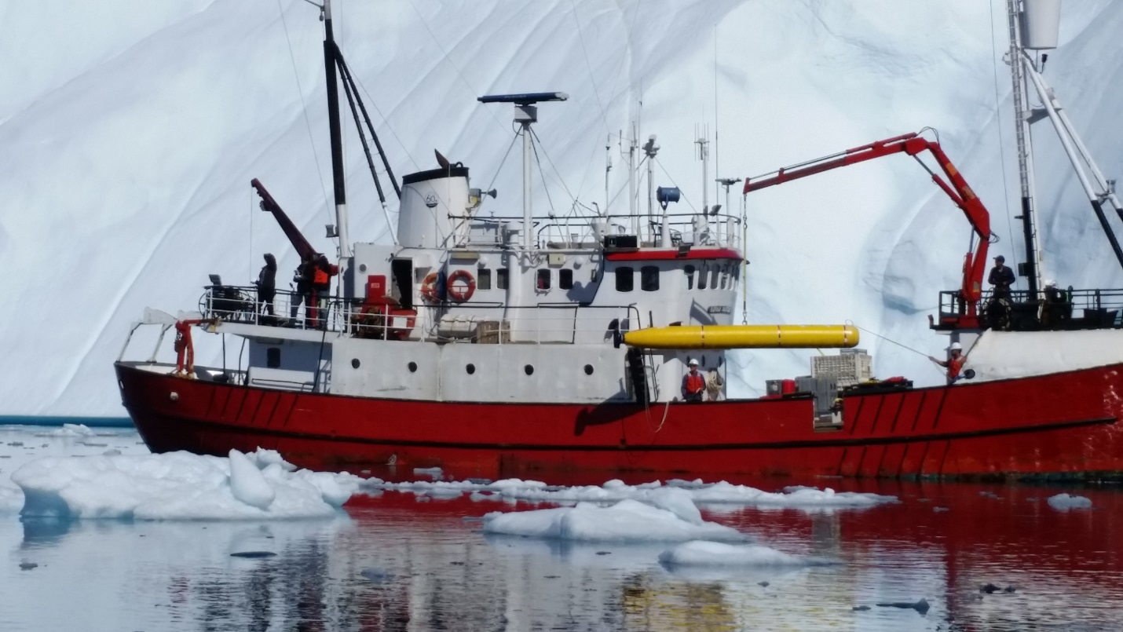
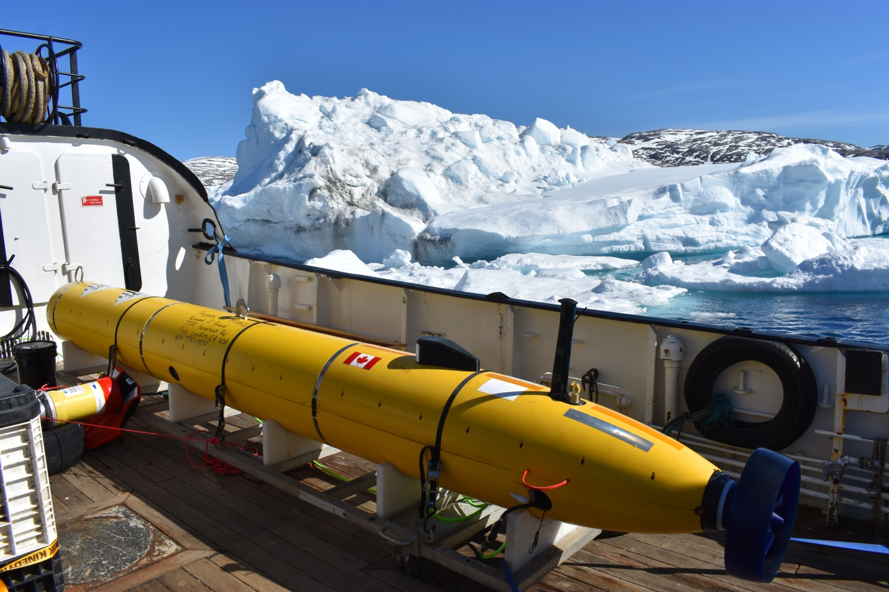
- Mobilzed Iceberg AUV onto R/V Adolf Jensen in Tassilaq, Greenland
- Successfully operated vehicle around and under a variety of icebergs
- Performed surveys of drifting icebergs calved from Petersen Glacier
Beaufort Sea Expedition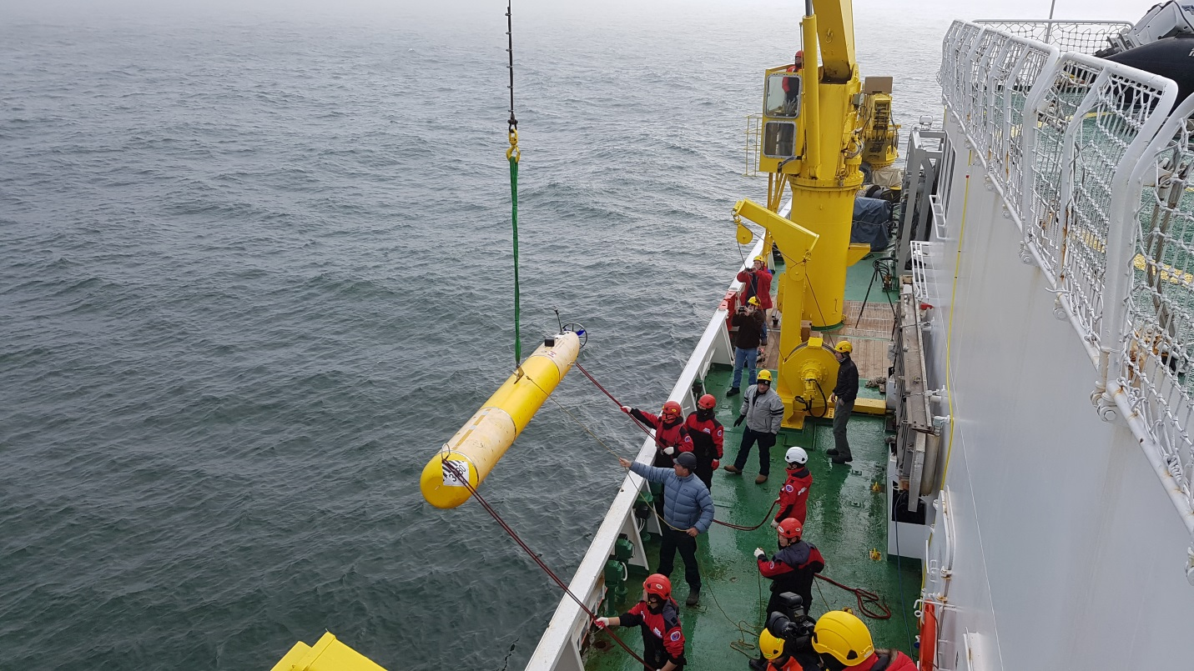
- Shipped Mapping AUV and Mini-ROV from Taiwan Straits Expedition to Incheon, South Korea for loading onto RVIB Aroan (operated by Korean Polar Research Institute in June
- Shipped ITAR-controlled INS equipment to Barrow, AK in August to load onto ship
- Mobilized AUV and Mini-ROV while offhosre
- Performed 3 mapping AUV surveys (limited by ice and weather conditions)
