MBARI Dorado AUV’s Scientific Results

MBARI Dorado-class AUV Description

MBARI’s Dorado-class AUVs are 53.3 centimeters (21 inches) in diameter and can be as short as 2.4 meters (8 feet) or as long as 6.4 meters (21 feet), depending on the mission. Currently operational Dorado-class AUVs include the upper-water-column vehicle (CTD/Gulper), the seafloor Mapping AUV, and the seafloor Imaging AUV. The core vehicle elements are rated to xx m depth and have been operated as long as 20 hours before batteries required recharging.

CTD/Gulper AUV (Y. Zhang, J. Harvey, and J. Ryan)

The Dorado CTD/Gulper AUV has a suite of physical, chemical, and biological sensors, as well as ten water samplers (called “gulpers”) [Bird et al. 2007, Thompson 2007]. The AUV combines synoptic environmental data acquisition, high-intake-rate water sampling and real-time signal processing algorithms to enable targeted sampling of oceanographic processes [Ryan et al. 2010, 2013a; Harvey et al. 2012b]. Two prominent examples are as follows.

- Peak capture in phytoplankton patches

Phytoplankton patches have important impacts on patterns of primary productivity, the development of harmful algal blooms (HABs), and the survival and growth of zooplankton, including fish and invertebrate larvae. We have developed a peak-capture algorithm for the AUV to precisely detect chlorophyll fluorescence peaks and trigger water sample acquisition in phytoplankton patches [Zhang et al. 2010]. The algorithm cross-checks for concurrent, high optical backscatter signal values to ensure that sampled fluorescence peaks are true biomass maxima. Using sliding temporal windows, the algorithm keeps track of the background levels of chlorophyll fluorescence and optical backscatter signals, as well as the fluorescence signal’s average peak level on successive yo-yo profiles, thereby adapting sensitivity to ambient conditions. Application of this method during a patch-tracking study revealed small-scale variability in the toxicity of a HAB species and indicated causative processes [Ryan et al. 2013a]. Specifically, where the toxin producing phytoplankton populations were influenced by resuspended sediments, the phytoplankton were distinctly more toxic (Figure 1). The hypothesis for this relationship concerns trace metals, which have been shown in laboratory studies to regulate toxin production and which may be transported with the sediments.
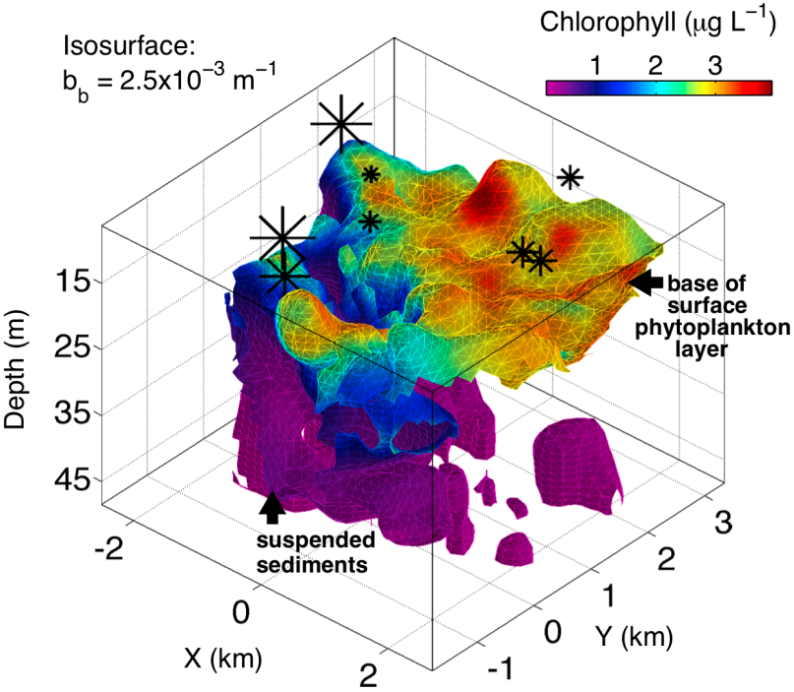

- Fig. 1. Quasi-Lagrangian view of the interaction between the surface phytoplankton layer and suspended sediments evidently influencing the toxicity of specific phytoplankton taxa. While phytoplankton are identified in AUV optical data by high chlorophyll fluorescence and optical backscattering (b_{b}), suspended sediments are identified by low chlorophyll fluorescence and high optical backscattering. This description was derived from intercalibrated measurements by the Dorado and Tethys AUVs within a 46-h period while following a patch tagged by a satellite-tracked drifter. X and Y locations are relative to the drifter. At each sample location, toxin per cell is represented by an asterisk scaled accordingly. From Ryan et al., 2013a.

In an experiment in Monterey Bay, California, during October 2009, the AUV triggered water sampling in a phytoplankton patch that was evidently subducted from near-surface waters to the seafloor in an upwelling front. The water sample contained the highest concentrations of mussel and barnacle larvae detected in the study [Ryan et al. 2013b]. Autonomously locating phytoplankton patches, the AUV sampled this unexpected near-bottom feature. This intelligent sampling, combined with high spatiotemporal resolution of the front in which it was sampled revealed the physical dynamics driving accumulation and transport of larvae. The AUV peak-capture algorithm has been successfully applied in a series of field programs studying harmful algal blooms (HABs) and zooplankton populations. In April 2013, the AUV ran this algorithm to accurately locate and acquire water samples from subsurface chlorophyll maximum in a HAB study in San Pedro Bay, California, as shown in Fig. 2. Sampling of the phytoplankton populations across two water types (shelf and deep channel) and the front between them, thus enabling examination of species diversity and origins of “seed populations” for blooms of toxin producing species.
Fig. 2. On 17 March 2013, the Dorado CTD/gulper AUV ran the peak-capture algorithm to acquire water samples (six peak samples plus one off-peak control sample) from subsurface chlorophyll maximum in San Pedro Bay, California.

- Upwelling front detection and sampling

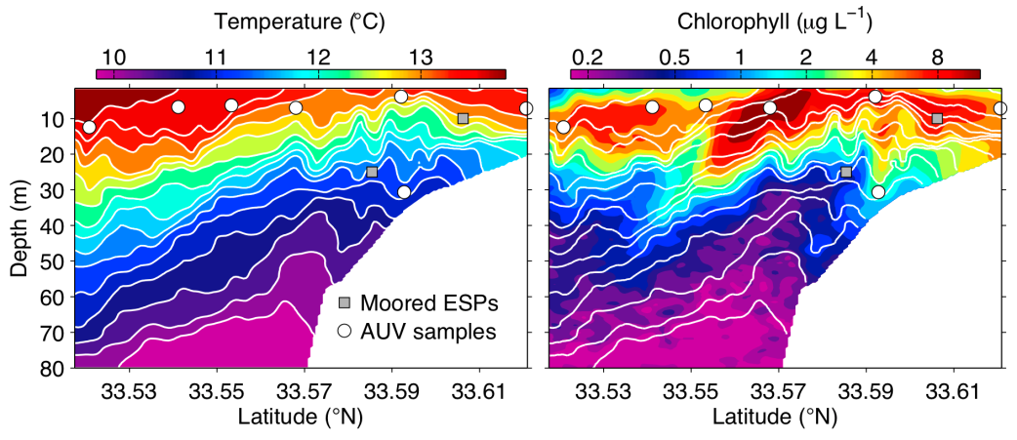
Nutrients carried up by coastal upwelling fuel primary productivity and support commercially important fisheries. Previous, non-targeted AUV sampling in the Monterey Bay, suggests that zooplankton (e.g., invertebrate larvae and copepods) are aggregated by upwelling fronts and associated with elevated chlorophyll fluorescence [Harvey et al. 2012a]. To investigate complex coastal upwelling ecosystems, we have developed an AUV algorithm to autonomously distinguish between upwelling and stratified water columns and accurately detect the temperature gradient front between them [Zhang et al. 2012]. During June 2011 and May–June 2012 in Monterey Bay, the Dorado CTD/gulper AUV successfully classified three distinct water types (stratified water, upwelling water, and the front in-between), accurately located the narrow front, and acquired targeted water samples from each water type. Molecular analysis of AUV-acquired water samples showed distinct zooplankton signals in the three water types. Novel detection and targeted sampling capabilities thus permit the Dorado AUV to autonomously conduct “surgical sampling” of complex, spatially and temporally variable marine ecosystems.

Mapping_AUV

- Hydrothermal Chimneys (D. Clague)

The mapping AUV surveys let us identify hydrothermal chimneys and then dive directly on them instead of having to do the usual homing in on water column anomalies using expensive ROV or submersible time. At the Alarcon Rise, because we mapped the region first, our first ROV dive on the ridge reached tall chimneys within 15 minutes of hitting bottom. Prior searches for active chimneys commonly required many dives and a good deal of luck to locate. The chimneys, of course, are of interest to geologists, water chemists, and biologists and have been the focus of an enormous amount of submersible and ROV work over the last 35 years.

Another discovery relates to how deep sea lava flows are constructed--the architecture of the flows. They are commonly combinations of the pillow, lobate, and sheet lavas that have been known for decades, but we now can see that all these lava morphologies are commonly produced during single eruptions and are arranged in specific configurations that reflect the processes of flow emplacement.

Sidescan results allow us to map out young, nearly sediment-free flows from older flows with more sediment cover. This, coupled with the bathymetry that lets us identify flow boundaries, allows us to design ROV dives that can sample the maximum number of flows during single dives rather than driving around on single flows for long periods.

- Repeat bathymetric surveys (D. Caress)

Technically, our most difficult achievement has been resolving lava flow thickness of the Axial Seamount 2011 eruption using repeat surveys [Caress, et al., 2012]. We surveyed the region before and after the eruption, which enabled us to precisely map the extent, volume, and changing morphology along the length of the flows. In addition to showing in great detail the architecture of the flows (as above), it taught us that the same fissures and channel systems can be reused eruption after eruption, which is intriguing volcanologically but also means that mapping out the boundaries of older, partially buried flows might be more difficult.

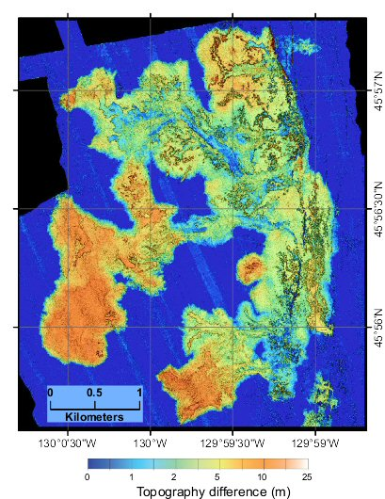
Fig. 2. The volcanic eruption in 2011 at Axial Seamount on the Juan de Fuca mid-ocean ridge produced lava flows that are well-defined in this map of the difference between pre- and post-eruption AUV bathymetry. The eruption reused pre-existing fissures and channels, flooded across large areas as sheet flows, and at the distal ends transitioned to inflated lobate flows 10-15 m thick [Caress et al., 2012].

- Surprise discoveries (C. Paull)

Unexpected results include crescent shaped bed forms common within the California Canyons; the size of the bed forms in Monterey Canyon at ~1,850 m; the shape of Bullseye Vent (Canada), previously there was no hint it is a distinct depression); the clarity with which very subtle faults can be identified and traced on the seafloor (e.g., Palos Verdes)

- Davidson Seamount lava flows (J. Paduan)

A surprising result is the ponded and collapsed lava flow at Davidson Seamount that we observed in the AUV map and then dove on with the ROV. Such a feature is unusual on the seamounts off California, which are otherwise composed of blocky or pillow flows. It was not visible in the lower-resolution ship-based bathymetry but was clear in the AUV data, and is an example of how one can’t assume everything is known about a seamount from low-resolution maps or a few submersible dives.

