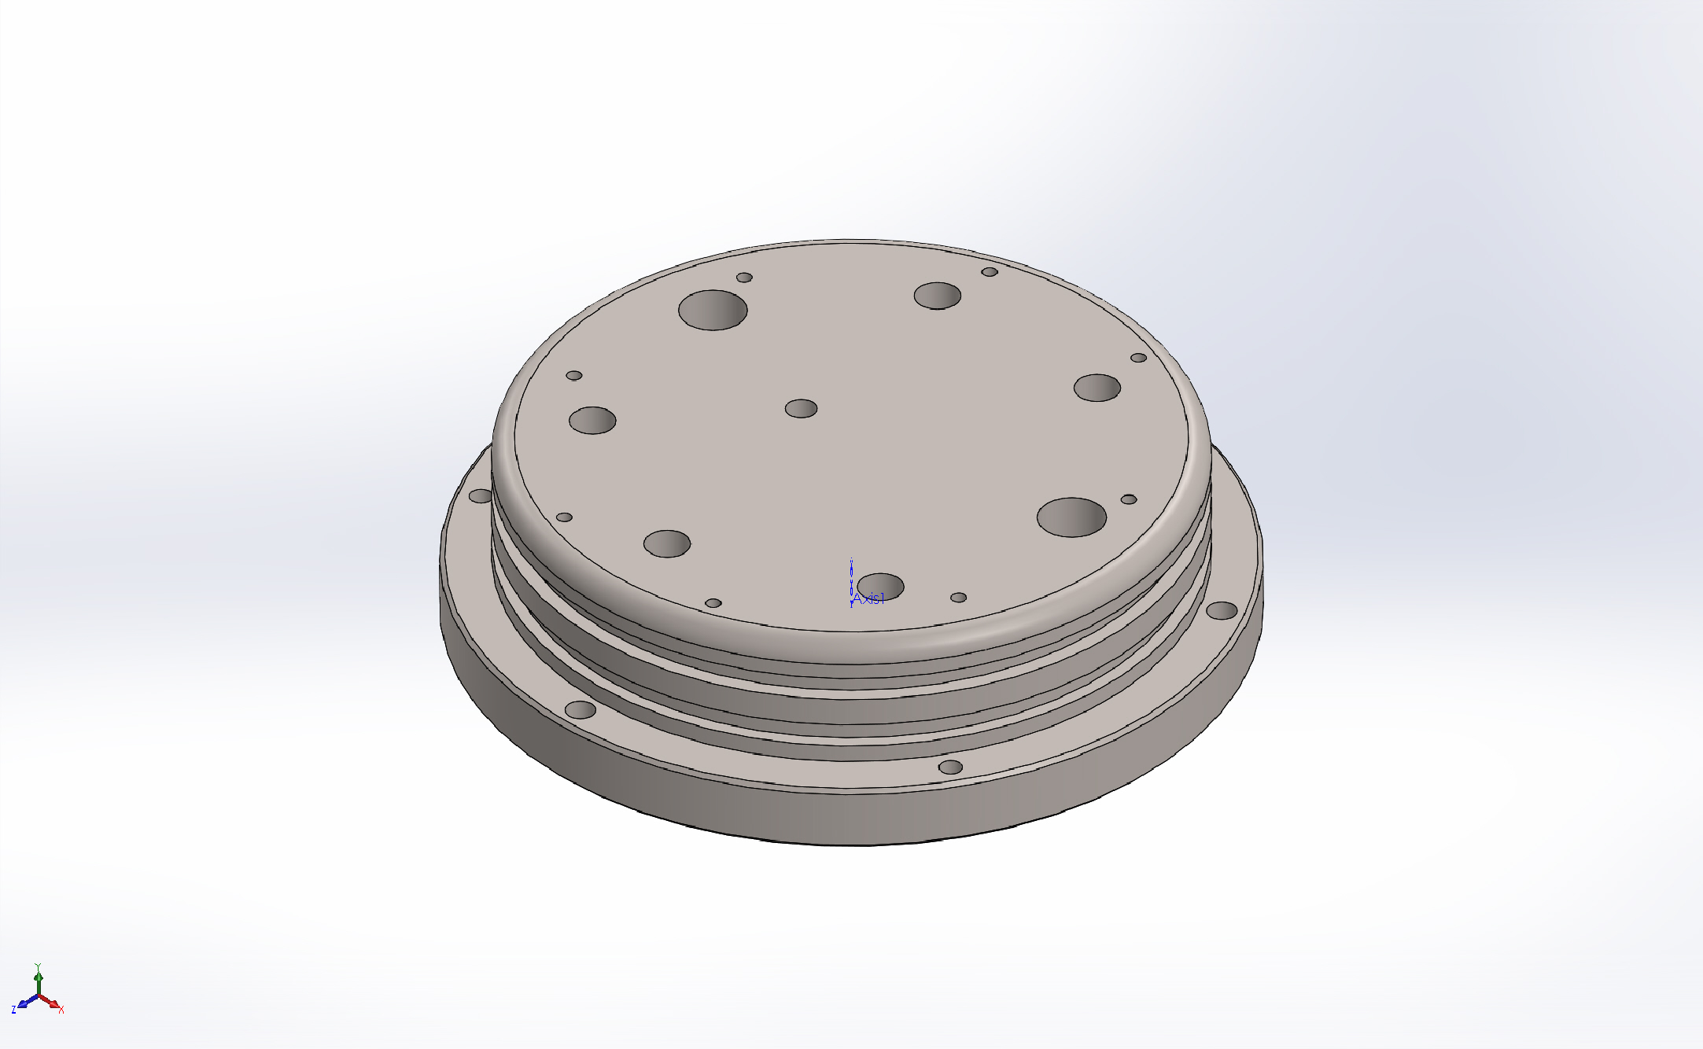
  Simulation of 6in Bottle Endcap-FEA
  Date: Tuesday, March 15, 2016
  Designer: Solidworks
  Study name: Static 1
  Analysis type: Static
  Table of Contents
  Description 1
  Assumptions 2
  Model Information 2
  Study Properties 3
  Units 3
  Material Properties 4
  Loads and Fixtures 5
  Connector Definitions 6
  Contact Information 6
  Mesh information 7
  Sensor Details 8
  Resultant Forces 8
  Beams 9
  Study Results 10
  Conclusion 12

Description
No Data

Assumptions

Model Information

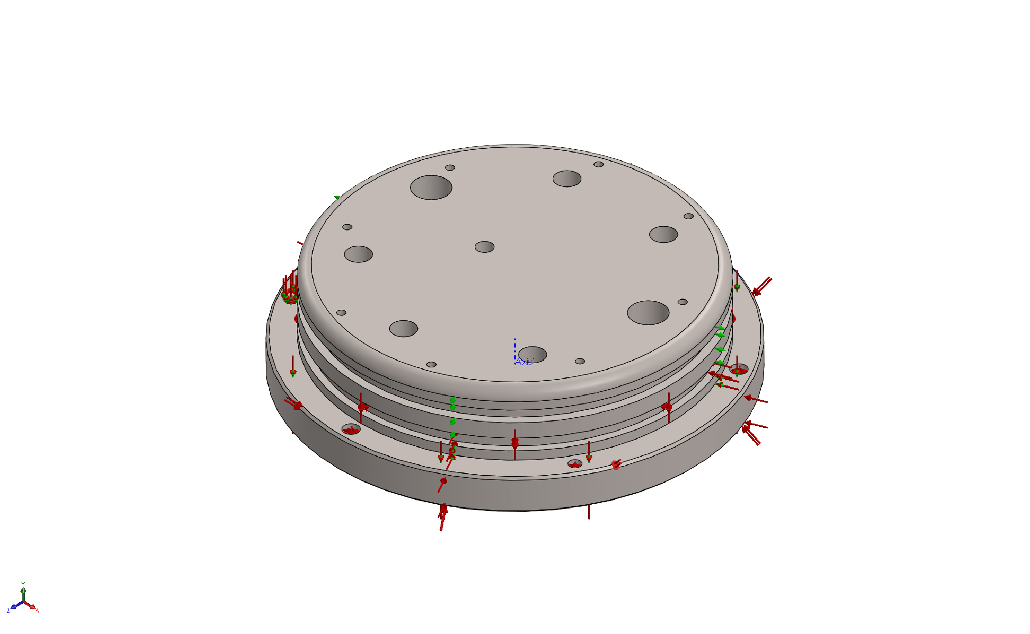
Model name: 6in Bottle Endcap-FEA
Current Configuration: Default
Solid Bodies
Document Name and Reference | Treated As | Volumetric Properties | Document Path/Date Modified
M4x0.7 Tapped Hole1  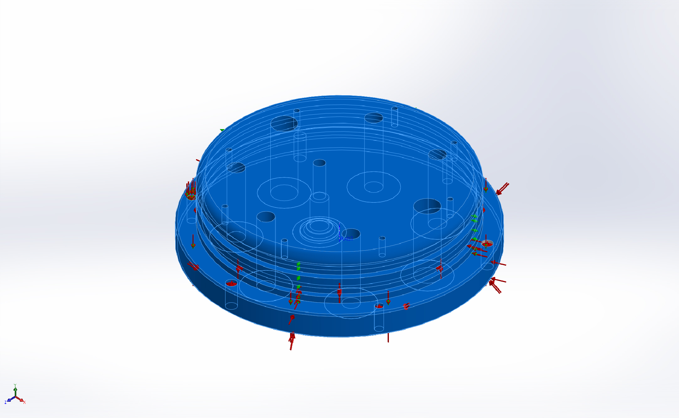 | Solid Body | Mass:3.80942 kg  Volume:0.000844662 m^3  Density:4510 kg/m^3  Weight:37.3324 N | X:\368000_DMO_AUV\Drawings\AUV-3 Reson System\6in Bottle Endcap-FEA.SLDPRT  Mar 15 11:01:12 2016

Study Properties
Study name | Static 1
Analysis type | Static
Mesh type | Solid Mesh
Thermal Effect: | On
Thermal option | Include temperature loads
Zero strain temperature | 298 Kelvin
Include fluid pressure effects from SOLIDWORKS Flow Simulation | Off
Solver type | Automatic
Inplane Effect: | Off
Soft Spring: | On
Inertial Relief: | On
Incompatible bonding options | Automatic
Large displacement | Off
Compute free body forces | On
Friction | Off
Use Adaptive Method: | Off
Result folder | SOLIDWORKS document (X:\368000_DMO_AUV\Drawings\AUV-3 Reson System)

Units
Unit system: | SI (MKS)
Length/Displacement | m
Temperature | Kelvin
Angular velocity | Rad/sec
Pressure/Stress | N/m^2

Material Properties
Model Reference | Properties | Components
 |  | SolidBody 1(M4x0.7 Tapped Hole1)(6in Bottle Endcap)
  Name: | Commercially Pure CP-Ti UNS R50700 Grade 4 (SS)
  Model type: | Linear Elastic Isotropic
  Default failure criterion: | Unknown
  Yield strength: | 5e+008 N/m^2
  Tensile strength: | 5.5e+008 N/m^2
  Elastic modulus: | 1.05e+011 N/m^2
  Poisson's ratio: | 0.37
  Mass density: | 4510 kg/m^3
  Shear modulus: | 4.5e+010 N/m^2
  Thermal expansion coefficient: | 9e-006 /Kelvin
Curve Data:N/A

Loads and Fixtures
Fixture name | Fixture Image | Fixture Details
Reference Geometry-1 | 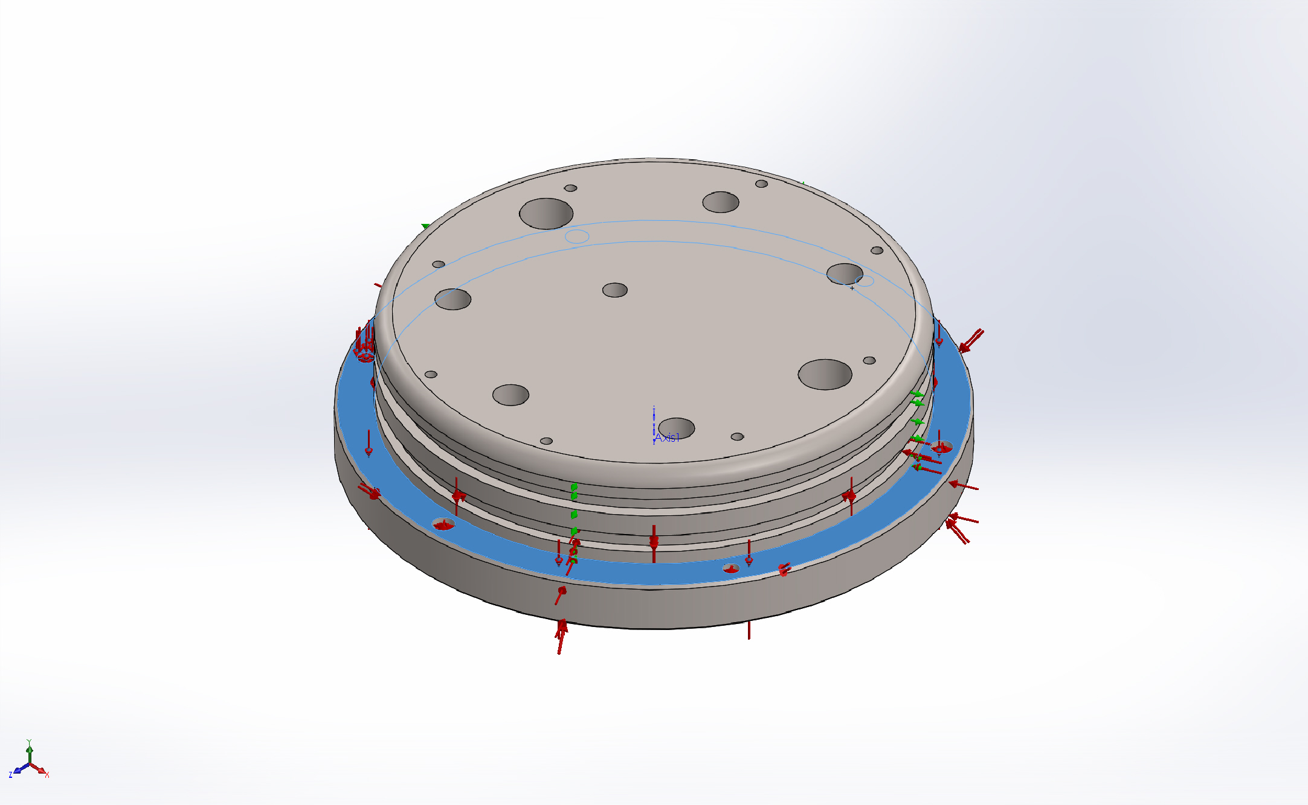
  Entities: | 1 face(s)
  Type: | Use reference geometry
  Translation: | ---, ---, 0
  Units: | m
Resultant Forces
Components | X | Y | Z | Resultant
Reaction force(N) | 0 | 1.09788 | 0 | 1.09788
Reaction Moment(N.m) | 0 | 0 | 0 | 0

On Cylindrical Faces-1 | 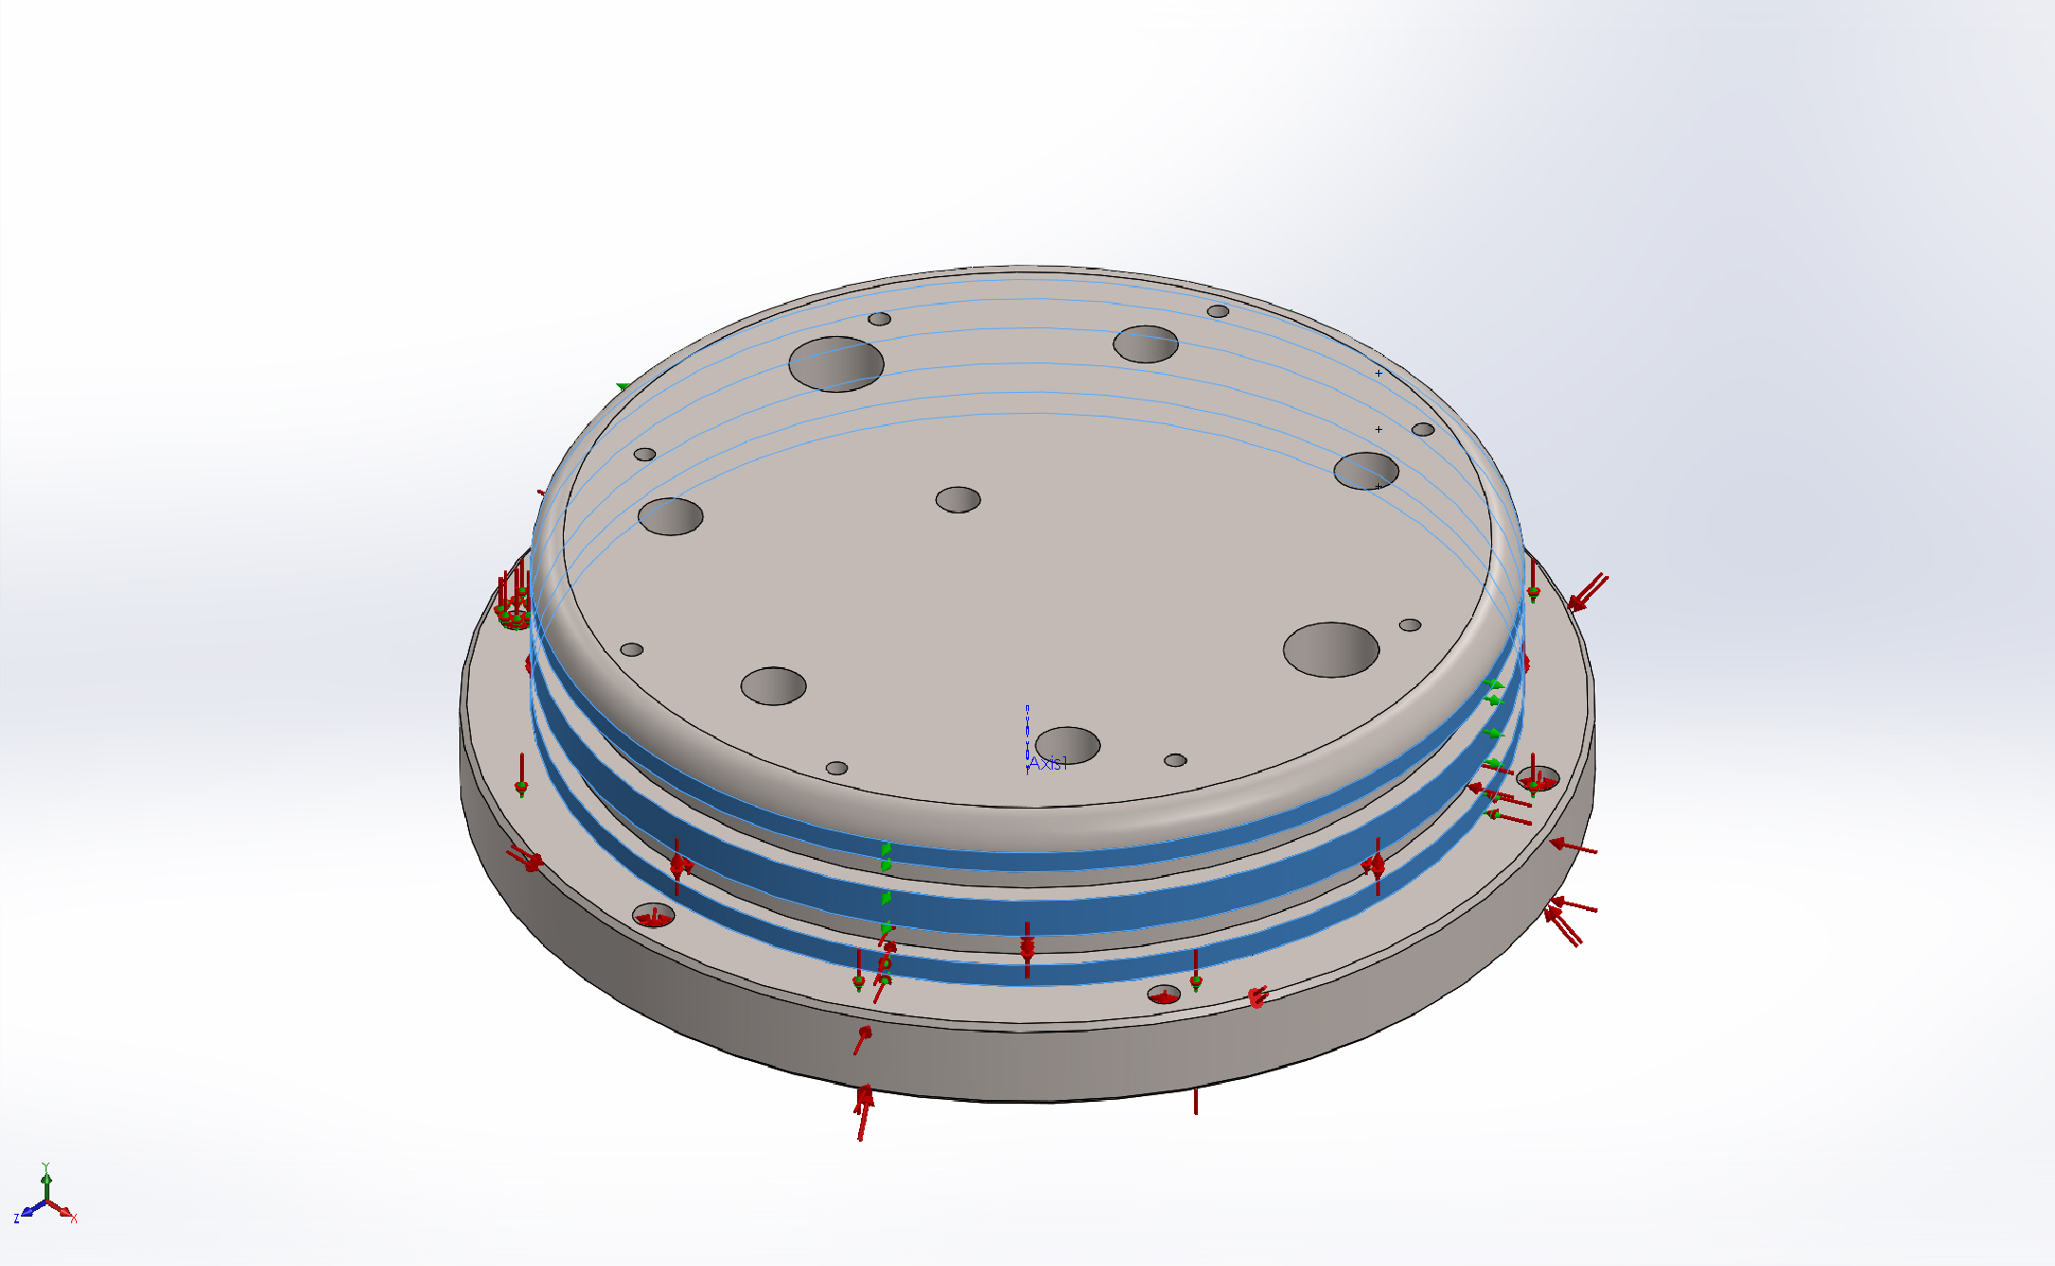
  Entities: | 3 face(s)
  Type: | On Cylindrical Faces
  Translation: | 0, ---, ---
  Units: | m
Resultant Forces
Components | X | Y | Z | Resultant
Reaction force(N) | 9.15527e-005 | -159266 | 0.00216675 | 159266
Reaction Moment(N.m) | 0 | 0 | 0 | 0

Load name | Load Image | Load Details
Pressure-1 | 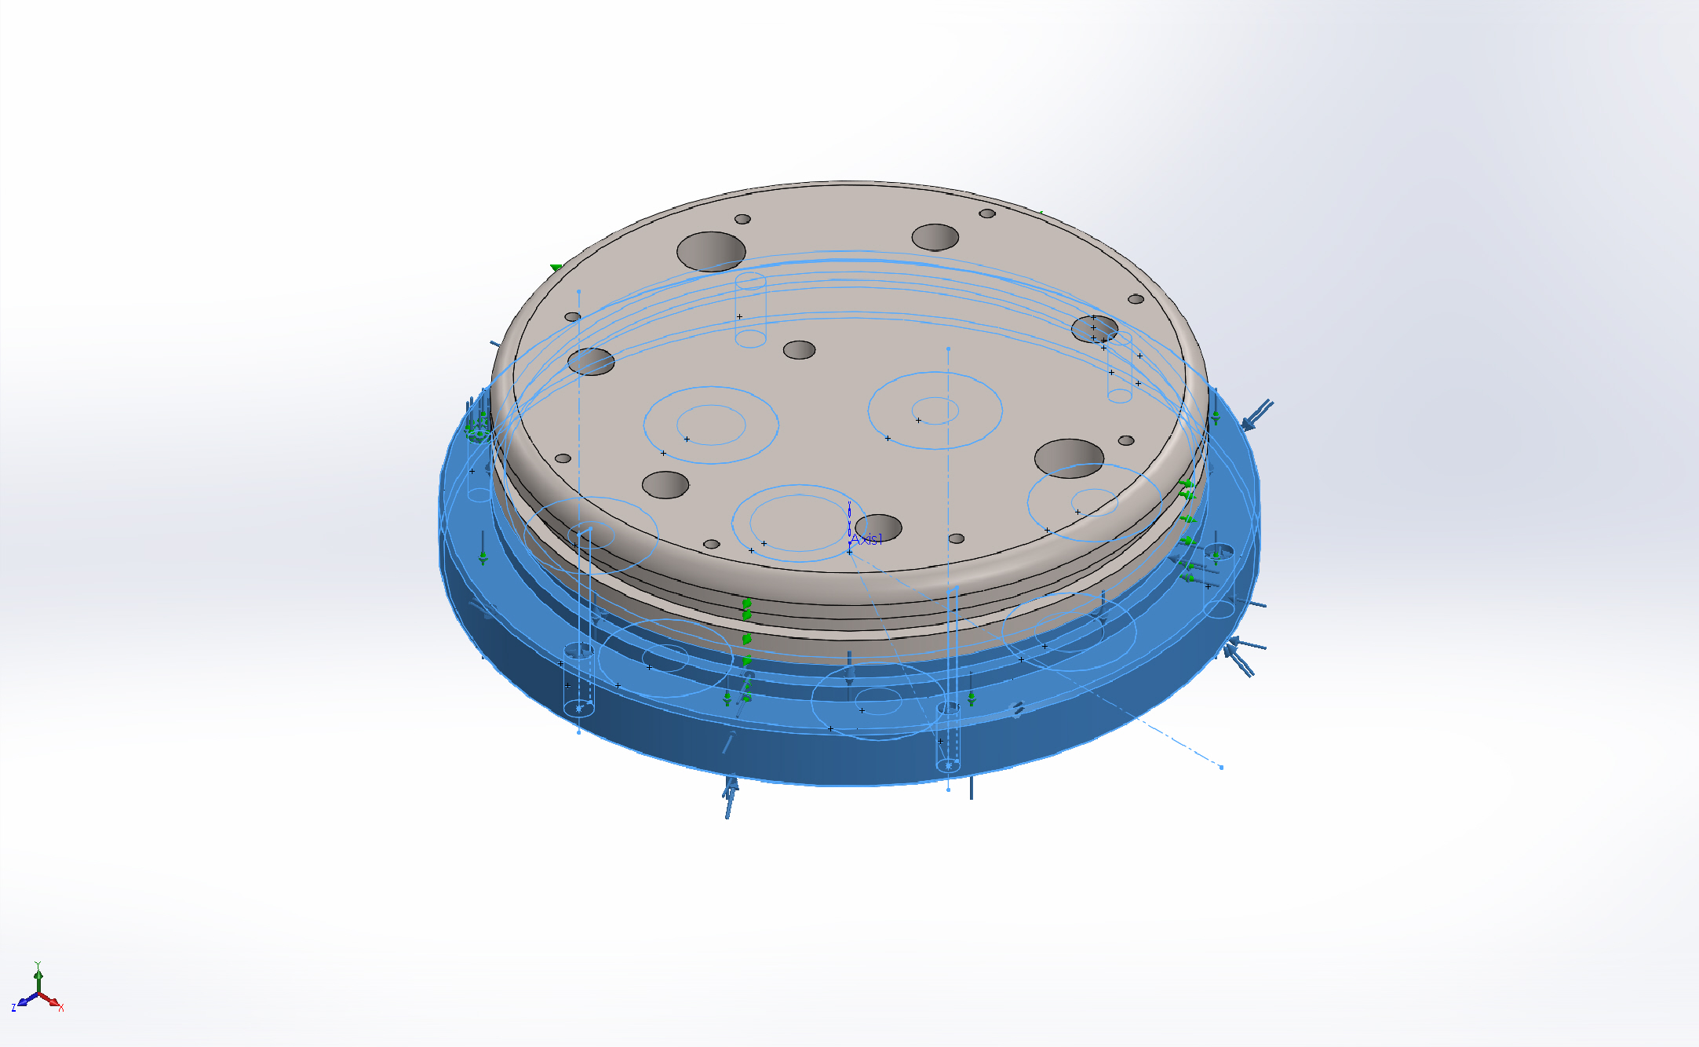
  Entities: | 30 face(s)
  Type: | Normal to selected face
  Value: | 9000
  Units: | psi
  Phase Angle: | 0
  Units: | deg

Connector Definitions
No Data

Contact Information
No Data

Mesh information
Mesh type | Solid Mesh
Mesher Used: | Standard mesh
Automatic Transition: | Off
Include Mesh Auto Loops: | Off
Jacobian points | 4 Points
Element Size | 0.372246 in
Tolerance | 0.0186123 in
Mesh Quality | High

Mesh information - Details
Total Nodes | 32156
Total Elements | 20706
Maximum Aspect Ratio | 15.385
% of elements with Aspect Ratio < 3 | 89.2
% of elements with Aspect Ratio > 10 | 0.116
% of distorted elements(Jacobian) | 0
Time to complete mesh(hh;mm;ss): | 00:00:07
Computer name: | HUNGA-TONGA
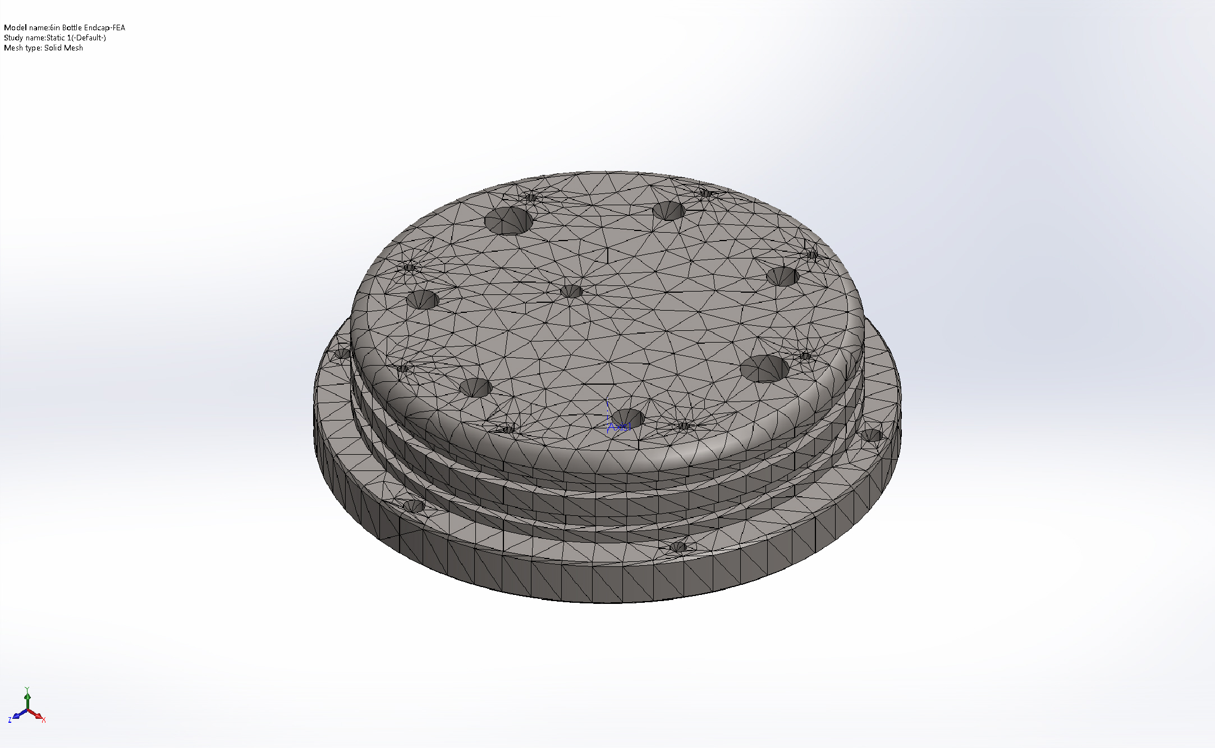

Sensor Details
No Data

Resultant Forces

Reaction forces
Selection set | Units | Sum X | Sum Y | Sum Z | Resultant
Entire Model | N | 0.00105054 | 1.09788 | 0.00182243 | 1.09788

Reaction Moments
Selection set | Units | Sum X | Sum Y | Sum Z | Resultant
Entire Model | N.m | 0 | 0 | 0 | 0

Beams
No Data

Study Results

Name | Type | Min | Max
Stress1 | VON: von Mises Stress | 95.4436 psi  Node: 5491 | 20306 psi  Node: 27179
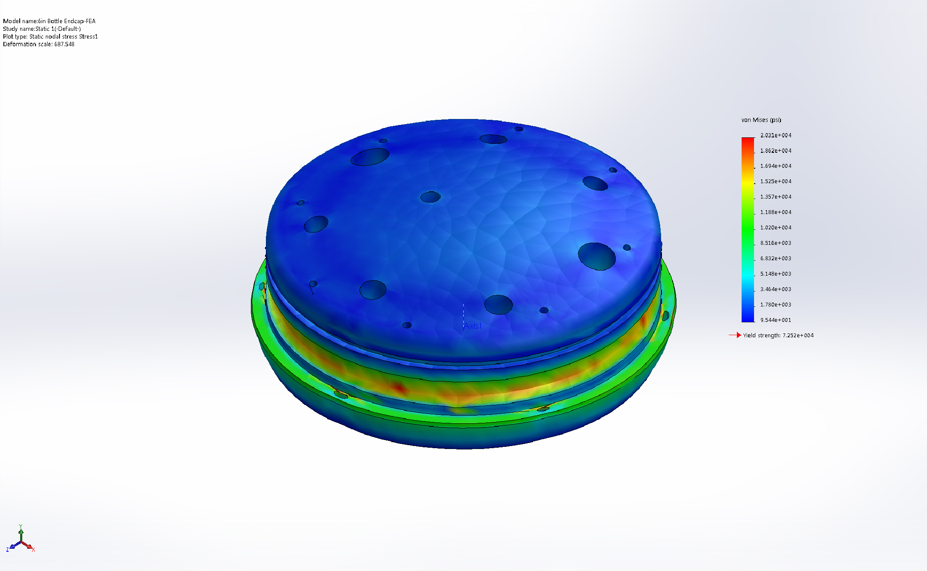
6in Bottle Endcap-FEA-Static 1-Stress-Stress1

Name | Type | Min | Max
Displacement1 | URES: Resultant Displacement | 1.39261e-005 m  Node: 20615 | 2.75089e-005 m  Node: 29515
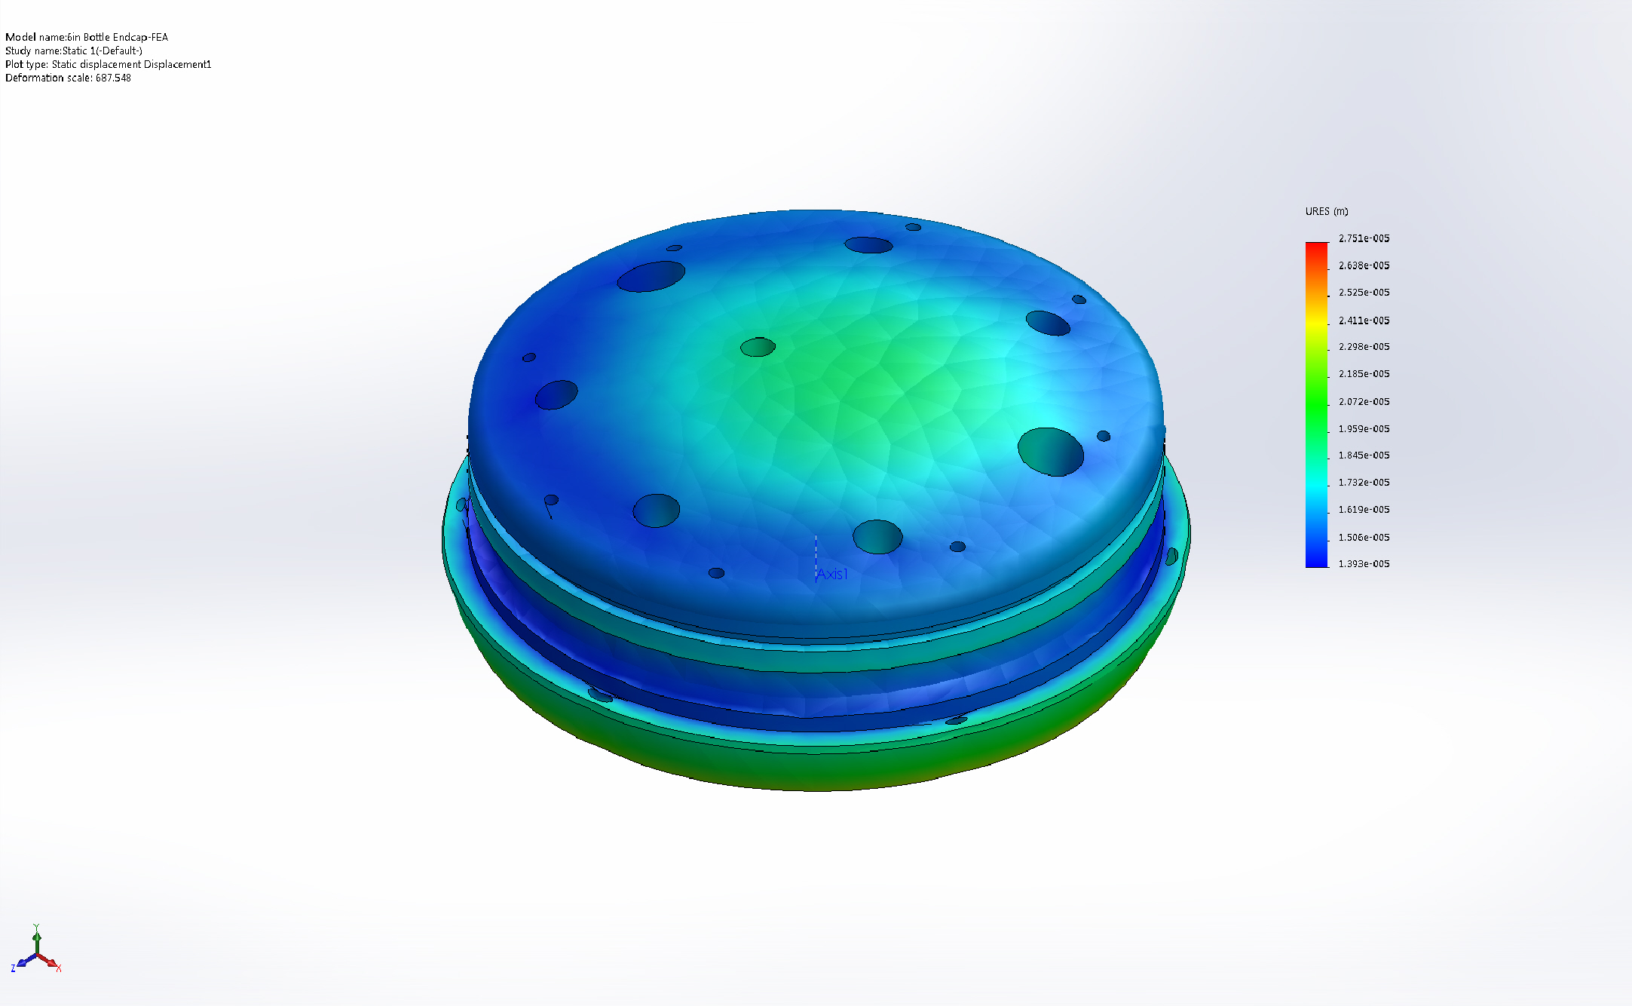
6in Bottle Endcap-FEA-Static 1-Displacement-Displacement1

Name | Type | Min | Max
Strain1 | ESTRN: Equivalent Strain | 1.39019e-005  Element: 8924 | 0.000988144  Element: 9891
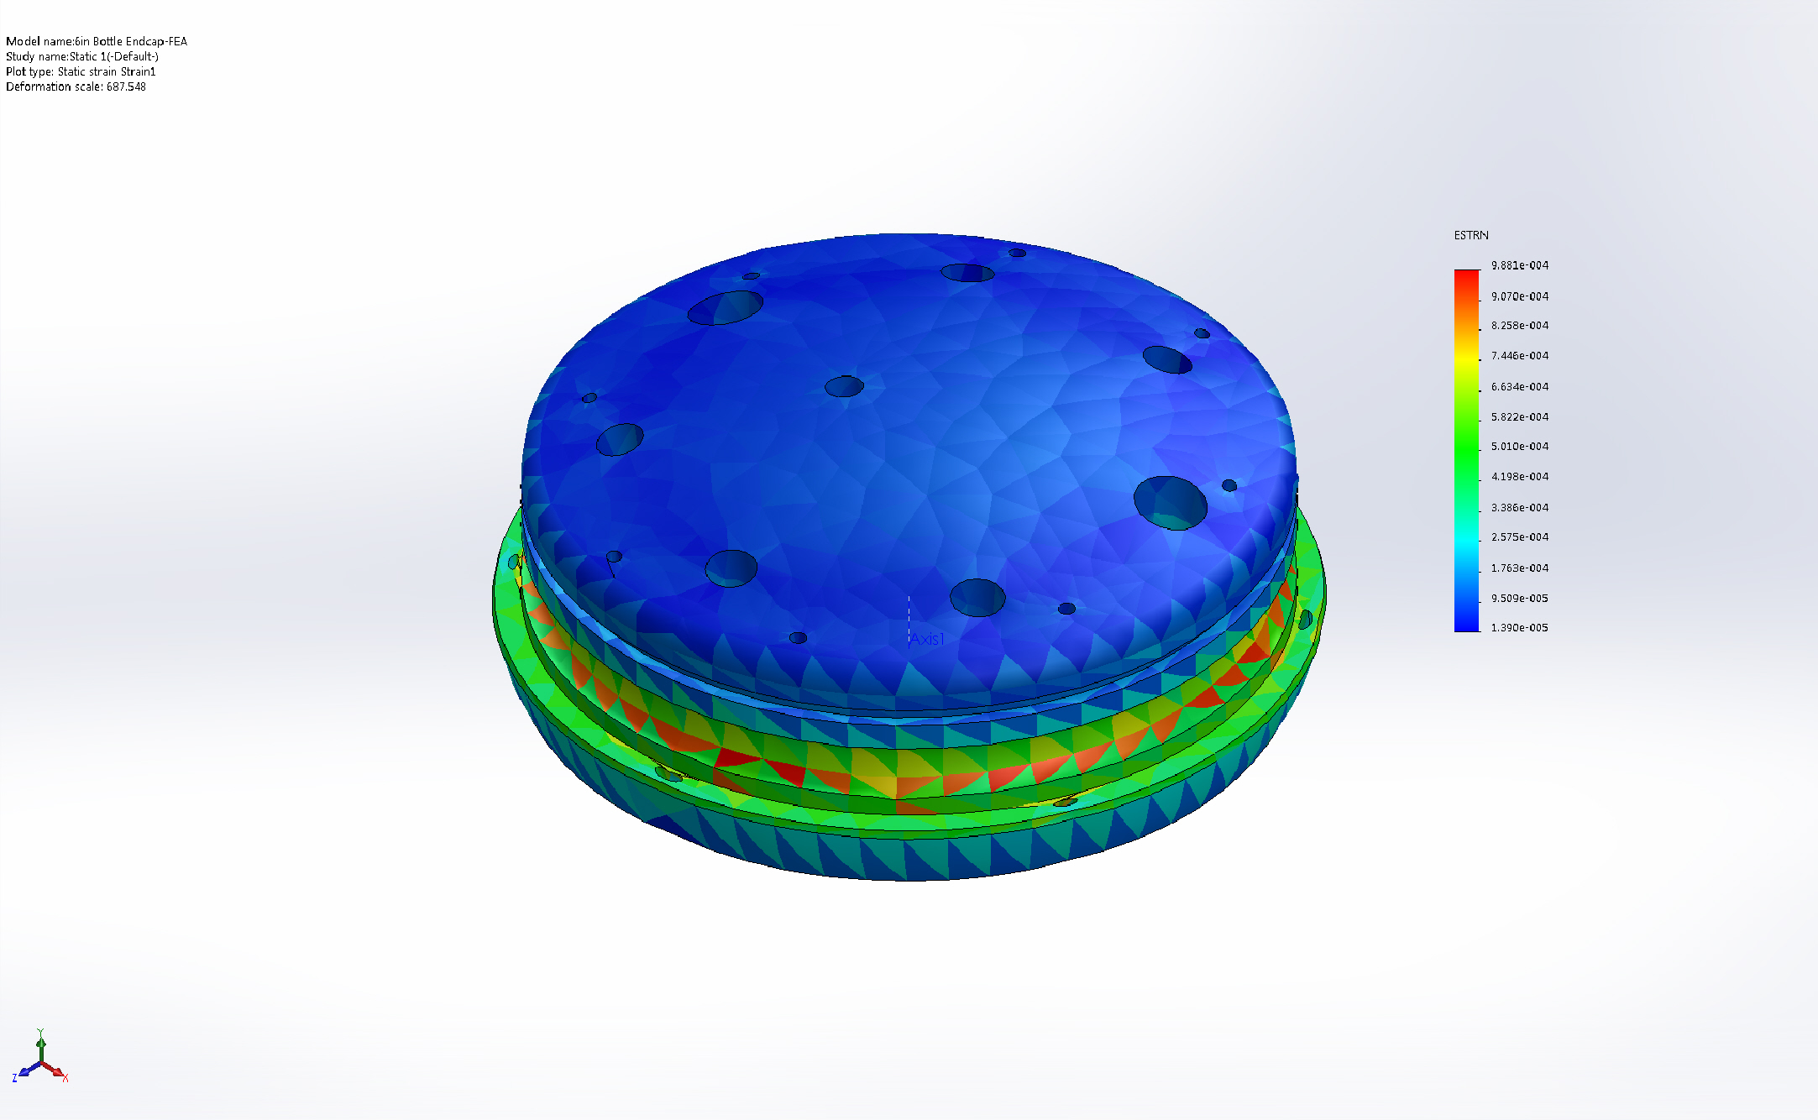
6in Bottle Endcap-FEA-Static 1-Strain-Strain1

Conclusion

