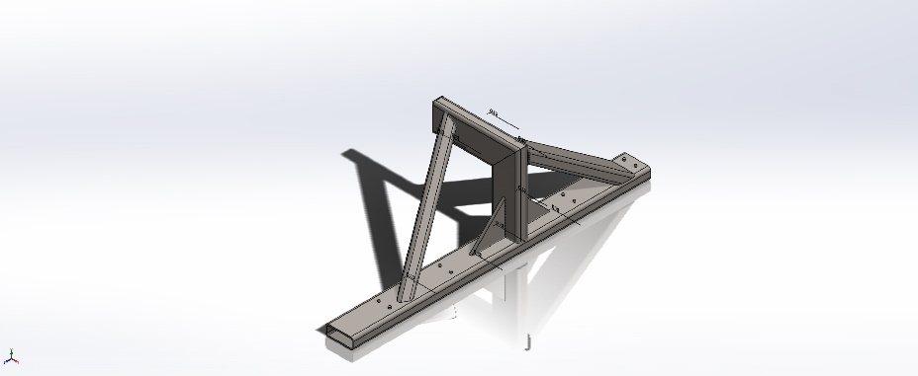
  Simulation of Cradle Arm Rev AB
  Date: Thursday, May 16, 2019
  Designer: Solidworks
  Study name: Static 1
  Analysis type: Static
  Table of Contents
  Description 1
  Assumptions 2
  Model Information 2
  Study Properties 3
  Units 4
  Material Properties 4
  Loads and Fixtures 5
  Connector Definitions 5
  Contact Information 6
  Mesh information 7
  Sensor Details 8
  Resultant Forces 8
  Beams 8
  Study Results 9
  Conclusion 14

Description
No Data

Assumptions

Model Information

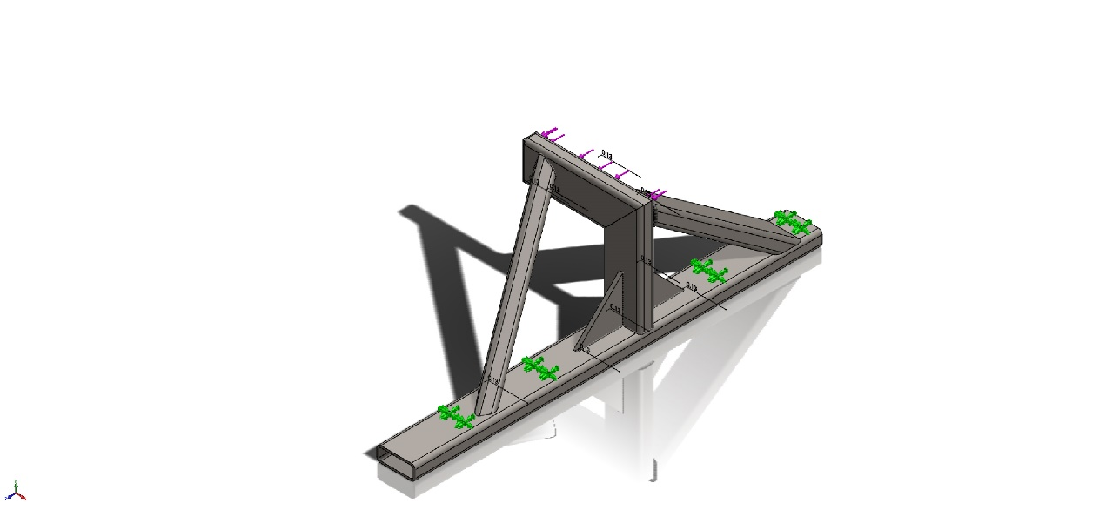
Model name: Cradle Arm Rev AB
Current Configuration: Default<As Machined>
Solid Bodies
Document Name and Reference | Treated As | Volumetric Properties | Document Path/Date Modified
Template RECTANGULAR TUBE 5X2X.25(1)[2]  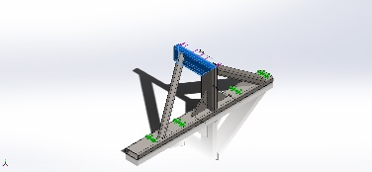 | Solid Body | Mass:5.06748 kg  Volume:0.000645541 m^3  Density:7,849.98 kg/m^3  Weight:49.6613 N | C:\PDM_Vault\DMO\Capture Head Boom Crutch Rachel Carson\Cradle Arm Rev AB.SLDPRT  May 16 15:39:44 2019
Template RECTANGULAR TUBE 5X2X.25(1)[3]  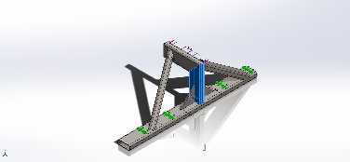 | Solid Body | Mass:4.76857 kg  Volume:0.000607461 m^3  Density:7,850 kg/m^3  Weight:46.732 N | C:\PDM_Vault\DMO\Capture Head Boom Crutch Rachel Carson\Cradle Arm Rev AB.SLDPRT  May 16 15:39:44 2019
Boss-Extrude2  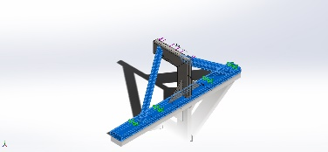 | Solid Body | Mass:36.0056 kg  Volume:0.0045867 m^3  Density:7,850 kg/m^3  Weight:352.855 N | C:\PDM_Vault\DMO\Capture Head Boom Crutch Rachel Carson\Cradle Arm Rev AB.SLDPRT  May 16 15:39:44 2019
Gusset1  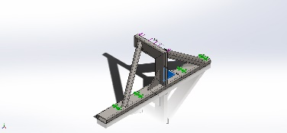 | Solid Body | Mass:1.15775 kg  Volume:0.000147484 m^3  Density:7,850 kg/m^3  Weight:11.3459 N | C:\PDM_Vault\DMO\Capture Head Boom Crutch Rachel Carson\Cradle Arm Rev AB.SLDPRT  May 16 15:39:44 2019
Gusset2  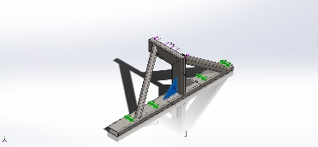 | Solid Body | Mass:1.15775 kg  Volume:0.000147484 m^3  Density:7,850 kg/m^3  Weight:11.3459 N | C:\PDM_Vault\DMO\Capture Head Boom Crutch Rachel Carson\Cradle Arm Rev AB.SLDPRT  May 16 15:39:44 2019
End cap1  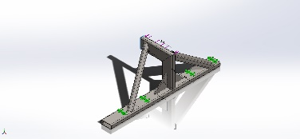 | Solid Body | Mass:0.267327 kg  Volume:3.40543e-05 m^3  Density:7,850 kg/m^3  Weight:2.6198 N | C:\PDM_Vault\DMO\Capture Head Boom Crutch Rachel Carson\Cradle Arm Rev AB.SLDPRT  May 16 15:39:44 2019

Study Properties
Study name | Static 1
Analysis type | Static
Mesh type | Solid Mesh
Thermal Effect: | On
Thermal option | Include temperature loads
Zero strain temperature | 298 Kelvin
Include fluid pressure effects from SOLIDWORKS Flow Simulation | Off
Solver type | Direct sparse solver
Inplane Effect: | Off
Soft Spring: | Off
Inertial Relief: | Off
Incompatible bonding options | Automatic
Large displacement | Off
Compute free body forces | On
Friction | Off
Use Adaptive Method: | Off
Result folder | SOLIDWORKS document (C:\PDM_Vault\DMO\Capture Head Boom Crutch Rachel Carson)

Units
Unit system: | SI (MKS)
Length/Displacement | mm
Temperature | Kelvin
Angular velocity | Rad/sec
Pressure/Stress | N/m^2

Material Properties
Model Reference | Properties | Components
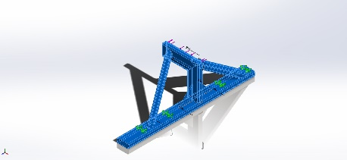 |  | SolidBody 1(Template RECTANGULAR TUBE 5X2X.25(1)[2])(Cradle Arm Rev AB),  SolidBody 3(Template RECTANGULAR TUBE 5X2X.25(1)[3])(Cradle Arm Rev AB),  SolidBody 4(Boss-Extrude2)(Cradle Arm Rev AB),  SolidBody 5(Gusset1)(Cradle Arm Rev AB),  SolidBody 6(Gusset2)(Cradle Arm Rev AB),  SolidBody 10(End cap1)(Cradle Arm Rev AB)
  Name: | ASTM A36 Steel
  Model type: | Linear Elastic Isotropic
  Default failure criterion: | Unknown
  Yield strength: | 2.5e+08 N/m^2
  Tensile strength: | 4e+08 N/m^2
  Elastic modulus: | 2e+11 N/m^2
  Poisson's ratio: | 0.26
  Mass density: | 7,850 kg/m^3
  Shear modulus: | 7.93e+10 N/m^2
Curve Data:N/A

Loads and Fixtures
Fixture name | Fixture Image | Fixture Details
Fixed-8 | 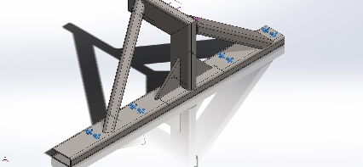
  Entities: | 8 face(s)
  Type: | Fixed Geometry
Resultant Forces
Components | X | Y | Z | Resultant
Reaction force(N) | -0.000329018 | -0.000343323 | -40,034 | 40,034
Reaction Moment(N.m) | 0 | 0 | 0 | 0

Load name | Load Image | Load Details
Force-1 | 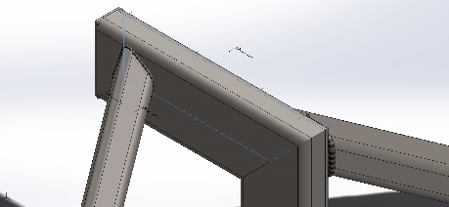
  Entities: | 1 face(s)
  Type: | Apply normal force
  Value: | 9,000 lbf

Connector Definitions
No Data

Contact Information

Contact | Contact Image | Contact Properties
Global Contact | 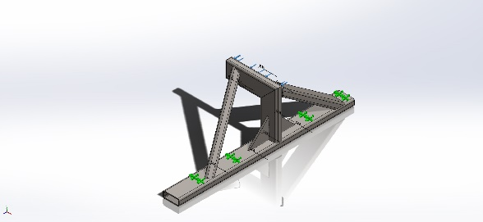
  Type: | Bonded
  Components: | 1 component(s)
  Options: | Incompatible mesh

Mesh information
Mesh type | Solid Mesh
Mesher Used: | Standard mesh
Automatic Transition: | Off
Include Mesh Auto Loops: | Off
Jacobian points | 4 Points
Element Size | 0.548383 in
Tolerance | 0.0274192 in
Mesh Quality Plot | High

Mesh information - Details
Total Nodes | 61824
Total Elements | 30776
Maximum Aspect Ratio | 10.744
% of elements with Aspect Ratio < 3 | 72.4
% of elements with Aspect Ratio > 10 | 0.0162
% of distorted elements(Jacobian) | 0
Time to complete mesh(hh;mm;ss): | 00:00:09
Computer name: | ORIGINATOR
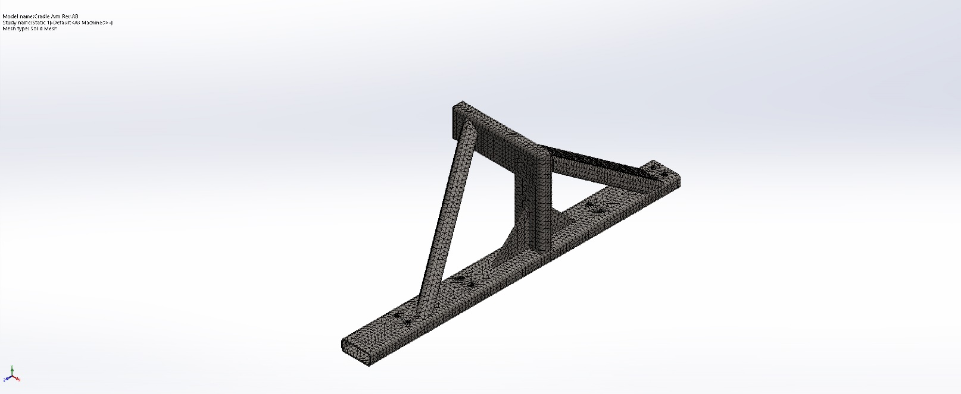

Sensor Details
No Data

Resultant Forces

Reaction forces
Selection set | Units | Sum X | Sum Y | Sum Z | Resultant
Entire Model | N | -0.000329018 | -0.000343323 | -40,034 | 40,034

Reaction Moments
Selection set | Units | Sum X | Sum Y | Sum Z | Resultant
Entire Model | N.m | 0 | 0 | 0 | 0

Beams
No Data

Study Results

Name | Type | Min | Max
Displacement1 | UZ: Z Displacement | -1.925e-04in  Node: 51461 | 1.957e-02 in  Node: 2460
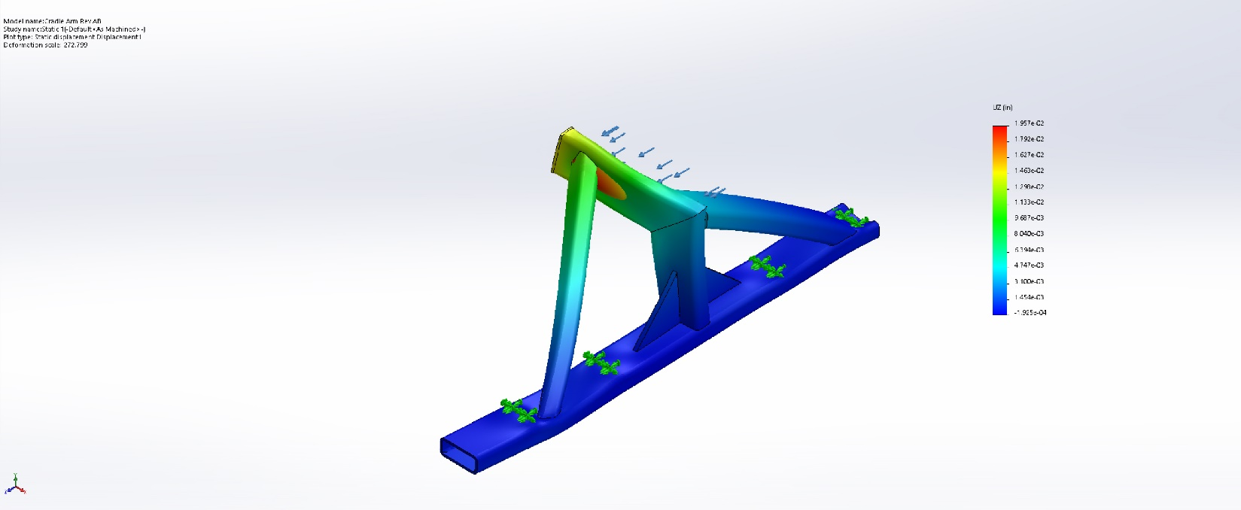
Cradle Arm Rev AB-Static 1-Displacement-Displacement1

Name | Type
Displacement1{1} | Deformed shape
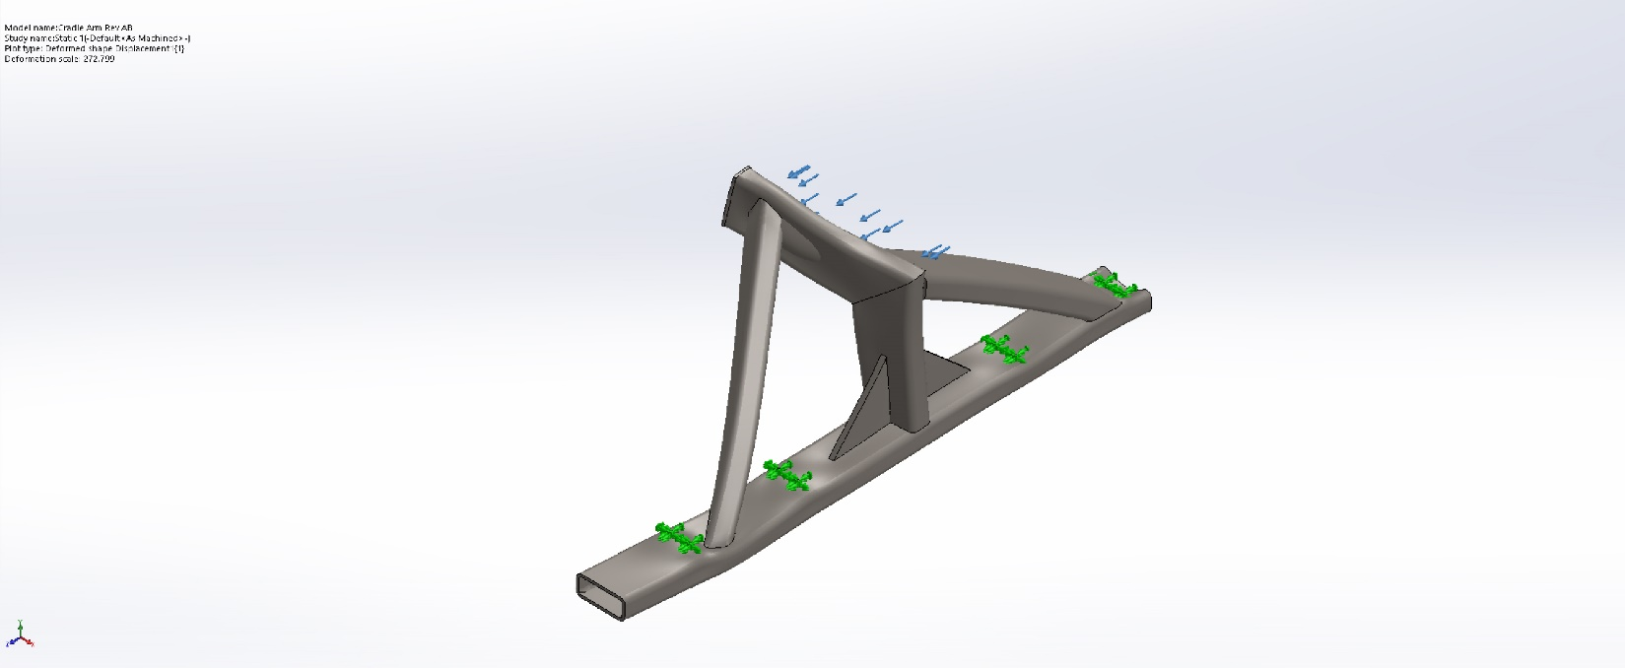
Cradle Arm Rev AB-Static 1-Displacement-Displacement1{1}

Name | Type | Min | Max
Stress1 | VON: von Mises Stress | 3.792e+04 N/m^2  Node: 54845 | 2.207e+08 N/m^2  Node: 58925
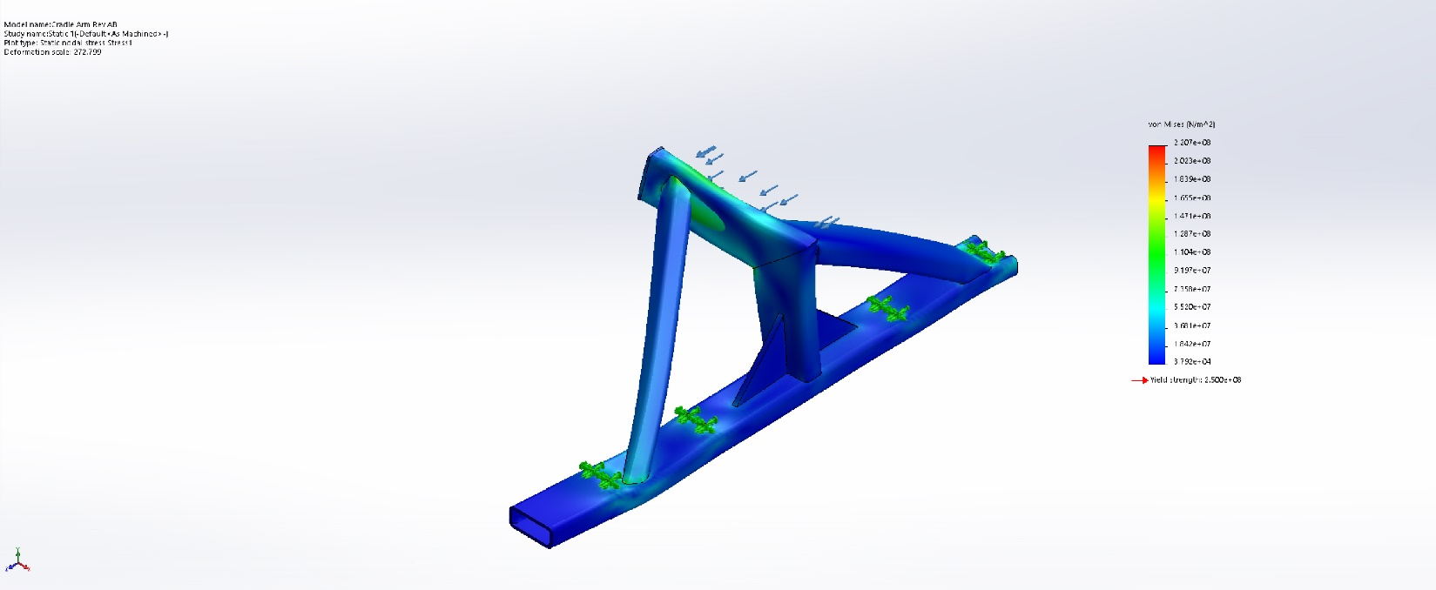
Cradle Arm Rev AB-Static 1-Stress-Stress1

Name | Type
Design Insight1 | Design Insight
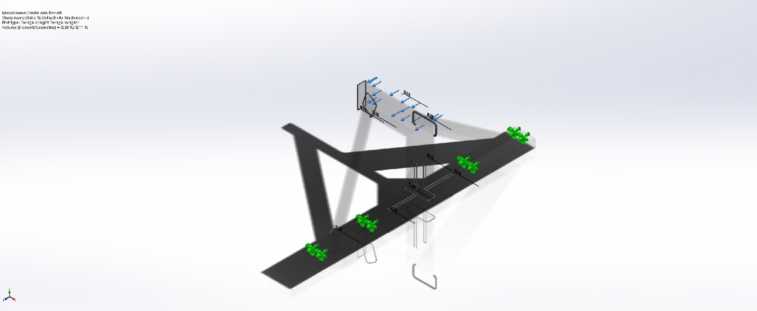
Cradle Arm Rev AB-Static 1-Design Insight-Design Insight1

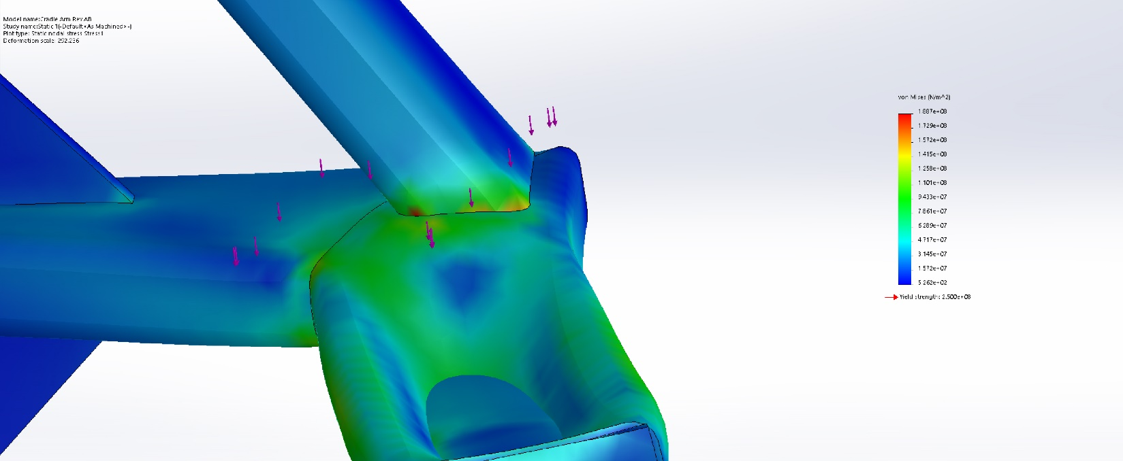
Image-1

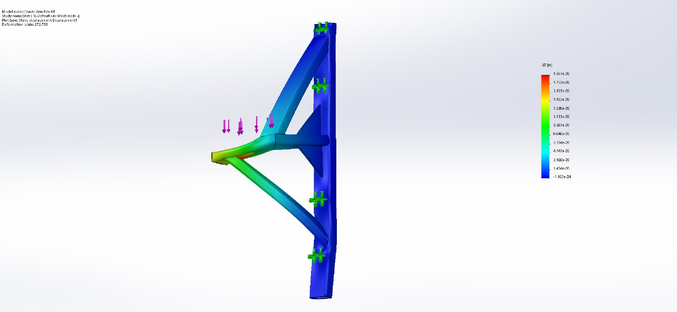
Image-2

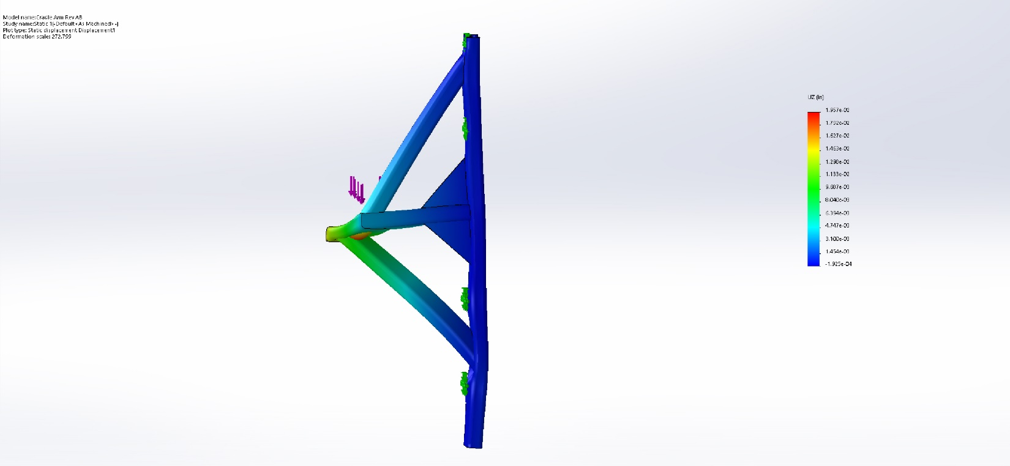
Image-3

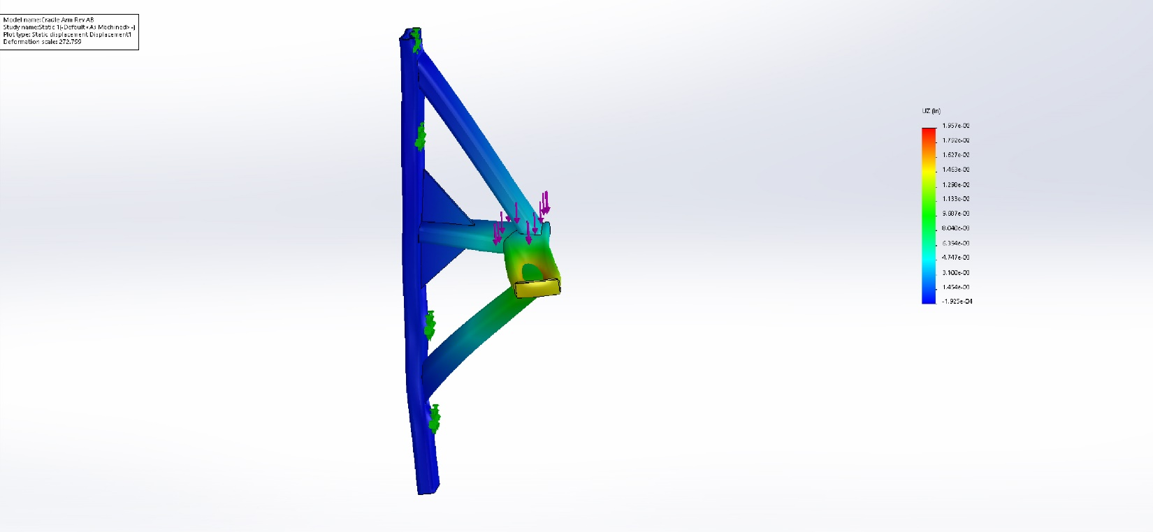
Image-4

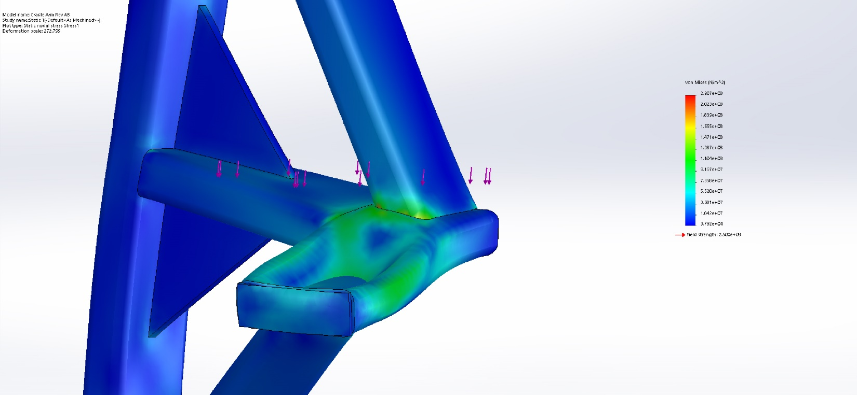
Image-5

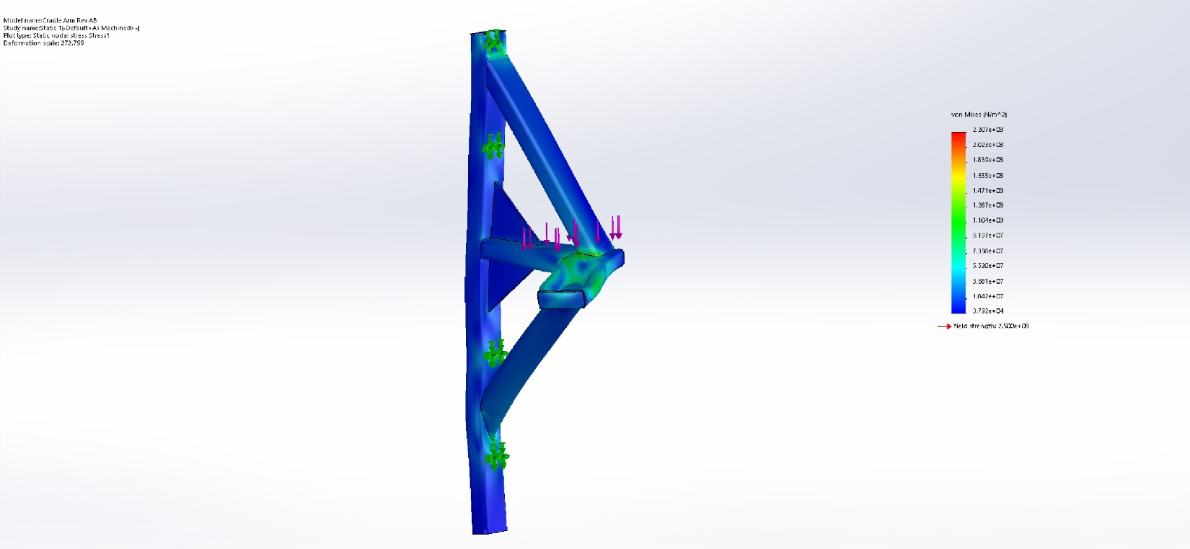
Image-6

Conclusion

