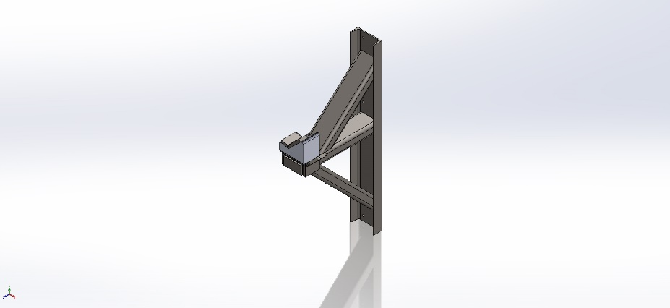
  Simulation of 20190610 Crane Crutch Assembly
  Date: Monday, June 10, 2019
  Designer: Solidworks
  Study name: Static 1
  Analysis type: Static
  Table of Contents
  Description 1
  Assumptions 2
  Model Information 2
  Study Properties 3
  Units 4
  Material Properties 4
  Loads and Fixtures 5
  Connector Definitions 5
  Contact Information 6
  Mesh information 7
  Sensor Details 8
  Resultant Forces 8
  Beams 8
  Study Results 9
  Conclusion 14

Description
No Data

Assumptions

Model Information

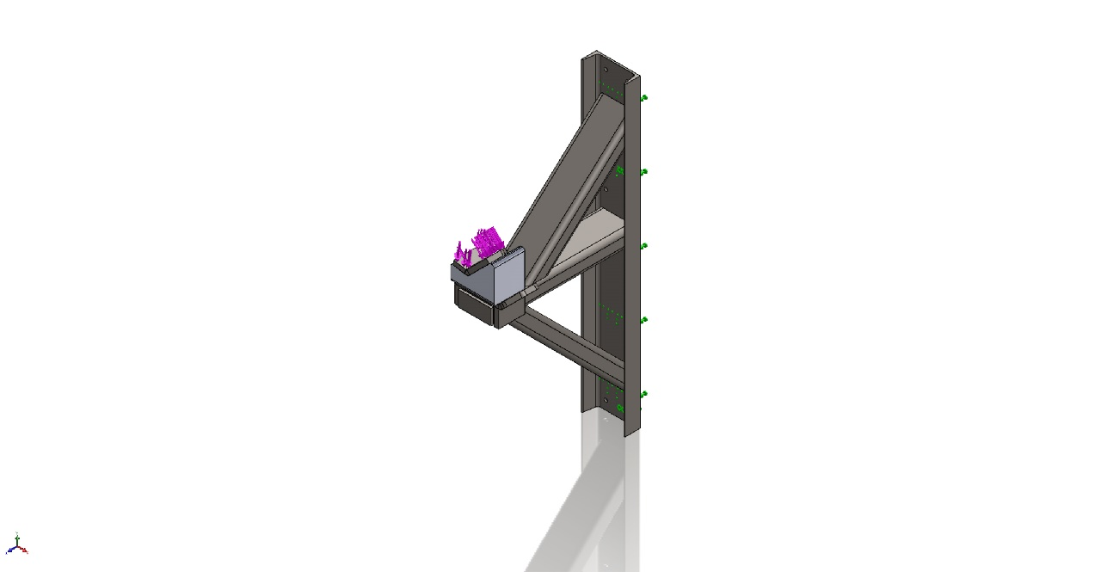
Model name: 20190610 Crane Crutch Assembly
Current Configuration: Default
Solid Bodies
Document Name and Reference | Treated As | Volumetric Properties | Document Path/Date Modified
Combine1  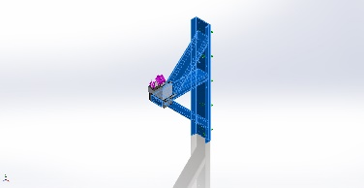 | Solid Body | Mass:24.6528 kg  Volume:0.00314048 m^3  Density:7,850 kg/m^3  Weight:241.598 N | C:\Users\enolasco\Desktop\RC Boom Crutch Atached to ROV Winch Chassis\Crane Parts\Crane Cradle Arm Tubing.SLDPRT  Jun 10 16:02:06 2019
Boss-Extrude2[2]  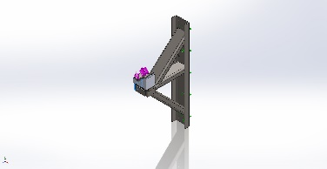 | Solid Body | Mass:0.385915 kg  Volume:4.91612e-05 m^3  Density:7,850 kg/m^3  Weight:3.78197 N | C:\Users\enolasco\Desktop\RC Boom Crutch Atached to ROV Winch Chassis\Crane Parts\Crutch Base Mount.SLDPRT  Jun 10 10:35:49 2019
Boss-Extrude2[1]  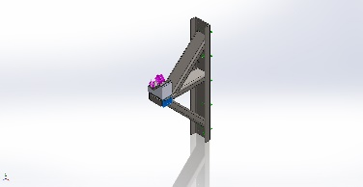 | Solid Body | Mass:0.385915 kg  Volume:4.91612e-05 m^3  Density:7,850 kg/m^3  Weight:3.78197 N | C:\Users\enolasco\Desktop\RC Boom Crutch Atached to ROV Winch Chassis\Crane Parts\Crutch Base Mount.SLDPRT  Jun 10 10:35:49 2019
Fillet1  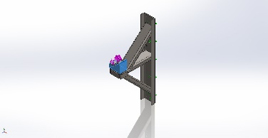 | Solid Body | Mass:0.975889 kg  Volume:0.00069212 m^3  Density:1,410 kg/m^3  Weight:9.56371 N | C:\Users\enolasco\Desktop\RC Boom Crutch Atached to ROV Winch Chassis\Crane Parts\UHMW Cradle.SLDPRT  Jun 10 11:23:52 2019

Study Properties
Study name | Static 1
Analysis type | Static
Mesh type | Mixed Mesh
Thermal Effect: | On
Thermal option | Include temperature loads
Zero strain temperature | 298 Kelvin
Include fluid pressure effects from SOLIDWORKS Flow Simulation | Off
Solver type | Direct sparse solver
Inplane Effect: | Off
Soft Spring: | Off
Inertial Relief: | Off
Incompatible bonding options | Automatic
Large displacement | Off
Compute free body forces | On
Friction | Off
Use Adaptive Method: | Off
Result folder | SOLIDWORKS document (C:\Users\enolasco\Desktop\RC Boom Crutch Atached to ROV Winch Chassis\Crane Parts)

Units
Unit system: | SI (MKS)
Length/Displacement | mm
Temperature | Kelvin
Angular velocity | Rad/sec
Pressure/Stress | N/m^2

Material Properties
Model Reference | Properties | Components
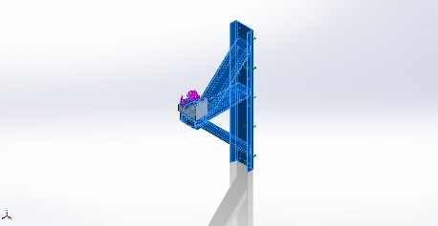 |  | SolidBody 1(Combine1)(Crane Cradle Arm Tubing-1),  SolidBody 1(Convert-Solid1)(Crane Foot Attachment-1),  SolidBody 1(Fillet1)(Crutch Base Mount-1),  SolidBody 2(Boss-Extrude2[2])(Crutch Base Mount-1),  SolidBody 3(Boss-Extrude2[1])(Crutch Base Mount-1)
  Name: | ASTM A36 Steel
  Model type: | Linear Elastic Isotropic
  Default failure criterion: | Unknown
  Yield strength: | 2.5e+08 N/m^2
  Tensile strength: | 4e+08 N/m^2
  Elastic modulus: | 2e+11 N/m^2
  Poisson's ratio: | 0.26
  Mass density: | 7,850 kg/m^3
  Shear modulus: | 7.93e+10 N/m^2
Curve Data:N/A
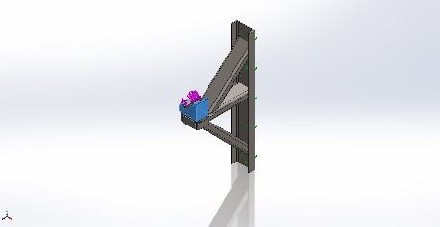 |  | SolidBody 1(Fillet1)(UHMW Cradle-1)
  Name: | Delrin 2700 NC010, Low Viscosity Acetal Copolymer (SS)
  Model type: | Linear Elastic Isotropic
  Default failure criterion: | Unknown
  Yield strength: | 6.3e+07 N/m^2
  Tensile strength: | 4.07e+07 N/m^2
  Elastic modulus: | 2.9e+09 N/m^2
  Poisson's ratio: | 0.3
  Mass density: | 1,410 kg/m^3
Curve Data:N/A

Loads and Fixtures
Fixture name | Fixture Image | Fixture Details
Fixed-2 | 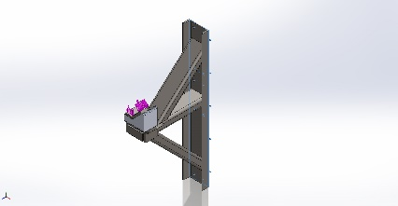
  Entities: | 1 face(s)
  Type: | Fixed Geometry
Resultant Forces
Components | X | Y | Z | Resultant
Reaction force(N) | -18,871.6 | 33,809.6 | 0.0162602 | 38,719.9
Reaction Moment(N.m) | 0 | 0 | 0 | 1e-33

Load name | Load Image | Load Details
Force-1 | 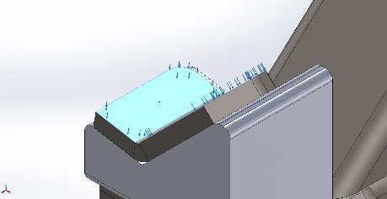
  Entities: | 2 face(s)
  Type: | Apply normal force
  Value: | 9,533 lbf

Connector Definitions
No Data

Contact Information

Contact | Contact Image | Contact Properties
Global Contact | 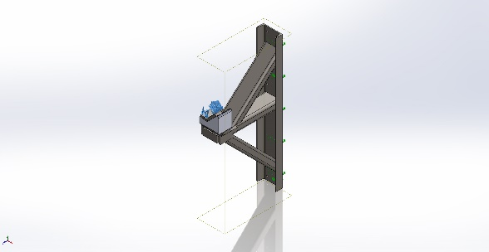
  Type: | Bonded
  Components: | 1 component(s)
  Options: | Compatible mesh

Mesh information
Mesh type | Mixed Mesh
Mesher Used: | Standard mesh
Automatic Transition: | Off
Include Mesh Auto Loops: | Off
Jacobian points | 4 Points
Jacobian check for shell | On
Element Size | 0.555272 in
Tolerance | 0.0277636 in
Mesh Quality Plot | High
Remesh failed parts with incompatible mesh | Off

Mesh information - Details
Total Nodes | 40410
Total Elements | 20385
Time to complete mesh(hh;mm;ss): | 00:00:10
Computer name: | ORIGINATOR
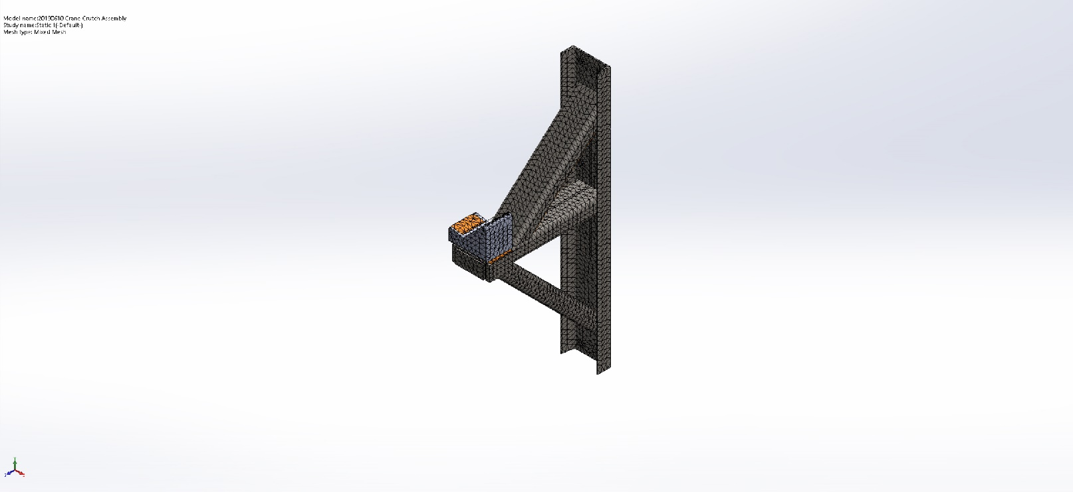

Sensor Details
No Data

Resultant Forces

Reaction forces
Selection set | Units | Sum X | Sum Y | Sum Z | Resultant
Entire Model | N | -18,871.6 | 33,809.6 | 0.0162602 | 38,719.9

Reaction Moments
Selection set | Units | Sum X | Sum Y | Sum Z | Resultant
Entire Model | N.m | 0 | 0 | 0 | 1e-33

Beams
No Data

Study Results

Name | Type | Min | Max
Stress1 | VON: von Mises Stress | 2.752e-07 N/mm^2 (MPa)  Node: 28006 | 3.697e+02 N/mm^2 (MPa)  Node: 28249
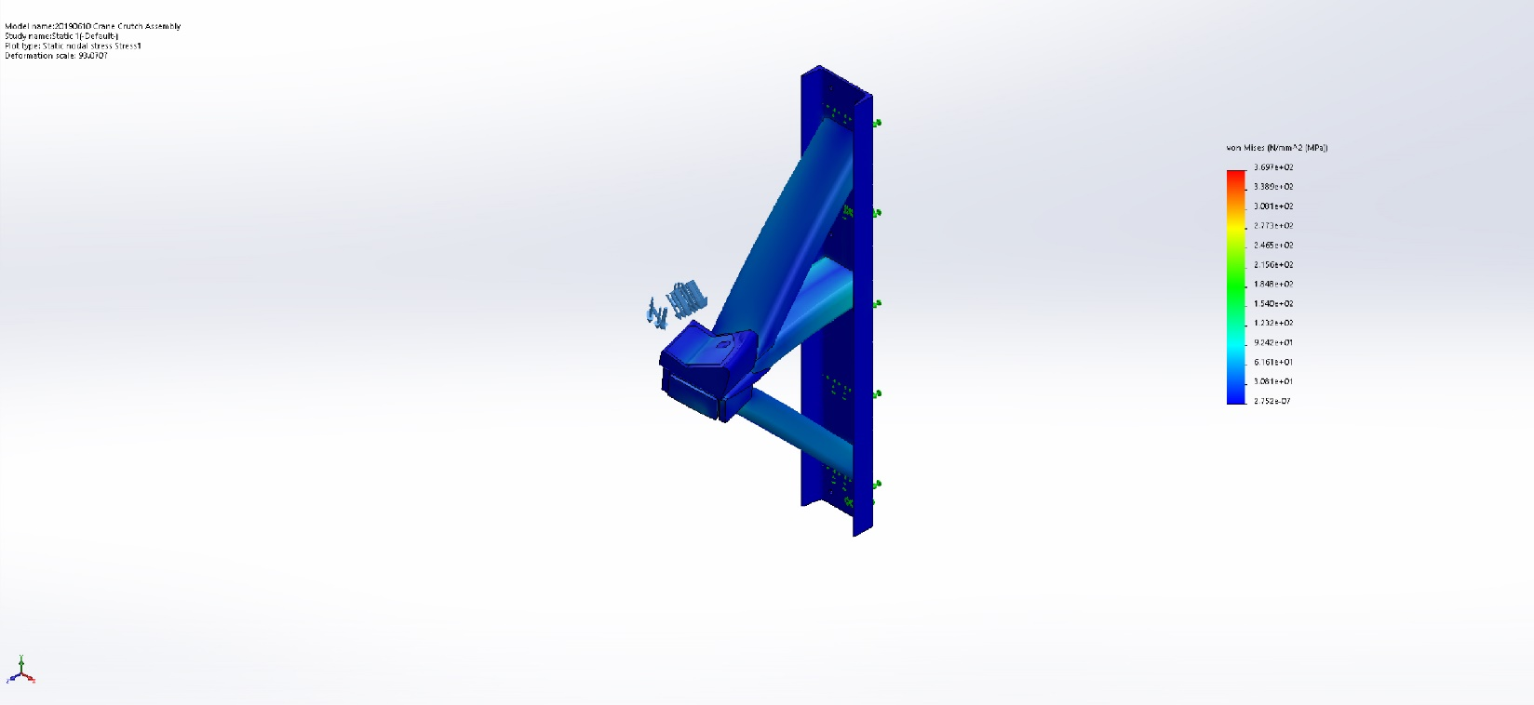
20190610 Crane Crutch Assembly-Static 1-Stress-Stress1

Name | Type | Min | Max
Displacement1 | UZ: Z Displacement | -5.351e-03in  Node: 36633 | 8.295e-03 in  Node: 37102
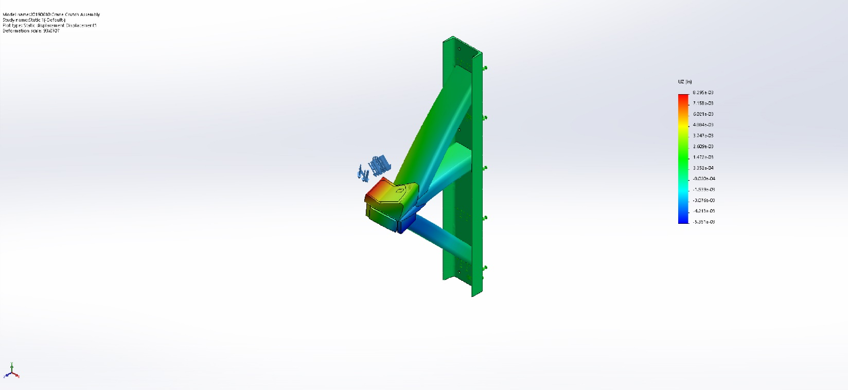
20190610 Crane Crutch Assembly-Static 1-Displacement-Displacement1

Name | Type | Min | Max
Strain1 | ESTRN: Equivalent Strain | 9.181e-13  Element: 8279 | 4.185e-03  Element: 19314
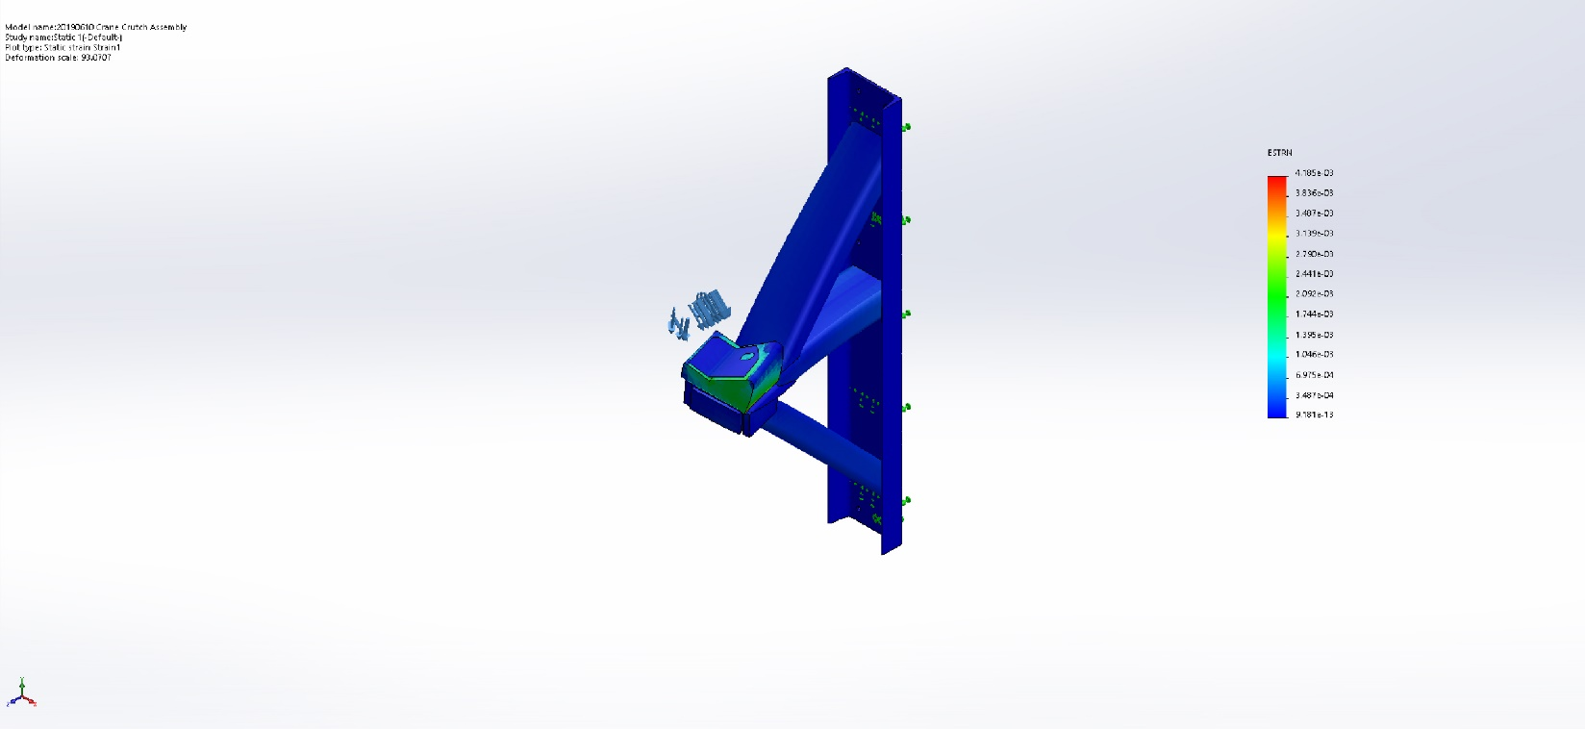
20190610 Crane Crutch Assembly-Static 1-Strain-Strain1

Name | Type
Displacement1{1} | Deformed shape
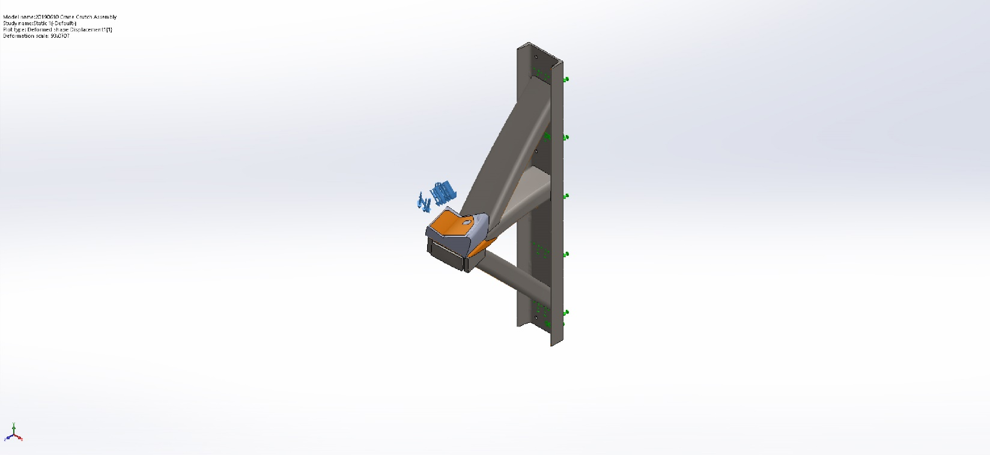
20190610 Crane Crutch Assembly-Static 1-Displacement-Displacement1{1}

Name | Type | Min | Max
Factor of Safety1 | Automatic | 6.763e-01  Node: 28249 | 9.085e+08  Node: 28006
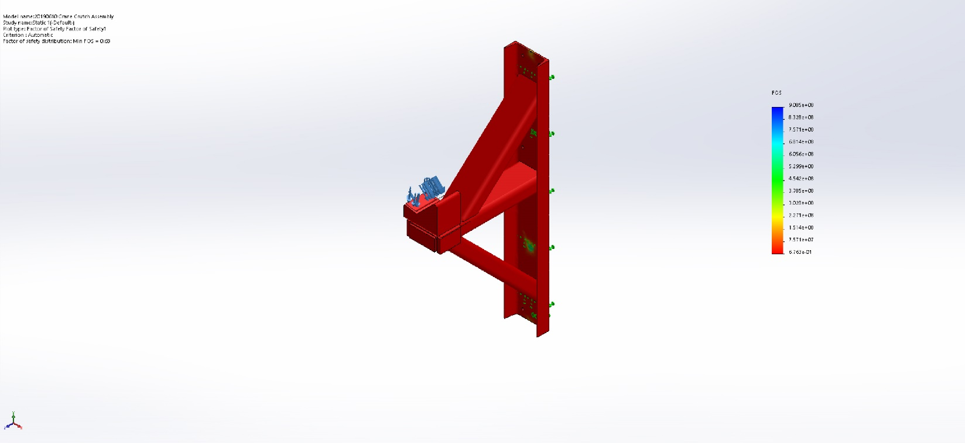
20190610 Crane Crutch Assembly-Static 1-Factor of Safety-Factor of Safety1

Name | Type
Displacement2 | Deformed shape
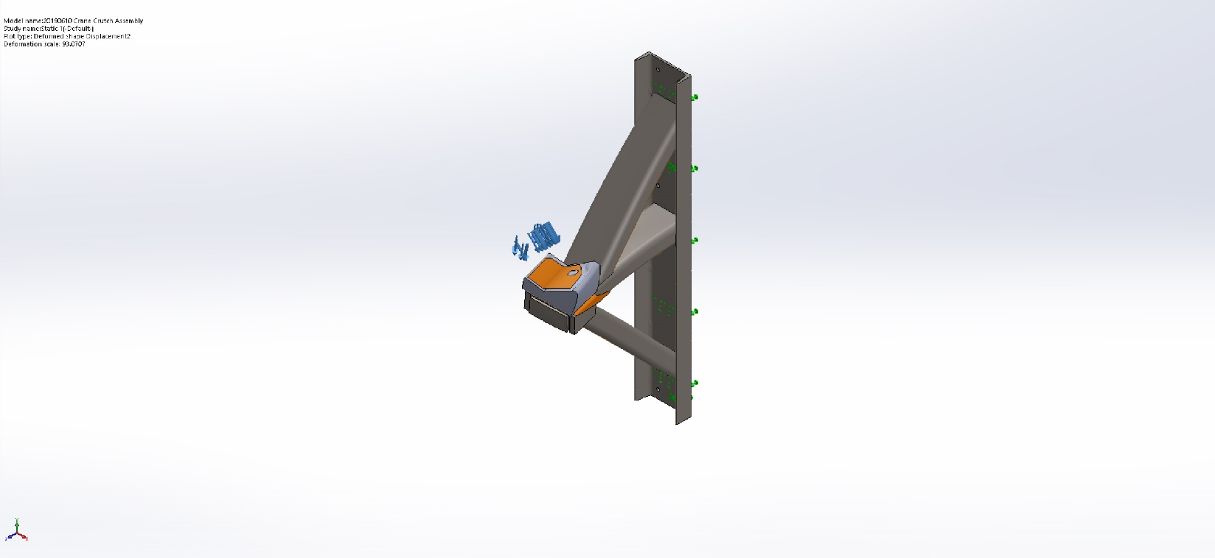
20190610 Crane Crutch Assembly-Static 1-Displacement-Displacement2

Name | Type
Design Insight1 | Design Insight
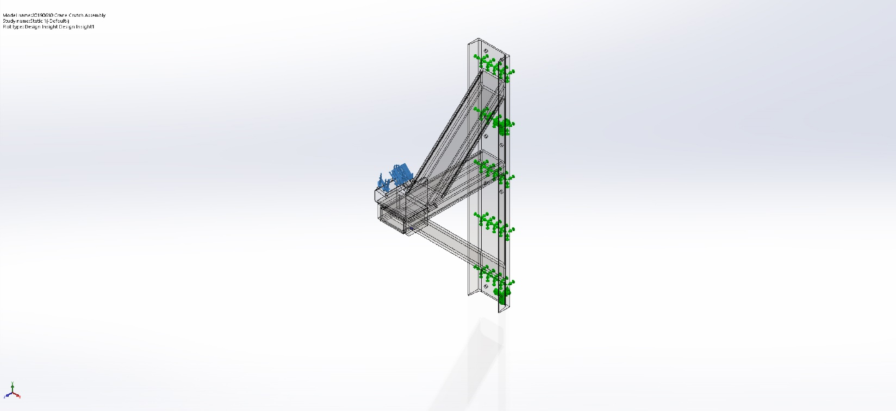
20190610 Crane Crutch Assembly-Static 1-Design Insight-Design Insight1

Name | Type | Min | Max
Stress2 | P1: 1st Principal Stress | -3.350e+07N/m^2  Node: 28244 | 1.860e+08 N/m^2  Node: 3911
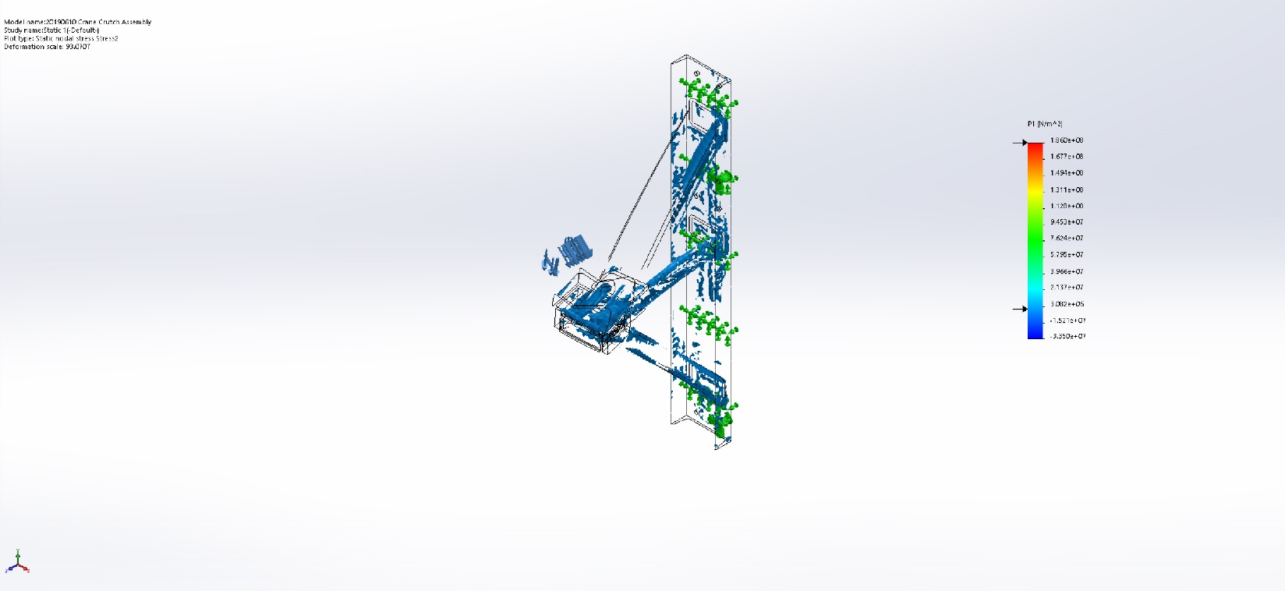
20190610 Crane Crutch Assembly-Static 1-Stress-Stress2

Name | Type
Design Insight2 | Design Insight
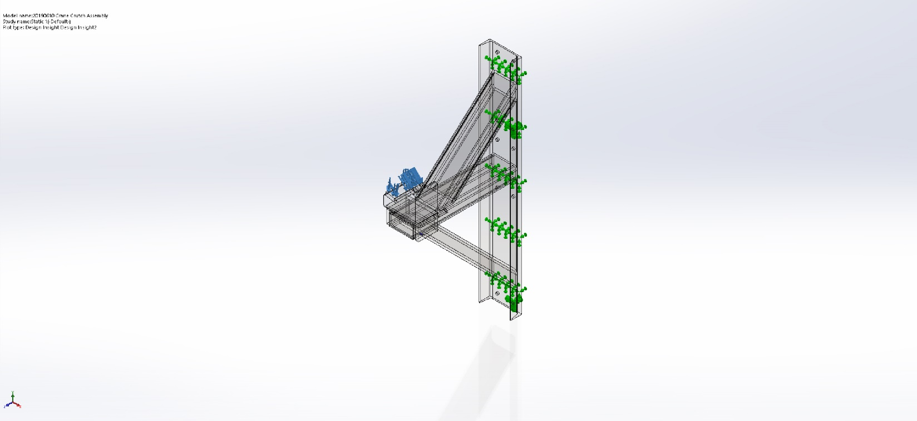
20190610 Crane Crutch Assembly-Static 1-Design Insight-Design Insight2

Conclusion

