- Overview
This README is intended to establish and inform, the specifics of how to organize the AUV SolidWorks Models and Drawings.

- How to Name
  - Description Title
If it is a single part, it should be short description, basic name.
    - Example: MHDL-16 CCP to NetG CCP, CABLE

  - If you’re making a distinct assembly and have different components as part of it
    - AUV TAG LINE HANDLE
      - AUV TOW LINE HANDLE, HANDLE
      - AUV TOW LINE HANDLE, BASE
    - EK80 ECHOSOUNDER, BRACKET
    - PMEL, BRACKET
      - PMEL, HOUSING
    - 30 IN MIDSECTION TOP, RAILING
    - 30 IN MIDSECTION BOTTOM, RAILING

    - Examples of unacceptable names:
      - I2MAP, BRACKET
      - MIDSECTION, BRACKET
  - SolidWorks Model
    - H-100221350 AUV TOW LINE HANDLE
    - H-100221351 AUV TOW LINE HANDLE, HANDLE
  - Drawings
    - H-100221351 AUV TOW LINE HANDLE, HANDLE_RevB.PDF
  - MasterCam File
- How to File
\\atlas\ProjectLibrary\368000DMO_AUV\documents\AUV_SOLIDWORKS_LIBRARY\
  - ASSEM AND PART LIBRARY
  - GULPER
  - I2MAP
  - MAPPER
  - TAILCONE
  - If the part is altered specifically for the vehicle, add it to Configurations under the vehicle name that is altered
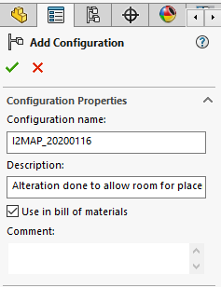
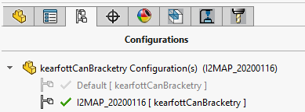

- Symbols
Symbol | Category | Examples
C | Circuit Boards | MVC, Battery Board,
CE | Batteries and Cables | Batteries, Bus,
F | Fairing-Related Hardware | Fairings, Fairing Handles, Lifting, Railing
H | In-House Hardware | Brackets, Custom Housings, Guards, Tail Cone Railings,
M | Motors, Actuators, Props | Prop, Prop Guard, Actuator,
N | Navigation | Antenna, DVL,
O | Off the Shelf Hardware | Connectors, Bolts, Nuts, Couplings, Housings, Glass Spheres
S | Science Sensors | Transducers, CTD,
SH | Science Mechanisms | Gulpers
T | Tooling and Jigs | Fairing Hole Tool, Gulper Cocker

- MBARI Numbers
  - How to Obtain a number
  - Go to the MBARI Canyon head (mww.mbari.org) and click on “Engineering Drawings”
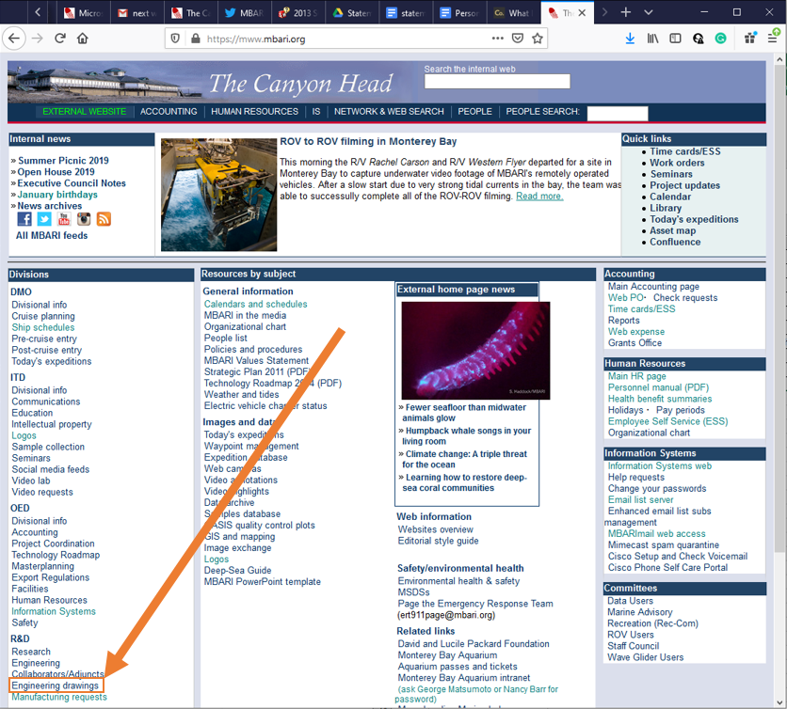
  - Click “Get a New Drawing Number”
  - Fill out “GET A NEW DRAWING NUMBER” form. If applicable, start with Highest Assembly first,
    - Drawing TITLE
    - Designer Name
    - Project Number
    - Revision number A to Z
    - Software Program
      - The options are
        - Solidworks
        - AutoCAD
    - File Extension Type:
    - Location of Software Program File Path
    - Description Line 1 (Limit 50 Characters):
    - Description Line 2 (Limit 50 Characters):
    - Next Higher Assembly (Limit 50 Characters):
    - Review and click “Submit”
  - Get
- Library of common DESCRIPTIONS

