Chili Contestant Name Card
MBARI wants to make sure that all food eating styles are welcome so in 2019 we split the categories into Veggie and Meat and added Allergen Checkboxes. The Allergen checkboxes include: Dairy, Eggs, Nuts, and Gluten. From this list, it can be determined if certain Veggie Chilies are vegan or not. The following is an example Name Card.

Judge Score Card
The chilies are community judged and the methods that we deploy is to remove any bias that could occur. The Judges will have three points to give per category and they could distribute it among their favorite chili any way they please. The reason we use point cards instead of using physical points is because the score card allows people to make notes and it deters bias because it doesn’t create a physical indicator that chili is winning.
The following is an example of the Judge’s score card:
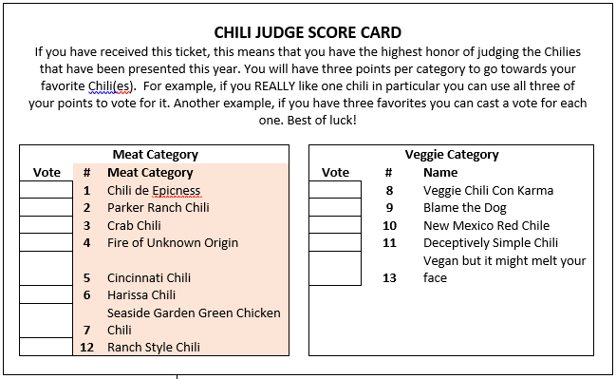

Shirts
Custom Ink is pricey for the amount of shirts we get. In addition, the quality of the print isn’t durable. I recommend this contact, ~$10-15/shirt 12 shirt minimum buy:
Joy Henderson
Screen Printing Apparel
33447 Western Avenue
Union City, CA 94587
510-441-2377
www.screenprintingapparel.com

Table Set Up
The tables need to be set up in a way that keep the cords out of the way, accessible to the judges, and doesn’t cause build ups.
There are 6 accessible plugs that are connected to 3 breakers. Each breaker can take 20 AMPs. Crockpots typically pull 2 AMPs. The most crock pots we want on a breaker is 9, equating to 18AMP load.
It’s best to have the tables set up the morning off so the contestants only have to set up their items once. Notify Facilities of your set up date at least one week before the event, although the earlier the better.
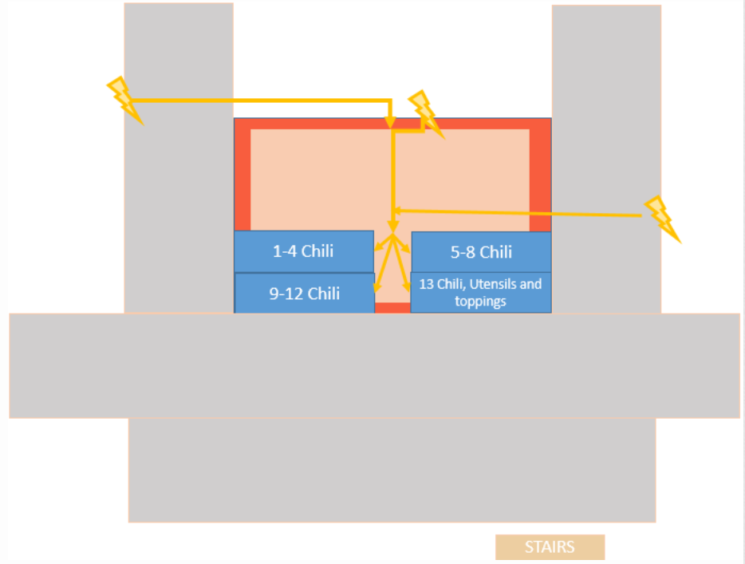
Money Collection
2018 the first year the Chili Cook-Off was $5. 2019 the Chili Cook-Off ticket is $8. There has been some talk that $10 would be a fair price. Since money will be exchanged it’s good to have a safe place and some change to give. Notify Accounts Payable that you will be requesting a Money Bag and Change the day of the event. You should let them know at least a week prior.

