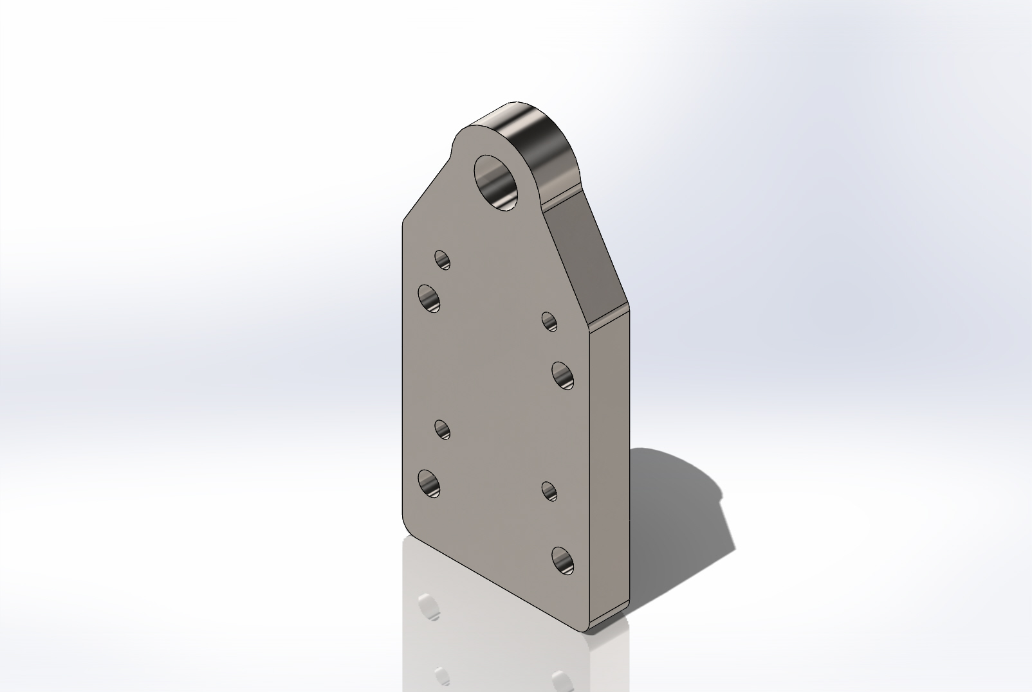
  Simulation of LiftingBailPullTestMount
  Date: Wednesday, January 22, 2014
  Designer: Solidworks
  Study name: SimulationXpress Study
  Analysis type: Static
  Table of Contents
  Description 1
  Assumptions 2
  Model Information 2
  Material Properties 3
  Loads and Fixtures 4
  Mesh Information 5
  Study Results 7
  Conclusion 10

Description
No Data

Assumptions

Model Information

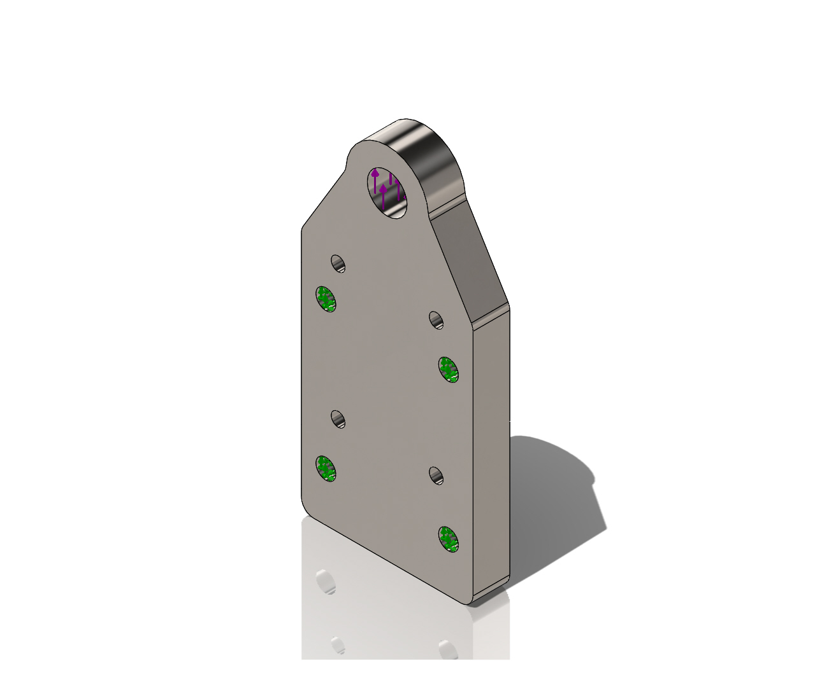
Model name: LiftingBailPullTestMount
Current Configuration: Default
Solid Bodies
Document Name and Reference | Treated As | Volumetric Properties | Document Path/Date Modified
Fillet1  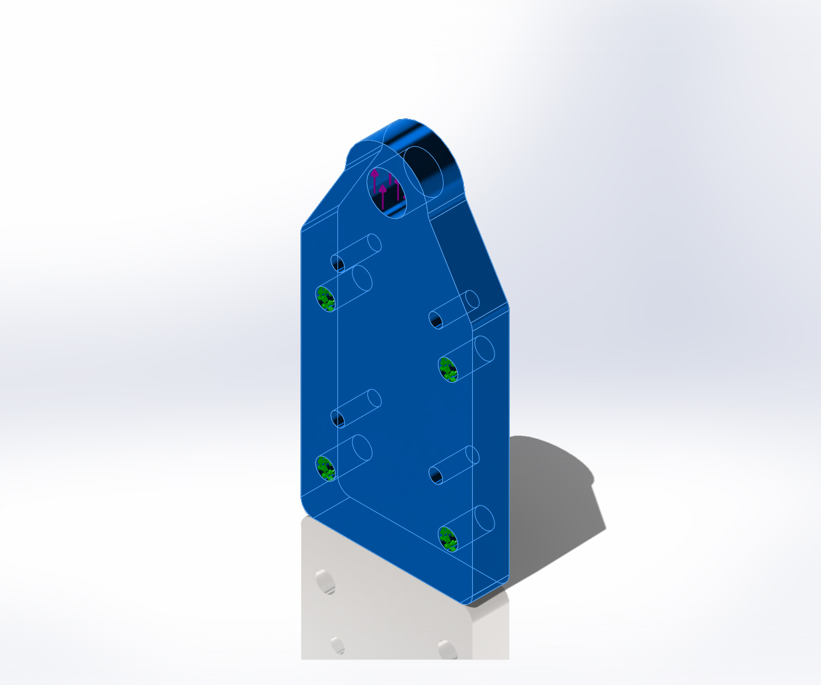 | Solid Body | Mass:2.00512 kg  Volume:0.000260405 m^3  Density:7700 kg/m^3  Weight:19.6502 N | Y:\Solid Models\LiftingBailPullTestMount.SLDPRT  Jan 22 10:57:55 2014

Material Properties
Model Reference | Properties | Components
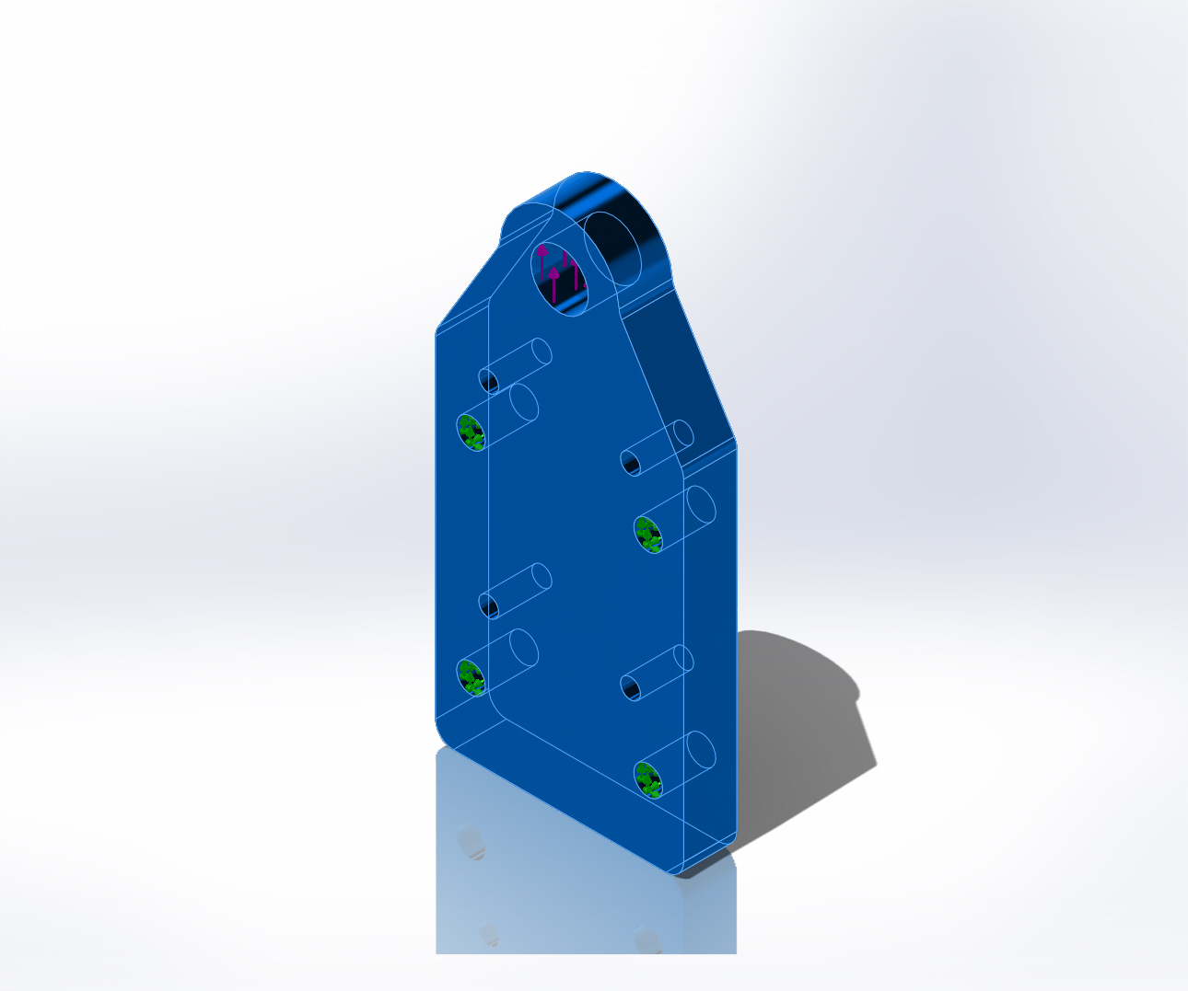 |  | SolidBody 1(Fillet1)(LiftingBailPullTestMount)
  Name: | Alloy Steel
  Model type: | Linear Elastic Isotropic
  Default failure criterion: | Max von Mises Stress
  Yield strength: | 6.20422e+008 N/m^2
  Tensile strength: | 7.23826e+008 N/m^2

Loads and Fixtures
Fixture name | Fixture Image | Fixture Details
Fixed-1 | 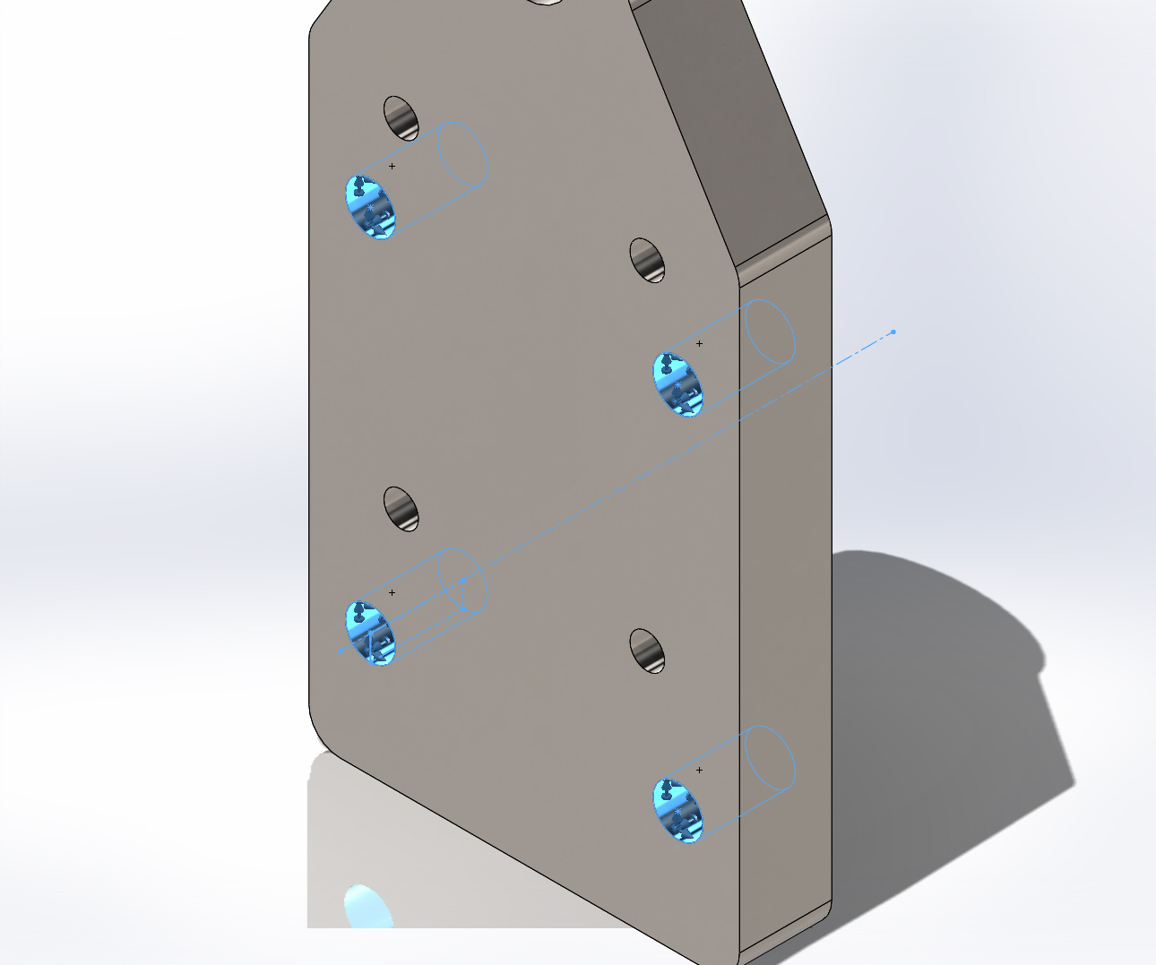
  Entities: | 4 face(s)
  Type: | Fixed Geometry

Load name | Load Image | Load Details
Force-1 | 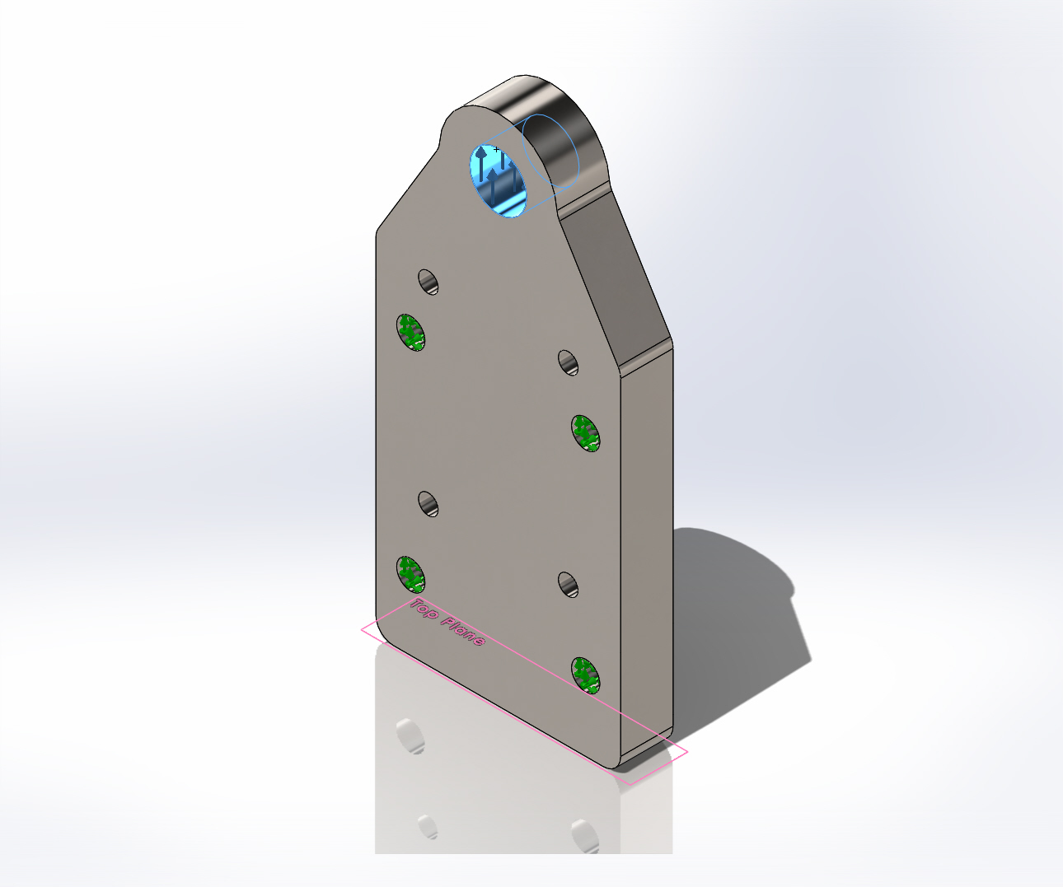
  Entities: | 1 face(s), 1 plane(s)
  Reference: | Top Plane
  Type: | Apply force
  Values: | ---, ---, 3000 lbf

Mesh Information
Mesh type | Solid Mesh
Mesher Used: | Standard mesh
Automatic Transition: | Off
Include Mesh Auto Loops: | Off
Jacobian points | 4 Points
Element Size | 0.251479 in
Tolerance | 0.012574 in
Mesh Quality | High

Mesh Information - Details
Total Nodes | 15150
Total Elements | 9439
Maximum Aspect Ratio | 4.2454
% of elements with Aspect Ratio < 3 | 99.5
% of elements with Aspect Ratio > 10 | 0
% of distorted elements(Jacobian) | 0
Time to complete mesh(hh;mm;ss): | 00:00:01
Computer name: | DEUTSCHLAND
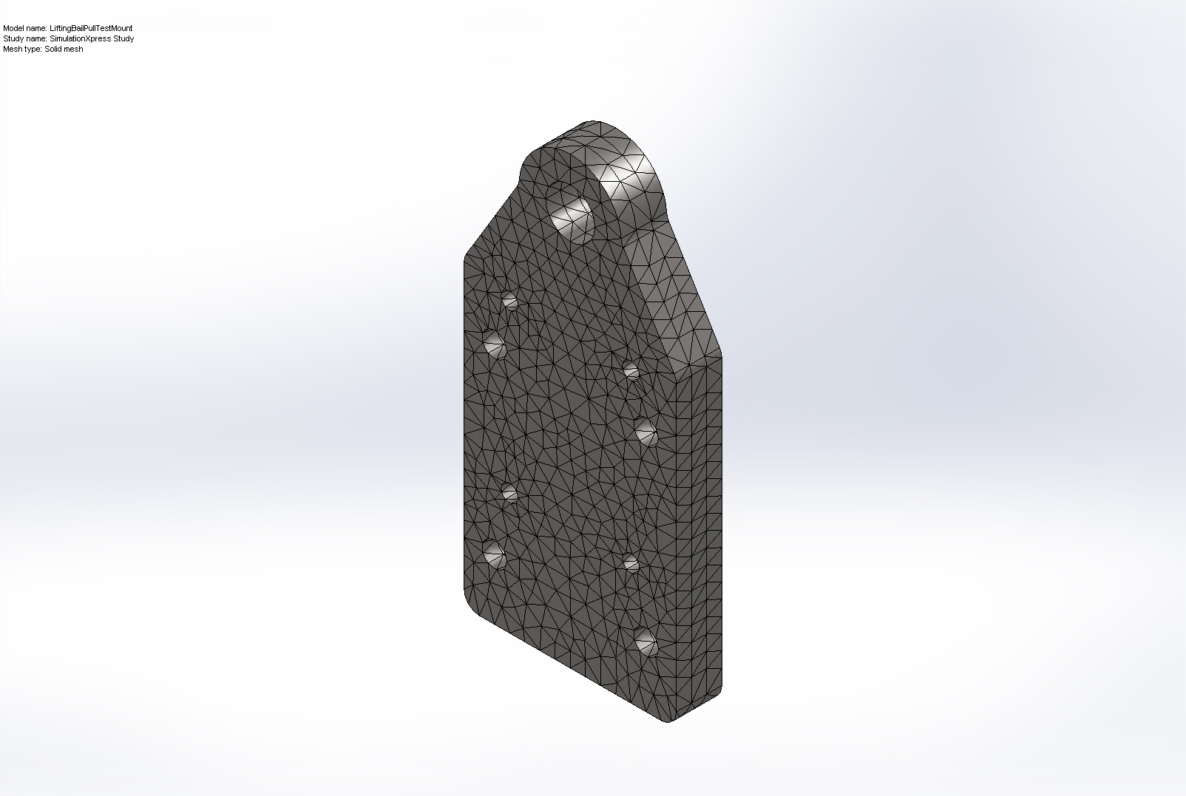

Study Results

Name | Type | Min | Max
Stress | VON: von Mises Stress | 10944.2 N/m^2  Node: 12712 | 3.34453e+007 N/m^2  Node: 13677
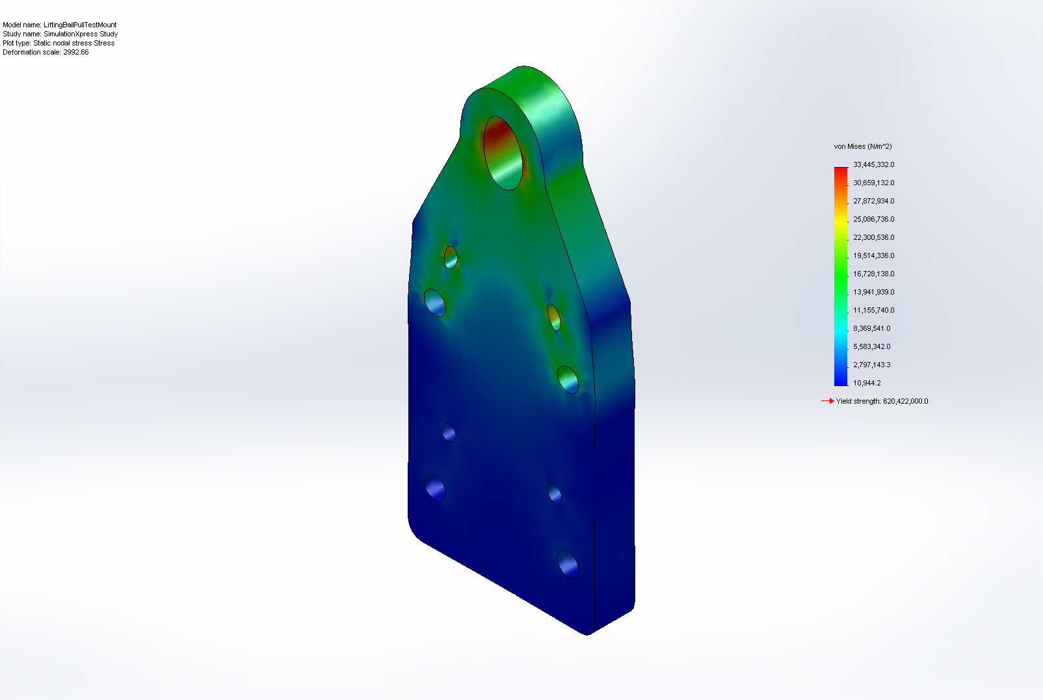
LiftingBailPullTestMount-SimulationXpress Study-Stress-Stress

Name | Type | Min | Max
Displacement | URES: Resultant Displacement | 0 mm  Node: 1 | 0.00623244 mm  Node: 888
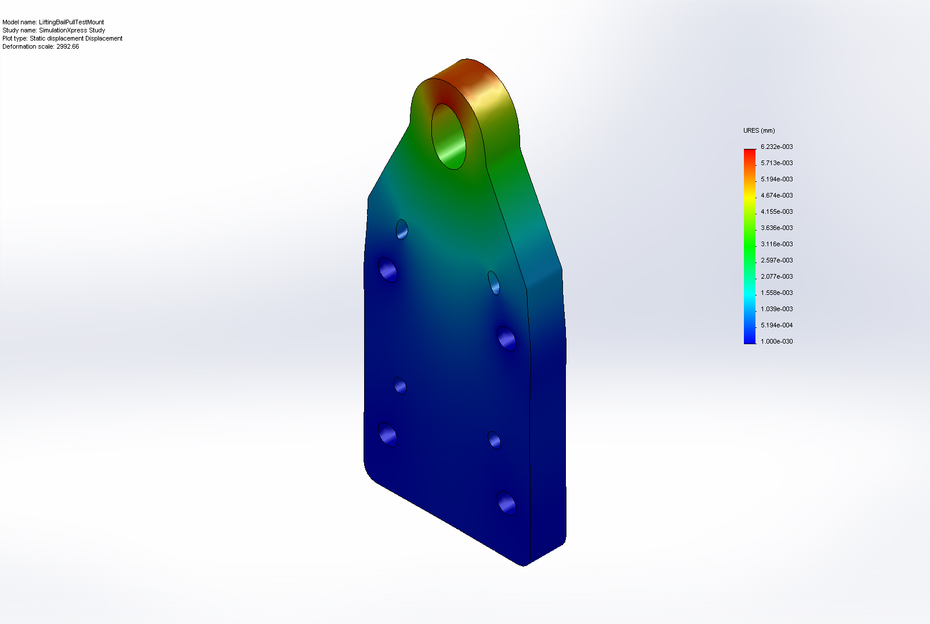
LiftingBailPullTestMount-SimulationXpress Study-Displacement-Displacement

Name | Type
Deformation | Deformed Shape
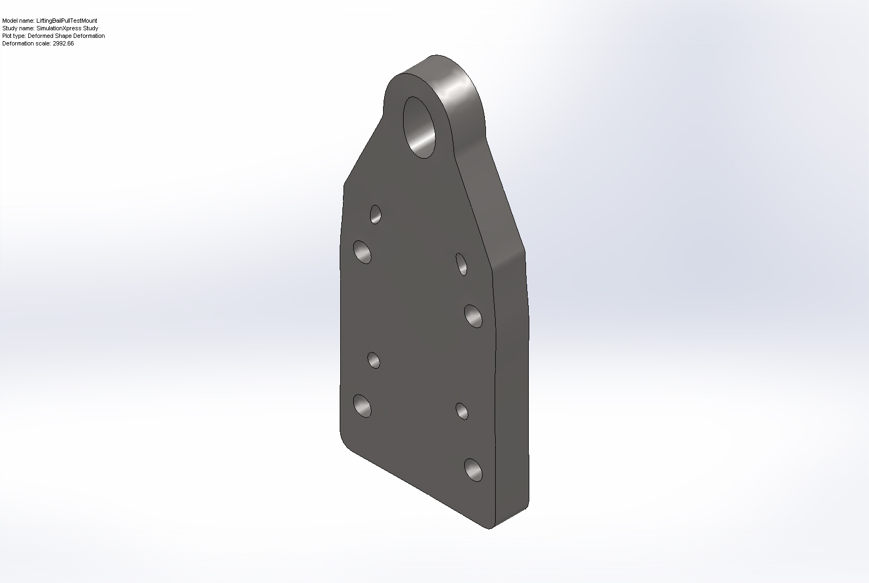
LiftingBailPullTestMount-SimulationXpress Study-Displacement-Deformation

Name | Type | Min | Max
Factor of Safety | Max von Mises Stress | 18.5503  Node: 13677 | 56689.5  Node: 12712
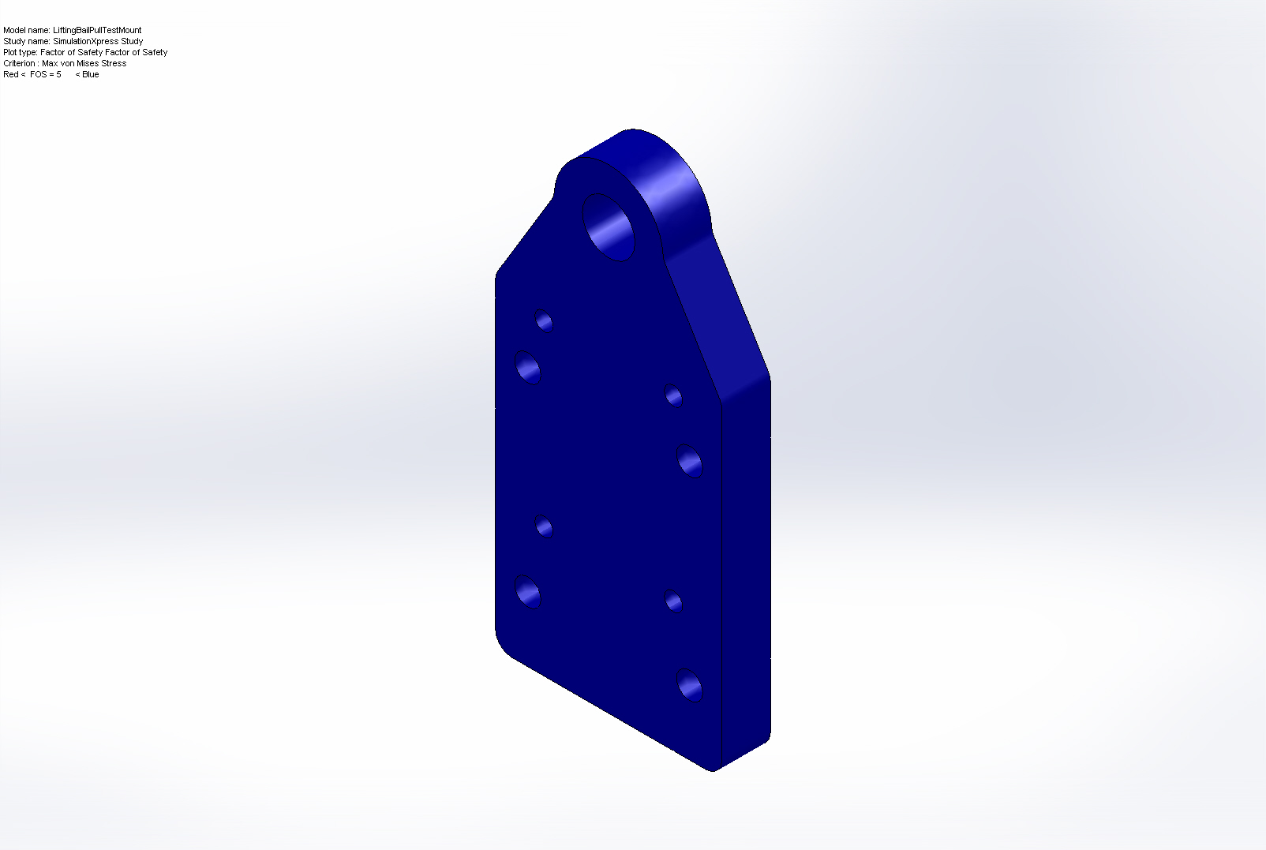
LiftingBailPullTestMount-SimulationXpress Study-Factor of Safety-Factor of Safety

Conclusion

