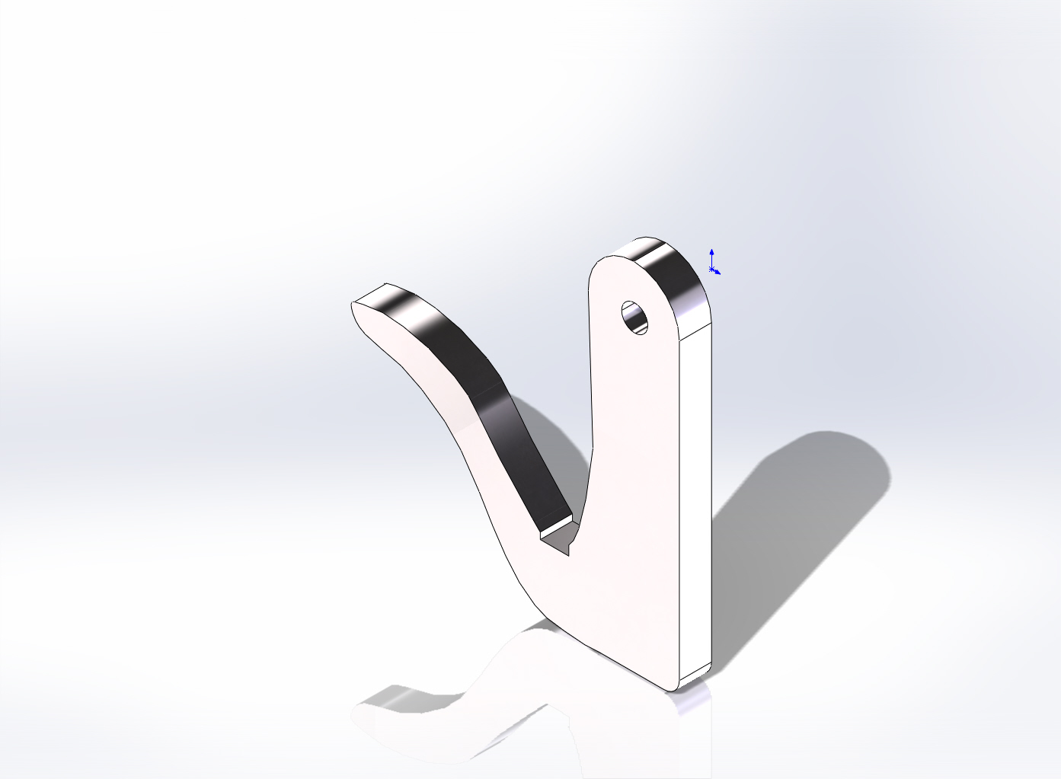
  Simulation of Fugro_hook
  Date: Monday, October 29, 2012
  Designer: Solidworks
  Study name: SimulationXpress Study
  Analysis type: Static
  Table of Contents
  Description 1
  Assumptions 2
  Model Information 2
  Material Properties 3
  Loads and Fixtures 3
  Mesh Information 4
  Study Results 6
  Conclusion 9

Description
No Data

Assumptions

Model Information

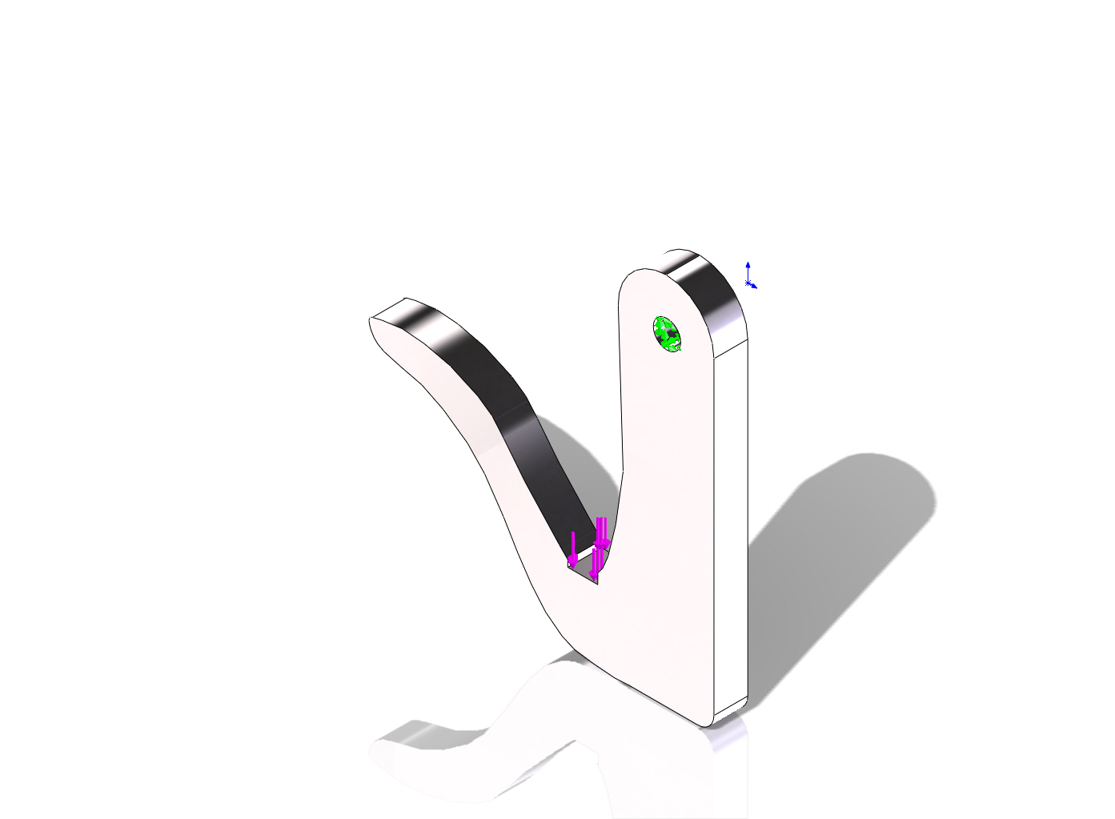
Model name: Fugro_hook
Current Configuration: Default
Solid Bodies
Document Name and Reference | Treated As | Volumetric Properties | Document Path/Date Modified
Cut-Extrude2  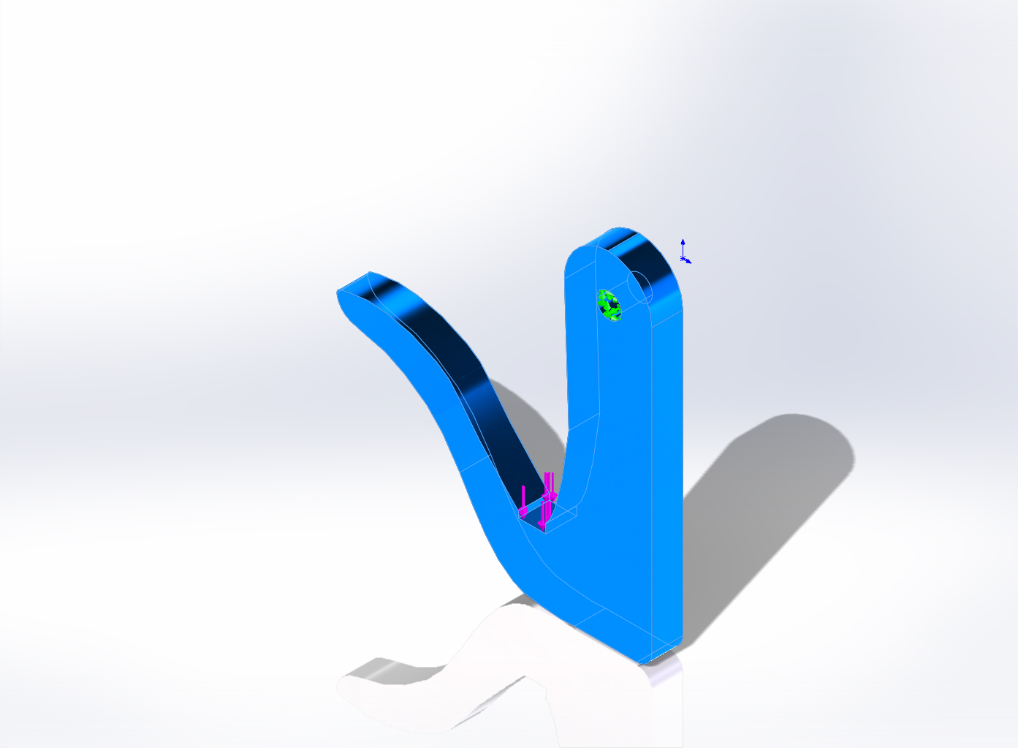 | Solid Body | Mass:0.433097 kg  Volume:9.77914e-005 m^3  Density:4428.78 kg/m^3  Weight:4.24435 N | Y:\Solid Models\Mapper Recovery Hook\Fugro_hook.SLDPRT  Apr 26 14:02:04 2007

Material Properties
Model Reference | Properties | Components
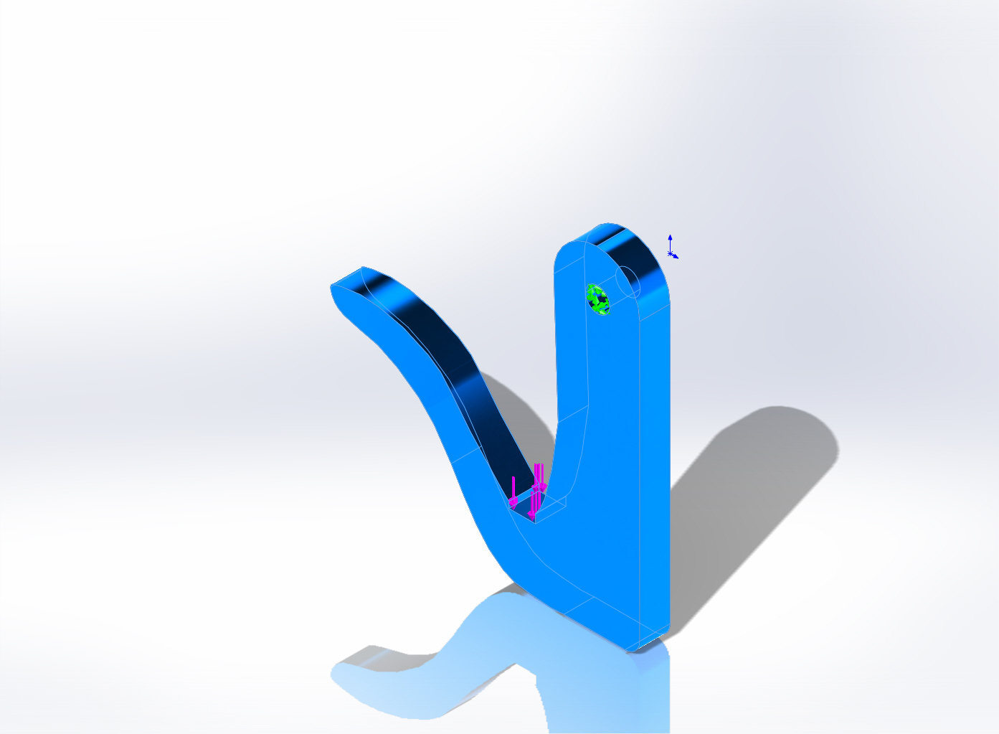 |  | SolidBody 1(Cut-Extrude2)(Fugro_hook)
  Name: | Ti-6Al-4VSolution treated and aged (SS)
  Model type: | Linear Elastic Isotropic
  Default failure criterion: | Unknown
  Yield strength: | 8.27371e+008 N/m^2
  Tensile strength: | 1.05e+009 N/m^2

Loads and Fixtures
Fixture name | Fixture Image | Fixture Details
Fixed-1 | 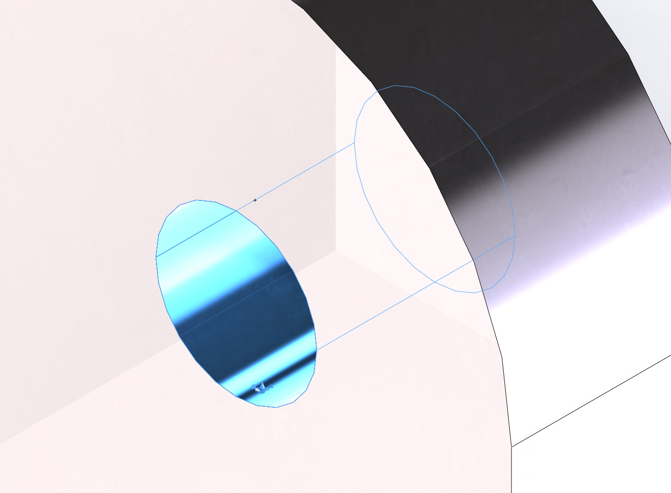
  Entities: | 1 face(s)
  Type: | Fixed Geometry

Load name | Load Image | Load Details
Force-1 | 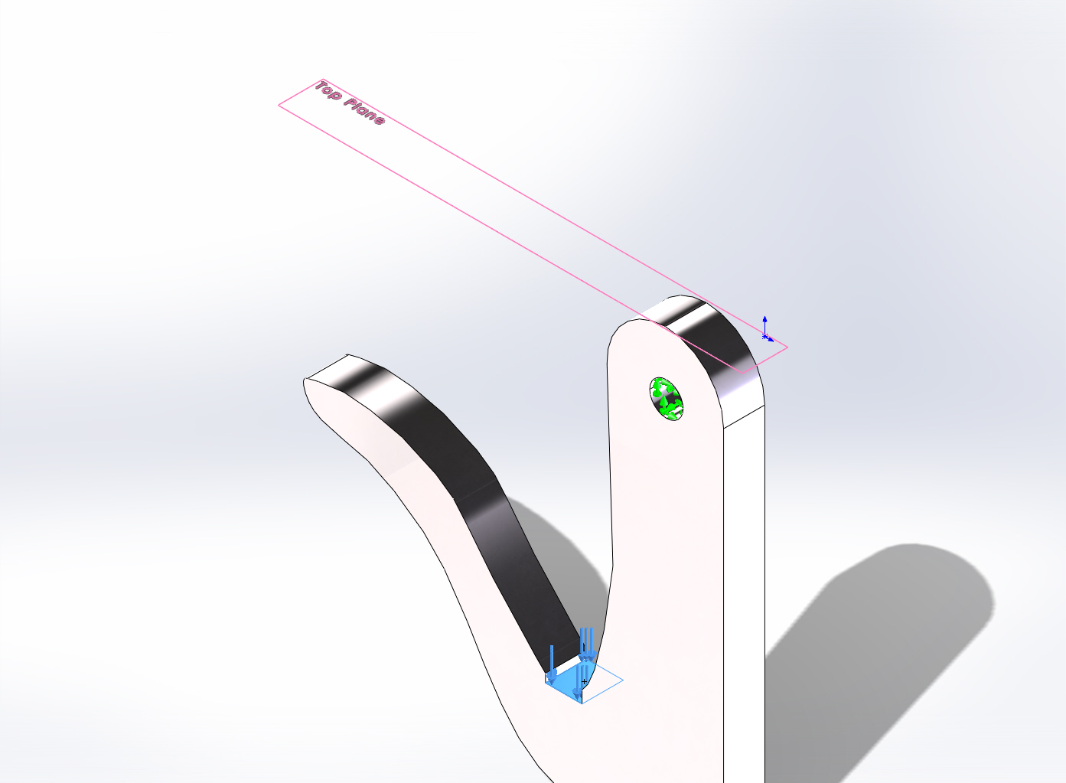
  Entities: | 1 face(s), 1 plane(s)
  Reference: | Top Plane
  Type: | Apply force
  Values: | ---, ---, -2000 lbf

Mesh Information
Mesh type | Solid Mesh
Mesher Used: | Standard mesh
Automatic Transition: | Off
Include Mesh Auto Loops: | Off
Jacobian points | 4 Points
Element Size | 0.181399 in
Tolerance | 0.00906995 in
Mesh Quality | High

Mesh Information - Details
Total Nodes | 11953
Total Elements | 7213
Maximum Aspect Ratio | 3.7978
% of elements with Aspect Ratio < 3 | 99.9
% of elements with Aspect Ratio > 10 | 0
% of distorted elements(Jacobian) | 0
Time to complete mesh(hh;mm;ss): | 00:00:01
Computer name: | DEUTSCHLAND
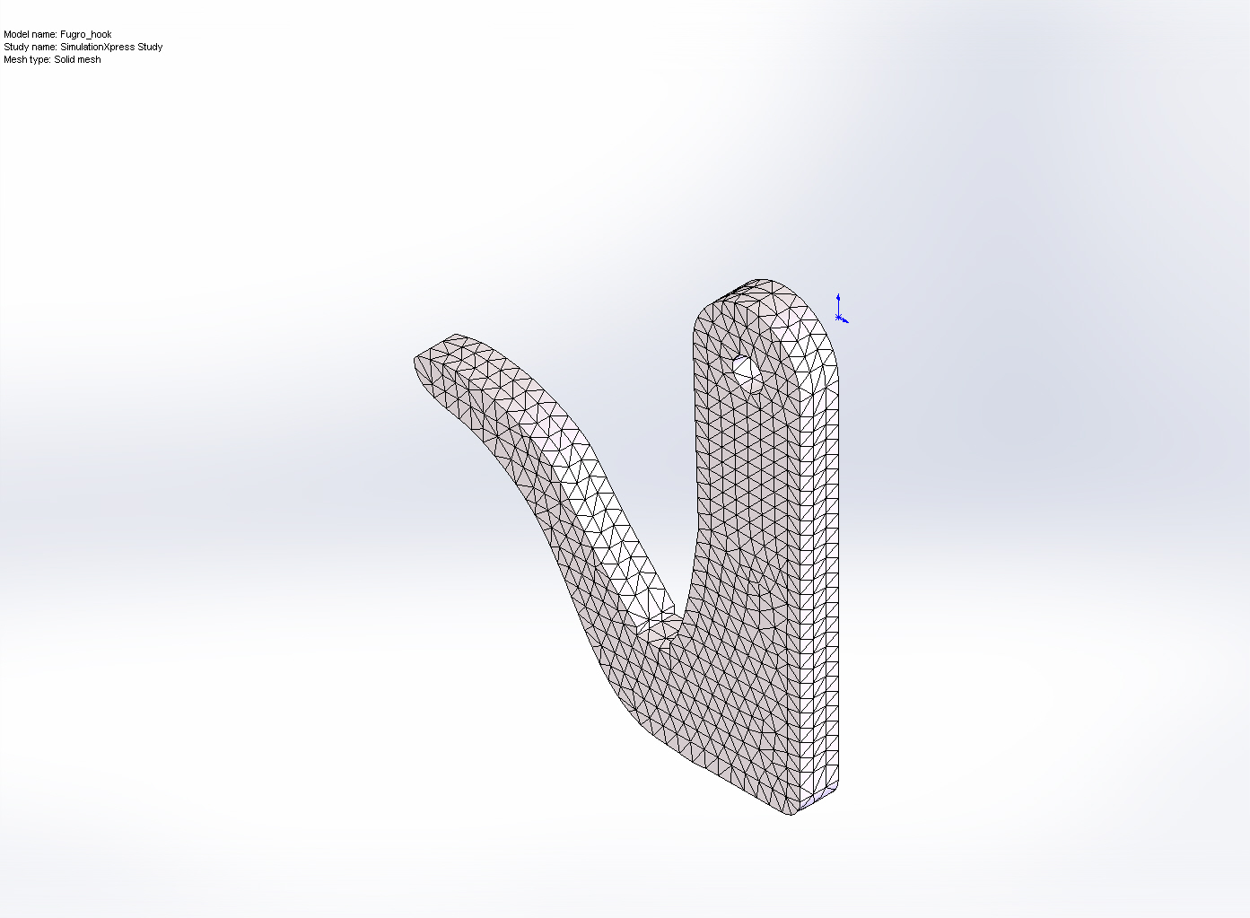

Study Results

Name | Type | Min | Max
Stress | VON: von Mises Stress | 1.92899 N/m^2  Node: 11256 | 2.72039e+008 N/m^2  Node: 15
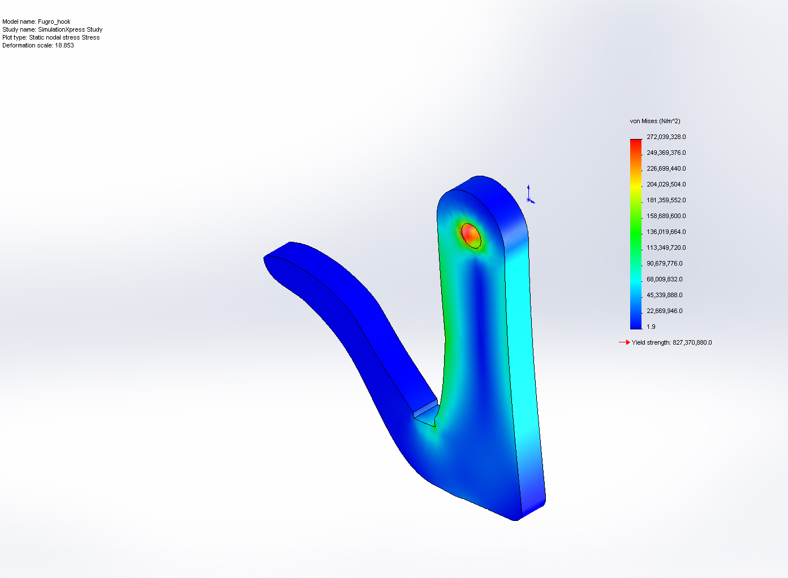
Fugro_hook-SimulationXpress Study-Stress-Stress

Name | Type | Min | Max
Displacement | URES: Resultant Displacement | 0 mm  Node: 1 | 0.78027 mm  Node: 11219
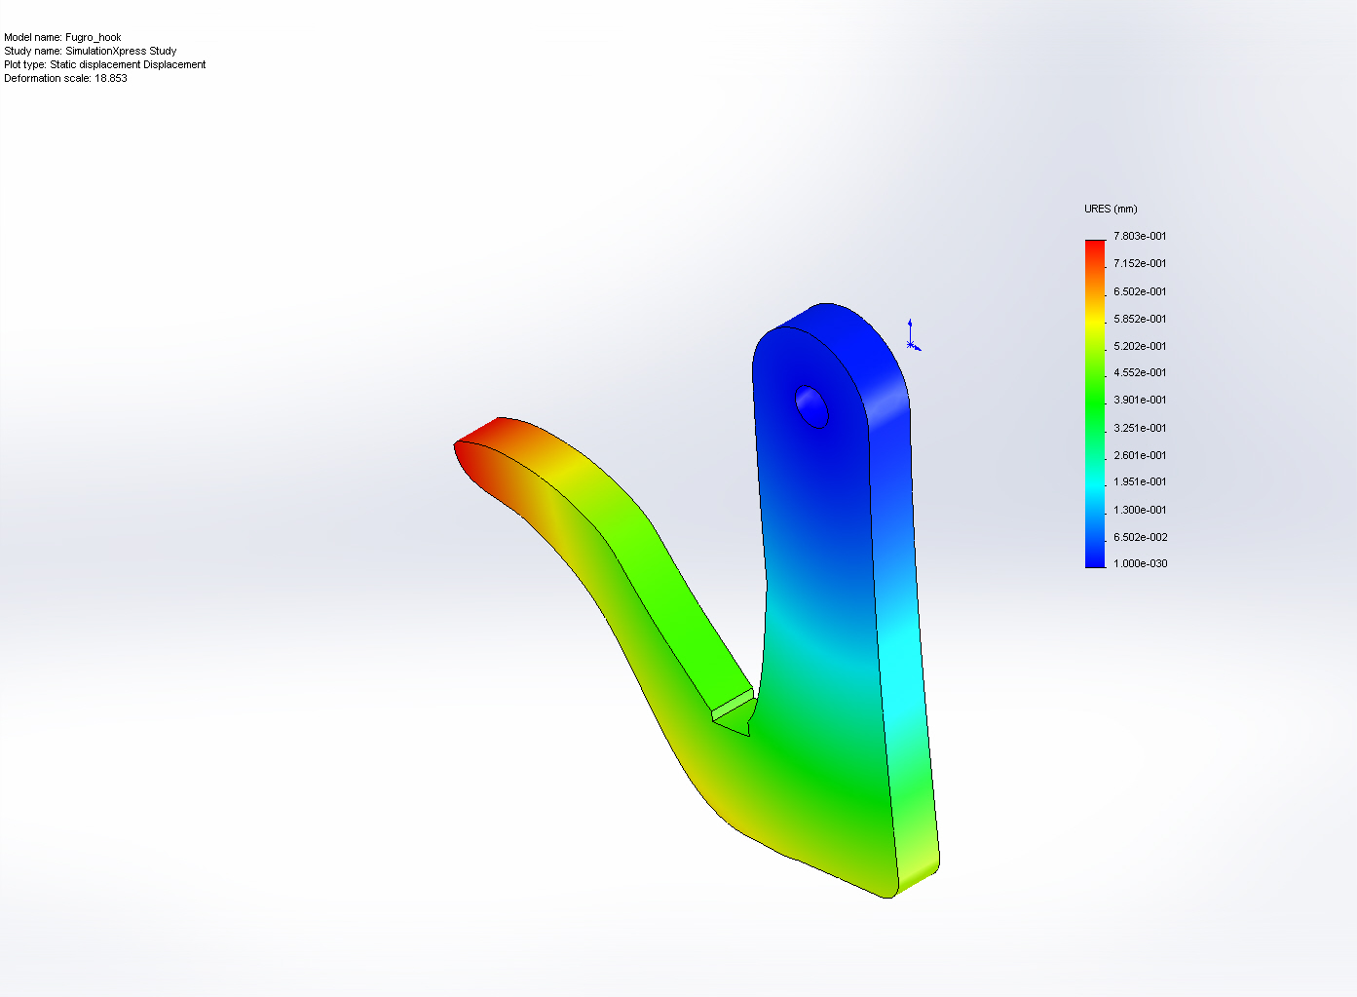
Fugro_hook-SimulationXpress Study-Displacement-Displacement

Name | Type
Deformation | Deformed Shape
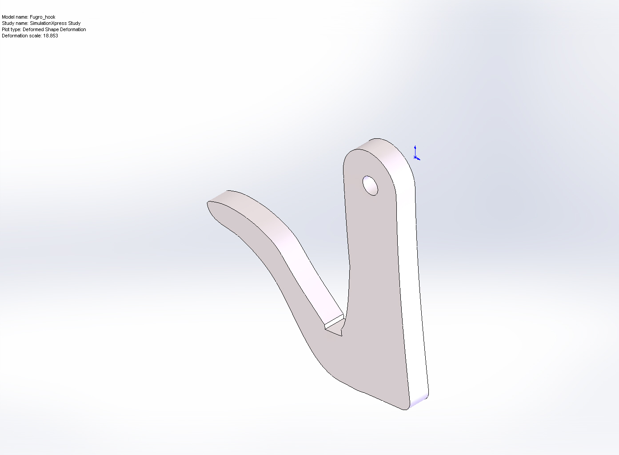
Fugro_hook-SimulationXpress Study-Displacement-Deformation

Name | Type | Min | Max
Factor of Safety | Max von Mises Stress | 3.04136  Node: 15 | 4.28913e+008  Node: 11256
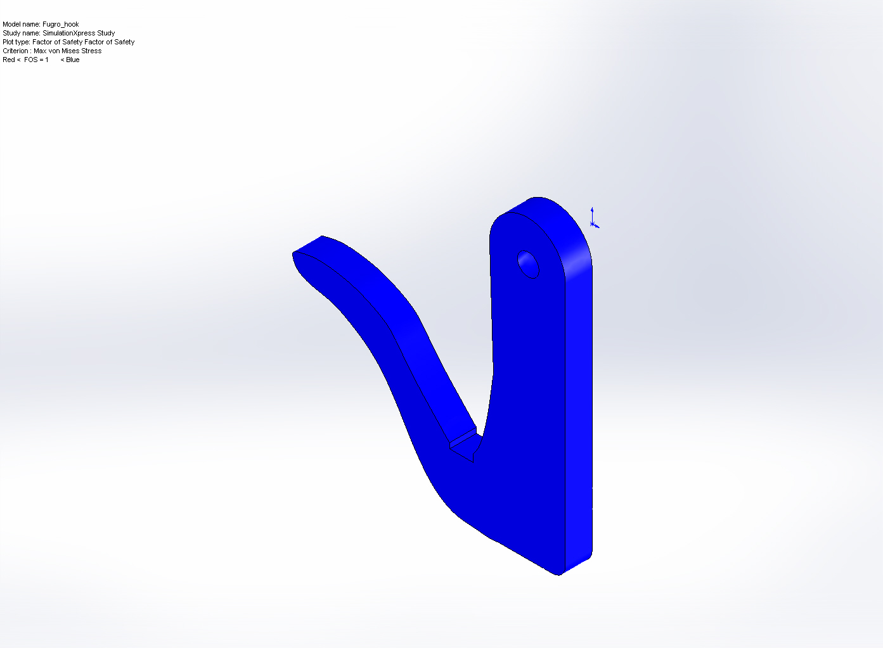
Fugro_hook-SimulationXpress Study-Factor of Safety-Factor of Safety

Conclusion

