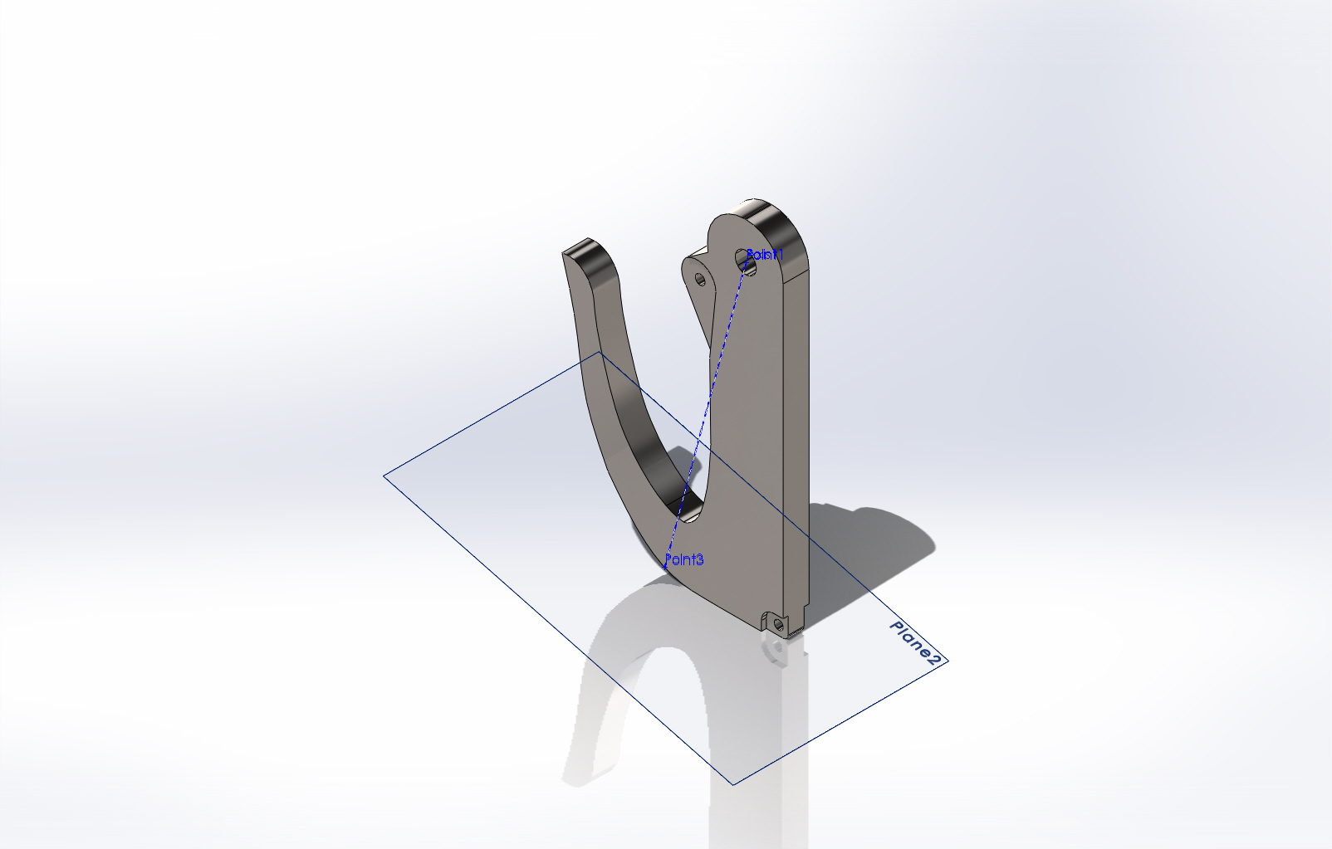
  Simulation of Fugro_hook_with_snapgate
  Date: Tuesday, November 13, 2012
  Designer: Solidworks
  Study name: SimulationXpress Study
  Analysis type: Static
  Table of Contents
  Description 1
  Assumptions 2
  Model Information 2
  Material Properties 3
  Loads and Fixtures 3
  Mesh Information 4
  Study Results 6
  Conclusion 9

Description
No Data

Assumptions

Model Information

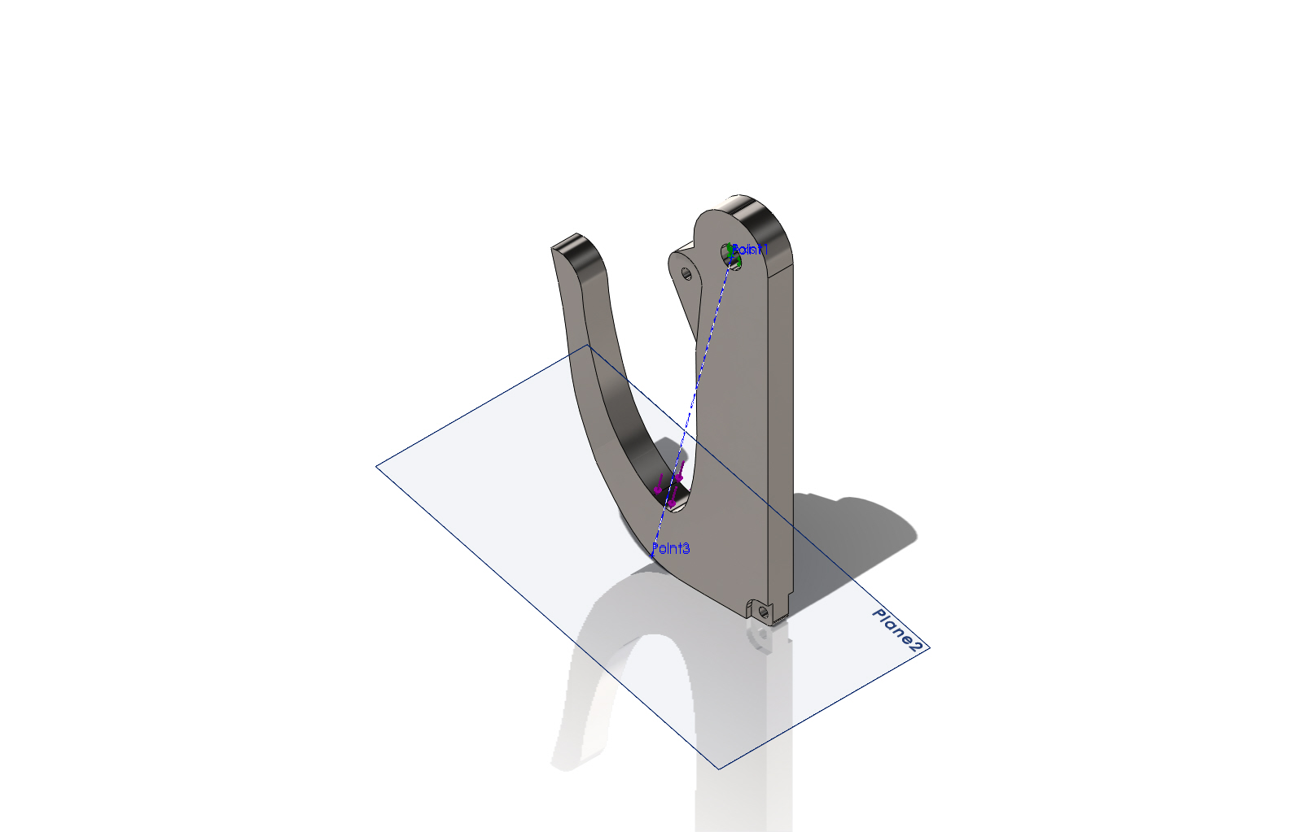
Model name: Fugro_hook_with_snapgate
Current Configuration: Default
Solid Bodies
Document Name and Reference | Treated As | Volumetric Properties | Document Path/Date Modified
Split Line3  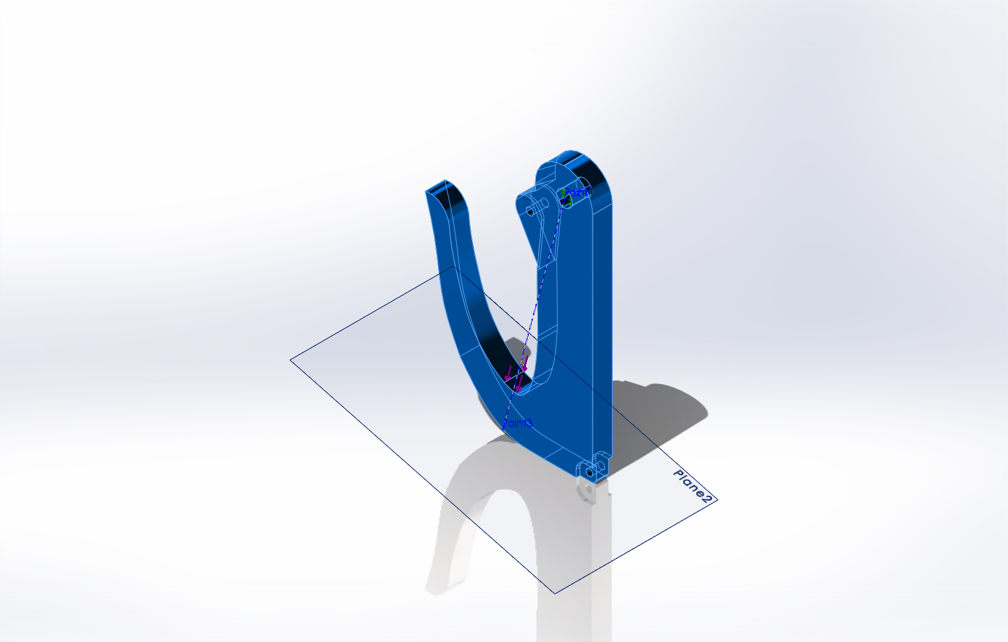 | Solid Body | Mass:1.18824 lb  Volume:7.4265 in^3  Density:0.16 lb/in^3  Weight:1.18743 lbf | Y:\Solid Models\Mapper Recovery Hook\Fugro_hook_with_snapgate.SLDPRT  Nov 13 11:48:05 2012

Material Properties
Model Reference | Properties | Components
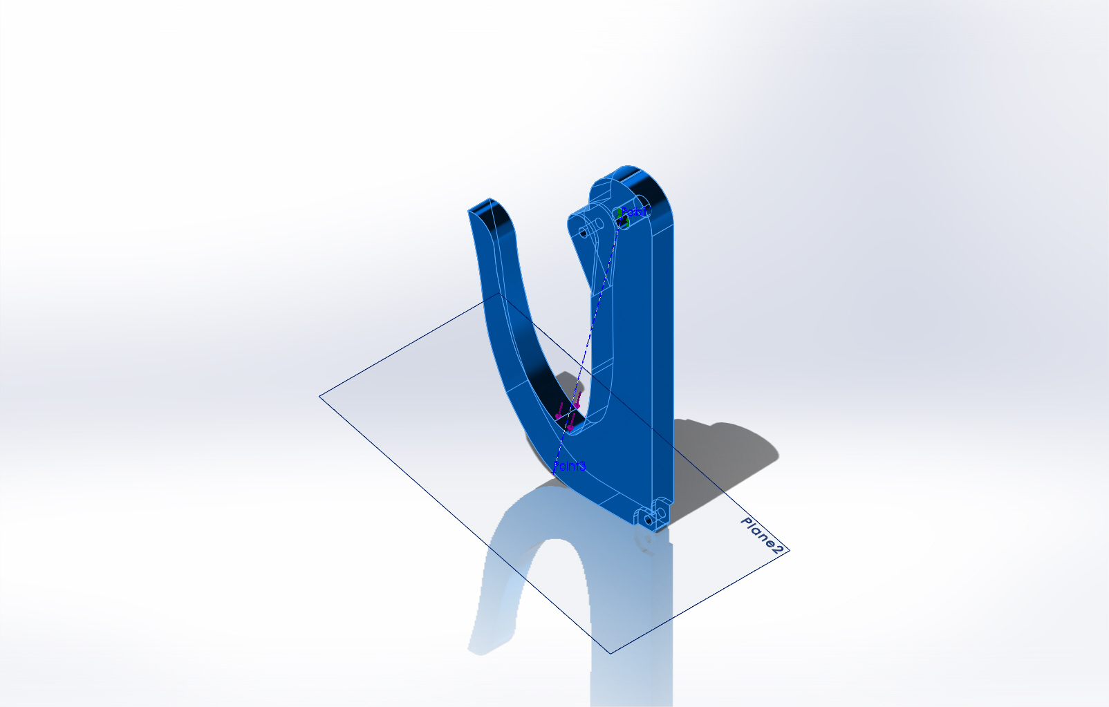 |  | SolidBody 1(Split Line3)(Fugro_hook_with_snapgate)
  Name: | Ti-6Al-4VSolution treated and aged (SS)
  Model type: | Linear Elastic Isotropic
  Default failure criterion: | Max von Mises Stress
  Yield strength: | 120000 psi
  Tensile strength: | 152290 psi

Loads and Fixtures
Fixture name | Fixture Image | Fixture Details
Fixed-1 | 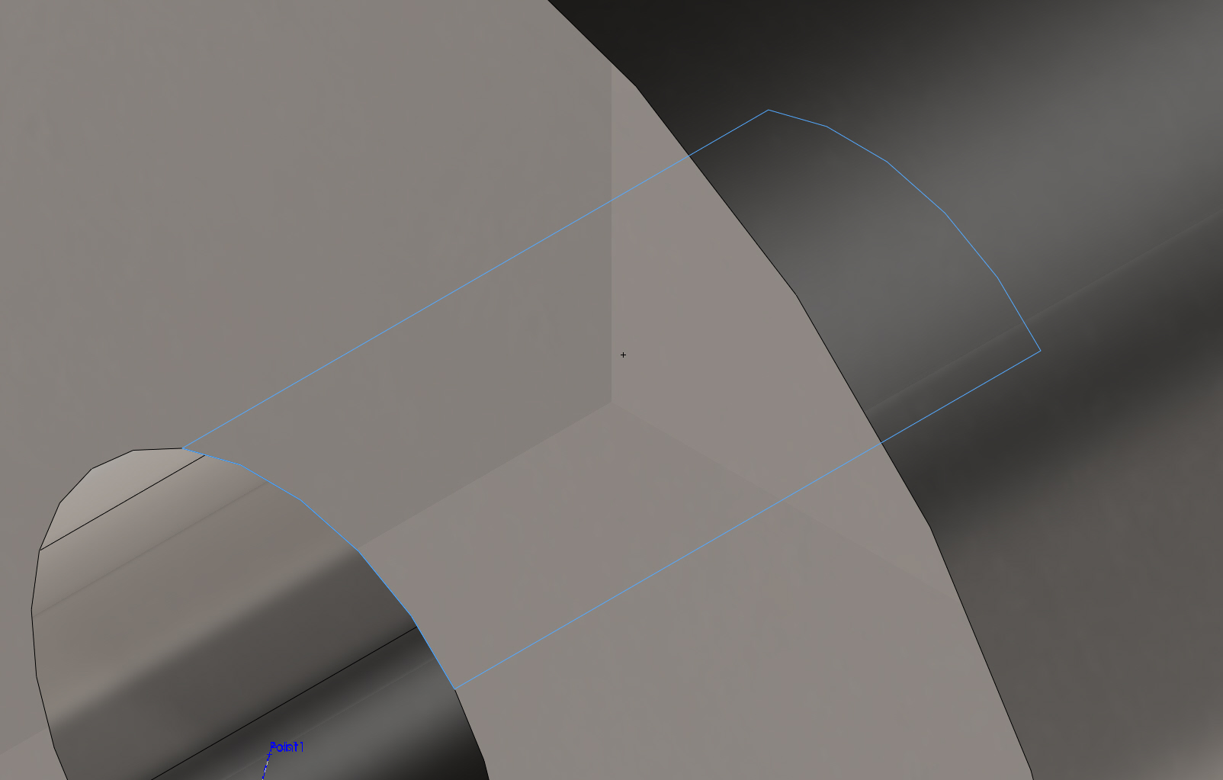
  Entities: | 1 face(s)
  Type: | Fixed Geometry

Load name | Load Image | Load Details
Force-1 | 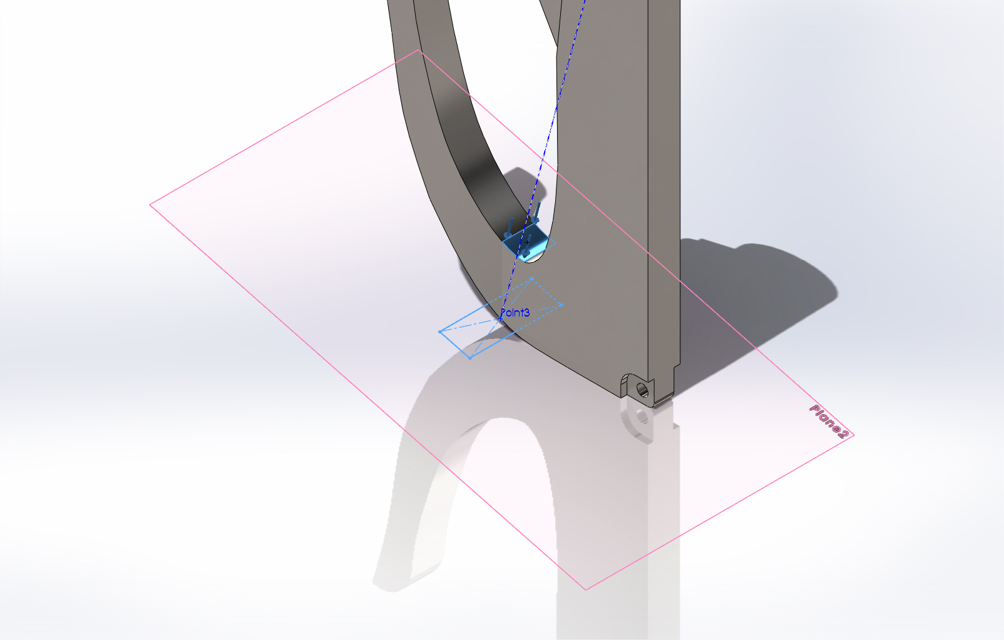
  Entities: | 1 face(s), 1 plane(s)
  Reference: | Plane2
  Type: | Apply force
  Values: | ---, ---, 2000 lbf

Mesh Information
Mesh type | Solid Mesh
Mesher Used: | Standard mesh
Automatic Transition: | Off
Include Mesh Auto Loops: | Off
Jacobian points | 4 Points
Element Size | 0.195159 in
Tolerance | 0.00975797 in
Mesh Quality | High

Mesh Information - Details
Total Nodes | 14565
Total Elements | 8811
Maximum Aspect Ratio | 68.652
% of elements with Aspect Ratio < 3 | 97.6
% of elements with Aspect Ratio > 10 | 0.193
% of distorted elements(Jacobian) | 0
Time to complete mesh(hh;mm;ss): | 00:00:02
Computer name: | DEUTSCHLAND
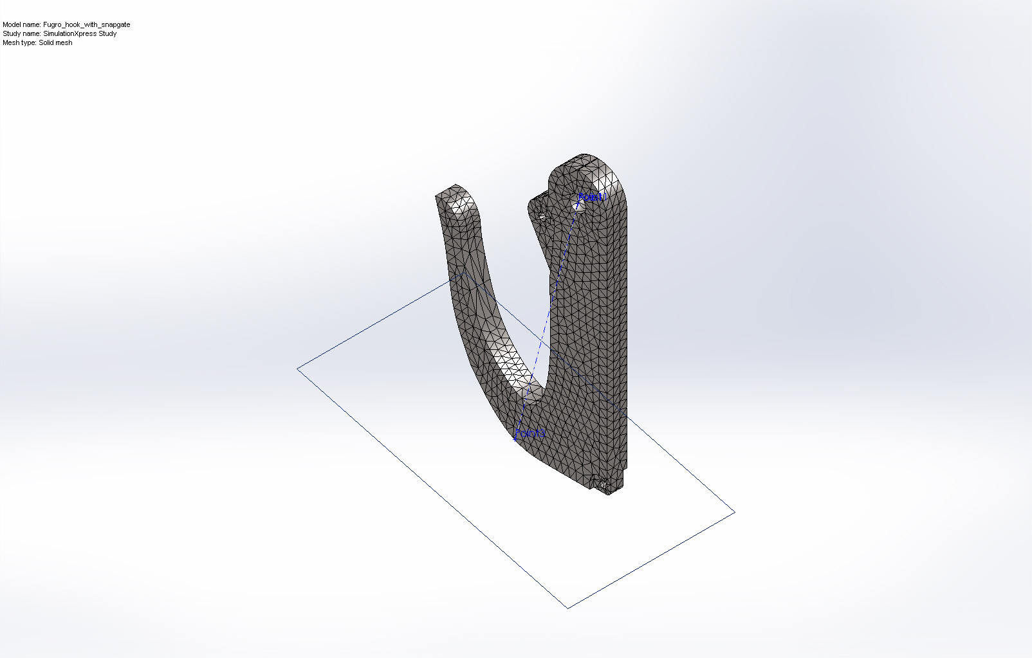

Study Results

Name | Type | Min | Max
Stress | VON: von Mises Stress | 0.000227263 psi  Node: 6885 | 23990.9 psi  Node: 123
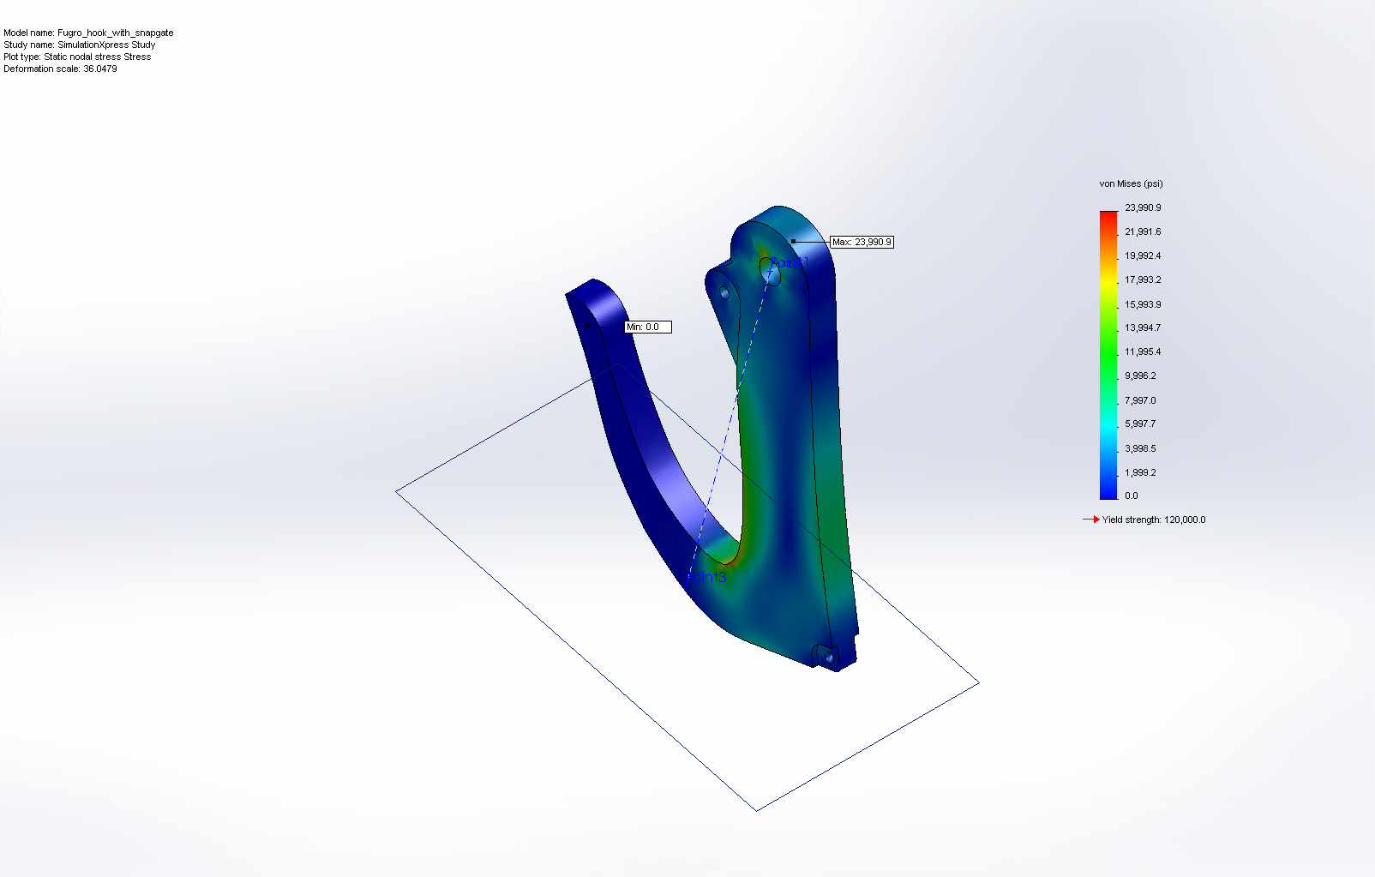
Fugro_hook_with_snapgate-SimulationXpress Study-Stress-Stress

Name | Type | Min | Max
Displacement | URES: Resultant Displacement | 0 mm  Node: 108 | 0.533422 mm  Node: 84
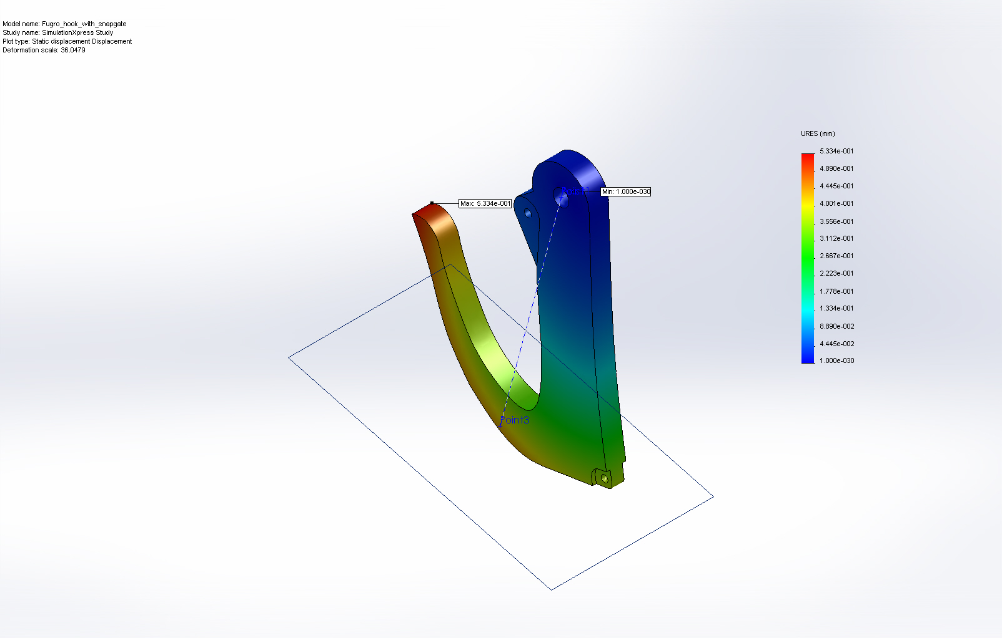
Fugro_hook_with_snapgate-SimulationXpress Study-Displacement-Displacement

Name | Type
Deformation | Deformed Shape
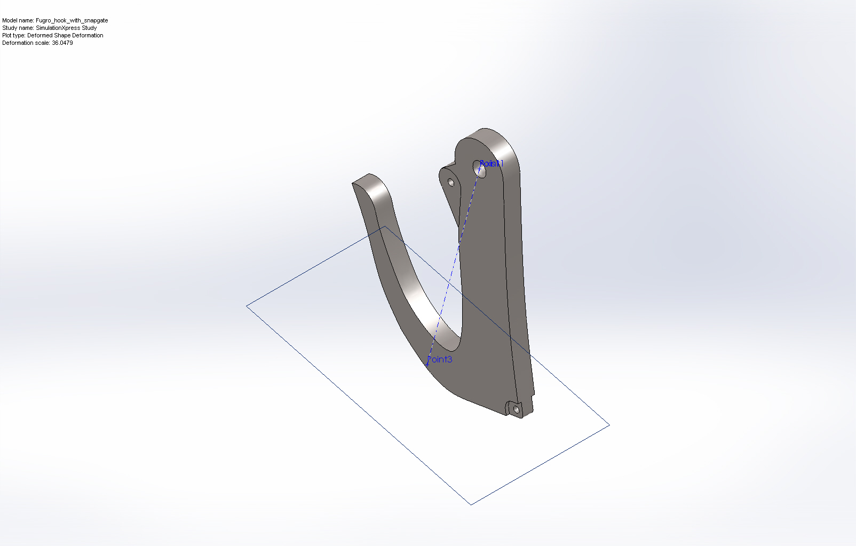
Fugro_hook_with_snapgate-SimulationXpress Study-Displacement-Deformation

Name | Type | Min | Max
Factor of Safety | Max von Mises Stress | 5.0019  Node: 123 | 5.28023e+008  Node: 6885
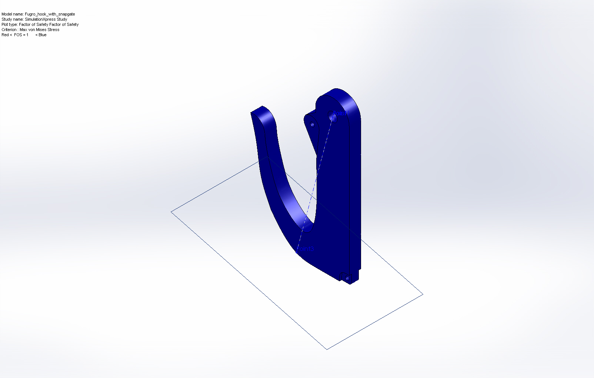
Fugro_hook_with_snapgate-SimulationXpress Study-Factor of Safety-Factor of Safety

Conclusion

