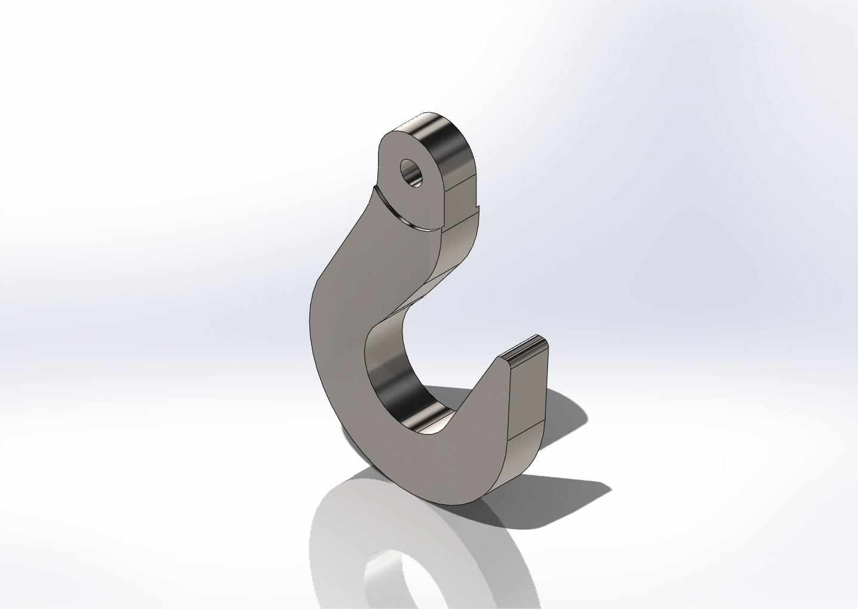
  Simulation of SeaCatchCopy3-Thick
  Date: Wednesday, October 31, 2012
  Designer: Solidworks
  Study name: SimulationXpress Study
  Analysis type: Static
  Table of Contents
  Description 1
  Assumptions 2
  Model Information 2
  Material Properties 3
  Loads and Fixtures 3
  Mesh Information 4
  Study Results 6
  Conclusion 9

Description
Material: 17-4PH Stainless Steel heat treated to H900

Assumptions

Model Information

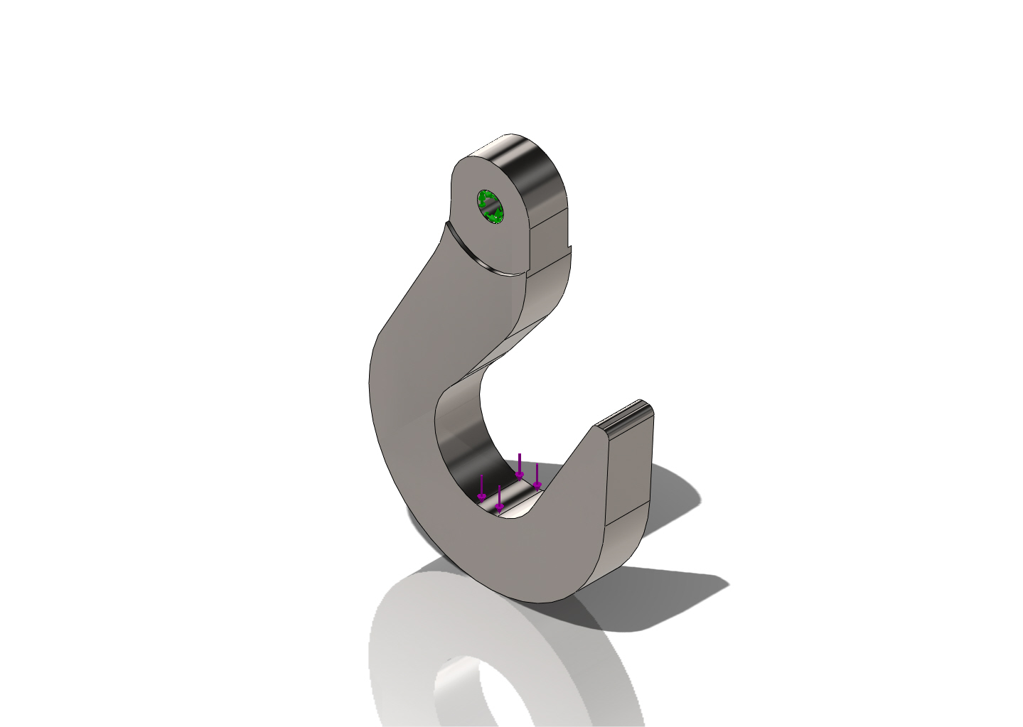
Model name: SeaCatchCopy3-Thick
Current Configuration: Default
Solid Bodies
Document Name and Reference | Treated As | Volumetric Properties | Document Path/Date Modified
Split Line1  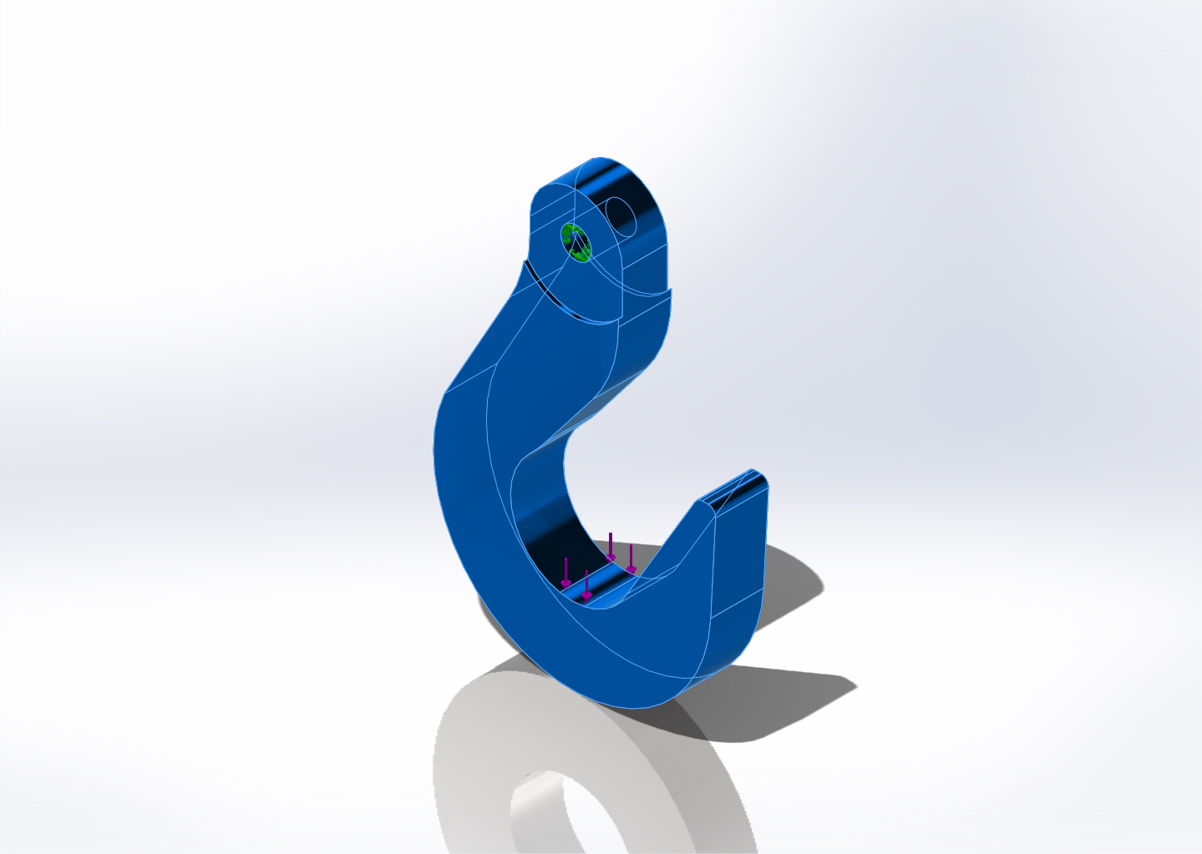 | Solid Body | Mass:3.39968 lb  Volume:12.0556 in^3  Density:0.282 lb/in^3  Weight:3.39738 lbf | Y:\Solid Models\Mapper Recovery Hook\SeaCatchCopy3-Thick.SLDPRT  Oct 31 10:33:51 2012

Material Properties
Model Reference | Properties | Components
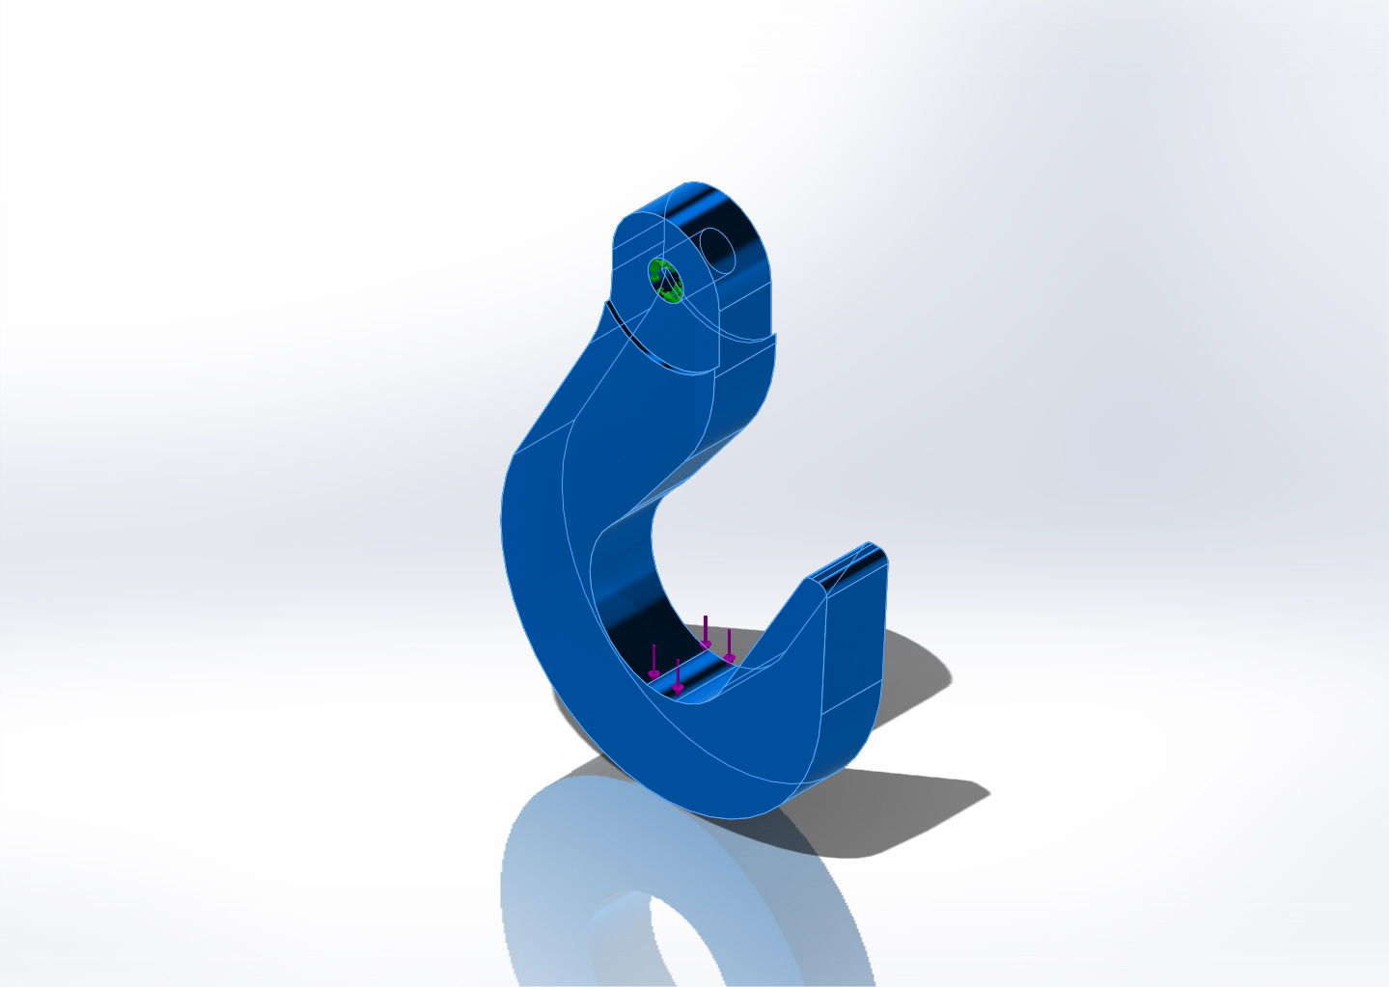 |  | SolidBody 1(Split Line1)(SeaCatchCopy3-Thick)
  Name: | 17-4PH Stainless Steel
  Model type: | Linear Elastic Isotropic
  Default failure criterion: | Max von Mises Stress
  Yield strength: | 200000 psi
  Tensile strength: | 210000 psi

Loads and Fixtures
Fixture name | Fixture Image | Fixture Details
Fixed-1 | 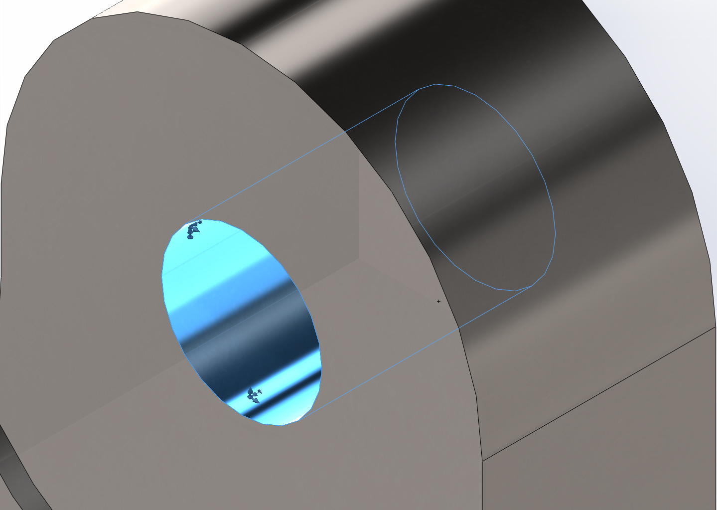
  Entities: | 1 face(s)
  Type: | Fixed Geometry

Load name | Load Image | Load Details
Force-3 | 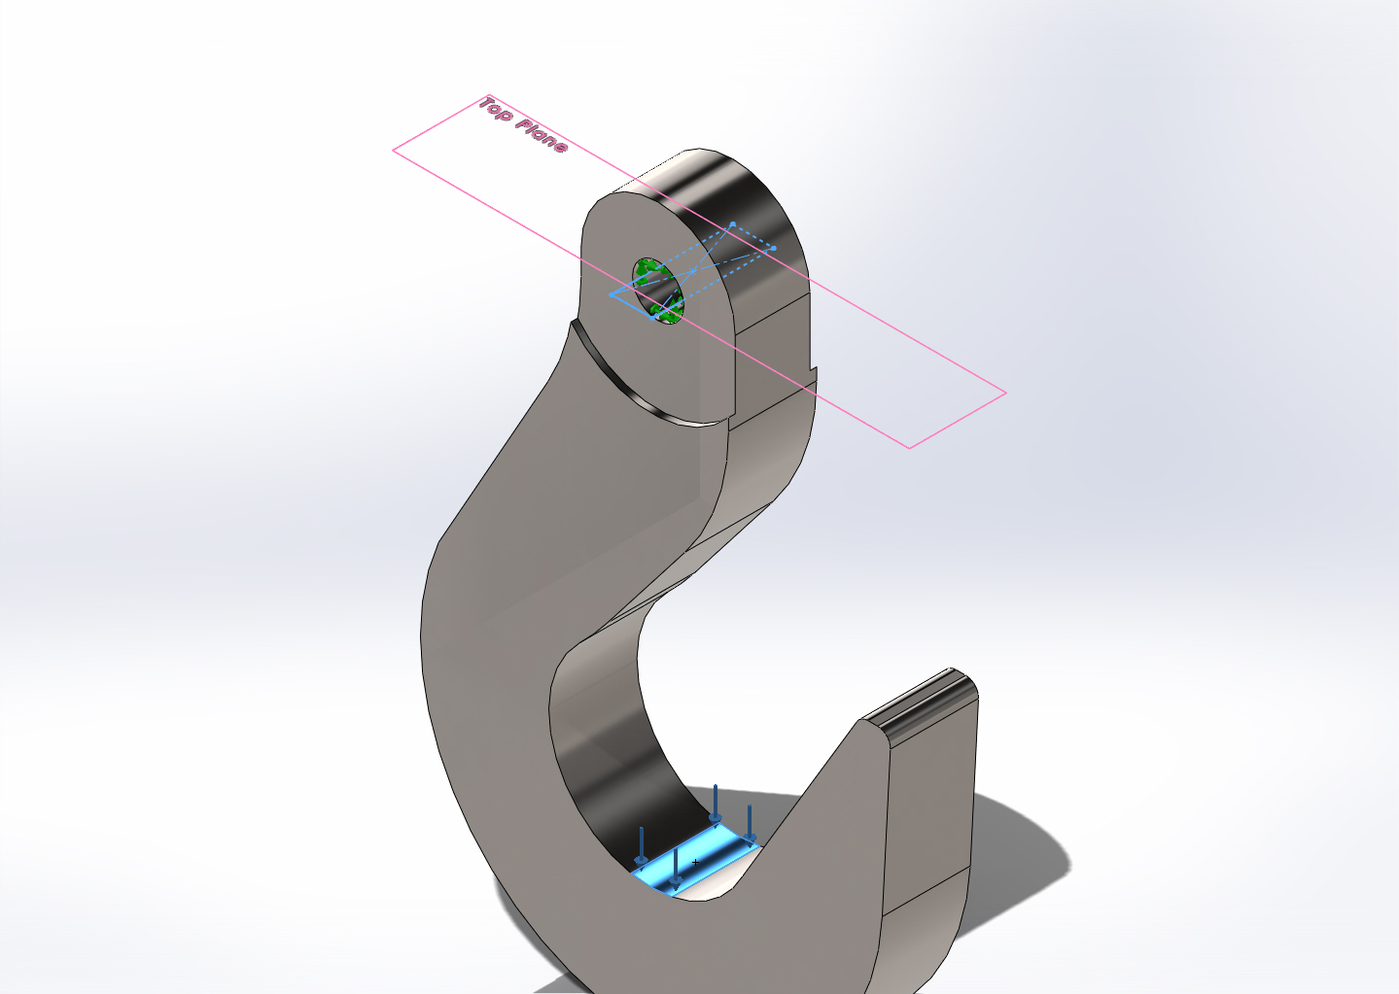
  Entities: | 1 face(s), 1 plane(s)
  Reference: | Top Plane
  Type: | Apply force
  Values: | ---, ---, -2000 lbf

Mesh Information
Mesh type | Solid Mesh
Mesher Used: | Curvature based mesh
Jacobian points | 4 Points
Maximum element size | 0 in
Minimum element size | 0 in
Mesh Quality | High

Mesh Information - Details
Total Nodes | 26823
Total Elements | 17270
Maximum Aspect Ratio | 4.283
% of elements with Aspect Ratio < 3 | 99.7
% of elements with Aspect Ratio > 10 | 0
% of distorted elements(Jacobian) | 0
Time to complete mesh(hh;mm;ss): | 00:00:01
Computer name: | DEUTSCHLAND
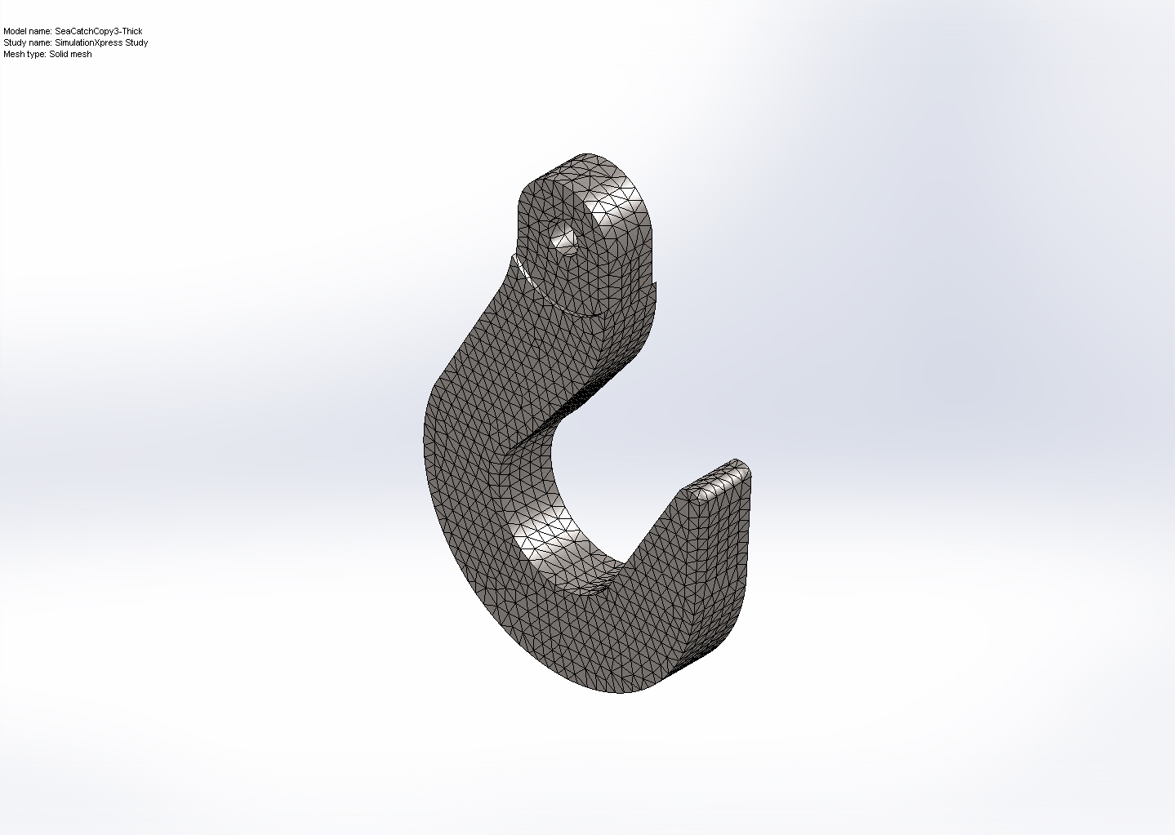

Study Results

Name | Type | Min | Max
Stress | VON: von Mises Stress | 0.000242996 psi  Node: 513 | 22309.5 psi  Node: 24649
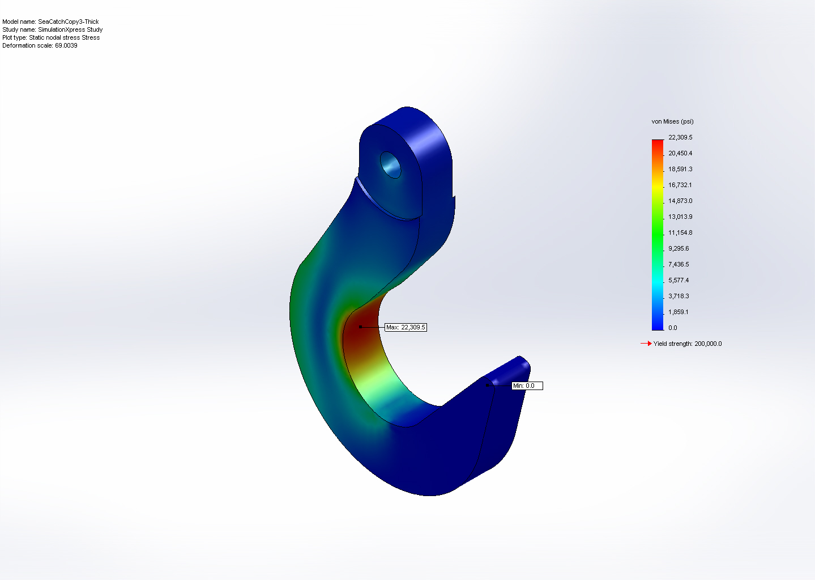
SeaCatchCopy3-Thick-SimulationXpress Study-Stress-Stress

Name | Type | Min | Max
Displacement | URES: Resultant Displacement | 0 mm  Node: 153 | 0.271141 mm  Node: 23687
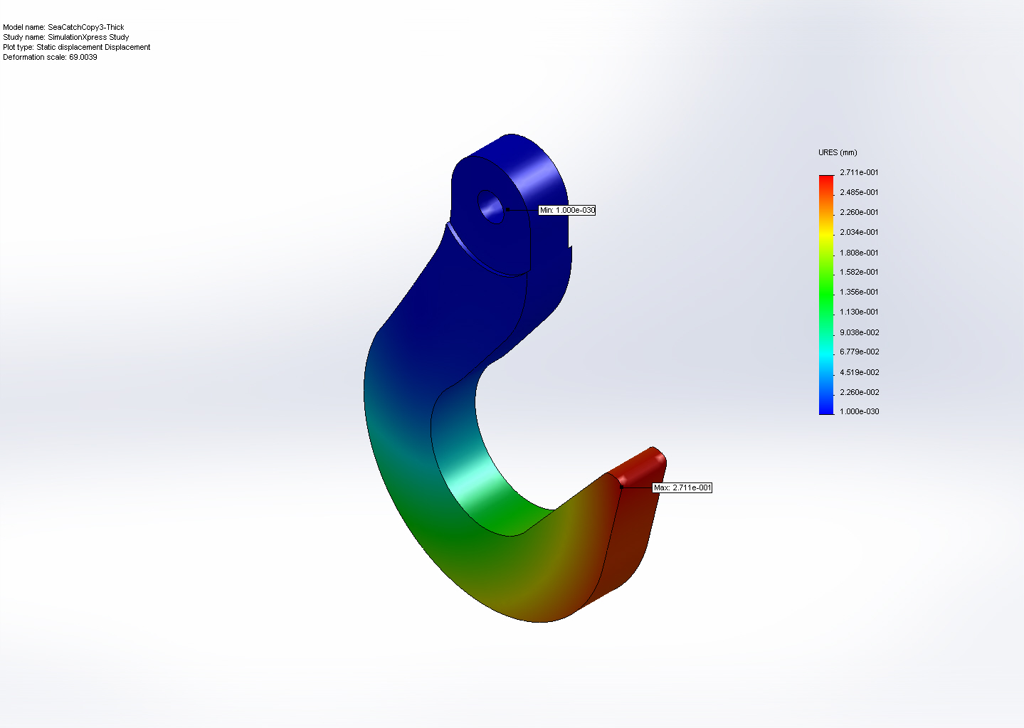
SeaCatchCopy3-Thick-SimulationXpress Study-Displacement-Displacement

Name | Type
Deformation | Deformed Shape
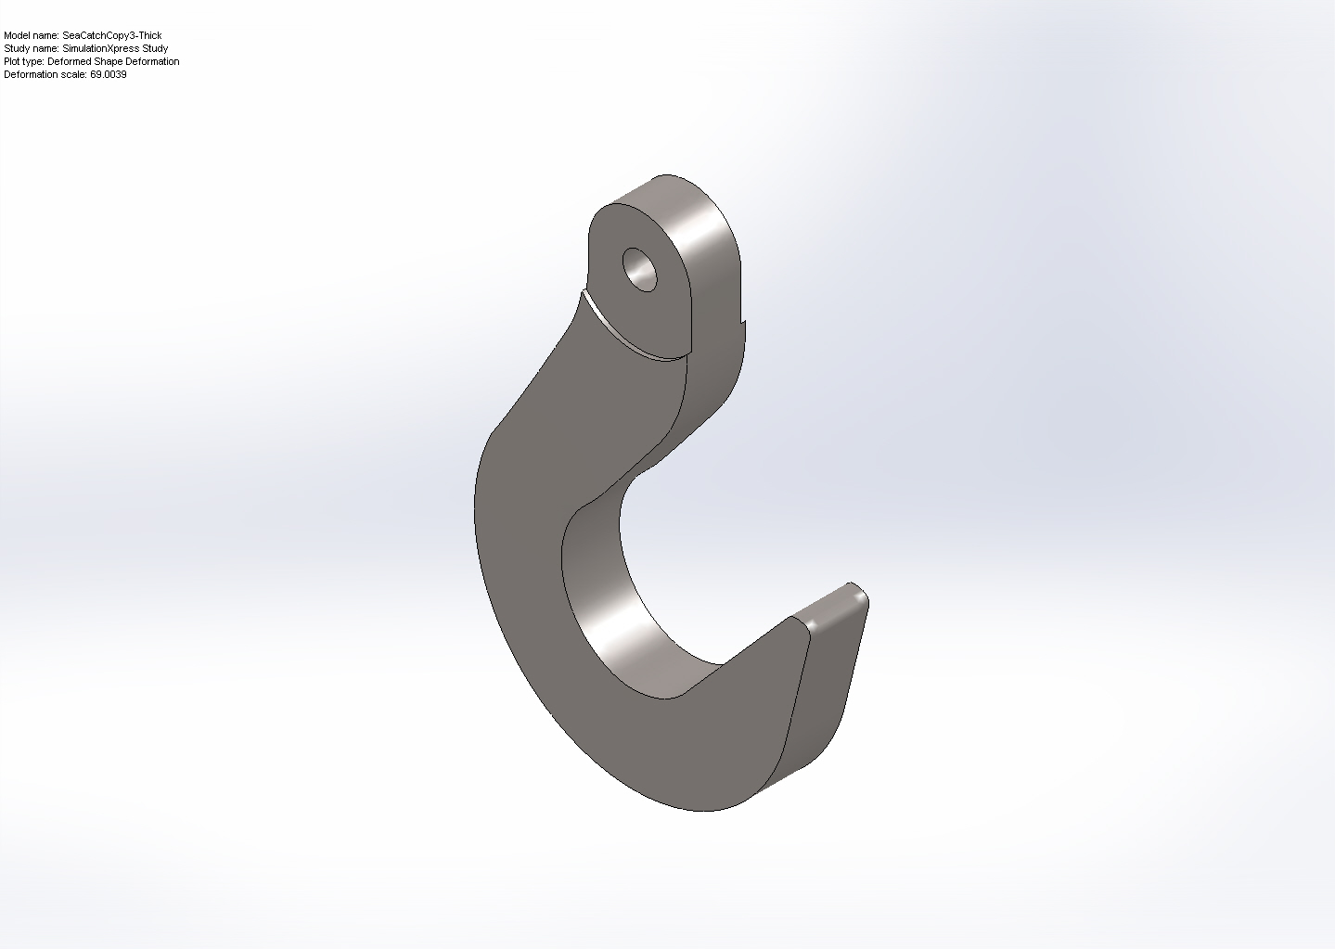
SeaCatchCopy3-Thick-SimulationXpress Study-Displacement-Deformation

Name | Type | Min | Max
Factor of Safety | Max von Mises Stress | 8.96478  Node: 24649 | 8.23058e+008  Node: 513
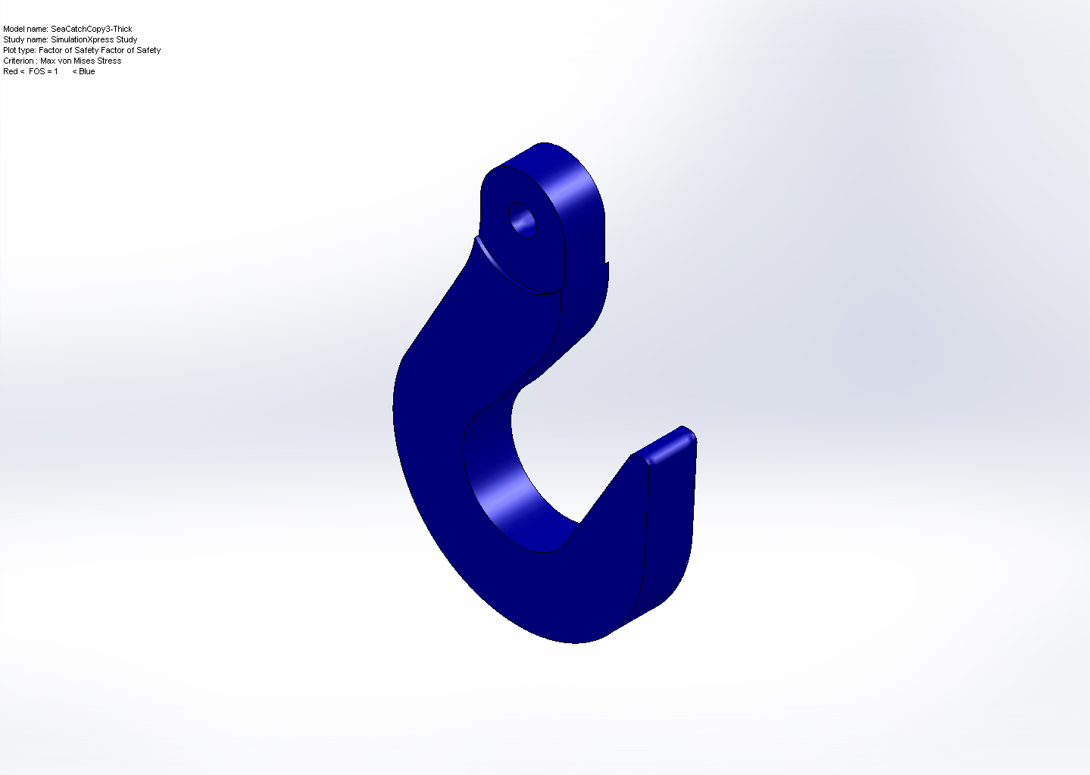
SeaCatchCopy3-Thick-SimulationXpress Study-Factor of Safety-Factor of Safety

Conclusion

