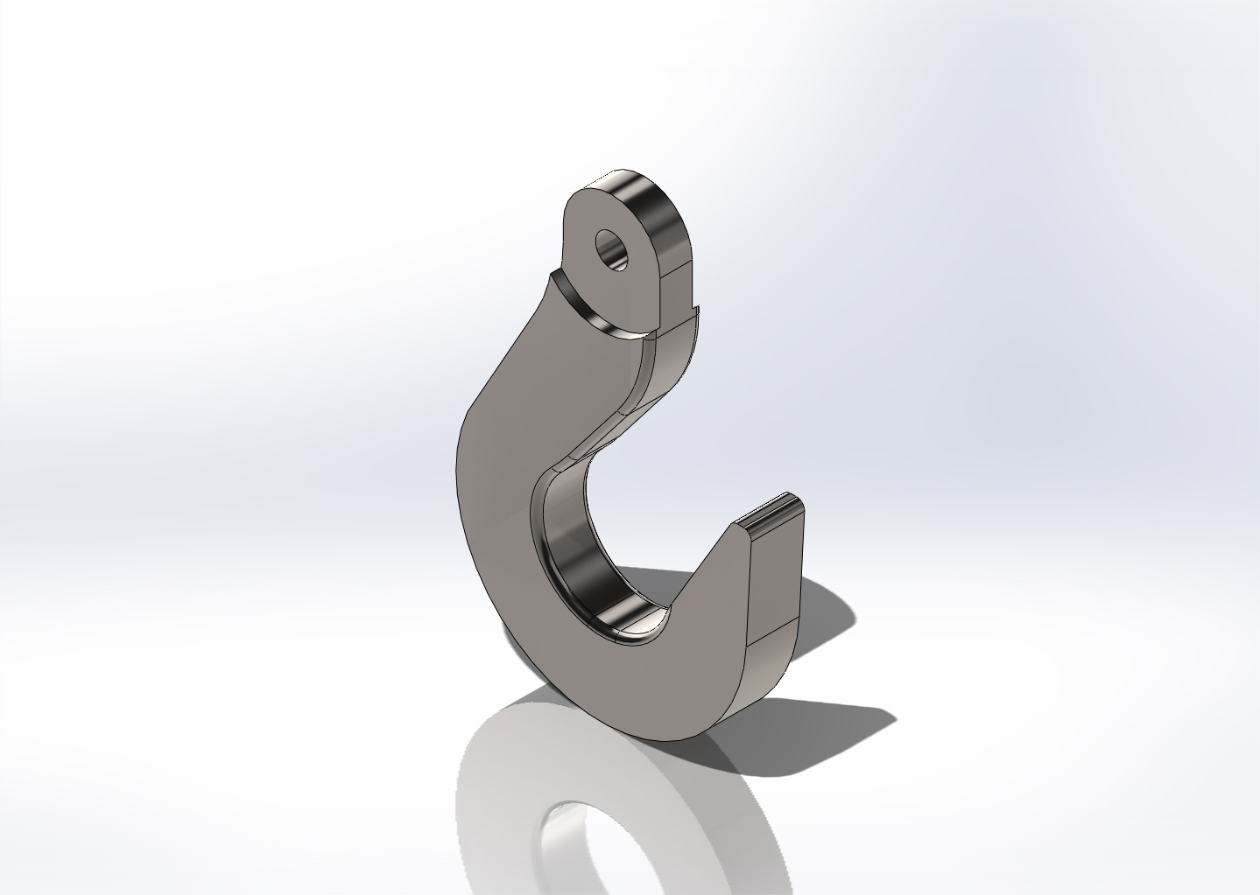
  Simulation of SeaCatchCopy3
  Date: Wednesday, October 31, 2012
  Designer: Solidworks
  Study name: SimulationXpress Study
  Analysis type: Static
  Table of Contents
  Description 1
  Assumptions 2
  Model Information 2
  Material Properties 3
  Loads and Fixtures 3
  Mesh Information 4
  Study Results 6
  Conclusion 9

Description
No Data

Assumptions

Model Information

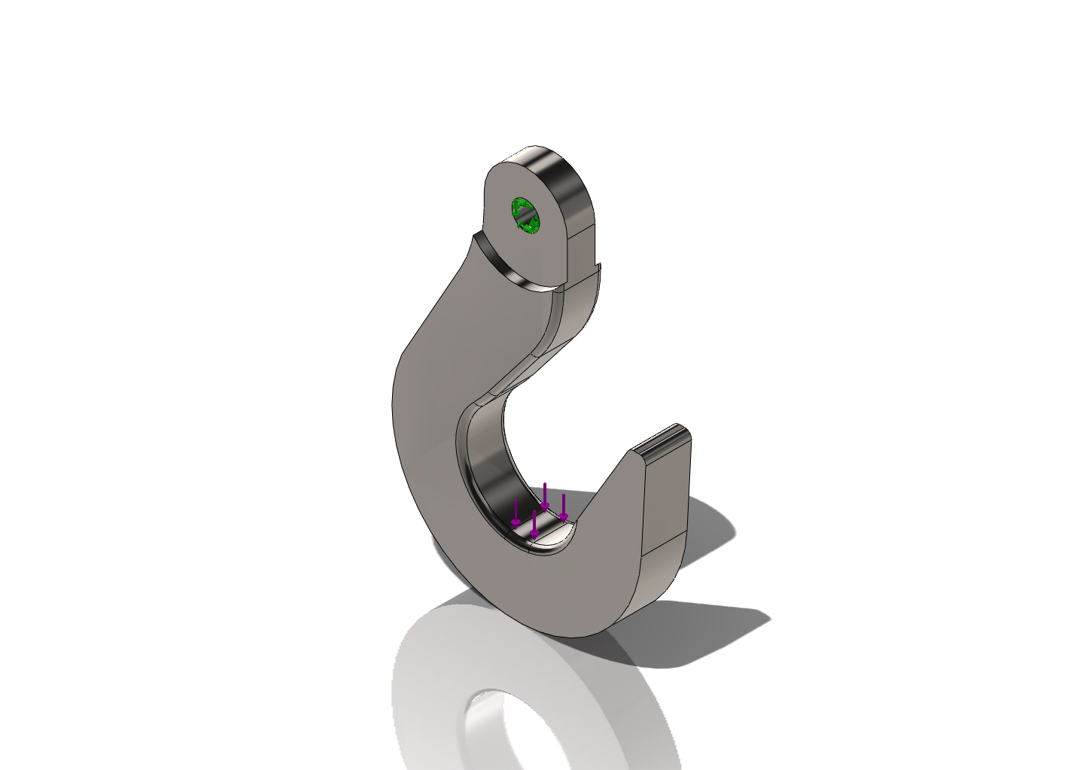
Model name: SeaCatchCopy3
Current Configuration: Default
Solid Bodies
Document Name and Reference | Treated As | Volumetric Properties | Document Path/Date Modified
Fillet3  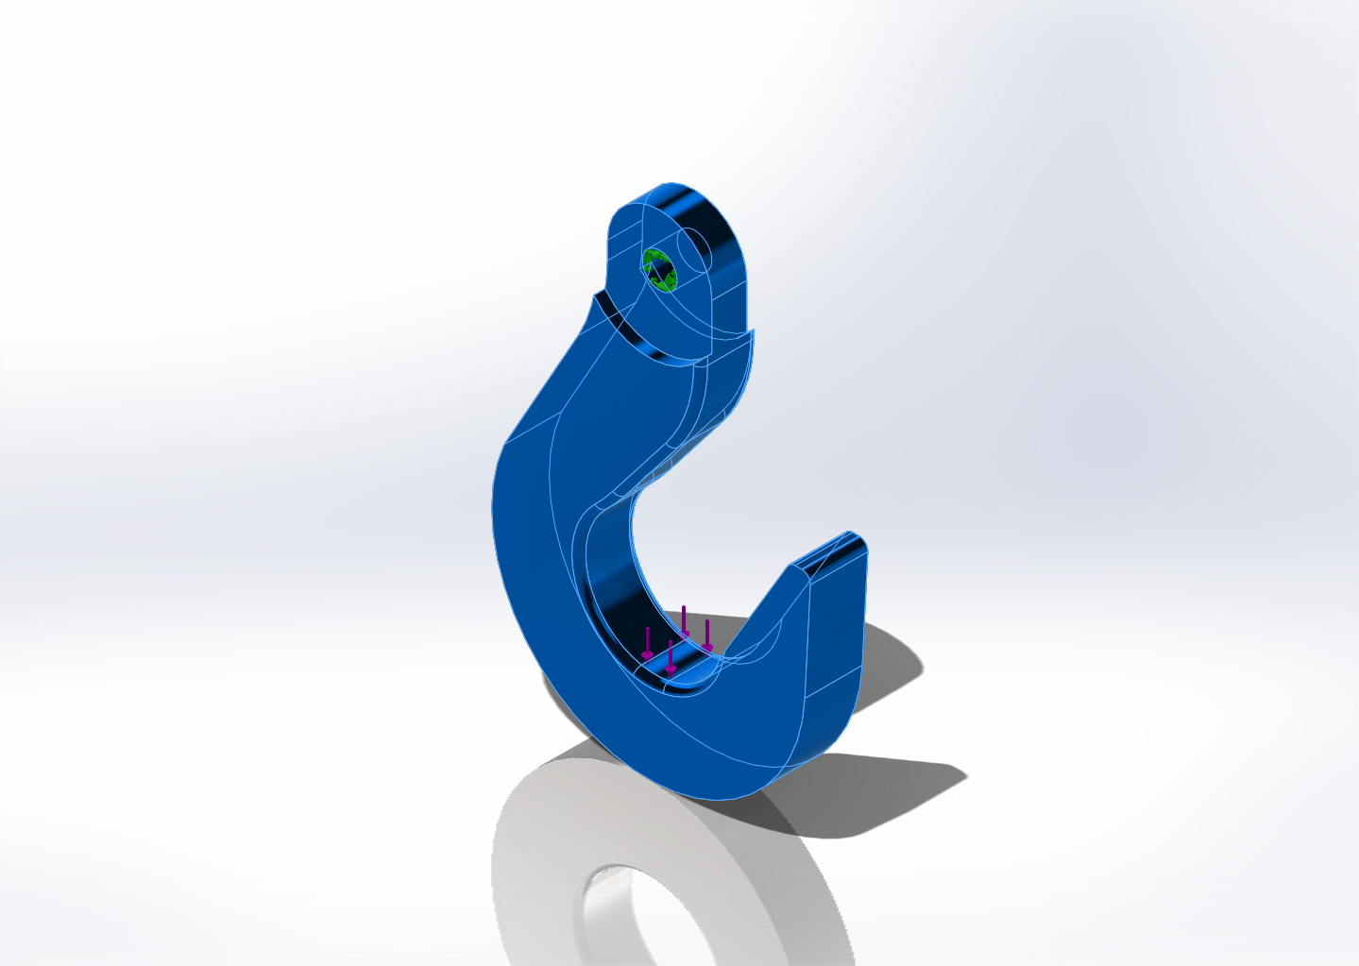 | Solid Body | Mass:1.78493 lb  Volume:11.1558 in^3  Density:0.16 lb/in^3  Weight:1.78372 lbf | Y:\Solid Models\Mapper Recovery Hook\SeaCatchCopy3-Thick.SLDPRT  Oct 31 10:33:51 2012

Material Properties
Model Reference | Properties | Components
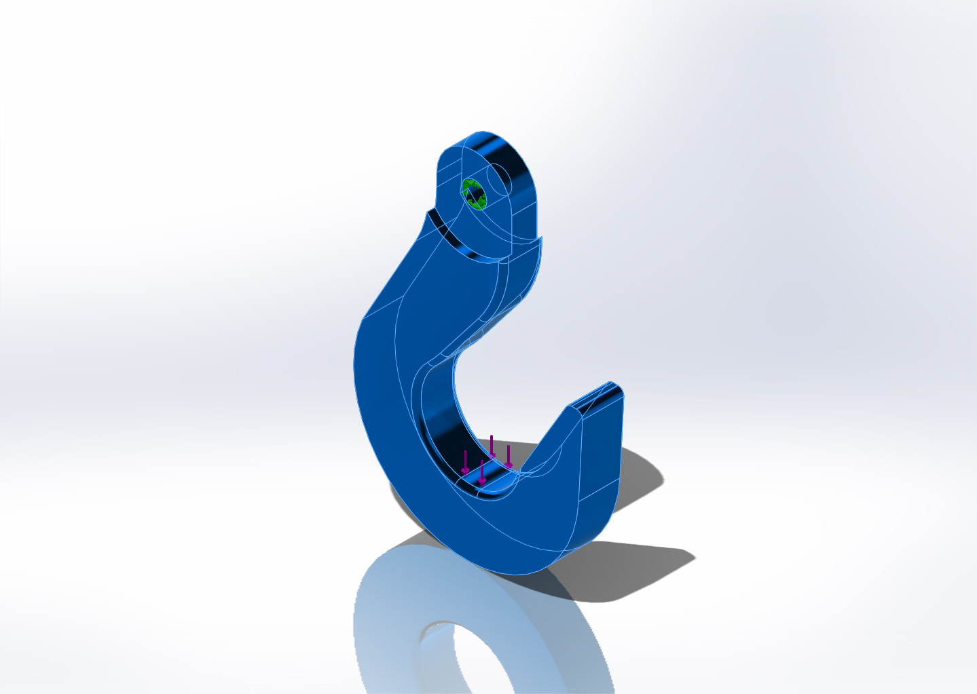 |  | SolidBody 1(Fillet3)(SeaCatchCopy3)
  Name: | Ti-6Al-4VSolution treated and aged (SS)
  Model type: | Linear Elastic Isotropic
  Default failure criterion: | Max von Mises Stress
  Yield strength: | 120000 psi
  Tensile strength: | 152290 psi

Loads and Fixtures
Fixture name | Fixture Image | Fixture Details
Fixed-1 | 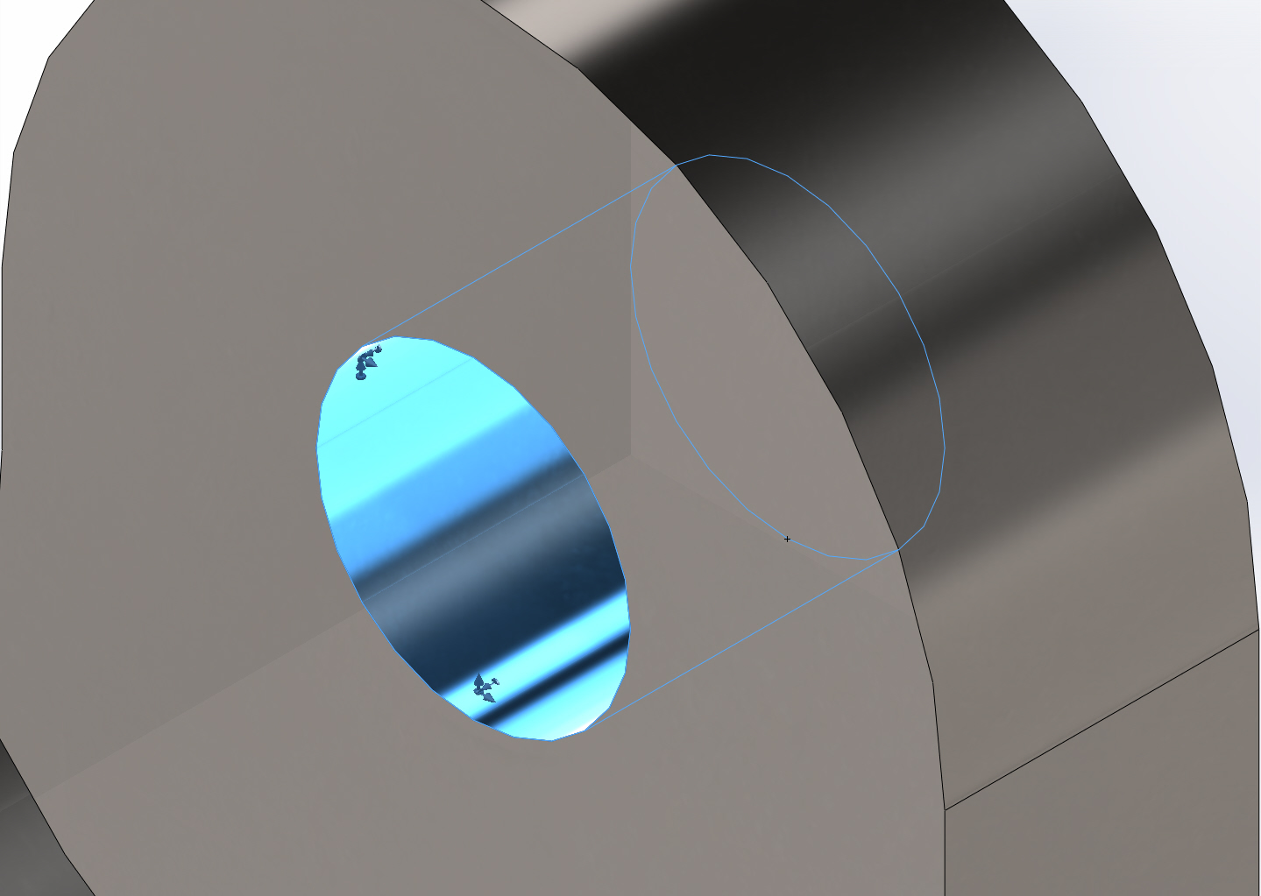
  Entities: | 1 face(s)
  Type: | Fixed Geometry

Load name | Load Image | Load Details
Force-3 | 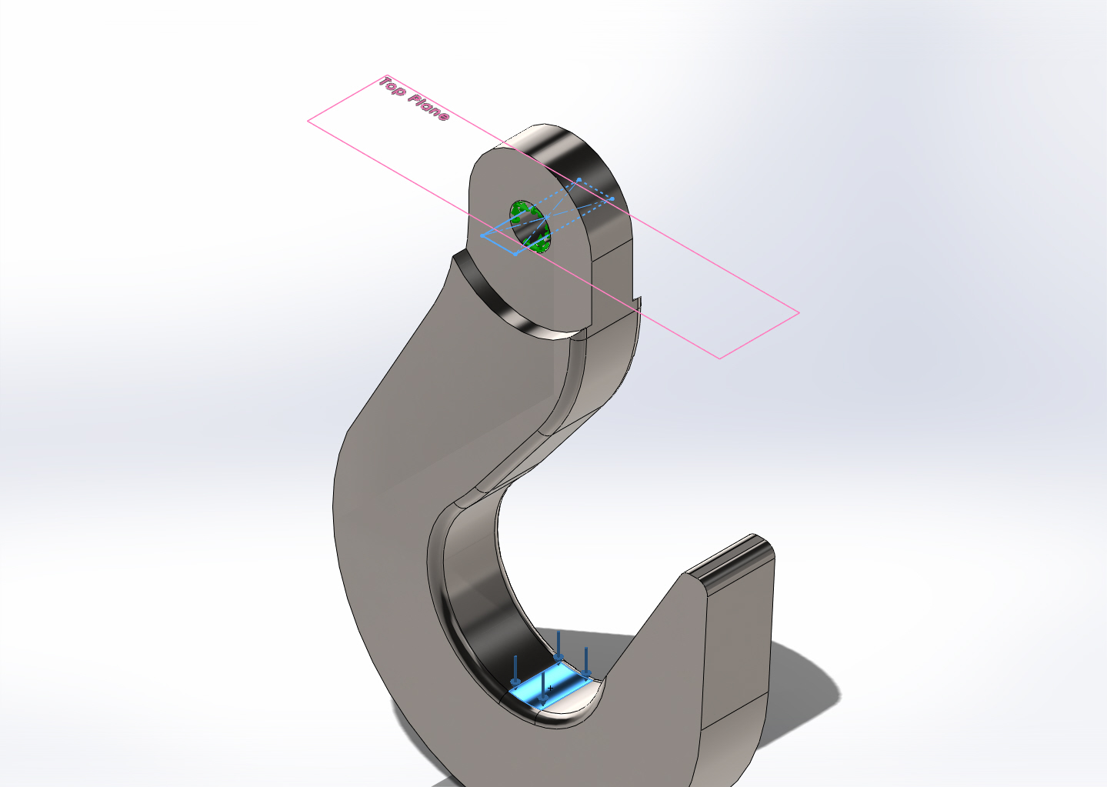
  Entities: | 1 face(s), 1 plane(s)
  Reference: | Top Plane
  Type: | Apply force
  Values: | ---, ---, -2000 lbf

Mesh Information
Mesh type | Solid Mesh
Mesher Used: | Standard mesh
Automatic Transition: | Off
Include Mesh Auto Loops: | Off
Jacobian points | 4 Points
Element Size | 0.169793 in
Tolerance | 0.00848964 in
Mesh Quality | High

Mesh Information - Details
Total Nodes | 25369
Total Elements | 16244
Maximum Aspect Ratio | 31.662
% of elements with Aspect Ratio < 3 | 99.7
% of elements with Aspect Ratio > 10 | 0.0554
% of distorted elements(Jacobian) | 0
Time to complete mesh(hh;mm;ss): | 00:00:01
Computer name: | DEUTSCHLAND
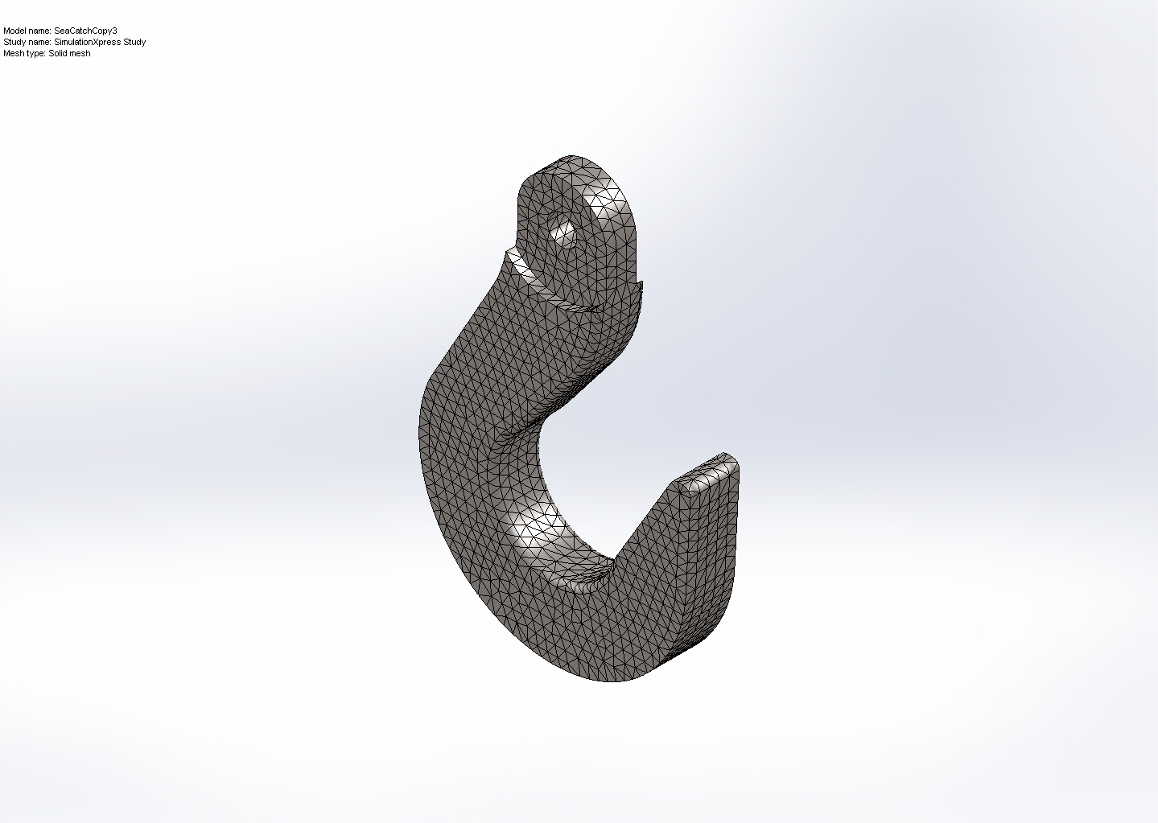

Study Results

Name | Type | Min | Max
Stress | VON: von Mises Stress | 0.000863328 psi  Node: 19109 | 23767.6 psi  Node: 23372
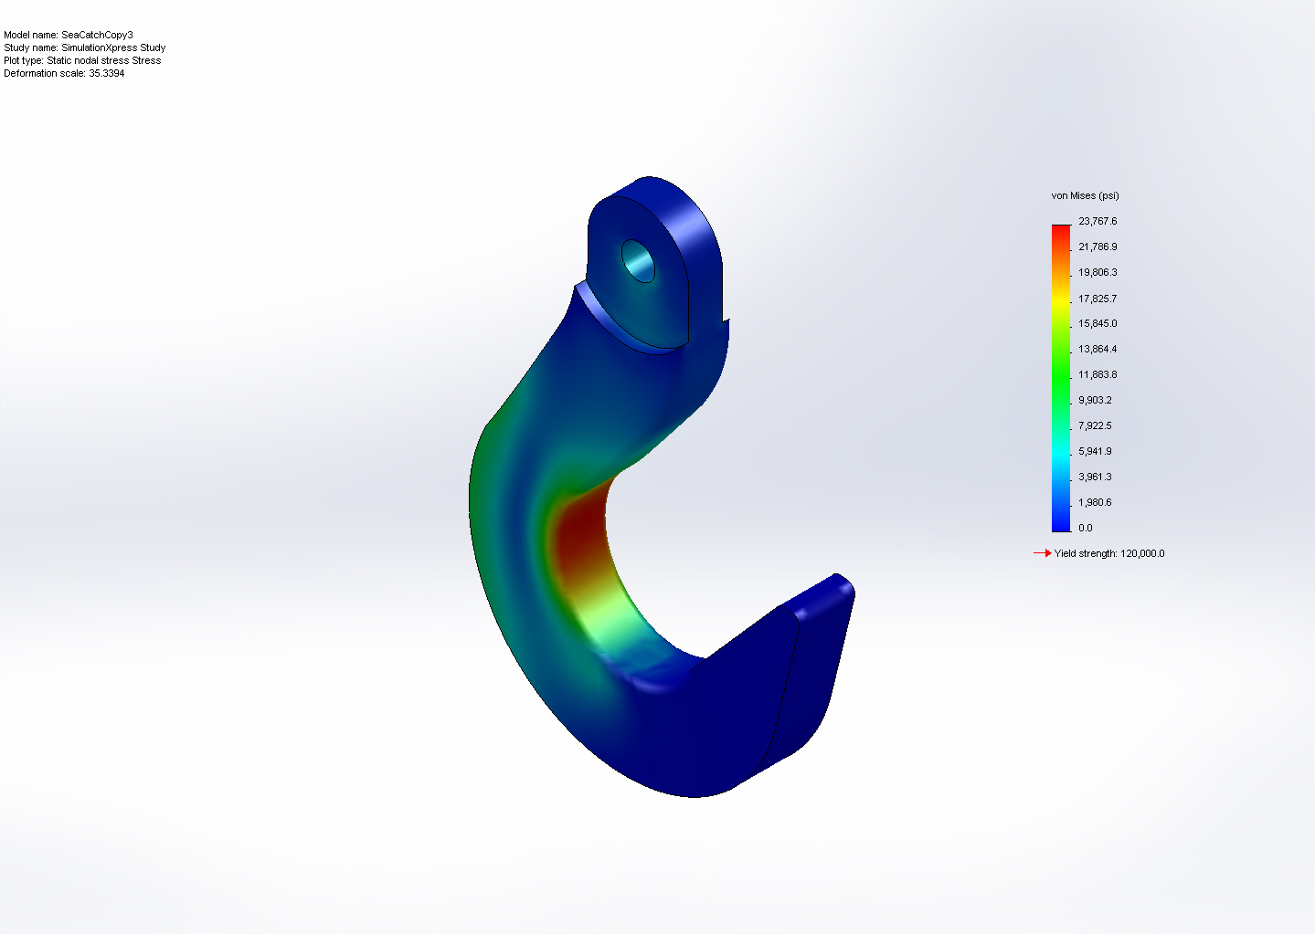
SeaCatchCopy3-SimulationXpress Study-Stress-Stress

Name | Type | Min | Max
Displacement | URES: Resultant Displacement | 0 mm  Node: 151 | 0.529241 mm  Node: 19450
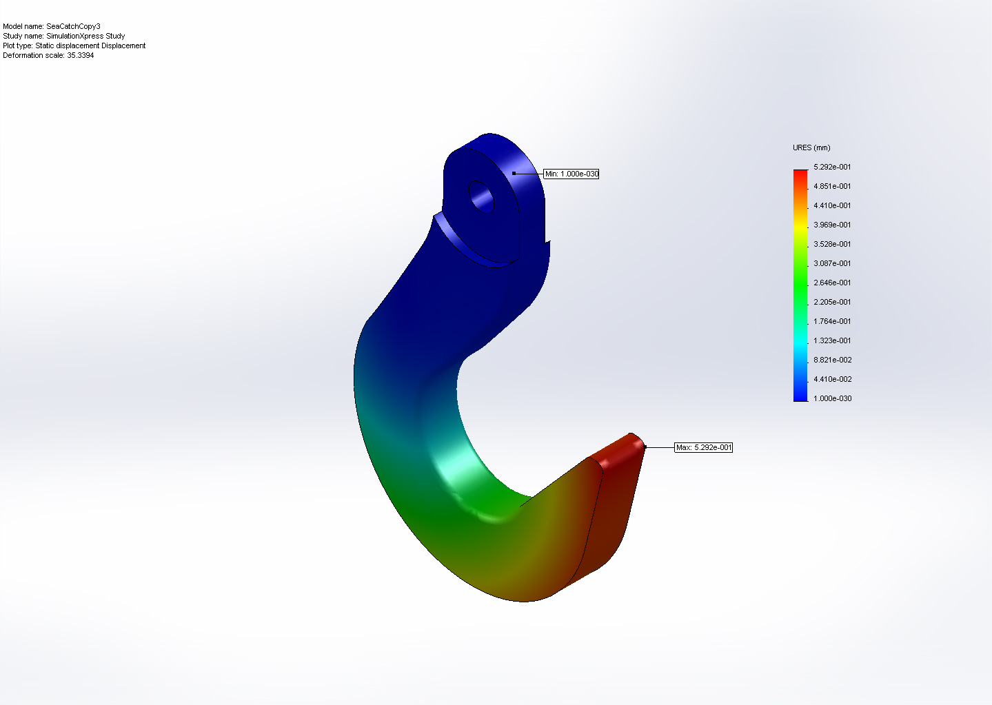
SeaCatchCopy3-SimulationXpress Study-Displacement-Displacement

Name | Type
Deformation | Deformed Shape
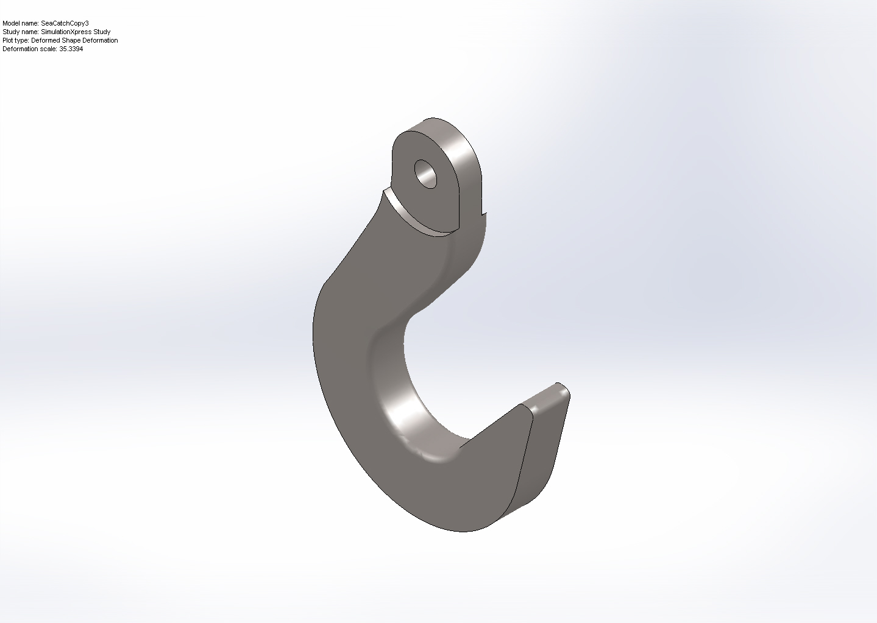
SeaCatchCopy3-SimulationXpress Study-Displacement-Deformation

Name | Type | Min | Max
Factor of Safety | Max von Mises Stress | 5.0489  Node: 23372 | 1.38997e+008  Node: 19109
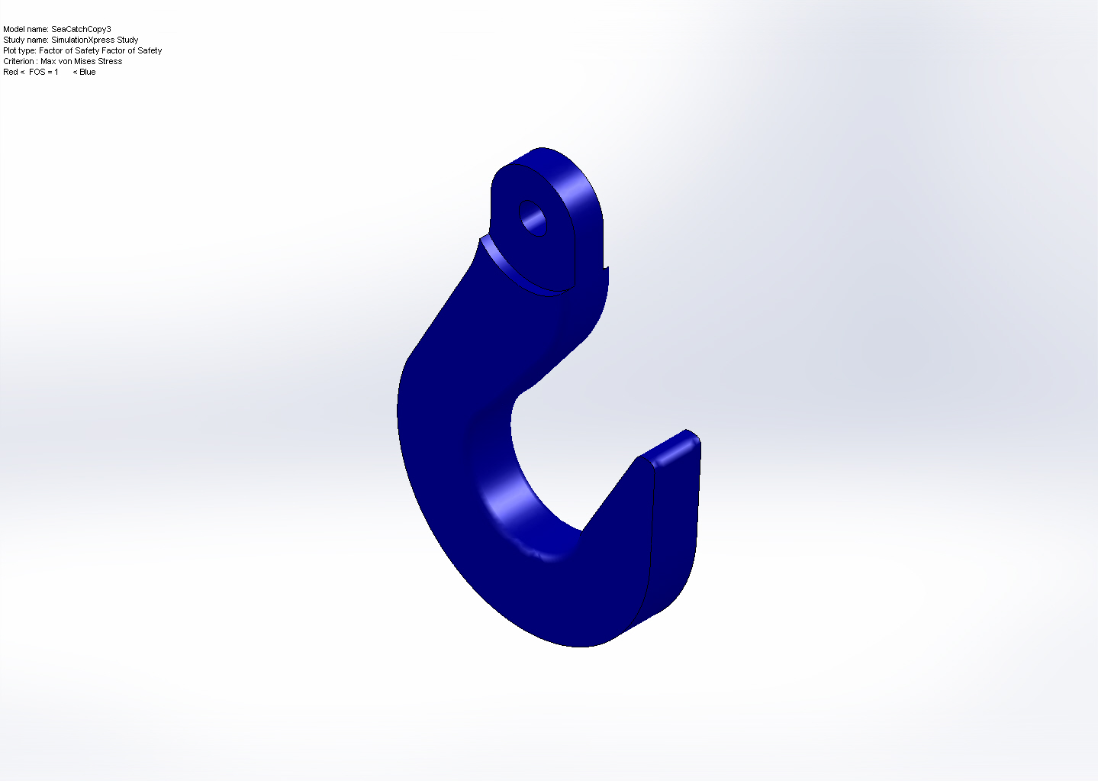
SeaCatchCopy3-SimulationXpress Study-Factor of Safety-Factor of Safety

Conclusion

