EdgeTech Sonar Command-Line Interface (CLI) User's Guide

Background
The EdgeTech Sonar CLI package is both a demonstration as well as a Software Development Kit (SDK) for customers wishing to control EdgeTech's sonar system within their equipment. An example configuration would be an EdgeTech sonar system deployed onboard an AUV.

System Requirements
To run the demonstration all that is required is a PC with Windows XP (with Service Pack 3 and .NET Framework 4.0) or Windows 7 connected with an Ethernet cable to a Discover 1 version EdgeTech sonar. The Sonar CLI application was developed using Microsoft Visual Studio 2010 and written in C#. Although Visual Studio 2010 and the corresponding .NET Framework allow assemblies to be written in differing languages (e.g. C#, C++ and Java), the most direct and straightforward approach toward software development using the Sonar CLI package is to develop in C#.

Prerequisites
The EdgeTech Discover 1 Sonar System is capable of driving up to three sonar subsystems at the same time: Side-Scan High Frequency, Side-Scan Low Frequency, and Sub-Bottom. Your particular configuration may not require all three subsystems. It is assumed the reader is familiar with basic sonar concepts such as the effect of ping rate upon range. A knowledge of such concepts will be necessary when configuring the sonar system.

Running the Demonstration
To run the demonstration connect the PC containing this package to the EdgeTech Sonar System using an Ethernet cable. (Although this CLI package can be in any folder, for ease of discussion we will assume it is located within folder C:\EdgeTech). Power up the EdgeTech Sonar System. On the PC go to folder C:\EdgeTech\Sonar CLI SDK\Demo\bin\Debug. At the command prompt type:
C:\> Demo2
If everything is configured properly you should see output similar to Figure 1. Demo2 has a few command line options. Enter "Demo2 h" to get a help list of those options.

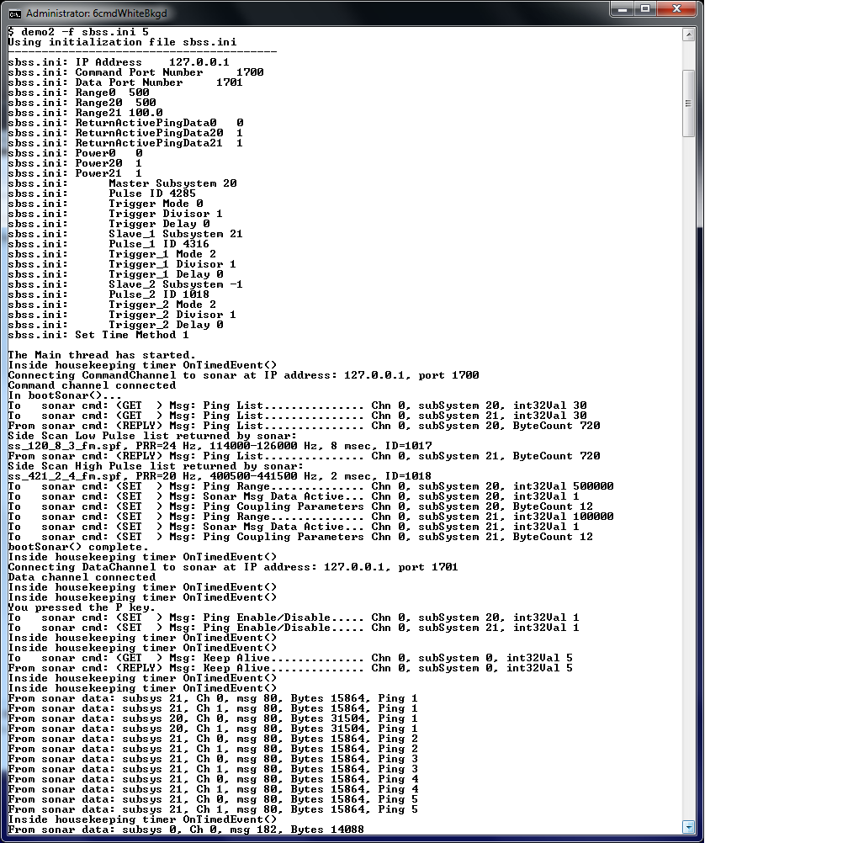
Figure 1 - Sample Demo2.exe output
To stop the demo press the "Q" key on the keyboard (be sure the command-line window has focus). Press "P" to start pinging, and press "S" to stop pinging.

Configuring Sonar using the sonar_cli.ini file
Demo2 configures Sonar using the sonar_cli.ini file. A sample sonar_cli.ini file comes with the SDK and is shown in Appendix A. This file resides in the same directory as the Demo2 executable. You must edit the parameter values in this file to represent your particular configuration. Since the keywords in this file (such as "IP Address" and "Data Port Number") cannot be altered it is a good idea to make a backup copy of this file before you edit it. As can be seen in Appendix A the file has comments explaining each of the parameters. You can easily verify the parameter values of the current sonar_cli.ini file by typing:
$ Demo2 ini
This will display the parameter values as shown in Figure 2.
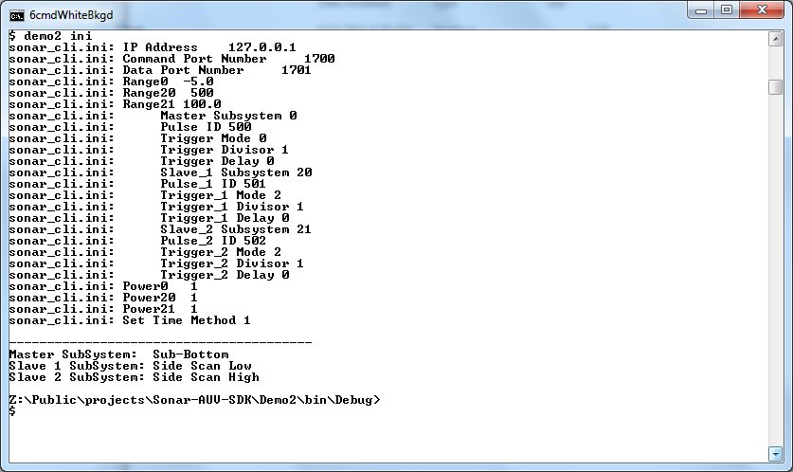
Figure 2 - Sample output using the "Demo2 ini" command-line option
In this case the sonar_cli.ini file is simply read, parsed, and displayed. No attempt is made to connect with Sonar so this option may be used without Sonar being present.
A couple of points are worth noting.

Subsystem ID designators
Discover 1 Sonar recognizes three sonar subsystems having the following ID values:
Side Scan Low Frequency (SSL): 20
Side Scan High Frequency (SSH): 21
Sub-Bottom (SB): 0
Use these values to specify the Master, Slave 1, and Slave 2 subsystems. If you are not using a subsystem (e.g. Slave 2 is not used) place a value of -1 in the sonar_cli.ini file for that subsystem. You can use a value of -1 for all three subsystems as a means of passively verifying communications with Sonar along with uploading and displaying Sonar's pulse list.

Triggering Options
The Master subsystem typically drives the triggering of all subsystems. This is done to avoid inter-ping interference. In this case the slave systems are said to be "coupled" to the Master. The Master may be triggered either internally or externally (via. the External trigger connector) and is specified by the Trigger Mode parameter. Each of the two slave subsystems may be triggered internally (free running mode) or coupled to the Master subsystem as specified by each subsystem's Trigger Mode parameter. All three subsystems have two other parameters - Trigger Divisor and Trigger Delay. Their behavior is described as follows:
Master Trigger Divisor - The value N of this parameter causes the Master subsystem
to trigger a ping on every Nth input trigger event. The input trigger may be either
internal or external. Subsystems that are coupled to the Master will respond
accordingly. If they are not coupled they will respond to the input trigger only.
Master Trigger Delay - The value N of this parameter causes the Master subsystem
to delay triggering a ping N microseconds after the input trigger. The input trigger
may be either internal or external. Subsystems that are coupled to the Master
will respond accordingly. If they are not coupled they will respond to the input
trigger only.
Slave Trigger Divisor - The behavior here depends on whether the slave is coupled
or not. If the slave is coupled to the Master (Trigger Mode = 2) the slave will trigger
a ping on every Mth input from the Master. Thus if the Master has a divisor of N=3
and the slave has a divisor of M=2 then the slave will trigger a ping on every 6th
input trigger to the Master. If the slave is not coupled to the Master (Trigger
Mode = 0) then the slave will be in free running mode and will ping on its own at
a rate specified by the Rangexx parameter. In this case the Trigger Divisor is
typically set to 1.
Slave Trigger Delay - Once again the behavior here depends on whether the slave is
coupled or not. If the slave is coupled to the Master the slave will trigger a ping M
microseconds after the trigger input from the Master. If the slave is not coupled to
the Master it will ignore the Master and trigger a ping M microseconds after the
internal trigger event.

Examples:
In the following examples the ping rate = 4 (so that the period T = 250 milliseconds)
In both cases the slave is coupled to the Master.

Example 1
Master Trigger Divisor = 3, Master Trigger Delay = 0
Slave Trigger Divisor = 2, Slave Trigger Delay = 0
Input trigger (msec): 0, 250, 500, 750, 1000, 1250, 1500, 1750, 2000, 2250...
Master trigger: 0, 750, 1500, 2250, 3000,...
Slave trigger: 0, 1500, 3000, 4500,...

Example 2
Master Trigger Divisor = 3, Master Trigger Delay = 10000 (i.e. 10 milliseconds)
Slave Trigger Divisor = 2, Slave Trigger Delay = 5000 (i.e. 5 milliseconds)
Input trigger (msec): 0, 250, 500, 750, 1000, 1250, 1500, 1750, 2000, 2250...
Master trigger: 0, 760, 1510, 2260, 3010...
Slave trigger: 0, 1515, 3015, 4515,...

The most common usage of the divisor is shown in the following example:
Master = HF susbsystem, with range set to 75 meters
Slave = LF subsystem, with a desired range of 4x75 = 300 meters
but the master trigger rate only supports 75 meters.
So we set the Trigger Divisor for the slave to 4, and set the LF slave
range to 300 meters. Done!

Appendix A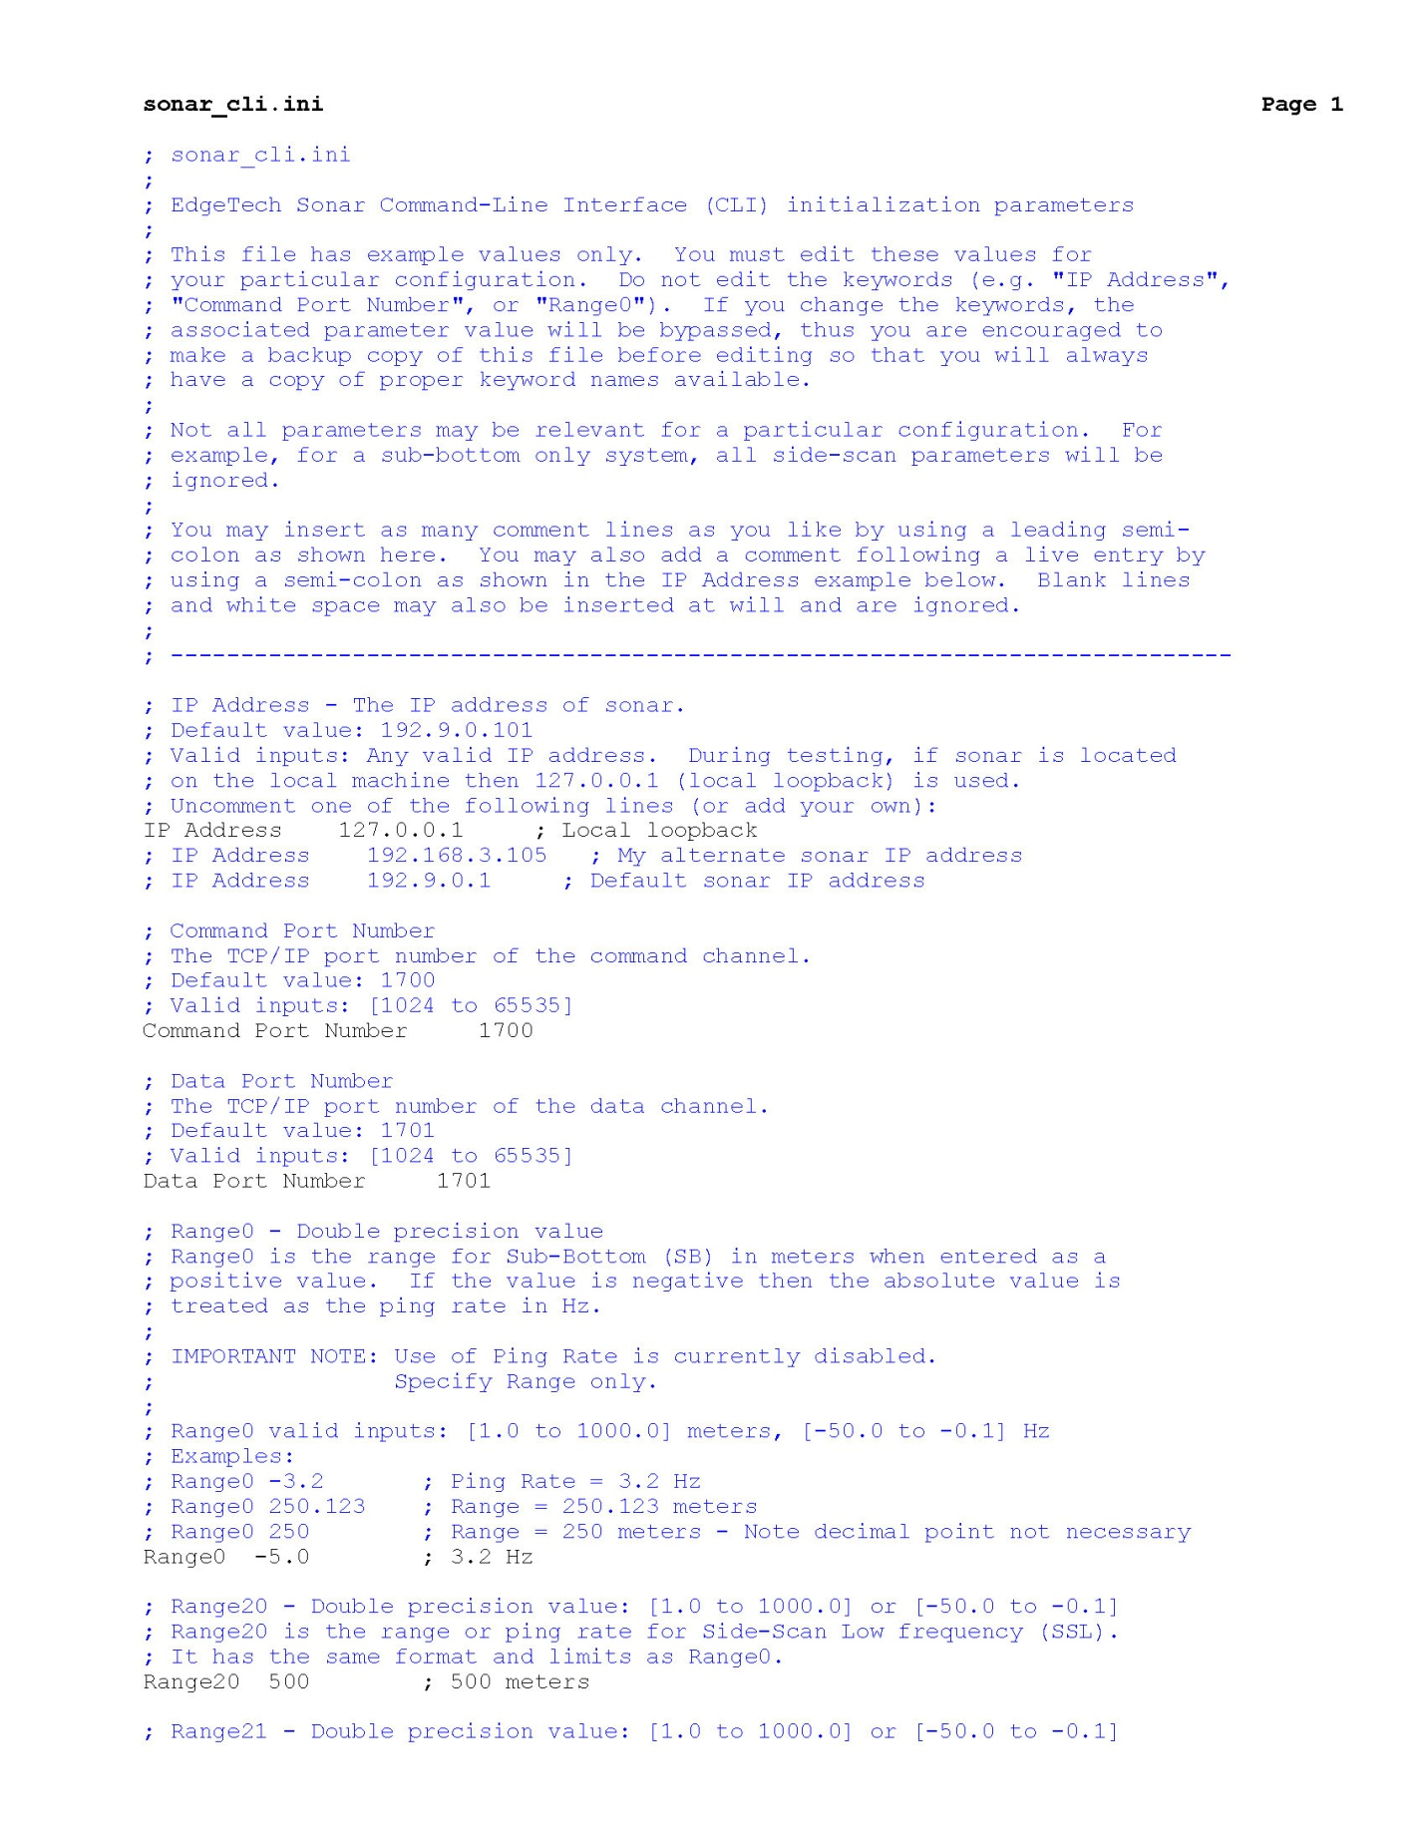

Appendix A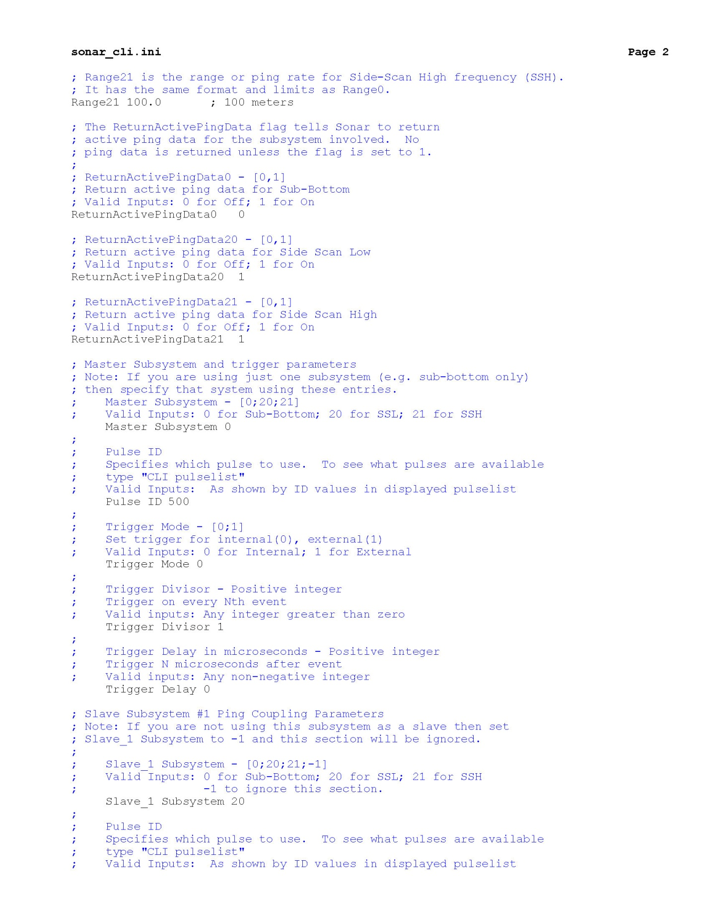

Appendix A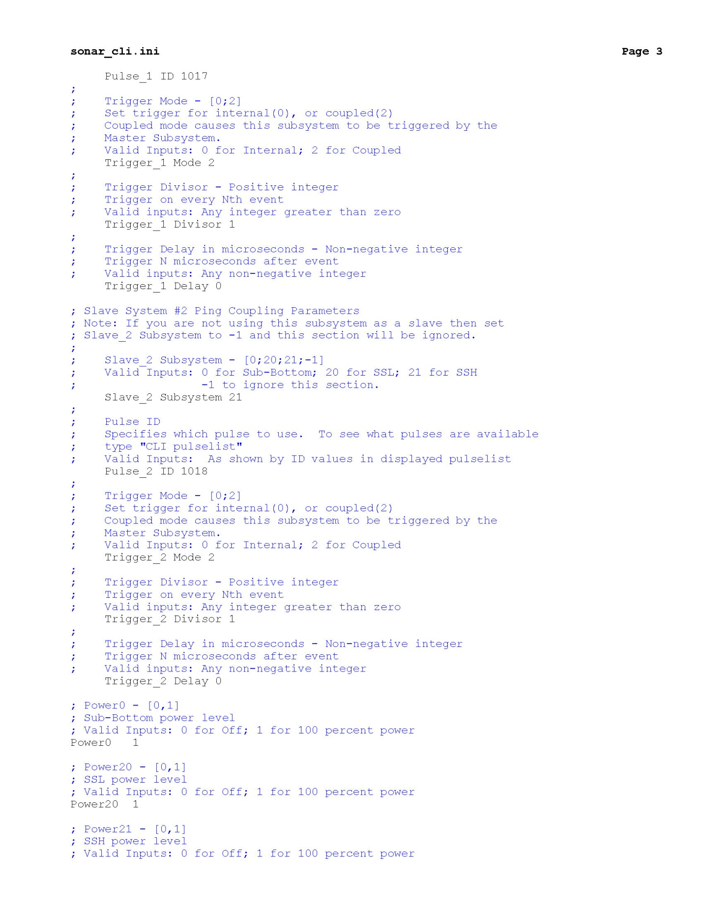

Appendix A