Materials
- ¼ ” wide Self-vulcanizing Rubber
- Devcon FL-20 Primer No.15985
- Devcon Flexane 94 Liquid 15250
- Cable Assembly
- Sand Paper
- Gloves

Safety
Please make sure to pour the resin in a fume hood or well ventilated area
Potting Procedure:

- Solder
- 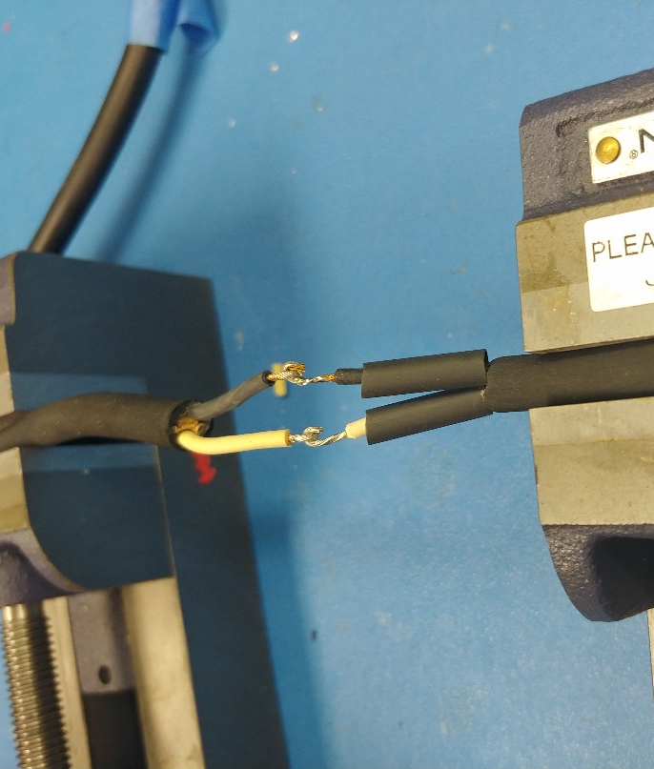

- PREP CABLE FOR MOLDING: Fit the cable assembly into the mold, ensuring that the amount of cable jacketing is in the mold evenly. Thoroughly clean blue area (See Figure 2) with an abrasive pad so that it is coarse and free from oil and dirt that may clog the "pores" of the rubber. Fit the cable into the mold again and with a sharpie, mark where the end of the mold is on the cable (See yellow marks on Figure 2).

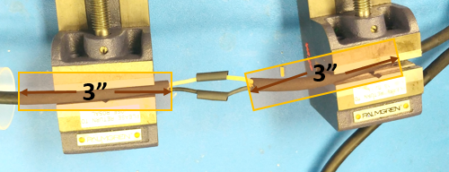
Figure 2: Prepping Potting Area

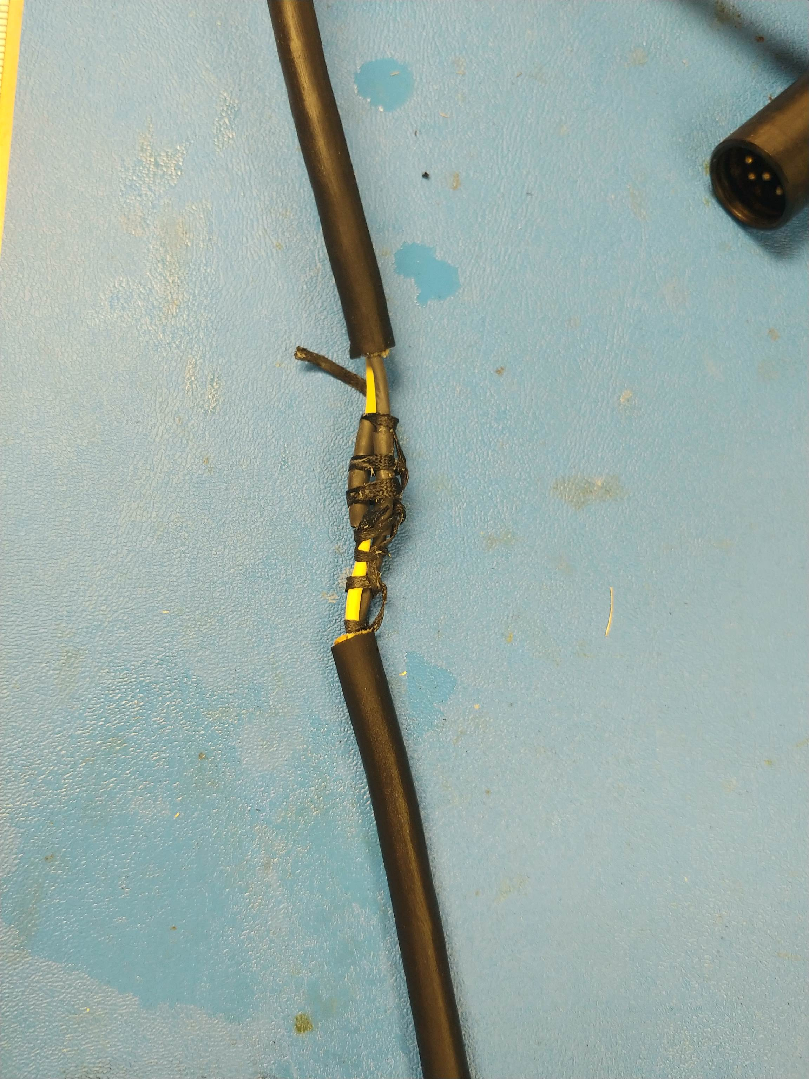
Figure 00: s

- Create a seal for the potting with Electrical tape. Line up the middle of the electrical tape with the sharpie mark (yellow, Figure 3). For the smaller diameter on the mold, wrap the tape approximately seven times, and check to fit. The fit should be snug but doesn’t prevent the mold from closing. (See Figure 4) . Take away or add wraps as needed to achieve the result. Apply tape to the main cable; the larger diameter cable needs about 17 tape wraps. The fit should be snug but doesn’t prevent the mold from closing. Take away or add wraps as needed to achieve the result.

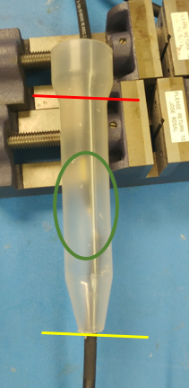
Figure 3: of the sharpie line

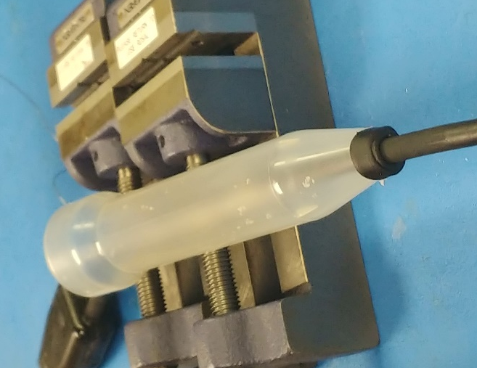
Figure 4: Fitting the tape to the mold.

- Do a final test fitting by laying the cable assembly into the mold, and clamping it shut. The mold should completely close, and the cable should be snug. Note: There is a chamfer around the hole in the mold and may give the illusion of the cable not fitting.

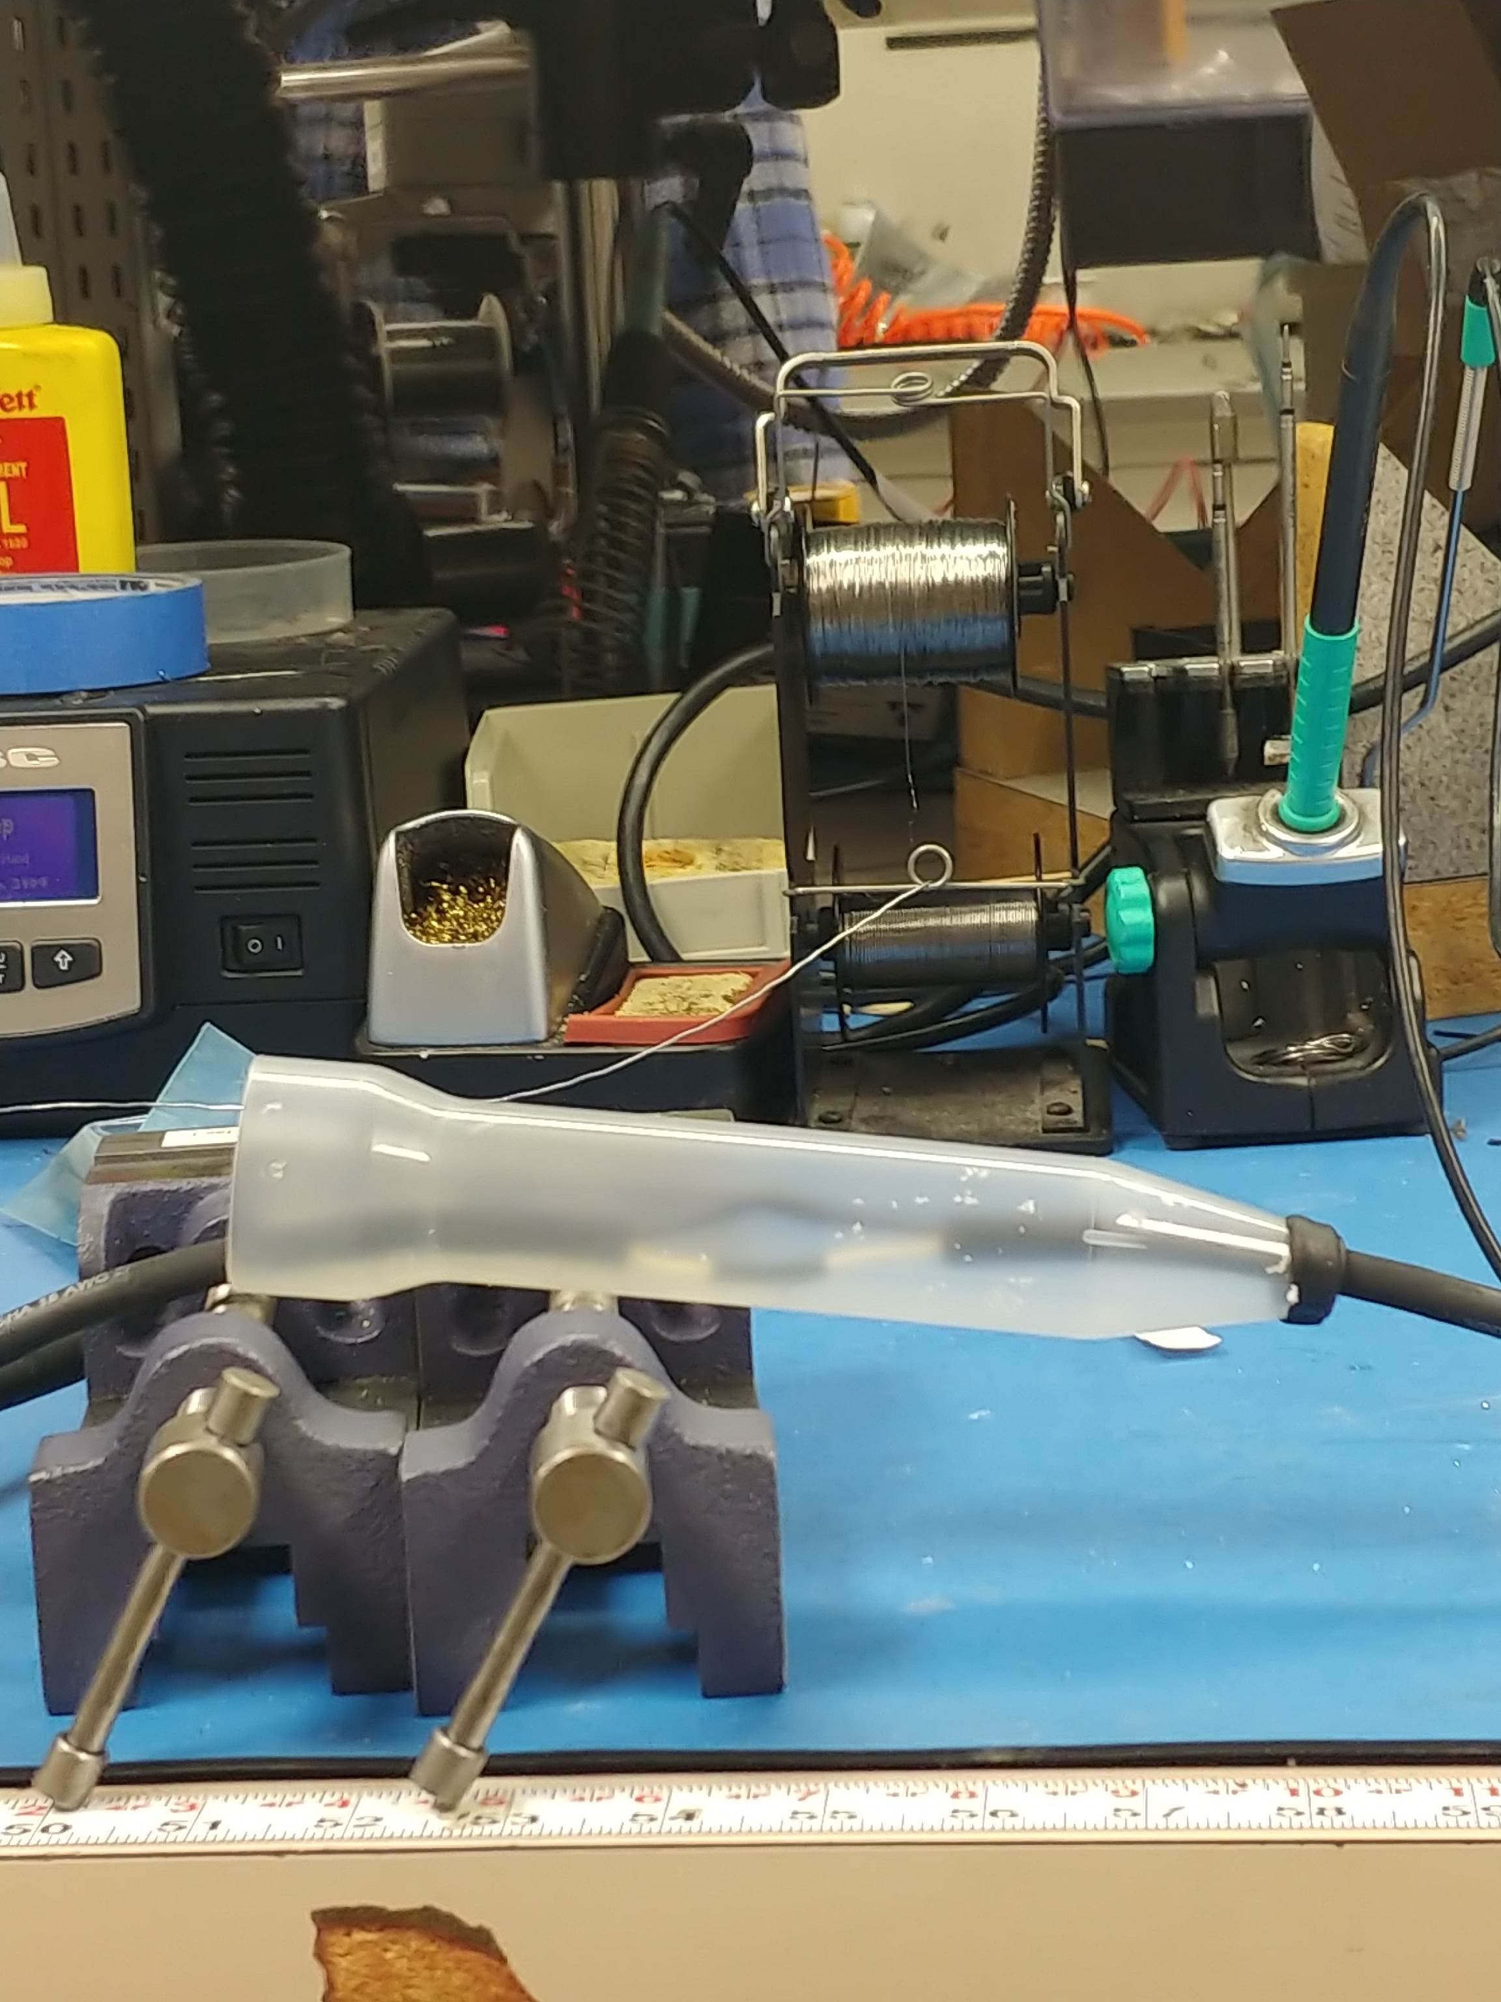
Figure 5: Clamp the mold shut

- PRIME POTTING AREA: Hang the cable assembly, as shown. Used compressed air to blow up any dust or debris that the cable may have on it. Place the hanging cable assembly in front of the fume vacuum (fume hood, well-ventilated area). Put on gloves to prevent your skin oils from contaminating the potting surface.
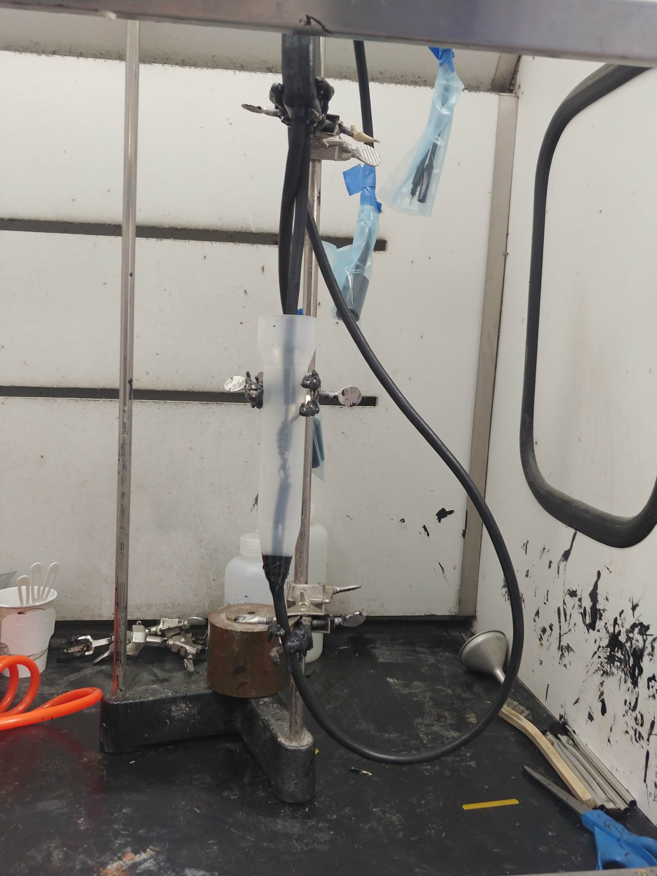 | 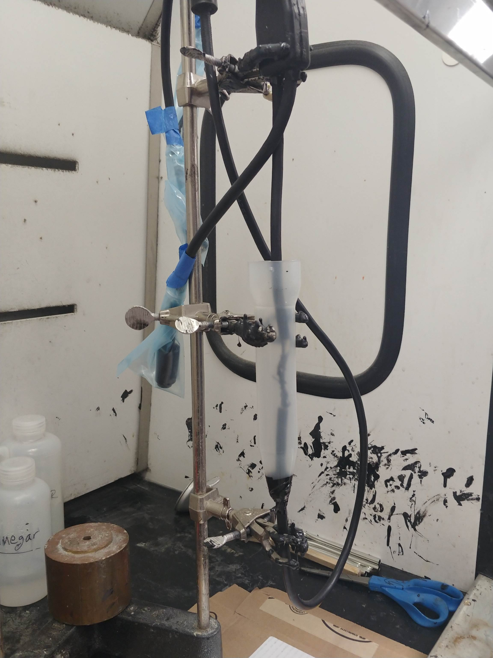
Figure 6: | Figure 7:

- Wipe the surface (green, Figure 7) with isopropyl alcohol until the cloth no longer picks up the color of the rubber or debris.
- To prime, this surface, apply a coat of Devcon® FL-20 Primer to the area in the green box in Figure 7 and allow it to dry tack-free for 15-20 minutes.
- Apply a second coat Devcon® FL-20 Primer to the area in the green box in Figure 7 and allow it to dry tack-free for 15-20 minutes.
- MOLD PREP: Scrape off residual epoxy from the mold. Blow off debris off the mold with compressed air. Wearing gloves, use non-particulate wipes and isopropyl alcohol to wipe down the mold. When moving the molds, be sure not to touch the potting surface, and transport mold by the edges.
- (Figure 8) In a well-ventilated area, apply a layer of Mann Release Technologies Ease Release 200 to the mold. Hold the can or spray gun 6 to 8 inches from the mold surface to ensure a light even coating. Wait 3 min to let it settle. Apply a second layer. Let dry.

Figure 8: Adding Mold Release to oil and particulate-free molding surfaces

- Set up one half of the mold so that it is face up and stable
- (Figure 9) Preferably with two people. Release the cabling assembly and set it into the mold. DO NOT LET THE PRIMERED CABLING ASSEMBLY TOUCH THE POTTING SURFACE. Carefully clamp the other half of the mold onto the assembly.

Figure 9: Carefully set prepped cable into the mold

- Sandwich the cable assembly between the two molds and clamp with the clamp handles up towards the side with the potting opening. (Figure 10)
- Using the self-vulcanizing rubber, create a small dam around the pour opening of the mold. This dam is a reservoir to capture the extra potting.
Insert Picture here
Figure 10: Carefully set prepped cable into the mold

- POTTING THE MOLD: Take The Devcon 94 parts out of the oven.
- Note: If the mold requires more than 100g of the combined mixture, due to the set speed of the potting, it is best to make half of the mixture, pour, and make the other half of the mixture and pour. Splitting the job allows you the time to pour slow enough to reduce the number of bubbles without it becoming too viscous before you’ve finished.
- Measure out Resin. Add respective hardener to resin. (See Reference 01)
- Vigorously mix with a mixing stirrer for one minute while continuously scraping material away from the sides and bottom of the container.
- Transfer the mixed material into the mold. Pour quickly but carefully to one side of the pouring hole. Over pour so that the potting mixture halfway fills the reservoir.

- PLACE IN PRESSURE POT (Figure 11): Careful not to the spill the mixture, place the assembly in the pressure pot. Cover pot with the lid and fully secure. Pressurize pot to 50psi +/- 5 psi.

Figure 11: Carefully place cable assembly into the pressure pot

- Allow curing six (6) hours before removing the cable assembly from the mold. A full cure takes seven (7) days at 70°F.
- FINISHING: Remove clamps. Remove cable assembly from the mold. Use ¼” hex key to aid in separating the assembly from the mold.

Figure 12: Use Hex Key to separate the mold from the cable assembly

- Remove electrical tape from cable assembly. With a razor or sandpaper, carefully (DO NOT CUT CABLE) remove flashing from the mold.

Figure 13: Cable Assembly released from the mold, with flashing | Figure 14: Cable Assembly with flashing removed

MEGGER TEST:
Ensure that the potting process provided full coverage of the electronics, test the cable assembly.

- Obtain the following:
      - 2500+ V megger
      - Adapter- Female to open wire
      - Potted cable assembly
      - Ground
      - A bucket full of saltwater

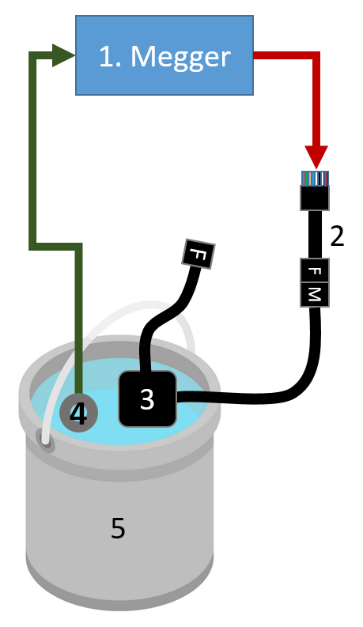 | 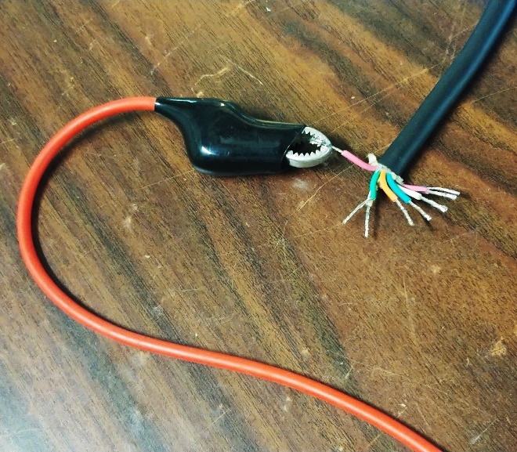
Figure 15: | Figure 16: Connection between Megger and Open Wire

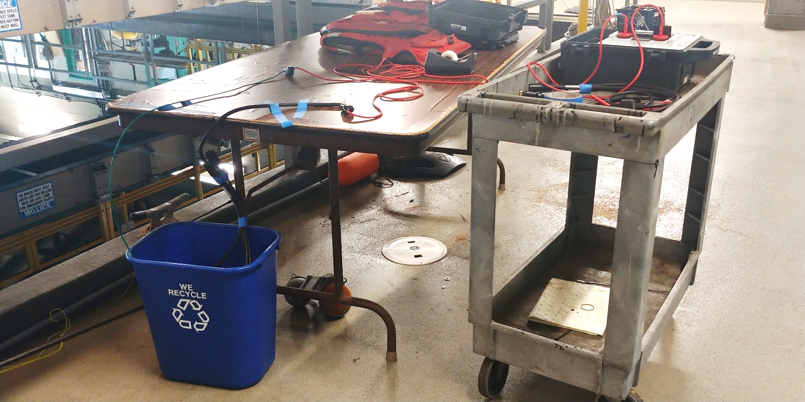
Figure 17:

- Set up a table with equipment. Ensure that both leads of the Potted Cable Assembly (3) are secure from falling into the water bucket. Select 2500 V as the test voltage on your Megger(1).
- Place the positive and negative probes of the Megger on the two terminals between which you are testing the insulation resistance. The two Terminals are the Adapter(2)(Figure 16) and Ground (4).
- Have all personnel stand away and start the test (Figure 18, 19)

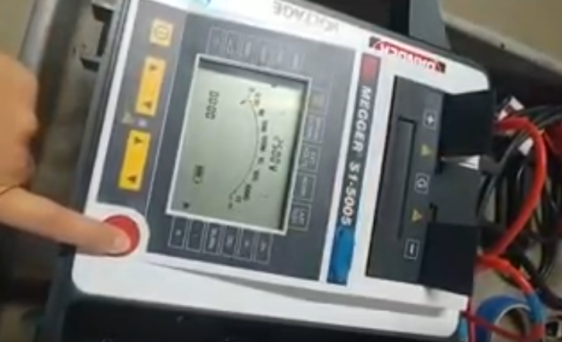 | 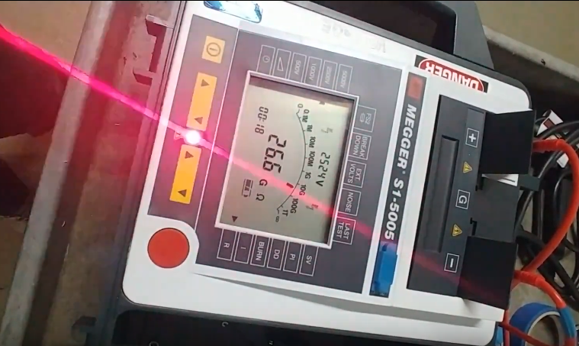
Figure 18: | Figure 19:

- Examine the resistance values you have entered in your table. According to the National Electrical Code, all values should be over 1 G Ω. If one of the values is <1G Ω or >30G Ω, check your connections and repeat the tests. If the connections are correct and the resistance is still <1G Ω or then that indicates that the potting job has an electrical leak and needs to be redone.
- Record Values and repeat steps 3-5 for all wires.

