Date: | Oct 27-28, 2020
Vehicle: | CTD
Location: | Monterey Bay
Major Objective: | MBTS Diamond
Dive Plan: | MBTS Diamond Pattern, gulp location provided by M.Blum

Accomplishments:
- Nominal Launch and Recovery
- Mission completed (Mission Filename: Diamond_07042020.cfg)

Vehicle Issues:

Note(s):
- Mission failed to start because HydroScat commented out because the instrument wasn’t installed. This caused “AdaptiveSampling” to abort the mission because the program was expecting the HydroScat to be running.
- There is suspicion that during the 4th leg from SC back to ML there were a couple of kelp hang ups since there was a large grouping of GPS hits. Further investigation is needed.
- The HydroScat was not part of this mission and a 3lb weight was put in the vehicle to make up for the absence and a trim check was done.
- Batteries: Pack 30 in the AFT Battery Ball was turned off (or never was turned on). Laughlin looked into it further and it seems that it’s a random single pack shut-off/fail-to-start and no correlation to pack number,
- The #2-5 Gulper Triggers were replaced on the motors, #1 still needs to be replaced.
- It looks like the tubes to the sensors were plugged at depth and eventually cleared up (See IMAGES 01-03 below)
IMAGES 01-03: Orange rectangles indicate section of the mission that the tubes were plugged up.
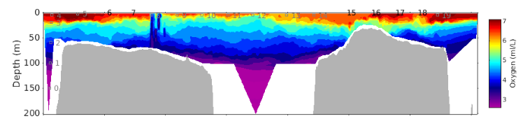
IMAGE 01: Oxygen
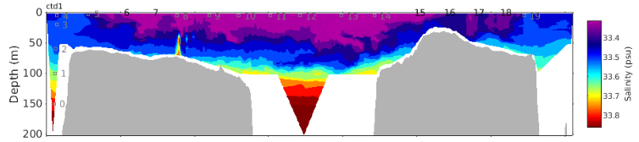
IMAGE 02: Salinity
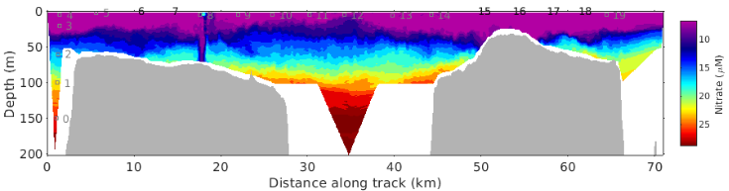
IMAGE 03: Nitrate

