Date: | Tuesday November 3-5, 2020
Vehicle: | CTD
Location: | Monterey Bay
Major Objective:
Dive Plan: | Diamond_11032020_48hours.cfg.pp

Accomplishments:
- Successful launch and recovery of a ~43 Hour Dive!

Vehicle Issues:

Note(s):
- The #1 Gulper Trigger was replaced on the motor
- The Hydroscat is still not installed in the vehicle
- The time out was not adjusted for a morning (~9AM) Recovery so there was a bit of a chase to intersect.
- BATT… 147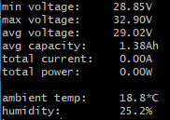
- BATT…128