Brief notes and figures from VN100 Octagon test on 6 July 2020.

Notes:
- Prior to octagon test, extended calibration mission was conducted.
- Incorrect lat/long were used during the calibration of the VN100, which resulted in a magnetic declination of approximately 4.59 degrees being used, rather than -13.19 degrees. Cause of this but was because VN100 driver expected lat/long units of degrees, while the workSite server returns them in radians. The graphs below have been corrected in post processing for this.
- The seas were relatively rough (5-10 ft peak to trough, with whitecaps), so the vehicle had lots of movement while on the surface.
- Abnormally long transit north caused by repeated mission launch failure. Diagnosed cause: non-integer durations in waypoint behaviors were generated by the wp2mc utility, and the mission parser script does not accept non-integer durations.

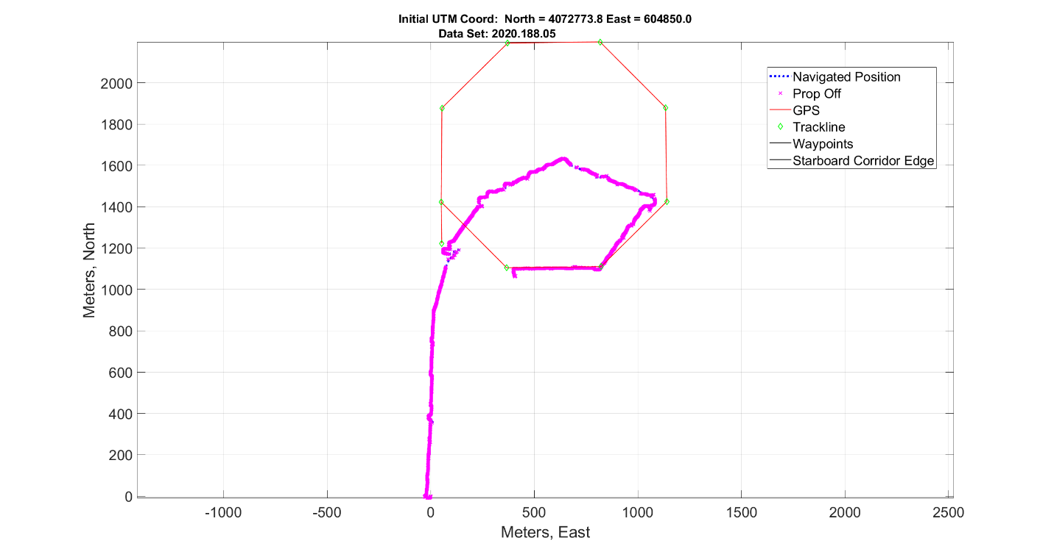
Figure 1: Navigated surface position of vehicle. Surface currents and excessive distance from intended start location resulted in waypoint durations timing out. Note that by the last waypoints the vehicle was in the vicinity and able to hit the last two points.

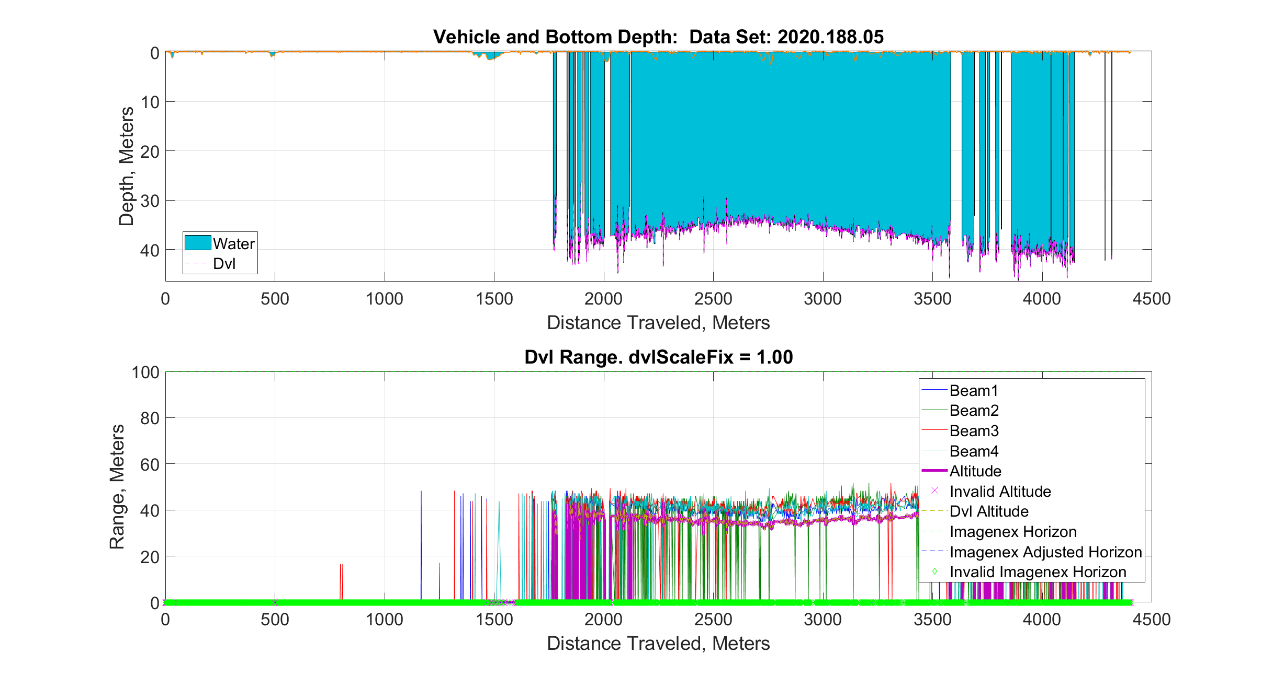
Figure 2: DVL Data. With the 1,200 kHz DVL installed, we were able to get bottom lock reliably at about 35m. The mission was designed assuming the 300 kHz DVL would be used, so the waypoints were placed in an area with an average water depth of 40-50 m.

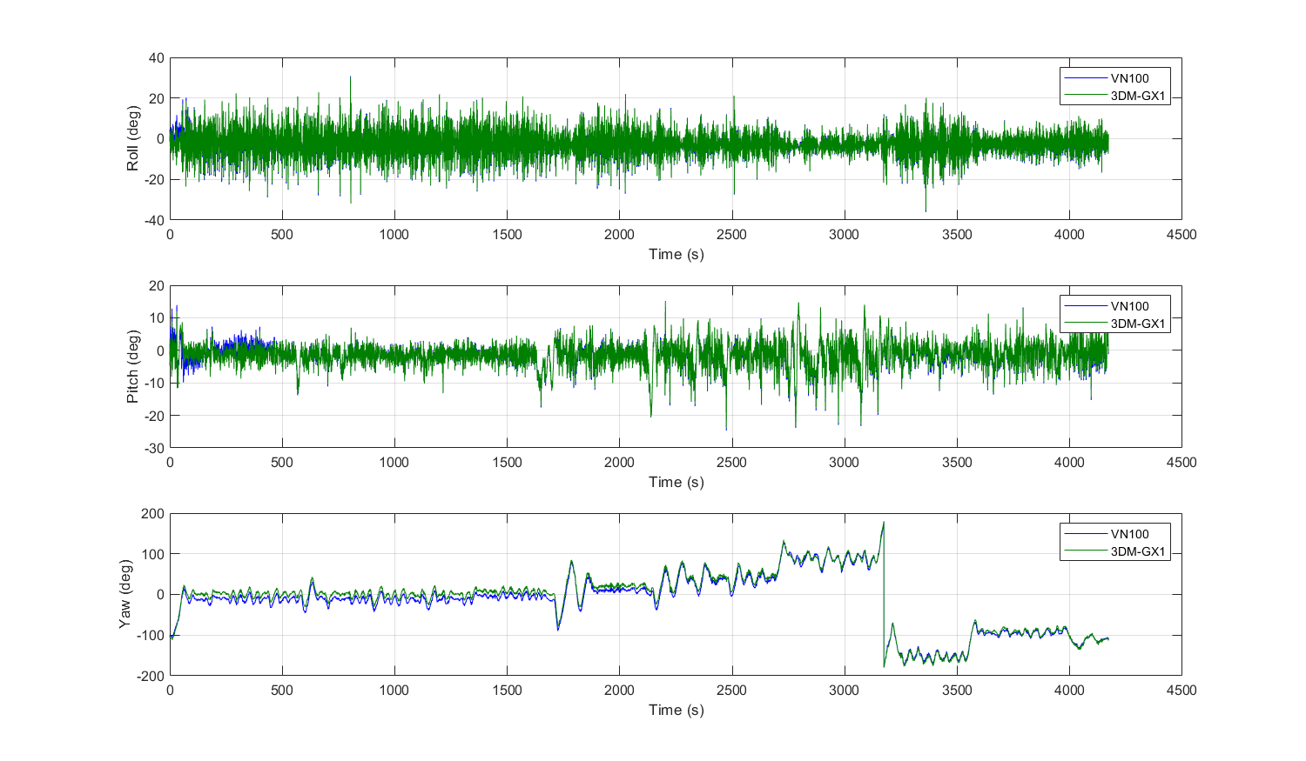
Figure 3: Vectornav (blue) and Microstrain (green) attitudes plotted over the course of the mission. Note that the VN100 yaw was corrected in this figure for the incorrect magnetic declination, as described above.

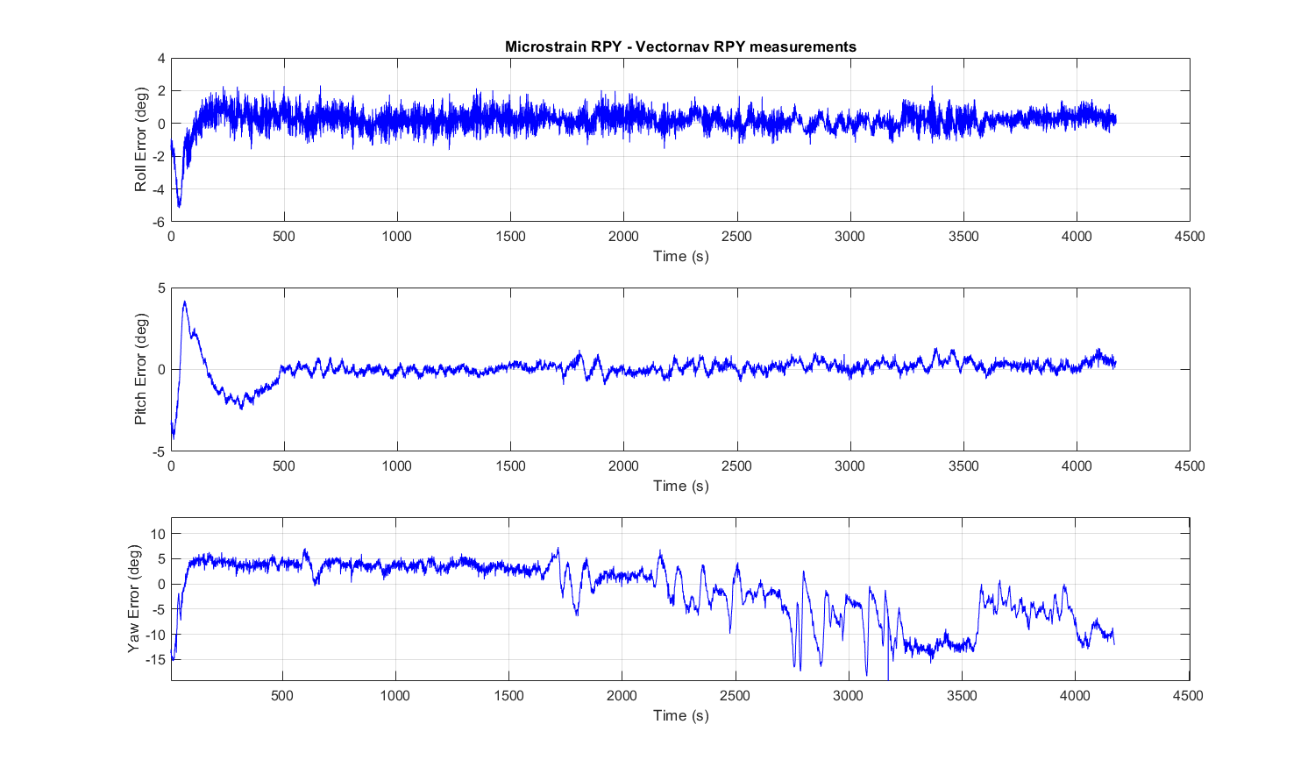
Figure 4: The difference between Microstrain and VectorNav reported attitude values (Microstrain RPY – VectorNav RPY). Overall the two devices seem to agree quite well in Roll and Pitch, but more disagreement is seen in Yaw. The magnetic calibration that was conducted on the VN100 was not ideal (wrong lat/long), and results from the calibration indicated poor ellipsoidal fit. Of note is that the error does not appear constant, but changes over time (or heading, for example).

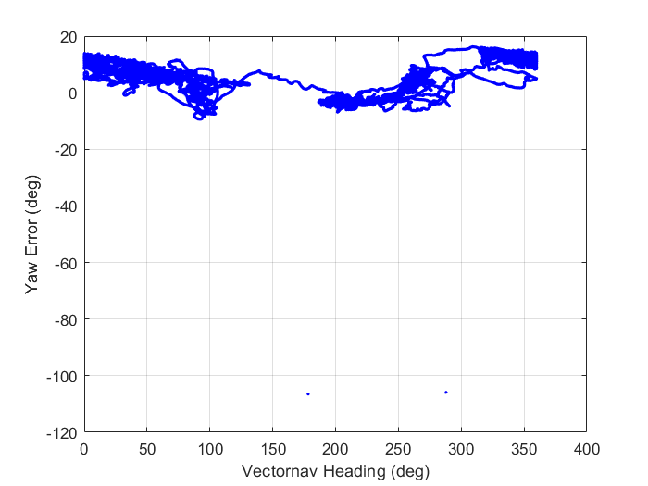
Figure 5: Difference in yaw, plotted as a function of VectorNav heading. No clear correlation is observed. One thing to note is that the Microstrain does not contain, nor compute a soft iron calibration, and that soft iron calibration which was used for the VN100 was less than ideal.

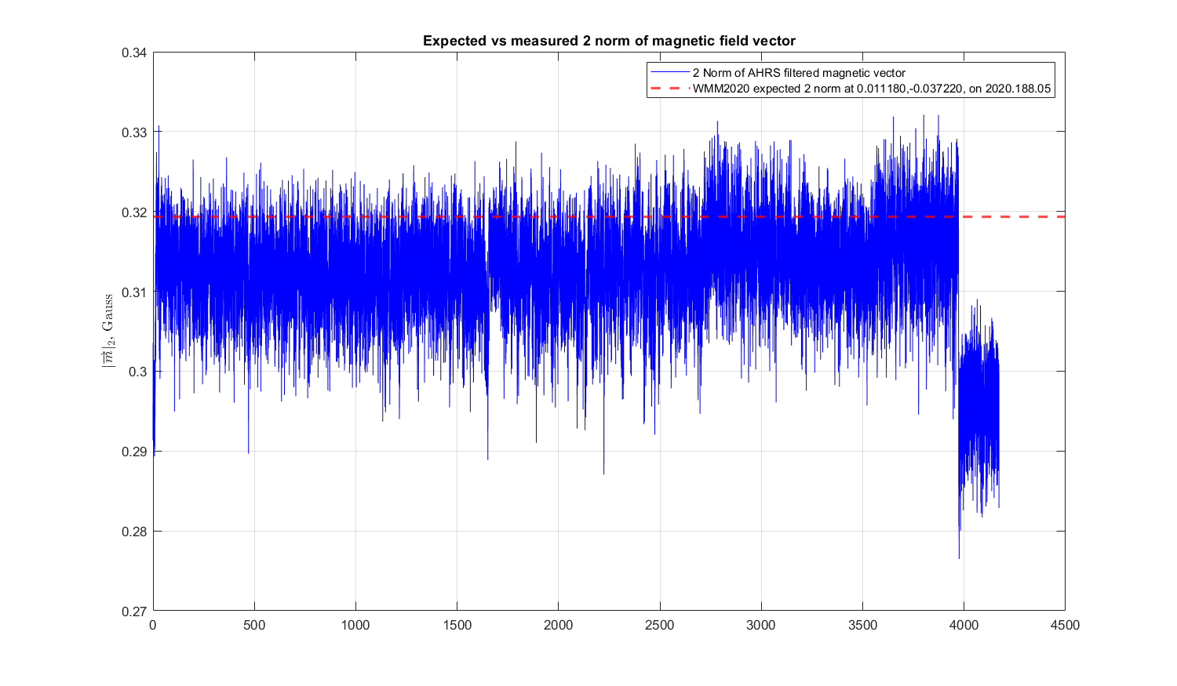
Figure 6: The norm of the magnetic vector should be near-constant, and is seen here near 0.31 Gauss, which corresponds nicely to the magnitude of the vector at the assumed (incorrect) lat/long. One thing to notice here is the drop in observed field strength at approximately 3900s. This corresponds with the mission clock expiring at 3972s, and the rudder stopping. This artifact can also be see at the start of the mission, prior to starting the prop while the vehicle is in getGPS behavior.

Overall, I would say this is a good first trail of the VN100. A fixed magnetic calibration is clearly required, and I hypothesize this will greatly improve the performance of the VN100 (in addition the magnetic declination, the compass also uses magnetic inclination, which was also clearly wrong for this survey location, and thus likely had an adverse effect on attitude tracking performance).
This would explain why the 3,3 component of the soft iron calibration matrix and z component of the hard iron calibration are so large compared to the X and Y components.

Result of calibration routine:
% Mon Jul 6 19:09:05 2020
%
% This file contains Hard and Soft Iron Calibration parameters, as computed by% the VN HSI Calibartion library.
% ========================

Number of measurements used in calibration: 1075

--Soft Iron Matrix--
0.637017 0.001996 -0.004743
0.018055 0.695703 0.015465
-0.015700 0.030208 0.861686

--Hard Iron Vector--
0.017121
0.013317
0.179362

FORMATTED FOR .cfg FILE:
Mag_C00 = 0.637017;
Mag_C01 = 0.001996;
Mag_C02 = -0.004743;
Mag_C10 = 0.018055;
Mag_C11 = 0.695703;
Mag_C12 = 0.015465;
Mag_C20 = -0.015700;
Mag_C21 = 0.030208;
Mag_C22 = 0.861686;
Mag_B0 = 0.017121;
Mag_B1 = 0.013317;
Mag_B2 = 0.179362;

Ellipsoid Fit Residuals (Percentage, lower is better)
Mean: -0.01 % Good
Maximum: 9.27 % Poor
Standard Deviation: 1.57 % Fair

Alignment Fit Residuals (Percentage, lower is better)
Mean: 0.00 % Great
Maximum: 12.62 % Poor
Standard Deviation: 4.06 % Poor

Ellipsoid fit coverage multiplier: 1.84 Poor
Alignment fit coverage multiplier: 0.13 Good

