Engineering Department
  - Interface Control Document
ICD #: | 001 | Published Date: | July 15, 2017
Title: | MSS ROV Basic Integration
Author: | aeg
Approval: | aeg

Revision | Initials | Date | Comments:
A | aeg | 7/5/2017 | Initial draft
B | Aeg | 5/9/2018 | Update mech drawing to defender  Update typical module configuration  Add comms hub picture  Add AHRS UDP and data sentence information

Table of Contents
1.0 Summary 4
2.0 System Overview 5
3.0 Mechanical Interfaces 8
3.1 Modules 8
3.2 Frame 8
3.3 Skid 8
3.4 Float 8
3.5 Topside 8
4.0 ROV Electrical Interfaces 9
4.1 8 pin tether connector 10
4.2 5 pin high power connector 11
4.3 9 pin accessory connector 12
5.0 ICB Electrical Interfaces 13
6.0 Software Interfaces 14
6.1 ICB compute platform environment 14
6.2 MSS Module Interfaces: 15
6.2.1 Thrusters (propulsion) 16
6.2.1.1 PROPULSION_COMMAND: 0xaa 17
6.2.1.2 RESPONSE_THRUSTER_STANDARD: 0x02 18
6.2.2 LEDs 20
6.2.1.1 RESPONSE_LED_STANDARD: 0x02 20
6.2.3 HD Camera 23
6.2.3.1 Standard video stream settings: 23
6.2.3.2 Standard Camera Control: 23
6.2.3.2 Camera Tilt Servo: 24
6.2.4 AHRS / Depth Sensor 25
6.2.1.1 AHRS 25
6.2.1.1 Depth 25
6.2.5 Power module 26
6.2.6 Comms Hub 27
7.0 3rd Party Interfaces 28
7.1 Rotating Manipulator 28
7.2 Sonars 28
7.2.1 Blueview (M900, M2250) 28
7.2.3 Tritech Gemini (720is, 720ik) 28
7.2.4 Blueprint Oculus (750d) 28
7.3 DVL 29
7.3.1 Nortek (DVL1000) 29
7.3..1.1 PD6 Data stream 29
7.3..1.2 DVL control interfce 29
8.0 Typical Module configuration: 30

1.0 Summary

Mission Specialist System (MSS) Remotely Operated Vehicles (ROV) are built around a core set of modular functional units, a frame, a buoyancy / ballast system, and optionally payload components.
This document defines the primary physical, electrical, and software interfaces required for basic integration of most MSS ROV.
This document should provide the basing information required for integrations of sensors and tooling onto the ROV.
This document should also provide enough information to perform a basic integration of MSS vehicles into a software control package or a system of systems. It explains the basic interfaces for controlling the ROV modules primary functions directly.
Additional module specific documents provide greater detail on the complete interfaces
More complex software integration with flight software installed on the ICB is not covered by this document.

2.0 System Overview

They typical MSS ROV system consists of an Integrated control box at the surface connected via a tether to a set of functional modules.
The primary communication interfaces are Ethernet (TCP/IP) and RS485.
The primary power buses are 400V at the surface and 48V, 12V, and 24V subsea.
Figure 1. shows a typical example of an MSS ROV.
The primary functional modules are:
- Thrusters
- LEDs
- AHRS/Depth sensor
- Power converter
- Communications Hub
- HD Camera
- Payload modules (manip, dvl, sonar, etc.)

Figure 2. shows a typical connectivity diagram of for an MSS System

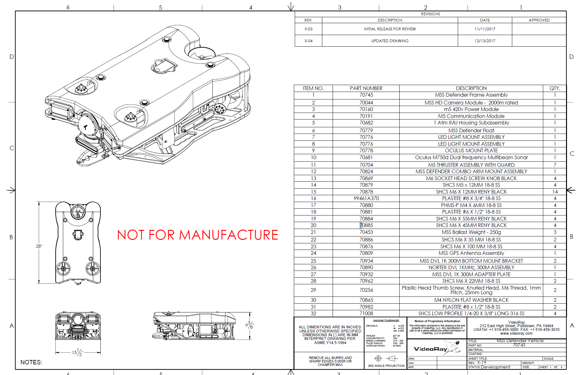
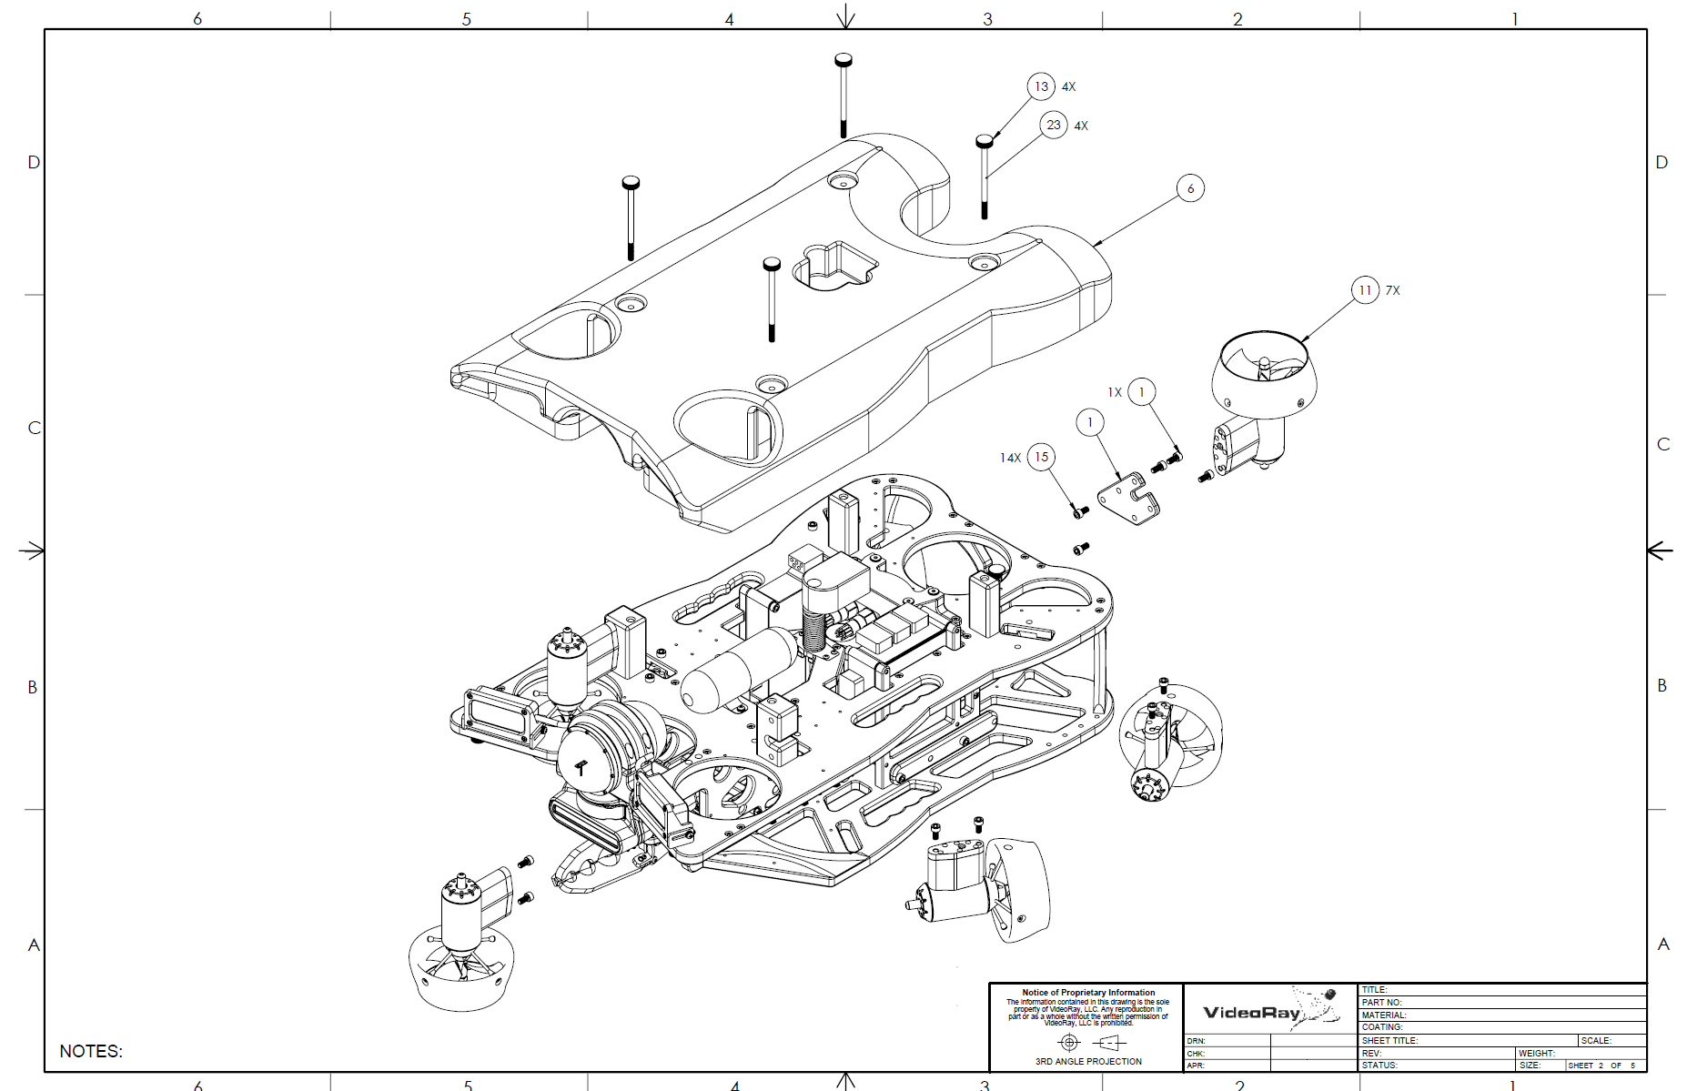
Figure 1. Typical MSS Defender ROV System

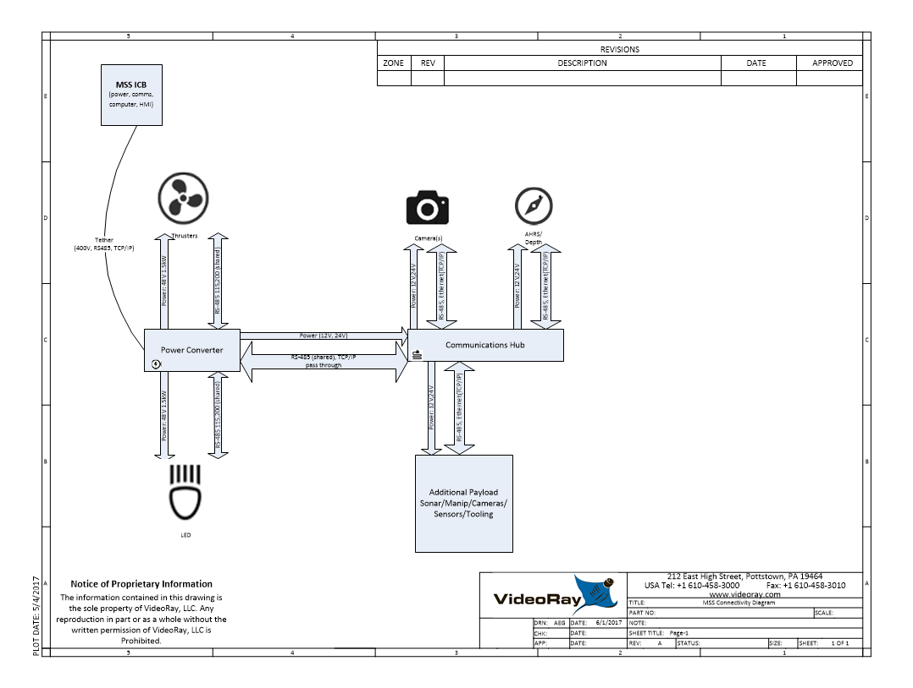
Figure 2. Typical MSS Base ROV Connectivity

3.0 Mechanical Interfaces

3.1 Modules
Please see the external drawings for the individual modules for mechanical interfaces.

3.2 Frame
The ROV frames typically have specific mount points for additional accessory integration. Please see the external drawing for the specific ROV model.

3.3 Skid
Some ROV support the use of integration skids for additional payload capacity. Please see the external drawing for the specific ROV model and the specific skid model.

3.4 Float
Some ROV support the integration of payload devices on the top of vehicle, integrated with the floatation. This includes devices such as scanning sonars, GPS masts, USBL transponders, etc. Please see the external drawing for the specific ROV model and specific float model.

3.5 Topside
There are no physical interfaces on the topside integrated control box (ICB).

4.0 ROV Electrical Interfaces

The MSS system makes use of 3 primary electrical interfaces; the 8 pin tether connector, the 5 pin high power connector, and the 9 pin accessory connector. These are complemented by various different connectors on 3-rd party devices.

Figure 3. MSS Connector Definition Table

4.1 8 pin tether connector
The MSS system is typically connected to the topside interface control box through a tether which uses an 8 pin connector.
Connector type: MCIL-8
Pin | Function
1 | Interlock
2 | Interlock
3 | Main Power + (400V typical)
4 | Long haul TCP/IP +
5 | Main Power Return
6 | Long haul TCP/IP -
7 | RS485 A
8 | RS485 B

Pins 1&2 form a safety interlock that must be connected in order for the topside to energize the supply voltage
Pins 3&5 are the main ROV power bus. Typically with a launch voltage of 400V on MSS systems
Pins 4&6 are the primary communication bus. They are used as a 2 wire long haul high bandwidth communication channel. The primary usage is as a TCP/IP bridge to the Ethernet switch in comms hub.
Pins 7&8 are a separate RS-485 channel. The primary usage is a second diagnostic channel to the power module and devices directly attached to the power module (typically thrusters and LED lights). The RS485 channel is typically configured as 115200,8n1.

4.2 5 pin high power connector
High power devices such as thrusters, LED lights, and some tooling are typically connected by way of a 5 pin connector to the MSS power module.
Connector type: LPBH-5
Pin | Function
1 | 48V +
2 | Signal GND (ROV local)
3 | 48V Return
4 | RS485 A
5 | RS485 B

Pins 1&3 carry 48V power.
Pins 2,4,5 are the communications bus. This RS485 channel is typically configured as 115200,8n1. It is a multiparty ½ duplex channel.

4.3 9 pin accessory connector
Most sensors and payloads connect to the communications hub through the 9 pin accessory connector. This interface is compatible with PRO4 serial interface devices (It is NOT compatible with PRO4 devices which require an analog video channel or a unique spare conductor pair)
Connector type: BHLP-9
Pin | Function
1 | Ethernet RX+
2 | Ethernet RX-
3 | 24V+
4 | Ethernet TX+
5 | Ground (ROV local (12V, 24V, and signal))
6 | Ethernet TX-
7 | RS485 A
8 | RS485 B
9 | 12V+

Pins 1&2&4&6 are a 100Mbit Ethernet interface.
Pin 3 is 24V power conductor
Pin 9 is 12V power
Pins 7&8 are designated as an RS-485 bus. However, the configuration and protocols used may depend on the attached accessory device.

5.0 ICB Electrical Interfaces

The MSS ICB contains an integral power supply, computer, and monitor.
In addition ot he AC power adapter the ICB provides some standard computer electrical interfaces.
These include:
3 Standard USB Type A sockets
1 RJ45 Ethernet connection
1 Display port video output
The MSS ICB is also equipped with the standard 8-pin tether connector (See above)
There is an internal Ethernet switch that connects the tether long haul Ethernet modem, the integral computer, and the RJ45 connector.

6.0 Software Interfaces

This document describes the minimal software interfaces required to perform the primary functions of each module.
Flight software primarily runs on the ICB integral computer.
Each of the subsea MSS module contains an embedded controller. All support the standard VideoRay CSR serial communications protocol. Some modules, the camera and AHRS also use a primary tcp/ip interface that is described in each module subsection.

6.1 ICB compute platform environment

The MSS ICB contains an Intel I7 computer platform with 16 GB of RAM and a 512GB SATA drive. The computer runs Ubuntu Linux LTS 14.04 64-bit. Several additional packages are loaded onto the computer (vlc, boost, pygame, gstreamer, videoray tools) as part of the standard provisioning.
There may also be third party flight control software installed. This document does not cover the interfacing with installed topside software.
Typical environment:
User:
videoray (autologin)

Ethernet connection:
Name: MSS-Vehicle
IP address: 192.168.1.215
Netmask: 255.255.255.0
Gateway: 192.168.1.1

Serial port (RS-485, connected to 8 pin):
/dev/ttyUSB0

6.2 MSS Module Interfaces:

All MSS modules support the VideoRay VR_CSR serial communications protocol. This is documented here:
https://github.com/videoray/VRCommsProtocol_doc
The basic packet structure is shown here:
Each field is a single 8-bit byte.
Start of Packet (Byte 1) | Start of Packet (Byte 2) | Network ID | Flags  * | CSR Address | Length |  |  |  |  | Payload Data**
Blue fields are 32 bit CRC header and payload checksums.
All multibyte data are sent LSB first.
The sync bytes are 0xf5, 0x5f.
The check sum is a 32-bit CRC with standard polynomial and 0xffffffff for both the seed and final xor.
Some modules, while supporting the VR_CSR protocol, use a secondary protocol to perform their primary function. The camera and AHRS are prime examples, they use a TCP/IP socket to stream data.
The following subsections detail the minimal interfaces required to perform the modules primary function.

Thrusters (propulsion)
MSS ROV primary propulsion is performed by the MSS Thruster Module.
Multiple thrusters are typically connected to the MSS Power module.
The thrusters are typically on a shared (possibly relayed) multiparty half duplex RS-485 bus.
The thrusters are typically actuated via a single an application specific multiparty broadcast command, rather than writes to each thruster. Data returns from each thruster are requested in a round robin format.
Thrusters are defined by their Node_ID, which is a communication address and their Motor_ID which is similar to a function or location designator. Each thruster in the system must have a unique Node_ID, thrusters performing the exact same function can have the same Motor_ID
In most configurations, all thrusters are connected to single power module. The standard protocol is to send the thruster command packet over a TCP/IP network to the comms hub where it gets relayed to a power module as a packet over an RS485 bus.
The power module relays the packet to all connected devices. This allows thrusters to be connected to any port on the power module. Power modules can also be used in parallel and the broadcast relay mechanism will work.
The power module is also typically connected to topside RS485 channel, however typically this is not used in order to consolidate comms over the tcp/ip channel.
The power module is connected to PORT 1 of the comms hub. So when using the default network interface packets should be sent to:
Comms hub to power module relay socket: TCP:192.168.1.64:7444
For example a socat virtual bridge could be made using:
socat -T0.5 PTY,link=vr_engage_port,raw,echo=0 TCP:192.168.1.64:7444

VR_CSR packets sent to that socket will be relayed to the all modules connected to the power module

The topside RS485 bus is also connected to the power module and can be used as a secondary comms channel or fallback.

Typically, only the multicast application specific Propulsion command (0xaa) is sent.

The thrusters are all usually on a single multiparty ½ duplex bus. So telemetry responses from the thrusters are requested in a round robin fashion

This is a single command packet where they payload specifies the node id of the motor that should respond with telemetry and an array of thruster power settings. The thruster application specific Motor_ID acts as an index into the array of thruster power settings. A specific motor NODE_ID is included in the payload for the command to request the standard thruster response from the thruster with that NODE_ID

6.2.1.1 PROPULSION_COMMAND: 0xaa
The propulsion command is an application custom command which is sent as a write request to CSR address 0xF0 (the custom command register. It has the following data payload format:
- 0xAA R_ID THRUST_0 THRUST_1 THRUST_2 ... THRUST_N
Where:
- 0xAA is the command byte
- R_ID is the NODE ID of the thruster to respond with data
- THRUST_X is the thruster power value (-1 to 1) for the thruster with motor id X
Typically this is sent as a group multicast to address 0x81 which is reserved for thrusters.
The format for this command payload is defined by the following structure:
Propulsion_power_setpoint_command {
/** Measured shaft rotational velocity */
const uint8_t command; // must be set to PROPULSION_COMMAND;
uint8_t node_id_to_reply; // protocol node address for the device which should send a response
float *power_target; // Variable length array of normalized power set point -1 to 1 (negative number are reverse)
}

6.2.1.2 RESPONSE_THRUSTER_STANDARD: 0x02
The standard thruster response is typically used in conjunction with the multicast PROPULSION COMMAND to retrieve data from each thruster in the system in a round robin fashion.
When the FLAG byte is set to 0x02 the RESPONSE_THRUSTER_STANDARD data payload is sent.
The format of this payload is defined by the following structure:
Response_Thruster_Standard {
/** Measured shaft rotational velocity */
float rpm;
/** Bus voltage (Volts) */
float bus_v;
/** Bus current (Amps) */
float bus_i;
/** Temperature (Degree C) */
float temp;
/** fault flags */
uint8_t fault;
}
Here are some example packet transactions:

Request thrusters 0,1 to thrust forward at 10% power, the thruster with node ID 0x1 shoudl respond
f5:5f:81:02:f0:0a:80:7c:d6:ec:aa:01:cd:cc:cc:3d:cd:cc:cc:3d:60:6e:bb:bc
The response:
f0:0f:01:02:f0:12:95:0c:3d:7a:81:00:00:19:44:e9:71:2b:42:01:00:d2:3d:00:00:24:42:00:34:59:fe:8b
Parsed:
Sync: 0x0ff0
Id: 1
Flag: 0x2
Address: 0xf0
Length: 0x12
Checksum: 0x7a3d0c95

Device Type: 0x81
RPM: 612.000000
Bus Voltage (V): 42.861240
Bus Current (A): 0.102539
Temp (C): 41.000000
Fault: 0x0
Checksum: 0x8bfe5934

Request thrusters 0,1,2,3,4,5,6 to stop (0% power) the thruster with node ID 0x1 should respond
f5:5f:81:02:f0:1e:fd:a8:0c:f6:aa:01:00:00:00:00:00:00:00:00:00:00:00:00:00:00:00:00:00:00:00:00:00:00:00:00:00:00:00:00:16:ab:ef:f3
The response:
f0:0f:01:02:f0:12:95:0c:3d:7a:81:00:00:00:00:e9:71:2b:42:01:00:70:3d:00:00:24:42:00:b9:6b:cf:31
Parsed:
Sync: 0x0ff0
Id: 1
Flag: 0x2
Address: 0xf0
Length: 0x12
Checksum: 0x7a3d0c95

Device Type: 0x81
RPM: 0.000000
Bus Voltage (V): 42.861240
Bus Current (A): 0.058594
Temp (C): 41.000000
Fault: 0x0
Checksum: 0x31cf6bb9

Request thrusters 0,1,2,3,4,5,6 to full reverse (-100% power) the thruster with node ID 0x1 should respond
f5:5f:81:02:f0:1e:fd:a8:0c:f6:aa:01:00:00:80:bf:00:00:80:bf:00:00:80:bf:00:00:80:bf:00:00:80:bf:00:00:80:bf:00:00:80:bf:ab:cc:20:9e
The response:
f0:0f:01:02:f0:12:95:0c:3d:7a:81:00:00:00:00:bf:50:2b:42:01:00:34:3d:00:00:24:42:00:e8:45:70:ab
Parsed:
Sync: 0x0ff0
Id: 1
Flag: 0x2
Address: 0xf0
Length: 0x12
Checksum: 0x7a3d0c95

Device Type: 0x81
RPM: 0.000000
Bus Voltage (V): 42.828854
Bus Current (A): 0.043945
Temp (C): 41.000000
Fault: 0x0
Checksum: 0xab7045e8

LEDs

MSS ROV primary illumination is performed by the MSS LED Module.
Multiple LED modules can be connected to the MSS Power module.
The LEDS are typically on a shared (possibly relayed) multiparty half duplex RS-485 bus.
Since the control rate of the illumination is much lower than the propulsion, the LEDs are typically actuated via a single CSR write to each LED module. However, an application specific response is used for the response.
LED are defined by their Node_ID, which is a communication address and their LED_ID which is similar to a function or location designator. Each LED in the system should have a unique Node_ID. The LED_ID is currently not used.
In most configurations, all LEDs are connected to single power module. The standard protocol is to send the LED command packet over a TCP/IP network to the comms hub where it gets relayed to a power module as a packet over an RS485 bus.
The power module relays the packet to all connected devices. This allows LEDs to be connected to any port on the power module. Power modules can also be used in parallel and the broadcast relay mechanism will work.
The power module is also typically connected to topside RS485 channel, however typically this is not used in order to consolidate comms over the tcp/ip channel.
The power module is connected to PORT 1 of the comms hub. So when using the default network interface packets should be sent to:
Comms hub to power module relay socket: TCP:192.168.1.64:7444
For example a socat virtual bridge could be made using:
socat -T0.5 PTY,link=vr_engage_port,raw,echo=0 TCP:192.168.1.64:7444

VR_CSR packets sent to that socket will be relayed to the all modules connected to the power module

The topside RS485 bus is also connected to the power module and can be used as a secondary comms channel or fallback.

6.2.1.1 RESPONSE_LED_STANDARD: 0x02
The standard LED response is typically used .
When the FLAG byte is set to 0x02 the RESPONSE_LED_STANDARD data payload is sent.
The format of this payload is defined by the following structure:
Response_LED_Standard {
/** Measured shaft rotational velocity */
float rpm;
/** Bus voltage (Volts) */
float bus_v;
/** Bus current (Amps) */
float bus_i;
/** Temperature (Degree C) */
float temp;
/** fault flags */
uint8_t fault;
}
Here are some example packet transactions:
Request 3 banks of LED (Node_ID 11) to illuminate at 20% power
f5:5f:0b:02:00:0c:57:6e:ed:93:cd:cc:4c:3e:cd:cc:4c:3e:00:00:00:00:a1:36:8d:f0

The response:
f0:0f:0b:02:f0:0e:be:b0:81:01:83:00:c6:25:42:cd:cc:00:be:00:00:14:42:00:4f:d8:95:61
Parsed:
Sync: 0x0ff0
Id: 11
Flag: 0x2
Address: 0xf0
Length: 0xe
Checksum: 0x181b0be

Device Type: 0x83
Bus Voltage (V): 41.443359
Bus Current (A): -0.125781
Temp (C): 37.000000
Fault: 0x0
Checksum: 0x6195d84f

Request 3 banks of LED (Node_ID 11) to illuminate at 100% power
f5:5f:0b:02:00:0c:57:6e:ed:93:00:00:80:3f:00:00:80:3f:00:00:00:00:e2:fb:99:51

The response:
f0:0f:0b:02:f0:0e:be:b0:81:01:83:00:e7:25:42:cd:cc:0f:be:00:00:24:42:00:a1:da:22:30
Parsed:
Sync: 0x0ff0
Id: 11
Flag: 0x2
Address: 0xf0
Length: 0xe
Checksum: 0x181b0be

Device Type: 0x83
Bus Voltage (V): 41.475586
Bus Current (A): -0.140430
Temp (C): 41.000000
Fault: 0x0
Checksum: 0x3022daa1

HD Camera

The MSS HD camera provides an h.264 compressed HD video stream over a unicast UDP transport directly to the host computer in the topside ICB. Camera control is performed via HTML POST operations to the camera. The internal tilt servo is controlled via VR_CSR commands on the camera’s RS485 interface.

6.2.3.1 Standard video stream settings:
The primary video stream is a unicast UDP h.264 stream
Protocol: UDP
Destination: 192.168.1.215:1802
Format: H.264 VES

Example reception:
gst-launch-1.0 -e udpsrc port=1802 ! tee name=data ! queue ! h264parse ! avdec_h264 ! avdeinterlace ! videoconvert ! autovideosink sync=false data. ! queue ! h264parse ! matroskamux ! filesink location=~/Videos/rovvideo.mkv sync=false

6.2.3.2 Standard Camera Control:
Several features (zoom/focus/etc.) are controllable by an HTML post interface.
Protocol: HTML POST
Destination: 192.168.1.11
Zoom out:
wget -q -O- --post-data="Capture.Zoom=4" http://192.168.1.12/controls

Zoom in:
wget -q -O- --post-data="Capture.Zoom=64" http://192.168.1.12/controls

Focus infinite:
wget -q -O- --post-data="Capture.Focus=inf" http://192.168.1.12/controls

Focus automatic:
wget -q -O- --post-data="Capture.Focus=auto" http://192.168.1.12/controls

Focus steps:
wget -q -O- --post-data="Capture.Zoom=3" http://192.168.1.12/controls
wget -q -O- --post-data="Capture.Zoom=-1" http://192.168.1.12/controls

Read all settings: This will also give an idea of all settable parameters
wget -O- http://192.168.1.12/config.txt

6.2.3.2 Camera Tilt Servo:
Camera tilt is controlled via the Camera’s RS485 interface.
Protocol: VR_CSR RS485
Destination: 192.168.1.64:7445

The camera tilt servo is controlled via VR_CSR write to the raw_servo_tilt register.
This is address 0x54.
The datum written is a 32 bit integer, representing the PWM servo signal in mS.

This is typically followed by a periodic read of the internal temp and pressure registers, at address 0x44.

Refer to the camera adapter CSR map for more information.

AHRS / Depth Sensor
The AHRS/Depth Sensor module implements the standard VR_CSR communication protocol.
However, in basic operation no commands are sent to the module. Instead two sockets are opened, one for the AHRS data stream and one for the depth sensor data stream.
The AHRS supports both UDP and TCP connections.
The default configuration is to stream data on to 192.168.1.215 on UDP ports.
AHRS: 192.168.1.215:8444
DEPTH: 192.168.1.215:8445

AHRS/ Depth sensor standard IP Address: TCP:192.168.1.65

6.2.1.1 AHRS
TCP Port: 7444
UDP Destination: 8444

The ahrs can be set to different output formats using ./vr_ahrs_config_output.py –PSONCMS

Format:
$PSONCMS Quaternion, Acceleration, Rate of Turn, Magnetic Field, Temperature $PSONCMS,Q.QQQQ,P.PPPP,R.RRRR,S.SSSS,XX.XXXX,YY.YYYY,ZZ.ZZZZ, FF.FFFF,GG.GGGG,HH.HHHH,NN.NNNN,MM,MMMM,PP.PPPP,TT.T*hh

Q.QQQQ q0 from quaternions
P.PPPP q1 from quaternions
R.RRRR q2 from quaternions
S.SSSS q3 from quaternions
XX.XXXX acceleration X in m/s2
YY.YYYY acceleration Y in m/s2
ZZ.ZZZZ acceleration Z in m/s2
FF.FFFF rate of turn X in rad/s
GG.GGGG rate of turn Y in rad/s
HH.HHHH rate of turn Z in rad/s
NN.NNNN magnetic field X in a.u.
MM.MMMM magnetic field Y in a.u.
PP.PPPP magnetic field Z in a.u.
TT.T Sensor temp

Format:
$PRDID Pitch, Roll, Heading
$PRDID,PPP.PP,RRR.RR,hhh.hh
PPP.PP -> Pitch in degrees
RRR.RR -> Roll in degrees
hhh.hh -> True Heading in degrees

Examples:
UDP:
>socat -u UDP-RECV:8444 -
Or TCP:
>socat - TCP:192.168.1.65:7444

If AHRS is configured for $PSONCMS
$PSONCMS,0.0934,-0.0007,0.0087,-0.9956,0.0565,-0.1151,9.7902,-0.0020,-0.0033,-0.0023,-0.5046,0.1212,-1.0369,33.5*51
$PSONCMS,0.0934,-0.0007,0.0087,-0.9956,0.0515,-0.1121,9.7937,-0.0065,-0.0025,0.0061,-0.5014,0.1270,-1.0276,33.5*76
$PSONCMS,0.0935,-0.0007,0.0088,-0.9956,0.0605,-0.1174,9.7958,-0.0190,0.0026,0.0111,-0.5017,0.1241,-1.0322,33.5*51
$PSONCMS,0.0935,-0.0007,0.0088,-0.9956,0.0630,-0.1047,9.7977,-0.0094,-0.0065,0.0095,-0.5048,0.1236,-1.0419,33.5*7C
$PSONCMS,0.0935,-0.0007,0.0088,-0.9956,0.0692,-0.1234,9.8044,0.0080,-0.0078,-0.0024,-0.5043,0.1241,-1.0322,33.5*73
$PSONCMS,0.0935,-0.0007,0.0088,-0.9956,0.0701,-0.1105,9.7872,-0.0031,-0.0052,0.0060,-0.4939,0.1130,-1.0336,33.5*7C
$PSONCMS,0.0934,-0.0007,0.0088,-0.9956,0.0635,-0.1077,9.7856,0.0004,-0.0041,0.0021,-0.5019,0.1186,-1.0342,33.5*51
$PSONCMS,0.0934,-0.0006,0.0087,-0.9956,0.0587,-0.1064,9.7977,0.0191,-0.0009,0.0076,-0.4992,0.1212,-1.0344,33.5*55
$PSONCMS,0.0935,-0.0006,0.0087,-0.9956,0.0451,-0.1099,9.7915,-0.0072,-0.0063,0.0071,-0.5045,0.1160,-1.0340,33.5*72
$PSONCMS,0.0935,-0.0006,0.0087,-0.9956,0.0458,-0.1116,9.7917,0.0033,-0.0034,0.0104,-0.5045,0.1240,-1.0347,33.5*50
$PSONCMS,0.0935,-0.0007,0.0087,-0.9956,0.0676,-0.1048,9.7905,-0.0065,-0.0091,0.0020,-0.5098,0.1268,-1.0350,33.5*7C
$PSONCMS,0.0935,-0.0007,0.0086,-0.9956,0.0644,-0.1158,9.7991,0.0140,-0.0054,0.0048,-0.5045,0.1187,-1.0342,33.5*5C

If AHRS is configured for $PRDID:
$PRDID,1.17,2.89,207.79
$PRDID,1.17,2.89,207.78
$PRDID,1.16,2.90,207.80
$PRDID,1.16,2.90,207.81
$PRDID,1.16,2.91,207.80
$PRDID,1.18,2.91,207.81

6.2.1.1 Depth
Port: 7445
UDP Destination: 8444
Format: $PVRPT, Pressure, Temp, *xsum
Pressure is in mBar
Temp is in degrees Celsius,
Xsum is a standard nmea-0183 XOR
Rate: ~10Hz
Examples:
UDP:
>socat -u UDP-RECV:8445 –
Or TCP:
> socat - TCP:192.168.1.65:7445
$PVRPT,1006.104,30.35*67
$PVRPT,1006.104,30.40*65
$PVRPT,1003.052,30.35*60
$PVRPT,1006.104,30.40*65
$PVRPT,1003.052,30.40*62

Power module

The power module implements the standard VR_CSR communication protocol.
However, in basic operation no commands are sent to the module.
The power module relays packets to all ports, so it does not matter (from and electrical and communications point of view) which 5 pin port is used.
The comms hub module is typically connected to the 9 pin female connector on the power module

Comms Hub
The comms module implements the standard VR_CSR communication protocol.
In basic operation no commands are sent to the module, however dockets can be opened to the various ports on the comms hub, to act as virtual serial ports.
The ports can be configured in the module diagnostic/configuration mode.
The IP Address of the comms hub is typically 192.168.1.64 and the ports are typically 7444-7449
For example socat virtual bridges could be made to all ports using:
socat PTY,link=vrport1,raw,echo=0 TCP:192.168.1.64:7444 &
socat PTY,link=vrport2,raw,echo=0 TCP:192.168.1.64:7445 &
socat PTY,link=vrport3,raw,echo=0 TCP:192.168.1.64:7446 &
socat PTY,link=$DIR/vrport4,raw,echo=0 TCP:192.168.1.64:7447 &
socat PTY,link=$DIR/vrport5,raw,echo=0 TCP:192.168.1.64:7448 &
socat PTY,link=$DIR/vrport6,raw,echo=0 TCP:192.168.1.64:7449 &

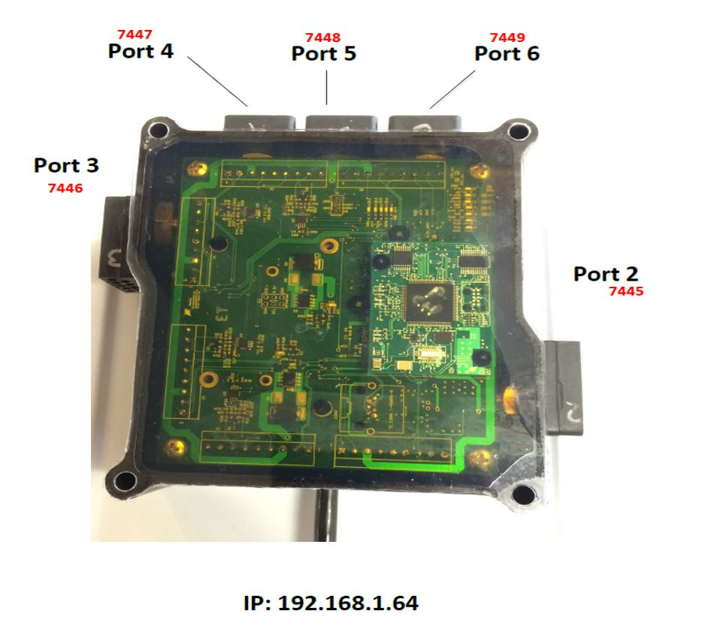
Figure 4. comms hub port assignments

7.0 3rd Party Interfaces

7.1 Rotating Manipulator
The MSS ROV uses the VideoRay rotating manipulator.
This is an RS485 device which uses the Inuktun Version 2 Serial Protocol.
The rotating manipulator is typically connected to the comms hub module at port 3
Comms hub port 3 socket: TCP:192.168.1.64:7446
The serial port on the comms hub must be set to the baud rate of the manipulator: 38400
Each of the 2 joints (wrist, end-effector) require a separate packet.
Each command packet will respond with a data packet reporting voltage and motor current.
Refer to the Inuktun Version 2 Serial Protocol document for more information.

7.2 Sonars

7.2.1 Blueview (M900, M2250)
The blueview sonar is typically set to 192.168.1.45.
Proviewer or other host software can be used to view the data and control the sonar.

7.2.3 Tritech Gemini (720is, 720ik)
The Gemini sonar is typically set to 192.168.1.45.
Seanet Pro of the Gemini software can be used to view the data and control the sonar.

7.2.4 Blueprint Oculus (750d, 1200d)
The oculus sonar is typically set to 192.168.1.45.
Oculus Imaging Software or other host software can be used to view the data and control the sonar.

7.3 DVL

7.3.1 Nortek (DVL1000)
The DVL is configured to stream PD6 data sentences to the host computer using UDP.
The DVL can also be configured using an html interface.

7.3.1.1 PD6 Data stream
Destination IP: 192.168.1.215
Port: 9000

Examples:

:TS,17071020151251,35.0,+23.3, 0.8,1530.2,000
:BI, -62, -59, -6, -3,A
:BD, +0.00, +0.00, +0.00, 1.27, 0.00
:TS,17071020151301,35.0,+23.3, 0.8,1530.2,000
:BI, -66, -25, -16, +10,A
:BD, +0.00, +0.00, +0.00, 1.27, 0.00
:TS,17071020151326,35.0,+23.3, 0.8,1530.2,000
:BI, -52, -50, +0, -6,A
:BD, +0.00, +0.00, +0.00, 1.27, 0.00

7.3.1.2 DVL control interface
An HTML web based control interface is provided.
Destination IP: 192.168.1.50
Port: 80

8.0 Typical Module configuration:

Gizmo | Part Number | Serial Number | Node ID | Group ID
Power Module | 70160 | PWRCV | 1 | 195
Comms Module | 70191 | COMHB | 2 | 193
IMU | 70273 | NAV | 3 | 194
Camera Forward | 70044 | CAMADP | 4 | 196
LED Port | 70023 | LED | 11 | 131
LED Starboard | 70023 | LED | 12 | 131

Thruster | Part Number | Serial Number | Node ID | Group ID | Motor ID | Required Prop | Reverse Rotation | Max Power
Front Port | 70503 | THR | 5 | 129 | 0 | Right | Disabled | 400
Front Starboard | 70503 | THR | 6 | 129 | 1 | Left | Enabled | 400
Rear Starboard | 70503 | THR | 7 | 129 | 2 | Right | Disabled | 400
Rear Port | 70503 | THR | 8 | 129 | 3 | Left | Enabled | 400
Front Vertical Port | 70503 | THR | 9 | 129 | 6 | Right | Enabled | 400
Front Vertical Starboard | 70503 | THR | 10 | 129 | 4 | Left | Disabled | 400
Rear Vertical | 70503 | THR | 20 | 129 | 5 | Left | Enabled | 400

Reference Document | Current Revision
VideoRay CSR Communication Protocol | 2.11
Inuktun Version 2 Serial Protocol document | May 5, 2017
Nortek DVL Integrators Guide | Aug 24, 2017

