Maritime Expeditionary Standoff Response (MESR)
System of Systems (SoS)
Increment I
VideoRay Defender Response Vehicle
Interface Control Document (ICD)

Version 1.0



Proprietary - All Rights Reserved

This document includes data that shall not be duplicated, used, or disclosed outside the Government, in whole or in part, without the permission of VideoRay LLC. This restriction does not limit the Government’s right to use information contained in this data if it is obtained from another source without restriction.

Record of Changes
Version  Number | Date | Description of Change
1.0 | 1/30/2021 | Initial Release

Table of Contents
1.0 Introduction………………
1.1 Scope……………………....
1.1.1 Summary of Changes for New Document Revision ………
1.2 System Overview…………
1.2.1 System Functional Relationships…………
1.2.2 System Configuration…………..
2.0 System Interfaces……………
2.1 Physical/Mechanical Interfaces……………
2.1.1 Assumptions………….
2.1.2 Constraints……………
2.1.3 Available Interfaces……………..
2.1.4 Risks………………
2.2 Electrical Interfaces…………….
2.2.1 Assumptions……………..
2.2.2 Constraints………………..
2.2.3 Available Interfaces………………..
2.2.4 Risks………………..
2.3 Communications/Network Interfaces……………….
2.3.1 Assumptions……………
2.3.2 Constraints……………..
2.3.3 Available Interfaces………………
2.4.4 Risks……………………..

MESR Increment I
VideoRay Defender Response Vehicle ICD

1.0 Introduction

An Interface Control Document (ICD) provides details on the internal and external interfaces (e.g., mechanical, electrical, communications, etc.) of a system. The system and subsystem interfaces documented in the ICD provide sufficient detail of the hardware and software architecture to enable organizations other than the Original Equipment Manufacturer (OEM) to design, integrate, and test new system-specific capabilities within the limits of the data rights provided to the Government.

With respect to the MESR SoS program, the Navy is interested in tools and sensors that enhance the capabilities of the Increment I Response Vehicle. Areas of potential investment for which interface information may be required include:

- Situational Awareness Tools
- Autonomous Navigation & Reacquisition Tools
- Detection & Classification Tool
- Diagnostic Sensors
- Neutralization & Render Safe Tools
- Recovery Tools
- Manipulators & End Effectors
- Alternate Mobilities & Active Buoyancy

1.1 Scope

This ICD describes the architecture of the VideoRay Defender Response Vehicle and documents the details of the physical/mechanical, electrical, and communications/network interfaces to enable the design, integration, and testing of mission-specific payloads as part of the MESR Increment I program. The content of this ICD protects the intellectual property of the OEM, and if information beyond that contained in this ICD is required for a specific development effort the necessary authority and data security will be coordinated separately.

    - Summary of Changes for New Document Revision
N/A

1.2 System Overview
The VideoRay Defender Response Vehicle system consist of three segments:

- The Surface Segment, which includes the power supply, the human machine interface (HMI) called the operator control console (OCC), and supplemental surface navigation sensors such as a global navigation satellite system (GNSS / GPS)

- The Tether Segment, which connects the Surface Segment to the remotely operated vehicle (ROV). This segment can consist of one or more tethers and zero or one reel.

- The Remotely Operated Vehicle (ROV), which consists of the base vehicle as well as subsea payloads.
Figure 1 Top level system components, showing ROV, OCC, and Tether segment (left to right)
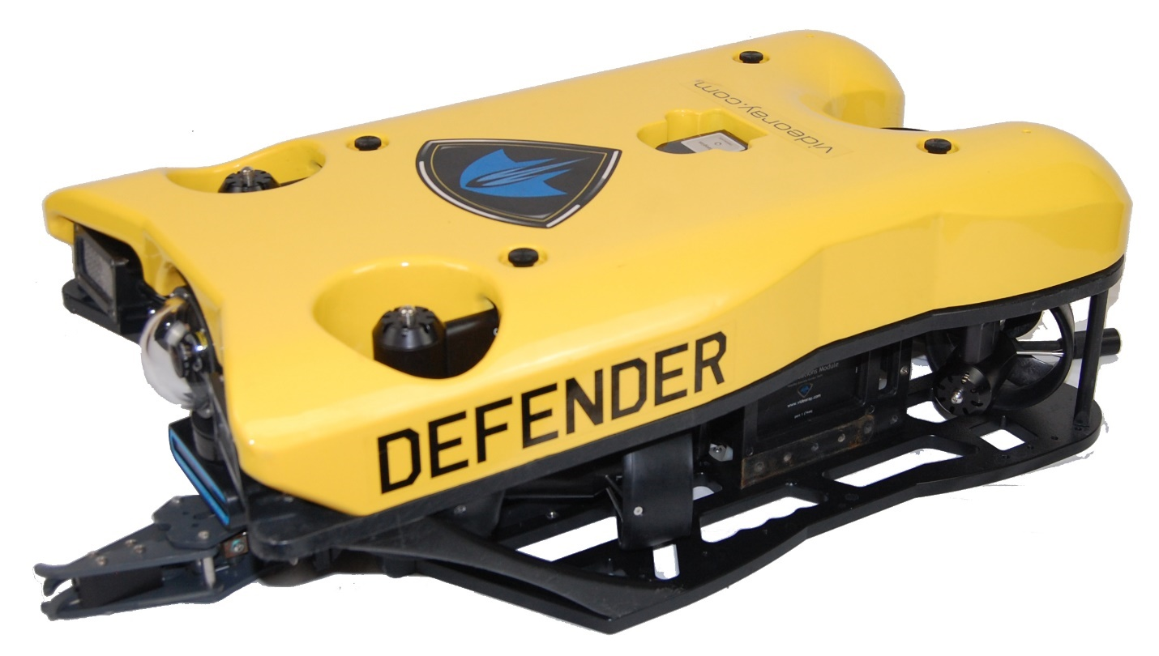
Figure 2 VideoRay Defender ROV

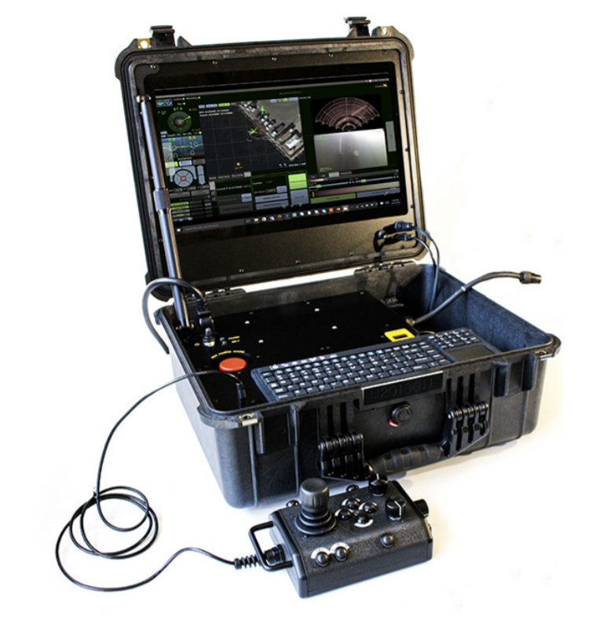
Figure 3 VideoRay OCC

1.2.1 System Functional Relationships

The VideoRay Defender Response Vehicle is a highly modular system with several subcomponents and interfaces across all functional segments.
At the topmost level an operator interacts with the interface at the surface, typically through human machine interfaces including keyboard, trackpad, and hand controllers equipped with buttons knobs and joysticks.
Data (command and control, imagery, etc.) is exchanged across a tether to the ROV.
The ROV is made up of a base vehicle consisting of modular subassemblies, connected by standard interfaces, and various optional payloads.
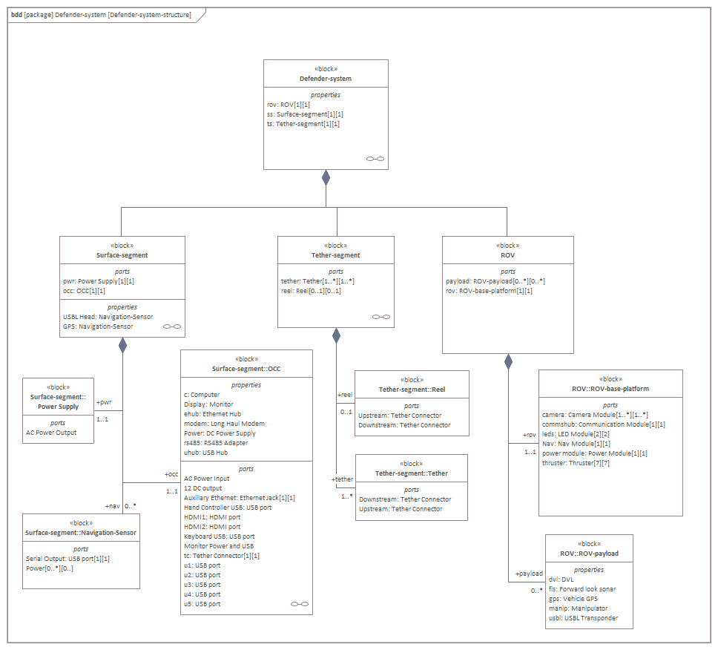
Figure 4 VideoRay Defender System functional block diagram
1.2.2.1 System Functional Relationships – Surface segment

The surface segment typically consists of a topside power supply, the OCC, and surface segment navigation devices.
The OCC supports multiple inputs and connects to the ROV through the tether. Command and control data is sent down the tether, data and telemetry is sent from the ROV system to the OCC.
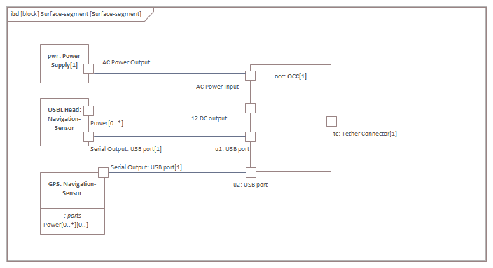
Figure 5 Functional block drawing of typical surface segment

There are standard interfaces (multiple USB, Ethernet, HDMI) on the OCC that are used for human input and can also be used for third party integration of new surface segment devices. This might include new power systems, human machine interfaces.
The compute platform inside the OCC runs a Linux based operating system and the primary flight software.

1.2.2.2 System Functional Relationships – ROV

The ROV is made up of a base vehicle with standard modules and additional payload devices.
The base vehicle is made up of the frame, buoyancy, ballast, power conversion, communications distribution, propulsion, illumination, and an attitude and depth sensor module.
Typical primary payloads include forward look sonar, doppler velocity log, vehicle carried GPS, manipulator, and USBL transponder.
Payloads are typically connected to the communications hub module or an expansion hub connected to the communications hub module.
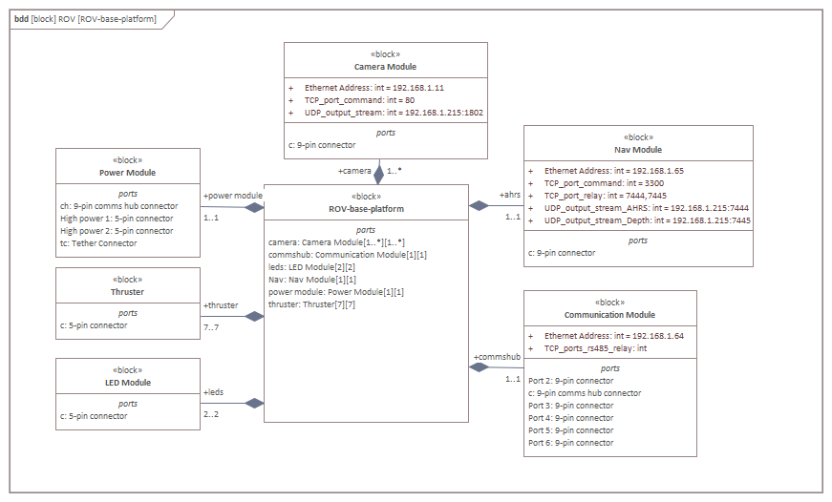
Figure 6 Functional block diagram of base ROV
The system is fully distributed with all command and control coming from the flight software running on the OCC.
1.2.2 System Configuration
Due to the modular nature of the VideoRay Defender the system configuration closely matches the system functional relationships.

1.2.2.1 System Configuration – Surface segment

The OCC, while a mostly monolithic device does, include some removable sub-assembles (keyboard, hand controller). Internally to the OCC there are power conversion, compute platform, and communication and safety modules.
There flight software running on the OCC consists of a linux (Ubuntu) operating system and EOD Workspace from Greensea systems as the primary flight software. There are additional support applications loaded on the OCC as well.
EOD workspace implements a unified user interface to the ROV system and primary payloads. Software required for new payloads is typically initially implemented as an isolated standalone application.

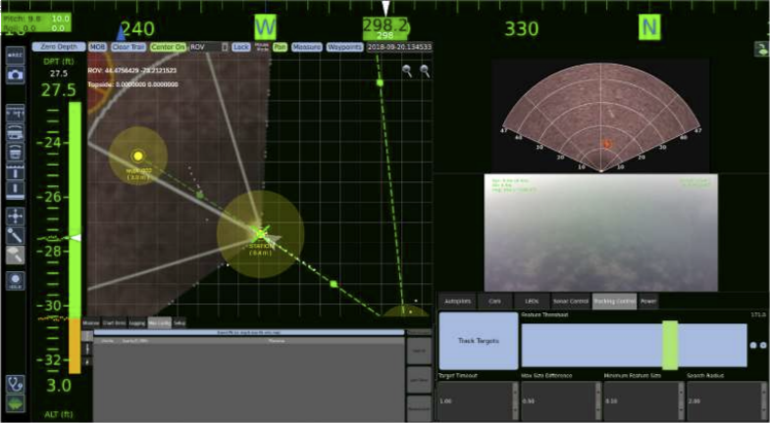
Figure 7 EOD Workspace Display
Surface segment human machine interface devices are connected to the OCC via USB connectors and present as standard Human Interface Devices (HID) to the operating system.
Surface segment navigation devices, which include GNSS and surface usbl transponder are connected to the OCC through a USB connection utilizing cabled USB to serial (RS-232 or RS-485) converters.
Figure 8 OCC Assembly, including keyboard and OCC cables.

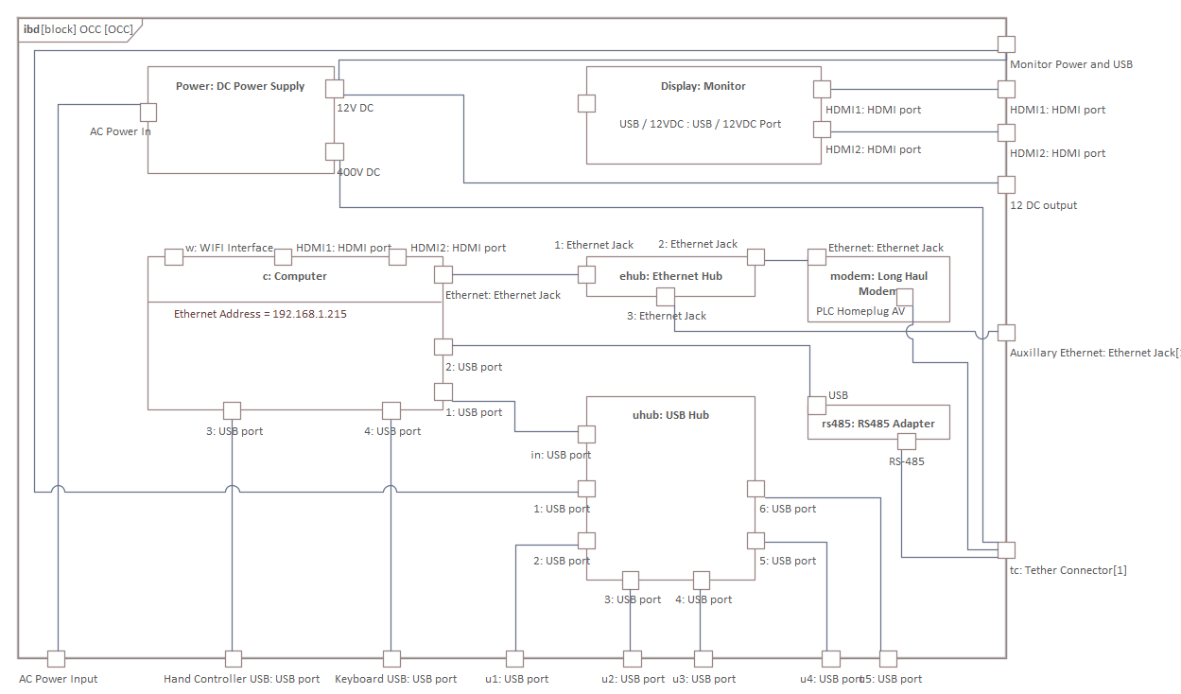
Figure 9 OCC Internal functional block diagram

1.2.2.2 System Configuration – Tether Segment
The system tether segment configuration can be changed depending upon operational requirements.
The configuration consists of 1 or more tether segments and zero or 1 deployment reels or storage apparatus.
Tethers to tether connections and tether to reel connections combine both an electrical connection as well as a physical connection for strain relief.

1.2.2.3 System Configuration – ROV

The ROV system configuration is divided into several modules that closely map to the ROV functional relationships.
The ROV is made up of a frame subassembly which carries the buoyancy and ballasts systems as well as several functional modules. The ROV system consists of a set of module which are almost always present as well as several primary payloads that are frequently present but may be removed depending upon operational needs or other new payload integrations. These non-primary payloads are highlighted in blue in the following table.

ROV
Frame
Buoyancy
Ballast
Power module
Thruster Modules
LED modules
Communication Module
Camera
AHRS / Depth Module
Forward look sonar
Submersible GPS
USBL Transponder
Manipulator
Figure 10 Simplified ROV configuration table

The tether connects to the Power Module which converts the tether voltage to ROV local power busses.

The tether communication is routed to the Communication module which distributes power, RS485, and ethernet to the rest of the ROV system.

Payload devices are typically connected to the communications module or extension hubs connected to the Communication module; however high-power devices can be connected to the power module.

Figure 11 ROV Base Configuration

2.0 System Interfaces

2.1 Physical/Mechanical Interfaces

The following paragraphs provide details regarding the physical/mechanical interfaces for the VideoRay Defender Response Vehicle.

While surface segment integrations are possible, there are no mechanical interfaces provided.

Integration with the tether segment should consider the standard locking sleeves for the tether connectors as well as mechanisms for connecting the strain relief systems.

2.1.1 Assumptions
It is assumed that any device or system to be integrated onto the ROV is suitable for subsea use at depth. ROV depth rating may be limited by payload integrations.

While physical modification of the ROV frame is possible, it is assumed that mechanical integration will be done using the designed in provisions.

2.1.2 Constraints

Any physical integration on the OCC should not block the cooling system intake or exhaust.
Physical integrations are limited by the amount of buoyancy carried and available locations for trim modifying ballast. Theoretically custom buoyancy and ballast can be designed for almost any payload, however reasonable system deployment and real-world flight characteristics will impose some upper bound.
Primary on-board sensor keep out zones should be respected. These include the camera, forward look sonar, and DVL. VideoRay can provide CAD models with more precise keep out zones.

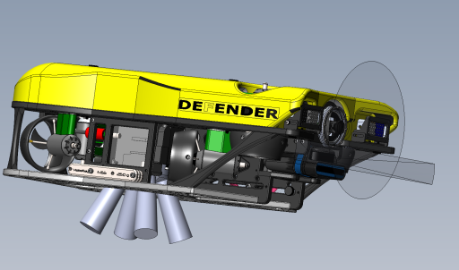
Figure 12 Primary sensor keep out zones
Water flow around the thrusters should be kept as clear as possible.

2.1.3 Available Interfaces

2.1.3.1 Surface Segment Interfaces

The surface segment physical interfaces are limited to the connectors that provide electrical signals to the OCC.

2.1.3.2 Tether Segment Interfaces

The tether segment strain relief physical interface consists of mating locking sleeves and additional equipment. Equipment integrated between tether sections can use similar strain relieving interfaces.

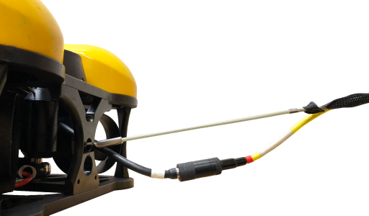
Figure 13 Tether to ROV physical connection

The standard tether connector is an 8 pin micro circular wet mateable underwater connector.

The ROV presents a MALE connector, the Surface presents a FEMALE connector. The tether segment is a straight through connection of the 8 conductors.

2.1.3.3 ROV Physical Interfaces

Payloads are physically integrated onto the ROV using three different methods.

A quick release bottom mount latch attachment provides a secure interface that allows for easy exchange of different payloads.

A payload can be integrated to the underside of the ROV using designed fastener attachment points. This may be less complex than integration of the quick latch assembly, but removal and attachment requires more effort.

Payloads can be attached to the top of the ROV by repurposing the buoyancy block attachment bolts as mount points.

2.1.3.3.1 Bottom mounted physical interfaces

The ROV bottom frame plate [p/n: 70771] provides both quick release latch and fastener-based interfaces.

Payloads can be integrated using a quick latch assembly which mates directly to the in blue cutouts in figure below. A standard quick latch mechanism supplied by VideoRay [p/n: 72950] can be used, or a custom designed compatible latch could be used.

The bottom plat cutouts utilized for the quick latch assembly is a nominal 1.5” x 1.5”.

An example payload skid is shown below.
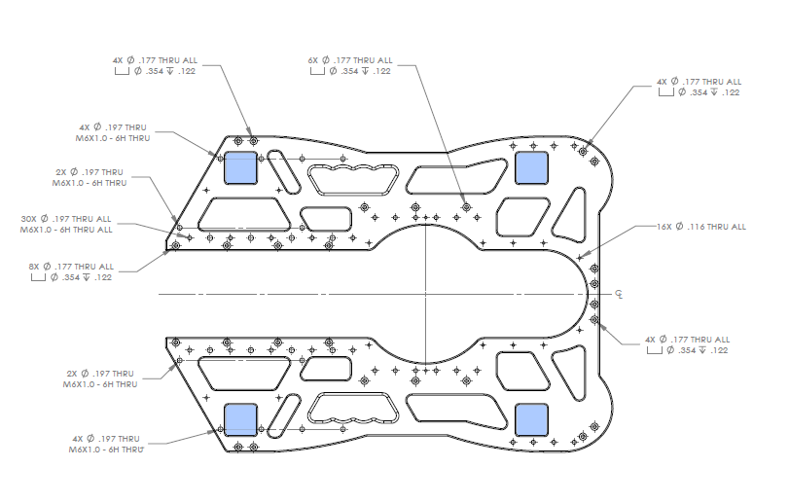
Figure 14 Bottom Frame Plate showing quick latch mount locations

Figure 15 Quick latch assembly [p/n: 702950]

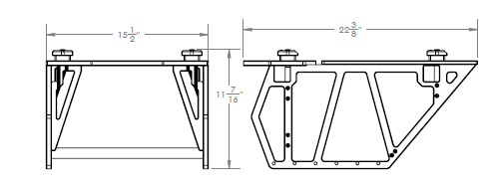
Figure 16 Example payload skid with quick latches
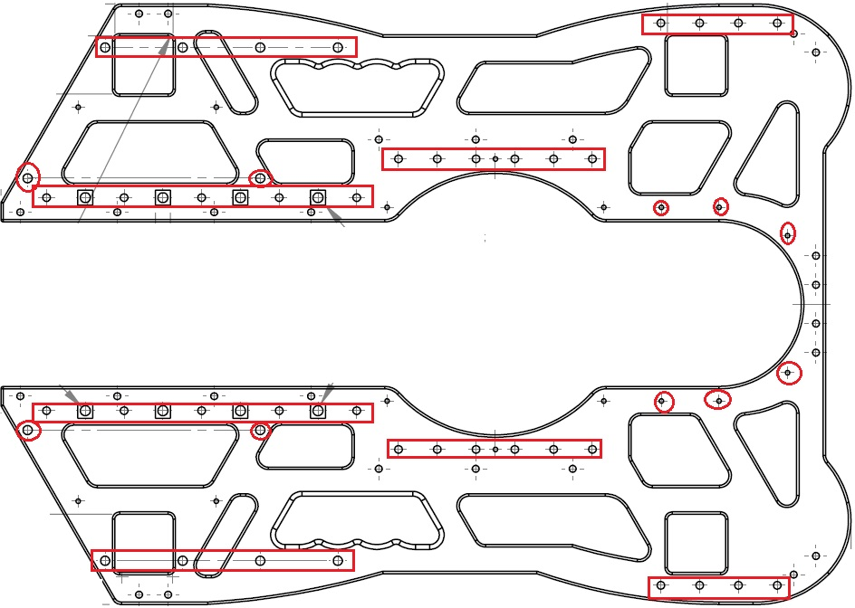
Figure 17 Bottom plate, highlighting available fastener locations

2.1.3.3.3 Top mounted physical interfaces

In addition to bottom mount payload integrations, the VideoRay Defender also supports top mounted payloads that reuse the bolts which hold on the main buoyancy float.

Typically, a custom integration plate is placed on top of the float and the main float attachment bolts may be replaced with longer bolts.

M6 bolts at least as long as 100mm can be used. There are 4 bolts used to secure the float, and the bolts secure to M6 hex nuts secured to the frame with custom retainers.

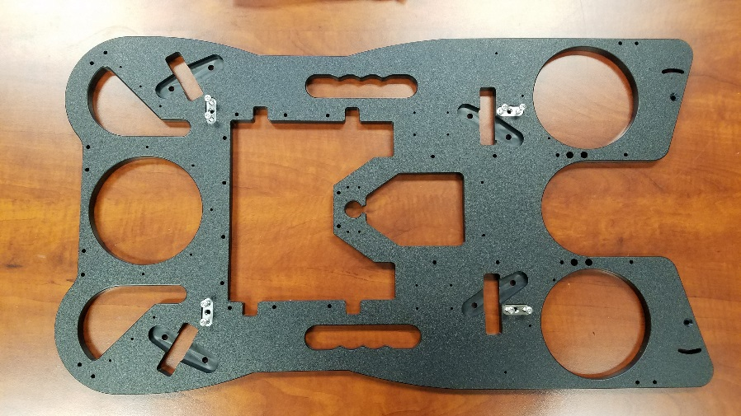
Figure 18 Top Frame plate showing mounting nuts with retainers.

Figure 19 Example top mount payload integration

TBD ADD DIAGRAM SHOWING CG/CB with ballasted for fully integrated ROV

2.1.4 Risks
Subverting the tether segment strain relief can cause damage to the tethers, connectors, and possible loss of the ROV.

Exceeding the reserve buoyancy or lift capabilities of the ROV system can be mitigated using custom buoyancy blocks, or possibly the addition of additional propulsion.

Blockage of sensor (camera, FLS DVL) view zones or propulsion flows if should be mitigated through design of payload placement. If unavoidable, in some cases sensors could be repositioned or augmented with additional sensors.

If payload fastener attachment tear out strength is exceeded additional interface plates can be used to increase the number of engaged fasteners. If further mitigation is required, new frame members could be designed and integrated into the ROV. In some cases frame member material changes could be made, this may of affect weight, ballast and trim.

If the addition of payloads degrades the tuning of the auto control systems severely then control loop parameters can potentially be modified.

2.2 Electrical Interfaces

The following paragraphs provide details regarding the electrical interfaces for the VideoRay Defender Response Vehicle.

2.2.1 Assumptions

It is assumed that multiparty serial data links all use the same, multiparty capable, communication protocols.

All VideoRay modules communicate with a standardized protocol.

2.2.2 Constraints

Power and bandwidth constraints should not be exceeded.

Power constraints:
The OCC can deliver 2400W at 400V at the surface.

The Power converter on the ROV has the following constraints:
Input Voltage Range: 200-420V
Total Power per bus:
48V: 1500 W
24V: 300 W
12V: 120 W

Communication constraints:
Individual Serial links, RS-485 & RS-232 are limited to a max baudrate of 921,600
ROV local Ethernet is 100 Mbps 100-BaseT
ROV long haul modem is constrained to around 60Mbs but depends on tether length.

2.2.3 Available Interfaces

2.3.3.1 Surface segment Electrical Interfaces

The surface segment physical interfaces are limited to the connectors that provide electrical signals to the OCC.

These interfaces consist primarily of industry standard receptacles.

This includes:
1 IEC320-C20 AC power socket
- USB-A sockets
2 HDMI sockets
- RJ45 Ethernet socket
- 12V 5.5 x 2.1 DC Jack
1 AMPHENOL LTW 8 pin socket (custom monitor power and touch screen USB)
- MCBH8F ROV Tether connection, typically connected to a small extension whip.

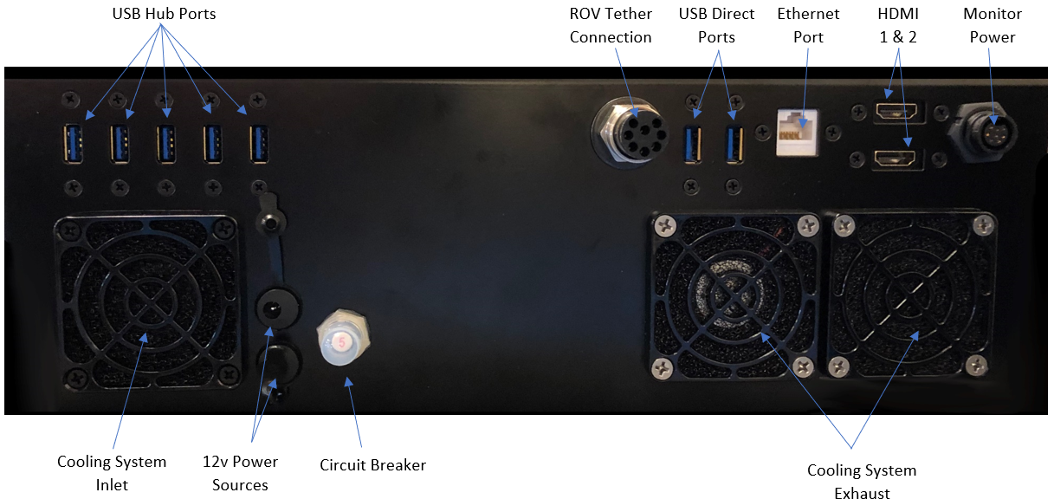

The USB interfaces are typically used as inputs to the OCC, however they can also be used as bi-directional point-point links to other systems using serial null modems for example.

The ethernet port allows for expansion of the OCC/Vehicle TCP/IP network. This provides a direct connection to the ROV payload as well as the compute platform inside the OCC.

2.3.3.2 ROV segment Electrical Interfaces

There are 3 primary electrical interfaces to the ROV system.

- The 8 pin tether connector provides power (400V, 2400W) from the surface as well as the primary communication link (two wire long haul ethernet), there is also a safety interlock that prevents energizing the tether without a ROV connected.

- The 5 pin connectors, located on the power module provide a high power (1500W, 48V) source as well as RS-485 communications. The RS-485 communications are multiparty and can be daisy chained.

- The 9 pin connectors on the communications module are the primary electrical interface for payload integration. The 9 pin connectors provide power (12V 300W, 24V 150W) and communications (RS-485, Ethernet 100 Base-T). The RS-485 communications are multiparty and can be daisy chained, however there can only be one ethernet device per port.

Figure 20 Standard Connectors used on the VideoRay Defender.
Connectivity can be expanded by connecting ethernet expansion hubs to the communication hub module.
There are several cables available to help with payload integration:
Part number | Description | Use case
CW9-001M | 9 Pin Whip Male (24") | Main cabled connector for accessory payloads
70008 | 5 Pin Whip Male (24") | Main cabled connector for high power devices
70570 | 5 pin M/F extension cable (21") | Extension cable for 5 pin devices
70571 | 9 pin M/F extension cable (21") | Extension cable for 9 pin devices
DD8-001MD-CS | 8 pin M/F extension cable (13.5") | Extension cable for tether connection

2.2.4 Risks

Exceeding available power on the ROV can lead to brown outs of the entire vehicle. If a payload with excessive power draw is required, decreasing the available power to the propulsion system is usually the best mitigation strategy.

Exceeding available communication bandwidth can lead to degradation in vehicle control. Compressing or reducing the data rate of high bandwidth sensors, especially video imaging is the primary mitigation strategy.

2.3 Communications/Network Interfaces

The following sparagraphs provide details regarding the communications/network interfaces for the VideoRay Defender Response Vehicle.

2.3.1 Assumptions

All communications use standard link layer protocols (RS-232, RS-485, TCP/IP over ethernet and HomePlug)

2.3.2 Constraints
The VideoRay MSS Defender currently uses fixed statically allocated IP addresses on the 192.168.1.X subnet.

The communications hub only has 6 ports total. In a fully equipped Defender ROV there are no spare ethernet ports.

In a fully equipped Defender ROV port usage is standardized.
Port (tcp/ip port) | Usage
1 (7444) | connection to power module and high power bus
2 (7445) | connection to ahrs/depth module
3 (7446) | connection to main camera module
4 (7447) | connection to forward look sonar
5 (7448) | connection to doppler velocity log
6 (7449) | connection to manipulator, GPS, and usbl transponder

2.3.3 Available Interfaces

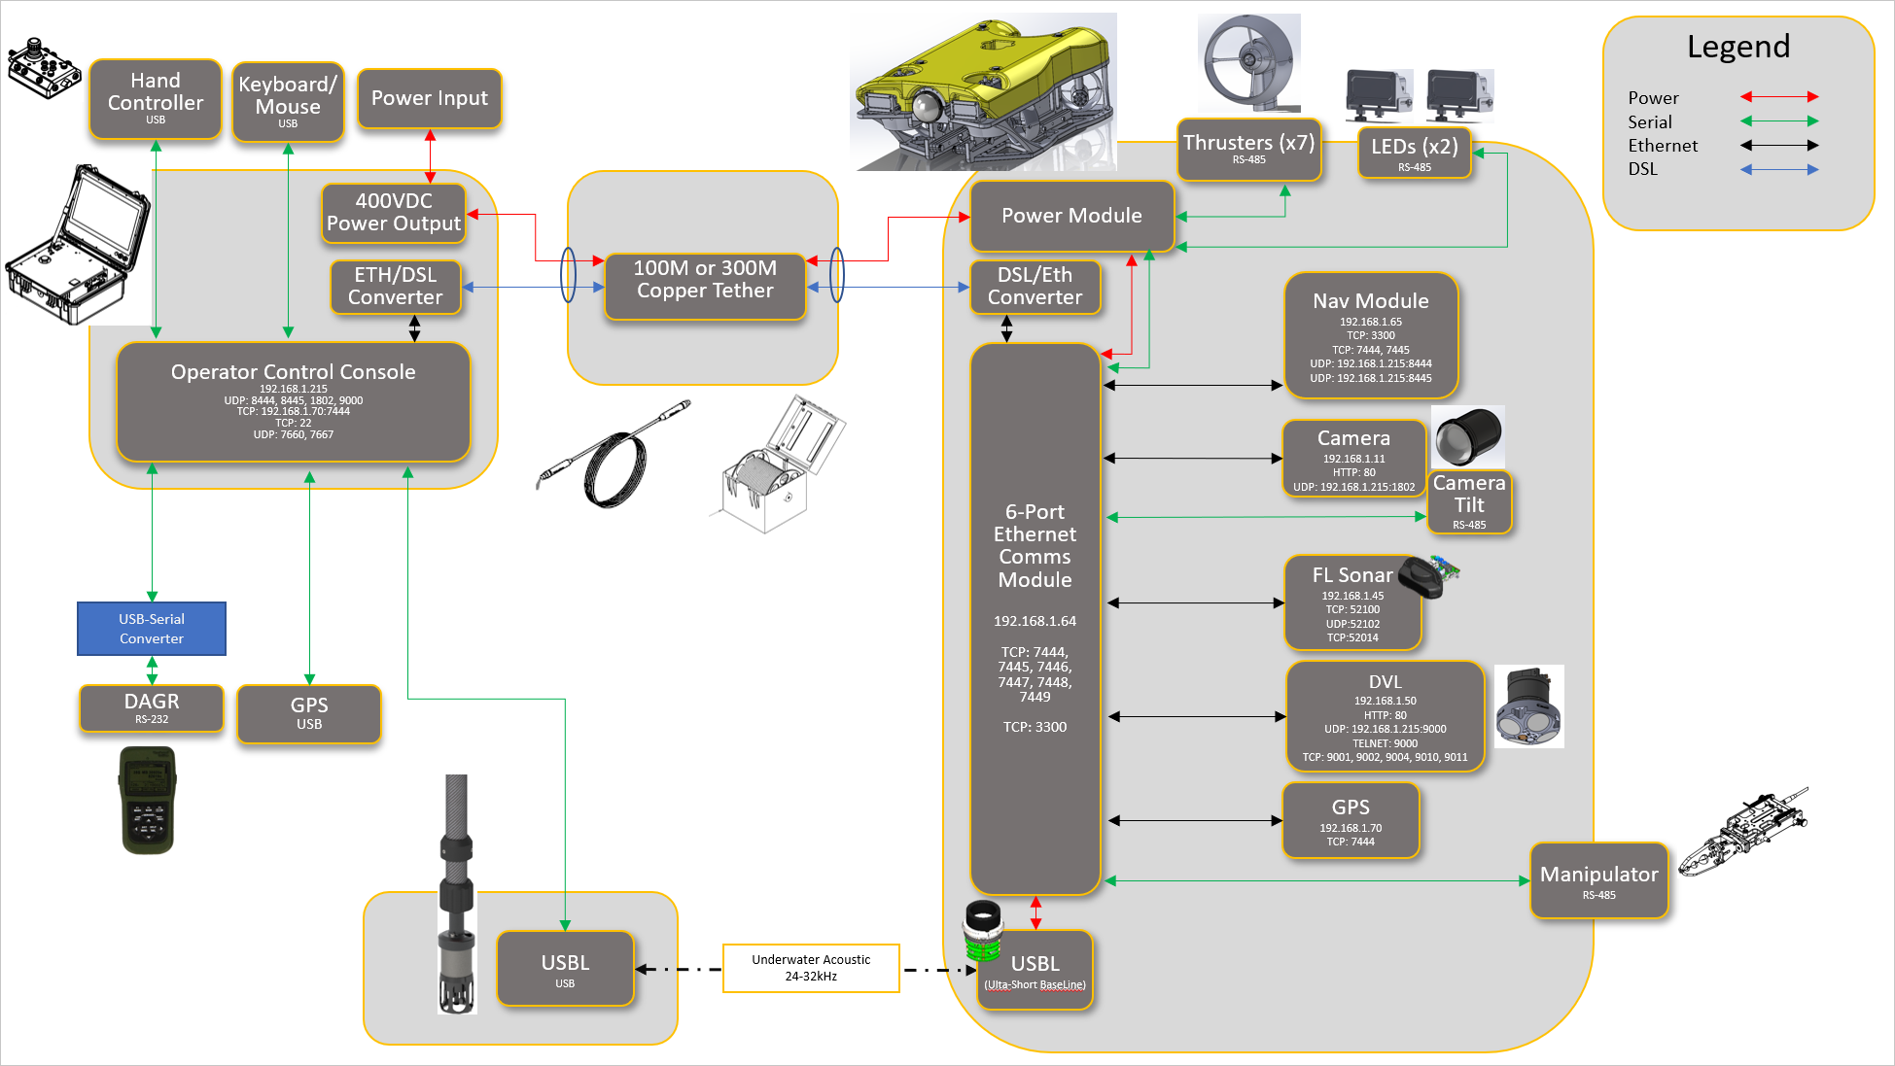
Figure 21 Network diagram for VideoRay Defender System

The VideoRay Defender is essentially a distributed network of functional modules. Most devices exist as nodes with static IP addresses on the same subnet (192.168.1.X). Non ethernet enabled devices are typically RS-485 serial communication enabled, in which case communications are bridged over a TCP/IP socket through the communication hub module.

The computer platform in the OCU acts as just another host on this subnet, the standard default address is 192.168.1.215. Some payload devices (camera, dvl) unicast UDP packets to this fixed address.

The communication hub module acts as the primary switch in the ROV system. The standard default address is 192.168.1.64. It includes a 100Base-T ethernet hub routed to all ports. It also is capable of routing serial communication (RS-485 / RS-232) traffic to each of its ports.

By default, the TCP/IP ports for the serial relays are 7444 - 7449.

PORT6 on the communication hub is cable of RS-232 when configured properly, however standard use is RS485.

Communication to the power module and then on to the high-power bus subsystem is routed through PORT 1 (7444). Bi-directional communication to that socket is relayed to the power module and then out both ports on the power module. This functions as a single 1-hop multiparty RS-485 network.
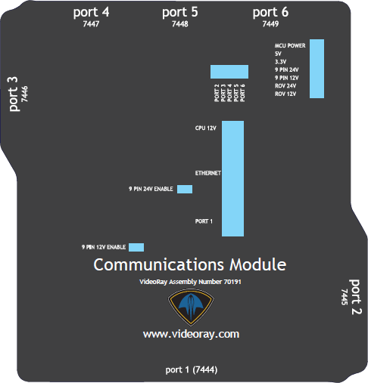
Figure 22 Communication port overlay showing TCP/IP ports

The following table enumerates the standard IP addresses and network ports used in the system.

 | EOD Response ROV DEFENDER - Ports Protocols and Services
Device | Interface | Port | Protocol | Service | Direction | DoDI 8551.1/NTD 08-10 Compliant?
Camera | 192.168.1.11 | 80 | http | Command/  control/  configuration | Bi-directional | No
Camera | 192.168.1.11 | 192.168.1.215:1802 | UDP | Video stream | Outbound | No
FLS | 192.1.168.45 | 52100 | TCP | Sonar data | Bi-directional | No
FLS | 192.1.168.45 | 52102 | UDP | Sonar data | Outbound | No
FLS | 192.1.168.45 | 52014 | TCP | Sonar data | Bi-directional | No
DVL | 192.1.168.50 | 80 | http | Command/  control/  configuration | Bi-directional | No
DVL | 192.168.1.11 | 192.168.1.215:9000 | UDP | DF21 DVL BT Binary | Outbound | No
DVL | 192.168.1.50 | 9000 | telnet | ASCII interface (requires username/  password) | Bi-directional | No
DVL | 192.168.1.50 | 9001 | TCP | Raw binary  (requires username/  password) | Bi-directional | No
DVL | 192.168.1.50 | 9002 | TCP | Binary data | Outbound | No
DVL | 192.168.1.50 | 9004 | TCP | ASCII data | Outbound | No
DVL | 192.168.1.50 | 9010 | TCP | Additional data output | Outbound | No
DVL | 192.168.1.50 | 9011 | TCP | Additional data output | Outbound | No
Comms | 192.1.168.64 | 7444  7445  7446  7447  7448  7449 | TCP | Serial comms relay | Bi-directional | No
Comms | 192.1.168.64 | 3300 | TCP | Command/  control/  configuration [RESERVED] | Bi-directional | No
Navigation | 192.1.168.65 | 3300 | TCP | Command/  control/  configuration [RESERVED] | Bi-directional | No
Navigation | 192.1.168.65 | 7444  7445 | TCP | Serial comms relay | Bi-directional | No
Navigation | 192.1.168.65 | 192.168.1.215:8444 | UDP | NMEA AHRS data | Outbound | No
Navigation | 192.1.168.65 | 192.168.1.215:8445 | UDP | NMEA pressure sensor (depth) data | Outbound | No
Vehicle GPS | 192.1.168.70 | 7444 | TCP | NMEA  GPS data | Outbound | No
OCC | 192.1.168.215 | 192.1681.64:7444 | TCP | Main command and control (thrusters, led, power) | Bi-directional | No
OCC | 192.1.168.215 | 8444 | UDP | NMEA AHRS data | Inbound | No
OCC | 192.1.168.215 | 8445 | UDP | NMEA AHRS data | Inbound | No
OCC | 192.1.168.215 | 1802 | UDP | Video stream | Inbound | No
OCC | 192.1.168.215 | 9000 | UDP | DF21 DVL BT Binary | Inbound | No
OCC | 192.1.168.215 | 192.168.1.70:7444 | TCP | NMEA  GPS data | Inbound | No
OCC | 192.1.168.215 | 22 | TCP | SSH | Bi-directional | No
OCC | 239.255.76.67 | 7660 | UDP/ LCM  NOTE:  TTL 0 | GREENSEA Sonar imagery | Outbound multicast | No
OCC | 239.255.76.67 | 7667 | UDP/ LCM  NOTE:  TTL 0 | GREENSEA Other LCM traffic | Bi-directional multicast | No

2.4.4 Risks

Since everything, including command and control, uses the same TCP/IP network bandwidth limitations should be respected. Exceeding available bandwidth on the network can degrade control of the ROV.

IP address are statically allocated, care must be taken to ensure new payloads do not replicate addresses already in use.

