DORISS2 Embedded Electronics Upgrade Requirements

Introduction
As part of project 901216, it has been requested that development upgrade existing systems that have become antiquated in the DORISS II system, primarily the embedded computing electronics. The following proposal excerpt clearly dictates the goal of this project:
We have enjoyed a long period of reliable operations and ROV “plug and play” functionality with the DORISS2 system. The engineering effort that brought the system online in 2005 has been a model example of how to develop an instrument for science use and successfully transfer the operations to a science team. The DORISS2 system is beginning to show signs of age however, and we would like to bring it up to current standards of software and electronics operation. The PC stack boards and components are 9 years old, it is almost impossible to find exact replacement parts or repair pieces that are the key to the reliable and successful operation at sea. The DORISS2 remote desktop boots up from a compact flash (CF) card on the PC104 stack and this has always been a weak point in this system if the card becomes corrupted during unexpected shutdowns or power failures thru the ROV’s. Furthermore, this past year we have lost some dive time due to communication errors thru the ROV’s and we suspect that some of the internal DORISS2 Ethernet communication protocols are not compatible with the GigE systems now commonly used on our ROVs. DORISS2 is now referred to as a “legacy system” by the ROV pilots. We expect to go thru a similar effort with the LRS3 system as we develop the power, CPU and communications boards, and it makes sense operationally if both Raman systems interface with our ROV platforms using similar power and communications protocols. We request software and electronics engineering support to scope, design and build the necessary electronics hardware for operating both Raman systems.
In order to determine the appropriate solution for the replacement system, the existing system and attached electronics needs to be characterized, as it has evolved from its last major design effort in 2008. Some of these functions have become vestigial and as some items will be marked for removal instead of replacement.

Existing System
The diagram pictured in Figure 1 is a reference for the functionalities that currently exist in the system from PC/104 Stack perspective. Cursory inspection of this chart illustrates that while the PC/104 stack is important to the software dependencies of this system, the workhorse for the various hardware connections is the Thermocool Environmental Fan Card.

Existing Software
Currently the host operating system on-board the RoadRunner II is Windows XP. On this OS, two pieces of software run.
- ATServer: software written by KOSI to allow for remote control of the camera system from the HoloGRAMS software running from another workstation on the same IP network.
- Parvus PC/104 Environmental Fan Access Panel: software supplied by the manufacturer of the Thermocool Environmental Fan card that allows readout and control over the many functions this board performs.

Existing Hardware
Within the PC/104 Stack hardware exists that supports sensing and control over all aspects of DORISS2, including:
- Lippert Cool RoadRunner II: Main CPU with Windows XP Embedded running software described above, an provides the network inferace for communication, as well as USB for camera communication. Its PC/104 bus is attached to the Fan Card.
- Parvus Thermocool Environmental Fan Card: PC/104 board with onboard pressure/humidity and relay contacts as well as analog input channels. The following external devices are supported. This component is no longer in production.
  - 3 Analog Inputs (0-5VDC): (1) Power board heat sink, (2) laser module, and the (2) output of the analog isolator/amplifier.
  - 2 Relays: (1) Heater Relay Circuit coil, (2) Laser Analog Controller Module Interlock Switch.
- Heater Relay Circuit: Simple circuit to supply power to a heater previously mounted near the laser unit.
- Analog Isolator/Amplifier Circuit: Isolating module to scale and isolate the in-circuit temperature sensor used in the servo loop of the KOSI Grating Cavity Controller found in the spectrometer.

Supported Devices
- Andor Camera using USB to the CPU.
- Three Temperature Sensors mounted at the laser and power board heat sink.
- Laser Analog Controller through control of the interlock switch pins, enabling/disabling laser output.
- Host Control via the Ethernet connection through the Seacon MINK10LBCR.

Vestigial Components
Of the already listed components, some are available for removal as they no longer serve a purpose within the housing. Those are:
- Laser Heater Relay: The heater is no longer used.
- Power-on Delay Circuit: These large components were installed to help charge the capacitors of the power board and limit fuse-blowing inrush currents associated with use on the Tiburon system. While they consume little electrical resources, the space they occupy could be valuable in future design iterations.
- Network Switch: As there are no items attached to this at present, its purpose is questionable, and it should be marked for removal.

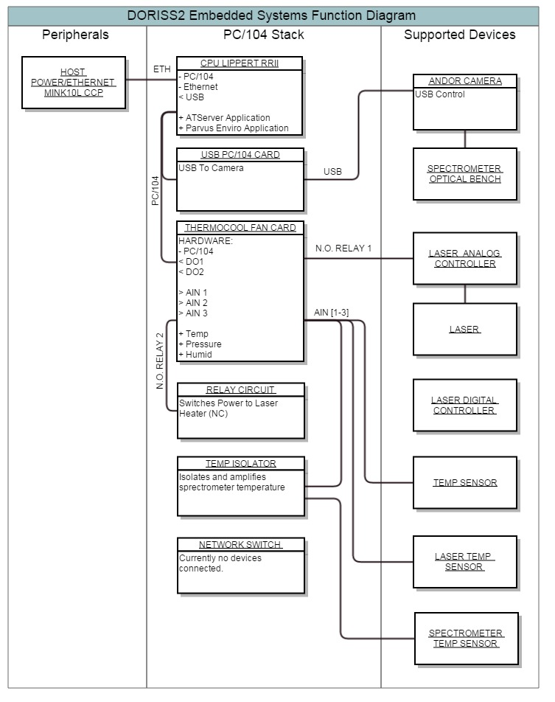Figure 1: Embedded system diagram (existing)

Functional Requirements

Performance Functions
The computing system must continue to perform existing functions as listed:
- Facilitate communication with the existing camera system for data-acquisition.
- Facilitate communication with the future camera systems as well.
- Control the laser output.
- Observe temperature from multiple locations.
- Observe the current humidity within the housing.
- Observe pressure from within the housing.
- Communicate successfully through common MBARI ROV interfaces.

Concept of Operations
Ideally, this system will perform very similarly to the existing system.
- The system will continue to be powered from ROV AC voltage sources and communicate through Ethernet connections to the surface electronics.
- Remote control of the computer will be a necessity, and a user in the control room will coordinate subsea operations through this dedicated link.
- Data can be stored subsea or immediately transferred to the surface application. Data collected will be processed in the same manner it currently endures.
- The system must facilitate operation in all current settings, observing deck and lab safety rules.

Preliminary System Design Requirements

Electrical Requirements
- Convert existing analog temperature sensors in the housing to digital values and transport that data to the surface interface.
- Provide control of the laser by opening and closing the interlock switch pins in the analog controller.
- Interface to the camera using the USB 2.0 interface. This specification satisfies both the existing and new camera systems.
- Incur no further power conditioning, running from supplied AC or existing conditioned DC (see Section 4.3.1 for available voltages)
- Provide an ethernet link (100Mb/s) 4-wire interface or better. It must be compatible with both Ventana and Doc Ricketts fiber transceiver systems.

Software Requirements
- There must be a Windows 7 or newer operating system to accommodate the Andor camera software, as well as the KOSI HoloGRAMS software.
- A simple interface must exist to control the laser power and observe the temperature/humidity/pressure data in real-time.

Design Constraints

Power
Table 1 below illustrates the existing power system present in DORISS2. If we assume total removal of the existing PC/104 Stack alone, there is power available in 5VDC. Since the PC/104 was powered by an independent DC/DC, it would be possible to change this converter for a different output voltage if desired.

 | DORISS II Existing Power Budget
 | DC SUPPLY
 | Voltage Bus | Voltage Input | Maximum Power (W) | Primary Load
 | 5VDC A | 100-375VDC | 75 | PC/104
 | 5VDC B | 100-375VDC | 75 | Camera
 | 24VDC | 100-375VDC | 100 | Laser
 | 12VDC | 100-375VDC | 75 | Spectrometer
 | +/- 15VDC | 24VDC | 20 | Camera
 |  | Total: | 345
 | TYPICAL LOADS
 | Item | Voltage (VDC) | Current Bus Assignment | Maximum Load (W) | Nominal Load (W)
 | PC/104 | 5 | 5VDC A | 15 | 12.5
 | Laser | 24 | 24VDC | 75 | 40
 | Spectrometer (& Heater) | 12 | 12VDC | 75 | 3.3
 | Camera | 5 | 5VDC B | 20 | 18
 | Fans | 12 | 12VDC | ? | ?
 |  |  | Total System Loads: | 185 | 73.8
 | POWER DISTRIBUTION (MAXIMUM LOADS)
 | Voltage Bus | Current Load (W) | Remaining Power (W) |  | Remaining Power w/o PC104 (W)
 | 5VDC A | 15 | 60 |  | 75
 | 5VDC B | 20 | 55 |  | 55
 | 24VDC | 95 | 5 |  | 5
 | 12VDC | 75 | 0 |  | 0
Table 1: DORISS II Power budget for the existing system.

Space
There are few space constraints, as the current stack is very large. Any system fitting the existing footprint or smaller will suffice.

Temperature
Located nearby the existing PC/104 stack there is a bank of fans used to force air over the power electronics. This airflow should be sufficient to aid in cooling the stack. Regardless it would be wise to choose a self-cooled or fanless CPU.

Time
This project should be completed prior to the next scheduled deployment of the system, August 2015, if at all possible.

