Mesobot Load Control Configuration 9/15/2017
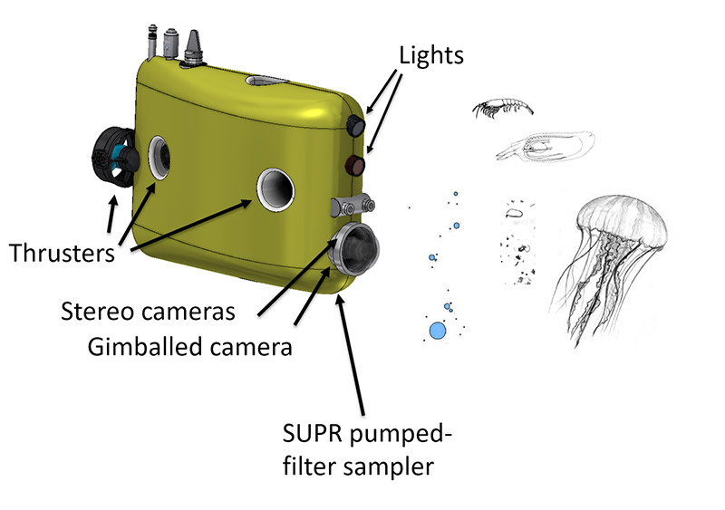
  - Load Control

    - C7 xx-232-12 science future expansion
    - C6 xx-232-12 science future expansion
    - C5 xx-232-12 C-Star Transmissometer (?)
    - C4 xx-232-12 WET Labs Eco Triplet, Serial #
    - C3 xx-232-12 Seabird GPCTD+O2 Serial #, #, #

    - C2 xx-232-12 Seabird PAR Serial
    - C1 xx-485-Batt-5A Light Strobe 1
    - C0 xx-485-Batt-5A Light Strobe 2
    - B7 xx-232-12 Iridium + GPS Xeos, Serial #, IMEI:
    - B6 xx-off-Batt-5A Tether DSL Modem

    - B5 XXXXXXX 3/5V Hotel Power Converter
    - B4 xx-off-Batt-5A Tether Dropper Motor

    - B3 xx-off-Batt-5A Science Camera and Sync Distribution
    - B2 xx-off-Batt-5A Tracking Camera and Ethernet Switch

    - B1 xx-A/D Depth sensor Keller PA-6ST, SN XX

    - B0 xx-232-5 Sparton AHRS-M2 Compass, Serial #
    - A7 xx-232-Batt-5A Benthos ATM885PCB, Serial #

    - A6 xx-485-Batt-5A Thruster channel 6
    - A5 xx-485-Batt-5A Thruster channel 5
    - A4 xx-485-Batt-5A Thruster channel 4
    - A3 xx-485-Batt-5A Thruster channel 3

    - A2 xx-485-Batt-5A Thruster channel 2
    - A1 xx-485-Batt-5A Thruster channel 1
    - A0 xx-485-Batt-5A Variable ballast pump (5A)

- Standalone relocations
  - Benthos transponder 26/29 kHz , Serial xxxx, 26/29 kHz ??
  - Telonics Argos/VHF beacon TAM-4310-3,160.785 MHz, Standalone battery powered
- Notes:

