By Aaron Steiner, DeepSea Power & Light
DeepSea Power & Light’s exclusive FleXlink™ technology offers an alternative to high cost and delicate coaxial and fiber optic interconnects to HDSDI cameras on subsea vehicles and platforms. FleXlink uses unshielded twisted pair (UTP) conductors in ubiquitous subsea Ethernet cable assemblies and connectors to link the HD camera to the vehicle data multiplexer (MUX). The system comprises a camera with a custom designed SDI differential cable driver, a qualified Ethernet interconnect solution, and a receive-side media converter board.
High bandwidth signals in High Definition Serial Digital Interface (HD-SDI) video, up to 1.5GHz for 1080p/30 video, necessitate high bandwidth and controlled impedance cables and connectors. The first few meters of the datalink from an HD camera to the system multiplexer has relied on high cost and often delicate hybrid coaxial copper connections or fiber optic connector and cables. Additionally, many of the available solutions are application specific and are often not with other equipment on a vehicle.
The HD camera’s built-in cable driver is configured to directly drive the 100Ω controlled impedance UTP conductor pairs and ensures optimal signal transmission through up to 10m of cable. DeepSea has tested and qualified the FleXlink cable driver to the industry standard Society of Motion Picture and Television Engineers standard for HD-SDI video (SMPTE 292M), ensuring the HD video signal meets the requirements for signal quality, jitter, and pathological video patterns.
DeepSea’s FleXlink Media Converter is a value-add piece of hardware which receives the HD-SDI video from the camera, recovers the video signal and restores it to the original levels without adding latency. The FleXlink media converter uses a standard Small Formfactor Pluggable (SFP) module to retransmit the HD-SDI video. This allows for easy switching between copper coax and fiber optical interfaces using off-the-shelf digital video SFP modules. At 40x63mm in size it will fit almost any application and simple on-board connectors provide RS-232, RS-485, or tristate control interfaces, DC input power, and a backup analog video feed.
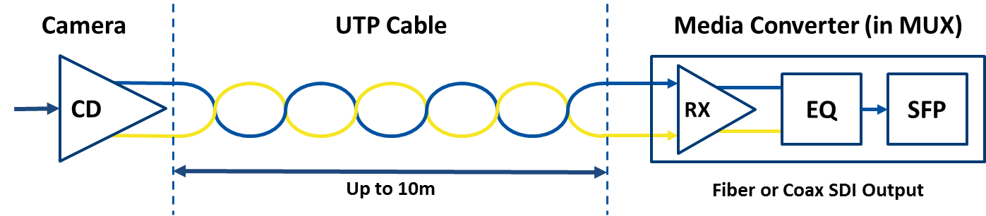
Figure 2 – FleXlink system block diagram: Camera Cable Driver (CD), 10m of UTP Ethernet Cable, and the FleXlink Media Converter containing Receiver(RX), Equalizer (EQ), and Small Form-factor Pluggable (SFP) module.
The FleXlink media converter reduces HD video system overhead by providing a direct to fiber solution without extra MUX hardware. The copper to optical conversion needed to integrate the FleXlink media converter with optical coarse or dense wavelength-division multiplexing (C/DWDM) data multiplexers is built in. Adding HD video to an available CWDM or DWDM channel is as simple as selecting an appropriate wavelength SFP module. With a pressure rated SFP module, the FleXlink Media Converter can also be used in pressure balanced oilfilled (PBOF) applications¹.
Subsea Ethernet connectors and cables offer distinct advantages over fiber optic and coaxial options. The cables are typically more flexible and offer more robust interconnects, especially in dynamic mounting applications such as pan-and-tilts and manipulators. These connectors also have a significant size advantage over coaxial or fiber options which enables smaller and more compact HD camera solutions.
FleXlink allows system integrators to leverage existing spare component inventories helping reduce the logistical costs of HD video. Since these Ethernet cables and interconnects are already in wide use for sonars and other high speed digital systems, the overall burden of spare components is significantly improved.

Key Capabilities:
- Send SMPTE 292M compliant HD-SDI over UTP up to 10m from camera to MUX
- Replace coaxial and fiber optic interconnects with Ethernet connectors
- Use robust and fatigue resistant UTP subsea cable
- Leverage existing Ethernet spares kit cables
- Drop-in for C/DWDM optical multiplexers
- Compatible with installed HD-SDI infrastructure
- Uncompressed with no added glass-to-glass latency
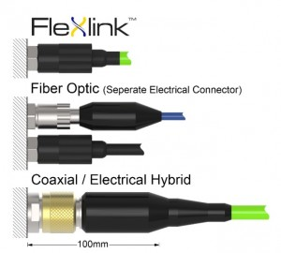
Figure 3 – Bulkhead connector comparison for HD-SDI video

