Clifford Pontbriand
Woods Hole Oceanographic Institution
266 Woods Hole Rd
Woods Hole, MA 02543
cpontbriand@whoi.edu
work: 508-289-2909
cell: 774-392-3016

Multiray LED Sealite 2025 Setup Guide: RS-485 SeaSense® protocol

Introduction
The mesobot project (WHOI, Dana Yoerger PI) has purchased three (3) Multiray LED Sealite 2025 units from Deep Sea Power and Light, part number 712-049-001. See figure 1 for an excerpt from the packing list detailing specifications and serial numbers. The purpose of this document is to describe the wiring and protocol for these devices in order to establish basic functionality. For more detailed configuration information, refer to the DSPL document number 792-004-013, “SeaSense® Serial Protocol Specification”.

The lights communicate via RS-485 bus using the DSPL SeaSense® protocol. It seems the default address of each Multiray LED Sealite is 001, so in order to operate on a single bus each device must be given a unique address. Cliff Pontbriand has set the address of SN 12-049-00435 to 003, adding an address label to the unit.

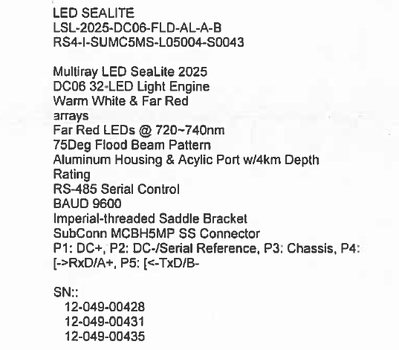
Figure 1-- Multiray Sealite Specifications

Wiring
The lights operate on 10-48 VDC, and communicate via RS-485 bus using the DSPL SeaSense® protocol. See table 1 for DSPL pin descriptions, and see Figure 2 for Sealite MCIL5F-to-DB9 wiring pinout for communication using a MOXA Uport 1100 USB-serial converter.
MCBH5M PIN NUMBER | DESCRIPTION
1 | DC +
2 | DC -
3 | CHASSIS
4 | [RxD/A+
5 | [TxD/B-
Table 1---- DSPL Multiray LED Sealite pin descriptions

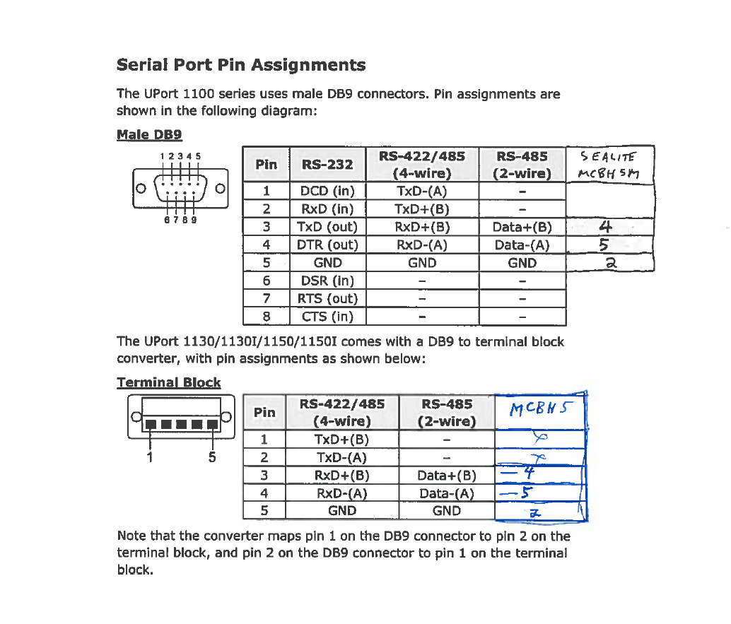
Figure 2-- DSPL Multiray LED Sealite RS-485 serial connection

Terminal Setup
Communication with the Multiray LED Sealite requires a serial RS-485 port with serial terminal set to 9600, 8-n-1, no flow control. Figure 3 shows the terminal window properly configured.
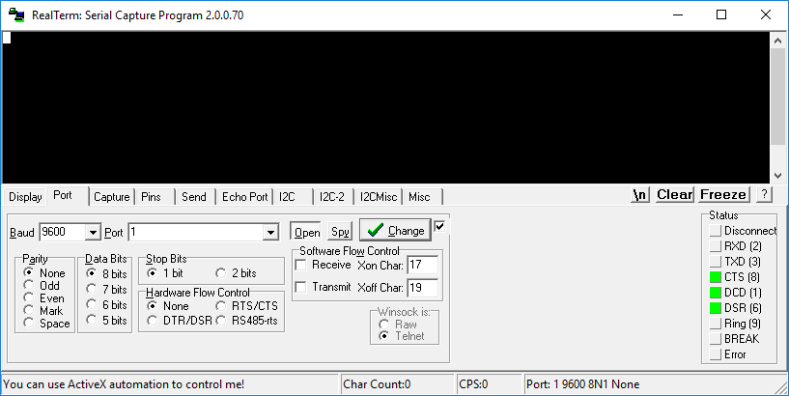
Figure 3-- Serial terminal (RealTerm) for communication with Multiray LED Sealite
When powered, the device resumes its most recent state. To change state (LED intensity/dimming, red/white LED) requires single-line commands as outlined in the protocol specification, document number 792-004-013. The general format of the commands used here is:
Start-of-frame indicator, “!”
Device address, “001”
Address separator, “:”
Command ID, “LOUT”
Access code, “+”
Data payload, “1”
End-of-frame indicator, “<CR><LF>”

Resulting command string: !001:LOUT+1<CR><LF>

Command Examples
The following figures step through a series of commands to make these state changes, and also to read device information, temperature, and set device address. Table 2 lists the command strings, their description, and the figure in which they appear. Command ID is not case sensitive.
Command | Description | Example Figure
!001:LOUT+1<CR><LF> | Increment LED output level | Figure 4,5,6
!001:LOUT-1<CR><LF> | Decrement LED output level | Figure 4,5,6
!001:info?<CR><LF> | Retrieve device information | Figure 4, 5
!001:TEMP?<CR><LF> | Retrieve device temperature (C) | Figure 4
!001:CHSW=2<CR><LF> | Change LED driver to bank 2 (RED) | Figure 5
!001:CHSW?<CR><LF> | Retrieve device driver information | Figure 5
!001:BOOT?<CR><LF> | Retrieve device BOOT configuration | Figure 5
!001:ADDR=003<CR><LF> | Change device ADDRESS | Figure 6
Table 2-- Useful command examples

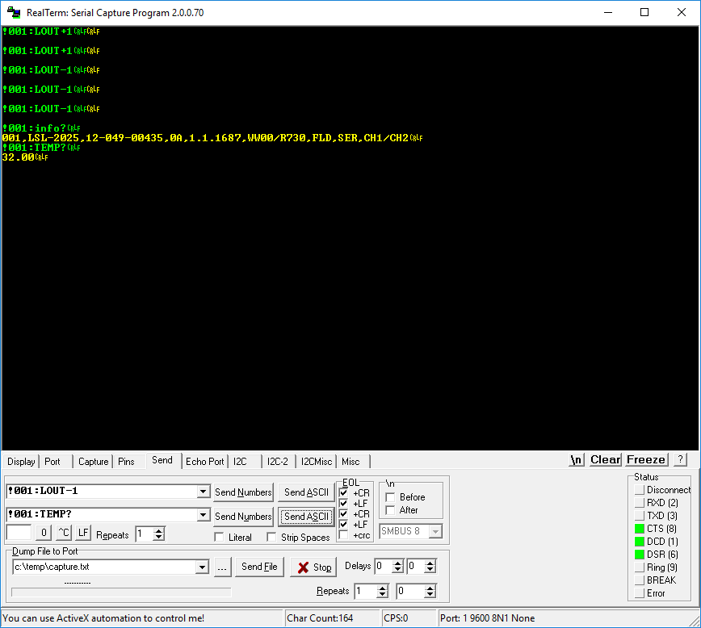
Figure 4-- Example serial configuration commands
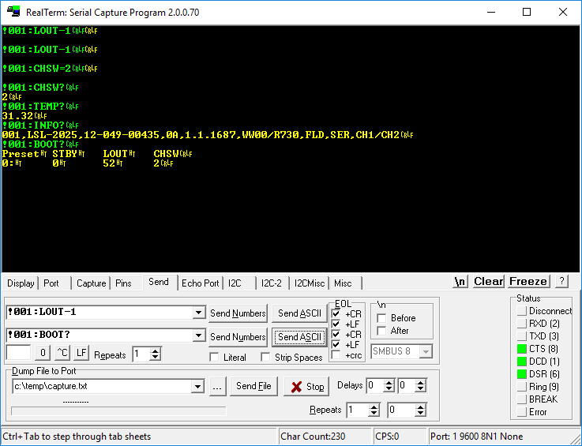
Figure 5-- Example serial configuration commands

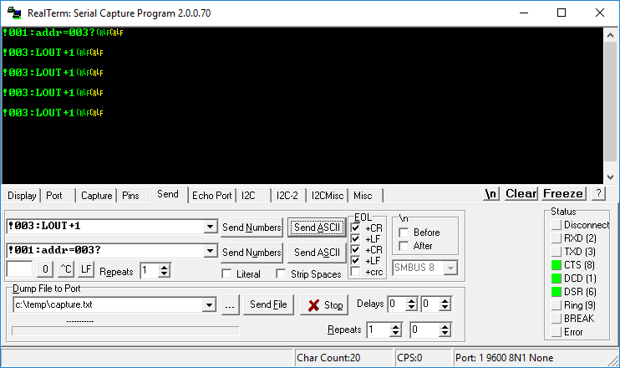
Figure 6-- Example serial configuration commands: setting device ADDRESS

