Mesobot LRAUV Configurations
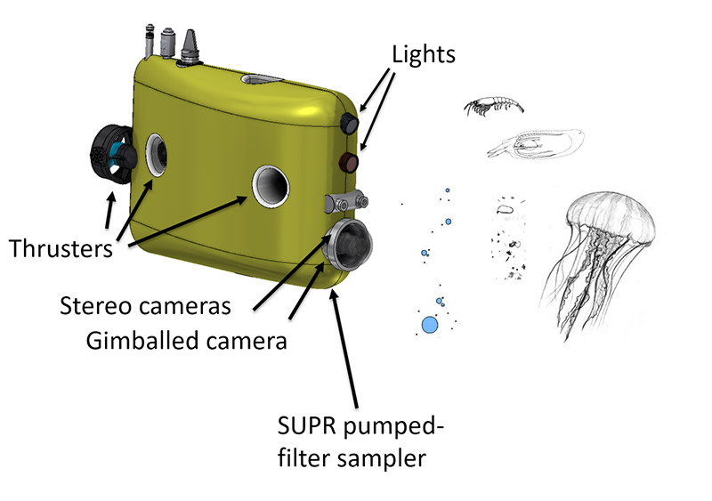
  - Load Control
    - C7 3.3V/5V future expansion
    - C6 xx-232-12 Seabird GPCTD, Serial #, pump
    - C5 xx-232-5 Sparton AHRS-M2 Compass, Serial #
    - C4 xx-232-5 GPS?
    - C3 xx-232-12 C-Star Transmissometer (?)
    - C2 xx-232-12 WET Labs Eco Triplet, Serial #
    - C1 xx-232-12 Aandera O2, Serial #
    - C0 xx---A/D PAR Licor UWQ #
    - B7 xx-232-12 Iridium ?, SN, IMEI:
    - B6 xx-off-12 Cradlepoint WiFi/3G, Serial #, IMEI
        - IP wired: xxx
        - IP cell: xxx
    - B5 XXXXXXX 3/5/12 Power Converter
    - B4 xx-232-24-5A DVL/ADCP, Serial #
    - B3 xx-232-24-5A Benthos DAT or Micromodem Acoustic Modem, Serial #Tx
    - B2 XXXXXXX 24V Power Converter
    - B1 xx-232-12 Camera housing (cameras, TX2….) (?)
    - B0 xx---A/D Depth sensor Keller PA-6ST, SN XX
    - A7 xx-232-Batt-5ASUPR
    - A6 xx-232-Batt-5A Release motors (?)
    - A5 xx-485-Batt-5A Thruster channel 1
    - A4 xx-485-Batt- 5A Thruster channel 2
    - A3 xx-485-Batt-5A Thruster channel 3
    - A2 xx-485-Batt- 5A Thruster channel 4
    - A1 xx-485-Batt-5A 5A EzServo Variable ballast pump (5A)
    - A0 Spare Analog Expansion
- Standalone relocations
  - Benthos transponder 26/29 kHz , Serial xxxx, 26/29 kHz
  - Telonics Argos/VHF beacon #xxA,160.785 MHz, Standalone battery powered
- Notes:

