Mesobot Load Control Configuration 9/5/17
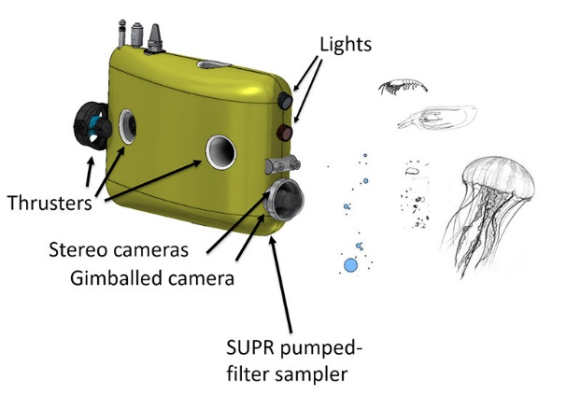
  - Load Control
    - C7 xx-232-12 Stereo Cameras
    - C6 xx-232-12 Science Camera

    - C5 xx-232-5 Sparton AHRS-M2 Compass, Serial #
    - C4 xx-232-12 Satlantic PAR

    - C3 xx-232-12 Seabird GPCTD+O2 Serial #, #, #

    - C2 xx-232-12 WET Labs Eco Triplet, Serial # (could share with CTD)
    - C1 xx-232-12 GPS/Iridium Xeos Apollo, Serial #, IMEI:

    - C0 xx-232-12 DSL modem, tether dropper
    - B7 XXXXXXX 3/5/12 Power Converter

    - B6 XXXXXXXX 24 VDC Power converter

    - B5 xx-xx-12 TX2, ethernet switch, video recorder & encoders

    - B4 xx-232-Batt-5A SUPR microbial sampler with large pump

    - B3 xx-232-24-5A Benthos Acoustic Modem, Serial #
    - B2 xx-232-Batt-5A Light 1 – MultiRay – dimmed to 50%
    - B1 xx-232-Batt-5A Light 2 - MultiRay – dimmed to 50%

    - B0 xx---A/D Depth sensor Keller PA-6ST, SN XX
    - A7 xx-232-Batt Release Motor
    - A6 xx-485-Batt-5A Variable ballast pump (5A)
    - A5 xx-485-Batt-5A Thruster channel 1
    - A4 xx-485-Batt-5A Thruster channel 2
    - A3 xx-485-Batt- 5A Thruster channel 3
    - A2 xx-485-Batt-5A Thruster channel 4
    - A1 xx-485-Batt- 5A Thruster channel 5
    - A0 xx-485-Batt- 5A Thruster channel 6

- Standalone relocation devices
  - Benthos transponder 26/29 kHz , Serial xxxx, 26/29 kHz
  - Telonics Argos/VHF beacon TAM-4310-3,160.785 MHz, Standalone battery powered
- Notes: *** Light output limited to 50% to keep under ~60 watt
limit of load control board and backplane with all thrusters running. We may still exceed the limits of the backplane so we need to define the worst cxase system maximum current.***

