Project Title
Open Wave-Energy Control System Development Platform

Federal Agency and Award Number
DOE – EERE
DE-EE0009444

Principal Investigator Contact Info
Andrew Hamilton, Ph.D.
hamilton@mbari.org (831) 775-1861

Recipient Organization
Monterey Bay Aquarium Research Institute

Submission Date
10/30/2023

DUNS Number
178341772

Business Point of Contact
Danielle Haddock
danielle@mbari.org (831) 775-1803

Project Period of Performance
10/1/2021 - 9/30/2025

Reporting Period End Date
9/30/2023

Accomplishments
- Major Goals and Objectives
The primary goal of this project is to create a software infrastructure for the MBARI Wave Energy Conversion buoy that will allow outside collaborators to develop control algorithms that take advantage of all features of the MBARI buoy, and execute these algorithms during the regularly scheduled deployments. The intent of this is to provide an at-sea test-bed for controls researchers that they would not ordinarily have access to, and promote real-world control system research and testing in this manner. The project contains three main activities;
- Buoy Software Infrastructure: This is the development of an application programming interface (API) on the buoy system that provides developers consistent access to all sensor data on the buoy and a means by which to programmatically specify control inputs to the wave-energy converter. With this API, developers will be able to concentrate almost entirely on the control algorithm portion of the task, without needing to develop specific expertise in the lower level software and hardware infrastructure of the wave-energy converter. The architecture of the MBARI wave-energy converter buoy is well suited to this abstraction and allows new control code to be uploaded and executed in this model, while the buoy is at sea. It is intended to be routine to perform design iterations in which code is uploaded and run, results analyzed, modifications made and new code uploaded and run, without the need to recover the system.
- Simulation Environment: In order for developments using the API to proceed efficiently, a simulator is also required that allows newly developed code to be tested before deployment on the hardware. A key requirement of this simulator is that it provides an API that is identical to the buoy API. Meeting this requirement means that code that runs in the simulation environment can also run entirely unchanged on the buoy while it is at sea. This simulation environment also will provide some safety checks on code before it is run on the buoy, and allow researchers to do some algorithm performance testing before at-sea testing. The simulator is being developed to run faster than real-time, and will have a range of settings that balance code execution speed and simulation fidelity.
- Marketing and Outreach: The most challenging component of this project is developing engagement with our target users. There are a wide range of potential users and we are targeting academic and non-profit institute researchers as per the funding opportunity announcement. We also envision teaching opportunities for this platform and can imagine a university course in marine hydrokinetic energy harvesting being developed that uses the materials resulting from this project. We are planning a number of activities such as webinars, seminars, and conference events to support this. Additionally, we have included requirements in our software development and documentation specification for ease of use for individuals new to ROS and this type of programming.
To facilitate these activities, this project includes Open Robotics Software Foundation (ORSF) as a significant subaward. ORSF develops and promotes the popular “Robot Operating System” (ROS, https://www.ros.org) which is a middleware that allows robotics and other real-time software to be divided into a number of processes that share data over a common publish/subscribe message architecture. By developing the required API using this framework, we expect to provide an API that uses a well-documented form and that is approachable for academic researchers. ROS provides language bindings in C++ and Python, which provides some built-in flexibility to meet researchers in their own areas of computing expertise.
Budget Period 1 of this project concentrates on building the necessary software tools, and incorporating a few beta users into the system, using the simulation tools in the near term and for on-buoy operations in the second year of the project. Budget Period 2 is focused on marketing the result and helping users make use of the system.

Table 1: Budget Period 1 Milestone Progress
 |  |  |  |  | Completion Month
 | Milestone |  | Percent Completed |  | Scheduled | Actual
1.7.1 | ROS Running on MBARI WEC Computer |  | 100% |  | 6 | 5
2.2.1 | Simulator selected |  | 100% |  | 5 | 5
2.8.1 | Simulator integrated |  | 100% |  | 8 | 12
3.4.1 | All software packages are published publicly |  | 100% |  | 9 | 18
4.3.1 | MBARI control running in ROS system |  | 100% |  | 9 | 5
5.3.1 | Portal ready to launch |  | 100% |  | 9 | 20
6.2.1 | Webinar completed |  | 100% |  | 11 | 20
7.2.1 | Buoy Deployed |  | 100% |  | 16 | 17
8.2.1 | Successful on-buoy use of user code |  | 75% |  | 21
9.1.1 | Workshop or online training completed |  | 0% |  | 16

- Accomplishments and Developments in this Reporting Period

In this reporting period an updated version of the software was released, now called v1.0.0 which replaces the original “release candidate” release (v1.0.0-rc2). This update fixed a lingering problem in the code and added some features. As has been previously discussed, this first version of this software wasn’t faithfully reproducing the at-sea performance of the buoy in all cases, with a near factor-of-two difference between some measures being present. An error has been found and corrected that was causing this discrepancy, Figure 1 illustrates the current capabilities of the simulator and compares several hundred 30-minute periods of at-sea data collection (orange) to the results of the simulator run (blue) with wave-conditions corresponding to those time periods. The first, fourth and fifth panes of this figure correspond to the power capture, the RMS piston velocity, and the RPM generator RPM of the device. These measures indicate excellent electrical and mechanical agreement of the model to the at-sea measurements, certainly within expectations for a simplified numerical model of what is a complex device in a complex environment. The second and third panes are the piston mean position and pneumatic spring stiffness of the model compared to the at-sea device, and don’t match as well. This is not unexpected as the behavior of the pneumatic spring in the system changes with time and the exact state of the physical device is difficult to capture from the measured data, therefore it is challenging to exactly capture this components behavior in the simulation. However, the net measures of electrical and mechanical performance are not terribly sensitive to these settings so the discrepancies don’t translate through to the electrical and mechanical behaviors of the model.

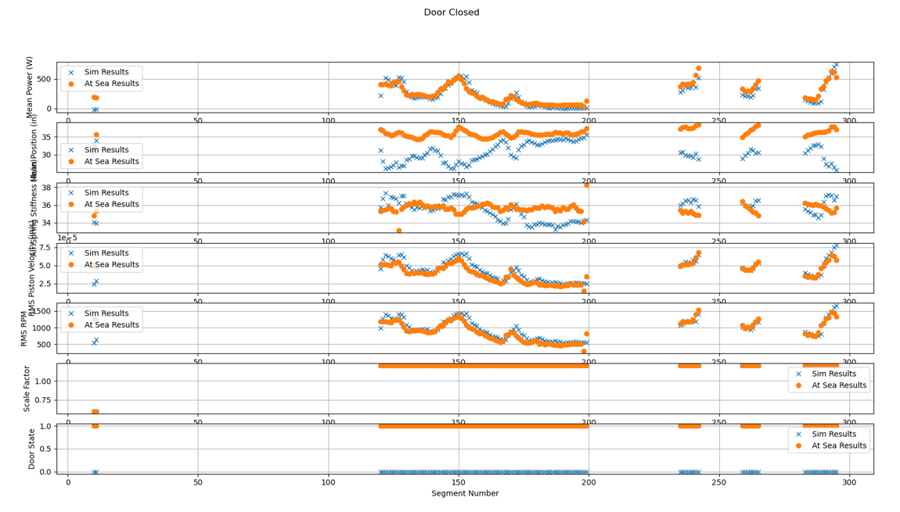
Figure 1: Comparison of at-sea results with simulation results.

In addition to the important bug-fix described above, this recent software release also introduces new features that allow the reporting of “latent data” from the simulation. This is data that is present in the simulation, but isn’t measurable in the at-sea device. The prime example is the wave-height at various times and locations, something that is well known in simulation but very difficult to measure in the at-sea environment. This was added in anticipation of a future project in which the UofW/OSU group has expressed interest in deploying wave-measurement buoys alongside the MBARI WEC. The latent data additions will allow simulation of this situation prior to field testing. At the same time, other data was added that allow closer tracking of the power and energy flow in the system, improving the understanding of the systems behavior and performance. New tutorials describing the use of these features are being developed.

In this reporting feature, it was decided with DOE management to execute a no-cost time extension for this project to delay the conclusion of budget period one six months, until 3/31/2024. This extra time is very helpful for completing outstanding mile-stones in BP1 and as such we plan to submit the continuation report by the end of January, 2024. This shift in time-frame also allows this projects time-line to better line up with the expected UofW/OSU project described above, we are told that funding is still expected, but will not start until mid-2024. By delaying budget period 2 of this project, the support we are able to provide as part of this project will better align with those efforts.

The 2023 buoy system deployment continues to be our most successful buoy deployment. This deployment in Monterey Bay is now greater than six months in length and has extended the longevity testing of this hardware significantly. In fact, this hardware has now been in operation for greater than 14 months without refurbishment of the high-wear items (hydraulic seals). Our current plans are to recover this deployment before the end of 2023, perform some maintenance items and re-deploy in March 2024 to continue to support this project and other efforts.

In this reporting period, we have concluded our subaward with Open Robotics, after completing the scope of work originally contracted for. As previously discussed this organization has undergone some major changes as a result of its acquisition by Intrinsic, a Google subsidiary. A result is a diminished focus on the type of consulting services they have provided this project. This group did complete the scope of work we had planned on in Budget Period 1 of this project. As the project has matured, we do not expect to require their continuing support in Budget Period 2, and an alternative staffing plan for Budget Period 2 that makes use of MBARI resources will be presented in the upcoming continuation report.

We continue to advertise this project in the pursuit of developing collaborators, on July 19, 2023 Hamilton presented an online seminar which was hosted by UMERC/POET. This presentation has been archived here https://www.youtube.com/watch?v=jpVva8tQeNc and has generated some interests, both inquiries about the project and invites to give this seminar to other groups.

- Training and Professional Development Opportunities
Post-doctoral fellow Chris Dizon at Oregon State University (under Professor Ted Brekken) continues to work with the MBARI and Sandia Engineering teams. Chris is now running the simulation developed by this project and working towards a paper that characterizes the performance of the Gazebo simulator developed here as well as the WEC-Sim model of the MBARI system developed by Sandia National Labs. In each case these simulations are being compared to field-data collected from the current deployment of the MBARI system.
- Results Dissemination
The open-source software development in this reporting period represents the bulk of the results dissemination as the public at large has had access throughout the development process. As described above, the wave-body interaction hydrodynamic computations used in this project have been broken out into a stand-alone library that may be useful for several outside efforts.
- Plans for the Next Reporting Period
In the next reporting period we plan to continue to court users of this system by following up with leads we have and continuing to improve the documentation and support materials. In particular we have been contacted by Geoff Hollinger at Oregon State University who has expressed some interest. We will also continue to work towards validation of the systems performance, culminating in a publishable paper outlining the comparisons of the simulator performance with the at-sea measurements. Finally, we will be working on the continuation report and suggested plan for budget period two, for evaluation in the second quarter of 2024.

Products
- Publications, conference papers, and presentations:
- On July 19th of this reporting period, Andrew Hamilton presented this project at as an online seminar hosted by UMERC/POET: https://www.youtube.com/watch?v=jpVva8tQeNc

- Websites:
The names of the GitHub repositories that make up the bulk of this project have changed from our working titles to more descriptive names. As a result, the various websites that contain the project output.
The following web-sites contain software developed by this project:

The top-level websites for the code and documentation are:
- https://github.com/osrf/mbari_wec
- https://osrf.github.io/mbari_wec/

And the constituent repositories that provide specific functionality are:
- https://github.com/osrf/mbari_wec_gz
- https://github.com/osrf/mbari_wec_utils
- https://github.com/hamilton8415/FreeSurfaceHydrodynamics

The first group of these are likely to be visited by users, and the second group by developers.

- Technologies or Techniques
This project has spurred changes to the Gazebo simulation framework to properly include added-mass effects in the physics simulation and that work is now complete and available in all the most recent distributions of Gazebo. This is a necessary capability for Gazebo to be used for marine robotics and this capability was highlighted by Mabel Zhang from Open Robotics at the recent IROS conference in Detroit.

- Inventions, patent applications, and/or licenses
None.

- Other products
None.

Participants & Other Collaborating Organizations
- Individuals

1. Name: Andrew Hamilton
2. Total Number of Months: 2
3. Project Role: PD/PI
4. Researcher Identifier: None
5. Contribution to Project: Principal Investigator and Project Manager, directs all activities.
6. State, U.S. territory, and/or country of residence: California, U.S.A.
7. Collaborated with individual in foreign country: No
8. Country(ies) of foreign collaborator: Not Applicable
9. Travelled to foreign country: No
10. If traveled to foreign country(ies), duration of stay: Not Applicable
1. Name: Michael Anderson
2. Total Number of Months: 3
3. Project Role: Other Professional – MBARI Software Engineer
4. Researcher Identifier: None
5. Contribution to Project: Performs Software Engineering, Programming, and Documentation Tasks. Participates in all meetings.
6. State, U.S. territory, and/or country of residence: California, U.S.A.
7. Collaborated with individual in foreign country: No
8. Country(ies) of foreign collaborator: Not Applicable
9. Travelled to foreign country: No
10. If traveled to foreign country(ies), duration of stay: Not Applicable

- Change in PI/Senior Personnel
During this reporting period, the subaward MBARI has had with Open Robotics has ended after completing the scope of work we had planned on.

- Partner organizations
1. Open Robotics Software Corporation. – Ending this reporting period.
2. Mountain View, CA USA.
3. Partner’s contribution to the project is Collaborative research and In-kind support.
4. Open Robotics Software Foundation is a domestic organization that that supports all administrative and technical development of ROS, ROS2 and the associated Gazebo simulator. These open-source projects form the software basis for most of this project. Having this organization as an official subaward on this project provides access to expertise and best-practices for these software products. This is allowing this project to produce a professionally developed product that will be maintainable and suitable for inclusion in the larger ecosystem of ROS and Gazebo software.

- Other collaborators
- We have a long-standing collaboration with the Ryan Coe group at Sandia with funding independent of this project. We anticipate this project will benefit that effort and facilitate some of the goals of that partnership. Therefore, we continue to keep the Sandia group apprised of our work here and this project is benefiting from previous modelling work done by Sandia, and their expertise in general.
- We continue to develop a relationship with Ted Brekken and Chris Dizon at Oregon State University as users of this project’s products.
- We have had been speaking with Brittany Lydon who is a PhD candidate at the University of Washington (Polagye lab). Brittany has expressed interested in using this platform and we are encouraging and helping her get started. At this she is interested for her own research interests, and she may become involved in the UofW/OSU/PMEC project depending on how her career develops.

Impact
- Impact on the principal disciplines
As part of this project we have developed a general-purpose software library that computes wave-body interaction forces for floating bodies. This is used by this project, and also available to others as it has no specific ROS/Gazebo characteristics. In the future we hope to facilitate research results in the area of wave-energy conversion device control.

- Impact on other disciplines
This project has spurred changes to the Gazebo simulation framework to properly include added-mass effects in the physics simulation. This is a necessary capability for Gazebo to be used for marine robotics. Additionally, in the course of this project three small issues with ROS itself came to light, we fixed those and had the necessary changes accepted into the ROS 2 source-code tree.

- Impact on development of human resources
None

- Impact on teaching and education
None yet.

- Impact on infrastructure
None expected.

- Impact on technology transfer
None yet.

- Impact on society
None.

- Budget percentage spent in foreign countries
0%

Changes/Problems
- Changes in approach.
We anticipate a change in staffing approach in Budget Period 2, relying more on MBARI engineering in the place of Open Robotics.

- Actual or anticipated problems or delays and actions or plans to resolve.
We continue to work towards finding appropriate users, and need to expand this some as we move forward.

- Changes that have an impact on expenditures
None.

- Changes in use or care of human subjects, vertebrate animals, biohazards, and/or select agents.
None and not expected to be applicable.

- Change in primary performance site location.
None.

