Andy Hamilton
Wave Energy Conversion (901405)
Since the June board meeting, this project has been working hard to finalize the design and complete fabrication for the integration of the MBARI Wave-Energy conversion system with the Liquid Robotics style propulsion system. We have completed the one-quarter sized testing and have used that data to refine the full-scale device design. Fabrication is underway and we plan to test at sea before the end of 2016. Because the wave-energy conversion system necessarily creates large loads in the system, an important challenge in this design has been providing necessary strength in the wings. Composite wing structures are employed and these have been tested to loads larger than expected at sea. Other developments include the rudder actuator and control system that will allow the device to navigate at sea autonomously, and refinements to the electro-mechanical cable that carries power and data between the surface buoy and the sub-surface flapping foil. Because the behavior of this system is relatively unknown, we are exploring numerical modeling techniques to analyze the flow over the wings that occurs during operation. This requires a sophisticated computation fluid dynamics effort but it may be worth the effort to further understand and refine the design.
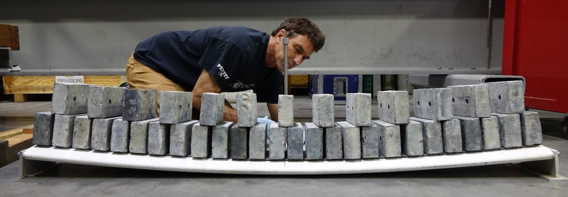The wing prototype is load tested in the lab.
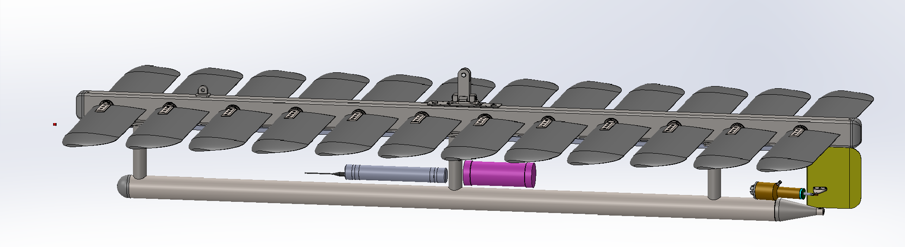
The large flapping foil device currently being built and that will be integrated with the MBARI wave-energy conversion system.
Collaborations
In July 2016 we worked with our collaborators from the University of Washington, Applied Physics Lab (Andy Stewart) to field and test a different wave-energy prototype that has been funded by the DARPA TUNA project. This was the first time this prototype had been to sea. We agreed to continue this collaboration into phase two of the DARPA effort and wrote the Power Electronics components from the MBARI system into the DARPA proposal. This would fill a significant need in that effort and provide as a technology transfer path of some of the work performed under MBARI funding.
In October 2016, we met with Alan McCall of Dehlsen Associates and discussed incorporating some advanced control techniques they have developed under a Department of Energy grant into our system. This would provide them with a chance to validate the effectiveness of their algorithms at sea, and would provide us with technology that has the potential to double the power capture from the system.
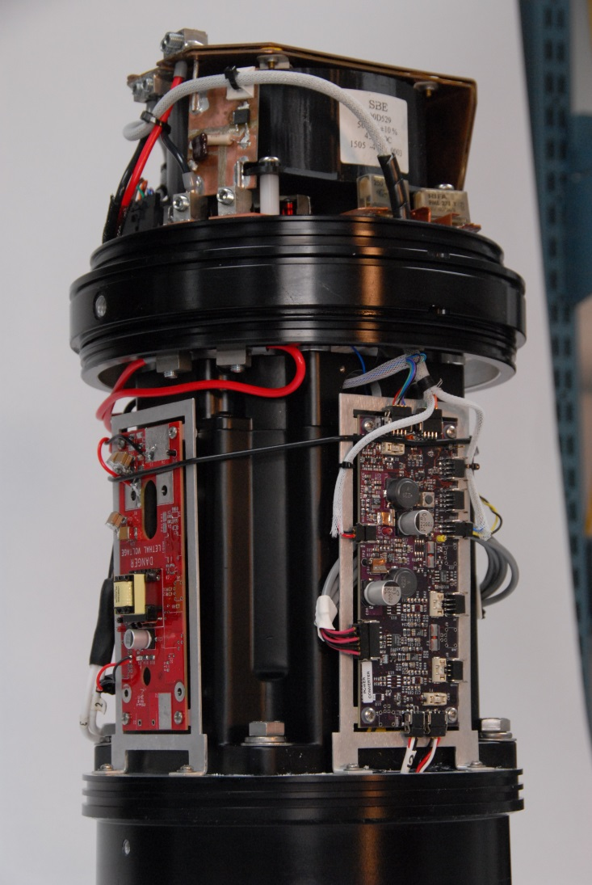MBARI developed power electronics which includes features needed for advanced control techniques that may be able to greatly increase the power capture of the system. We are pursuing a DARPA grant that would provide a technology transfer path for this component.

