PowerBuoy Power Converter Review
May 12, 2015

Introduction
The MBARI PowerBuoy is a point-absorber time wave-energy converter that consists of a surface buoy connected to a submerged anti-heave plate by an electro-hydraulic power take-off device. Wave excitation causes the two bodies to move relative to one another and the power take-off device converts the energy in this relative motion from mechanical energy to electrical energy. Inside the power take-off device the piston forces oil through a hydraulic motor, this turns an electrical generator. A challenging aspect of this design is that the energy to be converted occurs across a wide range of power levels, for average powers of 300W in the system, the range of instantaneous power is from 0 to 8000W. Because the generator is a permanent magnet type, the voltage range that this power is delivered out of the generator is also wide, zero to hundreds of volts. This document and review outlines the electrical conversion system being developed to convert this wide range of voltage and power to a constant voltage suitable for storage in batteries. Figure 1 illustrates the basic components of the system.
Figure 1 Block diagram of power flow through wave-energy buoy. Mechanical power is translated by the hydraulic system (piston and motor) to rotational power, which is converted to electricity by the generator. Depending on the state of the batteries, this electrical energy is then used to charge the batteries, or is dumped into a load to maintain a target loading on the system.

The previous iteration of this power converter system utilized commercially available DC to DC converters to convert the generator output to 28 Volts, suitable for charging a 24V lead-acid battery bank. Although this system has been used in several deployments, it suffered from several drawbacks.
- The system had limited capacity and was not able to convert more than ~1000W, at powers above this level current was directed to a load dump at the generator output voltage. It would be possible to increase this capacity by adding more converters. In addition to being cost prohibitive, without complicated switching, this makes the system less efficient at lower powers by running several DC-DC converters in parallel at low loadings compared to their capacity.
- No DC-DC converters were available to cover the entire input voltage range, so the system switched between converters as the generator output voltage changed (Two converters were used, 35-150V, and 150V-425V). Because the output voltage of the generator sags when it is loaded, the current that each converter was allowed to draw at the bottom end of its voltage range had to be limited, or the generator voltage would drop below the converter range and they would turn off again.
Although limited by these features, that system powered several deployments and a wealth of data has been collected, this has been very useful in designing the power converter scheme described here.
The goal of the current design effort is to create the necessary power electronics to overcome the previous limitations and develop a system that has sufficient capacity to convert all (or almost all) of the available energy to a voltage suitable for storage. For reasons to be described in the next section, the resulting system utilizes a higher voltage battery bus that is at or above the maximum voltage the generator produces when it is spinning at top speed. In this way the capacity of the system to provide useful voltages (i.e. 24 Volts) only needs to be large enough to satisfy the peak system loads of a few hundred watts, not the peak generation power levels. As described below, the power conversion system therefore consists of a boost-only system that raises the generator voltage up to the battery system voltage. Should the batteries be full, this system redirects the energy to a load dump to keep the power take-off system loaded.

Converter Operating Points
Data from previous deployments provides a good estimation of the power levels and required operating points of the power conversion system. Figure 2 illustrates the distribution of energy captured over three deployments (6 months total) as a function of generator RPM for three deployments. As is clear, the bulk of the total energy is captured when the generator is spinning at between 1000 and 3000 RPM, so this is the speed band the power conversion system should operate best at. Although the peak speeds observed are close to 8000RPM, these events occur rarely so the system needs to survive these events, but does not necessarily need to capture energy efficiently at those extremes. Similarly, zero or very low speeds occur often, but there is little total energy in these occurrences. This means that the total efficiency of the converter can be increased significantly if it has a low quiescent current and doesn’t use a lot of power when the generator isn’t spinning.
Figure 3 shows the range of expected power/rpm points the system needs to work effectively at. The loading depends upon sea-state, so there is a range of loads that are encountered. The upper edge is approximated by the 0.027*N^{1.5} curve, and the lower edge is approximately 0.5 W per RPM. At very low speed (< 1000RPM), the typical loading is below the 0.5W/RPM line and is approximated by the 0.011*N^{1.5} curve. The hydraulic system includes a pressure relief valve that opens at a set pressure (below 3000psi) and acts as a power limiter into the generator. As long as the power converter system increases the current flowing through the generator at higher speeds, this limiter also acts as a peak voltage limiter. e.g. as the piston moves faster, the RPMS and the pressure increase together until the pressure relief valve opens, effectively limiting the peak rotational speeds observed. The few data points above 6000 RPM are from a single storm in which the pressure relief valve was set too high to effectively limit the generator speed.
Figure 4 and Figure 5 provides some information about the duration of high power levels, this is important for sizing the current carrying capacity of the electrical elements throughout the system. The data shows the instantaneous power captured throughout the three deployments, filtered by a variety of moving average window lengths. It is clear that high power events don’t last very long. From this data a power handling specification for all elements of the system has been set at 1000W continuously, with 4 second long 8000W pulses.

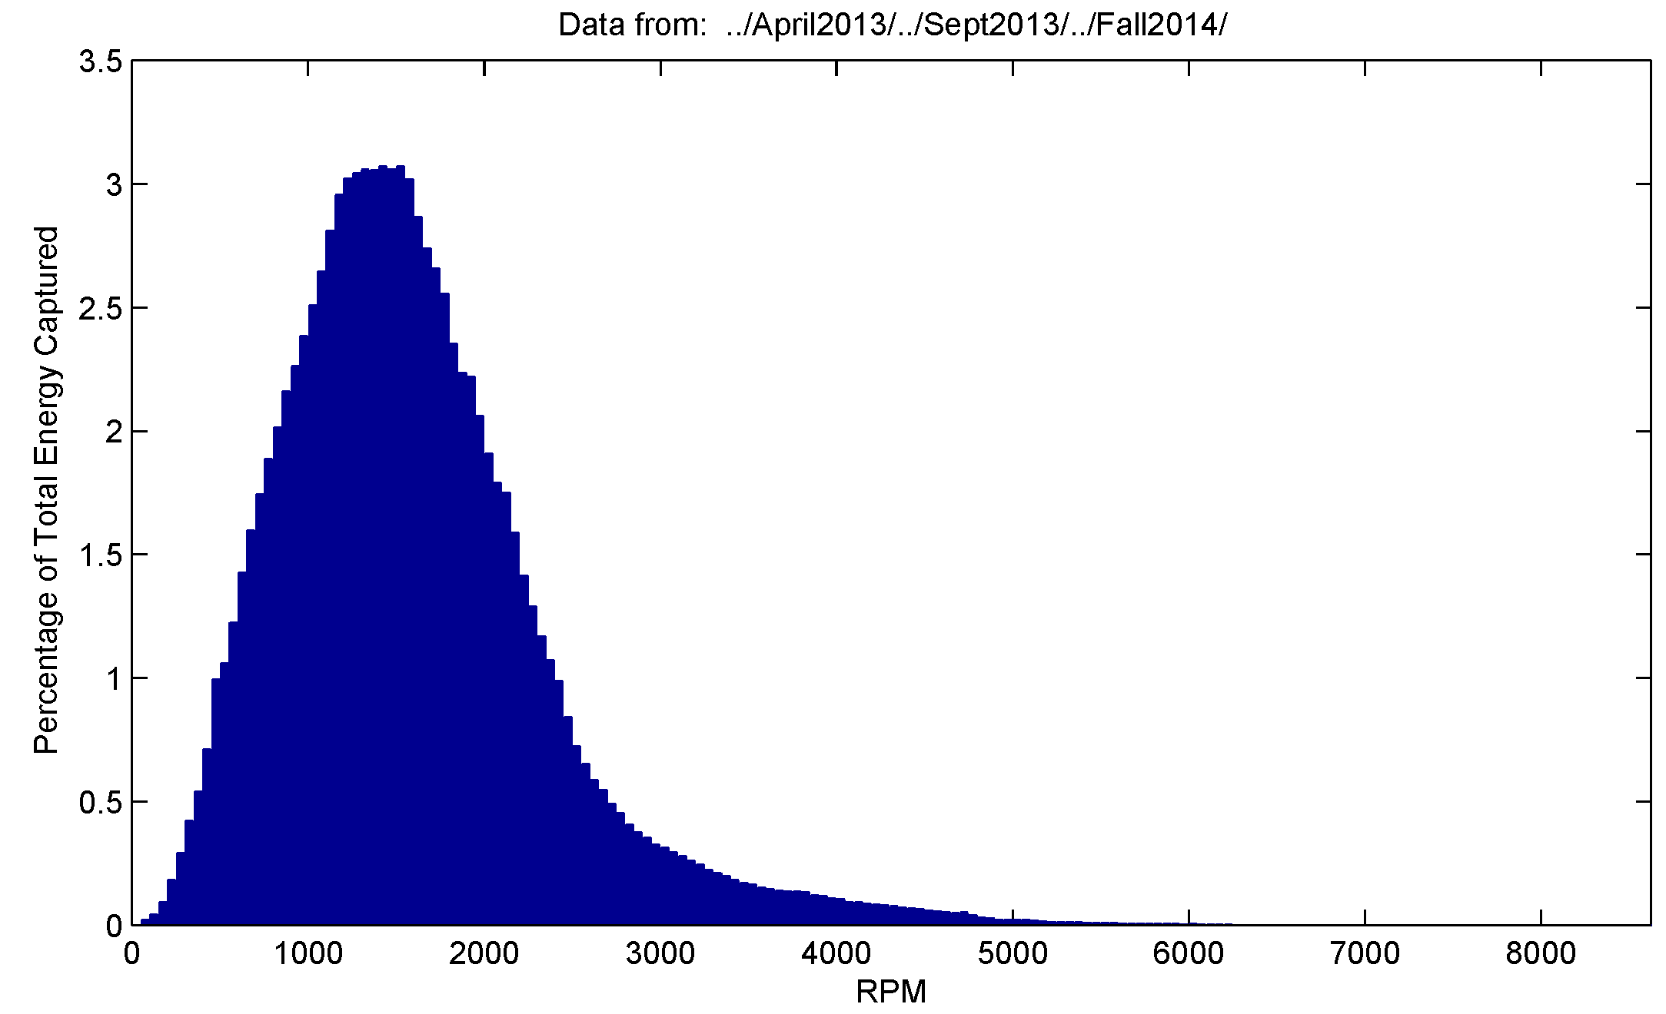
Figure 2 Histogram of energy capture versus generator RPM. The bulk of the energy captured by the system occurs between 1000 and 3000 RPM, so the systems efficiency should be optimized in this range.
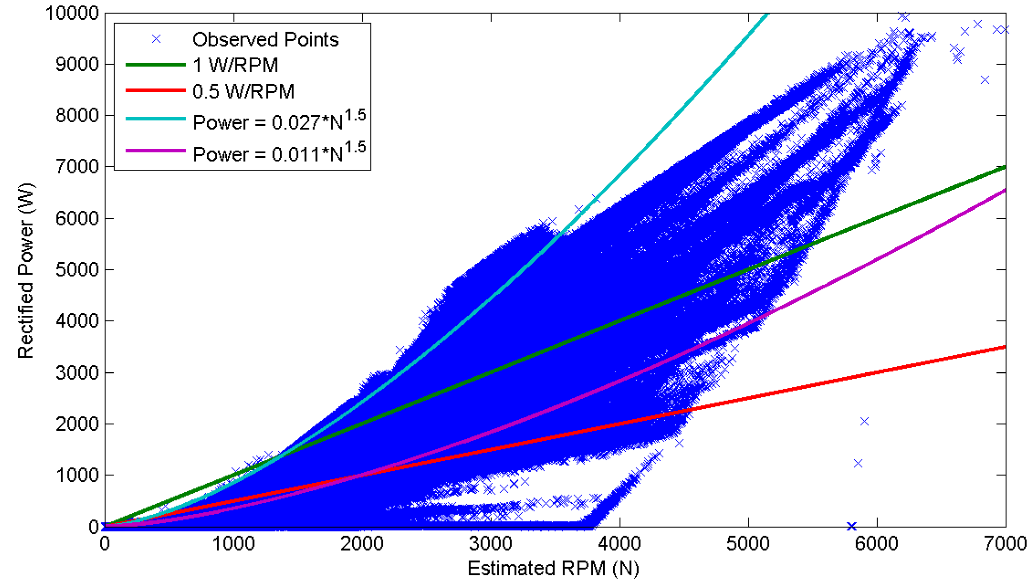
Figure 3 Output power versus generator speed operating points.

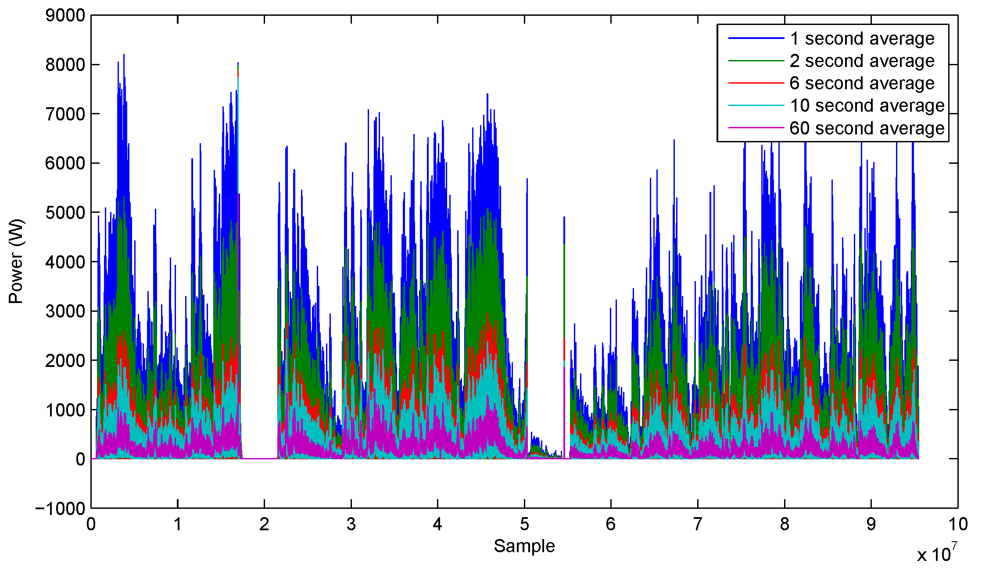
Figure 4 Time histories of power captured, filtered by various length moving average windows.

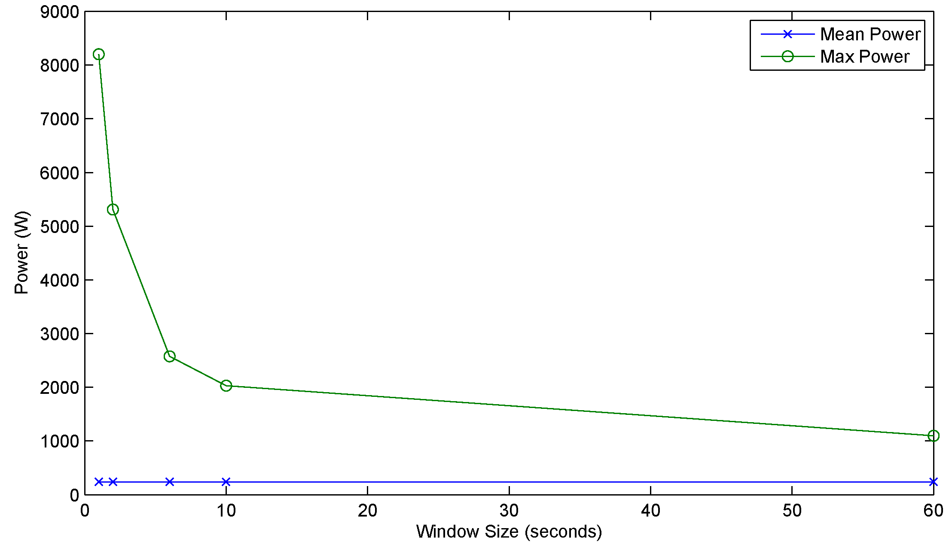
Figure 5 Max observed power for each window size.

Requirements
In addition to being able to handle the power levels described above, and being optimized for efficiency between 1000RPM and 3000RPM, additional requirements for the system include:
- An ability to act as a battery charger that delivers more power when the battery bank is discharged, and less (zero) power when the batteries are fully charged. Additionally, the power converter should limit electricity flowing to the batteries to a peak voltage and current. These targets depend on the size/type of battery pack installed.
- An ability to maintain a target load on the hydraulic motor that is a function of motor speed and direction. This target needs to be adjustable during operation as the wave-energy platform performs best when lightly loaded in calm sea-states, and heavily loaded in rough sea-states.
- An ability to dump excess power safely to maintain the loading targets if the batteries are full and cannot accept additional charge.
- An ability to operate independently, with or without a battery connected (in case of a failed cable or batteries),
- An ability to provide a low-voltage (i.e. 24V) connection for independent buoy equipment to draw power from. In the case of depleted batteries, the system shall turn this voltage off to preclude external equipment from discharging the battery pack below safe levels. Some hysteresis in this low-voltage disconnect is required to keep the disconnect from cycling.
- The power converter shall collect instantaneous voltage and current data during operation and make that available for logging by an external buoy controller, no long-term storage of performance data within the power system is required.

Other Desirable Features
In addition to providing the capabilities described above, there are a handful of other features that are desirable, but are not absolutely required for upcoming test deployments.
- Bi-directional operation. In some applications, it may be desirable to run the generator in reverse and use the power system to move the hydraulic ram in and out. To accomplish this the system needs to be able to transfer energy from the batteries to the generator to run it as a motor. Typical applications would require at a minimum a torque mode, and possibly the ability to close a loop to maintain a measured value at a target (such as a pressure sensor indicating the depth of the submerged anti-heave plate).
- The ability to adjust the operating point of the converter (load versus RPM) based on recent (10’s of minutes) history of the generator behavior (RPM) which represents the current sea-state.

Proposed Design Overview
In order to meet the requirements and goals described above, the design that has been pursued is a boost-only power converter that boosts the output of a permanent magnet generator (whose output voltage depends on RPM) to a higher voltage battery bus. This design uses the inductance of the motor windings as the inductive element, uses MOSFETs for the rectifier bridge, and includes a large (1mF) capacitor to smooth the output. By turning on the lower three FETs in the bridge for part of a high frequency cycle (20kHz), the output voltage of the bridge is boosted above the generator voltage depending on the ratio of on-time to off-time of the lower three FETs in the bridge. Typical of a boost converter, the effect is that when the leads of the motor are shorted together, energy accumulates in the windings of the motor and the inductance insists that the resulting current keeps flowing when the lower FETs are turned off. The resulting energy flowing onto the bus is at a voltage higher than it would otherwise be in a simple rectifier. By adjusting the pulse width of the signal driving the lower part of the bridge, the output voltage can be controlled. The capacitor on the bus filters the resulting ripple and relatively constant current flows up to the batteries.
The control system is relying on the fact that the batteries draw higher current when a higher voltage is applied, this allows the control system to adjust the total power (increasing voltage increases current) and hence can follow a target power which is a function of motor RPM as desired. In the case that the batteries are full, and therefore can’t draw power without exceeding their peak voltage, the control system must dump the excess power through a power resistor. This is done by pulse-width-modulating a single transistor which is on the low side of a resistor that is well heat-sunk by the sub-sea housing itself. The control system to achieve this functionality is described in more detail below.
The battery system is nominally selected to be 24 lead-acid batteries in series, fully discharged these have a voltage of 250V, and the float voltage for the system is 330V. This provides the range of voltages the system must produce current at. Different battery chemistries would change this requirement somewhat.
Although not required, there are some performance enhancements possible by commutating the transistor bridge.
Design Particulars
- Generator: AKM64S Permanent Magnet motor, Kv = 40V/kRPM, Rw = 0.15 Ohms, Lw = 0. 87 mH. Peak continuous current = 24A.
- MOSFETs: Cree SiCarbide FETs, RDSon = 0.025 Ohms
- Capacitor: 600V, 1.03mF
- Load Dump Resistor. 2X1kW 10 Ohm Ohmite TAP resistor
- Current measurements. Resistive shunts (immune to magnetic fields near to motor/generator)
- Control micro-controller: dsPIC33FJ
- Bus Voltage (250V->330V), corresponds to 24 Lead-Acid 12V cells in series.

Figure 6 Block diagram of major power system components. Everything in this drawing except for the batteries will be in a single housing sub-sea. The control system is microprocessor based (dsPic) and is responsible for monitoring the output voltage and current and adjusting the bridge and load dump PWM signals. Not shown is a fourth circuit board that provides 15V from the high voltage bus to power the controller board, measurement board, and bridge board.

Prototype Performance
Most of this system has been prototyped in the lab, performance measurements have been made by spinning the generator with a second motor that allows the entire operating range to be exercised. Figure 7 shows the test setup.
Estimates of the boost converter behavior can be made by making some small-ripple assumptions about the current flow, and equating the energy stored in the windings during the charge part of the cycle with the energy accepted by the capacitor in the discharge part [Ref: Erickson & Maksimovic]. Since the time spent in each is a function of the duty cycle, the analysis results in an estimate of output voltage as a function of duty cycle for various loadings. Figure 8 presents some of the test data collected at two loadings, 0.5W/RPM, and 1W/RPM. As can be seen the measured results consistently underperform the expected results. This is most likely because although the model includes the generator winding resistance and the FET on resistance as loss terms, it does not include losses that occur during transistor switching, the diode voltage drops, or a myriad of other small losses.
As can be seen there is a duty cycle above which the boost effect diminishes, meaning that there is a peak output voltage achievable. As can be seen, at the speeds illustrated, the 330V peak target necessary for charging the batteries can be achieved in all cases.
The maximum power levels tested so far have been limited by failures that occur at higher power levels. These failures are under investigation and are likely related to ringing seen on the FET gate drive lines. To control these oscillations resistance has been included in the gate drive signal which slows the transition time, and increases switching losses. An improved prototype board is under development.
In spite of the failures, this test set-up has allowed us to prototype nearly the entire system, include the current and high voltage measurements, data acquisition, control system, and CAN communications.

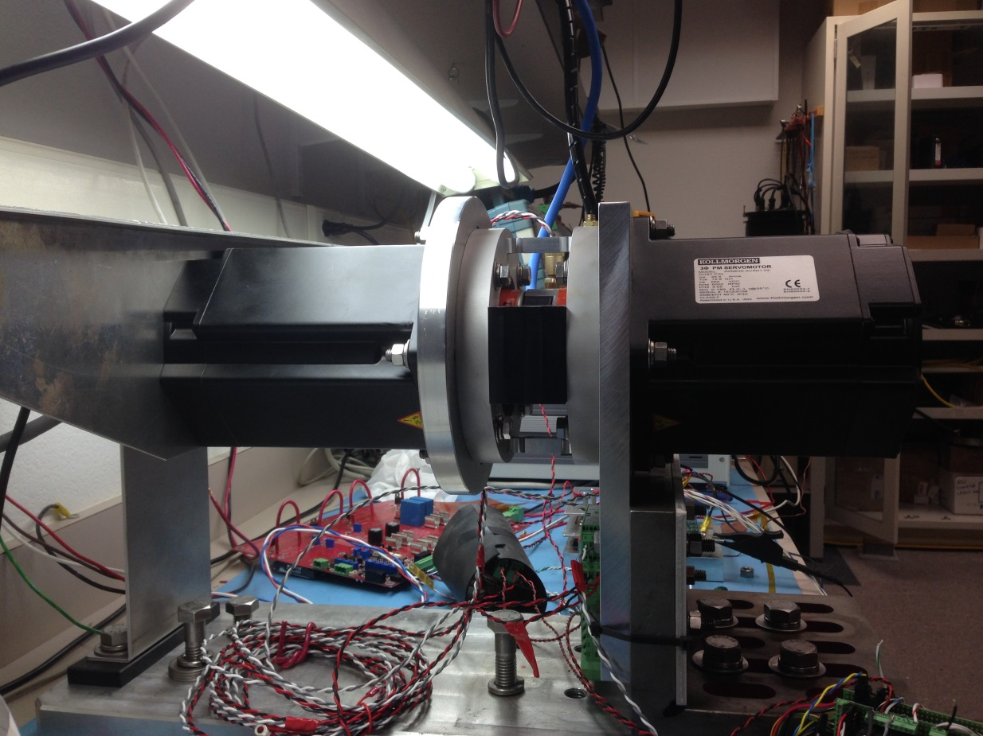
Figure 7 Lab test setup, the motor on the right is the driving motor, and the generator under test is on the left. Between the two is a torque sensor for measuring mechanical input power. The sheet-metal wings on the left are to support calibrating weights for the torque sensor, and the sheet metal angle behind that hold the power conductors and encoder wires at the axis of the motor so they contribute as small a torque as possible.
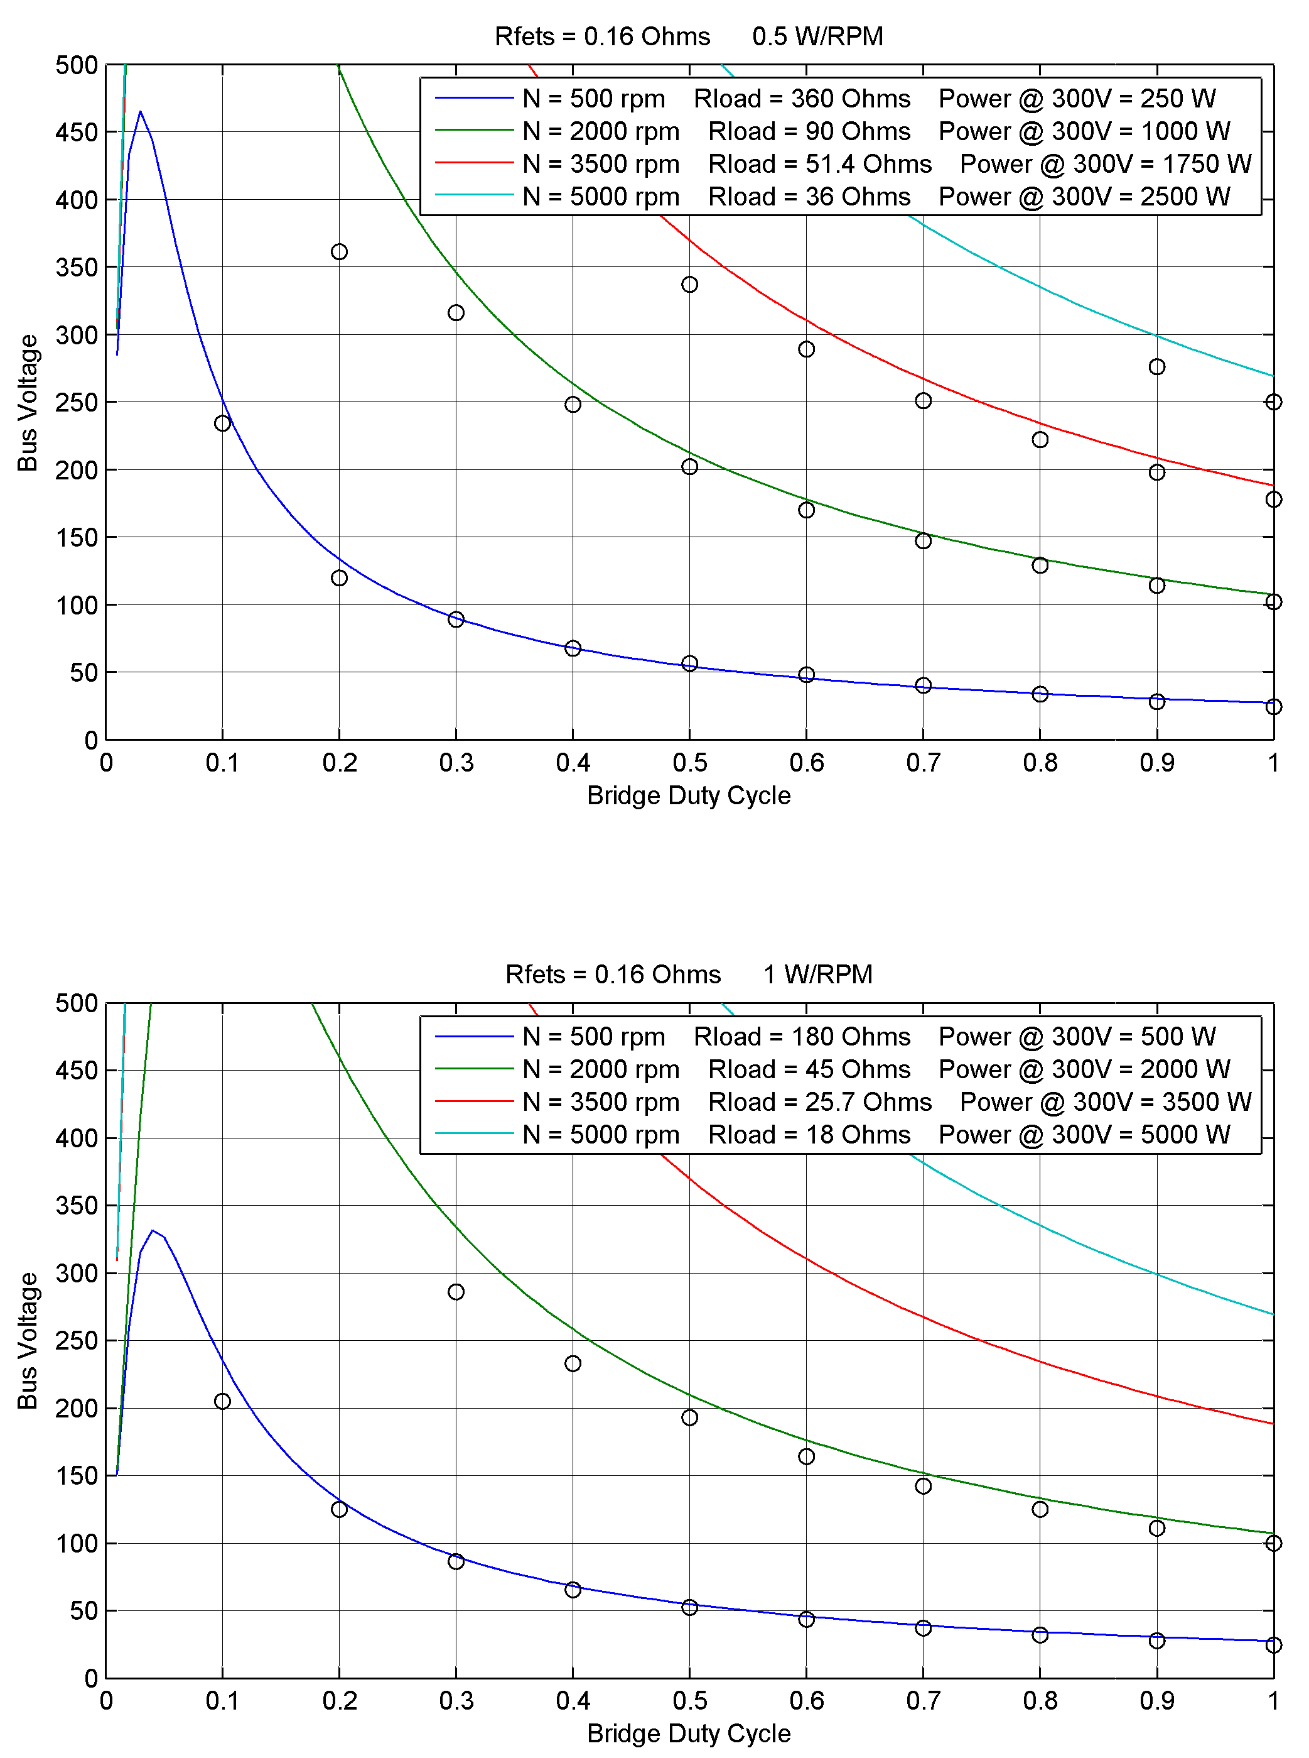
Figure 8 Test results for output voltage at different boost duty cycles, motor speeds, and loadings. The colored lines are predictions that include the winding resistance and FET on resistance as loss items, the black circles are measured results.

Reference Materials

- System Block Diagram and Overall Wiring Diagram
- Power Converter Housing Mechanical Arrangement
- Bridge Board Schematic and Specifications
- High Voltage Measurement Board Schematic
- BootStrap Power Supply Schematic
- Controller Board Schematic
- Battery System Schematic
- Firmware Overview
- Electrical Safety

