Deployment of Power Buoy
By François Cazenave 12/30/2010.
This document describes our plan for deploying the power buoy.
Tentative deployment date: Last week of January – Depending on weather.
Ship: RV Shana Rae and small boat for maneuvers in harbor.
Plan of action:
One day before deployment:
- The submerged plate shall be attached to the back of Shana Rae (figure 1). The plate shall be attached using 3 pad eyes. The main one is at the top, attached to the A frame, and two on the sides. The line used to lower and recover the plate must be approximately 60 m long. It shall be tied to the winch with a knot or splice that can easily be removed and fit through the A frame block.
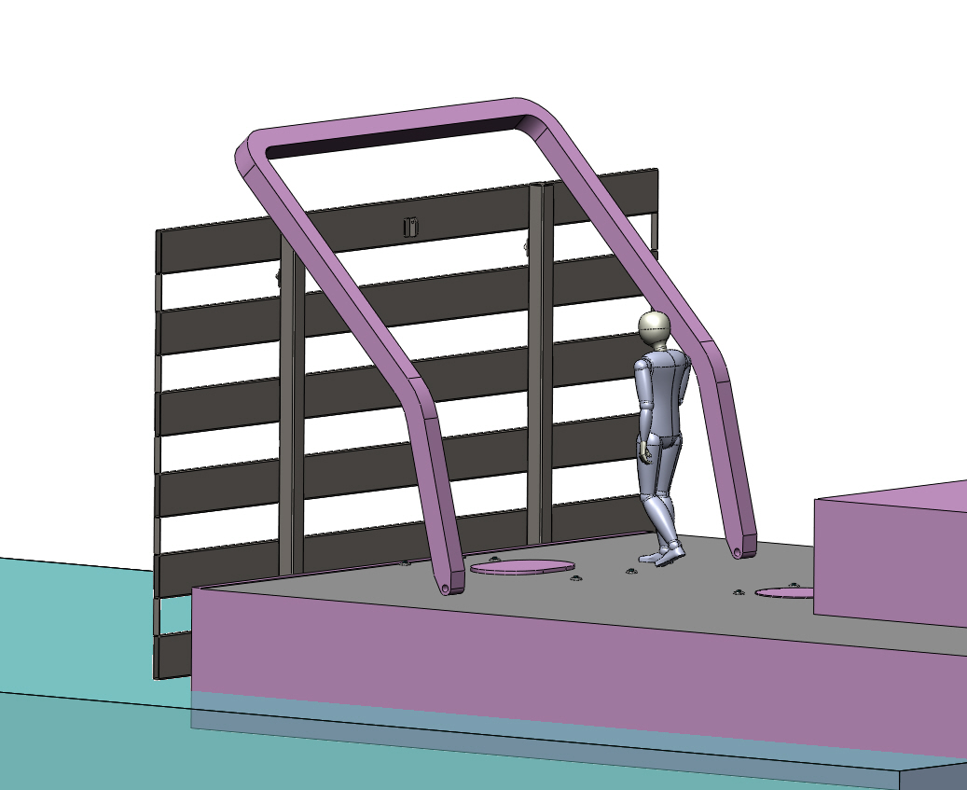
Side attachment
Side attachment
Main attachment
Figure 1.
- The powerbuoy shall be placed on the dock (figure 2) and the lifting rig shall be tested with the crane.
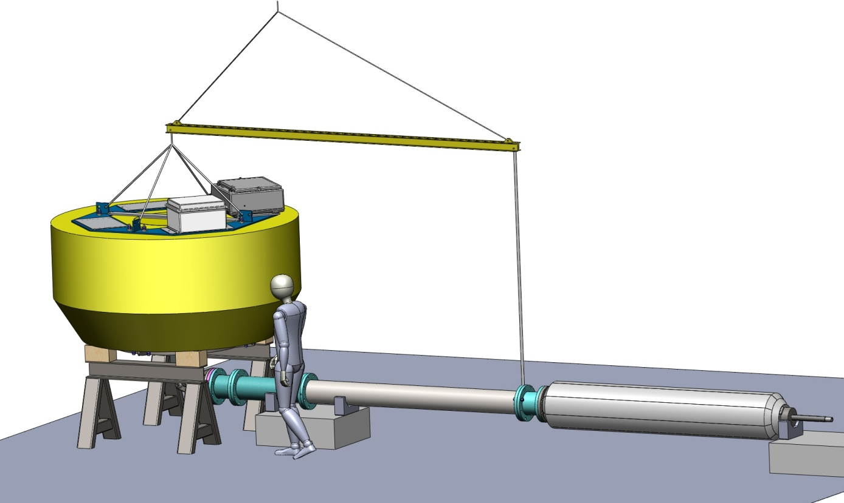
Figure 2
Deployment
The buoy shall be placed in the water, behind the Shana Rae, using the crane. The PTO shall be aligned with the boat, behind the buoy (figure 3). The buoy shall be tied with a line to the back of the Shana Rae using two attachment points (one on top of the buoy and one underneath, to keep the buoy level during tow). The tether shall be attached to the bottom of the PTO, strung along the PTO and the buoy, and attached to the plate.
A small boat shall be used to help guide the PTO during the maneuver out of the harbor.
The buoy shall be towed out a few miles offshore. The Shana Rae shall not make tight turns to prevent damage to the PTO attachment.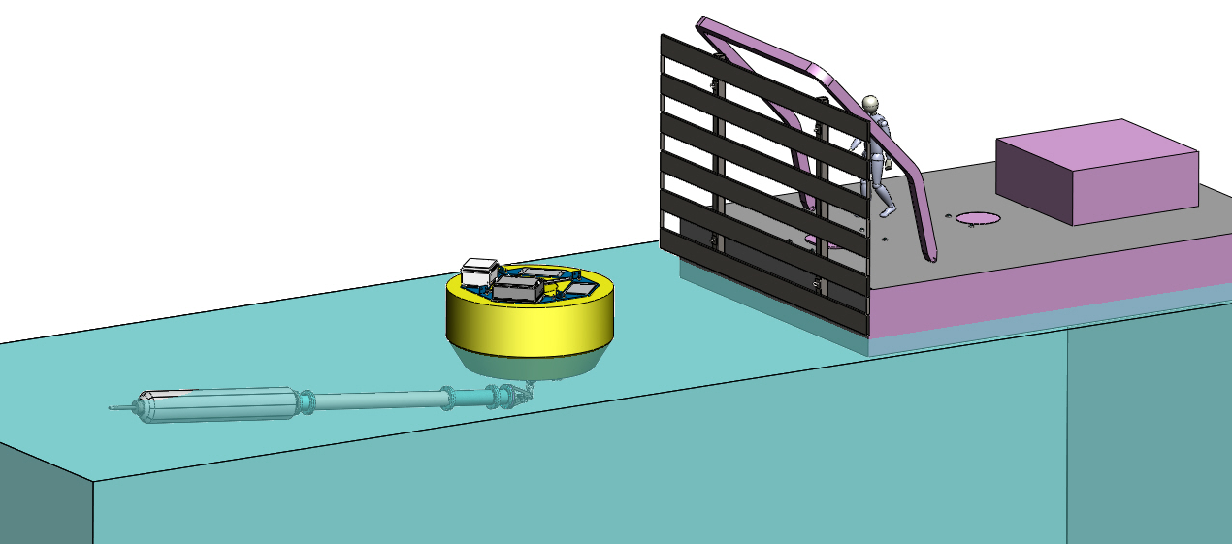
Figure 3
Once arrived at the proper location (about 5 miles out, over the shelf) the buoy shall be released. The Shana Rae shall very slowly motor away from the buoy until the tether (between the bottom of the PTO and the plate) is taut. The plate shall then be lowered, while still slowly motoring away from the buoy, to keep the PTO away from the back of the boat. Eventually the PTO will sink, under the weight of the submerged plate (figure 4).
The line used to lower the plate shall be untied from the winch, an easily visible float shall be attached to it and it shall be let loose.
The buoy shall be monitored for a few hours.

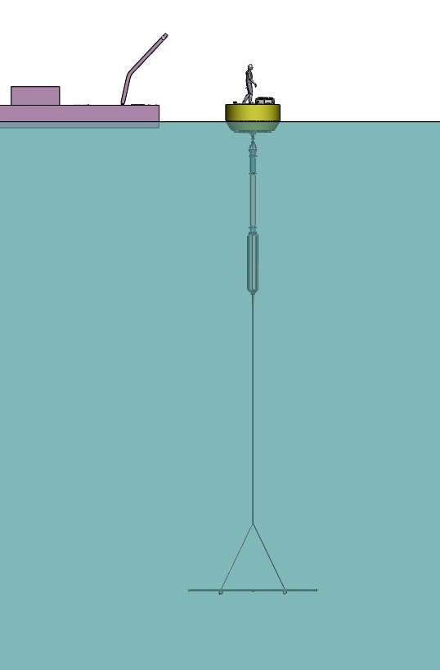
Paul chasing the seals
Figure 4: Plate depth: 20 m.
Recovery:
The float shall be recovered and untied from the line. The line shall be threaded through the A frame block and tied to the winch. While slowly motoring away from the buoy, the plate shall be brought to the surface and attached to the back of the Shana Rae. It is important to keep the boat away from the buoy because while the plate is being recovered, the PTO will float back to the surface, in an unpredictable manner.
Once the plate is secured, the tether shall be untied from the plate and let loose.
Shana Rae shall approach the buoy so that the towing line may be attached to it. The buoy shall be towed back to the harbor. A small boat shall be used to help guide the PTO and buoy during maneuvers in the harbor. The buoy shall be recovered using the crane.

Possible problems:
It is possible that the recovery line may get tangled around the PTO. In that case, we will try to pull on it to untangle it. If that does not work, divers will have to go untangle the line or tie a new line. This may be a dangerous operation which will have to be discussed and carefully planned with DSO Kim R.
If we are unable to recover the plate, an anchor shall be attached to the buoy and it shall be recovered later when conditions are better.

Hardware:
- 2 tethers (for 20m and 30m plate depth), with splices and hardware
- Tow line and convenient attachment to two points on both sides of the buoy.
- Line for plate deployment and recovery + 1 spare and all required hardware.
- 1 small float.
- Diving gear.
- 1 anchor for buoy in case recovery in not feasible.
Crew:
Andy Hamilton, Paul McGill, Wayne Radochonski, François Cazenave, John Ferreira, Jim Christmann, Kim Reisenbichler (or other MBARI diver).

