Summary of performance of tether and bridle during Powerbuoy deployments:
  - Engineer: François Cazenave
Date: January 17 2018
This document gives a brief summary of the performance of the tether and bridle during several deployments. Relevant details are listed. A quick summary is included at the end.

June 26 to July 10 2012 deployment:
Deployment was ended after one leg of the bridle broke. The bridle was stainless steel wire and much too weak.

November 13 to December 19 2012 deployment:
Submerged plate configuration:
Weight: 2130lbs (1830lbs in water).
Projected area: 13.75m²
Outside dimensions: 18’x10.2”. (see drawing on pdf document)
Estimated Added Mass = 9250kg
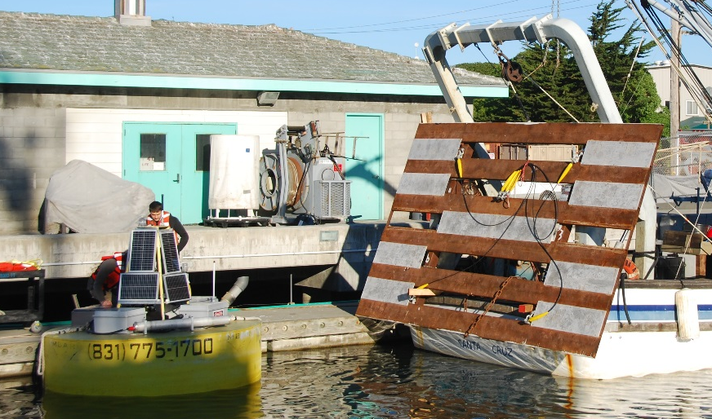

Tether:
The tether was spectra with splices on each end. The upper section that goes through the tether guide was 7/16 nilspin (18800lbs breaking strength) with swaged termination
Bridle:
The bridle was nilspin wire.
Failure:
The tether failed 17 days into deployment, after high sea state for several days. The nilspin section failed at or near the termination after the piston bottomed out. A spectra rope that was attached at the bottom of the PTO may have contributed to the failure when getting tangled with the tether (see before and after photos below).

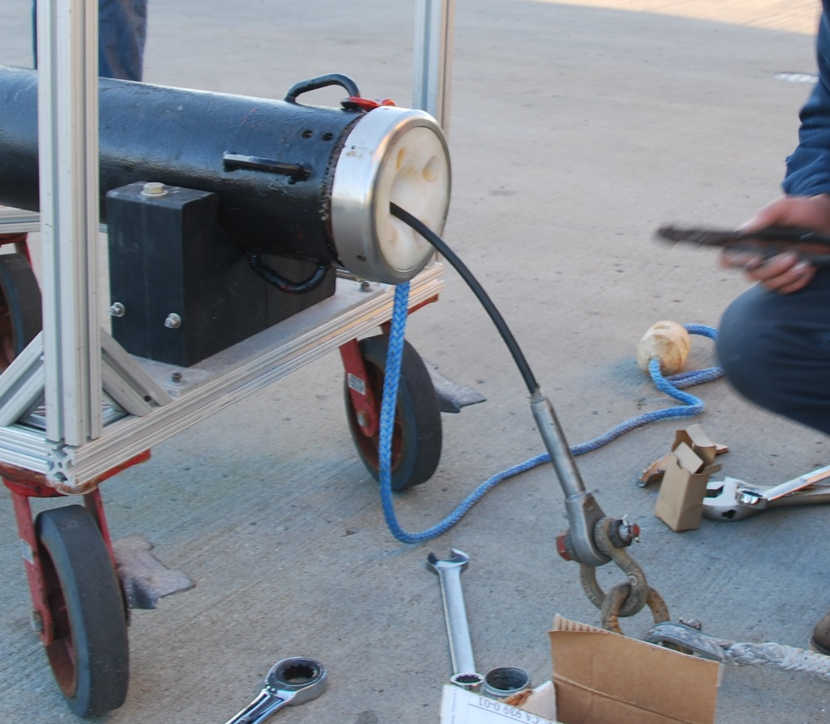.
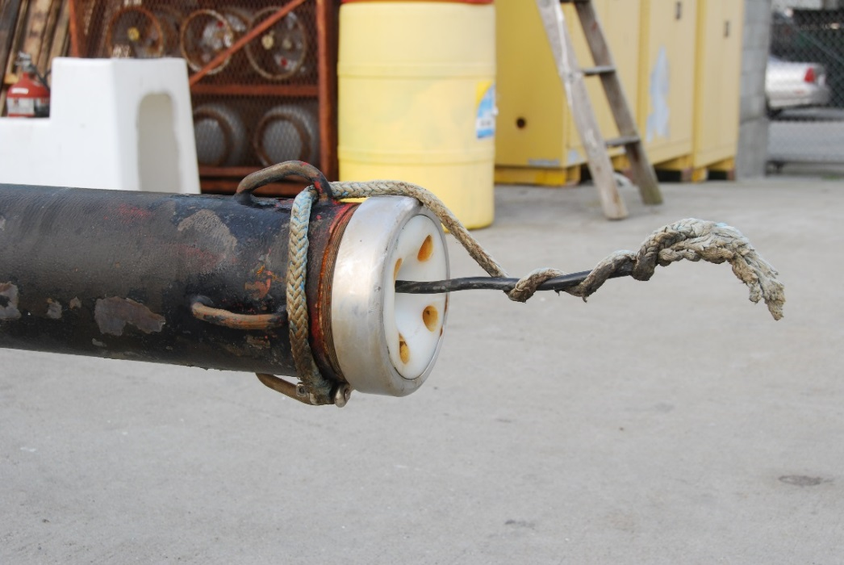

Piston position:
Piston mean distance was 40” throughout the deployment. There were numerous bottom-outs, even during moderate sea state.
Recorded loads
The load cell was not used for that deployment.
Weather:
The failure occurred during one of the most powerful storm of the winter. There was another powerful storm two weeks before.
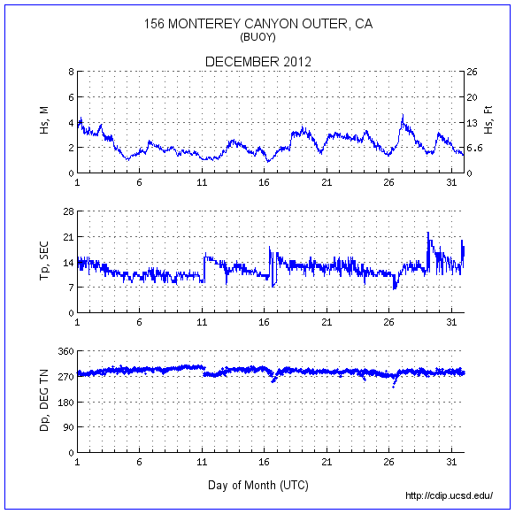

April 24 to May 20 2013 deployment:
Submerged plate configuration:
Projected area: 15.6M²
Weight in air = 2300lb, weight in water =1951LBs.
Estimated Added Mass = 15900kg

See pdf document in folder
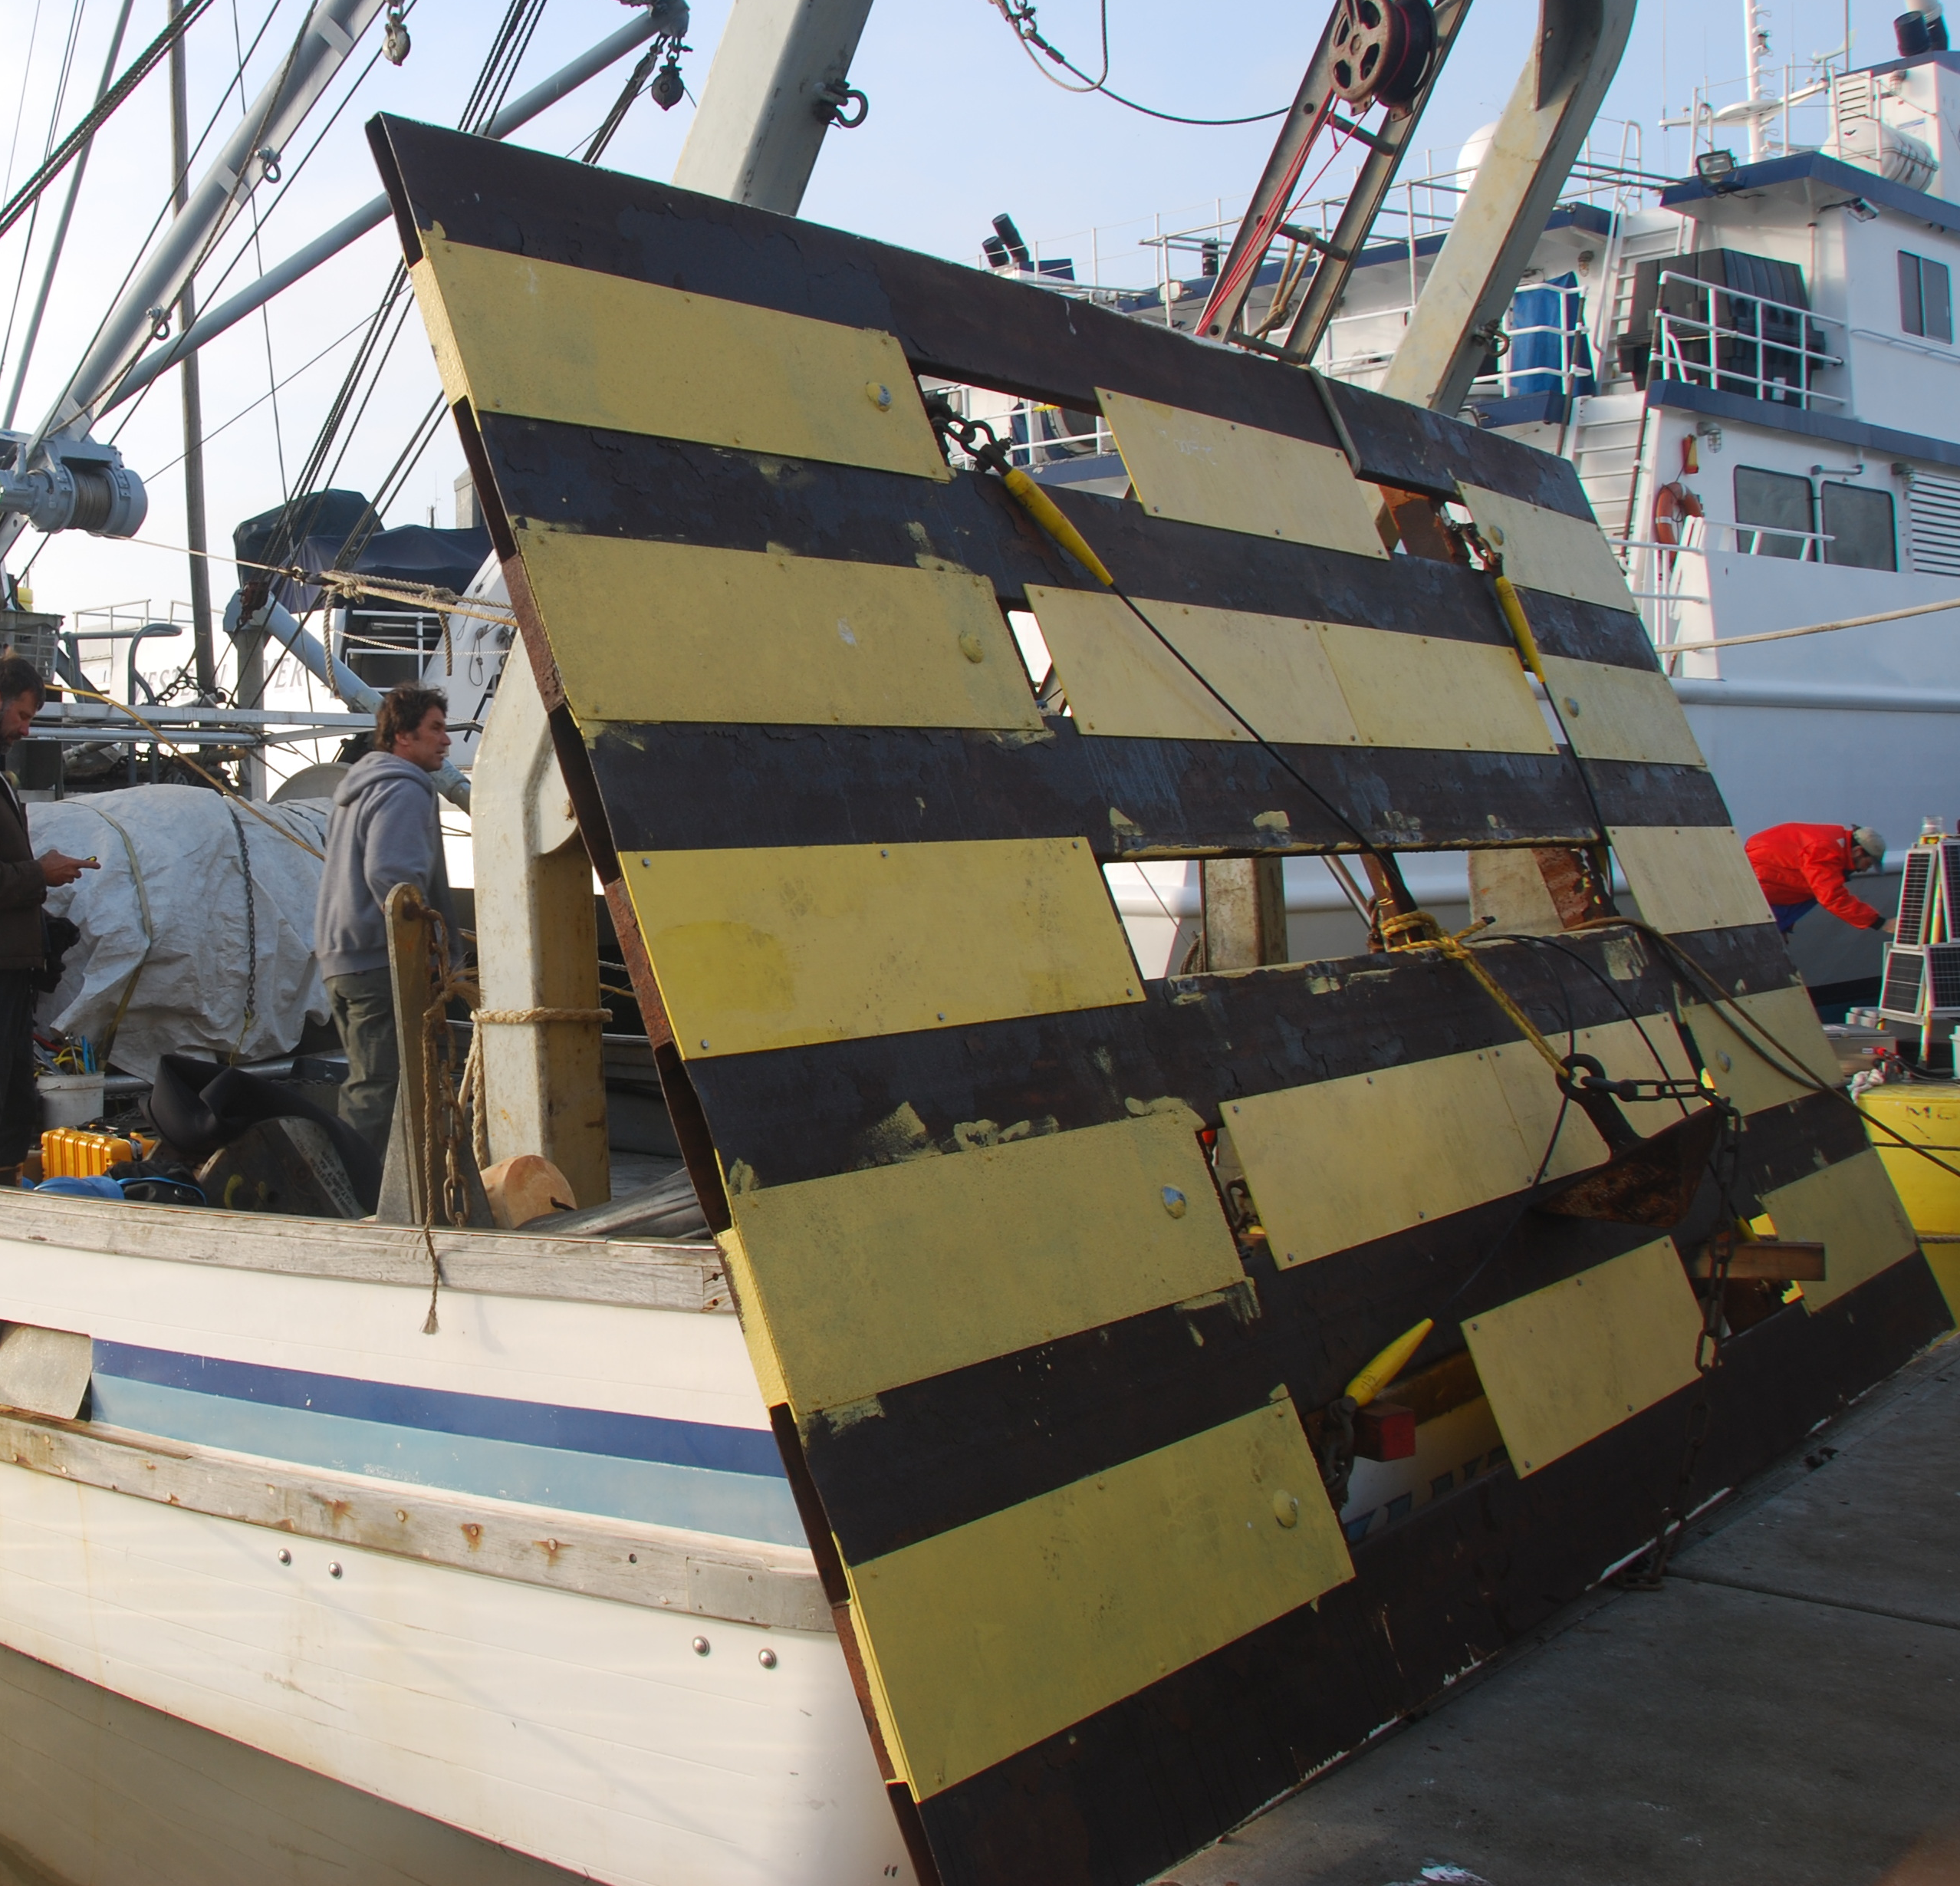
Tether:
The tether was 7/16 nilspin (18800lbs breaking strength) with swaged terminations.
Bridle:
The bridle was nilspin wire.
Failure:
The deployment ended after 25 days when gas leaked out of the PTO. The piston bottomed out and caused high loads on the tether which broke. The buoy went adrift and had to be chased at night. The plate sank to the seafloor and was later caught with a grapple.
Failure data file: D000030_130517_175612.mat
Piston position:
Piston distance drifted during the deployment due to a gas leak. It was near 30”at the beginning and near 35” near the end. There a few bottom-outs during stormy weather. At the very end, the gas leaked and the piston bottom out completely. Minimum piston distance was never lower than 15” (i.e. 15” of the cylinder were never used).
Recorded loads
The load cell was used for that deployment. Mean load was about 2750lb. Max load on wavy days was 8000 lb. When the piston bottomed out, the load exceed the load cell’s capacity (10000lb). Detailed analysis of load cell data is needed.
Weather:
The failure occurred during a strong NW wind event, with powerful short period waves.
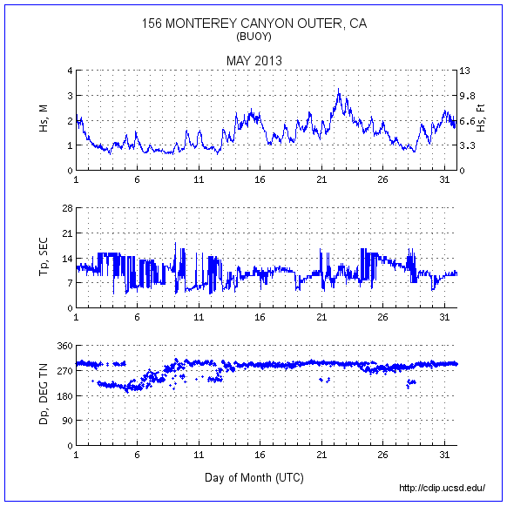

September 3 to October 16 2013 deployment:
Submerged plate configuration:
Weight and area: similar to November 2012 deployment.
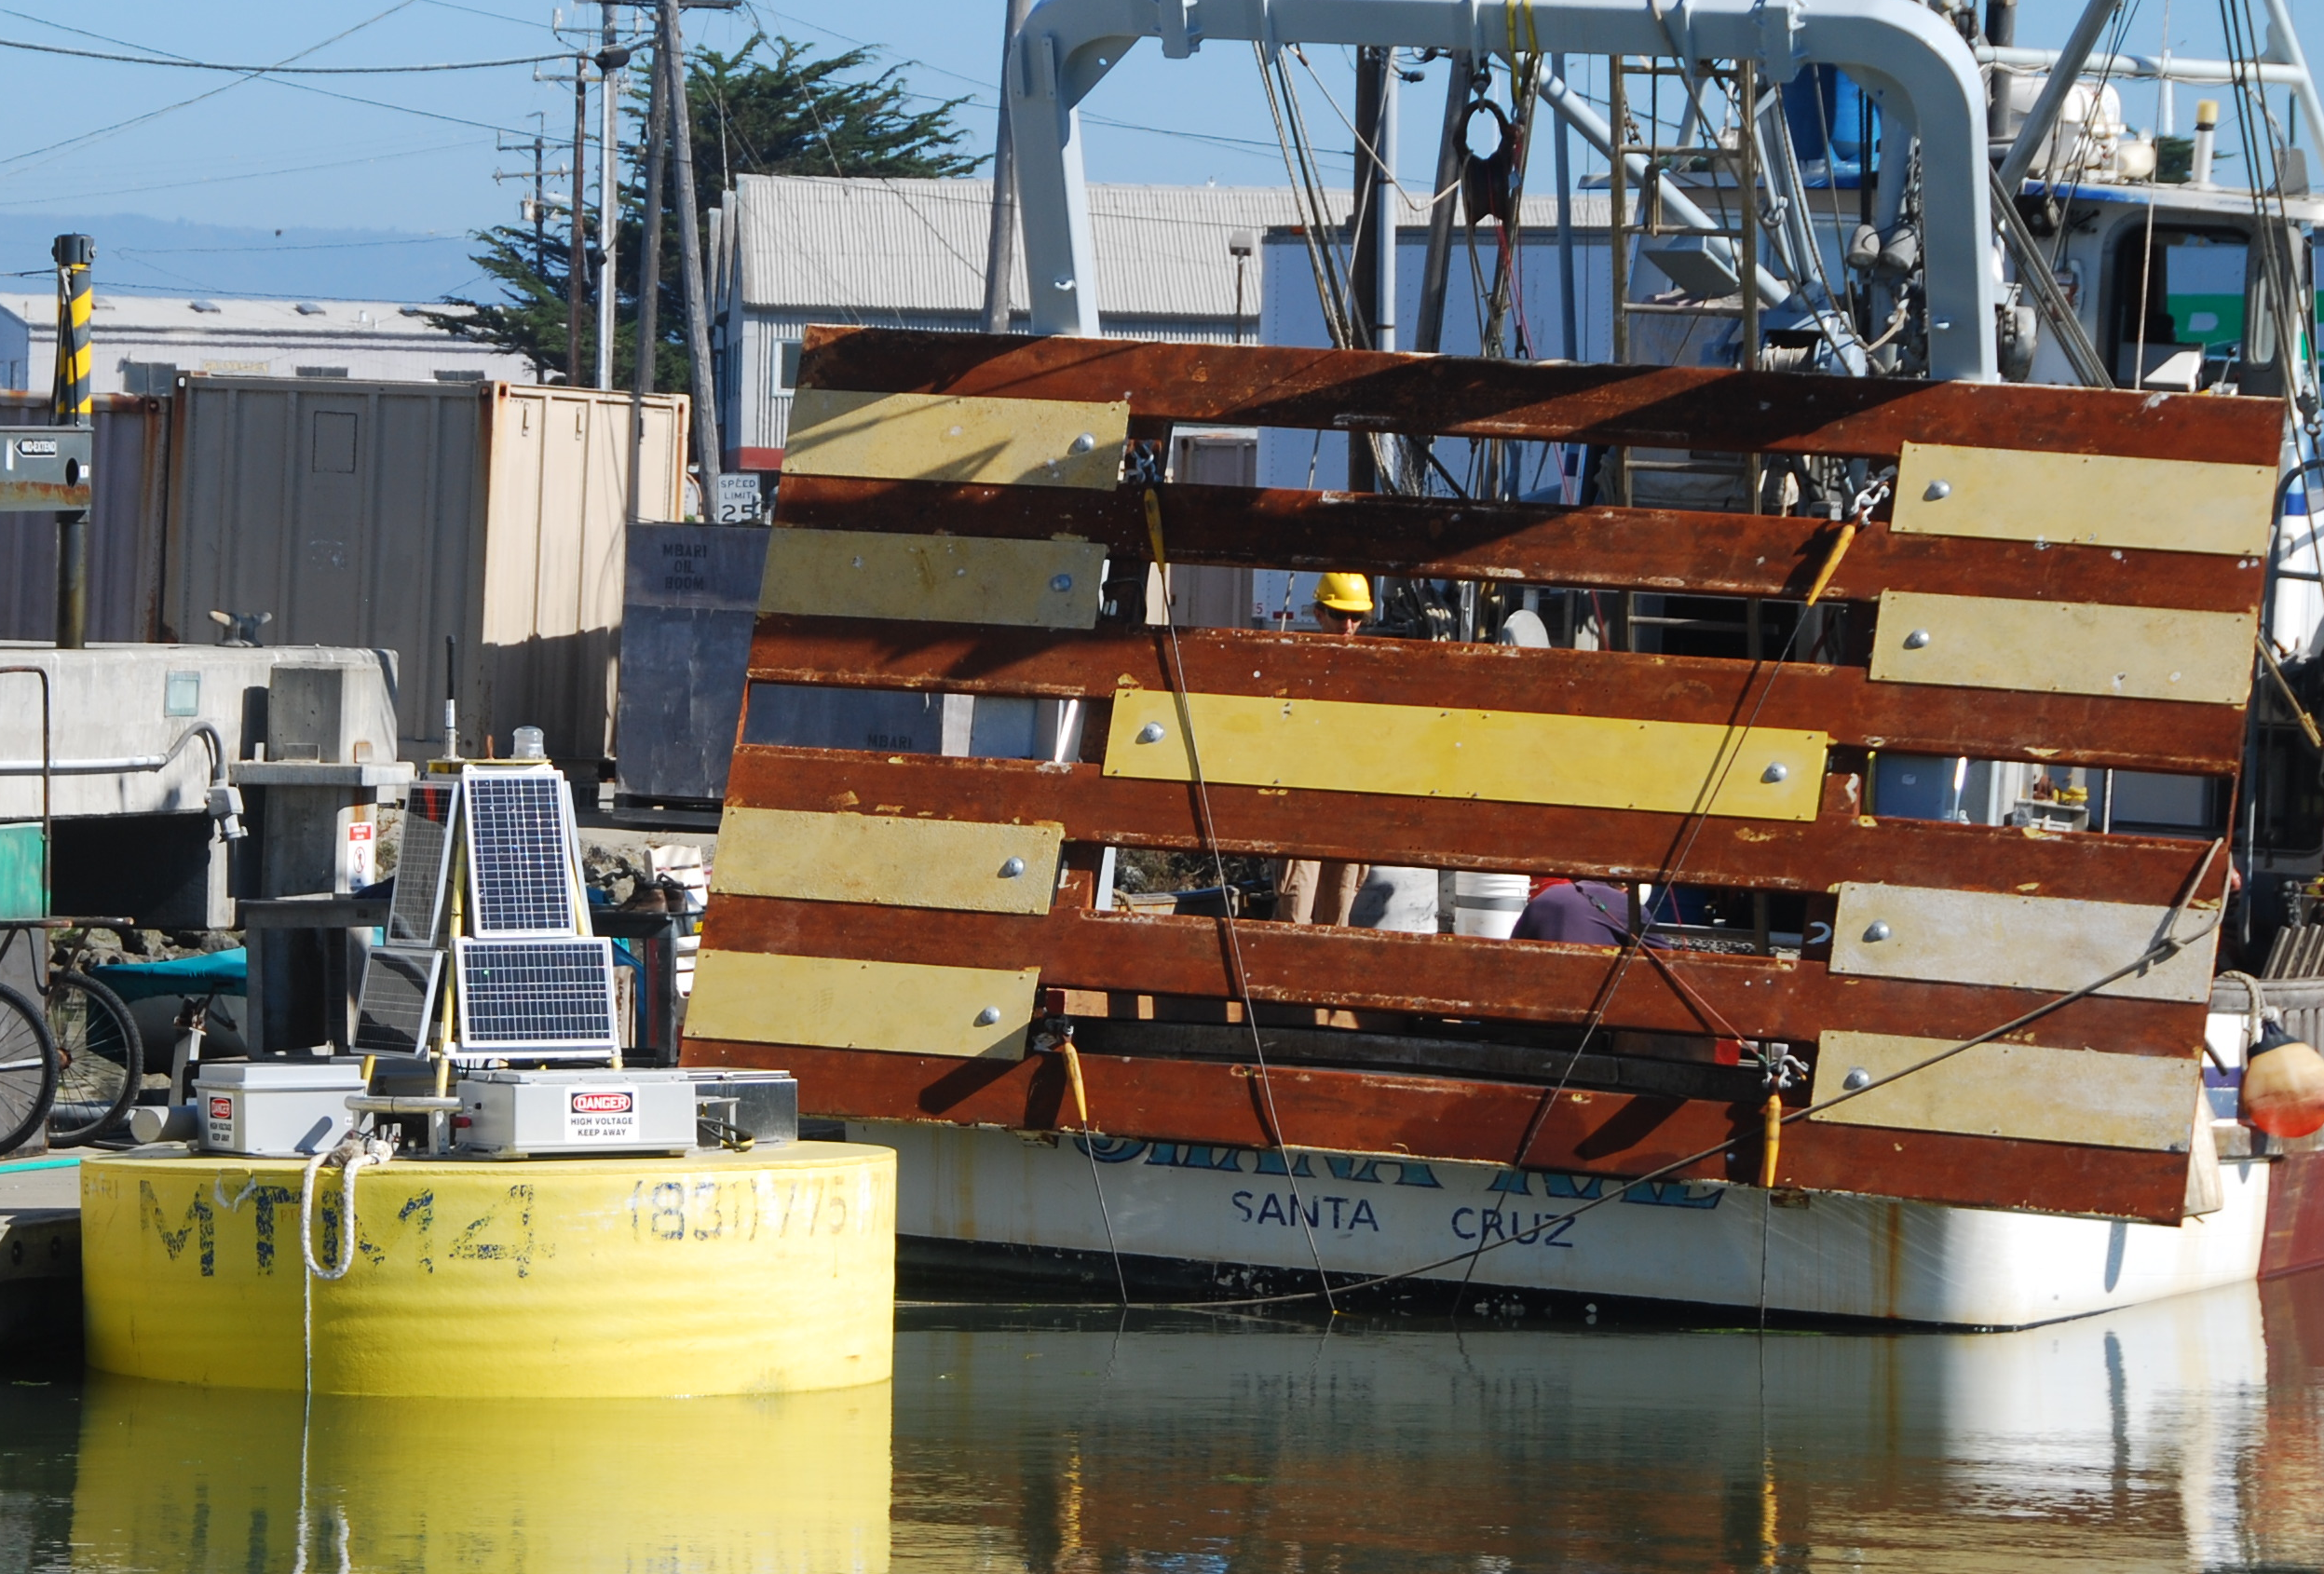
Tether
The tether was 5/8 nilspin (35000lbs breaking strength) with terminations potted by TMT.
Bridle:
The bridle was nilspin wire.
Failure:
The deployment ended after 43 days. One, then another of the bridle legs broke, likely due to fatigue in bending of the nilpsin going slack.
Piston position:
Mean piston distance was 25”-30”. The piston bottomed out a few time during stormy conditions. Minimum piston distance was 7”.
Recorded loads:
The load cell was used during this deployment. Mean load was about 2700lb, max load was about 8300lb.
Weather:
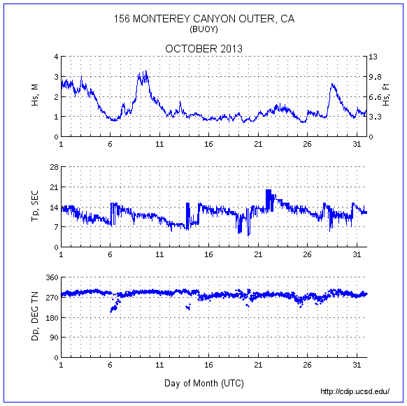

September 4 2014 to January 14 2015 deployment:
Submerged plate configuration:
Compliant plate.
Tether:
The tether was custom 5/8” steel wire (35000lb) with electrical conductors. Terminations were potted at TMT.
Bridle:
½” long link chain.
Failure:
The deployment lasted 132 days. The tether and bridle were intact at the end of the deployment.
Piston position:
The piston drifted due to gas leaking. Mean position started at 25” and went as low as 40”. Piston minimum was 10”-15”. Maximum was 80” a few times.
Recorded loads:
The load cell was used. Mean force was about 2500lb. High sea state max was about 7000lb. Data needs to be plotted.
Weather:
Hs exceeded 4m on one occasion.

February 2016 to March deployment:
Submerged plate configuration:
Compliant plate.
Tether:
The tether was custom 5/8” steel wire (35000lb) with electrical conductors. We built custom termination and add them potted at TMT.
Bridle:
½” long link chain.
Failure:
The deployment lasted 31 days. A leg of the bridle broke due to a weld on a pin that cracked a caused the pin to come out. The compliant plate broke and sank. The tether was intact.
Piston position:
Only hourly plots are available. But from looking at a few, it seems like mean position was 30” to 40”.
Recorded loads:
The load cell was used. Mean force was about 4100lb (there seems to be an offset in the data). Data needs to be plotted. During storm, load cell force was near 10000lb (possible offset).
Weather:
There were very large waves, reaching nearly Hs=6m on two occasions.
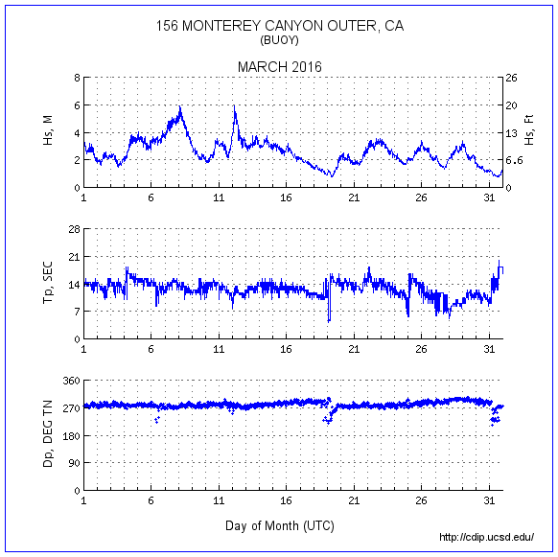

February 9 2016 to March 11 2016 deployment:
Submerged plate configuration:
Compliante plate
Tether:
The tether was custom 5/8” steel wire (35000lb) with electrical conductors. Terminations were potted at TMT.
Test ended when leg of bridle broke and compliant plate disintegrated and fell to the seafloor.

March 9 2016 to March 11 2016 deployment:
Submerged plate configuration:
Flapping foil device
Tether:
The tether was custom 5/8” steel wire (35000lb) with electrical conductors. Terminations were potted at TMT.
Bridle:
No bridle.

October 2 2016 to March 11 2016 deployment:
Submerged plate configuration:
Flapping foil device
Tether:
The tether was custom 5/8” steel wire (35000lb) with electrical conductors. Terminations were potted at TMT.
Bridle:
No bridle.

Summary

- The long link chain bridle is reliable. Do not weld the pins.
- The 7/16” tether (18000lb breaking strength) survived very stormy condition but failed on two occasions due to high seas and aggravating factors (tangled line (maybe) and bottomed out piston). The 5/8” tether (35000Lb) survived several deployments in high seas without loss of strength and is likely a reliable option even with the largest plate.
- The upper 15” of the piston was almost never used. Moving the mean position up will help prevent the piston from bottoming out. Preventing the piston from bottoming out is critical to prevent high peak loads.
- Further analysis of load cell data and comparison with plate size and sea state will be useful in sizing the new plate.

