Hi Denis, here's the list I started to put together this morning, with a few notes on my ideas also. The model I made is here: X:\707976 EPBuoyPrototypeAndTesting\BoostController\BatteryPackaging\24-14A-HrBattBox.SLDASM

I believe the best approach is to stay with lead-acid batteries for this deployment, at this point we don't need a high performance system. The battery subsystem of thing needs to have the following features.
- (24) 12V-14A-Hr lead-acid batteries in series.
- Mean charge power of 1000W, peak charge power, 8000W for four seconds
- A 300V->24V isolated power supply to supply up to 250 Watts to un-specified buoy equipment
- A low voltage disconnect that turns off the 24V to the outside when the battery pack drops below about 260V. This sense circuit needs some hysteresis and also some filtering on the sense to require that the voltage is above or below the thresholds for 10s of seconds.
- A switch that can be operated from inside the box to turn off/on the 24V.
- A fuse on the 24V
- A switch/contactor that can be operated from outside the box, and turn off high voltage to the connector outside the box.
- A fuse on the high voltage.
- A switch and appropriate resistors to slowly charge the 1mF capacitor when the system is initially connected (can be inside the box)
- A capability to monitor each battery for an over-voltage condition that could cause hydrogen to be created. Although a full balancer would be nice, it is most likely not needed for this system and simple monitoring should suffice and is simpler. Monitoring each batteries voltage requires a lot of analog signal isolation and multiplexing. For simplicities sake a threshold voltage monitor will be acceptable..
- Low power overhead. Somewhat arbitrarily, I think we should aim to keep the mean power consumption below 0.5W.
- Ground fault detection. Requirements TBD.

Other potentially nice to have items that aren't strictly required are:
- Hydrogen sensor
- Battery Temperature sensor.
- Moisture sensor.

So, I've been thinking about this a bit and have been thinking of some low power comparators (see Texas Instruments TPS3700) with voltage reference parts to monitor the voltage of each battery. These could be powered by each individual batteries and drive an opto for isolation and provide an "OR" behavior to provide one signal for over voltage, and one signal for under voltage. What to do with these signals is a bit of a question. As a starting point, we could put an instance of our other controller in the box and have it monitor the signals and broadcast the results on the CANBus. This controller could be powered directly through the 300V bus, or alternatively from the 24V supply. In the later case we'd save some complexity but lose monitoring during low voltage conditions, and the low-voltage disconnect would need to not rely on the microcontroller to turn things back on when voltage returns. The advantage of using that board is it has a variety of other analog inputs so temperature and other items in the box could be monitored.

- (24) 12V-14A-Hr lead-acid batteries in series.
  - Power Sonic PS-12140 F2

- Mean charge power of 1000W, peak charge power, 8000W for four seconds
- A 300V->24V isolated power supply to supply up to 250 Watts to un-specified buoy equipment
- A low voltage disconnect that turns off the 24V to the outside when the battery pack drops below about 260V. This sense circuit needs some hysteresis and also some filtering on the sense to require that the voltage is above or below the thresholds for 10s of seconds.
- A switch that can be operated from inside the box to turn off/on the 24V.
- A fuse on the 24V
- A switch/contactor that can be operated from outside the box, and turn off high voltage to the connector outside the box.
- A fuse on the high voltage.
- A switch and appropriate resistors to slowly charge the 1mF capacitor when the system is initially connected (can be inside the box)
- A capability to monitor each battery for an over-voltage condition that could cause hydrogen to be created. Although a full balancer would be nice, it is most likely not needed for this system and simple monitoring should suffice and is simpler. Monitoring each batteries voltage requires a lot of analog signal isolation and multiplexing. For simplicities sake a threshold voltage monitor will be acceptable..
- Low power overhead. Somewhat arbitrarily, I think we should aim to keep the mean power consumption below 0.5W.
- Ground fault detection. Requirements TBD.

Other potentially nice to have items that aren't strictly required are:
- Hydrogen sensor
- Battery Temperature sensor.
- Moisture sensor.

How long is it going to be working?
Number of cycles?

Power Sonic
CORPORATE OFFICE • 7550 Panasonic Way • San Diego, CA 92154 • USA • Tel: +1-619-661-2020 • Fax: +1-619-661-3650
TECHNICAL SUPPORT
Tel: +1-619-661-2020
Fax: +1-619-661-3648
support@power-sonic.com
call 1-619-661-2020 5/20/2015 11:13
Tonya in customer service – forward to tech support
Shaw Pourchian (Persian) – tech support.
Recommending PDC series for fast charging and slow discharging. Look at the mOhm ratings – some PDC series have ½ of resistance, and this translates into better charging characteristics.

1277751263_20100627-TechManual-Lo-Commented.pdf
At 10 C, capacity is about 95% of nominal 20C capacity; at 30C about 103%.
Battery life is ½ for every 10C above nominal temperature.

Discharge
- At 0.1C current or below, to 1.75V / cell , or 10.5V
- At 1C to 2C, discharge to 1.5v/cell or 9V
- 20 hours (0.05C) rate is nominal

Float charging: 2.3/cell or 13.8V
Fast charging: 2.45/ cell or 14.7V

Charge in Cycle Operation:
- Initial charge current do not exceed 0.3C
- Constant current charge, normally 0.1C, and not higher than 0.15C
- Constant voltage charge at 2.45+/-0.05V/cell or 14.7 +/- 0.3V,
- When current drops to 0.01C, battery is full.
- Disconnect, or float to 2.25-2.30V / cell, or 13.5 to 13.8V
- The voltage should not be allowed to rise above 2.45 ± 0.05 volts/cell.

Temperature compensation at cyclic use:
- At 50C, CV charge at 2.30+/-0.05V/cell or 13.80 +/- 0.3V
- At 40C, CV charge at 2.36+/-0.05V/cell or 14.16 +/- 0.3V
- At 30C, CV charge at 2.42+/-0.05V/cell or 14.52 +/- 0.3V
- At 25C, CV charge at 2.45+/-0.05V/cell or 14.7 +/- 0.3V
- At 20C, CV charge at 2.48+/-0.05V/cell or 14.88 +/- 0.3V
- At 10C, CV charge at 2.54+/-0.05V/cell or 15.24 +/- 0.3V
- At 0C, CV charge at 2.60+/-0.05V/cell or 15.6 +/- 0.3V

Temperature compensation for float:
- At 50C, float at 2.225+/-0.025V/cell or 13.35 +/- 0.15V
- At 40C, float at 2.245+/-0.025V/cell or 13.47 +/- 0.15V
- At 30C, float at 2.265+/-0.025V/cell or 13.59 +/- 0.15V
- At 25C, float at 2.275+/-0.025V/cell or 13.65 +/- 0.15V
- At 20C, float at 2.285+/-0.025V/cell or 13.71 +/- 0.15V
- At 10C, float at 2.305+/-0.025V/cell or 13.83 +/- 0.15V
- At 0C, float at 2.325+/-0.025V/cell or 13.95 +/- 0.15V

(20C to 0C float voltage increases by 0.24V).
Mounting
- Shock, vibration – shock absorption
- Avoid upside-down position
- No sparks or flames
- Avoid heat exposure, or place next to heat-emitting components
- Air space between batteries 0.4” (10 mm)
- Never mount in airtight enclosures.

Safety
- Relief valve 2-6 PSI
- Charging in 6-7 hrs (0.15C) is not normally recommended. Unlimited current charging can cause increased off-gassing and premature drying. It can also produce internal heating and hot spots resulting in shortened service life.
- Too high a charge current will cause a battery to get progressively hotter. This can lead to “thermal runaway” and can destroy a battery in as little as a few hours.

Power Sonic PS-12140 F2
- General purpose 12V; 14 AH; 12 mOhm
- Pack of 24: 14 * 24 = 336 AH
- 336 Ah * 12 = 4 kWH
- Charging voltage: 14.7 * 24 = 352 V
- Charge rates:
  - nominal 14*0.1 = 1.4A,
  - max 14*0.15 = 2.1A,
  - absolute maximum 14*0.3=4.2A
- Charge power:
  - nominal 352*1.4=392 W
  - max 352*2.1=740 W
  - absolute maximum 352*4.2=1478 W

Power Sonic PDC-12200
- Deep-cycle battery 12V; 21AH; 8 mOhm
- 7.14 long x 3.03Wide x 6.44 high
- Max discharge current 60 A for 7 min, or 200A for 10 sec.
- Battery pack of 24 in series: 21 AH x24 = 504 AH
- 504 AH * 12V = 6 kWH
- Charging voltage: 14.7 * 24 = 352 V
- Charge rates:
  - nominal 2.1A,
  - max 3.15A,
  - absolute maximum 6.3A
- Charge power:
  - nominal 700 W;
  - max 1058 W,
  - absolute maximum 2116 W

Availability:
Power Sonic PS-12140, 12V 14AH, F2: $38.47 at Mouser
Power Sonic PS-12180, 12V, 18AH, F2 terminal: $56 at Mouser
Power Sonic PS-12200, 12V 20Ah, nut-and-bolt: $67 at Mouser
Power Sonic PSH-12180FR, 12V 21AH, F2 and NB2: $60 at Mouser
Power Sonic PDC-12200, 12V 21AH, T12 terminal (12 mm x M5): $70, Mouser

14 AH *12 V * 24 = 4032 WH at 38.47*1.1 * 24 = $1015 or $251/ kWh
21 AH * 12V * 24 = 6048 WH at $70 * 1.1 * 24 = $1848 or $305 / kWh

LRAUV: 6.4 AH * 62 * 14V = 5.5 kWH

call 1-619-661-2020 6/09/2015
Transferred to Shaw; no answer; 15:11 left message

Table 1. Battery pack reporting signals forming and controller response.
Voltage level | Battery Signal | Equalizing load | Pack signal activated by | Controller action
14V and higher | Stop charge | On | Any battery | Stop charge
13.8 and higher | Battery full | On | Any battery | Slow down charge/ trickle charge
11.0-13.8V | Voltage good | off | All batteries | Normal charge/discharge
11.0V and lower | Battery low | off | Any battery | Pack low - warning
10.5 V and lower | Stop discharge | off | Any battery | Stop discharge

Discussion at 16:00 – top 2 are highest priority. 3rd one – may eliminate if hard to implement.
5th one – clearly excessive due to presence of low voltage disconnect. Failure of one battery could be ignored with bypass diode on the controller board.

Table 2. Battery pack reporting signals forming and controller response.
Voltage level | Battery Signal | Equalizing load | Pack signal activated by | Controller action
14V and higher | Stop charge | On | Any battery | Stop charge
13.6 and higher | Battery full | On | Any battery | Reduce charge rate
11.0-13.8V | Voltage good | off | All batteries | Normal charge/discharge
11.0V and lower | Battery low | off | Any battery | Pack low - warning

Need battery reporting test mode.
Battery failure mode: battery open, battery shorted.
Battery open - charge mode – needs circuitry to handle full 350V.
Battery open - discharge mode – bypass diode.
Battery shorted – charge mode – may not be enough voltage to generate battery low signal
Battery shorted – discharge mode – may not be enough voltage to generate battery low signal

Battery reporting by voltage across 6 cells does not guarantee safety from hydrogen generation.

Need battery partitioning
- reduce voltage
- maintenance, debugging.
- Switch, fuse, jumper.
- Fuse on every battery?
- Fusible link?

Priority:
- Heat
- Hydrogen
- Corrosion
- Inspection
- Repair

Safety:
- Cover cap
- Cover plate

call 1-619-661-2020 6/10/2015 at 9:30
Transferred to Shaw
- Faster charge, 1C pulse?
  - Limit to 0.3 C at 25 deg C;
  - AGM batteries are charged by both voltage and current
  - PDC-12200 – charge at 5A + 1A – so not more than 6A
  - It is only COS (cast on strap) battery they have.
  - Lower resistance, limit creation of heat.
  - Low resistance and vibration – all car batteries are COS
- Resistance is 8 mOhm?
  - Actual resistance is even lower (may be 5 mOhm)
- Other options?
  - Other chemistries – Lithium Iron Phosphate is coming this fall.
- Charging 2 – level reporting with equalizing load? 13.8V; 14.0V?
  - There are similar recommendations – will send circuitry.
- Battery holding by terminals?
  - Do not use terminals – could weaken the bond around terminals
  - Leaking or breaking around terminals
  - Do not strap in the middle
  - Pressure building, bulging: give it some room.
  - Side mounting
  - Look how car battery is mounted.

Discharge voltage depending on rate. Voltage is always > 12.6-12.7V at 20C.
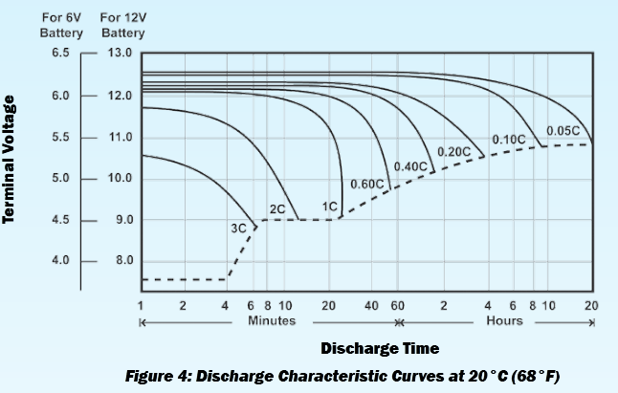

Open-Circuit Voltage of a Power-Sonic battery is 2.16 V/cell when fully charged and 1.94 V/cell when completely discharged. Maximum voltage 13.2V at 100 % capacity; 13.4V at 110% capacity. Using 20C to 0C float voltage increases by 0.24V, maximum open-circuit voltage at 100% capacity and 0C is 13.2V + 0.24V = 13.44V

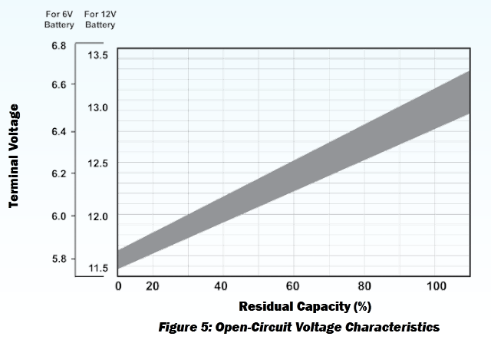

Table 3. Battery pack reporting signals forming and controller response. 14V selected as CV charge voltage in cyclic use for elevated temperature 40C worse case. 13.5 V selected as float charge voltage at elevated temperature 40C.
Voltage level | Battery status | Battery Signal | Equalizing load | Pack signal activated by | Controller action
14V and higher | Battery full; CV cyclic use | Stop charge | On | Any battery | Stop charge
13.5 and higher | Charge float voltage | Charge float voltage | On | Any battery | Reduce charge rate
13.44 and lower | Open circuit voltage at 100% capacity | Open circuit voltage at 100% capacity | On | Any battery | Reduce charge rate

Power Sonic

call 1-619-661-2020 11/5/2015 at 11:00
Shahrooz H.Pourhashemi (Shaw)" <shaw@power-sonic.com>
PDC-12200 – 24S pack.
If immediately – ok. Do not go below 8V. If immediately charged – should be ok. From 8V to 4V – several minutes.
Deep discharge battery – it more tolerant for this, do not do it often, if happens occasionally, and recharged – ok. 24 hours to charge – still ok.
Water still there – corrosion, if couple of days – corrosion is not happening yet. The warmer it is – need fast recharge. More than 25C - bad. Below 20C – couple of days is ok.
Capacity – good indication.
Corrosion – conductivity suffers. Inversion of resistance. Many on the market to measure.
Test fully charged battery.
ELK-BLT
http://www.elkproducts.com/product-catalog/elk-blt-battery-lifetester
Sulfation – apply higher voltage. Apply same voltage for lower, or higher voltage for 10 min. Up to 15-18V per battery.
Base line – then retest, 20-30% drop – is not good, replace. If critical, 20%, if not critical – go up to 40%.

