Preliminary requirements
Battery backup for TF Controller
- Capacity: supply 48V
  - Function of number of open-close cycles, and run time (per spreadsheet)
  - 44-48V; 1 AH
  - Peak current 4A
- Rechargeable desired
  - Need to access to replace primary – not desirable
- Discharge path
  - Fail-over without interruption if 48V supply voltage disappears
  - Comes from Vicor
  - Resistive line 100 ft of ~20 AWG wire;
    - 20 AWG: 33mOhm /m or 10.15 Ohm/ 1000 ft
    - 10.15 Ohm /1000 ft * 100 = 1 Ohm per wire
    - 1 Ohm * 2 wires = 2 Ohm / pair
  - Some inefficiency in the switch-over is ok
- Charge path:
  - slow is ok; 10s or 100s of hours ok
  - Low quiescent current
- Operation
  - TF Controller needs to know if 48V disappeared
  - Digital signal?
  - Measure voltage?
- Battery disconnect
  - Disconnect by the signal from controller?
  - Low voltage?
  - Reconnect when 48V from tether restored
- Motor driver disconnect
  - Keep disconnected to reduce quiescent current
  - Activate by the signal from the TF Controller
- TF controller has decent capability for logic as needed, IOs, etc

Test data on stick capacity as a function of charging voltage applied to the input of Inspired energy controller. Voltage drop across the driver board is not taken into account (not a battery stick voltage). Voltage drop across charging power path ~ 0.2V
(2017 test data, LRAUV project)
Charge Voltage, V | Charge, % capacity
14 | 17
14 | 18.4
14.5 | 33.5
14.5 | 32
15 | 54.4
15 | 53.3
15.5 | 65.6
15.5 | 67.9
16 | 81.9
16 | 82.5
16.5 | 94.7
16.5 | 95
16.8 | 100

6/6/2018: conceptual design of the backup pack using 3x Inspired Energy 4S1P Lithium-Ion packs, ND2034 series
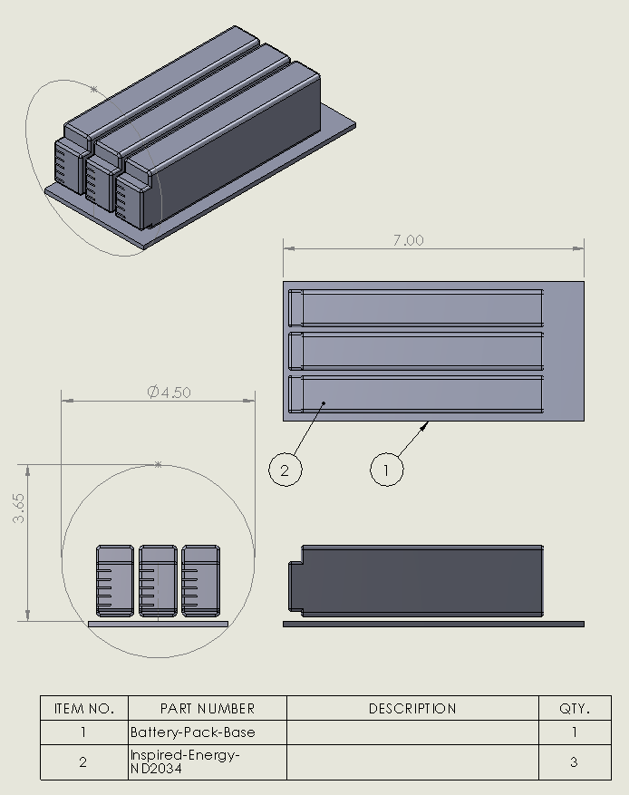
Testing 6/2018. Purpose: test simplified charging protocol for Inspired Energy “stick”. In particular, how primary protection circuitry would work, in case is DC-DC converter would attempt to overcharge the battery “stick”. The simplified charging protocol is done by connecting lab power supply dire4ctly to the battery terminals, while the Ocean Server board is monitoring the status of the battery “stick”. The positive of charging path if Ocean Server board is disconnected from the battery “+” terminal.
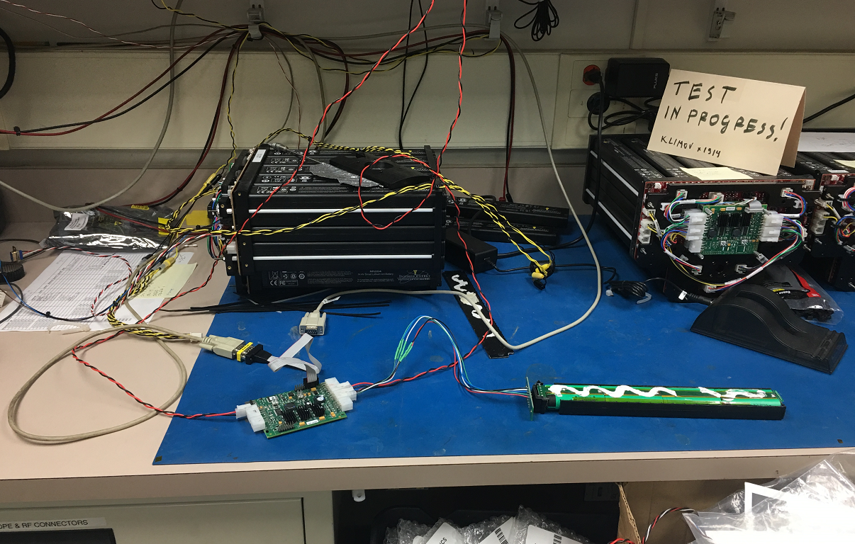
Test Setup for charging Inspired Energy battery stick using Ocean Server controller
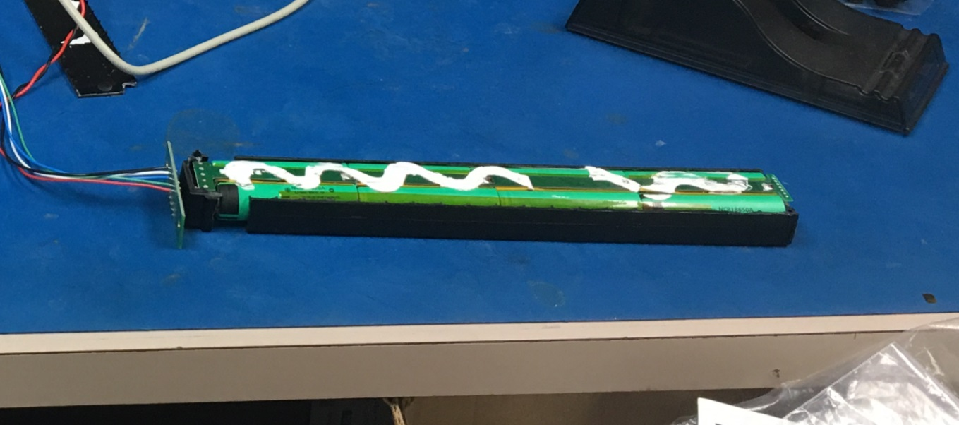
Inspired energy battery stick with housing open, to monitor each cell group

06/2018 test data
Charging 6AH battery stick with 0.2V steps, 120mA; ~ 100000 sec (27H) each step; final current ~0.5mA
Charge Voltage, V | Charge, % capacity | Charge, AH | Voltage, actual, V
15 | 58 | 3.44 | 15.006
15.2 | 63 | 3.79 | 15.209
15.4 | 69 | 4.14 | 15.407
15.6 | 75 | 4.53 | 15.605
15.8 | 81 | 4.88 | 15.805
16 | 85 | 5.17 | 16.007
16.2 | 90 | 5.44 | 16.207
16.4 | 100 | 6.09 | 16.606
16.6 | 100 | 5.96 | 16.607
16.8 | 100 | 6.1 | 16.808
17 | 100 | 6.1 | 17
17.159 | 100 | 6.1 | 17.159
17.2 | 100 | 6.1 | 16.697
Note: primary protection circuitry disconnected cells at 17.2V, preventing further charging

Voltages across cell-groups of 4s2p battery "stick" NH2034 with ~6AH capacity, while charging with 0.2V stapes at 120mA (0.02C rate); ~27H each step; final current ~1 mA
Voltage, cell 1, V | Voltage, cell 2, V | Voltage, cell 3, V | Voltage, cell 4, V | Average, voltage,V | Combined voltage, V | Max deviation, mV
3.9517 | 3.9538 | 3.9545 | 3.9544 | 3.9536 | 15.8144 | 1.9
4.1504 | 4.1537 | 4.1553 | 4.1549 | 4.153575 | 16.6143 | 3.175
4.1504 | 4.1538 | 4.1554 | 4.1549 | 4.153625 | 16.6145 | 3.225
4.1379 | 4.1408 | 4.1422 | 4.1418 | 4.140675 | 16.5627 | 2.775
4.1632 | 4.1655 | 4.1671 | 4.1689 | 4.166175 | 16.6647 | 2.975
4.1851 | 4.1871 | 4.1886 | 4.1907 | 4.187875 | 16.7515 | 2.825
4.2008 | 4.2018 | 4.2034 | 4.2045 | 4.202625 | 16.8105 | 1.875
4.2026 | 4.204 | 4.2041 | 4.2043 | 4.20375 | 16.815 | 1.15
4.252 | 4.2541 | 4.2544 | 4.2547 | 4.2538 | 17.0152 | 1.8
4.2522 | 4.254 | 4.2545 | 4.2548 | 4.253875 | 17.0155 | 1.675
4.288 | 4.2902 | 4.2905 | 4.2905 | 4.2898 | 17.1592 | 1.8
4.1938 | 4.1936 | 4.1919 | 4.187 | 4.191575 | 16.7663 | 4.575
4.2121 | 4.2146 | 4.215 | 4.2161 | 4.21445 | 16.8578 | 2.35

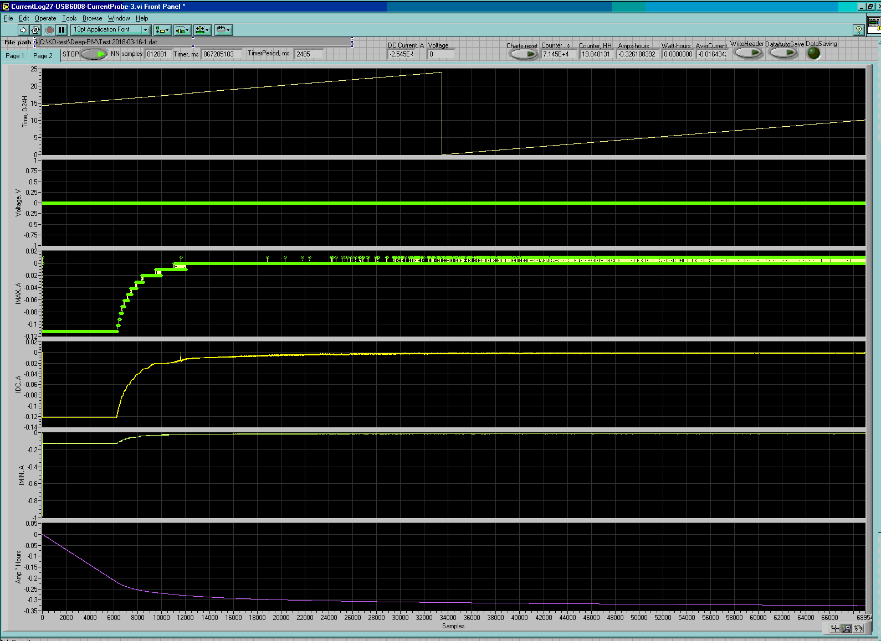
Current step-charge profile, charging from 16.4 to 16.6V at 120mA. Other profiles within 15 to 16.8V range look similar, except it takes different amount of time to charge the battery by 0.2V

6/2018 testing observations:
- Nominal protection threshold of built-in “primary protection circuitry” is 4.3V across any cell-group, so with good balancing between cell-group, the disconnect would happen at 4.3V x 4 = 17.2V
- Built-in primary protection circuitry disconnected the 4s2p cell string very close to 17.2V, preventing further charging. At this point, the charger voltage allowed to jump further up to max set voltage (in this case, to 17.4V) across battery terminals, while internal string voltage remained close to 17.2, or slowly relaxing down from 17.2V.
- Battery stick with triggered primary overcharge protection had floating voltage on the terminals ~ 16.7-16.8V (while internal 4s string voltage was higher, ~ 17.1-17.2V)
- Primary protection circuitry allowed immediate transition to discharging a “stick”, with voltage across terminals rising to internal cell string voltage, once legal load was placed across terminals.
- Before the cell-string voltage dropped below ~ 16.6-16.8V, the protection circuitry “remembered” the overcharge condition, immediately tripping protection with attempt to charge to even to normally-allowable 16.8V voltage level, and immediately transiting back to discharge when load is placed across terminal again
- Cell-group voltage balancing remained within 5mV max deviation from average within 15.8-17.2V string-voltage interval
- Proposed / desirable un-monitored maximum charge voltage in under 16.5V, anywhere between 15 and 16.5V, depending on desirable charge level, and available DC-DC converters.

8/9/2018 ordering battery “sticks”
Inspired Energy, LLC
25440 NW 8th Place, Newberry, FL 32669 USA
P: 352-472-4855
Toll Free: 888-546-7747
ND2034HD34 – 3.4Ah / 49Wh

8/10/2018
352-472-4855 x0 customer service
Brenda Sellers customer service. ND2034HD34?
$107.40 + shipping. Lead time 5-6 weeks regular lead time; 6 weeks now trying for smaller orders (12 weeks larger orders); due to restructuring and high demand. Quantity discount for 12: $86.4each + shipping
PO to Customer.service@inspired-energy.com
7700 Sandholdt Rd. Moss Landing CA 95076
831-775-1914
$107.40 x 6
Klimov@mbari.org
Send the PO number when approved, will be added to the order system.

