Heave cone design
Over the course of the 2010’s, MBARI has deployed its wave energy device numerous times, improving the design of the system year after year. The heave plate that hangs 30 m below the buoy has been through several redesigns. Its first iteration consisted of a 18’x10’ rectangular plate made of 12” wide steel slats, with 10” gaps between the slats. A four-leg bridle was used to connect it to the tether. This design was inexpensive, very robust, but problematic. When pulled vertically through the water, the plate tended to move sideways, like a falling leaf or a kite, causing snap loading of the tether and wear on the bridle. The loads on the tether became extreme during large wave events (we estimated them at 15000 lb, far exceeding the load cell’s capacity). After losing the plate several times during storms, it became obvious that the heave plate needed to change shape during large wave events to prevent extreme loads. We designed a new heave-plate consisting of spring-loaded slats, which deflected under load (figure 2). This design proved effective in reducing extreme loads and improving stability, however it was much more expensive (the torsion springs had to be made out of heat-treated titanium) and it reduced the WEC’s power production in small waves significantly.
A recent upgrade of the power-take-off device and a new electro-mechanical tether allowed the installation of electrical power and communications in the heave plate. This allowed us to design a new device (figure 3, 4), referred to as the ‘heave cone’ that can change its shape actively, when commanded. As the name implies, it has a conical shape for greater stability and it includes a door at the bottom of the cone that can be opened by a motor, in order to decrease the drag and the added mass whenever necessary. The size of the heave cone was determined carefully after computing the drag, the added mass and the damping (details in paragraph xxx).
The heave cone is made of welded steel tubes and plates and weighs 1850 lb. Lead weights are bolted to the bottom to lower the center of mass, while the attachment point for the tether is at the top of a tall stem on the central axis, giving it stability. During testing in MBARI’s test tank, we observed that the heave cone moved vertically through the water, either when falling or when being pulled up. The negative effect that we had observed on the flat plate were absent.
The door consists of three steel plates welded to a central ring, in a trefoil shape that can rotate around the central axis. Opening the door reduces the heave cone’s drag and the added mass significantly (figure 5) (details in following chapter). The door is mounted on a large slewing ring, coupled to a gear motor by a spur gear ring. There is a small gap (1/4”) between the trefoil and the supporting frame to avoid any friction. Thanks to low friction bearings in the slewing ring, a small motor is capable of rotating the door, thereby saving energy. The structural design is simplified by the fact that forces on the door can only be large in one direction: when the heave cone is falling down, the only load is the heave cone’s own weight. When it’s being pulled up by a large wave, loads can be much larger. Then, water pushes down on the door which bends down slightly to rest on the supporting frame. If this happens when the trefoil is rotating, it will cause it to stall briefly because the friction suddenly increases greatly. The rotation resumes has soon at the forces decrease. This allows the door to be rotated in any sea state. A battery stores enough energy to open the door in case the electrical communication with the buoy is lost.

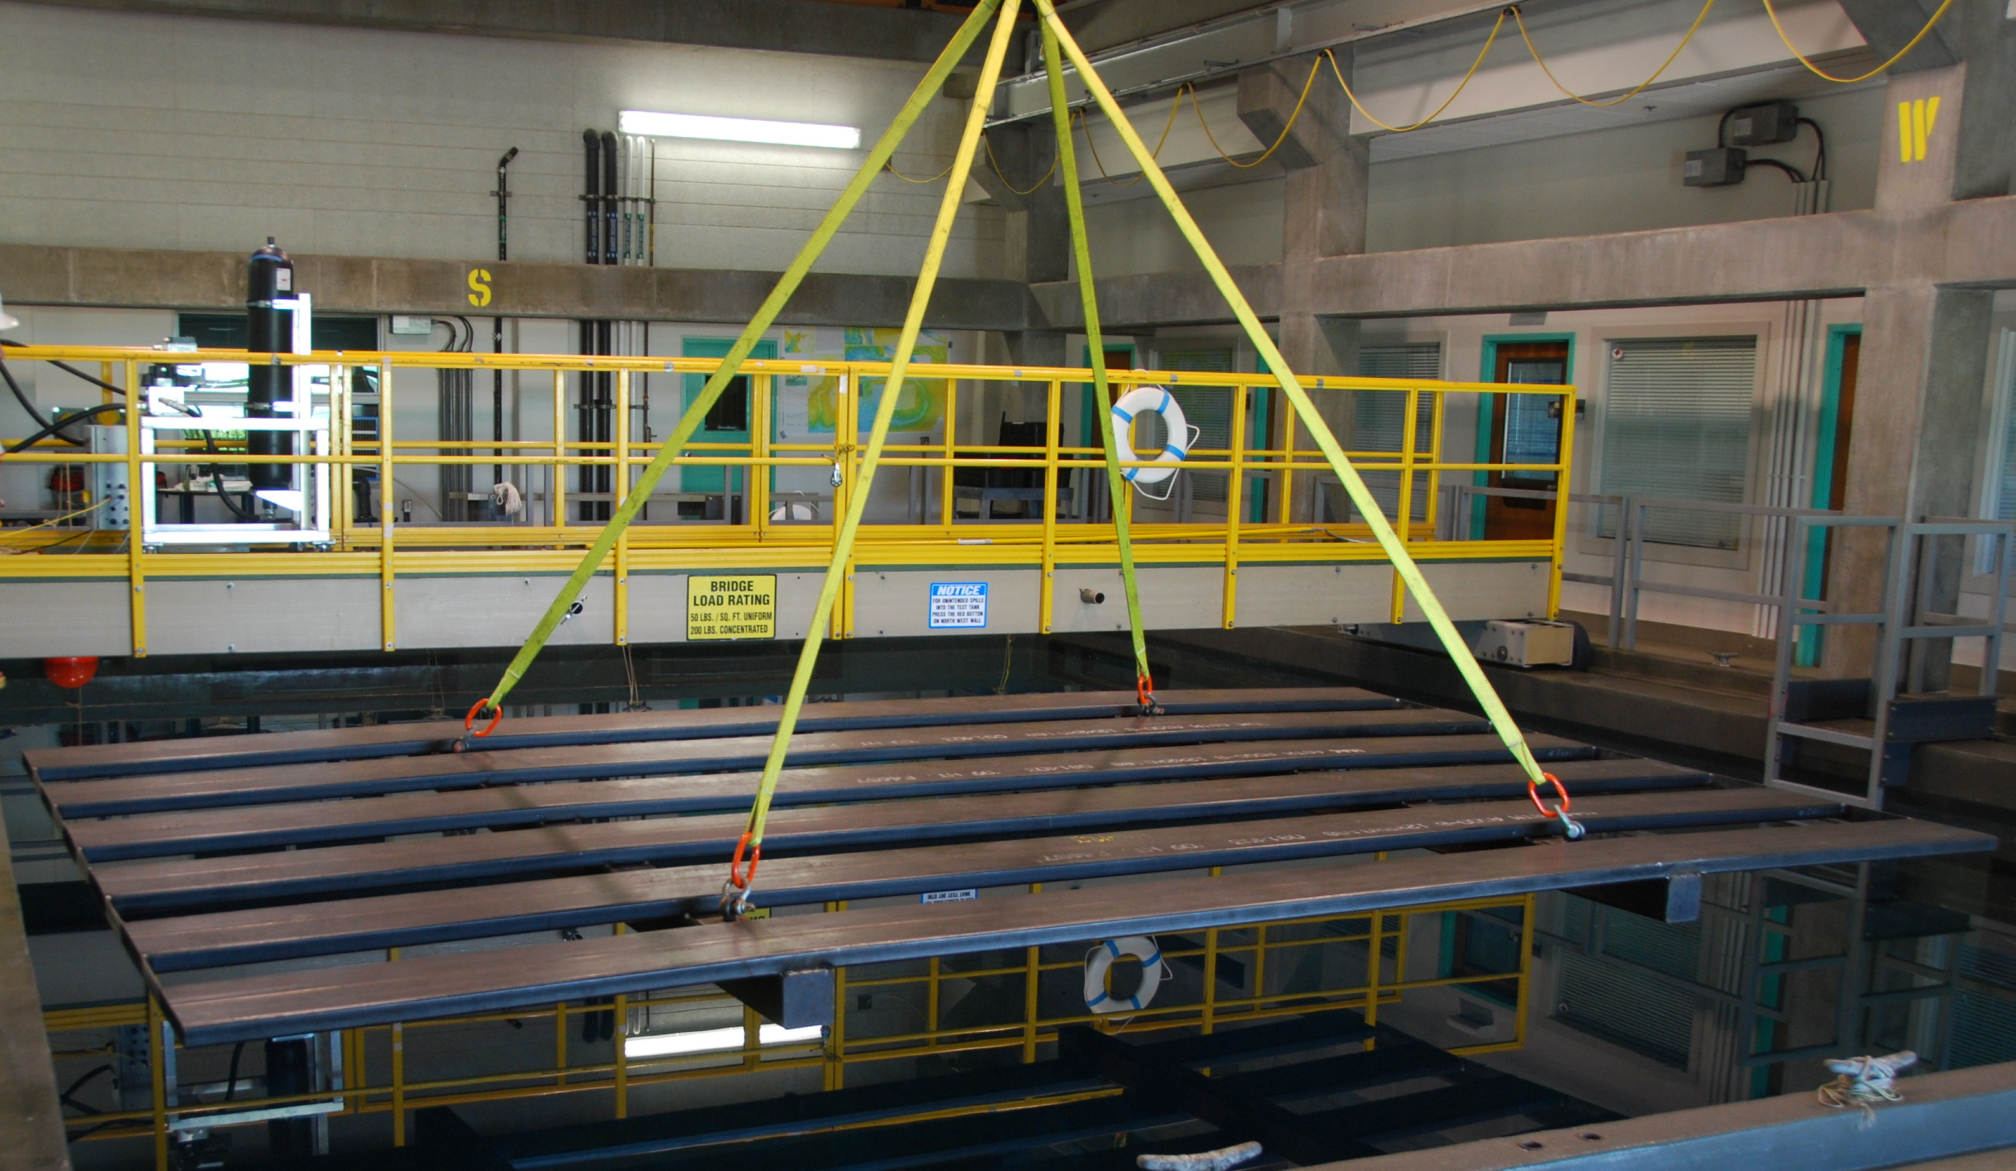
Figure 1: The first heave resisting element was simple and effective but generated extreme loads on the tether during large wave events.
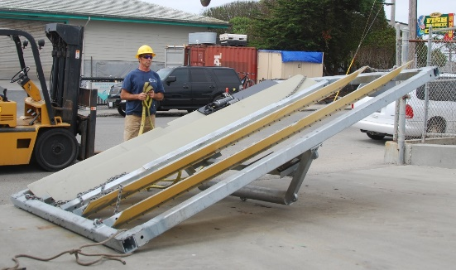
Figure 2: MBARI’s ‘compliant plate’ has 4 fiberglass slats that deflect under load.

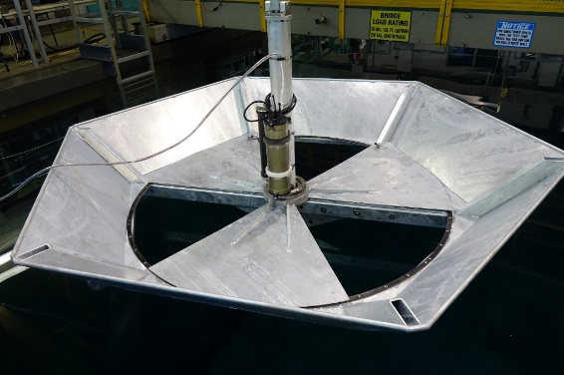
Figure 3: The heave cone shown in the open position
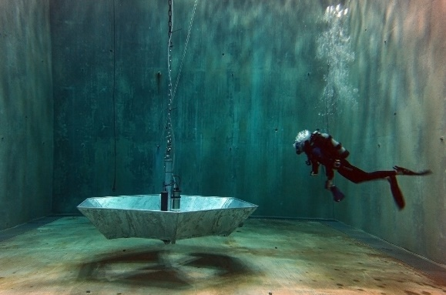
Figure 4: The heave cone was tested in MBARI's seawater tank.
Figure 5: Heave cone projected areas

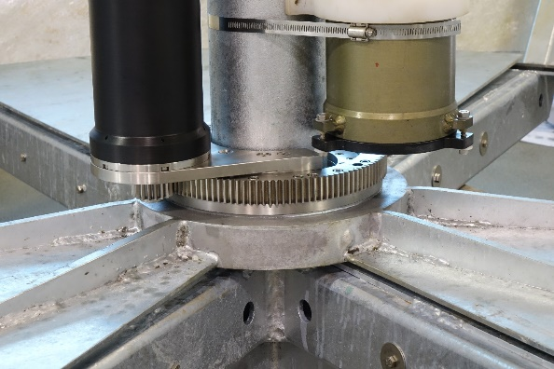
Figure 6: the trefoil-shaped door rotates on a slewing ring and is actuated by a gear motor

Results from field deployments:
MBARI’s WEC was deployed with the heave cone twice: from October 10 to December 3, 2018 and from February 28 to March 14, 2019. There was no significant difference in the device between the two deployments. During both deployments, we closed or opened the heave cone’s door depending on the sea state. At first, we simply sent a manual command when the waves became very large and when they became small again. Eventually, we implement an algorithm that opened the door automatically. The system monitored the maximum piston extension in the PTO. Anytime it reached or exceeded a limit, the door was opened. The limit was set so that there would be very little risk for the piston to bottom out, which would cause potentially very high forces. The door was always closed by a manual command, meaning the closing did not necessarily happen in a particular sea-state.
The buoy’s data-logging system records a large number of parameters at 10 Hz. Relevant to this study are the position of the PTO’s piston, the force between the PTO and the buoy, the motor’s RPM, the power generated by the WEC and the times of opening and closing of the heave cone’s door.
There were a few gaps in the data due to system downtime; there was a total of 60 days of useful data and 28 closings or opening of the door (excluding tests). We combined the data in one large file and analyzed it to understand the effect of opening or closing on the loads and the power output.

Because the wave conditions are constantly changing, it doesn’t make sense to average the data over the entire deployment. Rather, each state change (closing or opening of the door) must be looked at individually, for a short period of time over which the sea state does not change much. We analyzed the data for 45 minutes before and after each state change and calculated the following parameters:
- Mean load (at the buoy to PTO interface)
- Mean of load peaks (the load peak was detected for each cycle)
- Maximum instantaneous load
- WEC power output (mean and maximum)
- Maximum motor RPM
- Piston amplitude (maximum position minus minimum position)
- Piston mean speed.
For each of these, we calculated the percent change. The percent change was always calculated relative to the closed state. Table 1 contains a summary of the data. On average, a 30% decrease of the peak loads was observed, and a 22% decrease of the piston speed. The decrease of the WEC’s power output was 51%. The effect of closing the door varies significantly depending on the sea state. Generally, the decrease in peak load was greater in small sea state. Table 2 shows examples of the values observed during 5 closings that occurred in very large sea states.

 |  | Decrease (%)
Maximum instantaneous load (lb) |  | 27
Mean of load peaks (lb) |  | 30
Piston amplitude (in) |  | 23
Piston mean speed (in/s) |  | 22
Maximum instantaneous motor RPM |  | 21
WEC mean power output |  | 51
Table 1: Summary of changes observed when the heave cone's door was closed. 28 events were averaged.The mean load has been subtracted from the peaks. The mean load is approximately 2780 lb, equal to the weight of the PTO and the heave cone. The load was measured at the attachment point between the buoy and the PTO.

Table 2: Examples of parameters measured before and after door closings during large wave conditions.

