Chain bridle for the Powerbuoy’s submerged plate

By François Cazenave
April 14, 2016

Purpose
The purpose of the chain bridle is to attach the submerged plate to the tether. Due to the design of the plate, it must be supported in its 4 corners. Spectra rope and steel wire were used during early deployments of the Powerbuoy but they proved to be unreliable and eventually failed.

Design description
The bridle has 4 legs. Each leg is 12’ long. The ends of the chains are connected using double clevis links. At the top they are attached to a 3/4” Crosby ring. The Crosby ring is attached to the tether termination using a 3/4” shackle. At the bottom, the clevis links are attached to a 1 1/4” ID pad-eye that is welded to the frame.
Chain: 3/8” grade 4 anchor chain. SWL 5400lb, breaking strength 16200lb. Total weight of the chains is 67lb.
Clevis links (Crosby S-247, PN 1013049): SWL 5400lb, breaking strength 21600lb. The advantage of this clevis link is that it replaces two shackles. Using shackles of equal strength (1/2”) would require using 1/2” chain which would be 60lb heavier.
Shackle ¾” Crosby galvanized shackle, SWL 9500 lb, breaking strength 57000 lb.
Ring: Crosby ¾” ring, 24000 SWL
Pad-eyes: McMaster PN: 3024T26. Not load rated. We tested it, lifting a 6000lb load at 45º angle. The pad eyes are welded to a 3.5”x3.5”x1/4” plate that is welded to the frame to distribute the load. This design has been tested during nearly 1 year of testing at sea.
Load calculations:
The angle of the bridle is 30º.
Load on each chain = total load /(4*cos 30) = total / 3.5
Typical load: 3000 lb. Load on each chain 857 lb. There is a very large safety factor and no danger of fatigue.
As a worst case, assume highest load is 10000lb and assume load is on 2 chains only:
Load in each chain = 10000/2cos30 = 5773 lb. This does not exceed the strength of the weakest component (pad eye). There is still a large safety factor for all the load-rated components.

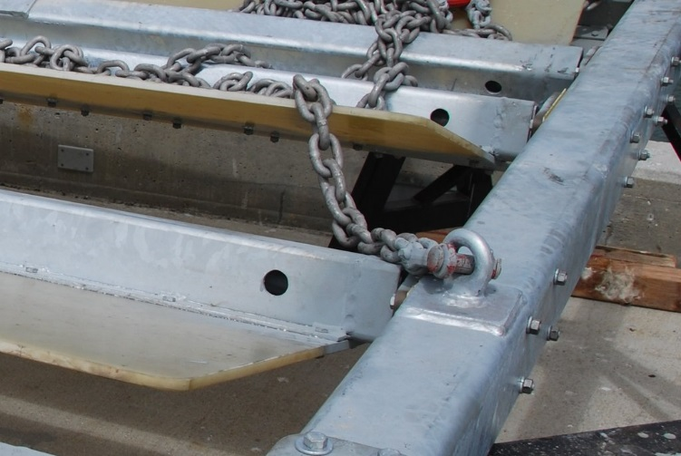
Pad eye, clevis connector and chain on the compliant plate.
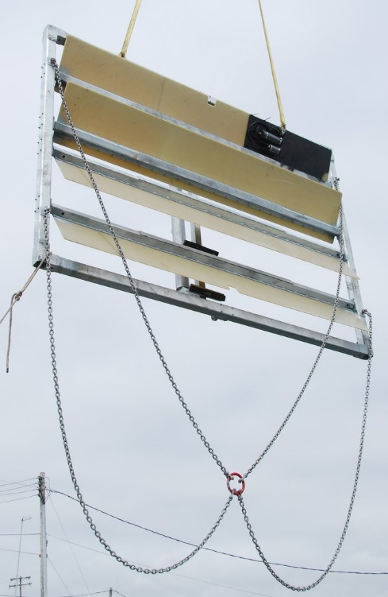
Chain bridle attached to the compliant plate.

Deployment
The current design has been deployed twice, for a total of 5 months. During the last deployment, a pin on one of the shackle connectors came undone and caused the loss of the submerged plate. The pin had been welded to the body of the connector because we were concerned that cotter pins might fail due to corrosion. Unfortunately, the weld was in the load path and it cracked. On one of the connectors, the crack was so smooth that it allowed the pin to slide out.
If the clevis connector had been used like it was intended to be, there would not have been a failure. The cotter pin will last several months and can be inspected by a diver every few months for very long deployment.
Video footage of the pad eye connections during deployment showed that the chain occasionally becomes slack in large waves. The clevis connectors are adapted to this behavior because they cannot get tangled or caught at an angle. Also, the distance between the chain and the flapper was sufficient to avoid interference.

Conclusion
Considering the large safety factor of the rated components, the risk of failure is very low. The breaking strength of the pad eye is not known but it was tested to 6000 lb, a load that is very unlikely to ever be reached. Also, the pad-eye has been used successfully for nearly a year at sea, including with the larger plate.
The design should be kept the way it is and 316 stainless steel cotter pins should be used on the clevis connectors. Visual inspection by a diver may be needed for deployments exceeding 6 months.

