POWER BOUY TO PTO 7/16/18
Jim Scholfield
This molding procedure is a little more tricky than other overmolds because the overmolded portion is very short ~3/8”, so does NOT provide a robust physical or waterproof connection. Most similar connectors have a 1” or more of metal or rubber to fulfill this role. The best way to successfully use this arrangement in the field is to carefully insert into the mating connector, minimizing any twisting or torqueing on the overmolded section, then when in place, securely tiewrap or otherwise lock into position eliminating any motion which could fatigue the overmold bondline.
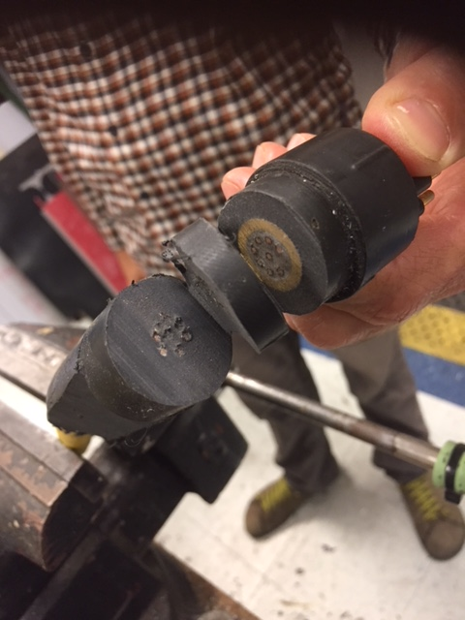
Earlier effort cut open.
MATERIALS NEEDED—
1. Devcon Flexane 15800, Shore 80. This material is recommended due to 30 minute worktime and low viscosity. Both allow time to degas and pour flexane into the mold from one end.

2. Devcon Primers, FL-10 for metal and FL-20 for rubbers, plastics. Or P2
3M Scotchcast Rubber Primer , 5136N as a rubber primer, Much better shelf life than FL-20

3. Mold, marked --Bouy to PTO
4. Mann Easy Release 200, from Smooth-On , or equivalent.
5. Sandpaper, or Dremel tool, and Acetone for cleaning
6. Sturdy stand to hold mold and wiring vertical.
7. Vacuum system. Use a 2 Liter tub for mixing the Flexane and degassing – large size is necessary due to amazing volume change from bubbling during the degassing procedure.
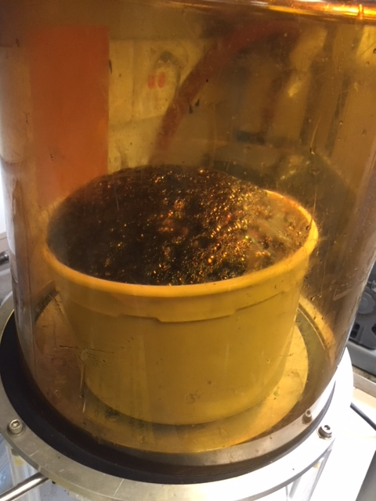
PROCEDURE-

1. set everything up, Abraid the rubber/plastic wire outer covering appropriate for extent of overmold, the metal collar to be overmolded. Clean all parts in acetone, 2 X. use gloves for personal safety and fingerprint contamination on bonding surfaces.
2. apply FL-10 to the metal collar, let dry 30-60 min.
3. apply FL-20 or Scotchcast 5136Nto all rubber, metal, wires, coating parts to be overmolded, let dry 30-60 min.
4. Set up mold and wire with connector.
5. Mix in large container, ~120-150 cc/gms of Flexane 80, note mix ratio of 77/23 A/B. Careful to scrape bottom and sides several times during mixing
6. Work time is 30 minutes, degas until bubbles collapse, ~28 inHg or so. Carefully scrape material to one side so don’t lose too much.
7. Pour into mold, might have to xfer smaller amounts into smaller container to accomplish this, be careful to minimize bubbles
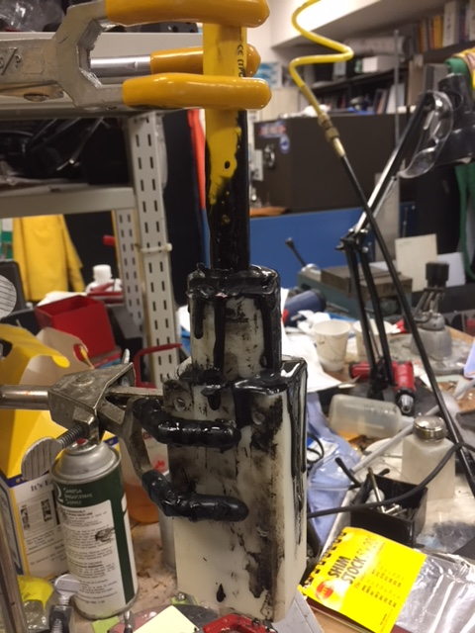
Messy job, wear gloves

8. Demold after overnite , clear flash and drips p3
