Power Bouy Back Potting Procedure
Jim Scholfield 6/25/18

Required Components-
Unique Mold for this connector- Francois
Connector-Francois
2 plastic or rubber wire spacers
Devcon Flexane 80 or 3M 2131, Polyurethane 2 part potting compounds
Devcon primers, FL 10 and FL 20
Smooth-on Easy Release 200, or equivalent mold release
Suitable balance if weighing out Flexane
Vacuum chamber big enough to handle bucket, 28”Hg
Suitable stand to hold wires and connector vertical
Large bucket for degassing Flexane
Acetone for cleaning parts
NOTE-Both compounds will work, I have started using Flexane 80 because I can weigh out the amount I need, 120 gms in this instance, so there is less waste of unused product and 80 has ~ 25 min work time which allows time for proper degassing. ( Flexane 94 is only 5-6 min) The 2131 product will work fine, there is a lot of wasted product, however it does not need degassing since mixed in bags. Both products need the application of primers, for best adhesion.
Procedure—
1. In this particular application, it is advisable to bare the wires for ¾” or so, to form a gas block (similar to a water block) to preclude gas working its way up inside the wire insulation. This is done close to the metal shell.
2. Apply solder to the wire braid to provide a solid, smooth wire surface.
3. sand or otherwise scratch the metal surfaces to provide some “bite”, likewise carefully scratch, dull, the shiny plastic wire coverings. Sand ~3 inches from shell. Teflon is the worst, rubber the best for adhesion.
4. Clean parts in acetone, wear rubber gloves from this point forward to keep surfaces clean.
2.
5. Place wire separators above and below the bared sections
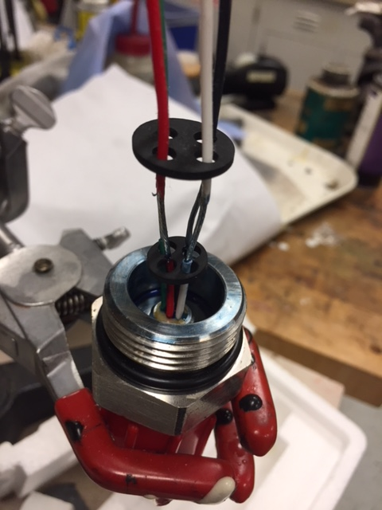

3.
6. 1st apply a coat of FL10 to the metal surfaces, let dry for 30 min or so
7. Follow with a coat of FL 20 on all prepared plastic and metal surfaces, likewise dry 30 min or so
8. Coat inside of mold with EasyRelease 200 – dry for a few minutes
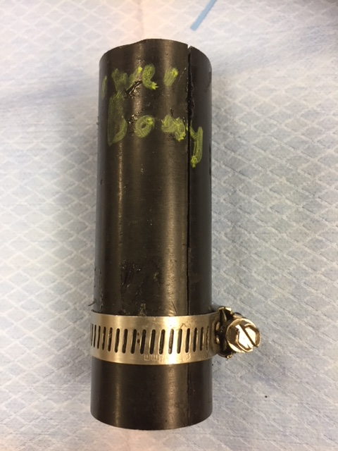

9. Attach mold to connector, close gap in mold side with some tape to stop leaks, secure with clamp.

4.
10. If using Flexane, In large bucket, required for exceptional volume expansion during degassing, Follow mixing instructions, 77/23 for Flexane 80, the volume of the pour is ~75 ml (75gms) but a lot of material is difficult to remove from the mixing bucket so mixing 120 gms total is smart.
92.4 gms A + 27.6 gms B. Mix thoroughly, scraping bottom and sides occasionally.
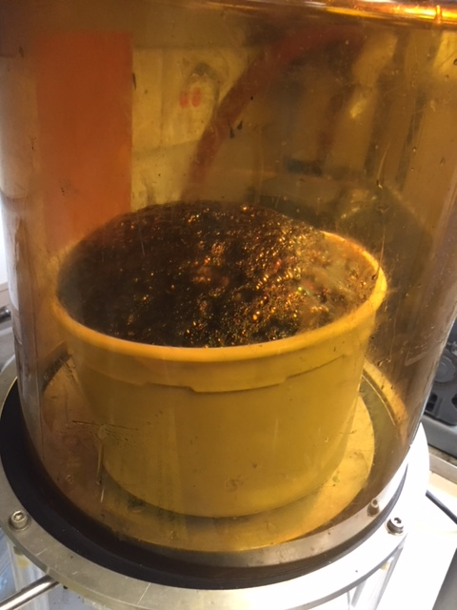

11. Degas- Place in vacuum chamber, start pump, Material will completely fill the bucket, throttle the expansion by bleeding air in with your finger on the bleed tube. “Pumping” the air bubble mix up and
5.
down will eventually allow enough bubble bursting to allow the whole thing to collapse, this is what is desired. Bleed back down to 0.
12. Carefully scrape material off sides and bottom so minimal bubbles are formed, allow to flow, carefully (slowly) fill mold up 2.5” or so above metal shell.
13. Let cure overnight
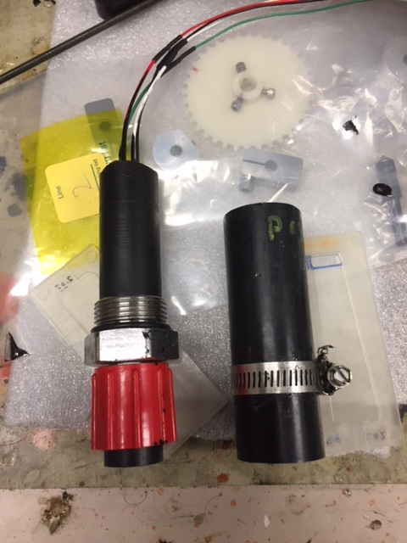

14. Remove mold, Clean up flash

