MBARI_WEC: https://github.com/osrf/mbari_wec
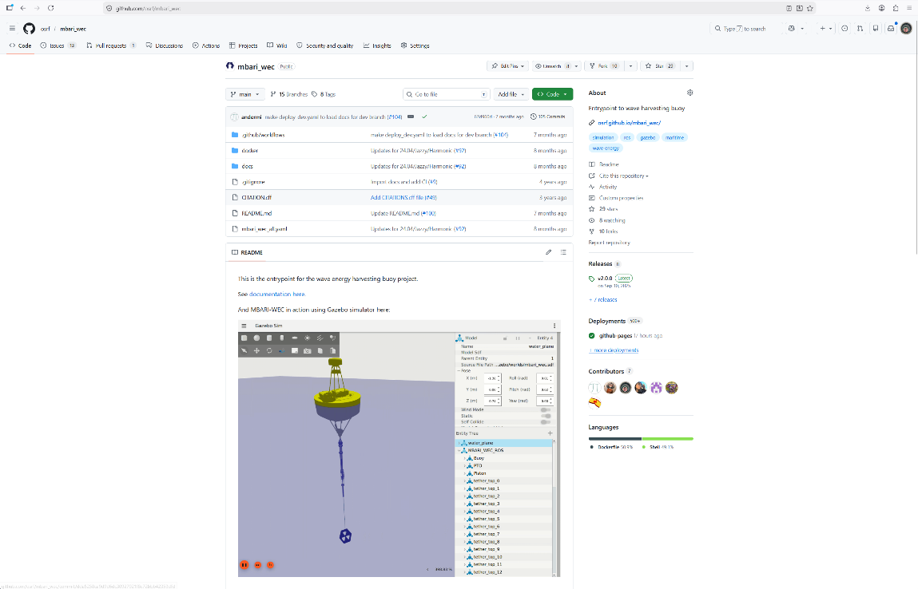

FS_Hydrodynamics: https://github.com/hamilton8415/FreeSurfaceHydrodynamics
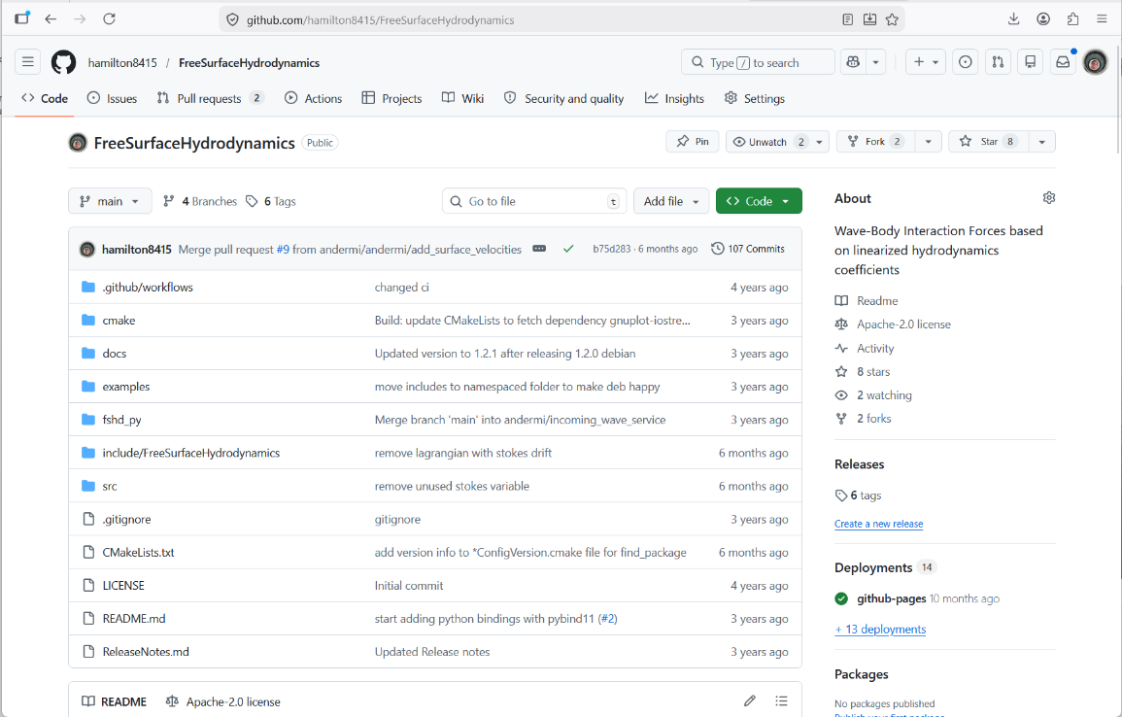

Andrew Hamilton: hamilton@mbari.org
Michael Anderson: anderson@mbari.org

