Short Description
We propose to develop technology to dock autonomous underwater vehicles to wave-energy conversion devices to enable high impact, long-duration and remote scientific observations in the ocean. In particular we aim to dock and transfer power between the AUV and vertical mooring wires. The technical challenge is to transfer power across a loosely coupled wire latch that leaves the vehicle free to tolerate wire motions as opposed to rigidly constraining the vehicle as is typical in seafloor mounted docking approaches.

Written Technical Narrative
Communities comprising ocean ecosystems, ranging from microbes to whales, are patchy in distribution and exhibit large variations in productivity over both space and time. Ship-based studies of these complex communities have pointed to key parameters that govern the function and services ocean ecosystems provide, and also highlighted many “unknowns” that require further study, but the logistical and practical constraints associated with ship operations limit the time available for on-site investigations. To overcome this limitation, an autonomous, persistent, mobile pelagic observation system is needed to find, follow and characterize ocean communities throughout the water column as they evolve spatially and temporally. Some of the platforms and sensors needed to achieve this capability exist now and others are maturing quickly. However, many of these systems are inherently limited by available electrical power.
We propose to address the “power gap” by extracting energy from waves to recharge the batteries of a fleet of existing autonomous underwater vehicles. The MBARI Long Range Autonomous Underwater Vehicles (LRAUV) are 12” diameter, 105kg vehicles and will be equipped with complementary science/sensory payloads. In operation as a fleet, the vehicles will share measurement information about what plants and animals are present, how they are distributed with respect to the oceanographic parameters like temperature, salinity, oxygen, pH, the prevalence of bioluminescence, etc. In doing so, the fleet’s measurement and observation activities can be coordinated. The resulting data will allow shoreside scientists to observe an entire ecosystem and quantify the changes it undergoes from afar, over timescales ranging from hours to many months -- periods of time relevant to the processes that ultimately govern these systems.
The technological innovation proposed here focuses on developing an AUV docking component of a wave-energy harvesting ocean observing system. This development will allow the existing MBARI wave energy extraction device to recharge the LRAUV’s. This pairing will be used to demonstrate repeatable electrical recharge of a fleet of autonomous vehicles as they undertake a variety of integrated ocean observations, including basic chemical/physical measurements, eDNA assessments, bioacoustic surveys, etc., over an extended period of time.
The docking component of this system has been selected because the vehicle, sensor, water sampling, and wave-energy conversion technologies are relatively mature, available for use now, and their endurance is strictly limited by power. Achieving routine and flexible AUV docking/recharge capability will showcase one of the most compelling applications of small-scale wave-energy harvesting technology. Even a single autonomous vehicle requires more energy than a modest sized solar or wind system can provide. For these reasons the development of reliable AUV docking technology coupled with small-scale wave-energy conversion offers the potential to dramatically expand ocean observation opportunities.
Expanding the reach and capability of autonomous ocean observing measurements has been a focus of MBARI engineering and science collaborations for the past three decades. This focus is born from first-hand experience with the high cost and relatively short duration of ship expeditions. With ship resources becoming scarcer and a revolution in robotics and machine-learning occurring, the field is poised for a growth in the ubiquity of autonomous vehicles spending longer and longer times in the ocean without being recovered.
At MBARI we are currently working on, or previously have worked on, all of the relevant technology development areas needed to realistically strive to meet that goal, including routinely performing extended multi-vehicle scientific experiments with durations of up to a month. The best example of this type of work is the “Controlled, Agile, and Novel Observing Network” experiments, performed by MBARI and illustrated in Figure 1. To support these programs vehicles are periodically recovered and re-charged on shore. Not only is this a significant amount of labor and reduces the usage efficiency of the observing assets, it also precludes this observing network from being located in remote places where it is not practical to have regular human interaction with the observing vehicles and instrumentation. Even close to shore however, there is much to be learned from operating these fleets of vehicles in concert with one another, and these experiments provide an ideal test-bed for innovations such as the proposed docking/recharge capability.
MBARI has worked on AUV docking technologies in the past with a focus on sea-floor mounted docks, as illustrated in Figure 2. This experience has led to a variety of important conclusions. Although the seafloor mounted “cone dock” type of device is amenable to re-charge and communications because the vehicle is constrained, there are a few significant downsides. The primary problem is that seafloor installations can become extremely expensive to maintain if an ROV is required, and/or if a large ship is required to place a device in deep water. Such logistical challenges and economics will likely preclude wide-spread adoption of these technologies for ocean-observing systems. More recently we (and others) have been working on AUV docks that consist of a single vertical wire that the AUV can latch onto. For example, Figure 3 is a photo taken from an on-board camera in the nose of an AUV after it has latched onto a vertical wire. These devices are dramatically less expensive to deploy and maintain, and can support an AUV dock throughout the water-column. However, because the AUV is poorly constrained physically while it is docked, re-charge and communications becomes more challenging.
The specific innovation pursued here is technology that allows power and communications to pass across the wire-latch type dock without significantly restraining the motion of the vehicle. If this can be achieved, then the possibilities for AUV docking and recharge will open up considerably, and the costs will be reduced. In addition to no longer requiring a sea-floor installation, it may be possible to dock AUVs directly to surface moorings or wave-energy converters that have motions excited by surface waves. Experience with deep water oceanographic moorings has shown that while the mooring cables are very efficient at transmitting surface motions downward, that energy is almost entirely represented as axial wire-motion at sufficient depths because the lateral cable drag is much higher than the axial cable drag. The result is that an AUV latched onto a surface mooring cable will not be moved around much if the cable is free to slide and rotate through the latch. Naturally this complicates power transfer and leads to a specific requirement for a loosely coupled latch that still transfers power and data -- a primary focus of our work.
Impact
Extending the endurance of an AUV-based ocean observatory using in-situ battery recharging from a wave energy harvester will enable sustained measurements in remote areas at time scales appropriate to how the entire ecosystem responds to perturbations. Today ocean scientists are constrained to ship based observation, or possibly along-track measurements from a single AUV whose trajectory was pre-programmed. While a ship is capable of making an impressive suite of measurements, its utility for finding and following subsurface patches of heightened biological activity, or hot-spots, to document integrated ecosystem function over time, is extremely limited. A pre-programmed track of a buoyancy glider may fly through a hot-spot, and have the endurance to make measurements for many months along thousands of kilometers of trackline, but it lacks the on-board autonomy to adaptively follow a patch nor can it carry specialized sensors and samplers needed to characterize the ecosystem from microbes to larger animals of societal and economic interest.
Our existing fleet of AUVs are equipped with the sensors needed to find, follow and sample biological hot-spots. Figure 1 illustrates this concept for a pelagic observatory. Shoreside scientists pick a worksite by using satellite remote sensing, altimetery, model projections, and/or animal tracking data. Once on site, the vehicles start with a pre-programmed search mission using temperature, oxygen, and chlorophyll clues, bioacoustic sensors, and visual imaging. When features like water mass boundaries, or patches of plant and animals are detected, this information is shared via acoustic communication with other vehicles. To minimize the communication bandwidth, sensor data is processed on-board to extract the salient information. In addition to the specialized sensors and acoustic modems, our AUVs are all equipped with acoustic direction finding so they can home to each other and fly formations relative to one another. At least one of the vehicles in the fleet would be equipped with a 3G ESP eDNA sample processing payload, and that vehicle would position itself in an area of interest to collect/preserve genomic samples of top interest. The 3G ESP can also provide real-time detection of some target species or compounds (e.g., HABs). This multi-vehicle sensing, processing and collaboration has been demonstrated repeatedly, but is currently limited to about two weeks of duration, which isn’t sufficient to conduct operations far from shore or to document changes within systems evolving at longer timescales. While a doubling of the battery capacity is an option to extend the endurance of the vehicles, we have found that the related increase in vehicle size, and cost begins to erode the premise that a fleet of vehicles is a viable asset of a small group of science investigators or resource managers. We have found that a small science lab can manage (purchase, maintain and operate) a single LRAUV, and a group of 4 or 5 scientists working together is tenable. Larger AUVs typically require a dedicated operations group, which is a luxury only a few ocean scientists enjoy.
MBARI has been developing technology to extract energy from waves and has a working system shown in Figures 4 and 5 that generates an average of 250 Watts, this is sufficient energy to power a fleet of four Tethys LRAUVs indefinitely, though we currently envision deployments limited to about 6 months. This deployment length is adequate to capture seasonal variations and episodic events. If more endurance is required, two or three complete systems could be staged for series deployments.
Most of the proposed system is currently in use within a National Marine Sanctuary so all restrictions regarding possible impacts to the environment the Sanctuary requires are being met. Some acoustic emissions from the sonars and high speed turbine generator are emitted, but these are low in power and no negative effects to the animals or the environment have been observed, nor are expected. The missing technological links like the AUV docking and power transfer systems will likewise not pollute or in any way damage the environment.
End-User Market Potential
An innovation that successfully couples AUVs and a marine hydro-kinetic device has wide applicability. A solution to the AUV docking and charging problem is in fact required before small-scale wave-energy conversion devices will be able to realize their potential to dramatically increase ocean observing capabilities. Therefore, we believe that work on the docking and recharging aspect of this challenge offers the greatest cost/benefit proposition.
To be successful, however, the solution must be economically viable to operate, which precludes significant seafloor installations in most cases due to the high cost of ROV support. This requirement drives the proposed project and design, and reflects our experience fielding seafloor-based equipment. In addition, we require that the AUV re-charging take place from a surface-buoy (wave-energy converting or not) without a seafloor installation. Meeting this goal offers the opportunity to decouple this innovation from a strict requirement of installing a wave-energy conversion device, expanding applicability by allowing alternative AUV recharging options such as solar, although the available energy would be less and the number of AUVs that could be supported by a single installation would be reduced.
Testing and development of the docking system will be performed at MBARI using specific AUV/sensor hardware, but the goal is to create a docking device that is applicable to a variety of AUVs and wave-energy conversion devices. Should that come to fruition, MBARI offers a very attractive range of licensing options, from a fee-based structure for commercial entities to a no-cost use option for non-profit entities. Successful technology transfer is one means by which we assess our success.
Technical Feasibility
MBARI works heavily in the area of robotic ocean observing and has developed AUVs with a range of sensing/sampling systems, as well as a wave-energy conversion device suitable in size for recharging our fleet of AUVs. The wave-energy conversion device is routinely deployed and available for this work, as is the fleet of 12” diameter LRAUVs. The proposed project aims to integrate these two systems by providing the missing piece -- the docking and power transference technology.
The MBARI wave-energy device is a two-body point absorber design and has demonstrated power capture averages of 250W over months of deployment through various seasons in Monterey Bay. This system is completely self-powered from the wave energy it harvests, and has on-board battery storage to level out the hourly average power captures that range from 25W to 1400W depending on sea state. This system includes on-board computing, an always-on cell modem telemetry and command link to shore, and power/data communications from the surface buoy down to the sub-surface plate. The power/data communication link can be extended downward as needed to support AUV docking and recharge.
Our experience with similar sized oceanographic buoys that aggressively include both solar and wind power generation indicates power capture averages of about 40W through the seasons. The six-fold increase in the energy captured by the wave system, relative to what is possible from wind and solar in a similar sized device, and brings the power levels up to a level appropriate for recharging a fleet of vehicles such that the wave-energy system can effectively recharge one vehicle every day. In typical usage the LRAUVs operate for about two weeks on a charge, so the proposed system could support a fleet of 14 vehicles in constant operation at present. Alternatively, a smaller number of vehicles with more energy intensive instrumentation or propulsion requirements could be supported.
As stated above, the primary innovation being pursued in the planned work is to create a power-transfer device that can operate with the vehicle loosely latched onto a vertical mooring wire, which may or may not be moving due to wave motions. This is very challenging, but there are existing and also emerging technologies that are suited to this task and are awaiting integration and testing. The emerging technologies are promising and would result in the most reliable device. The application of these technologies is a prime objective of this effort, but should those ideas not prove possible more standard inductive charging technologies are under consideration as well.
MBARI has a complete machine shop and fabrication facilities as well as engineering staff who understand the challenges of developing this type of ocean-going equipment. In fact, the two supporting components (the LRAUV fleet and the wave-energy conversion device) were conceived of, designed, and fabricated at MBARI. These devices are also operated by MBARI science staff, so the proposed integration of these systems and use case demonstration will be carried out by a team including engineers, marine operational personnel, and science users.

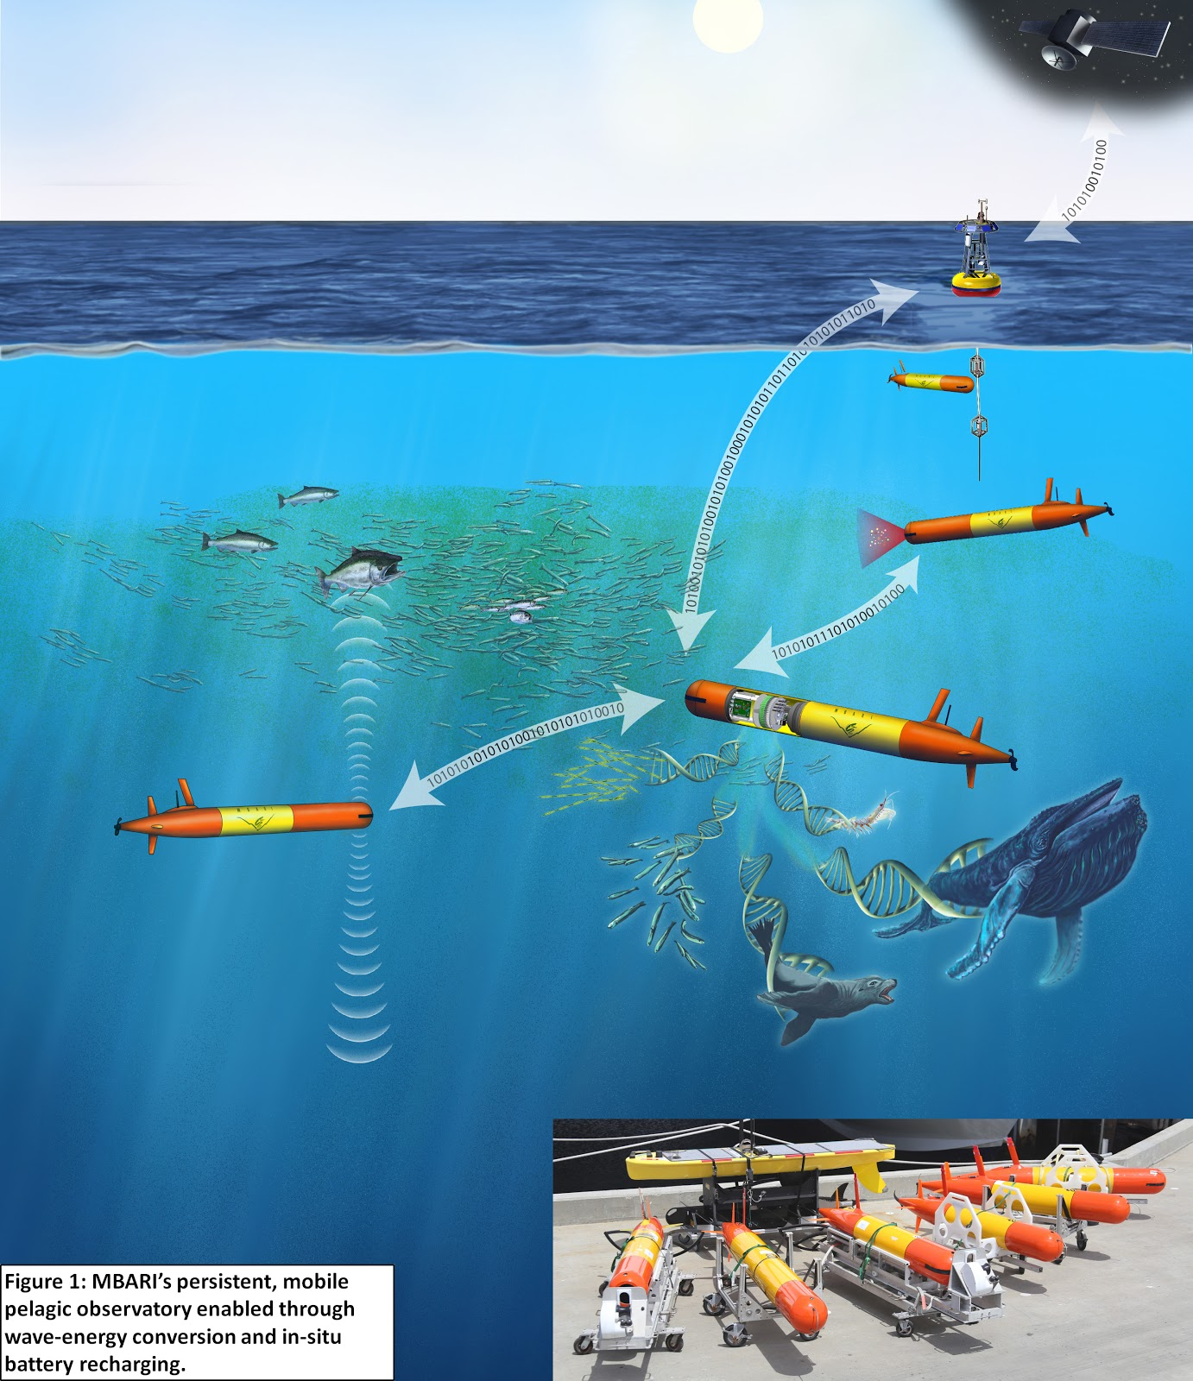
Figure 1: MBARI’s persistent, mobile pelagic observatory enabled through wave-energy conversion and in-situ battery recharging.

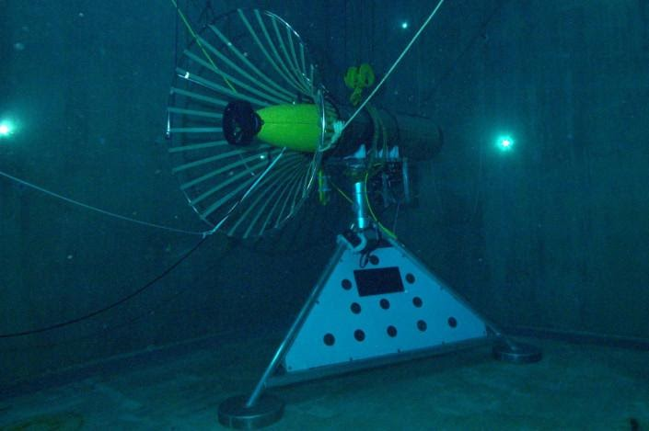
Figure 2: Seafloor mounted dock for MBARI Dorado class 21” AUV. The tight capture of the cone dock allows for effective inductive charging, at the cost of a significant seafloor installation.
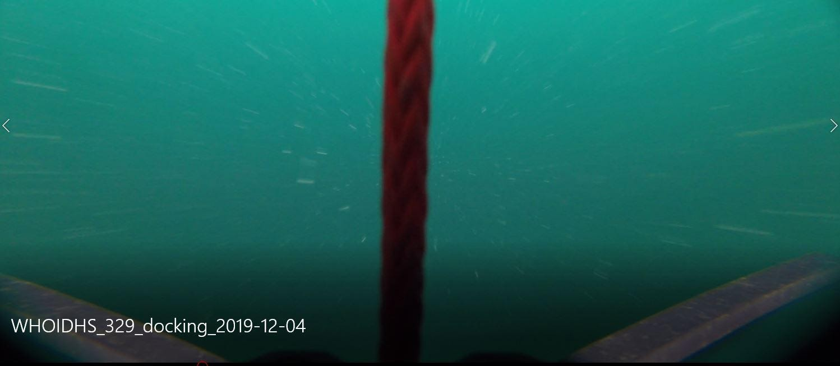
Figure 3: Onboard view of mooring line captured in the MBARI Long Range AUV nose latch.

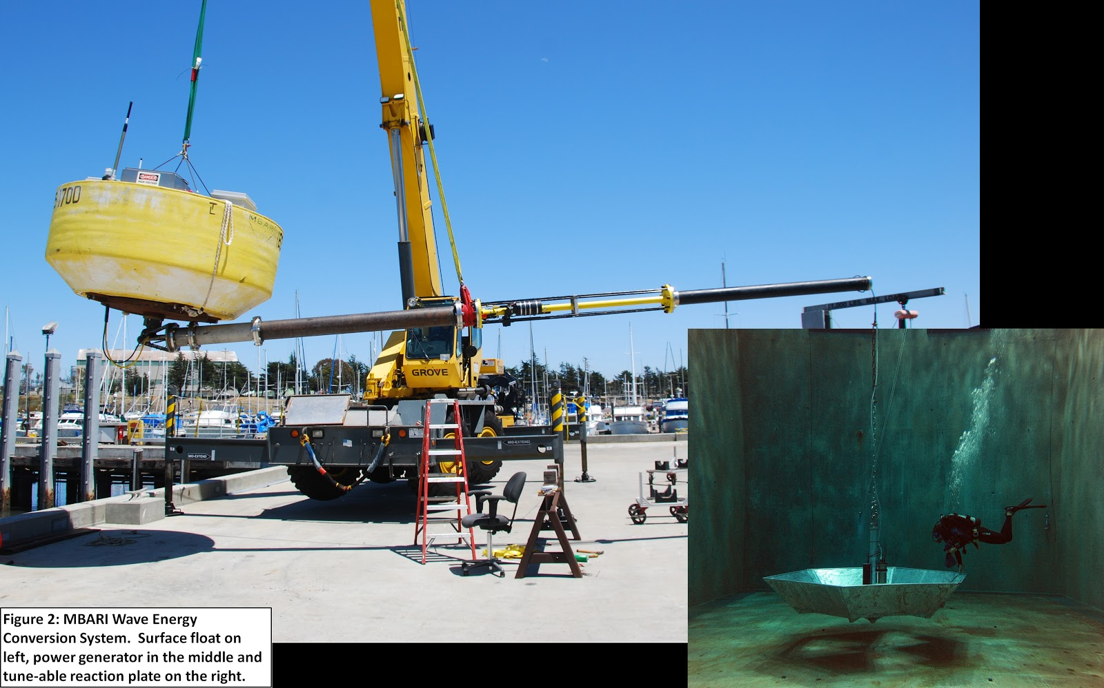
Figure 4: MBARI Wave-Energy Conversion System. Surface float on left, power take-off in the middle, and tune-able reaction plate on the right.

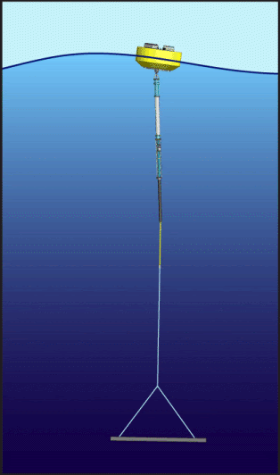
Figure 5: Schematic of the MBARI wave-energy conversion system with an electro-hydraulic PTO.

