Applicability of the MBARI Wave-Energy System to self-deployment at a smaller scale.

Introduction
The MBARI developed wave-energy converter is a relatively small system designed to provide small amounts of average power (~300W) to oceanographic instrumentation for extended periods of time. The Wave-Energy problem is very challenging and faces many problems related to systems in the ocean with moving parts. Nevertheless, if energy harvesting at levels greater than possible with solar and wind systems is required, it is one of the few options. As stated the MBARI system provides about 300W of power on average, compared to 50W from a solar and wind system developed at MBARI that is a similar size and weight.
The MBARI system is a two-body point absorber and is shown schematically in Figure 1. The power take-off device is an electro-hydraulic system developed at MBARI. The key elements of performance of this system are the buoy size (in terms of water-plane area), the submerged anti-heave plate size, and the amount of batteries that can be hosted to smooth out the wide variation in power harvesting that occurs as the sea state changes with the weather. For survivability, the total stroke of the power take-off system is important and must either be longer than the expected wave heights (very difficult to achieve), or the system must be designed to survive the power take-off system reaching the end of its travel in large sea states (difficult to achieve).
When this type of system is scaled down the power production drops off dramatically because the water-plane area scales as the square of the diameter. Additionally, as the forces in the system become smaller, inefficiencies due to friction and other losses become a larger percentage of the prime mover forces available.
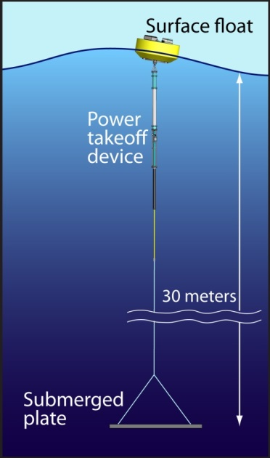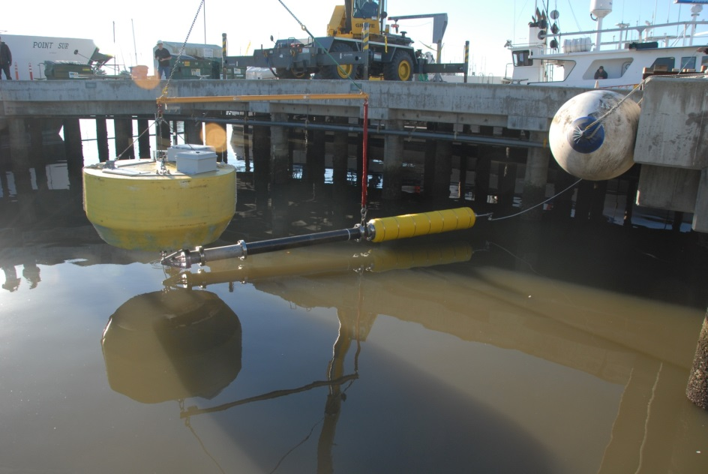
Figure 1: Schematic and photo of MBARI wave-energy conversion system.

Analysis
In order to analyze the effects of power-production at smaller scales for this system, the numerical modeling tools and analysis developed at MBARI for this project have been applied to scaled down versions of the MBARI system. Figure 2 illustrates the basic result in terms of a percentage of the power production the full-size MBARI system produces at various wavelengths. As expected the power production drops significantly as the size decreases, but also the production in longer period waves drops almost to zero. The effect here is that as the buoy becomes smaller and smaller, the wavelengths appear to it to be longer and longer and the system begins to just ride up and down with the waves instead of responding to them.

Figure 2: Expected average power capture of systems scaled down proportionally to the MBARI wave-energy system.

Packing Concept Design
In order for the MBARI type wave-energy extraction device to be packed in the specified envelop for this project, and still provide the required 30W of power on average, a number of problems would need to be addressed
- How to realize sufficient water-plane area and still fit within the 32 inch diameter envelope. An obvious solution to this would be to have a bladder inflate upon deployment and provide a ring of floatation around a core buoy which houses the electronics and batteries. Presumably inflatable life-raft technology could achieve this, and one might also consider an expanding foam inside a bladder to ensure positive floatation that doesn’t require refilling.
- The systems performance is also dependent upon the size of the anti-heave plate. Typically we aim for a surface area for that plate of 2-3 times the waterplane area of the buoy. This will be very difficult to pack in the tank dimensions and will require some clever mechanical engineering. For survivability we are now utilizing a system that changes shape depending on how hard and fast it is pulled through the water, the current design relies on spring loaded doors that vent when pulled hard, resulting in a force speed curve that levels out as the speed is increased instead of increasing quadratically as any fixed shape will. One possibility for this application would be a series of many disks that fit within the envelope and are spaced along and anchor cable. The performance of such a system is unknown, unfortunately it is the added mass of the anti-heave plate that strongly affects performance more than drag, rewarding a single large surface area plate.
- Power Take-off device stroke. The bottoming out of this element is unavoidable and therefore must be designed for. Shorter design strokes make this component of the survivability issues more difficult.

Figure 3 illustrates a concept design for a wave-energy system that would potentially fit within the tank envelope and provide the required power. The buoy expands to a diameter of 1.5 meters in this concept, with sufficient anti-heave plate area this will be large enough to provide an average of 30W of power in Monterey Bay sea states, provided sufficient battery capacity is included to provide power during calm conditions. The anti-heave plate is notional and a means of packing this has not been determined beyond a rough idea that perhaps the tank itself could unfold into place somehow…

Figure 3: Concept of a system shown packed into the tank, and deployed with the buoy and anti-heave plate expanding to fulfil their roles.

Summary
Converting the MBARI system into a tank-packed system that automatically deploys is a major undertaking and involves considerable re-design and testing of the system. Nevertheless, if this was to be undertaken, the MBARI system and provides a starting point. The power take-off device and power electronics would probably translate across relatively unchanged, the dynamic modeling tools we’ve developed would be applicable, and the experience operating the MBARI system would provide insight into the survivability issues. The major design tasks would be:
- the packaging in general
- development of the expanding buoy
- repackaging of the MBARI power take-off device into a shorter envelope (we currently arrange the spring element and the damper element in line, they would need to be arranged alongside one another to fit the length restriction)
- development of an anti-heave device which fits the envelope and allows sufficient power to be generated
- a mechanism to support AUV docking and re-charge.

