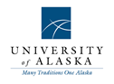

aw

Arctic Domain Awareness Center (ADAC)
A DHS Science and Technology University Program,
Center for Maritime Research

ADAC Work plan for Program Year 7:
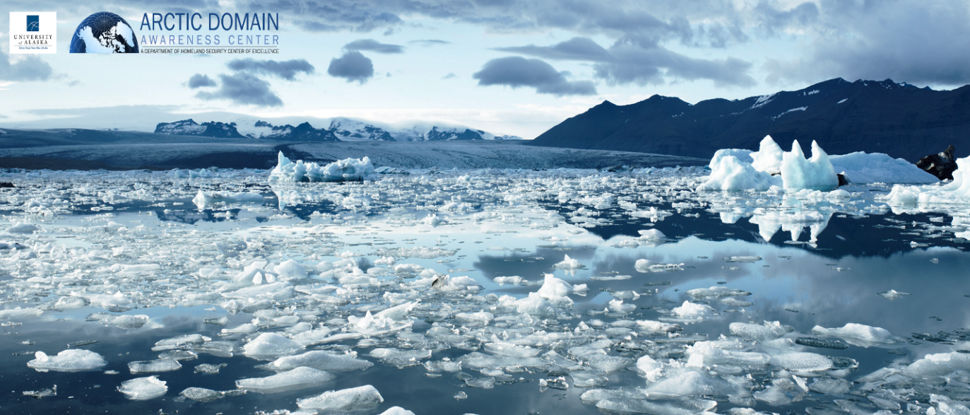
1 July 2020 - 30 June 2021
Version 1.0

Submitted by ADAC leadership team to DHS S&T UP
17 February 2020

Douglas Causey, PhD, Principal Investigator, University of Alaska, Anchorage (UAA)
Larry Hinzman, PhD, Research Director, University of Alaska Fairbanks (UAF)
Randy Kee, Maj Gen (Ret.) USAF, MS, Executive Director, UAA
Heather Paulsen, MBA, Finance Director, UAA
LuAnn Piccard, MSE, PMP, Project Management Director, UAA
Jason Roe, USCG (Ret), Assistant Director & Senior Research Professional, UAA
Elizabeth Matthews, MAS, Education and Administration Manager, UAA
Connor Keesecker, BA, Research and Communications, UAA

Table of Contents
Arctic Domain Awareness Center (ADAC) Year 7 Work Plan Executive Summary 6
Center Management Processes 9
ADAC Objective and Purpose: 9
Vision: 9
Mission: 9
Strategy: 9
Implementation: 10
Organization and Leadership: 10
ADAC Executive Counselors: 13
ADAC Overall Management Approach and Allocation of Effort: 15
ADAC Review Group and Project Evaluation Process. 19
ADAC Project Evaluation process to assess program activity 20
ADAC Research Transition Process: 21
ADAC Strategic Communications Plan: 22
USCG and Key Stakeholder Engagement: 23
ADAC Project Descriptions Aligned to DHS CMR FOA Themes: 24
THEME 1: Maritime Risk, Threat Analysis and Resilience Research Projects: 24
PROJECT: Mitigating the Damage to Arctic Copepods from Surface Oil Spills: When to Apply Dispersants 25
PROJECT: Photo-enhanced toxicity of dispersed and burned crude oil to Arctic mussels 34
PROJECT: Marine Induced Polarization Methods for the Detection and Mapping of Oil in an Arctic Marine Oil Spill; Including Investigation of Oil Within and Under Broken Ice Fields 51
PROJECT: Oil Spill Modeling for Improved Response to Arctic Maritime Spills: The Path Forward 61
THEME 2: Maritime Domain Awareness (MDA) Research 75
PROJECT: Ice Conditions Index for the Great Lakes Region (Great Lakes ICECON) and Arctic Ice Conditions Index (ARCTICE) 75
PROJECT: Arctic Vessel Monitoring Geofencing/Alert Awareness 85
PLACEHOLDER PROJECT: Research support to National Weather Service Arctic Testbed and Proving Ground. 91
PLACEHOLDER PROJECT: Next Generation Arctic Communications Systems: Requirements. 91
THEME 3 – Maritime Technology Research: 91
PROJECT: Development of Propeller Driven Long Range Autonomous Underwater Vehicle (LRAUV) for Under-Ice Mapping of Oil Spills and Environmental Hazards 92
PROJECT: Arctic-related Incidents of National Significance (Arctic IoNS) Workshop 104
PROJECT: Arctic Medium and Long Term Environment (Arctic MaLTE) Workshop 108
THEME 4: Integration of Science and Engineering with Maritime Security Governance and Policy Research 112
THEME 5: End-to-End (E2E) 112
PROJECT: Arctic Command Center Modernization: A Scoping Study: Identify End-to-End (E2E) needs for USCG District and Sector Command Center IT Systems integration and modernization oriented uniquely to USCG Arctic missions. 113
THEME 6: Integrated Education 123
PROJECT: Minority Serving Institution (MSI) and Significant Minority Enrollment (SME) Summer Internship (MSI). 127
PROJECT: ADAC Arctic Summer Intern Program (ASIP). An ADAC Fellow & Minority Student Integrated Summer Intern Program. 129
Appendix A: Acronyms 133
Appendix B. Budgetary Information. 136
ADAC Program Year 7 Financial Summary 136

List of Figures
Figure 1. ADAC Center Leadership. 12
Figure 2. ADAC Executive Counselors. 15
Figure 3: Mitigating Damage to Arctic Copepods from Oil Spill Overview 27
Figure 4: Photo-enhanced Toxicity of Dispersed & Burned Crude Oil to Arctic Mussels Overview 36
Figure 5: Marine Induced Polarization Project Overview 53
Figure 6. Photograph of oil slick in slush off the Canadian East Coast (left) and schematic showing many ways oil can be contained in and under ice (right, Dickins et al, 2004). 55
Figure 7. Diagram of a towed Marine IP streamer (in this example from a vessel in a near-shore marine spill), showing two transmit electrodes and four receiver electrodes. 55
Figure 8. Illustration of how the Marine IP cable will be manipulated through the CRREL ice tank. 57
Figure 9: Oil Spill Modeling for Improved Response to Arctic Maritime Spills 63
Figure 10. ARCTICE Overview. 77
Figure 11. POLARIS risk values for winter ice. Note: least risk (green) to greatest risk (red). 80
Figure 12 POLARIS index for the Arctic Ocean calculated from HIOMAS Model 81
Figure 13. Arctic Vessel Monitoring and Geofencing/Alert Awareness 87
Figure 14. Propeller Driven Long Range Autonomous Underwater Vehicle overview. 93
Figure 15 Whiteboard of ADAC converging research: Green represents current projects and yellow represents near-term research opportunities. Ultimate goals are in the center. 118
Figure 16 Stovepiped IT and duplicated data entry 119
Figure 17 IT solutions not aligned with Watch positions 119
Figure 18 Future one data entry point that feeds other systems 120
Figure 19 Current stovepiped IT and duplicated data entry 120
Figure 20 Future QRCs generated inside SAROPS 121
Figure 21 MISLE + Local Log + Auto-generated briefings/reports 121
Figure 22 Future SAROPS becomes the Operations Planning Tool and MISLE becomes the Command Center Database 121
Figure 23 Future How new tools would eliminate data entry overlap 122
Figure 24 ADAC Fellows Program Overview 126

List of Tables
Table 1. Tasks and associated metrics for direction and management of established projects. 16
Table 2. Tasks and associated metrics for continuation of Year 4, 5, and 6 research initiatives. 17
Table 3. Tasks and associated metrics for conducting outreach, engagement, and communications. 18
Table 4. Tasks and associated metrics for conducting education, outreach, and workforce development efforts. 18
Table 5. Project schedule and milestones 31
Table 6 Project Students 44
Table 7: Phased Research Timelines 45
Table 8: Upon completion of this experiment, team members will employ a Pugh concept selection method to rank the multi-dimensional options of the dataset. This can assist with decision tree development and transitioning data to policy 50
Table 9. Project student activities. 68

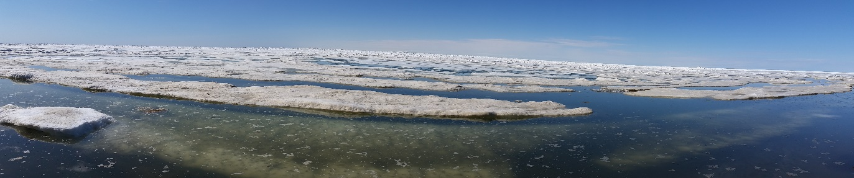
ADAC Photo, Pt Barrow Alaska, June 2019

Arctic Domain Awareness Center (ADAC) Year 7 Work Plan Executive Summary
The Arctic Domain Awareness Center (ADAC) is a U.S. Department of Homeland Security (DHS) Science and Technology (S&T) Office of University Programs (UP) Center of Excellence (COE) in Maritime Research.
ADAC supports the U.S. Coast Guard (USCG) and other DHS maritime missions in order to improve capability for Arctic search and rescue, humanitarian assistance, disaster response, and security. This includes efforts to “enable the decision maker” across those mission sets.
Accordingly, ADAC looks to the coming program year to ensure full transition of concluded research, advance research initiated in Year 5 and Year 6 to effect suitable transition, continue innovation of education programs and activities, add new research derived from Year 6 workshop efforts, and publish conducted research. Outside of the work plan, University of Alaska personnel associated with ADAC will seek sponsor diversification to take effect in Year 7 and beyond.
A core part of the ADAC mission is to continue to foster the next generation of scientists and engineers devoted to the discovery, development, and improvement of technologies and applications for Arctic Maritime Domain Awareness, Response, and Resilience. During Program Year 7, ADAC will continue to work with and mentor our student Fellows, presently at different stages in their studies, to ensure their successful transition to the Homeland Security Enterprise workforce once they graduate. ADAC Center leadership will continue to support student transition efforts with enrichment efforts that will enable their success.
ADAC’s Year 7 Work Plan management and administrative processes (Section II) highlights the Center’s strategy and overarching management plan. This includes ADAC’s organization and plans for: 1) engagement and strategic communications, 2) research investigation and development (including research calls and operator-driven workshops), 3) current project assessment, evaluation, and management, 4) research transition and/or commercialization, and 5) summary of education management and fiscal accountability.
ADAC’s Year 7 Work Plan project descriptions, located in Section III of the document, remains the heart of the Center’s mission. This section also describes ADAC’s efforts in education and workforce development.
As introduced in ADAC’s Year 4 work plan, ADAC’s Year 7 Work Plan format aligns research projects to the DHS Funding Opportunity Announcement’s (FOA) six overarching themes. These are:
- Maritime Risk, Threat Analysis, and Resilience Research;
- Maritime Domain Awareness (MDA) Research;
- Maritime Technology Research;
- Integration of Science and Engineering with Maritime;
- End to End (E2E);
- Integrated Education.
As due diligence requires, ADAC will monitor/finalize transition activities at destination locations with the following Year 6 completed projects:
- The Arctic All Hazards GIS Platform.
ADAC will advance research and plan to conclude specific investigative tasks for the following projects in Program Year 7, in accordance with designated HQ USCG Project Champion and DHS S&T UP Program Manager (PM) directions in order to effect transition:
- Ice Condition Index for the Great Lakes (Great Lakes ICECON) and the Arctic (ARCTICE).
- Marine Induced Polarization Methods for the Detection and Mapping of Oil in an Arctic Marine Oil Spill, including investigation of Oil within and under broken ice fields.
- Mitigating the Damage to Arctic Copepods from Surface Oil Spills: When to Apply Dispersants.
- Photo-enhanced toxicity of dispersed and burned crude oil to Arctic mussels
- Oil Spill Modeling for Improved Response to Arctic Maritime Spills.
- Arctic Vessel Monitoring and Geofencing/Alert Awareness.
- Development of Propeller Driven Long Range Autonomous Underwater Vehicle (LRAUV) for Under-Ice Mapping of Oil Spills and Environmental Hazards.
- Projects awarded and established responding to funded solicitation from “Stressing the system...managing a complex Arctic crisis” Arctic IoNS 2019 workshop, which are anticipated for award in ADAC Program Year 6.
- Directed Study awarded and established responding to a funded solicitation from “Arctic Air 2020 Tabletop Exercise” Arctic IoNS 2020.
Based upon significant advancements in collaboration between ADAC and USCG District 17 Sector Anchorage, and in careful review of the Center’s original mandate, ADAC proposes to conduct the following Center led research studies in Program Year 7:
- Research support to National Weather Service Arctic Testbed and Proving Ground. This investigative study will seek to experiment with concluded research already transitioned as well as completing research in order to affect better NWS leveraging to maximize DHS S&T and University of Alaska research investments.
- Next Generation Arctic Communications Systems: Requirements This Arctic and overall Alaska maritime communications study will scope a mid-to-longer term approach to identifying Alaska coastal regions communications gaps and shortfalls and propose solutions which correspond to USCG statutory mission requirements.
- Arctic Command Center Modernization: A Scoping Study: Identify End-to-End (E2E) requirements for Sector and District Command Center IT Systems integration and modernization.
ADAC will plan to conduct both an Arctic related incidents of National Significance (Arctic IoNS) & Arctic focused Medium and Long Term Environment (MaLTE) workshops collaborated with U.S. Coast Guard.
ADAC will continue integrated education and workforce development activities, research internships to specific project investigators, and a summer internship program that provides Arctic research opportunities for students from under-represented demographics.
ADAC will continue to seek and conduct activities in association with DHS S&T and/or USCG projects funded via DHS S&T UP-ADAC Basic Ordering Agreement. Based on Center understanding of current challenges and challenges of communications across Alaskan and Arctic waters, ADAC is prepared to support needs to address and alleviate these challenges, specifically oriented to the mid and longer term shortfalls in accordance with USCG requests/desires.
ADAC is also prepared to conduct a specific solicitation and field new research to meet HQ USCG identified needs as jointly determined between HQ USCG CG926 and DHS S&T UP.
Based on current understanding as regards the current ADAC Cooperative Agreement between the University of Alaska and DHS S&T UP, the Center is prepared to conclude DHS S&T UP funded activities at the end of Program Year 7. The University of Alaska and Center leadership is proud of the successes of the ADAC team in advancing operationally relevant research, educational and workshop activities in support of USCG Arctic mission needs, and remains ready to continue these activities if/as DHS S&T and USCG so agree and so provide the needed resources to accomplish.

Center Management Processes

ADAC Objective and Purpose:
The U.S. Department of Homeland Security, Science and Technology’s University Programs (DHS S&T UP) established ADAC in summer 2014 to research and provide a scientific basis to address the challenges faced by USCG and other DHS maritime missions in the Arctic region.
ADAC’s principal customer is the USCG. ADAC investigates capability shortfalls and gaps, and orients research activity to support the USCG mission needs. The particular areas that ADAC seeks to assist the USCG are related to missions in support of Arctic search and rescue, humanitarian assistance, disaster response, and security matters. While principally oriented to the USCG, ADAC also seeks to support other DHS maritime mission needs in the Arctic.
As founded, the Center remains focused to “enable the decision maker”...and continues to seek opportunities to conduct research and studies to realize the term. Throughout Program Year 6, ADAC has made significant advances in understanding USCG Arctic command center mission needs at the Sector level, and proposes new work to support modernization efforts to further advance endeavors to enable the decision maker.
As a university-hosted research venue, ADAC supports student education. Through the Center’s Fellows Program, ADAC provisions student research, internships, and entry into the Homeland Security Enterprise.
ADAC’s approach is to align the Center’s research agenda with U.S. national, DHS, and USCG Arctic strategies and strategy implementation plans. ADAC notes existing strategies may change, and DHS strategy for the Arctic remains in development. As the U.S. national, DHS, and USCG Arctic strategies adapt and develop over time, ADAC will seek to conform Center research endeavors appropriately.
As in prior year work plans, research and development conducted by ADAC will not only serve USCG and other DHS maritime missions, but also benefit an array of ADAC partners and collaborators and support the public good.
ADAC’s corresponding vision, mission and strategy remains unchanged:

Vision:
The DHS Center of Excellence provides networked and mission-focused support to the USCG Operator in the High North. ADAC strives to become a National Center of Arctic maritime research.

Mission:
ADAC’s mission is to develop and transition technology solutions, innovative products, and educational programs to improve situational awareness and crisis response capabilities related to maritime challenges posed by the dynamic Arctic environment. ADAC seeks to accomplish this mission through an inclusive approach.

Strategy:
ADAC will conduct a parallel effort over five lines of major collaboration with DHS S&T UP and USCG in order to:
- Investigate, develop, resource, and initiate new research.
- Execute approved research work plans that are appropriately detailed and resourced.
- Successfully integrate university student Fellows into the Homeland Security Enterprise workforce.
- Transition sufficiently mature research to meet customer acquisition needs, and commercialize as appropriate.
- Adapt Center activities, management, and communications to continue to learn and collaborate with an array of Center partners, and continue to suitably expand the reach of ADAC across U.S. and Canada to include Arctic government, military and security operators, researchers, and industry partners.

Implementation:
In order to implement the Year 7 strategy, ADAC will continue to improve established management processes, continue existing communications practices, execute approved work plans, seek commercialization opportunities, and continue to innovate in education and workforce development. This includes advancing and leveraging new management processes established in Program Year 6 as well as further development on ADAC’s cutting edge communications practices.

Organization and Leadership:
DHS S&T UP awarded ADAC’s cooperative grant to University of Alaska, Anchorage. ADAC has created and continues to refine a unified approach to leading the Center for the University of Alaska through close partnership with the University of Alaska Fairbanks. ADAC reports to the DHS S&T UP program manager in accordance with protocols established via the DHS S&T UP cooperative grant. ADAC’s Principal Investigator and Executive Director jointly report through the UAA Provost and Executive Vice Chancellor, the UAA Chancellor, and the University of Alaska System President for academic institutional support requirements.
ADAC leadership consists of the following team of both full and less than full time members. The overall leadership is maintained by a collaborative arrangement via the ADAC Principal Investigator, Research Director and Executive Director.
Full time Center members: Executive Director, Associate Director and Senior Research Professional, Education & Administrative Manager and Communications & Research Associate.
Less than full time members: Principal Investigator, Research Director, Finance Director, and Project Manager.
In program Year 7, ADAC will gain communications support from UAA resources at the Business Enterprise Institute.
ADAC has established an extensive research partnership and collaboration network across Arctic-minded universities and industries throughout the U.S. and Canada. ADAC also gains multi-faceted counsel through an external advisory board, and has established an effective student Fellows program. ADAC maintains committed collaboration with fellow DHS S&T UP Centers of Excellence. ADAC comprehensively engages with U.S. Federal, State of Alaska, and local Arctic authorities on Arctic research matters. Internationally, ADAC principally engages with Canada as well as other Arctic partners, including Denmark, Finland, and Norway. In Program Year 7, these engagement activities will continue.
In accordance with the DHS award, the senior leadership for the center is as follows: the University of Alaska Anchorage hosts the Principal Investigator and Executive Director. The ADAC Research Director is located at the University of Alaska Fairbanks campus, while also serving as the Vice Chancellor for Research at the University of Alaska Fairbanks.
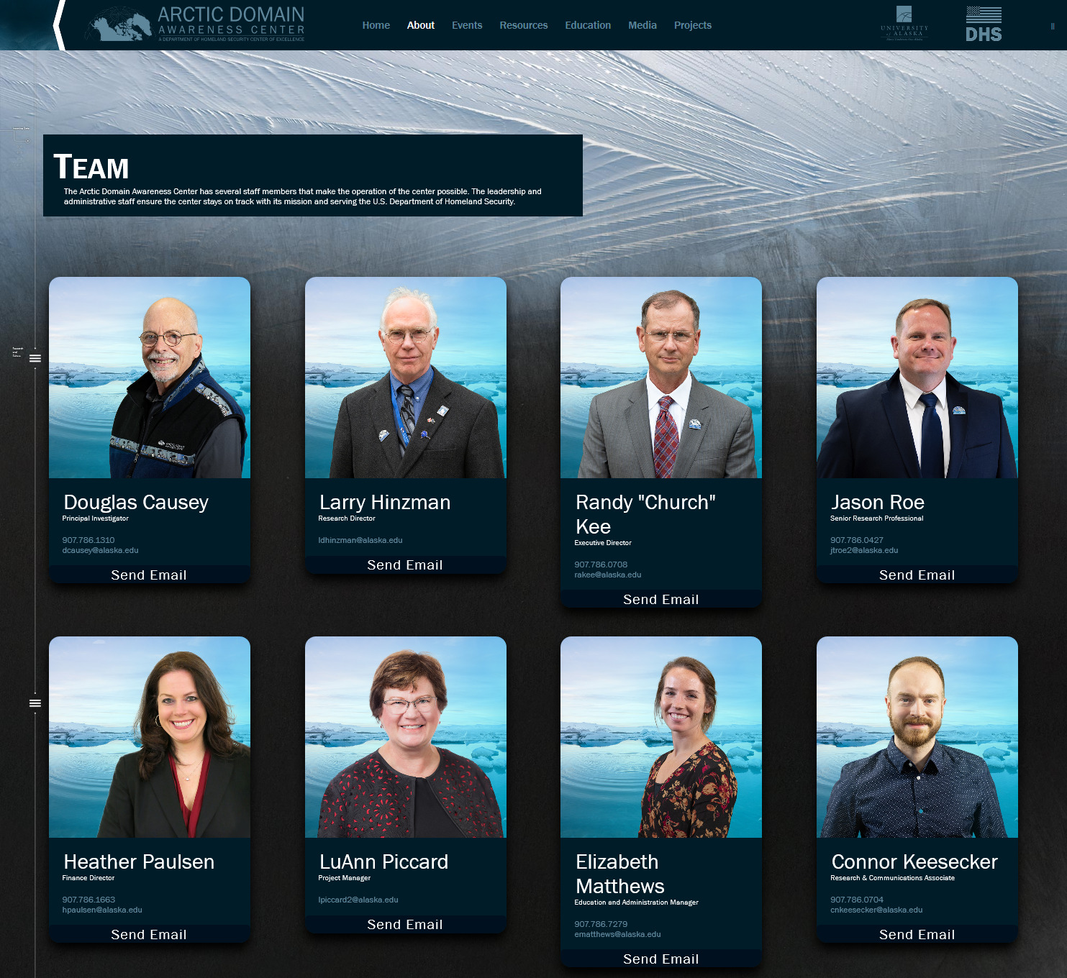
Figure 1. ADAC Center Leadership.

In sum, the ADAC team comprises a diverse blend of Arctic science and technology academics, Arctic-related strategy and policy expertise, and strong organizational and fiscal leadership credentials. The following is the leadership lineup for ADAC:
- Principal Investigator (PI), Douglas Causey, PhD, University of Alaska. The ADAC PI is responsible for close collaboration with the Executive Director and the Research Director to achieve ADAC mission goals. The ADAC PI will seek to connect ADAC with partners and opportunities. In coordination with the Executive Director, the ADAC PI is responsible for reporting to the University of Alaska System Leadership and DHS program sponsors on a regular basis. The DHS S&T – UAA ADAC Cooperative Agreement remains credited to the ADAC PI as the associated lead University faculty member.
- Executive Director (ED), Randy Kee, Maj Gen, USAF (Ret.), MS, University of Alaska. The ADAC ED provides direction of all Center activities to meet COE goals, achieve milestones, develop technology, communicate with customers and engage the broader Arctic community across the U.S. and Canada. The ED will organize site visits for demonstrations, interface with the end-users, and will work with ADAC leadership to ensure the Center complies with federal regulations and reporting. Together with the ADAC PI, the ED will regularly meet with DHS staff at DHS headquarters and represent the program at meetings required to support the needs of DHS management and the greater DHS enterprise. The ADAC ED works closely with USCG stakeholders to ensure the Center meets USCG expectations. Finally, the ED will ensure ADAC appropriately conducts internal processes, in particular assessment meetings, engagement forums, and DHS sponsored workshops.
- Research Director (RD), Larry Hinzman, PhD, University of Alaska Fairbanks. The ADAC RD provides leadership for the center in establishing research concepts and follow-on proposals. The RD also provides leadership to support research concept generation, individual project leaders, and research teams. ADAC’s RD is responsible for addressing and guiding scientific quality for the individual projects and the overall program. The ADAC RD, where suitable, interacts with DHS and stakeholders and interfaces with other DHS COEs and research centers to identify and formulate additional research projects. The ADAC RD is a key leader for the Center to identify when research projects are ready to transition to the next Technology Readiness Level (TRL) and whether they are suitable for transition from research to development.
- Finance Director (FD), Heather Paulsen, MBA, University of Alaska Anchorage. The ADAC FD is responsible for management and oversight of administrative operations of the COE and its group of associated subcontracts. The ADAC FD will provide program/project planning, budgeting, and implement operational policies and processes to support the COE. Further, the FD will work in close collaboration with the ED and the Project Management Director to develop budgets aligned to program and project planning objectives and to manage expenditures as aligned with the research mission of the Center.
- Project Management Director (PMD), LuAnn Piccard, MSE, PMP, University of Alaska Anchorage. In partnership with ADAC ED, Finance Director, and Project PIs the PMD will support efforts to integrate project plans into a cohesive program with phased solution and technology deliverables aligned with ADAC’s strategic mission and ADAC’s research-to-development process. This includes conducting research and develop a knowledge product describing current state experience and recommend best practices for transitioning applied research work products from DHS COEs to institutional users/partners (e.g. USCG, NOAA, U.S. Office of Naval Research, etc.).
- Associate Director and Senior Research Professional (AD/SRP), Jason Roe, USCG Ret, University of Alaska Anchorage. ADAC’s Associate Director and Senior Research Professional provides technical coordination with the USCG, to include investigating feasibility and applicability of ADAC research integration to USCG decision support systems. The ADAC AD/SRP leads Center operations in the absence of the ADAC ED. The AD/SRP supports transition activities and research diversification. The ADAC AD/SRP will support commercialization research and assist ADAC ED in representing the Center at technical exchanges, with DHS, USCG and industry. Lastly, the ADAC AD/SRP is the investigative lead for the Center in gaining insights and identifying challenges and describing solutions/solution pathways to address USCG technology shortfalls and gaps, to include challenges uniquely suited to the Arctic and the directly associated with “enabling the decision maker” at USCG command centers.
- Education and Administration Manager (EAM), Elizabeth Matthews, MAS, University of Alaska Anchorage. ADAC’s Education and Administration Manager oversees ADAC’s student development program. This includes DHS Career Development Grant Scholarships and student research interns. ADAC’s EAM will oversee and support the Center’s student, summer internship program for ADAC Fellows and under-represented students from Minority Serving Institutions (MSI), Federal Tribal Designations (FTD), and Significant Minority Enrollment (SME) universities or colleges. ADAC’s EAM will lead efforts to recruit, enroll, and monitor student performance and to graduate entry into the Homeland Security Enterprise. The ADAC EAM leads administrative management functions and supports communications outreach.

- Research Communications and Associate (CRA) Connor Keesecker, BA, University of Alaska Anchorage. ADAC’s CRA supports developments of Center written reports (such as Program Year Workplans and Annual Reports), conducting directed research tasks, developing products to support workshops oriented to USCG mission needs and supporting media development for ADAC events such as the Center’s Annual meeting.

ADAC Executive Counselors:
The Executive Counselors (EC) are ADAC’s external advisory board and are highly qualified senior leaders and/or research professionals. The EC provide counsel pro-bono. The EC principally provide strategic advice on Center management focus, critical commentary on current project work, and insights to future opportunities. In Program Year 6, ADAC will continue to meet individually with these Executive Counselors periodically, while also conducting three Strategic meetings with the Counselors via a dedicated forum (one associated an ADAC Program Quarterly Review).
ADAC’s Executive Counselors are:
- Tom Barrett, VADM (Ret), USCG, President, Alyeska Corporation, Anchorage, Alaska. Admiral Barrett is a former USCG Vice Commandant and District 17 Commander.
- Paul Hubbard, PhD, Canada Department of National Defense, Ottawa, Canada.
- John Farrell, PhD, Executive Director, U.S. Arctic Research Commission, Washington, D.C.
- Heather Quilenderino, CDR, USN, Director, National Ice Center, Suitland, Maryland.
- Ukallaysaaq Okleasik, Vice President and CEO of Sitnasuak Native Corporation.
- Tom Case, Chancellor Emeritus, University of Alaska Anchorage, and Lt. Gen, USAF (Ret).
- Michael Duxbury, Former Deputy Commissioner, State of Alaska Department of Public Safety, on assignment to Washington D.C.
- Rudy Peschel, RADM USCG (Ret), Fellow, Center of Arctic Study and Policy (CASP) U.S. Coast Guard Academy.
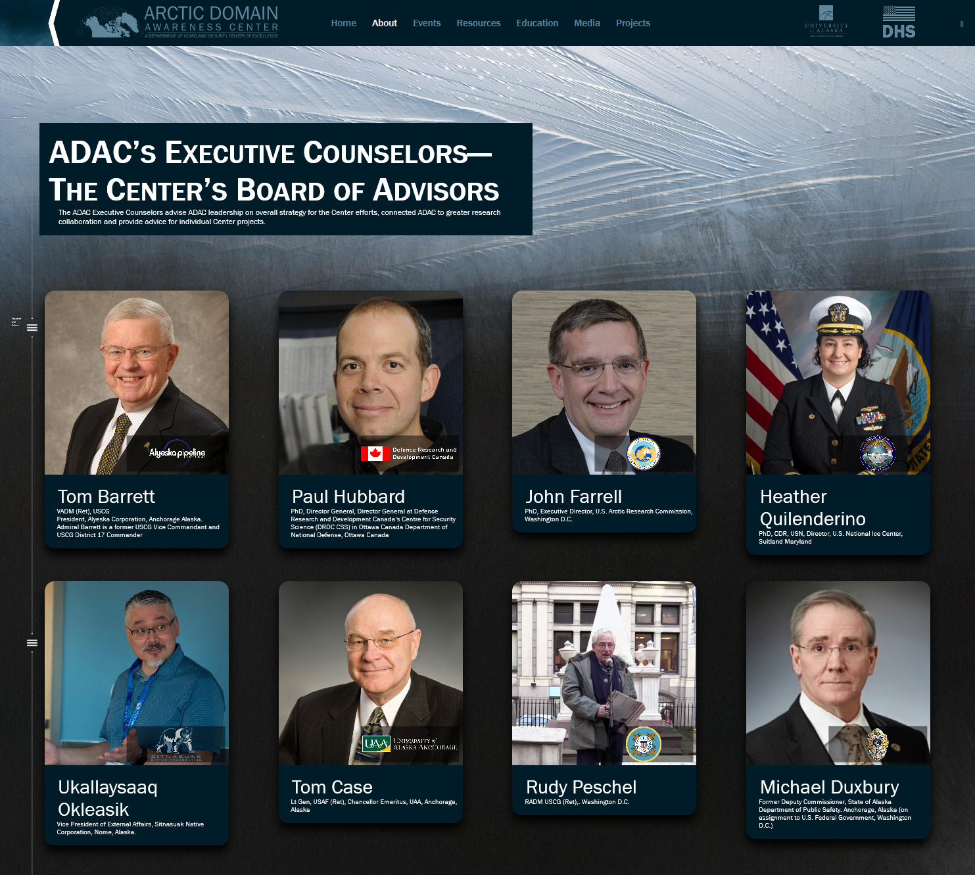
Figure 2. ADAC Executive Counselors.

ADAC Overall Management Approach and Allocation of Effort:
The USCG and other DHS maritime Arctic operators are the key end-users driving research for ADAC. The Center will conduct fundamental and applied research in MDA and maritime technology. Strategically, ADAC will:
- Advance Arctic domain awareness research areas by increasing the science of knowledge and understanding in order to improve USCG Arctic operator coordination, control, and decision- making.
- Conduct research in maritime technology to provide needed capability to support and effect increased domain awareness.
- Comprehensively investigate new research.
- Transition sufficiently mature or completed research. Transition outcomes are project specific.
- Pursue commercialization options as suitable for concluding or completed research.
- Initiate patents, trademarks, and other measures to protect developed intellectual property.
ADAC will continue to advance Center student research programs, including student Fellow participation within research projects and their participation in cross-Center activities.
ADAC’s leadership apportions the execution of the Program Year 7 Work Plan accordingly:
- Direct and manage the research of established projects, which includes extensive research transition coordination between Project teams, USCG Project Champions, HQ USCG Acquisition and DHS S&T OUP. This entails 60% of the ADAC management focus. Specific tasks and associated measurements include:
Table 1. Tasks and associated metrics for direction and management of established projects.
Task | Associated Metric
Conduct weekly teleconferences with ADAC Project leads and research teams. | Informed ADAC leadership and research team.
Participate in weekly teleconference with DHS S&T UP Program Manager. | Informed DHS S&T UP Program Manager.
Conduct monthly project invoice review. | Fiscal understanding of each project performance on monthly basis.
Conduct a Quarterly Review with ADAC Project Leads and research teams for DHS S&T UP Approved workplans that includes specific project transition planning. | Comprehensive review of project performance by ADAC leadership team, enabling oversight on a scheduled basis.
Conduct one Quarterly Review with ADAC Project Leads and research teams, with the Executive Counselors. | Comprehensive review as with regular reviews, with added recommendations from ADAC’s Executive Counselors.
Prepare Center and project Work plan for any approved research activities that extend beyond Year 7 (30 June 2021). | Approved plans and activities by DHS S&T UP PM.
Establish new projects from Spring 2020 Arctic IoNS workshop. This includes concluding proposal reviews, notification, development of workplans and establishing HQ USCG Project Champions. | Projects approved by DHS S&T UP PM.
Subrecipient monitoring via ADAC leadership in-person visits at each subrecipient of the DHS S&T OUP Cooperative Grant location (university or business). | Successfully concluded subrecipient monitoring. ADAC leadership plans to conduct a minimum of one subrecipient monitoring visit at each location at least once per two-year program period.
Prepare Annual Report reporting on Center activities and Project Research | Approved report by DHS S&T UP PM.
Participate in detailed effort for project transition, including collaboration with HQ USCG CG-9 ADAC point of contact and USCG Project Champions. | Established transition pathway for ADAC research to meet USCG acquisition needs.
Investigate commercial opportunities for research transition, including patent and licensing. | Approved patents and/or licensing from submitted proposals.

- Continue research development Initiative started in Program Year 4 and extended through Years 5 and 6. This entails 10% of ADAC leadership focus. This effort entails collaborating with DHS S&T OUP and USCG for workshops that generate research questions, conducting and processing calls for research. Specific tasks and associated measurements include:

Table 2. Tasks and associated metrics for continuation of Year 4, 5, and 6 research initiatives.
Task | Associated Metric
Plan and conduct Arctic IoNS workshop, with topic determined by USCG (in particular, USCG D17 Commander). | Successfully concluded workshop that provides as exercise Rapporteurs report and USCG approved directed study based on discovered mission needs. Research questions may result in ADAC funded solicitation, simply intended for mission agencies to consider future sponsoring research, which addresses priority shortfalls identified at the workshop.
Coordinate and conduct Arctic Medium and Long-Term Environment (Arctic MaLTE) workshop focused on HQ USCG security and safety concerns | Conducted workshop addressing HQ USCG security and safety concerns.

- Conduct outreach, engagement and communications with customers, partners and collaborators, including potential new partners, to inform of center initiatives and research project details, while advancing ADAC’s research networks. This encompasses 10% of ADAC leadership focus. Specific tasks and associated measurements include:
Table 3. Tasks and associated metrics for conducting outreach, engagement, and communications.
Task | Associated Metric
Prepare and conduct Annual meeting in Washington D.C. (preferably at HQ USCG). | Successfully presented meeting, informing DHS, USCG and invited participants of ADAC research and transition planning.
Conduct approximately quarterly Customers and Partners Roundtables via teleconference/webinar. | Successful completion of roundtables, and publishing of associated minutes.
Conduct semi-annual USCG focused ADAC “Principal Customer’s” research project teleconference. | Successful completion of teleconference.
Participate in Alaska Marine Science Symposium (January 2021). | ADAC completing a planned presentation.
Develop center and project motion graphics presentations in support of outreach. | Completed and posted motion graphics that describe ADAC efforts.
Prepare and release quarterly newsletters. | Published newsletters to established ADAC mailing list and posted to Center website.
Prepare brief noteworthy activities and project vignettes for DHS S&T UP communications staff. | Providing DHS S&T UP, communications needed information of ADAC activities and project research.
Update ADAC website, Facebook and Twitter of Center activities and noteworthy events. | Informing public of ADAC activities and research.
Publish specific ADAC events and activities to Interagency Arctic Research Policy Committee (IARPC). | Informing community of Arctic researchers about ADAC activities.

- Continue conducting education, outreach, and workforce development efforts consisting of a variety of activities that include both ADAC Fellows and minority students. ADAC anticipates this effort requires 10% of Center leadership focus.

Table 4. Tasks and associated metrics for conducting education, outreach, and workforce development efforts.
Task | Associated Metric
Recruit student interns (ADAC Fellows) for available research. | Achieve 100% fill for ADAC Fellow available slots.
Assign projects and develop workplans to ADAC Fellows. | Students fully assigned to projects with associated workplans.
Conduct monthly ADAC Fellows meetings. | Accomplish planned meeting schedule.
Conduct an ADAC Student research Symposium. | Completed symposium highlighting student research efforts.
Support ADAC Fellows entry into suitable 10- week summer internship; | All ADAC Fellows conclude a 10-week summer internship.
Support post-graduate student placement with Homeland Security Enterprise (HSE). | All graduated ADAC Fellows complete one year minimum service in a HSE related position or alternatives as described in the DHS OUP Terms and Conditions.
Recruit and conduct an abbreviated Minority Serving Institute (MSI) Arctic Summer Intern Project (ASIP) for May-June 2021. | Successful completion of an early MSI ASIP in early June 2021.

ADAC Information Protection Plan
ADAC has reviewed the Center’s Information Protection Plan established in Program Year 1. ADAC will continue to execute this plan that is already on file with DHS.
ADAC Research Safety Plan
ADAC has carefully reviewed Center’s Research Safety Plan established in Program Year 1. ADAC will continue to execute this plan that is already on file with DHS.

ADAC Review Group and Project Evaluation Process.
ADAC Review Group. Central to ADAC’s evaluation plan is establishing a comprehensive review of the Center’s work on a quarterly basis. Therefore, ADAC will schedule the convening of the ADAC Review Group to govern ADAC Quarterly Reviews. The ADAC Review Group will also review ADAC’s comprehensive approach to investigate and develop new research for DHS S&T OUP and USCG consideration.
ADAC’s Executive Director will Chair the ADAC Review Group at Center Quarterly Reviews, closely supported by the ADAC AD/SRP. Principal Investigator, Research Director will participate and consult in review group sessions. The remaining ADAC leadership (Finance Director, Education and Administration Manager, Project Management) will support ADAC Review Group sessions. ADAC ED will consider inviting additional subject matter experts to assist the ADAC Review Group in executing an overall “end to end” approach for the Center and for project examination. ADAC ED will consult with the ADAC Executive Counselors Board for appropriate participation to provide their assessments of program and project utility and performance.

ADAC Project Evaluation process to assess program activity
ADAC will use the following process to evaluate Center projects during Center quarterly reviews by the ADAC Review Group. As needed, ADAC leadership will conduct specific reviews on research projects outside of the quarterly review cycle.
- Evaluate the science and technology advances. The ADAC Review Group will assess the progress made by each individual project compared to the utility of the research for ADAC’s goals and objectives and make onward recommendations for proposed action.
- Assess project resourcing versus project execution. The ADAC Review Group will determine the appropriate alignment between project plans and resources. If a project’s importance, priority, and performance measures warrant additional resourcing during “in-year execution,” ADAC’s leadership will seek to address or mitigate the need by coordinating cross-funding from projects that are under-executing (according to project planned schedule and milestones) in resource expenditure. Any movement of resources between projects will comply with the terms and conditions of the DHS S&T - ADAC cooperative agreement protocols.
- Assess each project’s ability to communicate current findings and projected research trajectory. The ADAC Review Group will determine if project discoveries or developments warrant the pursuit of publication in the appropriate media, particularly scientific journals. The ADAC Review Group stresses the importance of publishing ADAC funded research.
- Assess project TRLs. The ADAC Review Group will determine if the actual TRLs versus the planned TRLs at given milestones for each project indicate that research is progressing as planned. Additionally, assessment will seek to determine if research indicates planned TRLs are on a trajectory to produce a useful capability for the Arctic operator.
- Review Project Transition Plan. The ADAC Review Group will review and consult with the project team and Project Champion for discoveries in new intellectual property, commercialization opportunities, and alignment that meet end-user acquisition needs.
- Determine actual program execution versus planned in terms of schedules, milestones, and metrics. The ADAC Review Group will assess how well each project is progressing according to their work plan submitted by ADAC to DHS UP for the project year. If the project is substantially off schedule, the project team will develop a “Get Well Plan” to re-establish adherence to the prior approved project schedule, milestones, and metrics.
- Assess project team overall performance. For projects that are significantly under-performing, the ADAC Review Group will determine if the project lead is able to present an acceptable approach to Center leadership. If necessary, ADAC leadership will consult with the DHS S&T OUP Program Manager to restructure the project’s leadership, team, and/or project plan in accordance with DHS S&T OUP - ADAC grant terms and conditions. If a project is unable to proceed accordingly, ADAC leadership will consult with DHS S&T UP PM to discontinue the project. Following such a decision, ADAC leadership will conduct documentation and provide reprogramming recommendations.
- Specific process for Education Program Management: ADAC’s Education and Administration Manager will present assessments of the education program during quarterly reviews or during periods between quarterly reviews as needed. Following each quarterly education assessment, the ADAC Review Group will:
  - Examine the effectiveness of student participation in individual projects.
  - Evaluate Center performance for recruitment of under-represented students in both the ADAC Fellows program and for the summer internship program.
  - Assess individual ADAC Fellow performance in meeting their work plan objectives.
  - Evaluate the Education Outreach and Workforce Development Program by assessing schedules, milestones, and planned metrics for the overall program.
  - Assess recommendations by the Education and Administration Manager to address any deficient areas of performance.
- Subrecipient monitoring visits by ADAC leadership. Independent of the ADAC quarterly review cycle but instrumental in the overall management of project work for the Center, ADAC leadership will conduct subrecipient monitoring visits. ADAC leadership has developed a subrecipient checklist to guide awardees in preparing and presenting their project’s compliance with the cooperative grant terms and conditions. ADAC’s Executive Director and Finance Director normally conduct these subrecipient monitoring visits.

ADAC Research Transition Process:
As a DHS S&T UP Center of Maritime Research (CMR), ADAC’s priority is to transition research that is sufficiently mature to DHS acquisition processes. In pursuit of acquisition, ADAC seeks to connect sufficiently mature research to industry, HQ USCG CG-7 (Assistant Commandant for Capabilities), and HQ USCG CG-9 (Assistant Commandant for Acquisitions). In addition to working with HQ USCG CG-7 and CG-9, ADAC will conduct appropriate coordination with USCG Research and Development Center (RDC) for operational testing of research in advance of formal USCG acquisition of ADAC maturing research. While principally oriented to the USCG, ADAC also seeks to support other DHS maritime mission needs in the Arctic.
Research advancement towards transition is principal focus of ADAC Year 7. All ADAC’s projects included in Year 7 plan include transition as an integral part of their work plans. Center leadership evaluates project progress on schedules and milestones and advancement to overall transition planning during quarterly reviews via the ADAC Review Group. This review is one way to discern the pathway of transition planning needed to support end-user ADAC’s “Research-to-Capability Process” (RTCP). ADAC’s RTCP is the Center’s approach for finalizing the transition of research to end-users. ADAC will continue to recruit the support of the University of Alaska Business Enterprise Institute and UAA Office of Sponsored Programs to support transition activities.
This task team approach includes careful handling of transfer for appropriate documentation and patent initiation. ADAC’s Principal Investigator, Research Director, and Executive Director will determine the task organization needed to migrate research to receiving development and acquisition professionals. ADAC’s Executive Director will lead with Center’s Project Management Director and/or Assistant Director and Senior Research Professional in serving as deputy lead for the task-organized team. This team will include project PI(s), Center support personnel, and supporting institutions.
The task-organized team will prepare the transfer of research materials, associated physical hardware, software, and intellectual property. Transfer preparation will include a review of financial documentation, DHS S&T UP-ADAC grant terms and conditions, onward disclosure notifications to DHS S&T UP Program Manager, and appropriate public announcements.
The Project PI(s) will complete documentation. This will include fully describing the research, completed milestones, objectives, and project research conclusions while also initiating science review and preparing journal submissions. The Project PI(s) team, in coordination with ADAC leadership, will initiate patent application with University of Alaska as appropriate.
Following internal center preparations, ADAC’s Executive Director and Project Management Director will lead the task-organized team in correspondence and meetings with the receiving agency or organization to conclude transfer.
If a research project is not able to discern a pathway to DHS and USCG acquisition, ADAC’s secondary approach is to determine an alternative pathway to the research plan to realize an achievable acquisition for DHS and USCG.
If either primary or alternative pathway efforts for acquisition prove infeasible, ADAC’s next approach is to seek transition for commercial application. ADAC believes the following categories are the most feasible for commercial application of ADAC research:
- Oil and mineral extraction;
- Coastal and port security;
- Destination adventure cruises;
- Arctic region maritime shipping;
- Education materials.
Lastly, if research does not prove to be feasible for commercial applications, ADAC will seek to connect completed research with those in the community of Arctic maritime research who will benefit the most. In all cases, ADAC will continue to strive to ensure research outcomes benefit the public good.

ADAC Strategic Communications Plan:
Effective communications is essential for ADAC research success. ADAC will continue to advance cutting edge communications advances made in program Year 6, particularly with the Center’s greatly advanced Internet website. The ADAC Year 7 communication plan is both a chance to publicize Center and project activities and accomplishments, and to receive input from stakeholders. The below reflects both mediums and audiences targeted for communications.
ADAC’s plan will communicate progress on research projects and Center activities as well as announcements of workshops and research opportunities. The Center will engage with the community of Arctic researchers (particularly in the U.S. and Canada) to inform and be informed of S&T advances and research associated with Arctic Domain Awareness. ADAC plans to continue a comprehensive approach in various mediums to communicate to customers, partners, and collaborators. Therefore, ADAC plans to utilize the internet, social media, workshops, roundtables, and direct engagement with USCG entities and other key stakeholders to remain informed.
Correspondingly, in Program Year 7, ADAC will accomplish the following tasks to advance Strategic Communications:
- As part of ADAC’s Quarterly Review process, ADAC leadership will review communications activities. This includes review of ADAC’s internet website, quarterly newsletters, and proposed project journal articles. During the Quarterly Review, Center leadership will benchmark ADAC communications products based on a summary review of other DHS S&T UP COEs and U.S. university research centers. Following the review, ADAC communications team will implement changes.
  - Center newsletters will include focused project reviews and ADAC Fellow’s written contributions.
- Continue to use Facebook, LinkedIn, and Twitter social media when suitable.
- Continue ADAC outreach through utilizing the resources and venues of the University of Alaska, the Arctic Research Consortium of the U.S., the Interagency Arctic Research Policy Committee, and the U.S. Arctic Research Commission communications media.
- Engage fellow DHS S&T UP Centers of Excellence for collaboration opportunities.
- Collaborate with fellow University of Alaska research entities.
- Continue to improve engagement activities as discussed under USCG and Key Stakeholder Engagement. This includes providing a survey via Customers and Partners Roundtables to solicit feedback of all ADAC engagement. ADAC leadership will address surveys at ADAC Quarterly Reviews.

USCG and Key Stakeholder Engagement:
In Program Year 7, ADAC will build upon successful prior engagement with USCG, which encompasses Headquarters, Area Commands and District levels in the Arctic and Great Lakes regions. ADAC will also advance partnering activities which has particularly strengthened at the local level between USCG District 17 Sector Anchorage and Anchorage based ADAC team members. ADAC will also advance efforts with other U.S. Federal departments and agencies, particularly those agencies that also seek to support USCG missions in the Arctic. Current or planned collaborations with U.S. Federal agencies include National Oceanic and Atmospheric Administration (NOAA), National Aeronautics and Space Administration (NASA), U.S. National Ice Center (USNIC), National Geospatial Intelligence Agency (NGA) and National Maritime Intelligence-Integration Office (NMIO). ADAC will work to advance partnerships, and investigate potential for joint or sponsored research with these and other Federal agencies that are oriented toward USCG mission needs in the Arctic. ADAC’s leadership will conduct teleconferences and webinars with these key agencies, participate in their workshops and conferences when invited, and provide invitations for these agencies to participate in ADAC or University of Alaska hosted venues.
ADAC will plan a fall 2020 meeting with USCG D17 to meet with new personnel arriving to the command via summer duty change cycles. ADAC plans semi-annual teleconferences with USCG R&D Center, and will reach-out to USCG Pacific Area leadership in Program Year 7.
ADAC’s “Customers and Partner’s Roundtable” will continue to be an important research synchronization forum, that will be conducted on a quarterly basis in Program Year 7. This forum has proven itself as a useful venue to inform research and provide customers and partners alike, the opportunity to ask specific questions, and stay connected to ADAC’s research projects and Center activities. As a focused supplement to the open nature of Customers and Partner’s Roundtable, there will be a semi-annual USCG “Principal Customers” teleconference, which include HQ USCG Project Champions. This focused venue will be off-set from ADAC’s fall Annual meeting. The Project Champions’ teleconference provides the chance for extended conversations on Center activities and research, within a USCG-oriented format, for ADAC’s principal customers in the USCG.
Due to their reach across the network of Arctic research, additional key partners for engagement include the U.S. Arctic Research Commission, Arctic Research Consortium of the U.S., the Alaska Arctic Policy Commission (a State of Alaska agency), and the U.S. Interagency Arctic Research Policy Committee.
ADAC leadership and project leads will continue to routinely interact with HQ USCG Project Champions and key HQ USCG staff leadership, and engage with USCG Pacific Area, USCG Districts 9 and 17, and USCG RDC. ADAC will also continue interaction with DHS S&T Homeland Security Advanced Research Projects Agency (HSARPA). In addition to routine engagement with USCG Project Champions and project advocates, ADAC will conduct the following calendar driven engagement approach for program Year 7 as previously described.

ADAC Project Descriptions Aligned to DHS CMR FOA Themes:

THEME 1: Maritime Risk, Threat Analysis and Resilience Research Projects:
- Mitigating the Damage to Arctic Copepods from Surface Oil Spills: When to Apply Dispersants;
- Photo-enhanced toxicity of dispersed and burned crude oil to Arctic mussels;
- Marine Induced Polarization Methods for the Detection and Mapping of Oil in an Arctic Marine Oil Spill, including investigation of Oil within and Under broken ice fields;
- Oil Spill Modeling for Improved Response to Arctic Maritime Spills: The Path Forward;
- PLACEHOLDER TBD: Projects awarded and established responding to funded solicitation from “Stressing the system...managing a complex Arctic crisis” Arctic IoNS 2019 workshop.

PROJECT: Mitigating the Damage to Arctic Copepods from Surface Oil Spills: When to Apply Dispersants
Project Investigators: Dr. Christoph Aeppli, Dr. David Fields.
Lead Institution: Bigelow Laboratory for Ocean Sciences, East Boothbay, Maine.
Project Description:

Abstract:
While dispersants are a highly efficient and proven tool for oil spill response in sub-Arctic and Arctic environments, there is concern about negative impacts on Calanus spp. copepods, which are critical zooplanktonic organisms in the Arctic food chain. This concern is based on laboratory experiments that place the animals in a homogenous solution of oil and dispersants. However, such an experimental design does not allow for the vertical movement of copepods and may overestimate the potential toxicity for the copepods. Investigators will conduct a series of laboratory experiments to allow research on the impacts of dispersed oil on vertically migrating copepods. The main hypothesis of this project is that in the ocean, Calanoid copepods can spatially separate themselves from surface oil spills during portions of their developmental cycle. Therefore, they might be exposed too much lower concentrations and for much less time than has been assumed based on previous laboratory studies.
The three main products of this project are (1) Technical Report: A report with all results of this research will be produced for USCG and DHS, and (2) Three Peer-Reviewed Publications. We aim to produce three peer-reviewed scientific publications from this project, where all the results from this project will be described and discussed: ​(i) Do copepods avoid oil? (ii) The toxicity of surface oil and dispersed oil on vertically mobile copepod. ​(iii) The distribution of oil and dispersed oil in a stratified and un-stratified water column; (3) Produce Publicly Available Data: All data produced during this project will be made publicly available.
We propose to use the Knowledge Network for Bio-complexity (KNB) data repository (knb.ecoinformatics.org). KNB accepts open environmental and ecological data and metadata, assigns DOIs, and replicates data to other DataONE member repositories for redundancy and secure long-term preservation.
Note: This project is a continuation of research activities approved as a result of awarded project responding to the “Coping with the Unthinkable, An Arctic Maritime Oil Spill” Arctic IoNS 2017 workshop. Project was awarded and funded in ADAC Program Year 5 with planned completion in Program Year 7. ADAC is not requesting new funds in Program Year 7 to complete this project.

Objectives:
This project addresses two key research questions: (i) what is the impact of an oil spill, with and without dispersant, on copepods that are able to move vertically in the water column, thereby potentially avoiding the oil? (ii) Are there times in the year (stratification of the water column) when the impact of dispersant application on copepods is minimal? In order to address these questions, the research plan is focused to the following three objectives:
- Objective 1: Determine whether C. finmarchicus copepods actively end effectively avoid oil or dispersants in mesocosm experiments (Phase I of this project, Year 6)
- Objective 2: Investigate how dispersants influence the exposure of subsurface animals to oil products (Phase II, Year 6).
- Objective 3: Determine how water column stratification and light influence the contact between copepods and oil (with and without dispersants) (Phase III, Year 7)
In order to achieve these objectives, researchers will investigate this migration behavior in a novel mesocosm system, which will allow the team to determine the effects of dispersants and oil in a more environmentally-relevant condition than the traditionally-used systems using a water-accommodated fraction (WAF) or chemically enhanced WAF (CEWAF; i.e., oil with dispersants). Specifically, investigators will perform experiments using 2-m vertical mesocosms in which copepods can move vertically in the water column. Furthermore, this system will allow the team to investigate the effects of water column stratification on the distribution of oil and copepods. Researchers will use C. finmarchicus as a model Calanus species to test the project hypothesis. These results will fill critical knowledge gaps about the toxicity of oil and dispersants on Calanus spp. copepods, which are essential organisms for the Arctic food web as well as for commercial fishery.
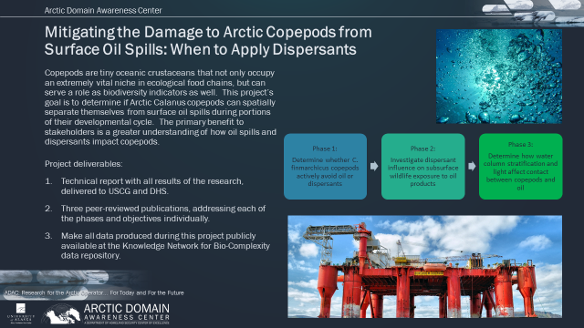
Figure 3: Mitigating Damage to Arctic Copepods from Oil Spill Overview

Baseline:
The rising demand for petroleum products has led to an increase in oil drilling in the sea as well as in shipping using ocean waterways. Over the past 50 years, oil spills have become a major environmental concern. With the decreased ice coverage in the Arctic and sub-Arctic, there has been a substantial increase in trans-Arctic shipping and renewed interest in Arctic oil and gas exploration. This poses a growing risk for oil pollution in the Bering and Beaufort Sea and raises concern about its impact of Arctic food webs. The opening Arctic Ocean has increased interest in the Northern Sea Route and the Northwest Passage. Transits through the Bering Strait are already growing from 220 transits in 2008 to roughly 500 per year in recent years. This increased shipping brings the inherent risk of oil spills. This risk comes not just from oil tankers, but from the heavy fuel oil that all ships carry. In addition to increased shipping, Arctic oil exploration is expected to increase. Current estimates suggest that 30 billion barrels of not-yet undiscovered oil lie in the U.S. Arctic. While the oil exploration in the Chukchi and the Beaufort Seas came to a temporary stop in 2016, the U.S. Congress recently opened Area 1002 in the Arctic National Wildlife Refuge (ANWR) for oil exploration. Extracted oil from these sites would be transported through the trans-Alaskan pipeline to Port Valdez in the Gulf of Alaska, where it is loaded onto tanker ships and shipped for refining.
Dispersants are an effective tool, but research indicates dispersants can also make things worse. A recent comprehensive literature review argued that dispersants potentially especially useful in the Arctic since they can be deployed by airplanes in remote location. Through breaking up oil into droplets (< 100 um), dispersants fulfill two primary functions: they increase the surface area of the oil, which enhances the biodegradation rate, and they displace oil from the water surface and dilutes it into the water column. New types of dispersants (e.g. Corexit 9500) are considered less toxic than crude oil alone, and have been suggested to have minimal effects on marine life. However, recent studies of Corexit and chemically dispersed crude oil provide evidence of its toxicity for Calanus spp. copepods and other planktonic species dispersed oil can be ingested by planktonic species and pose a risk for these marine organisms.
Among the biological components of marine ecosystems, planktonic organisms are particularly vulnerable to crude oil pollution. More than 90 percent of the biological processes in the ocean are due to planktonic organisms. Therefore, any attempt to assess the ecological impact of oil spills in marine environments requires a good understanding of the effects of crude oil pollution on planktonic communities, as well as a clear understanding of the organism’s natural vertical distribution pattern and their behavioral response to chemical pollutants.
A critical research aspect of this project is: Calanus spp. are essential Arctic species. Copepods (0.5-5 mm) are the most numerically abundant multicellular zooplankton in the water column. They are a primary consumer of microalgae, and are a major food source for young fish and krill, which also serve as prey for higher trophic levels. Lipid-rich copepods of the Calanus species are a critical foundation species that provides an energy-rich food source for higher trophic level organisms in boreal and high latitude regions. These copepods serve as a primary source of energy to consumers such as herring (Clupea harengus), mackerel (Scomber scombrus), capelin (Mallotus villosus), and sand lance (Ammodytes spp.). These species are in turn prey for top predators including groundfish, tuna (Thunnus thynnus), marine mammals, and many seabirds. Copepods often dominate the gut contents of wild-caught larval fishes. Since Calanus spp. plays such a crucial role in sub-Arctic and Arctic ecosystems, oil-related impacts would likely have important consequences for coastal and shelf ecosystems of the North Pacific, the North Atlantic and northern littoral seas (such as the Bering, Chukchi and Beaufort Seas) and of the Arctic Ocean proper.
A handful of Calanus species are the major players in Arctic and sub-Arctic ecosystems: C. finmarchicus and C. marshallae are sibling species; C. finmarchicus is restricted to the North Atlantic Ocean and C. marshallae to the North Pacific Ocean and the Bering Sea. These latter two species are closely related and been identified as the same species until 1974. Another species, C. glacialis, is slightly larger and resides primarily in the Arctic but is found in sub-arctic regions in early spring. Finally, C. hyperboreus occupies the high Arctic and is the largest of all the Calanus species with a life cycle (egg to adult) that spans several years. For this project, we will investigate C. finmarchicus as a model Calanus species to test the hypothesis that copepods may minimize their interaction by changing their vertical position in the water column. C. finmarchicus is a good model species because (i) it is closely related to the other Arctic Calanus species, and (ii) because the toxicity of oil and dispersants to this species has been reported in a number of studies, which will facilitate the interpretation and comparison of our results to these published WAF- or CEWAF-based studies.
A key facet of the research is identifying and understanding knowledge gaps related to oil toxicity for Arctic copepods. Most crude oil toxicological studies on plankton have been conducted using water-soluble fractions of crude oil, or individual dissolved petroleum hydrocarbons. However, petroleum is present in the water column in both dissolved and particulate forms (i.e. crude oil droplets) after a crude oil spill in the natural environment. Plumes of small crude oil droplets generated by wind and waves or by treatment with chemical dispersants are frequently observed after crude oil spills. These dispersed oil droplets can be transported down the water column and serve as a reservoir of dissolved oil hydrocarbons that can affect copepods. Furthermore, these droplets can be in the same size spectra of the food for many zooplankton species, and there is evidence that they ingest crude oil droplets suspended in the water column.
The existing literature on copepod toxicity is very useful and provides knowledge of toxic effects when copepods and dispersed oil are brought together. In these studies, copepods are exposed WAFs or CEWAFs at constant concentrations for hours to days to assess toxicity. While these studies provide toxicity information at discrete concentrations, they likely overestimate that actual toxicity of the oil to copepods in the field for two reasons: First, these studies do not allow copepods to avoid hydrocarbons by vertically migrating. It is currently not known, whether such an avoidance behavior of copepods occurs. Second, existing studies do not allow to account for the vertical hydrocarbon gradients of oil or dispersed oil. Especially during the critical copepod developmental time of lipid accumulation in early summer, the water column is often stratified, which might separate oil from copepods. It is currently not known, whether this stratification is an effective barrier between oil and copepods.

Methodology:
The project research method is a sequenced set of scientific laboratory experiments conducted by select and qualified team of credentialed marine biologists. This team will investigate the effect of dispersed oil and vertically migrating copepods. Overall research methods are proposed below.
- Copepod Tower: During ADAC Program Year 5 and 6, the project team constructed The planned laboratory experiments will be conducted in 1200-L mesocosms (“Copepod towers”) that allow for measurable vertical migration of copepods (Calanus finmarchicus) as well as for oil/dispersant concentration gradients along the depth of the mesocosms. As outlined in detail below, experimentation plan includes investigations with and without oil, with and without dispersants, as well as with and without a water column stratification.
- Oil Treatments: The team will continue to measure the abundance, migration, and mortality
of copepods to an oil spill introduced at the surface of the 2-m vertical towers. Three treatments are continuing for investigations: ​(i) ​non-oiled controls​; ​(ii​) ​crude oil without dispersant​; and ​(iii​) ​crude oil with dispersant​. Alaska North Slope oil (ANS) will be used due to its relevant to the Arctic environment. The team is artificially pre-weathering the oil to remove the volatile BTEX compounds and volatile saturated compounds (heating at 80C for 24 hours). Due to their fast evaporation, these compounds are typically not relevant during surface oil spill situations. Researchers will add 5 mL of oil per column, leading to a 100 um thick oil sheen.
- Dispersed Oil Preparation: For the dispersed oil treatment, Corexit EC9500A (NALCO Environmental Solutions LLC), will be mixed with crude oil at the recommended of 1:20 dispersant-to-oil ratio. The dispersion will be prepared by manually shaking this mixture in a glass carboy containing 10 L seawater. This mixture will then be carefully added on top of the copepod tower along the tank walls without disturbing the water column. Energy will be added on top of the water column to all dispersions to form.
Note: as this project is investigating invertebrates, Institutional Animal Care and Use Committee (IACUC) protocols are not applicable.
The goal of this project is to test the ability of copepods to avoid surface oil spills with and without dispersants. Within the constraints of this budget, detailed investigations of the dispersion (e.g., oil droplet size distribution) will not be measured at this time. By adding the oil at the top of the water column (with no mechanical mixing after initial high-energy preparation of dispersion in a 10-L volume) we will generate a predictable gradient in the dispersed or dissolved oil concentration with depth with and without the dispersants. Using video observations of free swimming copepods we will be able to 1) determine if copepods avoid the oil by limiting their vertical movement in the water column and if the copepods do limit their vertical movement 2) what concentration of oil do they avoid. Mixing the oil throughout the water column would not allow us to determine these threshold concentrations of oil. Within the constraints of the project budget, detailed investigations of the dispersion (e.g., oil droplet size distribution) will not be measured.

Associated research goals/tasks planned/initiated in ADAC Program Year 7:
- Goal 1 - Oil distribution and avoidance by copepods.
  - Task 2-5: Constructing and calibrating the copepod tower/Experiments introducing oil to the copepods. ​During the first month of this grant we will construct replicate plankton towers with sampling ports (for measuring hydrocarbon concentrations), cooling and heating mechanisms (to generate a thermocline), and install light and temperature sensors in the tanks and scaffolding for the video cameras surrounding each tank. Early experiments will test the speed and depth to which oil penetrates into the water column. The next three months, experiments will be conducted with Copepods added to the towers, and we will determine if copepods avoid the upper layer when oil is added to the surface. These experiments will be conducted in an un-stratified water columns.
- Goal 2 - Measuring the impact of oil dispersants.
  - Task 6-8: Effect of oil distribution with added dispersants and avoidance by copepods. ​We will test the speed and depth to which oil penetrates into the water column when dispersants are added. Copepods will be added to the towers and we will determine if copepods avoid the upper layer when oil is added to the surface. These experiments will be conducted in an un0stratified water columns.
- Phase I and II of this project were conducted in Years 5 and 6 (see associated Table for a timeline)
- Phase III Goal 3 - Measuring the effect of water stratification (Note: this is the planned Year 7 Goal).
  - Task 9-11: Effect of water stratification on oil distribution and its impact on copepod distribution. ​We will establish a temperature gradient in the water column and determine if the thermocline inhibits oil and dispersants from reaching deeper into the water column, as well as copepods from swimming upwards. We will also test the impact on oil distribution (with and without dispersants) on copepods distribution and their mortality.
  - Task 12: A manuscript will be written summarizing and synthesizing the results form Phase II and III.
  - Task 13: A final report of the project will be written

Key Milestones.
The following tables provides the overall details of the project. Shown are performance periods (shaded areas) and Milestones (“x”) used to track the progress of this project.
Table 5. Project schedule and milestones

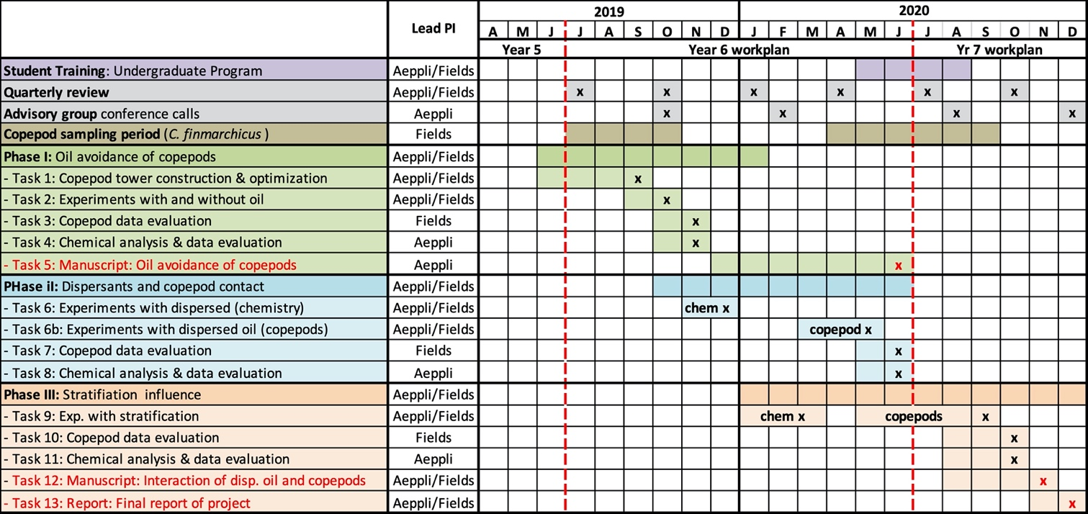

Key Stakeholder engagement plan.
Project team will continue to participate and be featured in the planned ADAC “Customers and Partners” Roundtables, in order to inform and receive feedback on project progress. In order to ensure the transfer of this research into the practice of oil spill response, researchers will conduct webinars with advisory group with oil spill responders and oil spill damage assessment professionals from various governmental agencies or from the private sector. The research team advisory group formed early in the project will continue and consists of representatives from USCG, EPA, and NOAA.
The Project Champion, CAPT Kirsten Trego, USCG, HQ USCG MER, leads the project advisory group that includes USCG Maritime Environmental Response, Environmental Protection Agency, NOAA and the USCG Academy. In coordination with the Project Champion, the research team will engage major oil and gas producers and consulting companies oriented to Arctic petrochemical exploration in Program Year 7.

Performance Metrics.
The below is the overall performance metrics planned for the research. Note: Successful performance review of Tasks 1a-1e by USCG Project Champion and Advisory Committee is required prior to starting Task 2. This evaluation will be completed prior to commencing Program Year 7.
- Task 2: Successfully perform 8 experiments: with and without oil (2 treatments) in 4 replicates, and record data.
- Task 3-5: Evaluate and quality control 100% of the data recorded in Task 2: copepod behavior and chemical data, Prepare one manuscript for publication in a peer-reviewed scientific journal.
- Task 6: Successfully perform 6 experiments: with and without oil/dispersant mixture (2 treatments: control, oil/dispersant), in 3 replicates, and record data
- Task 7-8: Evaluate and quality control of 100% of data recorded in Task 6.
- Two webinars with our advisory group will be held.
- Progress of the project will be presented at quarterly review and customer roundtable calls.
- Task 9: Perform 9 copepod behavior experiments with in a stratified water column; 3 treatments (control, oil, oil/dispersant), in 3 replicates.
- Tasks 10-11: Evaluate and quality control 100% of data recorded in Task 9.
- Task 12: Synthesize the data from Tasks 6-9 and write a manuscript for publication in a peer-reviewed scientific journal.
- Task 13: Final report of the project.

Outcomes/Outputs.
Overall Outputs for the entire project include:
- Technical Report (Task 13): Creating a report with all the results of this research for USCG and DHS S&T UP.
- Write Peer-Reviewed Publications (Task 12): Researchers plan to produce three peer-reviewed scientific publications from this project, where all the results from this project will be described and discussed: (i) Do copepod avoid oil? (ii) The toxicity of surface oil and dispersed oil on vertically mobile copepod. (iii) The distribution of oil and dispersed oil in a stratified and un-stratified water column;
- Ensure Publicly Available Data: All data produced during this project will be made publicly available. We propose to use the Knowledge Network for Bio-complexity (KNB) data repository (knb.ecoinformatics.org). KNB accepts open environmental and ecological data and metadata, assigns DOIs, and replicates data to other DataONE member repositories for redundancy and secure long-term preservation.
- ADAC will post all data and reports to the Center’s website.
- Technology Readiness Level (TRL): This project operates in TRL 1-3, and tests the Hypotheses 1: Subarctic copepods and dispersants are spatially separated in a stratified ocean, and Hypothesis 2: Subarctic copepods can actively avoid hydrocarbons, in a mesocosm setting.
Overall Outcomes include:
- Informing Oil Spill Response. Adding dispersants to the oil spill may redistribute the oil deeper into the water column reaching copepods well below the surface. Our data will help to provide seasonal and time of day protocols to minimize harm to copepod populations.
- Establishing an Environmentally-Relevant Testing System. The toxicity of oil to copepods is well known. However previous studies have exposed the copepods to homogeneous concentrations of oil with no opportunity for the animals to avoid the oil. This study will provide a more realistic scenario were copepods are free to move vertically in the water column to actively avoid the hydrocarbons or passively avoid the oil through pre-programmed behavioral patterns.
- Training Next Generation of Scientists. This project will train one two undergraduate students during the 2019-2020summer 2020 (May-August 2020) academic year. Bigelow Laboratory has a long and successful history working with undergraduate students.

Transition Approach.
Project team is committed to ensuring the results of this proposed research will be useful for the USCG and DHS mission, and for decisions making in dispersant application. We will coordinate and remain in close contact with USCG and DHS Arctic maritime operators throughout this project to make sure the technical report, as well as the scientific publication resulting from this research, will provide a clear rationale for conditions that minimize the negative impacts of dispersant application to copepods. Furthermore, inputs from the proposed advisory group (that includes USCG, EPA, and NOAA) will be instrumental in ensuring that the outputs of this research will be useful for USCG/DHS for the response to oil spill and transferred into practice. The laboratory results from this study will offer a course of action with the least environmental damage and can be implemented immediately.

Potential programmatic risks to completion:
The project team assesses overall risks to project completion as low. Specific risks and associated mitigation are listed below.
- Risk 1: Hypothesis of copepods’ avoidance of hydrocarbons is not true. Mitigation: The falsification of our hypothesis would not impede the importance of the results of this study. In contrast, it would inform responders that copepods could get in contact with dispersed hydrocarbons easily if the downward transport of oil droplets is not impeded by a water column stratification (i.e., during spring and fall).
- Risk 2: The experiments take longer than planned. Mitigation: We planned to have all experiments done by April 2020. That would still leave four months to complete additional experiment (the investigated species of copepods, C. finmarchicus, can be collected in the Gulf of Maine until August/September timeframe).
- Risk 23: The swimming copepods cause mixing which could distribute the WAFs quickly throughout the tower destroying the chemical gradient. Mitigation: We will use fewer copepods in each experiment and may need to pool the data from multiple trials to generate sufficient statistical power.
Study weakness. A weakness of the study is that the tested copepod species (C. finmarchicus) is a North Atlantic/Arctic species that is not present in the Alaskan Arctic. However, the species that is present is a closely-related sister species, C. marshallae (which is less studied). C. finmarchicus was chosen since numerous studies suggest that this species is a representative Canalus copepod species and a suitable model organism to test the hypotheses posed in this project. Using a species with a distribution that is limited to the North Atlantic will lead to [minor] uncertainty about how to apply the results to the Alaskan Arctic where this species is not present.” The value of this study is to test or reject the hypothesis of oil avoidance of copepods using the well-studied model species C. finmarchicus, which is highly related to the North Pacific species C. marshallae (which is less studied). Furthermore, Project Investigators are experimentally limited to using C. finmarchicus, since they plan to use wild-caught copepods, and sampling the necessary number of C. marshallae in Alaska, shipping them to Bigelow Laboratory, and keeping them in culture for the duration of the project is logistically and financially not possible for this project. Should the hypothesis be true, and with more financial resources, investigating the other relevant Arctic Calanus species (including C. marshallae and C. glacialis) would be the next step.

PROJECT: Photo-enhanced toxicity of dispersed and burned crude oil to Arctic mussels
Project PI: Dr. Patrick L. Tomco
Lead Institution: University of Alaska Anchorage
Supporting Team:
Colin McGill, UAA Chemistry Department
Katrina Counihan, Alaska Sea Life Center
Phoebe Zito, University of New Orleans
Project Description:

Abstract:
This project studies the direct effects of oil, dispersants, and in-situ burning, along with photo-enhanced effects, on several physiological, biochemical, and metabolic aspects of a cold-water species of mussel (Mytilus trossulus). Previous research has demonstrated that these organisms, when directly exposed to chemically-dispersed oil during a simulated spill event, exhibit physiological stress. Over 20 years of scientific studies in Prince William Sound indicate that sunlight-exposed oil can be more toxic to aquatic organisms than non-weathered oil, yet there remains little information on what effects (if any) dispersants and in-situ burning have on bay mussels in the Arctic environment when exposed to sunlight, which in the summer months is continuous. This study will determine if dispersed oil or burned oil are more toxic to bay mussels than oil alone and if these effects are more pronounced during periods of long sun exposure.
In ADAC Program Year 7, researchers will continue and conclude work to determine the changes in chemical composition of Alaska North Slope (ANS) crude oil as it is exposed in each of these scenarios using Ultra High Resolution Mass Spectrometry (UHRMS). Since the concentrations of oil and dispersant used in this study are what marine life would realistically be exposed to during an oil spill, these results can be applied to management decisions on the use of recovery methods.
Note: This project is a continuation of research activities approved as a result of awarded project responding to the “Coping with the Unthinkable, An Arctic Maritime Oil Spill” Arctic IoNS 2017 workshop. Project was awarded and funded in ADAC Program Year 5 with planned completion in Program Year 7. ADAC is not requesting new funds in Program Year 7 to complete this project.

Objective/Purpose:
The goal of this project is to understand which response method (dispersants vs in-situ burning) has a greater effect on Arctic mussel toxicity and whether the extreme seasonal differences in sunlight can affect acute sublethal response. Accordingly, this project seeks to address the following objectives:
- Objective 1: Conduct static exposure tests with bay mussels in seawater with oil, Corexit 9500, oil dispersed with Corexit 9500, and oil subjected to in-situ burn with three different photoperiods.
- Objective 2: Assess physiological and biochemical responses of bay mussels to the oil, dispersant, and in-situ burned oil in the exposure tests at different time points.
- Objective 3: Evaluate metabolic health of mussels in the exposure tests using metabolomics.
- Objective 4: Profile the chemical constituencies of oil, dispersed oil, and burned oil treatments used in the mussel exposures and how each treatment chemically weathers throughout the experiment.
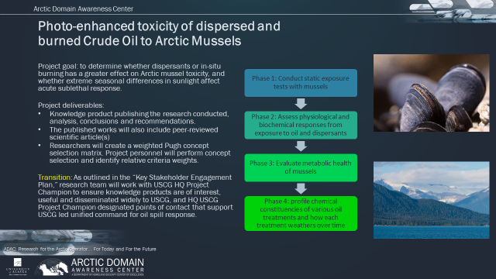
Figure 4: Photo-enhanced Toxicity of Dispersed & Burned Crude Oil to Arctic Mussels Overview

Baseline:
Oil and gas drilling have been occurring in Alaska since the 1950s, and additional lease sales are planned for Cook Inlet and the Beaufort Sea (State of Alaska, 2017). As regions in the Arctic continue towards reduced and ice-free marine environments, offshore drilling in that area is anticipated to increase (State of Alaska, 2014). As petroleum development increases in the Arctic, so does the risk of major oil-spill. Oil spills can have a devastating effect on the marine environment and chemical dispersants and in-situ burning are supposed to mitigate that effect. Dispersants are pre-authorized for use in certain regions around Alaska and other areas gain authorization on a case-by-case basis (State of Alaska, 2014). The use of herders and in-situ burning are also authorized on a case-by-case basis (US Coast Guard, 2008). Dispersant application and in-situ burning were conducted on a small scale after the Exxon Valdez spill, approximately 40% of the oil moved onto Prince William Sound beaches, and five years later, two percent of it remained (Atlas, 2011; Paine, et al., 1996; US Coast Guard, 2008). Dispersants were widely used during the Deepwater Horizon spill allowing microbial remediation to occur in deeper water, and in-situ burning removed oil slicks on the surface (Atlas, 2011; Shigenaka et al., 2015).
The toxicity of dispersed or burned oil to marine organisms can differ from untreated oil. The dispersion of oil is supposed to allow natural degradation such as evaporation, photochemical oxidation, microbial degradation, dissolution, adsorption and sedimentation, to occur more rapidly, but it may also increase the bioavailability of oil to marine species (Aurand, 1998; Hillman, 1998).
There have been a few studies on the toxicity of dispersants or dispersed oil to Arctic/Subarctic species. Testing performed at temperatures found in the Arctic with copepods and Arctic cod found that both species were more sensitive to physically dispersed oil than chemically dispersed oil (McFarlin, et al., 2011). The physiological responses of bay mussels (Mytilus trossulus) to oil, dispersant and dispersed oil in Subarctic conditions were investigated by members of our research team recently, and mussels exposed to non-dispersed oil experienced greater negative physiological impacts than mussels exposed to dispersant or dispersed oil (Counihan, 2018).
Furthermore, there is a lack of knowledge on the toxicity of burned oil to Arctic/Subarctic species (Fritt-Rasmussen et al., 2015). Burned oil from Deepwater Horizon was higher in density with an increased concentration of asphaltenes and pyrogenic polycyclic aromatic hydrocarbons (Shigenaka et al., 2015). Additional research is required to determine the impact of burned oil on Arctic and Subarctic marine species.
Bay mussels are ideal for monitoring programs. They are ubiquitous, sessile organisms that bioaccumulate pollutants through filter-feeding (IMW Project Secretariat, 1995). They are an integral component of coastal ecosystems and an important food source for both wildlife and humans (Blackburn, et al., 2014). It has been determined that Mytilus trossulus is a distinct species from Mytilus edulis and is the species present around Alaska and other northern cold water coastal environments (Behrends, 2002). Bay mussels would be easily sampled for cost-effective monitoring programs in the case of an oil spill. Therefore, we selected M. trossulus for use in this project because it is a cold-water species of commercial, subsistence and ecological importance in both the Arctic and Subarctic.
Photo-enhanced toxicity of crude oil is real and mussels inhabit the photic zone. Photo-enhanced toxicity, (i.e. the increase in toxicity associated with the presence of sunlight), of oil and dispersed oil has been identified in many studies over the past 20 years to various marine species, including copepods (Almeda et al., 2013), eastern oyster larvae (Finch et al., 2016), crab larvae (Alloy et al., 2015; Damare et al., 2018), mysid shrimp, and various fish (Alloy et al., 2016; Finch et al., 2017). Pelletier et al. (1997) determined that light enhanced the toxicity of crude oil 2 - 100 fold and the toxicity of anthracene, fluoranthene and pyrene (chemical compounds in oil) 12 - 50,000 fold. There are two pathways of photo-enhanced toxicity: photosensitization (initial hydrocarbon bioaccumulation, followed by UV activation of residues in translucent tissue) and photomodification (exposure to the oxidized hydrocarbons formed upon exposure of oil to sunlight) (Barron, 2017). Given that the shells of mussels act as a shield for UV exposure, we anticipate that photomodification is most relevant to observed toxicological endpoints. Nonetheless, photosensitization has been documented previously with juvenile bivalves (Pelletier et al. 1997).
An oil spill in Arctic regions during the summer would expose oil to sunlight for 24 hours per day and may result in significant photo-enhanced toxicity. In both ice-associated and open water conditions, whenever oil is exposed to the surface, the presence of sunlight may be a confounding variable affecting the weathering of oil and our understanding of efficient oil recovery in the Arctic.
Once petroleum enters the environment, it can undergo many chemical and physical changes making it difficult to analyze. Combustion and weathering processes can further alter the composition of petroleum making it more complex and enriched in oxygen (oxyhydrocarbons) (Aeppli et al. 2012, 2013, Ward et al. 2018, and McKenna et al. 2013). The ability to profile the polar organic components of oil, especially those containing nitrogen, sulfur, and oxygen, is an emerging area of study and is viewed as highly relevant to aquatic toxicity (Fingas 2017). Differences in chemical composition of petroleum transformation products have resulted in acute toxicity to organisms (Podgorski et al. 2018, McGuire et al. 2018). Conventional Gas Chromatography (GC) methods are great at resolving crude oils up to C₄₀, however, a major challenge that still exists today is the detection of those compounds not amenable to GC based methods, specifically, non-volatile, reduced, or polar petroleum compounds (McKenna et al. 2013, Ray et al. 2014). Gas Chromatography based methods are not suited for analysis of both parent crude oil and its photo-transformation products because they are complex mixtures that can contain relatively large polar and nonpolar compounds which elute as an unresolved complex mixture (UCM) (McKenna et al., 2013). To overcome these limitations, our research utilizes advanced analytical techniques to characterize samples to determine optical and molecular-level composition. The two state-of-the-art analytical techniques the project team will employ are ultra-high resolution Fourier transform ion cyclotron resonance mass spectrometry (FT-ICR MS) and fluorescence excitation-emission matrix spectroscopy (EEMs).
Considering that:
- Dispersants and in-situ burning each change the surface water chemistry of the spilled oil environment, and, thus exposure scenario to aquatic life;
- Sunlight has a major impact on crude oil weathering and environmental toxicology;
- The toxicological impacts of dispersed vs. burned crude oil exposure in the presence/absence of sunlight toward Arctic mussels have never been assessed in the extreme environmental conditions of the Arctic.
The research team finds it imperative for informing spill response contingency plans and monitoring programs to assess these variables. Project investigators believe it is reasonable to expect Arctic and Subarctic conditions to be unique in their exposure scenarios when compared to temperate climates, and the exposure scenario (and toxicity) of each spill response may be different in summer (continuous light) compared to winter (limited to continuous darkness). Accordingly, proposed efforts are the first in a series of future integrated research studies with the goal of understanding tradeoffs between spill response strategy, chemical exposure, and toxicological impacts in Arctic and Subarctic conditions. Project investigators will leverage the results of this research in developing substantial and continuing linkages within the spill response community.

Methodology:
Project method is a laboratory-based exposure study coordinated by select and qualified team of credentialed marine biologists, through three entities (Alaska Sealife Center, UAA, and UNO) designed to generate a substantial, scientific research derived knowledge product.
Note: as this project is investigating invertebrates, Institutional Animal Care and Use Committee (IACUC) protocols are not applicable.
A principal question this research seeks to resolve in support of U.S. Coast Guard decision makers leading spill response in Unified Command to an Arctic maritime is: Disperse or Burn? Is one strategy more toxic at different times of year due to sunlight? Despite some of the benefits dispersants and in-situ burning appear to have in oil spill mitigation, opinions on the utilization of these strategies are polarized, and the issue requires careful consideration and study. The presence of continuous sunlight in the summer months potentially confounds our knowledge of the seasonal toxic effects that these treatment strategies pose in comparison to no action.
Accordingly, the goal of this project is to understand which response method (dispersants vs in-situ burning) has a greater effect on Arctic mussel toxicity and whether the extreme seasonal differences in sunlight cause each response strategy to be more toxic in the summer than in the winter. In order to achieve this goal, the research team has planned for project methodology to proceed in six phases.
Accordingly, concluding aspects of the project previously planned to conclude in Program Year 6 are now planned to conclude in ADAC program Year 7. These are:
Start in ADAC Program Year 6, conclude in ADAC Program Year 7:
- Phase 2: Conduct physiological and biochemical assays
- Phase 3: Perform metabolomics analysis
- Phase 4: Profile chemical constituencies of water-accommodated petroleum and photo-degraded petroleum
Start and conclude in Program Year 7:
- Phase 5: Synthesize data and prepare knowledge products

Multiple factors contribute to this request.
- Due to maternity leave of a key investigator, the exposures started later than originally scoped.
- Researchers needed to run three successive experiments instead of the originally scoped large experiment, which pushed back the date that all tissues were collected.
- The analytical laboratory device malfunctioned and required a supplemental grant to secure the repair funds.
- In mid Program Year 6, the team is negotiating schedule conflicts to gain instrument time at the National Mag Lab to analyze the chemical composition of the water samples.
Investigators in Program Year 6 despite these obstacles have made excellent progress. All the exposures were conducted successfully at the Alaska SeaLife Center. Research tissue assays are nearly complete from the first round, and the personnel at the Mag Lab have indicated instrument time will be available in spring 2020. The team anticipates no problems finishing the project in program year 7 via a no-cost extension.
Phase 2: Conduct physiological and biochemical assays. In Phase 2 of the research project, the research team will conduct a series of physiological and biochemical assays to assess the exposed mussel tissues prepared in Phase 1 of the project: Phase 2 will start in Program Year 6 and conclude in Program Year 7. Details follow:

- Measure Hydrogen Peroxide Production. Hemocyte hydrogen peroxide production will be measured by diluting a hemolymph sample 1:1 with TBS. The sample will be tested in triplicate by pipetting the 1:1 hemolymph: TBS solution into a 96-well plate. After incubating the plate in the dark for 1 hour, phenol red solution (phosphate buffered saline pH 7.4, 5.5 mM dextrose, 0.56 mM phenol red, 8.5 U ml⁻¹ horseradish peroxidase, type II) will be added to each well and incubated for another 30 minutes in the dark. The reaction will be stopped by adding 1 N NaOH, and the plate will be read on a Molecular Devices SpectraMax Plus microplate reader (Sunnyvale, CA) at 620 nm (Akaishi, et al., 2007).
- Measure RNA to DNA Ratio. The RNA to DNA ratio will be measured by homogenizing the muscle portion of the mantle with a mortar and pestle. A volume of 1% sarcosyl tris-EDTA (STEB) will be added to the homogenate. The mixture will be vortexed for a maximum of 60 minutes at a medium speed until the tissue completely dissolves. Each sample will have TE buffer added and mixed. The sample will be centrifuged 15 minutes at 14,000 x g at room temperature and the supernatant saved for testing. The samples will be diluted 1:20 and each sample will be added to a 96-well plate in duplicate. Genomic, unsheared DNA from calf thymus will be used to prepare a DNA standard curve (Sigma-Aldrich, St. Louis, MO). RNA from bovine pancreas will be used for a RNA standard curve (Sigma-Aldrich). The stock solutions of DNA and RNA will be diluted in 0.1% STEB to the appropriate concentrations. The wells will have ethidium bromide solution (2 µg ml⁻¹) added to them and the microplate will be shaken for 5 minutes. The plate will be read in a SpectraMax Gemini EM fluorescent microplate reader (Molecular Devices) with 525 nm excitation, 600 nm emission to determine if the readings are in range. Each well will have RNase solution (20 U ml⁻¹) added to it and the plate will be shaken for 20 minutes and read on the microplate reader again with the same settings. The second reading will be the DNA only reading. The RNA content will be determined by subtracting the second reading from the first (Caldarone, et al., 2001).

- Measure Cytochrome P450 Activity. The digestive gland will be used to measure P450 activity by homogenizing it in buffer (25 mM Hepes, 125 mM NaCl, 0.1 mM EDTA, 0.1 mM dithiothreitol) at a 1:5 weight to volume ratio. The mixture will be centrifuged at 1,500 x g for 10 minutes at 2°C and the supernatant transferred to a clean tube. The supernatant will be centrifuged at 10,000 x g for 20 minutes at 2°C. The supernatant will be discarded and the pellet re-suspended in microsome buffer (25 mM Hepes, 140 mM NaCl, 1 mM KH₂PO₄). A microsome sample will be incubated with 30 uM rifampin for 48 hours to be used as a positive control. A 96-well plate will be inoculated with each microsome sample in triplicate. A media only blank will be included, as well. Each well will have 50 µM BFC solution (7-benzyl-4(trifluoromethyl) coumarin in phenol red-free Dulbecco’s Modified Eagle Medium) added and the plate incubated for 4 hours at room temperature. Stop solution (80% CH₃CN, 20% 0.5 M Tris base) will be added to each well and the plate read on a SpectraMax Gemini EM fluorescent microplate reader (Molecular Devices) at 410 excitation, 530 emission (Mensah-Osman, et al., 2007).

- Measure Heat Shock Protein. A portion of the gill will be homogenized and lysed in buffer (150mM NaCl, 1% Triton-X 100, 0.5% sodium deoxycholate, 0.1% sodium dodecyl sulphate, 50mM Tris, 1mM phenylmethylsulfonyl fluoride) at a ratio of 0.5mg tissue to 0.3ml buffer. An additional 2 volumes of buffer will be added and the solution agitated for 2 hours at 4°C. The homogenate will be centrifuged at 12,000 rpm for 20 minutes at 4°C and the supernatant collected. The protein concentration will be determined using a Bradford assay. The sample will be mixed 1:1 with 2X Laemmli buffer and boiled at 100°C for 5 minutes and then loaded on a gel. The gel will be run using SDS-PAGE to separate the proteins. Each gel will be run with a positive heat shock protein control and a molecular weight marker. The gel will be electrophoretically transferred onto a polyvinyl difluoride (PVDF) membrane. Total protein will be visualized by staining the gel with Pierce reversible protein stain (Thermo Scientific, Pittsburgh, PA USA). After the membrane is photographed, the stain will be removed. A Western blot will then be conducted to detect heat shock protein 70 by blocking the membrane with PBS that contains 5% BSA and 0.1% Tween 20. The membrane will be probed with anti-heat shock protein. The membrane will be washed and a secondary alkaline phosphatase labeled anti-mouse antibody will be incubated with it. The membrane will be washed again and an alkaline phosphatase substrate added. The membrane will be photographed to document bands.

- Measure Superoxide Dismutase. Half of the digestive gland will be homogenized in 1:5 w/v 0.05M phosphate buffer. The homogenate will be centrifuged at 10,000 x g at 4°C for 20 minutes. The supernatant will be collected and diluted 1:5 v/v with phosphate buffer. The diluted supernatant will be tested in triplicate in 96-well plates to determine superoxide dismutase (SOD) activity. Each sample will have reaction mixture added (1mM EDTA, 0.1M NaOH, 4.7mM xanthine, 0.2M cytochrome c, 6.7mU xanthine oxidase in 50mM sodium phosphate buffer). The amount of SOD activity in each sample will be determined using a standard curve (Turja, et al., 2013; Vlahogianni, et al., 2007).

- Measure Micronuclei. Each mussel will have 2 branches from their gills removed and each one will be placed in a drop of 3:1 ethanol acetic acid on a microscope slide. The gills will be dissociated with tweezers and the suspension spread across the slide to dry. Dried slides will be fixed with methanol and stained with Giemsa solution. Stained slides will be examined under a microscope at 1000x magnification to score micronuclei, nuclear buds, bi-nucleated and fragmented-apoptotic cells (Barsiene & Andreikenaite, 2007).

- Conduct TBARS assay. TBARS will be measured via fluorescent detection of a MDA-TBA adduct (Cayman Chemical TBARS kit). 25 mg tissue will be homogenized via sonication over ice in 250 µL RIPA buffer, centrifuged, and the supernatant removed for analysis. 100 µL samples will be combined with 100 µL SDS and 4 mL color reagent, mixed, and heated at 100 C for 1 hour. Reactant products will be cooled on ice, centrifuged, and the supernatant evaluated in triplicate versus a linear standard curve. Samples will be excited at 530 nm and emission evaluated at 550 nm. Signal will be normalized to total protein.

- Conduct ATP/ADP assay. The ATP/ADP ratio will be measured by bioluminescent detection of ATP utilizing luciferase enzyme. 10 mg tissue will be washed in cold PBS, gently dissociated to a single cell suspension and incubated in a nucleotide releasing buffer for 5 minutes at room temperature with gentle agitation. The suspension will be incubated with luciferine enzyme reaction mixture for 2 minutes and read on a lunimometer to detect APT activity. ADP converting enzyme will be added, incubated for 2 minutes, and read again to measure ADP. ATP and ADP will be normalized to total protein. Alternatively, ATP, ADP, and AMP can be quantified directly by LC-MS at UAA.

- Conduct Caspase-3/7 assay. Caspase activity will be measured via fluorescent detection of a product of enzymatic caspase cleavage of a non-fluorescent bisamide compound, rhodamine 110 (ThermoFisher EnzChek Caspase-3 assay kit). 5 mg tissues samples will be washed in cold PBS, lysed in 50 µL lysis buffer subjected to multiple freeze thaw cycles in liquid nitrogen, and centrifuged to remove debris. Samples will be incubated with 50 µL R110 substrate in reaction buffer for 30 minutes at room temperature and measured in triplicate. Samples will be excited at 496 nm and emissions measured at 520nm. Caspase activity will be normalized to total protein.

- Calculate Statistical Analysis. The mean and standard deviation will be calculated for each assay and the data analyzed using a one-way ANOVA to determine statistical differences in the biomarker assays between mussels from the different treatments. Results will be considered significant if P<0.05.

Phase 3: Evaluate metabolic health of mussels in the exposure tests using metabolomics. Metabolites will be extracted using the methods adapted from Capello et al. (2017). Posterior adductor muscle samples are collected, then flash frozen in liquid nitrogen. The frozen samples are ground in a liquid nitrogen-cooled mortar and lyophilized overnight. The metabolites are extracted using a 2:1 methanol/water solution and dried in a SpeedVac and once again lyophilized overnight. The samples are kept frozen at -80 °C until transport to the UAF Molecular Imaging Facility, where spectra are collected on a Bruker Avance 600 MHz NMR spectrometer. After spectral acquisition, signals correlating to specific metabolites will be assigned according to tabulated chemical shifts in Chenomx NMR software, then converted to a statistically analyzable format. Binned sample spectra will be statistically analyzed using Partial Least Squares regression and principal components analysis (PLS Toolbox, Matlab 2018a), using PCA scores and loadings of the validated model to regress specific metabolite concentrations from exposure scenario as in Capello et al. (2017). Phase 3 will start in Program Year 6 and conclude in Program Year 7.
Phase 4: Profile chemical constituencies of water-accommodated petroleum and photo-degraded petroleum. Water samples from each treatment will be taken at each time point throughout the experiments and frozen in HDPE vials. Samples will be overnight mailed on ice to UNO for the following chemical analysis. Phase 4 will start in Program Year 6 and conclude in Program Year 7. The following paragraphs provide details on the profile research:
- Conduct Dissolved Organic Carbon (DOC) Analyses. Each sample will be filtered through a pre-combusted (450 °C > 4 hours) Advantec GF-75 0.3 µm glass fiber-filter into a pre-combusted (550 °C > 4 hours) amber glass vial. The pH of each sample will be immediately adjusted with hydrochloric acid to pH < 2 and samples will be stored in the dark and refrigerated (< 4 °C) until subsequent DOC analysis. Dissolved organic carbon will be measured by high temperature combustion with a Shimadzu TOC Vcsn analyzer. DOC data are the mean of three to six replicate injections for which the coefficient of variance was less than 2%.

- Conduct Optical Analyses. Each sample will be filtered through a pre-combusted (450 °C > 4 hours) Advantec GF-75 0.3 µm glass fiber-filter prior to pH adjustment (pH 8) for absorbance and fluorescence measurements with an Aqualog® fluorimeter (Horiba Scientific, Kyoto, Japan) (Spencer et al. 2007, Tfaily et al. 2011, Yan et al. 2013). Measurements will be completed in a 10 mm quartz cuvette at a constant temperature of 20 °C. Absorbance and excitation scans will be collected from 240 – 800 nm in 5 nm increments with an integration period of 0.5 s. Milli-Q water (18.2 MΩ cm-1) will be used to dilute each sample to an absorbance of 0.1 at 254 nm to reduce inner filter effects (Ohno et al. 2002, Kowalczuk et al. 2003). Spectra will be blank subtracted and corrected for instrument bias in excitation and emission prior to correction for inner filter effects. Fluorescence intensities will be normalized to Raman scattering units and dilution corrected prior to Parallel Factor (PARAFAC) Analysis. PARAFAC of excitation-emission matrix spectra obtained for the water samples will be used to develop the model with the drEEM toolbox (tutorial and MatLab code, Murphy et al. 2013). The spectral properties for each of the components will be examined and then validated by residual and split-half analysis (Harshman et al. 1984, Stedmon and Bro 2008). Several optical proxies will be calculated to assess changes in aromaticity, size and reactivity of DOM_{HC} (Hansen et al. 2016).

- Conduct Fourier Transform Ion Cyclotron Mass Spectrometry. Water samples will be collected and pre-concentrated by the solid–phase extraction technique described by Dittmar et al. (2008). Briefly, each sample will be passed through a pre-combusted 0.27 μm glass-fiber filter and acidified to pH 2 prior to loading onto a Bond Elut PPL (Agilent Technologies) stationary phase cartridge. Each sample will be desalted with pH 2 MilliQ water and eluted with methanol at a final concentration of 50 μgC mL⁻¹. The extracts will be stored in the dark at 4 °C in pre-combusted glass vials until analysis by negative-ion electrospray ionization coupled with a custom-built Fourier transform ion cyclotron resonance mass spectrometer (FT-ICR MS) equipped with a 21 tesla superconducting magnet at the National High Magnetic Field Laboratory (NHMFL), Florida State University, Tallahassee (Blakney et al. 2011, Kaiser et al. 2011). Each mass spectrum will be internally calibrated with a “walking” calibration equation followed by molecular formula assignment with internally developed software provided by the NHMFL (Savory et al. 2011).

Phase 5: Synthesize data and prepare knowledge products. Project personnel will meet in September 2020 to summarize the findings and identify appropriate peer-review journals for submission. Team members Counihan and Zito will lead the manuscript preparation and submission aspects to peer-reviewed scientific journals (i.e. Aquatic Toxicology, Environmental Science and Technology). PI Tomco will work with ADAC and USCG Project Champion (outlined below) in synthesizing data to meet USCG needs and satisfying reporting outcomes as required by the program. Team member McGill and graduate students will assist in all aspects of reporting and manuscript preparation.

Throughout the project, project team will include two graduate students and two undergraduate students. The project will serve as the topic for two M.S theses in Interdisciplinary Studies at UAA. The research team plans to work with students to further develop their technical skills as environmental toxicologists and provide a unique opportunity for young scholars to contribute to research projects. Project PI will supervise student participants and students will gain experience in writing scientific publications. The students will be introduced to qualitative and quantitative methods of analysis in physiology, biochemistry, and environmental chemistry and will take part in data discovery efforts and in testing hypotheses. The students will be mentored throughout the project and will gain solid, practical experience that can be directly applied to their fields of specialty.
The students planned to participate beginning in summer 2019 and 2020 are as follows. They will be introduced to the USCG mission through invited interactions with Project Champion and via interactions with ADAC education manager. They will also participate in ADAC’s workshops with actual USCG personnel (to include the Arctic-related Incidents of National Significance (Arctic IoNS) workshop planned for 12-14 March 2019 at UAA. They will also be encouraged to attend the ASIP summer internship of 2020. Students will be further encouraged to integrate exposure to USCG mission into their college curriculum by registering for UAA’s BIOL 490: Arctic Environmental Security taught in spring semesters by ADAC PI Douglas Causey and Executive Director Randy (Church) Kee.

Table 6 Project Students
Key Milestones: The following “waterfall” graph illustrates the 4-phase research project planned schedule. Details describing each phase is provided below the graph.
The commencement and completion of phases 2-4 depend on Phase 1 and can begin separately at times which overlap. This is to ensure all necessary tissue is collected for priority samples before releasing splits to the other analyses.

Table 7: Phased Research Timelines

Phase 2: Physiological and Biochemical Assays (Mar 2019 – Oct 2020). Upon completion of Phase 1, the research team will perform a series of biomarker tests of sublethal stress. These assays are grouped by the lead investigator who will oversee analysis as outlined in the experimental methods section.
Milestones in ADAC Program Year 7:
- Upon completion of Phase 1, team member Counihan (ASLC) will complete the following analyses (anticipating these will be complete in ADAC Program Year 7):
    - Hydrogen peroxide formation in hemolymph
    - RNA:DNA ratio in mantle
    - Cytochrome P450 in digestive gland
    - Heat Shock Protein in gill
    - Superoxide dismutase in digestive gland
    - Micronuclei in gill
- Upon completion of Phase 1, team member McGill (UAA) will complete the following analyses (anticipating these will be complete in ADAC Program Year 7):
    - TBARS assay
    - ATP/ADP ratio
    - Caspace 3/7

While awaiting tissue samples from Phase 1, project personnel will optimize extraction protocols specific to mussel tissues.

Phase 3: Metabolomics (Aug 2019 – Oct 2020). Upon completion of Phase 1 and once tissue samples in Phase 2 are confirmed to be of appropriate mass to proceed (approximately one month after the commencement of Phase 2), PI Tomco will complete an assessment of the metabolic profiles of harvested mussel tissue samples (posterior adductor muscle)
Milestones anticipated in ADAC Program Year 7:
- Metabolites will be extracted from tissues and archived
- NMR spectral data will be acquired at the University of Alaska Fairbanks Molecular Imaging Facility
- Chemical constituencies that correspond to primary metabolites (polar and nonpolar) found in Human Metabolome Database will be identified
- Concentrations of the identified metabolites will be determined
- Mulivariate statistical analysis (PCA) will be performed on binned NMR spectra (i.e. unsupervised metabolomics)

Phase 4: Chemical Analyses (Nov 2019 – Oct 2020). Upon completion of Phase 1 and once water samples have been received, Team member Zito will analyze the chemical composition of aqueous-phase hydrocarbons at the University of New Orleans.
Milestones anticipated in ADAC Program Year 7:
- The dissolved organic carbon (DOC) content of each water sample will be calculated
- The three-dimensional fluorescence character of each water sample will be determined
- Water samples will be pre-concentrated for FT-ICR Mass Spectra collection
- FT-ICR MS data will be collected at the National High Field Magnetic Laboratory in Tallahassee FL

Phase 5: Synthesize data and prepare knowledge products (Oct 2020 – Dec 2020). Upon completion of Phases 2-4, project personnel will meet in September 2020 to summarize the findings, identify appropriate peer-review journals for submission, then author and submit manuscript(s).
Milestones anticipated in ADAC Program Year 7:
- Group teleconference in September 2020
- Appropriate peer-reviewed scientific journal(s) will be identified
- Manuscripts will be submitted to appropriate journal(s)

Key Stakeholder Engagement Plan:

The PI and the team will continue to work with the USCG, (in close coordination with ADAC leadership and the HQ USCG Project Champion) and other stakeholders throughout the remainder of the project to ensure that our project is useful for USCG knowledge needs. Principally, we seek to advance our broad understanding of how oil spill response strategies and sunlight patterns relate to environmental toxicology. Specifically, we aim to assess the sublethal acute toxicity in Arctic mussels as measured by multiple indices (physiological, biochemical, and metabolic) and relate these data to specific petrochemical-derived exposure. We will discuss with the relevant USCG personnel, foremost the Project Champion during the Kickoff Meeting and throughout the experiment to receive input on relatability of experiment outcomes.

Project Champion: The PI will continue engage LCDR John LaMorte, CG-MER-3 on a frequency basis as determined by LCDR LaMorte, but as a minimum we will have monthly teleconferences. Critical coordination is planned with all team members, the PI, and project champion.

Throughout the research, the project team will remain in close coordination with ADAC leadership and USCG mission users. The project team plans to meet with the project champion, other USCG personnel as defined by the project champion and personnel other government agencies at the discretion of the project champion.

We plan for the representation of our team at the following ADAC events:

- Meetings with Project Champion LCDR John Lamorte.
- Weekly All Hands meeting (Normally Thursdays, 1130-1230 Alaska Time via teleconference).
- Quarterly Reviews and Quarterly Customer’s and Partner’s Roundtable.
- Annual meeting at HQ USCG, Washington D.C.

Performance Metrics:
In order to evaluate the completion of Phases 1-4, outlined in Key Milestones and consistent with the project timeline, we will track the performance of the project with respective tasks specifically as follows:
- Student Training: Two graduate students and two undergraduate students are recruited and their projects are started.

- Metrics for Phase 1:
- Task A: Obtain approved State of Alaska Department of Fish and Game aquatic resource permit for hand collection of Mytillus trossulus in Resurrection Bay
- Task B: Obtain approved hazardous waste disposal and chemical safety approval.
- Task C: Construct 15 exposure chambers. Each capable is suitable for safely containing 50 mussels in 5L seawater and containing oil in the event of a spill.
- Task D: Collect >750 mussels from Resurrection Bay suitable for exposure assessment. Transport to exposure chambers.
- Task E: Successfully acclimate test organisms to exposure chambers. Record data on mortality. Ensure 50 mussels per exposure chamber are acclimated.
- Note: Performance review of Phase 1 Tasks A-E by USCG Project Champion and Advisory Committee is required before proceeding further.
- Task F: Successfully collected burn residue from 3 small-scale controlled in-situ burns.
- Task G: Expose collected mussels to 5 conditions: seawater, dispersant, oil, dispersed oil, and burned oil) under 3 light regiments. Organisms are harvested on the defined time intervals and dissected with the tissues archived, masses recorded, and recordings of mortality rates.

- Metrics for Phase 2:
- Task A1: Successfully perform 6 physiological and biochemical assays on archived tissues at ASLC: Hydrogen peroxide formation, RNA: DNA ratio, Cytochrome P450, Heat Shock Protein, Superoxide dismutase, and Micronuclei.
- Task A2: Statistically compare physiological and biochemical data between treatments, across time, and between individuals. Counihan to evaluate and quality control the data.
- Task B1: Successfully perform 3 physiological and biochemical assays on archived tissues at UAA: TBARS, ATP/ADP ratio, and caspace 3/7.
- Task B2: Statistically compare physiological and biochemical data between treatments, across time, and between individuals. McGill to evaluate and quality control the data.

- Metrics for Phase 3:
- Task A: Successfully collect NMR spectra from tissue extracts.
- Task B: Determine metabolic profile present in tissues based on database matches.
- Task C: Statistically compare metabolite profiles between treatments, across time, and between individuals. Tomco to evaluate and quality control the data.

- Metrics for Phase 4:
- Task A: Obtain necessary instrument time permissions for 180 FT-ICR MS samples at the National High Magnetic Field Laboratory.
- Task B: Successfully determine dissolved organic carbon concentrations in water samples
- Task C: Successfully collect spectrofluorescence and FT-ICR MS data from water samples.
- Task D: Statistically compare DOC, spectrofluorescence and FT-ICR MS data between treatments, across time, and between replicates. Zito to evaluate and quality control the data.

- Metric for Phase 5:
- Task A: Prepare two manuscripts and submit to peer-reviewed journals relating to phase 2/3 and phase 4 of the project. Prepare technical report detailing the project.

The success of the overall experiment will be measured by these tasks, which are centered around: acquisition of scientific data indicated above, and dissemination of knowledge products to USGC and scientific peer-reviewed journals.
Outcomes/Output:
The Outcome/output of this research project is to provide a knowledge product publishing the research conducted, analysis, conclusions and recommendations. The published works will include peer-reviewed scientific article(s).

Translating toxicity data generated in mesocosms into policy decisions and criteria for recovering spilled oil requires not only controlled experiments conducted under simulated realistic scenarios and complex data analysis; it also requires a “global perspective” cost/benefit weighing.

This project will study the effects of oil, dispersants, and in-situ burning, along with photo-enhanced effects, on various physiological and biochemical aspects of a cold-water species, the bay mussel. The goal of this project is to understand which response method has a greater effect on mussel toxicity and whether the extreme seasonal differences in sunlight cause each response strategy to be more toxic in the summer than in the winter. There is limited research on how oil response methods and photo-enhanced toxicity influence Arctic and subarctic marine organisms. Existing research is difficult to apply to Arctic and subarctic ecosystems because it was often conducted at temperate conditions with species that do not inhabit northern environments. The bay mussel was chosen for use in this project, because it is a cold-water species of commercial, subsistence and ecological importance that we have validated methods available for assessing their physiology. Mussels would also be easily sampled for cost-effective monitoring programs in the case of an oil spill.
The concentration of oil and dispersant that will be used in the exposure experiments was selected based on usage recommendations for the products and levels that were measured during field trials. Testing with ecologically relevant concentrations that marine life would be exposed to during an oil spill will allow these results to be applied to decisions on dispersant and in-situ burning utilization. Multiple time points will be analyzed to gain a full understanding of the acute and chronic physiological and biochemical impacts the contaminants have on mussels. Additionally, the sublethal effects of oil, chemically treated oil and burned oil exposure will be more fully investigated using metabolomics to assess the metabolic health of mussels. The results of this project will be helpful in advancing decision support systems for mitigation efforts during future oil spills to protect our natural resources in the Arctic and subarctic.
Transition Plan:
The major scope of this project is to develop knowledge products to advance our broad understanding of the environmental toxicology of petroleum, chemically-treated petroleum, and weathered chemically-treated petroleum exposure. Transition will be conducted by the research team and in compliance with ADAC Research to Transition Process. As outlined in the “Key Stakeholder Engagement Plan”, research team will work with USCG HQ Project Champion to ensure knowledge products are of interest, useful and disseminated widely to USCG, and HQ USCG Project Champion designated points of contact that support USCG led unified command for oil spill response. Research team will provide full range of research products to ADAC’s web portal and any further research destination as determined by the HQ USCG Project Champion. In addition to the providing the full published report to USCG and ADAC posting, the research team will submit summary of research, analysis and findings for peer review scientific journal.
Additionally, we will create a weighted Pugh concept selection matrix (decision matrix, example in Table 1). This will be a wide characterization of project personnel’s scientific opinions from several narrower bands of individual in-depth expertise. This synthesizes a selection process that can be useful as a decision tree input which can be useful for industrial entities. Project personnel will perform concept selection and identify relative criteria weights (e.g. X, Y, and Z in Table 1) and, based on the results, identify a perceived significance rank of each criteria/strategy pairing.

Table 8: Upon completion of this experiment, team members will employ a Pugh concept selection method to rank the multi-dimensional options of the dataset. This can assist with decision tree development and transitioning data to policy
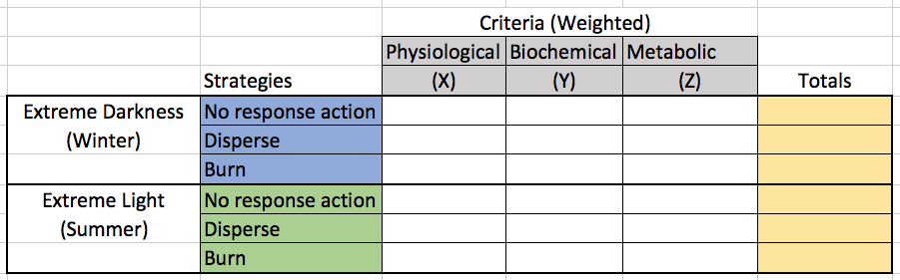
.

Potential programmatic risks to completion: The project team assesses overall risks to project completion as low. Specific risks and associated mitigation are listed below.
- Risk 1: Assay data reveal high variability between individuals; differences between treatments are not discernible due to inadequate sampling power. This is a fairly low risk since our sampling numbers are based on a combination of 1) preliminary data, 2) our previous studies, and 3) literature review. However, there is a chance that effects could be masked by inter-individual variability.
- Risk 2: Research and preparation in determining concentration of oil and dispersant, based on usage recommendations for the products and levels measured during field trials proves inaccurate, necessitating additional samples and laboratory experiments with adjusted concentrations. As noted, testing with conservative estimates of concentrations that marine life would be exposed to during an oil spill will allow these results to be applied to decisions on dispersant and in-situ burning utilization. While not a risk to program completion, if additional concentration-adjusted experiments are required, additional project research time will be needed.
Given that all team members are established experts in their relative fields, the project team does not anticipate any problems collecting the scientific data and publishing in peer-reviewed journals. They acknowledge that water quality, temperature, and ice content vary seasonally, which is not accounted for in this experiment. They also acknowledge the potential pitfalls present when attempting to merge four scientific datasets into a communicable consensus to ADAC, USCG and DHS S&T UP. Data can be ambiguous, “relevancies” can be difficult to extrapolate from correlations, and experts can disagree on the perceived relevance of each dataset. Preliminary data indicates there is a very high likelihood project investigators will observe significant differences between each treatment strategy and between light/dark conditions; this would make the decision matrix derivation straight-forward. Project team members are all experienced in identifying utility in scientific data and will communicate regularly via email and phone throughout this experiment, and the lead investigator (Dr. Tomco) has significant experience with communicating scientific data to non-scientific audiences.

PROJECT: Marine Induced Polarization Methods for the Detection and Mapping of Oil in an Arctic Marine Oil Spill; Including Investigation of Oil Within and Under Broken Ice Fields
Project Investigator: Dr. Socolofsky, Texas A&M University
Project supporting researchers:
Dr. Jeff Wynn, USGS (Ret.)
Kevin Hand and Kari Walker, IntelliSense Marine
Nathan Lamie, Lead Engineer/Facility Operator, CRREL (U.S. Army Corps of Engineers)
Project consulting researchers: U.S. Coast Research & Development Center Team (as determined by USCG RDC).
Additional Key Project Team members:
Art Wright, Safety & Environmental Coordinator, Induced Polarization Associates
Mike Williamson, Chief Scientist, Induced Polarization Associates
Kevin Hand, Project Planning and Reporting Support, Induced Polarization Associates
Joseph Radler, Technical Scientist, Induced Polarization Associates
Todd Stedman, Software Scientist, Induced Polarization Associates
Program Description:

Abstract:
Federal on-scene spill response need remote sensing tools to detect and map oil in the open-Arctic ocean, broken ice fields, and oil under and in ice. Marine Induced Polarization (Marine IP) has proven an effective tool to detect hydrocarbons in fresh, brackish, and seawater at all ocean depths including in the seafloor, and current research is underway assessing the performance for Marine IP’s suitability in Arctic environmental conditions. ADAC Program Year 6 research tests performed at the Cold Regions Research and Engineering Laboratory (CRREL) demonstrated the importance for the Marine IP field kit to be more compact and resistant to the effects of temperature, as well as vibration and jarring during transport and setup. Based on investigations conducted in ADAC Program Year 6, researchers assess the field kit needs to be redesigned to be a turn-key system that is easy to transport, set up and deploy by trained personnel, and the software interface and functionality needs to be redesigned to guide a user through the steps needed to collect data using the Marine IP system.
This research effort will leverage the previous Marine IP oil under ice detection research to inform the design, build, and delivery of an Arctic-ready, rugged Marine IP field kit for transition of the Marine IP technology into operational use, and provide the option for testing of the field kit aboard the USCG Healy beyond the scope of ADAC Program Year 7.
As such, based on the assumption of concurrence of USCG Project Champion, investigators seek to build on the original planned of outcome of providing knowledge products as the goal of this project, to now expand the research approach to conduct a 2-phase investigation within Program Year 7:
- Phase 1 – Re-design, build, and test an Arctic-Ready Marine IP System – Hardware.
- Phase 2 – Re-design, test, and deploy user-friendly software for the Arctic-Ready Marine IP System.

If/as approved, following Program Year 7, the Marine IP team is prepared to conduct a follow-on activity in the summer of 2021:

- Demonstrate the new system aboard the USCG Healy and conduct a brief training exercise.

The outcome of this research will be one Arctic-Ready Marine IP System with a re-designed interface and data visualization software package, to augment the transition of the Marine IP technology into the hands of the USCG.

Objectives:
Based on research successes and understood USCG interest in the Marine IP research in Program Year 6, the project team seeks to expand investigations beyond those conducted in Program Year 5 & 6. This new research activity seeks to enable the USCG and other oil spill responders to utilize Marine IP as a tool in detecting and potentially characterizing hydrocarbon contamination in Arctic waters through the production of an Arctic-Ready Marine IP System. Additionally, the project will result in further identifying preferred deployment mechanisms (such as ROVs or AUVs) for characterization. Further, following the program year, the project team is available and willing to seek to demonstrate the resulting field kit aboard the USCG Healy.

Researchers plan for concurrent testing to investigate the range of amperages that are effective for surveying to gain an understanding of the power budgets and requirements for the deployment of the Marine IP technology on autonomous vehicles. Accordingly, research will augment oil spill responder’s future options for oil detection in a broader range of environments, supporting the planning for deployment of spill cleanup resources, in-situ burning, and use of dispersants and will aid application of other spill response methodologies.

Strategically, this research seeks to transition the Marine IP technology to expand the USCG’s and the oil spill response community’s capability to perform wide area assessments – cost-effectively and rapidly – for the presence of oil in Arctic waters. Accordingly, a key objective is to provide reliable insight into a catastrophic problem where a solution currently does not exist: the ability to detect oil in broken ice and under ice formations. In sum, this project works to put Marine IP in the hands of the USCG and DHS to provide situational awareness of an oil spill’s extent, migration, and potential areas of contamination in various (and probable) Arctic situations.

Research objectives represents a two-phase research effort. Phase 1 focuses on researching, designing, and building an Arctic-Ready Marine IP System that is resistant to the effects of arctic temperatures and to the hardships of jarring and vibration during equipment transport and setup. It is during this phase that the project team will investigate the flexibility in and range of effective amperages that can be used to detect oil, enabling a better understanding of the power budgets required to run the system for the potential deployment from an AUV. Phase 2 focuses on researching, designing, building, and deploying new software for the Arctic-Ready Marine IP System, to make the system more user-friendly, automated, and easier for the user to visualize the data and identify targets. Following these phases, the team is willing and ready to proceed in demonstrating the new Arctic-Ready Marine IP System aboard the USCG Healy and conducting a brief training on the system for those in attendance.

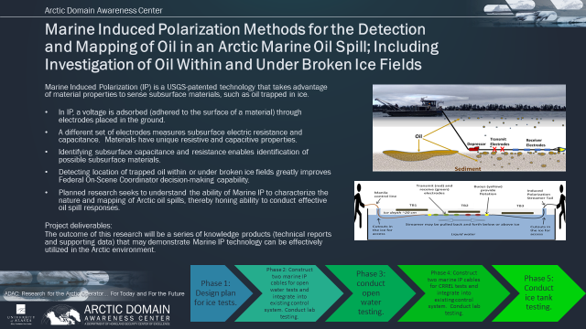
Figure 5: Marine Induced Polarization Project Overview

Baseline:
Induced polarization has been used on land for many years and has been more recently adapted for the marine environment - resulting in a very efficient application of the technology. Under an inducing voltage, charge is “adsorbed” (adsorb: form on the surface) onto certain materials. When the inducing voltage is removed, a time-delayed charge release can be measured similar to a capacitor bleeding off charge.
In modern induced polarization systems, this reaction is typically measured as a time delay or phase-shift between transmitted and received signals. The frequency at which the maximum phase-shift occurs has been shown to be diagnostic of the specific materials being polarized. Marine IP has the capability to work in a broad range of environments, from full ocean depth to as shallow as 1-meter depth. Induced polarization system research has yet to be applied in the Arctic. Such investigations may prove useful to help minimize the effects of spilled oil in the Arctic marine environment, U.S. Coast Guard led, Federal on-scene spill response needs. In particular, marine induced polarization may significantly contribute to remote sensing tools to detect and map oil slicks in the open-ocean, broken ice fields, and oil under ice. The below illustration depicts oil in an ice field off the coast of Canada and a schematic of various oil-ice scenarios that can occur.
When an oil spill occurs under ice, the oil collects on the bottom side of the ice and then becomes encapsulated as the ice grows and can infiltrate into brine channels, thereby complicating the ability to detect oil in these environments. During the melt season, the oil will migrate through the expanding brine channels, drawing the oil to the surface of the ice. Wind-driven sea ice formation and mixing in affected coastal polynyas will further complicate the cleanup effort.
These freeze-melt mechanisms and natural processes driving sea ice evolution can significantly increase the cleanup difficulty and the duration of the environmental impact of the spill. Therefore, the ability to detect and map the extent of oil below the ice and in mixed or broken ice is critical to the spill response effort.
Marine Induced Polarization (Marine IP) is a U.S. Geological Survey (USGS)-patented technology with capability to locate and assess very low percentage polarizable mineral and particle distributions, such as hydrocarbons, in water and sediment.
While Marine IP is a USGS patented technology, there is no royalty cost-basis for any onward research or knowledge product development, in support of a U.S federal mission (such as DHS S&T or USCG supported/sponsored activities. This includes all aspects associated with the: Marine Induced Polarization Methods for the Detection and Mapping of Oil in an Arctic Marine Oil Spill; Including Investigation of Oil Within and Under Broken Ice Fields.
Marine IP has demonstrated consistent potential to reliably detect hydrocarbons in fresh, brackish, and seawater sediments, but to date, there has been no associated research of Marine IP’s suitability to perform in Arctic environmental conditions or against hydrocarbons in the water column. The science behind the technology is environmentally safe, proven and well understood, and with additional research, the capability to detect oil within and under broken sea ice is a very strong possibility. Planned investigations will determine the extent to which the technology proves valuable to detect and map an Arctic oil spill in and under broken or mixed sea ice. Further investigations will seek to determine suitable deployment vehicles for Marine IP (such as remotely operated vehicles/ autonomous underwater vehicles (ROVs/AUVs). Accordingly, planned research seeks to understand the ability of Marine IP to contribute to characterizing the behavior of an Arctic oil spill, and therefore contribute to conducting an effective response.

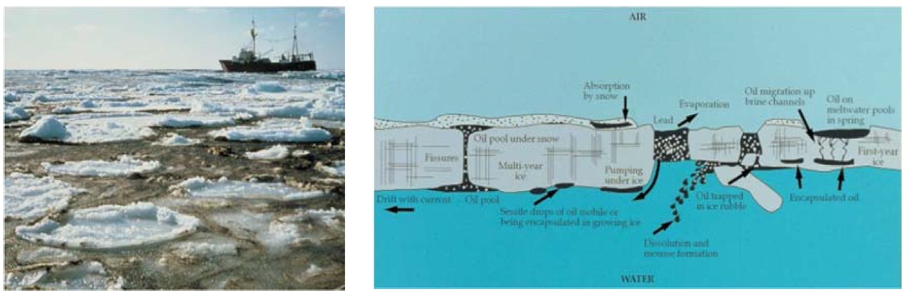

Figure 6. Photograph of oil slick in slush off the Canadian East Coast (left) and schematic showing many ways oil can be contained in and under ice (right, Dickins et al, 2004).

The research team developed a Marine IP method for open water measurements, via a modified streamer cable towed in the water. The cable has two transmit electrodes and multiple receiver electrodes (please see Figure 9 below). The small physical and logistical footprint allows mobilization using a conventional vehicle and allows flexibility of vessel size for deployment from small vessels/ROVs (nearshore, shallow) to large marine vessels (distant offshore, deep-ocean).

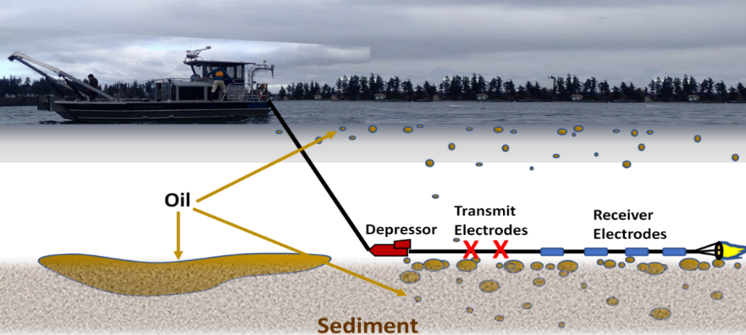
Figure 7. Diagram of a towed Marine IP streamer (in this example from a vessel in a near-shore marine spill), showing two transmit electrodes and four receiver electrodes.

Global positioning data is simultaneously acquired and USBL or layback calculations are made to determine the location of the source. For open water applications, the data results are reviewed in real-time in the field using proprietary data acquisition software, which shows a visualization of the raw data as it is collected. The detection swath width and measurement resolution are a function of the electrode spacing.

Methodology:
The project research method is a sequenced series of laboratory experiments oriented to a test plan examining Marine IP hardware design and engineering and investigating signatures of target contaminants simulating Arctic and open water conditions. Since much of the research tasks are conducted by the commercial team which has previously advanced induced polarization in coordination with USGS, the project team will be led by a Principal Investigator who will objectively assess the new research, (Dr. Socolofsky), supported by application to government users (Dr. Wynn).
During ADAC Program Year 7, the Marine IP Topside Control Unit, signal generator, power management system, data acquisition and real-time visualization software will be re-designed to be suitable for deployment by the U.S. Coast Guard led, Federal on-scene spill responders. Previous project research in the CRREL facility served to increase the research team’s understanding of how the Marine IP cable and topside control unit component materials performed in a low temperature environment and that understanding will be applied to the work performed for the ADAC Year 7 workplan. For the Arctic-Ready Marine IP System Topside Control Unit, research will be conducted to select new internal wiring, processing boards, and connectors, which will be tested and implemented to reduce the effects of harsh temperatures and the jarring and vibrations that are inherent to equipment transport and setup. Additionally, the whole of the system components will be extensively examined and combined as able to result in a more compact, robust system for easier transport and to allow the system to be setup in more space-limited workspaces. For the Arctic-Ready Marine IP System Software, research will be conducted to design a user-friendly software interface, data file management will be simplified, and the real-time data visualization will be modified to enable users to more easily identify targets during real-time data collection. It is desired to engage the USCG and oil spill response community during the design stage to gather input from this user community in an iterative process. After the Arctic-Ready Marine IP System hardware and software are complete, a demonstration aboard the USCG Healy would enable the USCG to get hands-on experience with the Marine IP system.
Accordingly, the research plan for ADAC Program Year 7 is oriented into the following phases (and each is described in the succeeding paragraphs):
Phase 1: Re-design, build, and test an Arctic-Ready Marine IP System - Hardware.
Research Task 1. Design Arctic-Ready Marine IP System – Hardware.
Research Task 2. Build Arctic-Ready Marine IP System – Hardware.
Research Task 3. Test Arctic-Ready Marine IP System – Hardware.

Phase 2: Re-design, test, and deploy user-friendly software for the Arctic-Ready Marine IP System.
Research Task 4. Design Software for Arctic-Ready Marine IP System.
Research Task 5. Build Software for Arctic-Ready Marine IP System.
Research Task 6. Test Software for Arctic-Ready Marine IP System.
Research Task 7. Conduct Field Trials of Arctic-Ready Marine IP System.

ADAC Program Year 7 Details:
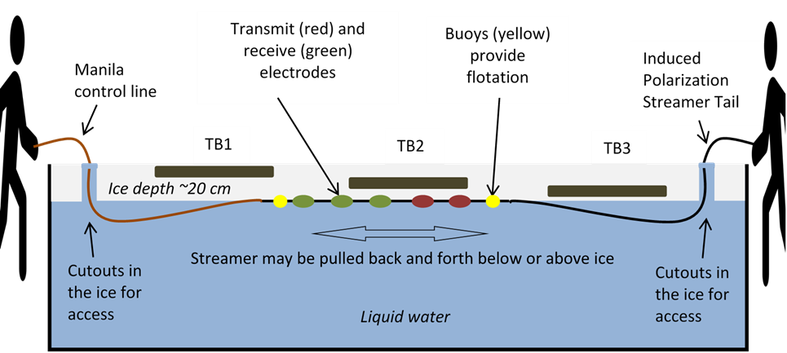
To be developed.
Figure 8. Illustration of how the Marine IP cable will be manipulated through the CRREL ice tank.

Key ADAC Program Year 7 Milestones:
The following are the planned schedule and milestones corresponding to ADAC Program Year 7.
- 15 Jun 2020: Conduct Program Year 7 kick-off meeting with HQ USCG Project Champion

- 30 Aug 2020:
  - Conduct research of components.
  - Test components and associated component integration

- 30 Dec 2020:
  - Complete draft design of software interface.
  - Fabricate Marine IP System prototype.

- 28 February 2021:
  - Complete collection of partner feedback on hardware and software interfaces.

- 31 May 2021:
  - Complete implementation of Arctic-Ready Marine IP System – Software.
  - Complete implementation of Arctic-Ready Marine IP System – Hardware.

- 30 Jun 2021:
  - Complete Field Trials of Arctic-Ready Marine IP System.
  - Complete data analysis and reporting.

Key Stakeholder Engagement Plan:
Project team will participate and be featured in the planned ADAC “Customers and Partners” Roundtable, in order to inform and receive feedback on project progress. The project team will work closely with ADAC leadership, HQ USCG Project Champion, associated steering committee, U.S. Army Corps of Engineers, and engaged Arctic maritime partners throughout this research project.
Project Champion. LT Matt Edes, USCG CG-MER. Project team will coordinate with ADAC and HQ USCG to create an associated steering committee to guide the project. In addition to monthly meetings with Project Champion, Project team will coordinate a quarterly project committee meeting chaired by the Project Champion. Proposed Program Year 6 membership is planned to include:
  - HQ USCG Project Champion (LT Matt Edes, CG-MER) (Chair)
  - USCG R&D Center POC
  - USCG Pacific Area POC
  - USCG District 17 POC
  - NOAA Office of Response and Restoration (ORR) POC
  - ADAC Leadership
As coordinated by HQ USCG Project Champion and ADAC, additional steering committee members who have interest in oil-in-ice scenarios, oil spill or emergency response and applicable advancing technologies may be identified and appointed.
Coordination with the USCG and the Project Champion, LT Edes, CG-MER-1, is of critical importance to the success of this research program. The PIs will engage with LT Edes on a frequency as determined suitable by LT Edes but seek to meet no less often than once a month, preferably more often as project milestones shall warrant. The project team will seek a Kickoff Meeting with the Project Champion and the associated committee as soon as possible after notification to proceed.
Principally, the project team will engage via the Project Champion, steering committee and ADAC to evaluate the utility of Marine IP technology in the event of an Arctic oil spill, in scenarios of open and ice-infested waters. Stakeholders’ views of functionality of such technology in the operational scope and within the USCG’s organizational mission will be assessed and documented. For example, the utility of Marine IP to assist USCG Incident Commanders during a spill event via the detection, location, and potential migration of a spill in the Arctic could be a powerful asset, and USCG’s incorporation of such technology shall be investigated.
Via ADAC coordination, researchers will leverage the Center’s Executive Counselors, such as Mr. Tom Barrett VADM (Ret), for guidance relating to industry perspective and applications of Marine IP to provide the best value to both industry and the US government.
The project team will conduct internal calls and participate in ADAC weekly all hands calls throughout the lifecycle of the project. During field operations, the project team will have pre-planning coordination and post-debrief sessions relating to tasks and results.

Performance Metrics:
The following qualitative indicators will measure research project performance:
- In development.

Outcomes/Outputs:
During ADAC Program Year 7 performance period the research team will accomplish the following:
  - Provide test plan for Arctic-Ready Marine IP System
  - Provide advancement of preliminary engineering specifications for integrating a Marine IP system onto an AUV/UAV system for potential deployment in sea ice conditions.

Overall Outputs for the entire project include:
- Arctic-Ready Marine IP System – Hardware: Provide a Marine IP measurement field kit designed for use in arctic conditions.
- Arctic-Ready Marine IP System – Software: Provide a new software interface for data collection using the Marine IP measurement field kit.
- Technical Report: Provide a report with all the results of this research for USCG, NOAA Office of Response and Restoration and DHS S&T UP.
- Engineering Design Report: Provide advanced information for the design parameters for applications of Marine IP with an autonomous underwater vehicle (AUV).
- Peer-Reviewed Publications: Research team will produce a draft peer-reviewed scientific publications from this project.
- Publicly Available Data: Researchers (in coordination with ADAC) will ensure all releasable data produced during this project is publicly available within 6 months of project conclusion

Overall Outcomes for the entire project include:
- Informing Oil Spill Response community of suitability of Marine IP for detecting and potentially characterizing contamination of hydrocarbons in Arctic waters, to include characterizing oil in partial ice formations as well as under pack ice. Included in the analysis is providing insights to preferred deployment mechanisms and ability to enhance planning for deployment of spill response mechanisms.
- Informing marine AUV community (including ADAC and the Center’s Long Range Autonomous Underwater Vehicle project team) of suitable design parameters for potential downstream integration of Marine IP.
- Informing Oil Spill Response community of suitability of Marine IP to detect and delineate contamination of seafloor sediments.

Transition Approach:
The goal of this research is to produce an Arctic-Ready Marine IP System that can be used in the field to enhance situational awareness by the USCG, DHS and other agencies relating to oil released in open or ice-laden water. Upon completion of the project, the System will be provided to HQ USCG MER for onward decision in transition destination.

Given that detecting and mapping oil under ice-covered seas or contained within broken ice constitutes a serious data gap for the government and spill response community, research was commenced in 2019 to provide a demonstration of value and effectiveness for the USCG and other stakeholders as the first step in transition.

With lessons learned from this first step, the re-design, build and deployment of an Arctic-Ready Marine IP detection system has been identified as the next critical step of transition for use by the USCG and other spill responders; aiding the US government in responding to emergencies and not only gaining further understanding of the wide applications of Marine IP technology, but also making the technology more accessible, is the strategic project goal.

A continuation from ADAC Program Year 6, this project will leverage what was learned in Year 6 and further the initial design parameters and engineering for applications of Marine IP with an autonomous underwater vehicle (AUV) to investigate under a solid-ice covered ocean surface is an additional important step in future utility for responding agencies.

Future transitional efforts should include the complete integration of Marine IP onto multiple fully autonomous marine vehicles, thereby providing scale coverage over a wide area and aid in oil migration/pattern forecasts. Marine IP technology can then provide detection, mapping, and migration information for oil under ice or in other scenarios where solutions currently do not exist.

Potential programmatic risks to completion:
The project team assesses overall risks to project completion as low. Specific risks and associated mitigation are listed below.
Risk 1: In development.

PROJECT: Oil Spill Modeling for Improved Response to Arctic Maritime Spills: The Path Forward
Project Investigator: Dr. Nancy E. Kinner.
Project Champion: CAPT Kirsten Trego (HQ USCG MER).
Project Advocates: NOAA ORR and USCG PACAREA and D17.
Lead Institution: University of New Hampshire Coastal Response Research Center (CRRC), Center for Spills in the Environment (CSE).

Project Description:

Abstract:
As examined during an ADAC 2017 maritime oil spill response workshop, the Arctic region is projected to realize more maritime shipping and natural resource development. Accordingly, the probability of more and larger spills, particularly of petroleum, is increasing the need for response-relevant computer modeling. The National Oceanic & Atmospheric Administration (NOAA) Office of Response & Restoration (ORR) provides scientific support to the U.S. Coast Guard (USCG) Federal On-Scene Coordinator (FOSC) during oil spill response. One principal product NOAA ORR supplies is decision support models that include: predicting the path and future location of the spilled oil; characterizing the habitats and species at risk (including humans) and the extent to which they must be protected; and analyzing the potential performance of various clean-up alternatives.
NOAA ORR has access to multiple environmental models useful to characterize an Arctic spill response, including several specifically for ice conditions (such as ADAC’s Arctic Oil Spill Modeling). The rising risk of an Arctic oil spill increases the urgency to identify the current state-of-the-art models and the potential for integration across current and emerging environmental models. Accordingly, this research investigation will create a knowledge project, as guided by a Project Core Team, Workshops and expert Working Groups, to assist future USCG-led spill response communities in strategizing new investment in model development and associated integration.
Accordingly, the Oil Spill Modeling for Improved Response to Arctic Maritime Spills, the Path Forward project provides a structured approach to solicit expert advice to develop such a strategy as driven by USCG FOSC core needs in an Arctic oil spill response. The project commences with forming a project “Core Team” (membership consists of ADAC center representative, University of New Hampshire Coastal Response Research Center, Center for Spills in the Environment, Headquarters USCG Maritime Environmental Response (HQ USCG MER), USCG Pacific Area (PACAREA) USCG District 17 (USCG D17), Alaska Department of Environmental Conservation (ADEC) and NOAA ORR). This core team will develop a list of needs/questions that Arctic response models should address. These will serve as guideposts to focus all of the project’s efforts. Subsequently, the project will develop and execute two workshops and establish 3-4 expert Working Groups to produce stakeholder consensus on approaches to Arctic response modeling that yield more accurate results with clear uncertainty bounds in response timeframes. The final knowledge product will recommend what new components/sub-models should be developed and validated and how best to coordinate further modeling efforts to aid a USCG-led FOSC in an Arctic maritime oil spill response.

Objective/Purpose:
This project is creating and publishing a knowledge product (a comprehensive report) that will detail:
- Specific needs and questions that must be addressed by Arctic oil spill response models;
- Current state-of-the-art Arctic oil spill models available;
- State-of-the-art Arctic oil spill response model utility in response modeling;
- Components from recent research efforts (e.g., Gulf of Mexico Research Initiative (GOMRI) useful for incorporation in order to improve current Arctic spill response models.
In addition, the knowledge product will clearly delineate the characteristics of oil spill response that makes some models inappropriate for the time-scales required to inform daily response planning and decision-making.
Finally, the knowledge product will recommend what specific new components/sub-models should be developed and validated so that Arctic maritime spill response models may better inform an FOSC’s crisis decision-making. The Project Team will recommend which new components/sub-models are most suitable to coordinate further model development in Arctic oil spill response modeling. It is likely that such model development will need to consider the special requirements of the U.S. Federal incident command system where the USCG FOSC receives scientific support from NOAA’s Office of Response and Restoration (ORR).

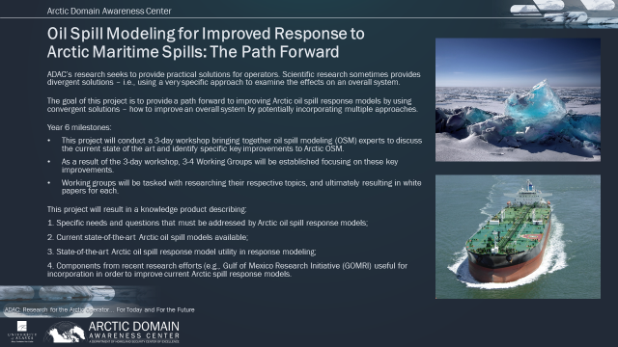
Figure 9: Oil Spill Modeling for Improved Response to Arctic Maritime Spills

Baseline:
ADAC and the Project Team note it is imperative that effective models be available for use during oil spills. Oil spill response modeling may be used as the basis to respond to numerous questions that an FOSC may need answers for during a spill response. For example, the modeling outputs may be used to predict the trajectory or path and future location of the oil slick. This information is also valuable in determining whether there are habitats or species that may be at risk from oil exposure or contamination and the extent to which habitats or species can/must be protected. Modeling during response may also be used to estimate oil weathering - the physical changes that result when oil is released into the environment. Decision makers may use response modeling to inform stakeholders and the public about the location of the oil slick. Further, response modeling is useful to predict/evaluate the performance/ success of various response alternatives (such as mechanical equipment, in situ burning and dispersant application). Understanding response needs, particularly those of the FOSC and associated response Unified Command, balancing evolving technologies with realistic response capabilities, ensuring data access and integrating forecasts and analysis into operations are all areas for consideration in spill response modeling (CRRC, 2008). Effective response modeling must consider availability and standards for data access, needed time/length scales of meteorological/ocean data, and non-transport modeling needs (i.e., wave or water level forecasts for salvage operations). In addition, the model must consider biological metadata in order to integrate consideration of natural resources with fate and transport forecasts (CRRC, 2008).
Spill response modeling has been a focus of UNH’s CRRC and its sister center the Center for Spills and Environmental Hazards (CSE) since 2006 when this team facilitated a workshop for NOAA ORR on “Innovative Coastal Modeling for Decision Support: Integrating Physical, Biological and Toxicological Models. [See https://crrc.unh.edu for more information on CRRC/CSE.]
CRRC and NOAA ORR facilitated a Spill Modeling Summit in June 2007 that concluded a Working Group was needed to move ahead. From 2008 to 2011, the Oil Spill Modeling Working Group (OSMWG), consisted of 30 modelers, responders and scientists who had the common goal of developing new 3D algorithms. OSMWG subgroups created associated working documents on topics such as spreading, water in oil emulsification, time-length scales, as well as a matrix of existing models that included dispersants, skimming, in situ burning and booming. The matrix included the inputs and outputs on fate, transport and biology, and the gaps in the models with respect to these processes.
In the wake of the Gulf of Mexico Deepwater Horizon spill, four GOMRI consortia have focused on modeling: Consortium for Advanced Research on Transport of Hydrocarbons in the Environment (CARTHE), Dispersion Research on Oil: Physics and Plankton Studies (DROPPS), Gulf of Mexico Integrated Spill Response Consortium (GISR), and Center for Integrated Modeling and Analysis of Gulf Ecosystems (C-IMAGE). Numerous publications and model advancements have resulted from the efforts of these consortia and some of GOMRI’s independent grants-funded projects. Coincident with these efforts, federal agencies such as BOEM (Bureau of Ocean Energy Management) and BSEE (Bureau of Safety and Environmental Enforcement), Environment Canada (EC) and Fisheries and Oceans Canada (DFO)/U.S. Environmental Protection Agency’s research have resulted in model advancements. Concurrently, modeling work has been funded through the American Petroleum Institute (API), and Oil and Gas Producers. The sum of these efforts has resulted in numerous modeling advancements, but there have been few efforts to coordinate their findings and their impact on oil spill response modeling.
Several global ocean and ice models (e.g., NWS, EUROGOOS) and oil spill trajectory and weathering models (e.g., GNOME, ADIOS, SINTEF OWM) exist that can be applied to spills in the Arctic. A few of these are actually coupled trajectory and weathering models. Among existing models, the Oil Spill Contingency Response (OSCAR) program developed by SINTEF is an advanced software tool used to predict the fate and transport of spilled oil in ice-covered waters. In addition, the Russian State Oceanographic Institute model “SPillMod” predicts spreading of oil in between fixed ice floes (Afenyo, Veitch, & Khan, 2016). An effort put forth by the International Association of Oil and Gas Producers (IOGP) in support of the Arctic Oil Spill Response Technology- Joint Industry Programme (JIP) is working to improve Arctic trajectory and fate models (French-McCay et al., 2017). Olason et al. (2016) advanced oil spill trajectory forecasting models by introducing new sea ice rheologies and validation techniques. ADAC is currently transitioning its Arctic Oil Spill Modeling (AOSM) project, which provides an analytical model, designed to estimate the spread of oil released in an ocean environment under ice due to a well blowout, ruptured pipeline or among ice due to a ship grounding. AOSM is currently in transition to NOAA’s General NOAA Operational Modeling Environment (GNOME).
An in-depth review of fate and transport models in open and ice-covered water by Afenyo et al. (2016) expanded reviews done by Spaulding (1988), Reed et al. (1999) and Fingas and Hollebone (2003). Afenyo et al. (2016) identified multiple research needs specific to ice-covered waters to improve oil spill trajectory and fate models. Wilkinson et al. (2017) suggested models be parameterized with values specific to ice-covered waters such that model output uncertainty is greatly reduced. Arctic oil spill response models must also quantify the uncertainty of their outputs to better guide decision-making. Furthermore, in a crisis response, modeling must be done in the relatively short time scale, aligned to rapid decision-making windows that are dictated by emergency oil spill response, while addressing the unique complications of ice, adverse weather, international waters, and lack of response equipment.

Methodology:
The objective of this project is to identify the: current state-of-the-art Arctic maritime oil spill response modeling, potential integration of these models, and specific needs to be addressed to obtain models that will be functional and effective in the response time scale to advance the FOSC’s decision making during an incident and improve the experience gained from exercises and drills. The focus will be on making models that consider the complications unique to the Arctic (e.g., ice, adverse weather, international waters, and lack of response equipment) that make response modeling particularly challenging. Accordingly, the project consists of 6 phases discussed below.
- Phase 1: Formation of Project Core Advisory Team. Project team accomplished this task in ADAC Program Year 5.
- Phase 2: Meeting of the Core Team and Key Agency Stakeholders to Determine the Needs of/Questions Addressed by Response Models to Facilitate FOSC Decision Making During Arctic Oil Spill Response. Project team accomplished this task in ADAC Program Year 5.
- Phase 3: A Three-Day Workshop on Arctic Maritime Spill Response Modeling. Project team accomplished this task in ADAC Program Year 6.
- Phase 4: Working Groups on Specific Response Model Components/Criteria (Draft of Knowledge Product Sections). Project team accomplished this task in ADAC Program Year 6.
- Phase 5: Two-Day Workshop to Review Working Group Drafts and Integrate Feedback into Knowledge Product. Project team will accomplish this task in ADAC Program Year 7.
- Phase 6: Completion of Knowledge Product. Project team will accomplish this task in ADAC Program Year 7.
Phase 1: Completed in Program Year 5.
Phase 2: Completed in Program Year 5.
Phase 3: Completed in Program Year 6. Arctic Maritime Spill Response Modeling Three-Day Workshop:
Once the list of needs/questions guideposts are coordinated and accepted by the Core Team, (including Project Champion Trego and ADAC leadership), the Project PI will initiate planning and development of a 3 day comprehensive workshop, developed via a Workshop Organizing Committee (OC). The Project PI will coordinate with the Arctic Maritime Spill Response Modeling Three-Day Workshop OC in consultation with the Project Core Team. The Project PI will contact potential workshop OC members and conduct coordinating conference calls. The OC will work with the Project PI to establish the agenda and select participants, plenary speakers, and breakout group leads for the workshop. The Project PI anticipates the OC will meet five times via conference call prior to the workshop (meetings every 2-4 weeks).
The Project Team conducted the Arctic Maritime Spill Response Modeling workshop in Anchorage, AK in December 2019.
The Arctic Maritime Spill Response Modeling workshop Breakout Groups are focused on critical elements associated with Arctic Oil Spill modeling:
- Marginal Ice Zone (MIZ);
- Sea ice extent, thickness and movement;
- Oil weathering and transport by Arctic currents;
- Oil movement in leads and under ice;
- Visualization and analysis tools including polar projections;
- Algorithms with higher concentrations of ice increasingly controlling oil movement;
- Coupling of ice and global ocean models with spill trajectory and fate models;
- 3D subsea blowout modeling in Arctic waters;
- Uncertainty analysis and incorporation in decision making; and
- Incorporation of Eco toxicological conditions.
All these discussions will be mindful of the ultimate goal of having useful oil spill response modeling for the Arctic that will inform decision-making during spills and will be conducted considering the guidepost needs/questions developed in Project Phase 2. The outcome of the workshop resulted in the formation of 3-4 Working Groups on key topics that need to be resolved to improve oil spill response modeling. The Project PI has constructed a detailed workshop report summarizing the presentations, Breakout Group discussions and major conclusions including specific research needs. The report will also include specific charges to and tasks for each of the Working Groups.
Phase 4: Formation and Onward Investigation via Arctic Maritime Spill Response Modeling Workshop Working Groups:
Following the 3-Day December 2019 spill response modelling workshop, the Project PI is convening and facilitating working groups. The Project PI designated a co-group lead for each Working Group. The Project PI coordinated these expert individuals including establishing one of the co-leads from a governmental agency concerned with oil spill response (i.e., NOAA ORR, USCG). The Co-Working Group Leads will work with the Project PI prior to each group’s meetings to set the agendas. The Project PI solicited Group members during the 3-Day spill response modelling workshop, and finalize membership in coordination with Project Champion Captain Trego and the overall Project Core Team. The Working Groups are meeting monthly via ZOOM conference calls. The Project PI will provide administrative coordination for all Working Groups, to include maintaining records and files for documents and relevant materials. The Working Groups will meet ~10 times for 1-1 ½ hour each. The Project PI and Co-Working Group Leads will coordinate and document group outcomes in a spreadsheet and a five-page white paper summarizing the group’s findings, their relevance to response modeling, resolution of issues and detailed research needs. The Project PI and Working Group Co-leads will complete all associated documents no later than one year after the Phase 3 Three- Day Workshop.
Working group topics include:
- Oil and Ice Interactions (approximately meter scale)
- Oil and Ice Interactions (approximately kilometer + scale)
- New and Existing Technologies for Observing Ice and Informing Models
- Visualization/Uncertainty
Phase 5: Creating Project Final Knowledge Product, Two Day Workshop: Planned for Program Year 7.
The goal of the Two Day Workshop, planned for Anchorage, Alaska, planned for November 2020, is developing a final knowledge product, which is a comprehensive project report summarizing the findings of the Working Groups and the project. The OC will be the same for the first and second workshops. The Project PI will leverage past deliberations from the first workshop and the follow-on Working Group activities to stimulate collaboration and consensus on a pathway forward for Arctic oil spill response modeling, including acceptance of standards, assumptions, algorithms and approaches to solve a variety of issues.
The key is to start and maintain an open channel of communication among responders, scientists and modelers. This follow-up workshop is essential to ensure that the final product is consistent and cohesive, especially because multiple groups will be working on the topics. Accordingly, the Creating Project Final Knowledge Product, Two Day Workshop will also allow the responders to be sure that the proposed products are useful and that suggested model developments will conform to key criteria that fulfill the decision maker’s needs. This workshop will consist of report outs from the Working Groups and feedback from the stakeholders (e.g., NOAA ORR, USCG, Core Team, and Project Champion). Breakout groups will modify their products, as needed, based on the plenary sessions and further cross-fertilization with other groups. The final product of the second workshop will be the final Working Group individual reports and a detailed outline of the final knowledge product. The Project PI will subsequently conduct report writing and coordination of the final Working Group products.
Phase 6: Creating and Submitting the Final Knowledge Product: Planned for Program Year 7.
The Project PI will draft the final knowledge product: Oil Spill Modeling for Improved Response to Arctic Maritime Spills: The Path Forward as a comprehensive report, providing reviews and conclusions, addressing the following:
- A review of the current state-of-the-art on oil spill response modeling for Arctic Maritime oil spills;
- A framework for an integrated response modeling suite to address oil spills under ice, in leads, in the MIZ and for 3/10 to 8/10 ice cover, etc.;
- Recommendations and conclusions for addition of submodels on response technologies;
- Recommendations and conclusions on incorporation of natural resource and food security protection, and Traditional Ecological Knowledge into models; and
- Detailed recommendations, conclusions and scopes of work on needed modeling research to fill gaps identified during the project. The Project PI will develop the content and outline of the final knowledge product with reviews and coordination by the Core Team and Project Champion Captain Trego. Following coordination of/concurrence with the overall outline, the Project PI will draft the associated final knowledge report, and plan to complete it within three months after the second workshop. Once drafted, the Project PI will send it to the Project Champion, Core Team, OC and Working Group Co-leads for edits. Once this level of coordination is accomplished, the Project PI will send it to ADAC for coordination. Within one month of receiving ADAC’s comments/edits, the Project PI will submit the final knowledge product to ADAC, the Core Team and Project Champion Captain Trego. Once the report is submitted and promulgated, the Project PI and ADAC will coordinate a corresponding peer-review journal article.

Student Participation:
Throughout the project, the PI continues workforce development with undergraduate- and/or graduate-level students from the University of New Hampshire’s Civil and Environmental Engineering Department to assist in gathering taking notes during conference calls and at the workshops and Working Group meetings. ADAC and the Project PI will continue to coordinate and integrate these students into the ADAC Fellows Program. Accordingly, these student Fellows are governed and supported in accordance with the DHS S&T UP-ADAC Cooperative Grant Terms and Conditions. These student Fellows also help write the progress reports and the final knowledge product. The students will also support the Project PI in administering project tasks, to include the on-going modeling literature review, and maintain the project database. Through conference call and workshop participation and attendance, notetaking, database maintenance and report writing, these students will meet key people in the field of oil spill response, assessment, restoration and research. This includes meeting with USCG experts and operators. These students are continuing to learn the foundational principles in the field, the state of the current science, and the new and emerging topics. Once they graduate, ADAC will coordinate their participation into the Homeland Security Enterprise.
The students participating in the program are shown in the table below.

Table 9. Project student activities.
Name | University | Year | Duties | Benefit
Megan Verfaillie | University of New Hampshire | M.S. | Note taking, report writing, literature search, database maintenance, workshop attendance | Exposure to and understanding of state-of-the-art Arctic and non-Arctic oil spill modeling
Melissa Gloekler | University of New Hampshire | PhD Candidate | Note taking, database maintenance, workshop attendance  Note taking, report writing | Exposure to and understanding of state-of-the-art Arctic and non-Arctic oil spill modeling. Exposure to and understanding of state-of-the-art Arctic and non-Arctic oil spill modeling
Jessica Manning | University of New Hampshire | Sophomore | Note taking, database maintenance | Exposure to and understanding of state-of-the-art Arctic and non-Arctic oil spill modeling.

Key Milestones:
The following provides the review of the project principal milestones. Details are provided for Program Year 6, while acknowledging the Year 6 milestones fit within the overall project which extends from ADAC Program Year 5 to Program Year 7.
Phase 1: Program Year Formation of Project Core Advisory Team (Completed in Program Year 5).
Phase 2: Meeting of the Core Team and Key Agency Stakeholders to Determine the Needs of/Questions Addressed by Response Models to Facilitate FOSC Decision-Making During Arctic Oil Spill Response (Completed in Program Year 5).
Phase 3: A Three-Day Workshop on Arctic Maritime Spill Response Modeling. (Completed in Program Year 6).
Milestones:
- Project PI leads selection of workshop Organizing Committee (OC) in coordination with Core Team.
- Project PI convenes OC and provides charge to its members.
- Project PI conducts monthly meetings of OC to solidify workshop objectives, dates/location, & agenda, including speakers and breakout groups, and participants.
- Project PI leads planning of logistical support for workshop (e.g., venue selection, travel arrangements, audio/video supplies, room arrangements, lodging contracts, participant packet materials) in coordination with ADAC staff.
- Project PI leads execution of associated workshop in September 2019
- Project PI completes report from workshop including charge to follow-on Working Groups (reviewed and approved by Core Team and OC).
Phase 4: Working Groups on Specific Response Model Components/Criteria (Draft of Knowledge Product Sections).
Milestones:
- Project PI leads formation of Working Groups following the Phase 3 workshop.
- Working Group Co-lead selection (one of the Co-leads from each group will be from governmental agency).
- Project PI facilitates monthly meetings of the 3-4 Working Groups.
- Project PI facilitates Monthly meetings of Core Team and Working Group co-leads for cross-coordination.
- Project PI conducts scheduled cross-team Working Group meetings.
- Project PI coordinates drafting of Working Group reports with onward edits provided by Co-leads, reviewed and approved by Working Group members.
Phase 5: Two-Day Workshop to Review Working Group Drafts and Integrate Feedback into Knowledge Product (Program Year 7).
Milestones:
- Project PI facilitates monthly meetings of workshop OC (same OC as for Phase 3 Workshop).
- Project PI coordinates delineation of Phase 5 workshop objectives.
- Project PI facilitates OC solidify workshop objectives, dates/location, agenda including speakers and breakout groups, and participants.
- Project PI plans logistical support for workshop (e.g., venue selection, travel arrangements, audio/video supplies, room arrangements, lodging contracts, participant packet materials) in coordination with ADAC staff.
- Project PI executes corresponding workshop, with planned dates of November 2020.

Phase 6: Completion of Knowledge Product (Program Year 7).
Milestones:
- Discussions with Core Team on format for Knowledge Product.
- Project PI commences writing of final Knowledge Product after the Phase 3 workshop
  - Project PI includes Guideposts, drafts of Working Group white papers into Knowledge Product.
- Project PI coordinates draft of final Knowledge Product in September 2020 for review and comments by Core Team and Working Group Co-leads.
- Project PI commences second draft of final Knowledge Product for review by Core Team and Co-leads in October 2020.
- Project PI writes third draft of final Knowledge Product in November 2020 after final workshop.
- Project PI completes Fourth (final) version of final Knowledge Product and submit to ADAC December 2020.
- Project PI and ADAC collaborate to draft and submit a peer review journal article.

Key Stakeholder Engagement Plan:
Project team will participate and be featured in the planned ADAC “Customers and Partners” Roundtable, in order to inform and receive feedback on project progress. The stakeholders including USCG PACAREA and D17, NOAA ORR and other federal agencies, and representatives of the Arctic spill response community delineated above will be actively recruited for this project. This will also occur for academics, industry, NGO, and state, local and indigenous representatives, including students (ADAC Fellows assigned to the project at UNH CRRC/CSE). Students of participating academics will also be invited to attend the Anchorage workshops.
Project PI will work with the Project Champion, the Core Team, in particular NOAA ORR, and other stakeholders in the project (e.g., the ADAC funded Arctic Oil Spill Modeling (AOSM) team; SINTEF, EC, DFO modelers) throughout the project to insure the outcome is a clear understanding of the state-of-the-art in oil spill modeling as it applies to the Arctic. Through initial engagement of the USCG and NOAA ORR, the Project PI will determine what modeling needs must be met and what questions must be answered during an Arctic response. This set of specific needs and questions will be vetted by the Core Team and once accepted will serve as guideposts for the rest of the project. These guideposts will be used in all engagement with the workshop OC and participants, and the Working Groups. They will help to insure that the driving force behind all of the Project Team’s efforts are addressing these needs and answering these questions – not to be confused with those questions that are research-focused (e.g., to increase understanding of the Arctic ecosystem).
The Project PI will work closely with Project Champion, Captain Kirsten Trego, Deputy Director of Incident Management & Preparedness Policy, and Executive Director of ICCOPR. Captain Trego’s knowledge of interagency and international oil spill response will be very helpful in guiding the project team to focus and coordinate spill modeling efforts in the U.S. Arctic and beyond, especially for large transboundary incidents. Captain Trego will chair the Core Team for the project and in that role will ensure that input from NOAA ORR, USCG PACAREA, USCG DA and its affiliate members AKDEC, and BSEE will be at the forefront of the Project Team’s consideration.
The Project PI will engage Captain Trego at a minimum on a monthly basis for a pre-scheduled conference call meeting. Subsequent to these meetings each month, The Project PI will meet with the Core Team via conference call. ADAC Center leadership will be informed of all of these meetings and included on all conference call meeting invitations. There will also be meetings with Captain Trego and the NOAA ORR modeling team leader. The Project PI or designated representative will participate in ADAC’s Quarterly Review, quarterly ADAC Customers and Partners Roundtable, the ADAC Annual meeting in Washington D.C. as well as on all Core Team calls. In addition, the Project PI or designee will participate in the weekly ADAC “all hands” team meetings.

Performance Metrics:
The Core Team, chaired by the Project Champion, will evaluated the project’s level of success at meeting the performance metrics for the project on a quarterly basis, a parallel review will be conducted by ADAC and the Project PI (in accordance with ADAC’s Annual management plan). These metrics will include:
- Is the project on time, based on the schedule set forth in the detailed work plan established between ADAC, the Core Team and Project PI?
- Are resources (e.g., references, workshop/working group participants) being gathered/recruited in sufficient numbers for the project tasks?
- Is the scope of the project adequate or does it need to change to meet unforeseen components that arise in the response modeling?
- Is the quality of the project products acceptable to the Project Champion/Core Team/ADAC? Are the products useful to responders and decision-makers in exercises and spills? Are they advancing the ability to model Arctic oil spills and inform decision-making by an FOSC?
- What actions need to be taken to continue the project/maintain quality/or improve quality?

Outcomes/Output:
The greatest outcome of the project will be a stakeholder consensus on the approaches to, and solutions for, improving response modeling in support of decision-making for the USCG FOSC during maritime oil spills in the Arctic. The long-term goal is to establish a credible and useable response model framework for response model(s), comprising modules for the various ice/weather/oil conditions that can occur in the Arctic. If such a model framework can be available for use by government entities such as NOAA ORR, it can be useful for exercises/drills and during incidents. The project will focus the energies of the stakeholders on moving Arctic response modeling in order to produce more accurate results with clear uncertainty bounds that the FOSC can understand and factor into response decisions. The final project is anticipated to meet at least TRL-3 threshold requirements.
The final knowledge product will be a comprehensive report containing:
- A list of the needs/questions related to oil spill modeling that must be addressed to support the USCG FOSC in decision-making during an Arctic response;
- A review of the current state-of-the-art on oil spill response modeling for Arctic maritime oil spills;
- A framework for an integrated response modeling suite to address oil spills under ice, in leads, in the MIZ and for 3/10 to 8/10ths ice cover, etc.;
- Recommendations for addition of modules on response technologies;
- Recommendations on incorporation of natural resource and food security protection, and TEK into models; and
- Detailed recommendations/scopes of work on modeling research needed to fill gaps identified during the project.
In addition to the final knowledge product, the Project PI and ADAC will coordinate a corresponding peer-review journal article. UNH CRRC/CSE will also host/maintain, for a minimum of 5 years, a section of its website dedicated to this project entitled “Arctic Oil Spill Modeling.” ADAC will correspondingly plan to cross-link this information. The UNH CRRC/CSE website will contain all of the information for each of the project phases. A complete bibliography will be maintained as a part of the project in a database that will be searchable.

Transition Plan:
The Comprehensive Research Report and corresponding peer-review journal article will be promulgated across USCG, ICCOPR, and NOAA and via ADAC and CRRC/CSE networks. The knowledge gained from this project will be directly transferable to HQ USCG Maritime Environmental Response, NOAA ORR and its Emergency Response Division (ERD) team, which is represented on the Core Team. This is important because NOAA ORR is responsible for providing scientific support to USCG during maritime incidents, so its oil spill modeling must be fully adapted to the varying and unique conditions in the Arctic. The Project PI also anticipates that much of the knowledge gained and consensus reached will be used by the private sector and other government agencies within and outside of the U.S., as well as NGOs. Many proprietary models exist (e.g., SIMAP) for use in the Arctic during spills, it is likely that they will also benefit from the consensus approach to modify their oil spill response modeling products, as needed.

Potential programmatic risks to completion:
The project team assesses overall risks to project completion as low. The project team is very familiar with the project methodology and is well acquainted with both the USCG Maritime Environmental Response (MER) community, the oil spill preparedness and response community within the U.S. Federal government, industry and academic disciplines, all of whom are planned as prime contributors and coordinators within the planned project. The product produced from the research is a knowledge document, which is a relatively simple approach to successfully conclude the research endeavor.

THEME 2: Maritime Domain Awareness (MDA) Research
- Ice Conditions Index for the Great Lakes Region (Great Lakes ICECON) and Arctic Ice Conditions Index (ARCTICE)
- Arctic Vessel Monitoring Geofencing/Alert Awareness, Alaska Marine Prevention and Response Network and UAA College of Engineering
- PLACEHOLDER TBD: Arctic Next Generation Communications
- PLACEHOLDER TBD: Projects awarded and established responding to funded solicitation from “Stressing the system...managing a complex Arctic crisis” Arctic IoNS 2019 workshop.

PROJECT: Ice Conditions Index for the Great Lakes Region (Great Lakes ICECON) and Arctic Ice Conditions Index (ARCTICE)

Project Investigators: Dr. Jifeng Peng, University of Alaska Anchorage.
Project supporting investigators:
Dr. Shawn Butler, University of Alaska Anchorage.
Dr. Jinlun Zhang, University of Washington.
Kelsey Frazier, University of Alaska Anchorage.
Project Champion: CDR Christopher B. Tuckey, HQ U.S. Coast Guard CG-WWM.
Project Support: LT Ryan Huebner and Sam Cheung, U.S. Coast Guard Research & Development Center (RDC).
Project Collaboration: U.S. Coast Guard RDC and Canadian Ice Services.

Project Description:

Abstract:
In collaboration with USCG and other government agencies, the project team is finalizing the development of an Ice Conditions Index for the Great Lakes Region (Great Lakes ICECON) and Arctic Ice Conditions Index (ARCTICE). In developing an Arctic ice condition index (ARCTICE) for the Arctic region, the team is focused on the ice laden waters of the Bering, Chukchi and Beaufort Seas (corresponding to the U.S. Arctic Extended Economic Zone (EEZ). Great Lakes ICECON has matured and producing ICECON via a transition process which automates ICECON via obtained environmental variables following a calculation protocol at Axiom Data Sciences in Anchorage, then transmitted to the USNIC. In Program Year 7, ingesting of a concluding variable (ice pressure) obtained from Canadian ice services and calculated into the overall Great Lakes ICECON will be finalized. Building on the successful Ice Conditions Index for the Great Lakes Region, ADAC’s Arctic Ice Conditions Index, or “ARCTICE,” produces an easy-to-understand numeral to communicate ice conditions that are relevant to the capabilities of an individual vessel. This index will be available for current and future ice conditions, providing forecasts from 72 hours up to 1 month in advance. Based on Great Lakes ICECON investigations, proposed research will result in providing marine operators a transition destination ready access to this information, in particular the U.S. National Ice Center (USNIC) and the Alaska Ocean Observation System supporting vessel captains and officers in route planning and in determining associated risk with traveling through a particular region in the Arctic Waters.
Similar to ICECON for the Great Lakes region, ARCTICE research, guided by the USCG-led “council of experts” will create a visualized decision support product, a numeric index that combines marine vessel size, gross tonnage and hull strength polar classification to contrast against current and forecast ice of the planned route of sail, to provide USCG and shipmasters improved safe passage insight in Arctic ice laden waters. In order to achieve improved usefulness and utility, ARCTICE will include an inclusive and iterative process principally with meteorological, marine traffic, and safety experts. Accordingly, project researchers plan workshops and seminars (using distant technologies as appropriate) in coordination with USCG D17 to collaborate with ice and maritime transportation experts. These experts are from a range of organizations including (but not exclusive to): NOAA, the U.S. National Ice Center, the US Army Corps of Engineers Cold Regions Research and Engineering Laboratory (CRREL), USCG RDC, USCG D17, Transport Canada, the Canadian Ice Service, the Finish Meteorological Institute, and the University of Alaska. Transitioned ARCTICE is planned to publish to U.S. National Ice Center and will be readily to USCG D17 and Arctic mariners.
As ARCTICE investigations continue, researchers will conclude a Great Lakes ICECON tasks in evaluating alternatives to environmental data from the Great Lakes Environmental Research Lab to incorporate to Great Lakes ICECON by switching to a new input source data from Water Cycle Prediction System (WCPS) from Environment and Climate Change Canada (ECCC), as requested by USCG and USNIC.
ADAC programmatically notes, ARCTICE is a continuation of Great Lakes ICECON project, simply focusing the research team on a different geographic region, while also continuing refinements of the Great Lakes oriented investigations as requested by the Great Lakes ICECON, Project Champion and USCG-led, Council of Experts.

Objective/Purpose:
In combination with experience from Great Lakes ICECON, extensive research, and customer input, ARCTICE will create a mariner decision support tool for vessels principally operating in the U.S. EEZ, specifically the Bering, Chukchi, and Beaufort Sea regions, and secondarily operating in the waters of the North American Arctic. This planned research investigation will leverage guidance from a USCG led Council of Experts and utilize environmental models for sources of ocean currents, sea ice presence, movement, thickness, and ridging. In line with metrics associated with Great Lakes ICECON, researchers plan ice indices to be available on a current and forecast basis, with the possibility providing hindcast data as well. ARCTICE plans to deliver the mariner support tool to operational destinations as determined and coordinated via the planned USCG led, Council of Experts.
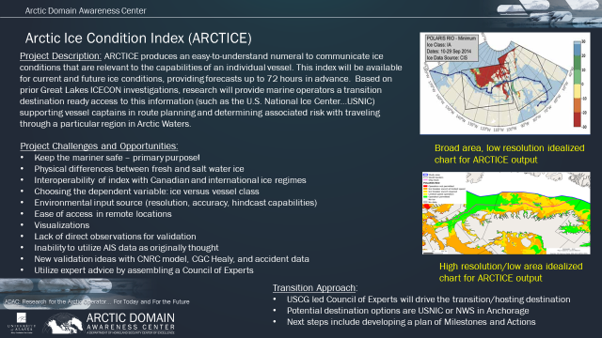
Figure 10. ARCTICE Overview.

Baseline:
Year to year and decade-to-decade, marine vessel traffic in the Arctic regions of the Bering, Chukchi and Beaufort Seas is increasing. The rise in vessel traffic is highest in summer months, but is also increasing in the summer “shoulder seasons” of spring and fall, and there is even a rise in winter related traffic, due in part from the establishment of Liquefied Natural Gas (LNG) in Arctic Russia, transiting the Chukchi and Bering Sea regions year round. Commercial interests are now exploring the feasibility of an Alaska North Slope LNG operation to carry LNG via ship to markets in lower latitudes. Marine vessels operating in the ice-laden waters within the U.S. Exclusive Economic Zone (EEZ) of the Bering, Chukchi and Beaufort Seas in the Arctic face a number of challenges.
These challenges include long distances between ports of call, communication shortfalls, increasingly difficult to predict weather, limited infrastructure, limited U.S. Coast Guard and other search and rescue forces, and a unique safety challenge to assess how to navigate complex sea ice. Currently, there are limited planning tools to support mariner route and decision-making in sea ice conditions. A real-world example was the USCG District 17 rescue of the 36 ft. “Altan Girl” inadvertently locked in Chukchi Sea ice in July 2014 . Specifically, there is no method to communicate the severity of ice conditions and associated risk related to specific vessel classes.
ARCTICE models research methods and developmental efforts from Great Lakes ICECON Research. Great Lakes ICECON is a decision support tool combining vessel class with nowcast and forecast, lake ice conditions. Great Lakes ICECON forecasts up to 120 hours into the future and uses circulation and ice models developed by NOAA’s Great Lakes Environmental Research Laboratory (GLERL). Great Lakes ICECON accounts for icebreaker activity and its impact via nowcasts and forecasts. In parallel with the development of Great Lakes ICECON, the research identified and adopted a vessel classification system to define a number of vessel classes and the ice-capability of ships in those classes (in terms of ICECON). The ICECON system supports USCG to provide guidance and appropriate decision support to Great Lakes marine vessels (for a given class) planning a given transit. ADAC researchers have previously delivered a Beta version of Great Lakes ICECON for integration to USNIC and are currently in progress in adapting prior feedback and the current winter season, lake ice associated environmental data to refine and deliver the finalized version.
ARCTICE research draws the same research team that delivered Great Lakes ICECON and will leverage many of the same experts who supported ICECON. Due to similar methods, the research team, while pursuing investigative tasks in Great Lake ICECON, have obtained most of the required knowledge to commence the ARCTICE project following delivery of the finalized Great Lakes ICECON.
USCG District 9 (D9) in partnership with USCG Research and Development Center (RDC) served as the pathfinder and catalyst for Great Lakes ICECON. Great Lakes mariners will benefit from finalized ICECON, as use of the tool should result in better route planning and less entrapment in lake ice. USCG D9 benefits from Great Lakes ICECON, as less mariner entrapment should result in lower numbers of rescue mariners. Arctic mariners, who by nature of operating in more extreme environmental conditions of the Arctic (coping with the significantly smaller and more dispersed rescue forces) have even greater need for a useful Arctic ICECON tool to plan safe routes and identify risks to safe navigation.
In order to ensure the safety and security of the vessels, personnel, and the environment, the development of a high resolution, Arctic Ice Condition Index (ARCTICE) is warranted to support Arctic mariner operational decision making.
There are numerous methods for communicating ice conditions and each Arctic nation has their own system. Russia and Canada, for example, both have systems to take ice conditions and translate those conditions into the relevant risk of transit based on a vessels’ particular class. Translating between Russian and Canadian systems can be challenging as each nation uses a different ice condition scale and a different vessel classification method. Following the adoption of the International Maritime Organization’s “POLARIS amendment” to the IMO Polar Code, those communication tools are starting to migrate to a uniform methodology. While the IMO has no existing or planned international enforcement privileges, the IMO Polar Code is seen as a “best practices” guide, many nations require that vessels comply with the code as it reduces the potential risks of death, environmental contamination, and excessive search and rescue support.
The POLARIS amendment to the IMO Polar Code is based on vetted ice condition processes from the Canadian AIRSS system, the Russian Ice Certificate concept, and additional inputs from other coastal administrators. The IMO offers a Polar Certificate to crews that train on, and comply with, the Polar Code. Therefore, crews on vessels traveling on Arctic routes will most likely have a Polar Certificate and will be familiar with the ice condition communication regime outlined in POLARIS.
As determined by ARCTICE Feasibility Study, investigators will research utility and effectiveness to communicate ice conditions using the index method outlined in POLARIS. The POLARIS amendment outlines the relationship between input environmental parameters and the output ice condition numeral as a function of ice class, season of operation, and vessel operational state (i.e., independent operation or icebreaker escort). This method may appear similar to the Transport Canada AIRSS method, but the POLARIS method considers vessel speed/escort operations, as well as seasonal ice decay and ice strength. While escort operations are not currently planned for the US EEZ, the influence of ice decay and strength is an important factor.
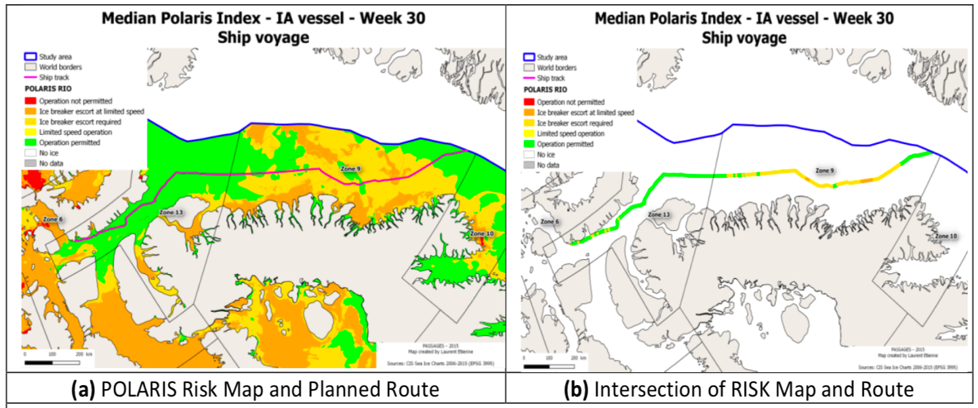
POLARIS quantifies the ice condition numeral by a “Risk Index Outcome” method (RIO). The RIO is calculated using the following equation:

$$RIO= C_{1}{RV}_{1}+C_{2}{RV}_{2}+…+C_{n}{RV}_{n}$$
Where C₁, C₂, …, C_{n} are the concentrations of ice types in tenths of percent over the total region in study, and RV₁, RV₂, …, RV_{n} are the risk values corresponding to each ice type per vessel classification. RV values are shown in Figure 12Figure 14. Positive RIO values correspond to low risk routes, while negative RIO values correspond to high risk routes.

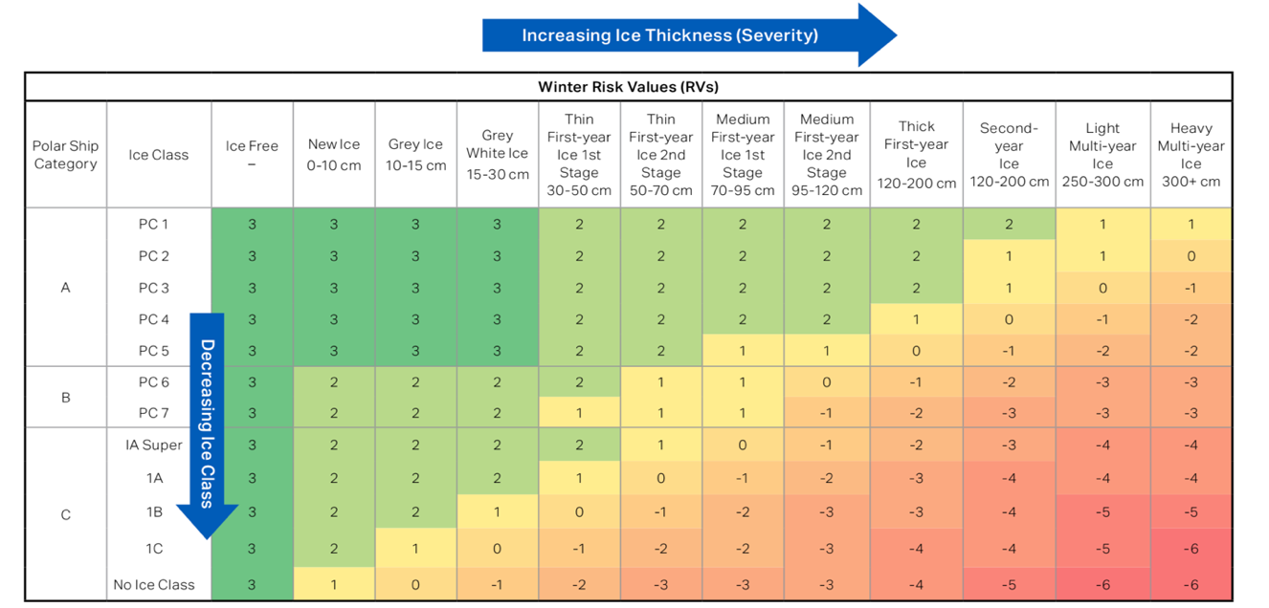
Figure 11. POLARIS risk values for winter ice. Note: least risk (green) to greatest risk (red).

Methodology:
ARCTICE is adapting research associated with Great Lakes ICECON to the Arctic Ocean environment. ARCTICE is planned as a 2-year research investigation that creates a mariner decision- support tool oriented to vessel categorization aligned with existing U.S. EEZ within the Bering Chukchi and Beaufort Sea regions. ARCTICE seeks to leverage Arctic vessel automated information systems (AIS) data from existing ADAC research, gain guidance from a USCG led Council of Experts and utilize sources of ocean current, sea ice presence, movement, thickness and ridging environmental model. ARCTICE plans to deliver the mariner support tool to operational destinations as determined and coordinated via the planned USCG led, Council of Experts.
In creating an ice conditions index for Arctic Mariners, (oriented principally to the Bering, Chukchi and Beaufort Seas), researchers seek to develop and transition readily accessible Arctic Ice Condition Index as a decision support tool for Arctic marine operators, useful to ships Captains, first mates and navigation officers. Arctic ICECON is distinct from Great Lakes ICECON in the following:
- Little to no available “local” ice observations.
- Research team has higher resolution environmental inputs than available in the Great Lakes region due to completed ADAC project, HIOMAS.
- Sea ice is inherently different than lake ice.
- There are new international standards for communicating ice conditions.
- USCG District 17 has operational challenges quite distinct in its region of responsibility compared to the operational environment faced by USCG District 9.
While there are significant differences between creating an Ice Conditions Index for the Great Lakes region and an Ice Conditions Index for the ocean regions of the U.S. Arctic EEZ, overall research methodologies are similar and experiences in creating Great Lakes ICECON are useful and complementary. Accordingly, ARCTICE investigations suitably leverage prior research associated with creating an Ice Conditions Index for the Great Lakes region.
In ADAC Program Year 6, the ARCTICE research team followed the ADAC Program plan and worked on these tasks:
- Provide and confirm the ARCTICE vessel classification index.
The Polar Code uses the International Association of Classification Society (IACS) Polar Class Unified Requirements and the Finnish-Swedish Ice Class Rules (Baltic Ice Class). The project team has identified the correlation between the Polar Class/Baltic Ice Class and the ABS Ice Class.

- Investigate other national models (in particular, Canadian programs).
The project team has investigated the Arctic Ice Regime Shipping System (AIRSS) as a regulatory standard for ice condition used by the Canadian authority. It is the basis of the POLARIS in the Polar Code and very similar to POLARIS.

- Determine suitable environmental factors.
Following Polar Code POLARIS, the project team used ice types and their area fractions (or partial concentrations) as the environmental parameters.

- Create, then optimize a forecast numeric Arctic ice condition index for Arctic waters.
A computer code has been developed to generate the POLARIS index for various Polar Class vessels (Fig. 14).
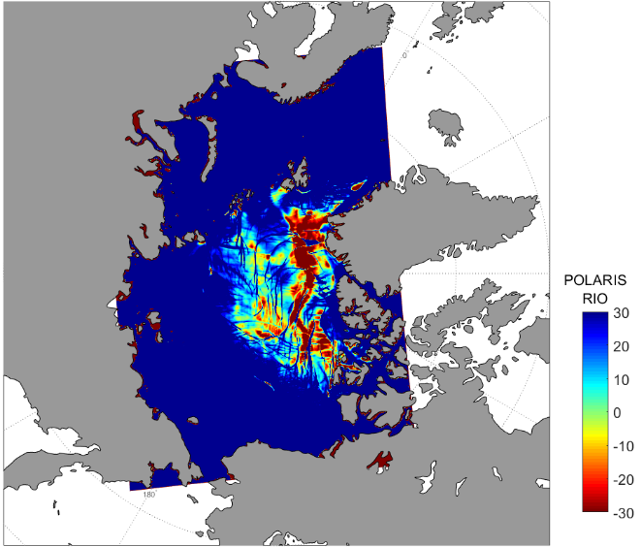
Figure 12 POLARIS index for the Arctic Ocean calculated from HIOMAS Model
- Investigate suitable access.
Ensuring ease of access to ARCTICE for the Arctic mariner is a particular challenge for this project. Output from the ARCTICE system needs to consider that operators will utilize satellite data for access and bandwidth will be limited. The team discussed with USCG D17 for the most suitable approach to publish the Ice Condition Index for easy access for mariners.

The research team will accomplish the following in Program Year 7.
Integrate the index to a visualization tool as an aid to vessel mariner planning and underway activities.
This research task takes the calculated ARCTICE to display for operator reference. While the numeric is a useful decision support aide, without suitable visualization, mariners are not able to suitably apply and benefit from ARCTICE to determine route of steam or adapt in underway circumstances (if the vessel can connect suitably to derive underway ARCTICE numeric).
Despite the limited bandwidth, operators will benefit from a visualization of the ice conditions on a graphical chart. This chart would be similar to the ArcGIS map produced by USNIC in connection to the Great Lakes ICECON project. The recommendation from the experts at D17 and USCG HQ is to offer a broad area/low resolution chart, augmented by a limited area/high resolution chart. Options to overlay or do a side-by-side comparison with hindcast data will also be included. Further, ARCTICE charts should be accessible by both desktop and mobile web browsers, offering the widest access possible.
Unlike ICECON, ARCTICE will have little access to mariner observations and therefore cannot use this method for developing relationships between ice conditions and an index numeral. Instead, researcher will use the construct that ships with Polar Certificates will programmatically be assigned an ice class based on IMO adopted standards. Those ice classes are based on regulated design practices across the ship building industry to determine ice capabilities, or lack thereof. For each vessel ice class, there is a specific, weighted value for a given ice condition. Unlike ICECON where a single map could be utilized by all mariners, ARCTICE will need multiple map options and toggles to effectively and accurately communicate the relevant ice conditions.
ARCTICE validation
ADAC researchers believe validation of the ARCTICE product will prove challenging, but not impossible. Unlike the Great Lakes project, direct observations of ice by marine operators are unavailable. However, accident data from Transport Canada might be obtained for hindcast evaluations. Accident data comes with indications of the ice conditions, and temporal and geographic information. We will also pursue a discussion with the Sea Ice for Walrus Outlook (SIWO) program at ARCUS with the intent of forming a cooperative effort to validate ARCTICE. Hunters are interested in the ice edge/thickness and, if they are willing, would offer observational data that could be compared to model output. This will likely require a new mobile app for collecting observed ice condition.
Automate a forecast numeric Arctic ice condition index for Arctic waters.
After establishing the numeric ice condition index for Arctic waters based on the POLARIS index from the Polar Code, the ADAC team will collaborate with Axiom Data Science to develop computer scripts to automate the process of calculating the ARCTICE index. The scripts will automatically obtain input source data from HIOMAS, run the ARCTICE script, generate POLARIS index plots, and publish the plot on a server.
Transition the ARCTICE to an operational destination
Overall, the ARCTICE transition will take a similar approach as for Great Lakes ICECON. After the ADAC team established the ICECON automation, the team will collaborate with Axiom Data Science to transition it to operation. Axiom data science will host the computer scripts to automatically obtain input source data, run the script, generate POLARIS plots, and publish the plot at a server. The ADAC team will also pursue agreements with USNIC and Alaska Ocean Observing System based in Anchorage for them to host the POLARIS data.
Explore an east-coast version of ARCTICE for USCG D1
Currently the ARCTIC covers the entire Arctic Ocean and will provide POLARIS index for all sailing routers within the Arctic Ocean. The jurisdiction area covered by USCG D1 on the east coast, is outside the current ARCTICE area. However, with a similar need from D1 for information to navigate in ice, the project team will also explore and discuss with D1 for the feasibility of an east-coast version of ARCTICE.

Key Milestones:
- Finalize a forecast numeric Arctic ice condition index for Arctic waters. Researchers started the forecast numeric Arctic ice condition index for Arctic waters in project year 6 and will finalize the model with feedback from shareholders in year 7.
- Integrate the index to a visualization tool as an aid to vessel mariner planning and underway activities. Project investigators will provide visualization of ARCTICE in ADAC Program Year 7.
- Conduct validation. ARCTICE validation is a Program Year 7 task.
- Transition the ARCTICE to an operational destination. Researchers will plan to transition ARCTICE to Axiom Data Science by 30 Jun 2021 for automated index generation to USNIC.

Performance Metrics:
Researchers will evaluate their investigations according to the following metrics:
- The ARCTICE algorithms enable accurate Arctic ice condition predictions 65% of the time.
- ARCTICE algorithms provide comparable Bering, Chukchi and Beaufort Sea ice-conditions index accuracy to known accuracy of Canadian ice services within Canadian waters.

Stakeholder Engagement:
Project team will continue to participate and be featured in the planned ADAC “Customers and Partners” Roundtable, in order to inform and receive feedback on project progress. As with the Great Lakes ICECON project, ARCTICE researchers will be in frequent contact with project champion, key project support at USCG RDC, USCG D17 and USCG-led Council of Experts. ADAC will establish a Council of Experts who are Arctic oriented experts from USCG Pacific Area, District 17, NOAA/NWS, and others as agreed by USCG, such as Arctic shipping company representatives, the American Bureau of Shipping, subject matter experts from the Alaskan Native community, and Arctic Ocean specialists from the Canadian Ice Service. Project will featured during quarterly ADAC Customer’s and Partner’s Roundtable.
Project Champion: CDR Christopher B. Tuckey (CG-WWM)/substitute LCDR Jamie Gatz. Project advocates include HQ CG-926, San Cheung, USCG RDC, the U.S. National Ice Center, and USCG D17.

Student Participation:
The research team plans for at least one participating student fellow on ARCTICE. Student participation will include assisting with the development of the ARCTICE algorithm and support advancement of validation methodology.

Outcomes/Outputs:
- A finalized set of ARCTICE algorithms for U.S. waters in the Bering, Chukchi and Beaufort Sea.
- A finalized vessel classification system U.S. waters in the Bering, Chukchi and Beaufort Sea.
- USNIC & or National Weather Service hosting POLARIS index from ARCTICE for U.S. waters in the Bering, Chukchi and Beaufort Sea.
- Final product development anticipated to conclude at TRL 7.

Transition Plan:
Overall, the ARCTICE transition seeks to replicate the transition planning used for Great Lakes ICECON from research to an operationally relevant tool. For the Great Lakes ICECON, the ADAC team established the ICECON algorithm and collaborated with Axiom Data Science to automatically obtain input source data, run the script, generate ICECON plots, and publish the plot at a server. USCG is able to download the ICECON plots direct from the server. In addition, through an agreement with USNIC, the ICECON plots are also transferred to USNIC to add to USNIC’s USCG D9 support data folder. This approach of using a third-party to run the script to generate ICECON plots and to only host the generated plots at USNIC is recommended by USNIC.
For ARCTICE, while noting the USCG led Council of Experts will direct the transition focus and overall destination, the research team notes that a similar approach is desired. The ADAC team will work with Axiom Data Science to establish the operation for ARCTICE script and pursue an agreement with USNIC to host the generated ARCTICE data. In addition to USNIC, the Alaska Ocean Observing System based in Anchorage potentially serves as an alternate or replication of a USNIC destination. In addition to directions and guidance received from USCG D17 and other Council of Expert members, transition planning will need to account and gain input/product feedback from Alaska-based mariners who comprise the bulk of the maritime traffic in the U.S. Arctic waters. The research team also will explore deploying the app with staff onboard the CGC Healy or other ships that frequent areas of interest.

Potential programmatic risks to completion:
Overall, the remaining Great Lakes ICECON risks are extremely low. The project team assesses overall risks to ARCTICE project completion as medium. Generating a suitable environmental data feed to generate ARCTICE is a programmatic risk. Auto generation of Great Lakes ICECON is proving successful. ARCTICE is intended to also be an “auto-generated” decision support tool. If environmental data is not available to support the auto generation, a useful ARCTICE will not be produced. Researchers will reduce risk by seeking to leverage ADAC’s successful sea ice modeling protocol, the High-resolution Ice-Ocean Modeling and Assimilation System (HIOMAS) via transition destination at Axiom Data Sciences (the Alaska Ocean Observation System, a NOAA affiliate), which as an “on-demand” and approximately bi-weekly computational cycle to provide modeled data to a multiple sea ice users. In addition to HIOMAS, researchers can also potentially leverage Navy Research Lab’s similar Research team believes such data will prove invaluable to ARCTICE.

PROJECT: Arctic Vessel Monitoring Geofencing/Alert Awareness
Project Investigators: Dr. Shawn Butler
Supporting Team:
TBA: Arctic Web GIS project investigators
Project Champion: Hank Blaney, HQ USCG CG-255
Lead Institutions: University of Alaska Anchorage (UAA)
Project Description:

Abstract:
This project seeks to extend the Arctic Vessel Monitoring Geofencing/Alert Awareness project, initially funded in ADAC Program Year 5, by providing enhanced command and control features that improve on the original goals of monitoring and alert awareness developed for the unclassified Marine Exchange PACTRACS system. As CG OneView 3.0, the US Coast Guard’s designated common operating picture, now displays both terrestrial and satellite AIS data, there is a need for a geofencing/alert awareness application that supports Coast Guard planning and command and control decision making tasks which easily integrates into CG OneView.
In addition, new geofencing capabilities could be implemented with the research outcomes developed in the Arctic Domain Awareness Center’s project Arctic all-Hazards GIS Platform. The Geofencing/Alert Awareness project in year 6 focused on the development of requirements and application design. Year 7 will result in a geofence implementation that can be integrated into the current (as of the end of year 7) CG One View version, which will allow users to ability to create, display, share, and manage static and dynamic geofences. In addition, planners and operators will receive alerts via the CG One View display. Operators will have the ability to define and display geofences and receive notifications via the CG One View console, either visually or textually.
The objectives of this project are to use the CG OneView application architecture and leverage the previous year’s Marine Exchange implementation to explore the human computer interface (HCI) features that facilitate efficient geofence creation, re-use, modification, deletion, and alert notification, which can be especially challenging in an information overloaded environment. Although this project will focus on Arctic maritime operations, the results should enhance geofencing capabilities in CG OneView and the Coast Guard in general.
Objective/Purpose:
The objective of this project is to extend both CG OneView and the initial ADAC geofence/alert notification project to include better geofence management and improved alert notification.
- Over time, the number of geofences created for planning and operational requirements will grow. Coast Guard users will need a mechanism to find existing geofences, perhaps modify some of the geofence attributes, and reuse or create altered copies. In addition, they will likely need to cull no longer needed geofences.
- Some geofences will be created that need to follow the shoreline. Users should be able to create a geofence that can be defined some specific number of meters/kilometers from the shoreline. ArcGIS is known to have tools that can identify the coastline which may be used to identify geofence boundaries. This will give the Coast Guard more accurate information when vessels cross geofences.
- Identify and implement additional features that may help improve planning tasks and operational response to vessels crossing geofences. For example, detect vessels that are approaching (i.e., likely to cross if the vessel doesn’t change heading), but have not yet crossed a geofence. Use color to show when a vessel is approaching (yellow)/crossing a geofence (red) so that operators can instantly see the geofence and vessel that is approaching/crossing. This will allow less clutter on the CG OneView operational picture.
- Operators and planners need to share geofences within their and across commands.
- It may be necessary to provide a historical record of a geofence violation for law enforcement reasons.

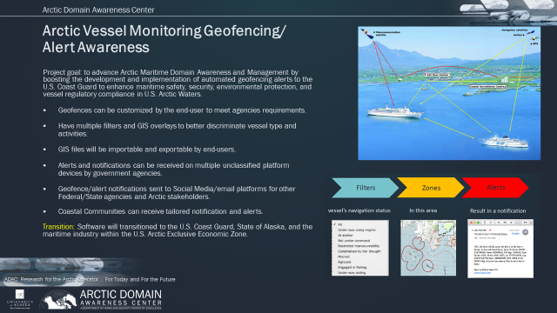
Figure 13. Arctic Vessel Monitoring and Geofencing/Alert Awareness

Baseline:
ADAC investigations conducted in Program Year 5 and 6 by the Maritime Prevention and Response Network and the Alaska Marine Exchange have resulted in the establishment of geofence/alert capability for static and dynamic targets available for USCG access and to support the public good via the PACTRACS system operated by the Alaska Marine Exchange. This has improved the previously automated geographic prescribed alerts with current fundamental geofencing software, which can now support AIS software interface to import /export customized geofences and automatically push alerts and notifications across multiple platform devices.
The CG OneView program office is currently fielding CG OneView 3.0. This version of CG OneView has been redesigned to leverage ArcGIS tools for the underlying mapping system and uses the Ozone Widget framework to create the overall application features and panels. This version also includes some limited geofencing features. The current ADAC Arctic Vessel Monitoring Geofencing/Alert Awareness project has identified the initial set of requirements for creating geofences and alerts using the PACTRAC system and enhancing AIS data and communication. Through their initial testing phase with the 17th District CG, they have identified additional requirements that will help enhance the CG One View geofencing capabilities. Finally, the Arctic Domain All-Hazards WebGIS project is identifying views that will improve how the USCG interfaces with web maps. These three projects form the baseline for this project to implement extended geofencing features using the Ozone Widget Framework, which would be compatible with CG OneView.

Methodology:
Through a select team of experienced computer information systems architects, and working with Coast Guard stakeholders in Alaska, the team will continue to analyze the geofencing features of CG OneView 3.0, the completed PACTRACS geofencing application, and the Arctic Domain All-Hazards WebGIS project to determine the set of extended features that will best improve Coast Guard planning and operational awareness efficiencies. In addition, we will work with Department of Homeland Security to identify the Geospatial Information Infrastructure (GII) that can leverage the GeoEvent server capabilities.
Researchers will also continue to work with the CG OneView program office to coordinate any future enhancements that they have planned. The team will use an agile development methodology to extend the geofencing/vessel tracking application with new features using the Ozone Widget Framework. The proposed enhancements will be vetted with the Alaska Coast Guard operational users so that we can be sure that we are providing effective and improved capabilities. We will also seek to receive continuous feedback from DHS GII to ensure that the geofencing development effort is compatible with HSIN security requirements. In addition, we will closely coordinate with the All Hazards WebGIS project developer to ensure that we seamlessly integrate into their software as it transitions into CG One View. The project will rely on the expertise of Axiom Data Science to provide expertise, development, and project continuity as students graduate.
The methodology includes
- Continued requirements elicitation from USCG stakeholders regarding geofencing feature set and development of use cases and design specifications within CG OneView.
- Software development that builds upon existing AIS datasets and geofencing technology...imported to CG OneView.
- Identify alternate sources of data that can be used to track vessels and monitor areas of interest.
- Synthetic test cases and test cases utilizing actual vessels.
- Acceptance testing and customer training.
- Peer-reviewed publication/presentation for validation and improvement.

Student Participation:
The project will seek the participation of four undergraduate student researchers. The students will be ADAC fellows. Specifically, the students will have a computer science background which will enable them to assist with the development of the enhanced geofencing/vessel tracking application. The work will be coordinated with the CG OneView and the Arctic All-Hazards GIS Platform projects so that there is a coherent vison for the geofencing capabilities, and it incorporates human-computer interface (HCI) best practices.

Research Objectives:
- Design and implement a software architecture that is based on the Ozone Widget Framework that can be adopted by the CG OneView project.
- Improve situational awareness with regards to geofencing and vessel alerting by using HCI best practices.
- Improve geofence management through improved creation, find and re-use, and deletion using enhanced Meta data for geofences.

Key Milestones:
- Simulate AIS data information arriving for the geofence application
- Use Ozone Widget framework to develop basic geofencing capability using the CG OneView App model
- Implement geofencing/vessel tracking enhancements per requirements from USCG stakeholders and Arctic All-Hazards GIS Platform project.
- Transition results to the CG OneView project office.

Key Stakeholder Engagement Plan:
Project team will continue to participate and be featured in the planned ADAC “Customers and Partners” Roundtable, in order to inform and receive feedback on project progress. Stakeholder engagement will be central to the success of this project. Deliberate investments in the collection of information required to develop the work flow diagrams and identify the end-user requirements of the tools and in how recipients can receive this information will be critical. This project will also work with the Coast Guard members of the geofencing Advisory council to ensure that we are providing an improved geofencing/vessel tracking application.
Project Champion: Hank Blaney, CAPT (Ret) USCG, HQ USCG CG255. The strategic customer is HQ U.S. Coast Guard Project Champion.
Project advocates (who are planned to join the steering committee): Personnel (as coordinated with Project Champion) from HQ USCG CG9, USCG PAC Area, D17 and R&D Center. The primary operational customer for this product is the 17th U.S. Coast Guard District, and the tactical customer is U.S. Coast Guard District 17 Sector Anchorage.
Two key collaborators are the U.S. Coast Guard R&D Center and the CG OneView project manager. Priority of engagement for research team is HQ USCG Project Champion, and the direct USCG end-users: USCG D17 and USCG D17 Sector Anchorage.

Performance Metrics:
- Design and documentation of Geosystem architecture, use cases, and test cases.
- Percentage completion/project velocity of features and use cases.
- Percentage of successful synthetic test cases (simulated vessel movements or other automated tests)
- Number of successful customer acceptance tests.
- Suitable application within CG1View/HSIN.
- Archival ability of created Geofences to support routine use-cases.
- Number and impact of peer-reviewed publications/presentations.

Outcomes/Outputs:
The project planned outcomes are:
- Enhanced geofencing\vessel alerting application based on the Ozone Widget Framework.
- Application architecture documentation
- Geofence management tools developed using the Ozone Widget Framework that allows users to find existing geofences based on geofence and alert Meta information.
- Documented user feedback from the 17th Coast Guard District Anchorage Sector

Transition Plan:
The transition plan will be conducted under the direction of the steering committee. The primary output of the project is new software. The research team will incorporate the new software into USCG hosted to CG1View/HSIN parallel to completed PACTRACS developments.
By hosting a version of software on the Marine Exchange servers and making it web/Internet accessible, the technology transition for stakeholders is simplified by removing the need for stakeholders to set up and install their own servers or software systems. Additionally, by hosting the new software on the Marine Exchange servers, data transport and access to vessel data stored on the same servers is more efficient than if the new software were hosted elsewhere.
Product will be delivered with robust training/instruction and documentation elements. The project team plans a comprehensive engagement investment principally focused on HQ USCG, and USCG End users. This engagement will result in co-development of a system that is user-friendly. Project team will provide a streamlined user’s guide and directions and supporting how-to video/webinar, with additional focused training support to USCG end users.
The interface between the system and social media access will also be server-based. Scripts that run on the server or cloud will provide requested data via social media channels. End-users will be responsible for managing social media or email software on their endpoint device. Any separate client-side tools (e.g. custom apps) will be made available from the server or from an appropriate application repository.
The project team will provide comprehensive training to stakeholders on how to use the new software. As the initial and primary stakeholder, we will engage with the USCG first across the development and deployment lifecycle and expect significant input from the USCG through the steering committee.
Since a version of the project will also be completed using the Ozone Widget Framework and coordinated with the CG OneView project office, the transition of the enhanced features should be relatively easy. Although our project will be using a slightly different version of the Ozone Widget Framework, conversations with the CG OneView project office indicated that the differences between the two architectures would be minor. All software and documentation will be turned over to USCG for inclusion into the next possible version of CG OneView.

Potential programmatic risks to completion:
Overall, the research team assesses programmatic risk as medium.

Risk 1: Geofence Archival system.

Risk 2: Creating an edition in CG1View/HSIN: The CG OneView project priorities may prevent timely coordination. The team will rely on the operational customer for developing requirements and validating whether the enhanced features are likely to improve District planning and operational tasks. In specific:

- ArcGIS and Ozone Widget technologies may limit what is possible. For example, there may be a limit to precisely identifying coast lines. The team will leverage any existing add on modules that improve coast line identification.
- Open source software is often not as intuitive to use as the contributors claim, which may delay our ability to set up the development environment. We hope to coordinate with the Arctic All-Hazards GIS Platform project, which has already worked with the ArcGIS Web version. In addition, project team will consult with other ADAC researchers who have particular expertise using ArcGIS. Researchers may also need to consult with the CG OneView project office as they have particular expertise using the Ozone Widget Framework.

PLACEHOLDER PROJECT: Research support to National Weather Service Arctic Testbed and Proving Ground.
This investigative study will seek to experiment with concluded research already transitioned as well as completing research in order to affect better NWS leveraging to maximize DHS S&T and University of Alaska research investments.

PLACEHOLDER PROJECT: Next Generation Arctic Communications Systems: Requirements.
This project will assist the USCG with establishing requirements for future communications in Alaska maritime regions. ADAC anticipates releasing a short term funded solicitation based on USCG and DHS S&T UP desired parameters.

PLACEHOLDER TBD: Projects awarded and established responding to funded solicitation from “Stressing the system...managing a complex Arctic crisis” Arctic IoNS 2019 workshop.

THEME 3 – Maritime Technology Research:
- Propeller Driven Long Range Autonomous Underwater Vehicle (LRAUV) for Under-Ice Mapping of Oil Spills and Environmental Hazards (Continuation Project);
- Arctic IoNS and MaLTE workshops.
- PLACEHOLDER TBD: Projects awarded and established responding to funded solicitation from “Stressing the system...managing a complex Arctic crisis” Arctic IoNS 2019 workshop.

PROJECT: Development of Propeller Driven Long Range Autonomous Underwater Vehicle (LRAUV) for Under-Ice Mapping of Oil Spills and Environmental Hazards
Project Investigators: Dr. James Bellingham (WHOI), Amy Kukulya (WHOI) and Brett Hobson (MBARI)
Lead Institutions: Woods Hole Oceanographic Institution (WHOI) and Monterey Bay Aquarium Research Institution (MBARI)
Supporting Team:
Noa Yoder (WHOI)
Amanda Besaw (WHOI)
Sean Whelan (WHOI)
Daniel Gomez-Ibanez (WHOI)
Brian Kieft (MBARI)
Project Description:

Abstract:
Increasing level of commercial marine activity in high latitudes creates an ever-growing risk of oil spills. Characterizing oil spills in remote and austere Arctic locations is a daunting challenge to the U.S. Coast Guard. Through 6 years of focused research and engineering, the LRAUV team at WHOI and MBARI have taken the original baseline Tethys Autonomous Underwater Vehicle (AUV), created by LRAUV Project Investigator Dr. Jim Bellingham, to design, develop and fabricate a specialized easily portable long-range Arctic-capable Tethys platform equipped with oil sensors, new software and navigation systems. In addition to creating (1) LRAUV, the project team has (2) provided demonstrations of the LRAUV survey capability, (3) created a simulator for establishing Standard Operating Procedures (SOP) related to AUV oil spill deployments, (4) designed and created three communications and navigation agnostic Arctic buoys, (5) designed and fabricated exchangeable nose sections with communications and homing capabilities and a mechanical retrieval and docking capability for ease of shipborne handling and recovery, (6) completed a review of a reduced cost design for USCG leveraging additive manufacturing; (7) demonstrated LRAUV system in extensive open water tests on real world oil seeps in Santa Barbara Channel California and (8) tested LRAUV in fresh water under ice.
In the coming program year, the LRAUV team will conduct planned high latitude testing at Point Barrow Alaska, complete the fabrication of a second vehicle, procure, design and complete integration of a multi beam sonar sensing capability and conduct extensive testing, to include under ice evaluations as a follow-up to tests conducted in Year 6.
The LRAUV is designed as a helicopter-portable platform, which will be multi-mission capable system. Through designing, fabricating and testing two platforms, two sets of sensing capabilities and three communication and navigation buoys, the LRAUV project team will provide a suitable deployment package to support USCG-led Arctic oil spill response. In sum, the ADAC LRAUV project, led by WHOI and MBARI, creates a rapid response solution to incidents occurring in the maritime environment, and increases situational awareness by characterizing the undersea and under ice conditions of ocean surroundings, autonomously, and capable at great distances from first responders in an Arctic maritime crisis.
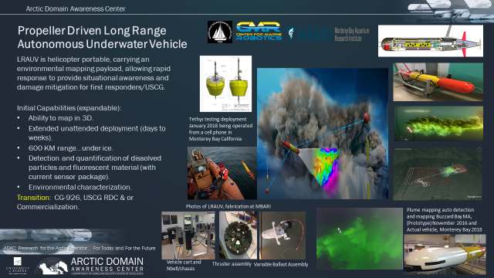
Figure 14. Propeller Driven Long Range Autonomous Underwater Vehicle overview.

In follow-up to the successful design and engineering accomplishments of the project, in the coming project year, ADAC and LRAUV project team continue an additional research and engineering program to (1) advance the technical competency of USCG RDC in operating and testing the platform, (2) seek to further reduced cost fabrication by constructing an additional LRAUV (spanned over Program Year 6 and 7), (3) conduct Arctic tests in partnership, (4) design and fabricate an additional sensor capability to LRAUV in order to create a multi-mission capable LRAUV. By project conclusion, ADAC and LRAUV project team will have provided USCG a state of the art capability in long range Arctic oil spill detection and characterization via a complete deployable package, advanced USCG RDC AUV competency, created additional LRAUV mission capability and conducted sufficient platform testing in Arctic conditions.

Objective/Purpose:
Advance LRAUV capability for DHS S&T UP and USCG through additional research and engineering program to (1) advance the technical competency of USCG RDC in operating and testing the platform, (2) seek to further reduced cost fabrication by constructing an additional LRAUV (spanned over Program Year 6 and 7), (3) conduct Arctic tests in partnership with USCG RDC, (4) design and fabricate an additional sensor capability to LRAUV in order to create a multi-mission capable LRAUV, and (5) create a knowledge product outlining various scenarios and approaches to conduct an LRAUV deployment.

Baseline:
PI Dr. Bellingham’s prior laboratories at MBARI originally created the Tethys platform specifically to carry biological and chemical payloads for long distances and extended durations. The vehicle is small, about 30 cm (12 inches) in diameter, and requires no special handling equipment. Prior deployments ranged from a few days to over three weeks, and were conducted without the direct supervision of surface escort vehicles. The longest-range mission to date was over 1,800 km at a speed of 1 meter/second (m/s) off the coast of Moss Landing, California. The vehicle operated as far as 500 km from shore independent of any escort. However, achieving ranges two to three times greater is possible. Maximizing the vehicle range is achievable by operating at a speed of 0.5 m/s, using the buoyancy engine, shifting internal weight, trimming the vehicle to neutral buoyancy, and drifting at zero propeller speed while using minimal sensors.
The vehicle is suitable to shore-launch (whether on land or on ice pack) and recovered. A small boat is readily used to tow the vehicle between the harbor entrance and a boat launch ramp. LRAUV is also helicopter transportable to remote areas. The fabricated vehicle is approximately 230 lbs. and is possible to be carried by 2-3 personnel for short distances. LRAUV can operate in shallow (2 meters) to medium range depths (300 Meters).
The baseline Tethys system occupies the design space intermediate between underwater ocean gliders and the current generation of propeller-driven AUVs. Existing ocean gliders such as the Teledyne Webb Slocum, the Scripps Spray, and Kongsberg Sea glider have a sufficient operational range to achieve the desired range goals needed by USCG. However, they do not have the payload capacity or power to carry the chemical and biological sensors that are required, and cannot operate at higher speeds without redesign. Typical gliders operate at speeds of about 0.3 m/s, and utilize a power source equivalent to 1W of energy with minimal power consumption.
In contrast, existing propeller-driven AUVs such as those manufactured by Hydroid, Bluefin, OceanServer, and Teledyne Gavia consume more power, resulting in a shorter endurance. These commercial propeller-driven systems can operate for a period typically up to 24 hours at speed of 1.5 m/s, and providing ranges of less than 130 km. As a result, LRAUV is uniquely capable in its combination of payload capacity, range, and endurance for remote under-ice oil detection.
Mission-level control of the LRAUV is achieved by using an architecture called ‘state-configured layered-control'. This is an improved variant of the layered control architecture developed by Dr. Bellingham (1991) and implemented on vehicles ranging from Webb gliders to the Dorado AUVs (the first asset deployed during Deep Water Horizon). State-configured layered control supports autonomous adaptive operations for long periods. The software building blocks of the system are behaviors, or control laws, that can be combined to accomplish tasks. These control laws are conditionally connected to the AUV to complete missions that are more complex or respond to certain contingencies. For example, vehicle software is able to detect faults in critical components and respond appropriately, greatly improving the reliability of the AUV. In some cases, through configuration changes, the Tethys may continue a mission after a component failure. For example, depth control of the submersible is a redundant system. If the elevator actuator fails, the vehicle can continue to control depth by shifting internal weight.
Operators interact with the vehicle via an Iridium satellite link in remote areas or via Wi-Fi in near shore zones by recovering data snippets in near real-time and sending new mission commands to the vehicle as desired. Communication with the vehicle is possible when it surfaces, and interpreted at operator-determined intervals.
Over several years of operation a web-based operator portal for the LRAUV has been developed, which includes a display of science and engineering data. On a secure portion of the site users can access a command interface and a variety of utilities, such as an alert page that operators can configure to send mission data via email or mobile phones based upon certain criteria. Prior research has established a design, created operating and navigation software, investigated the range of capabilities associated with critical components, implemented a systems integration plan, and conducted successful field-tests to validate research.
Completed research to date provided a suitable design for platform fabricators to construct an LRAUV platform to meet stated parameters in navigation, mission performance, and operator ease of use. Subsequent activities resulted in full fabrication of the LRAUV engineered design.
In addition to a completed fabrication and integration of the Arctic/oil science payload, project team has provided a completed augmented AUV simulator and test scenarios addressing high-risk elements, including navigation and sensing systems, demonstrating oil-spill following capabilities in Alaskan waters. The completed LRAUV operator simulator (with sea ice geographically situated in Alaska’s Cook Inlet), integrates software-modelling code from ADAC’s Arctic Oil Spill model (to include oil plume modeling). This simulator fulfills a research and development task to support orientation, training and mission rehearsal for LRAUV operators.
LRAUV has undergone ocean field trials to verify that top-level systems, as well as science sensors contained in the platform nose section: (Seaowl Ecopuck, CTD (Conductivity, Temperature & Depth), PAR (Photosyntheticly Active Radiation (Light)), Optode (optical measurement), and ADCP’s (Acoustic Doppler Current Profiler)), and have been found fully functioning in accordance within planned parameters. LRAUV now has two nose sections. The small nose contains all of the sensors listed above. The second ‘large’ nose contains the same sensors but with the added DUSBL (homing array) and dynamic docking (whisker box) system.
AUV navigation crucial system usefulness to USCG led decisions. LRAUV multiple modes of navigation to mitigate complex environmental conditions and changing scenarios to include:
- A GPS system built into the Tethys antenna will routinely obtain GPS fixes when the vehicle surfaces. If surfacing is not possible Arctic buoys can provide ground-truthing via acoustics;
- The vehicle will dead-reckon using a Doppler sonar to measure velocity relative to the bottom, and a compass for heading;
- An Ultra-Short-Base-Line (USBL) acoustic system will measure range and direction to a transponder/buoy acoustically, marking interesting sites for revisit by the vehicle.
- LBL navigation with two or more buoy transponder systems for aided navigation allowing for triangulated fixes.

In order to complete an Arctic capable oil spill deployment package, project team designed and constructed Arctic Communication buoys, oriented to an “agnostic” communications design. These communication buoys include long baseline (LBL) and ultrashort baseline (USBL) systems, ACOMMS, Wi-Fi, RF, Iridium, and thermistor capability. LBL allows for long range (up to 10 Km per buoy), while USBL allows for short range (<500 meters) homing and docking for recovery under ice or in open water. The buoy system will also allow for data transfer from the LRAUV back to Command Control Center via Iridium. In order to transfer data in a format that can be visualized by the receiving party, a software compression is included in the buoy development. These buoys are critical to enable LRAUV to operate as a “system” to effect characterization and communication of an Arctic oil spill, under sea ice, to USCG led unified command.
Advancing LRAUV further, project team designed, implemented and conducted initial testing of a platform “Umodem” to include advanced navigation capabilities inclusive of LBL and USBL systems.
The Umodem team at WHOI is new firmware to allow the buoys to be used as transponders. In sum, Umodem, USBL and whisker box are new hardware and software capabilities provided to LRAUV to assist with under ice navigation and docking.
Additionally, when Autonomous Underwater Vehicles (AUVs) are strategically equipped with multiple sensor technologies, including cameras and sonar, they are capable of remote detection and analysis of oil under sea ice.
Test data illustrates that AUV's remain the most mature tool for the search, chart, and classification procedures routinely performed in seafloor analysis and similar methodology can be effectively applied to under-ice anomaly detection. Beyond the need for rapid detection of oil and gas in the Arctic, based on discussions and conclusions from several Center-led workshops, ADAC and the LRAUV project team notes the important utility for small AUV platforms with a variable endurance range of hours to weeks capable of mapping the seafloor for the purpose of bathymetric surveys and anomaly detection to include leaking pipelines and infrastructure.
The project team’s investigations have determined, multibeam sonars are capable of providing a high-resolution swath map with precise readings of hard structure as well as water column oil and gas detections (see figures below). Multibeams are well suited in first return systems for mapping the seafloor or underside ice. Accordingly, in order to create a multi-mission capability to LRAUV, the project team PI's, will research, procure and integrate a multibeam sonar system for use on portable AUV platforms.

Methodology:
Research team employ a task-oriented team of expert marine mechanical and electrical engineers and operators to advance further capability in the creation of a readily deployable, easily handled, variable speed, and long range AUV capable of detecting and mapping oil spills under ice. The team leverages prior investments in AUV research and oil sensor technology, and under-ice operations. The overall objective is to leverage mechanical and electrical engineering to design, create, and test LRAUV and associated systems with sensors, navigation, and chemical mapping to operate under ice, while advancing reduced cost manufacture and create a project partnership with USCG RDC.
The ADAC LRAUV project is entering the critical push to Arctic demonstration of the full suite of capabilities required for oil spill response. Since this project has a series of ‘Arctic firsts,’ the effort is structured in a test-evaluate-fix cycle. Field programs are intended to push the envelope of discrete capabilities (logistics, homing, docking, navigation, sensing, etc.) to identify strategies for improving system performance and reliability. In parallel with this evolution, the hand-off of LRAUV operations from MBARI to WHOI is laying the groundwork for the ultimate goal of an operational system.
In year six the first under-ice operations are being carried out. As this is written, the Polaris LRAUV is back from its first under-ice tests in Bog Lake, Maine. Follow-up activity to the tests falls roughly into two categories – basic functionality that needs improvement, and system-level lessons that could generate significant rework. Examples of the former from the most recent tests include improving performance of the docking latch and undocking behavior. An example of the latter is improving ice-buoy endurance. Our philosophy is to learn all the lessons associated with Arctic tests, making only essential fixes, before making significant system level modifications. Our expectation is that these accumulated lessons, including many not learned yet, will be addressed in a round of transition engineering activity later in the project. The alternative, making significant upgrades while we are still working though Arctic capabilities introduces significant additional testing costs (to test the systems that have been upgraded) and schedule risk.
ADAC Program Year 7 revolves around moving LRAUV operations to high latitudes. The first field program will occur out of Barrow, AK in July 2020. These operations will serve a number of purposes, including building good working relationships with the local community, working out logistics for Arctic deployment, and testing aspects of vehicle operations which thus far have been only carried out at moderate latitudes. For example, tests of navigation off of Point Barrow will stress the compass due to closer proximity to the magnetic north pole. During ADAC Program Year 7, under ice operations will occur in New England and in Lake Superior, expanding and building from what was conducted in Program Year 6.
The one exception to the ‘no major upgrades’ philosophy of LRAUV System research and development is a series of investments neede to make the software more supportable and usable. The current code is very ‘tight’ in the sense that the combination of complex code running on a power efficient, minimalist processor, make code modification an expert only activity. MBARI has made a major step forward in opening the code by introducing an additional processor, the so-called backstreet driver. This is a strategy very familiar at WHOI, as a similar strategy was successfully used to make the REMUS vehicles more readily adaptable to new capabilities. In year 7 we have budgeted for code activities to introduce the necessary software hooks to make the back-seat driver functional, and to create a simulator that will allow testing of vehicle software on shore. We believe the simulation activity will ultimately be extremely useful for the Coast Guard, and consequently have budgeted some experimentation with the use of video game development environments (Unity or Unreal Engine) to support non-programmer interaction with the simulator.
Overall tasks for LRAUV System Year 7:
- Complete Long-BaseLine (LBL) navigation software and test in Woods Hole waters on Polaris, LRAUV-1 with two gateway buoys and the third used as a USBL dock.
  - LBL can be configured to be HF (25 kHz) or LF (10 kHz) prior to deployment.
  - LBL navigation will allow LRAUV to improve its navigation capability to help ‘pinpoint’ targets in the water column as well as under-ice and on the seafloor. For example, LBL capability will allow the new sonar payload to create accurate ‘maps’
  - Conduct further Intuaware software development for vehicle-side LBL.
  - Establish WHOI software engineer support (through familiarization in source code with MBARI).
- Conduct pen water test sonar payload and mapping tool capability using LBL and off-the-shelf mapping tools.
- Procure primary lithium batteries for three buoys which will triple their current endurance from the current range of 4-5 days.
- Build second docking nose and DUSBL system with long nose configuration to match Polaris.
- Purchase remaining science and navigational sensors.
- Evaluate low cost IMU for backup to onboard magnetic compass (expect high-latitude interference, therefore a low-cost, low-power IMU allows or risk mitigation.
- Evaluate alternative power sources (solar, turbines, etc.) for Arctic buoys in order to extend battery life.
- Redesign vehicle antenna for under-ice environment and build lot.
- Finish Platform #2 Build, configure and bench test.
- Procure auxiliary gear to support for build of second platform (tracking gear, carts).
- Conduct open water testing and training of systems (MBARI/WHOI/USCG).
- Conduct Point Barrow Summer 2020 Tests.
- Conduct New England ice tests winter of 2021.
- Conduct Great Lakes ice test winter of 2021.
- Conduct Oil sensor evaluation and testing in Ohmsett
- Participate in project meetings and project management, oversight, training.
- Program ROS and simulator interface.
Task 1:
Project team will advance the technical competency of USCG RDC in operating and testing the platform. Project team, led by WHOI investigators at Woods Hole, MA, will complete vehicle design and fabrication of a second LRAUV platform:
  - AUV technical design and assembly will be documented
  - A second docking nose assembly will be fabricated for LRAUV-2
  - Simulator and backseat software development will be developed
  - Planning and conducting under-ice testing (to include joint planning for an Arctic region testing regime for summer 2020).
Task 2:
Project team (in coordination with ADAC leadership and USCG RDC) will investigate further systems tests, particularly focused in testing the platform under ice for two test deployments. One test will be deployed in New England ice, then another in the Great Lakes. The following Arctic test opportunities will be investigated:
- Science initiatives at Point Barrow Alaska,
- Additional non-ice testing details. Validation metrics specifically include the following:
  - Ability to map in 3D;
  - Detection and quantification of dissolved particles;
  - Determine the physical ocean environment (and determine acute/critical variables, such as assessing hypoxia of the water column in/near spill area);
  - Take CTD measurements.
  - The SeaOWL will be calibrated in the lab and baseline signals will be determined allowed for anomaly spikes to trigger an 'autonomy mapping' mission. Different mission scenarios will be outlined and tested including: a.) finding the source, b.) mapping out the extent of the plume and, c.) broad-scale surveys to find where there is no signal of oil in the entire water column for 0 to 300 meters (or max depth of operating area up to 300 meters).
  - Once testing missions are complete, mission macros will be created so the operator can quickly decide the type of mission to run prior to launch. The vehicle simulator will be a valuable tool for running planned missions with simulated currents, etc. based on available environmental data from the test area.
  - Following initial Program Year 5 tests, Arctic buoys will have any follow-on tests as required deployed in local Cape Cod waters and a dye tracking mission will be conducted. The 3 buoys will be deployed in a pattern to maximize vehicle navigation, vehicle docking and vehicle communication back to command control. We will further test acoustic communication range, data transfer success and percentage of vehicle docking tries via USBL. We expect to receive navigation fixes from each buoy back to the LRAUV up to 10 Km away (environmental conditions fluctuate and can impact sound range.
- Summary Arctic testing details.
  - Replicating oil sensor tests from open water evaluations, project team will conduct a graduated approach to testing LRAUV under-ice. Basic handling tests in easy to recover scenarios (such in lake ice conditions) will be the initial steps, followed by more advanced testing dynamics,
Task 3:
- Sonar sensor capability development to LRAUV in order to create a multi-mission capable LRAUV, completing the task in Program Year 7. Conduct additional fabrication to support integration of new sensor to existing LRAUV as well as provide additional fabrication/technical support to complement a separate supplemental workplan which will create a second LRAUV platform.

- Tests have been carried out with Sonic echosounder at the National Oil Spill Response Research & Renewable Energy Test Facility (Ohmsett) in Leonardo, New Jersey, to distinguish heavy oil on the seabed from sand or other bottom material (Hansen et al., 2009). These tests concluded that it is possible to distinguish oil from ice. Today, newer, less expensive and less power-hungry sensors are available and offer a valuable solution for integration on portable AUV platforms.

- Multibeam sonars are versatile sensors, allowing for a multitude of underwater applications, including pipeline inspection, creating high resolution bathymetric maps as well as detection capabilities of oil and gas.

- However, to date no group has demonstrated operational viability in an under-ice setting of an AUV system equipped with these or any other sensors. To demonstrate operational viability, we contend that an AUV system, the logistics of deploying it, and the accompanying data processing and visualization pipeline must be sufficiently mature and rapid to permit integration with existing, community standard oil-response tools. To this end, we propose to integrate and implement an onboard 'back seat' autonomy computer for autonomous data processing capabilities.

- New technology multibeam sonar systems are more compact and energy efficient, making it possible to integrate on small vehicles like the LRAUV. In addition to the vehicle platform and sensor technology, advancements have been made in onboard image processing and anomaly detection. In the early 2000’s REMUS vehicles were capable of detecting man-made targets of interest and sending 32-byte image snapshots acoustically through the water column to be displayed on a laptop saving hours to days of time in data processing and vital decision making (Freitag, et al. 2006). Today, it is possible to take more complex data sets, like multibeam data, and achieve similar near real-time snapshots.

- This activity leverages advances in marine robotics to provide an AUV capability with 3D mapping of seafloor anomalies capable of operating with minimal human oversight. The sonar has been proven to be able to detect oil and gas in oceanic environments, however our goals here are limited to providing a vehicle and sensor capability for collecting 3D sonar data for making maps. Our efforts will also allow for a hands-on demonstration of a recon mission showing the vehicle’s capability to detect and map an anomaly on the seafloor.

- Advancing marine robotics to provide an AUV capability with 3D mapping of seafloor anomalies capable of operating with minimal human oversight the sonar system integration provides a significant advance in understanding and characterizing the undersea environs. Accordingly, project team goals here are focused to providing a vehicle and sensor capability for collecting 3D sonar data for making maps.

- Project team efforts will also include a hands-on demonstration of a reconnaissance mission showing the vehicle’s capability to detect and map an anomaly on the seafloor.

- Accordingly, the project objectives for integrating a sonar system to LRAUV are broken into the following actions: (1) integration of a 3D Norbit multibeam system on LRAUV, (2) tank and open water testing sensor integrated to LRAUV. Within the scope of this project, project team will conduct suitable evaluation of the new sensor on to LRAUV and can build the mechanical framework for integration, (3) demonstrate bottom imaging capability for small area surveys with sufficient navigation accuracy to enable habitat change detection, and (4) evaluate applicability of above systems to characterize oil and gas leaks/pools.
Task 4:
- Project team will develop a scenario-based concept of operations for the LRAUVs. Specifically, given 2-3 realistic risks in the Arctic, the research team in coordination with ADAC Center leadership, Project Champion and USCG stakeholders will outline employment concepts in how LRAUV, navigation and communications buoys and multiple sensors would be employed as a system, which would inform additional development needs (such as launch/recovery cradles, slings, USCG infrastructure that needs amending etc.) as well as potentially inform transition/future use of capability.
Task 5:
- Project team will provide expedition reports and any engineering schematics related to designs developed under DHS funding for this project

Student Participation:
LRAUV project team does not anticipate to employ student participation in this phase of the project.
Key Milestones:

Performance Metrics:
For Program Year 7, the goals, specific schedule and milestones are as follows for LRAUV are as follows:
      - Project team will test a multibeam system by 15 Sep 2020.
      - Project team will advance the technical competency of USCG RDC in operating and testing the platform. Project team, led by WHOI investigators at Woods Hole, MA, will conduct up to two training sessions. Project team will complete this task via two sessions, the first by 1 Feb 2021 and the second by 30 June 2021.
      - Exercise LBL and sonar mapping capability by March 2021.
      - Conclude science evaluations of late Program Year 5 and early Program Year 6 tests in Santa Barbara Channel to inform further Arctic tests. Project team will deliver science evaluations and follow on local testing by 1 March 2021.
      - Plan and conduct LRAUV and Arctic Ice Buoy under ice tests, in New England and the Great Lakes or other suitable ice-covered lakes. Project team will conclude initial under-ice tests by 30 March 2021.
      - Plan LRAUV and Arctic Ice Buoy in Arctic conditions. Project team, working with ADAC leadership and the ADAC Summer Intern Project will develop a plan for Arctic testing based from the Barrow Arctic Research Center for Summer 2021.
      - Design and initiate fabrication of an additional sensor capability to LRAUV in order to create a multi-mission capable LRAUV, completing the task in Program Year 7.
      - Create and provide the comprehensive report not later than 30 June 2021.

Stakeholder Engagement:
Project team will continue to participate and be featured in the planned ADAC “Customers and Partners” Roundtable, in order to inform and receive feedback on project progress. Project team will also participate in maritime oil-spill peer venues as much as practical, while also ensuring close collaboration with USCG Interagency Coordinating Committee on Oil Pollution (ICCOPR) leadership and members, as well as the USCG R&D Center. Researchers will also meet with USCG RDC to discuss the testing and evaluation reports and technical design documentation.
Project Champion: CAPT Kirsten Trego, USCG HQ USCG-MER. Project Advocates include USCG leadership of ICCOPR, HQ USCG-255, USCG Districts 9, USCG HQ CG-926, USCG R&D Center, USCG D17, NOAA Office of Response and Restoration, US Department of the Interior, Bureau of Ocean Energy Management and Bureau of Safety and Environmental Enforcement, U.S. Environmental Protection Agency, Oil industry (Exxon Mobil, Shell Oil and American Petroleum Institute).

Outcomes/Outputs:
The goal of this project is to create an operational system that the USCG can use for characterizing spills in ice-covered ocean environments. ADAC, WHOI and MBARI focus on creating, testing and documenting an LRAUV with multiple sensors and supporting navigation and communications buoys to provide and demonstrate a prototype system that is feasible and suitable for production. Included in these outcomes is the Project team will focus on creating an AUV sensor capability to provide and demonstrate a mature platform that is feasible and suitable for production and use by a non-expert. System engineering will emphasize the ability to transition capabilities from one AUV platform to the next depending on mission needs. Accordingly, efforts to (1) to integrate a Norbit 400 kHz multibeam sonar system onto the LRAUV, (2) Design and build a new payload nose for Tethys to incorporate the sonar payload, (3) develop sensor modularity, (4) Plan and perform water tests of man-made targets, will significantly advance gaining an autonomous underwater capability to survey oil spills and produce high resolution maps with a modular payload at short and long ranges with multiple AUVs, at high and low latitudes and under ice answers an unmet need for DHS and the USCG.
During Program Year 7, the project team plans the following outcomes/output:
- Advance the technical competency of USCG RDC in operating and testing the LRAUV and Arctic buoys and provide the results of the test in a report.
- A reduced cost design, planning to incorporate suitable and acceptable measures to support the design for a second fabricated LRAUV and provide the technical design document.
- Fabrication of LRAUV and provide the technical design document.
- LRAUV and Arctic Ice Buoy under Arctic ice tests,
- Complete fabrication of an additional sensor capability to LRAUV in order to create a multi-mission capable LRAUV platform.
- Integrate a Norbit 3D sonar system onto the LRAUV platform,

- Design and build a new payload nose for Tethys to incorporate the imaging payload,

- Collaborate with MBARI to develop sensor modularity,

- Plan and perform water tests of man-made targets including oil surrogates.

Outcomes of effort will provide a commercially available off-the-shelf sensor package that is AUV ready, and turnkey for Arctic seafloor and under-ice mapping. This turnkey system will be designed in parallel with MBARI for ease of integration onto the WHOI-ADAC LRAUV vehicle. Predicting and monitoring environmental hazards in the Arctic remains an outstanding challenge for under-ice surveys. Our approach builds on proven AUV technology and expands its capability by adding the latest COTS sensor technology for creating 3D maps. The power of this technology for investigation of oil spills in open water or under ice remains largely unexplored, but sample data shows strong potential for oil mapping and detection capabilities in the future.
Transition Plan:
ADAC and LRAUV project team seek an integrated approach with USCG RDC and HQ USCG to acquire and develop additional LRAUVs commensurate with USCG mission needs. In accordance with DHS S&T UP-ADAC Grant Terms and Conditions, LRAUV Intellectual Property (IP) rights developed under this project remain jointly held between ADAC, WHOI and MBARI. According to the DHS S&T Terms and Conditions, DHS and USCG may leverage this IP royalty free to acquire and construct additional LRAUVs to USCG and other DHS maritime mission needs. During LRAUV testing, ADAC, WHOI and MBARI recommend HQ USCG Project Champion, HQ USCG CG5R, CG7, CG9 as well as USCG RDC participation. Project team notes that NOAA is interested in LRAUV capabilities.
ADAC proposes a research transition specifically focused with HQ USCG CG-7 and CG-9 at the Flag Officer level to determine suitable destination for LRAUV. Presently ADAC is planning USCG RDC as the transition destination. Program Year 6 workplan is developed to create competency for USCG RDC to advance in Program Year 6, in order to become a full mission partner in Program Year 7, capable to conduct LRAUV operations in response to USCG mission tasks. Through the course of Program Year 6, ADAC and Project team will plan to conduct at least 2 conferences/conference calls, with at least one of these meetings to be an in-person meeting (such as following the ADAC Annual Meeting in Washington D.C.) in order to discuss and mature the transition destination to be completed by the end of Program Year 7.
Following the LRAUV’s testing plan, and completion of data relay devices, the overall system will be TRL 7/8 and ready for production. Depending on DHS and USCG acquisition desires, project team relays WHOI and MBARI have around-the clock technical expertise available if any such need arises. This technical support covers hardware, software, design, fabrication, specialty application, and operations expertise.
The Tethys completing fabrication in Program Year 4 is a modification of a proven vehicle developed by Research PI during previous investigation at MBARI. The Tethys vehicle has performance far beyond commercially available systems, and thus transition of that capability to the USCG requires some planning.
WHOI has a history transitioning technology to operational use, especially with the US Navy. WHOI uses a variety of transition methods tailored to the nature of the challenges associated with the transition. Factors influencing the nature of transition include technological maturity, complexity of operations, availability of investment for ‘hardening’ of systems, market prospects, and more.
Potential programmatic risks to completion:
Design and fabrication of LRAUV on two coasts is demanding and logistically expensive. While an equal partner in LRAUV success, MBARI’s capability to surge to meet a myriad of urgent tasks is limited. As a risk mitigation measure, Project team will continue to seek to shift more of the fabrication tasks to WHOI to reduce construction load at MBARI.

PROJECT: Arctic-related Incidents of National Significance (Arctic IoNS) Workshop
Project PI: ADAC Executive Director Randy Kee
Lead Institution: University of Alaska Anchorage
Partnered team: USCG District 17 Staff officers for Arctic IoNS. Note: ADAC Fellows provide preparation and administrative support.
Project Description:

Abstract:
ADAC plans to conduct one Arctic-related Incidents of National Significance (IoNS) workshop for the upcoming program year. ADAC has historically planned IoNS workshops in close coordination with USCG District 17 based on input from the USCG D17 Commander. This program year, based on increasing Arctic interest expressed by USCG D1 Boston, MA, ADAC will conduct an IoNS workshop that addresses the concerns of both D1, and D17 Commanders, to be held on the East Coast (TBD). Based on identified operator concerns, Arctic IoNS assembles expert academic and industry research professionals to work with select Canada and U.S. Coast Guard Arctic operators, along with U.S. and Canada government security officials in a structured workshop to understand gaps and shortfalls in science and technology and to provide corresponding research questions to address. ADAC publishes a corresponding workshop Rapporteurs report addressing research challenges and specific areas of focused future research. Arctic IoNS 2021 is designed to utilize a structured plenary and breakout workshop construct to identify areas for directed study that apply to both D17 and D1 operating areas. Following the workshop and development of the workshop Rapporteur’s report, ADAC will coordinate with DHS S&T and designated USCG officials to conduct a follow-on directed study, and deliver a comprehensive knowledge product to DHS S&T UP and USCG by the close of Program Year 7 (30 June 2021).
Objective/Purpose:

Conduct focused workshop, provide post workshop Rapporteur’s report with select researchers/paired with USCG and other suitable operators to discern USCG shortfalls as established by Commander, USCG D17. Following completion of workshop, ADAC plans a sponsored study as coordinated by USCG and approved by DHS S&T UP.

Baseline:
During a national incident, the public (including academia) offers technology solutions to the incident commanders to assist in the response. ADAC believes such an approach, while ultimately may assist in a successful outcome, often generates ad hoc solutions that prove to be sub optimal to capabilities developed by well-planned and researched processes.
The proposed workshops for the upcoming year will pull lessons learned from ADAC’s Arctic IoNS workshops conducted June 2016, October 2017, May 2019 and March 2020. The planned Arctic IoNS workshop will address a crisis response scenario as designated by USCG D17 and USCG D1. ADAC will lead the workshop using practices initiated in the Center’s Arctic IoNS 2019 workshop of employing a scenario-based guided response simulation. Arctic IoNS 2021 will create a directed study to address the shortfalls in the crisis response identified by USCG D1 and D17 Commanders.

Methodology:
ADAC plans its next Arctic IoNS workshop for Jan 2021. The workshop initially plans the scenario of an Arctic region, crisis response scenario associated with a major transportation accident that results in loss of life, significant injury and a maritime environmental response. The workshop method will employ a modified version of the “war-game” exercise scenario routinely used by the U.S. Joint Staff J-8 Wargaming Division, by creating designated “cells” representing various communities associated with the response, led by an exercise control team. Final scenario determination and workshop development will be coordinated by ADAC to USCG D17, USCG D1, USCG CG926 and DHS S&T UP.
Arctic IoNS development begins with the Arctic operators providing specified areas of concern to investigate. ADAC will seek to conduct a scenario-based seminar midway through Program Year 7 with USCG D17, USCG D1, and USCG Canadian counterparts to identify areas of crisis response concern in an Arctic maritime response scenario.
ADAC will conduct a comprehensive literature review through Center Fellows to establish a baseline of published experts and corresponding baseline capabilities associated with the crisis response. Guided by the review, ADAC solicits and assembles a framework of various response cells, corresponding to real-world crisis response decision-makers (oriented to Federal On-scene Unified Response. ADAC will then invite operators and government officials from U.S. (at Federal, State, Local and tribal compose crisis teams, and complement with relevant academic and industry leaders to form the response cells associated with USCG-led crisis response. ADAC will also invite Canadian response counterparts to join the proceedings.
Through a structured and sequenced plenary, guided exercise and breakout workshop, participants gain understanding of knowledge gaps and shortfalls in crisis response. Equipped with this understanding, participants will develop research areas of focus for onward study and research. ADAC will then create a Rapporteurs report, to establish a framework and needed details for a research study proposal for USCG and DHS S&T deliberation and approval considerations. The output of Arctic IoNS workshop will be workshop proceedings, and a proposal for relevant research study, to advance knowledge to support USCG mission needs leading to a comprehensive study and corresponding knowledge product.

Student Participation:
Center leadership plans that ADAC Fellows will aide preparation and administrative support as part of professional development and opportunity for networking.

Key Milestones:
- Work closely with DHS, USCG and Canadian counterparts on the workshop scenario.
- Conduct research to identify the universe of SMEs (international, domestic, in/out government, etc.); conduct research to determine what research is underway to address the likely challenges posed by the scenario and those challenges most relevant to USCG.
- Organize workshop (via securing facility, inviting participants, developing agenda etc.).
  - Completed workshop participants’ selection;
  - Completed workshop participants’ invitations;
  - Completed logistics arrangements;
  - Completed workshop announcement;
  - Completed workshop program.
- Make a determination to identify appropriate SME speakers to discuss relevant research activities across disciplines that likely address USCG challenges relevant to the scenario.
- Design exercise cells and guided simulation to support a USCG-led unified command response to address the simulated crisis.
- Execute workshop.
- Develop report/proceedings and study proposal representing the workshop discussions and submitted to DHS S&T UP and USCG for review
- Publish Rapporteur’s report/proceedings and submit follow-on study proposal to DHS S&T UP and USCG.

Performance Metrics:
- Planned and conducted workshops that meets USCG D17 Commander Desires and expectations.

Stakeholder Engagement:
Through a series of prior research and coordinating meetings, establish a network of Canada and U.S. operators, researchers and government official tailored to address each individual workshop. ADAC Project lead will work with DHS S&T UP, HQ USCG CG926, and USCG D17 to design and execute the planned workshop.
Project Champion: None designated, but ADAC will coordinate workshop closely with USCG D17 Arctic Planner, Mr. Phil Thorne to design and plan the workshop.

Outcomes/Outputs:
The output of Arctic IoNS 2021 will be prioritized research questions that will lead to an onward research study addressing specific USCG operational challenges identified during the workshop exercise and breakout groups and leading to recommendations as part of the overall study research gap. A collateral outcome is to provide USCG with a directory of subject-matter experts (SMEs) likely to understand the scope of challenges posed by the workshop. In addition, it will provide a directory of current ongoing research and expertise to help develop support plans in the future that can draw upon state-of-the-art technology and knowledge.
Workshop format:
Day 1:
- Meeting Product / Agenda / Logistics / Introductions
- Presentation and discussion of the Arctic IoNS scenario.
- Presentations by SMEs on current research underway related to the challenges posed by the scenario including description and analysis of the state-of-the-art decision science and supporting technology.
- Participants then form breakout groups oriented to combining complementary operators and response planners from both coasts identifying resources required to accomplish tasks as directed by unified command for Federal On-scene response.
- The day will conclude with refining exercise play to conclude the following morning.
Day 2:
- The day open with review of exercise play from the previous day, and advance to include breakout group discussions with a series of concerns made by each previous group during exercise play and the previous day.
- Workshop then continues with the formation of break out groups of experts for each research theme gap related to the scenario and discussions.
- Break out groups will discuss the gaps and shortfalls in crisis response and formulate research tasks to guide the overall follow-on research project to close those shortfalls and gaps. During the final afternoon, breakout groups will convene as a general plenary session to discuss each group’s findings.
- Following workshop conclusion, ADAC will formalize overall follow-on directed study for the end of Program Year 7, to provide to appropriate USCG colleagues along with DHS S&T UP PM for final review. Upon review by DHS, research questions will form a targeted study by ADAC/ADAC appointed researchers as coordinated by USCG and approved by DHS S&T UP.

Transition plans:
ADAC’s goal of the Program Year 7 Arctic IoNS workshop is to ultimately transition discovered crisis response gaps and shortfalls into a relevant follow-on study as decided by DHS S&T UP and USCG.

Potential programmatic risks to completion:
None.

PROJECT: Arctic Medium and Long Term Environment (Arctic MaLTE) Workshop
Project PI: ADAC Executive Director Randy Kee
Lead Institution: University of Alaska Anchorage
Project Champion: HQ USCG 5PW (Senior Arctic Policy Advisor...SAPA).
Project Support: ADAC Fellows
Project Description:

Abstract:
ADAC plans to conduct one Arctic focused Medium and Long Term Environment (MaLTE) workshop to understand and address the medium and long-term strategy, policy and planning needs specific to the USCG Arctic mission. The Arctic MaLTE format is a structured workshop involving select academics, industry researchers, and government officials, who explore long-range challenges comprehensively, from policy, governance, and science & technology vantages. The outcome of the MaLTE workshop is a comprehensive knowledge product which includes workshop analysis and recommendations.

Objective/Purpose:

Conduct focused workshops to meet medium and long-term strategy, planning and policy problems as determined by HQ USCG (specifically, HQ USCG Senior Arctic Policy Advisor to the Commandant.

Baseline:
As the longer-term compliment to Arctic IoNS, the Arctic MaLTE workshop will look towards the 10-20-year time horizon to investigate potential mission needs based on projected technology gaps driven by the anticipated Arctic operational environment. Building from lessons learned in the MaLTE workshops from May 2017, March 2018, September 2018, June 2019, and May 2020. ADAC is collaborating with HQ USCG 5PW to conduct a workshop focused on Pan-Arctic International competition and its effect on the MTS.

Methodology:
As a strategy, planning and policy oriented workshop, Arctic MaLTE events convene subject matter experts, Government Officials in both the U.S. and Canada, academic researchers, and respected leaders of the Arctic, to include Arctic residents from indigenous communities and organizations. The workshop structure is framed as a series of focused briefings, highlighting issues, concerns and recommendations, followed by roundtable discussions and breakout sessions using Delphi prioritized solutions that if taken for action through policy decisions, provide pathways to improved governance, safety and security for U.S. interests in the Arctic. ADAC will conduct a comprehensive literature review through Center Fellows to establish a baseline of published experts to support the workshop. In creating the workshop, ADAC solicits and assembles an appropriate panel of select researchers from the baseline to present to invited operators and government officials in Canada and the U.S. (at Federal, State, Local, and Tribal) to form cross-section expertise resulting in comprehensive discussions. After the plenary, ADAC divides participants across facilitated breakout workshops to discover pathways towards improved unified action.
While focused on strategy, policy and planning, through this structured plenary and breakout workshop, participants will also likely gain understanding of knowledge gaps and shortfalls in science and technology. In order to capture the discussions in plenary, roundtables and breakout groups, ADAC will create a Rapporteurs report, with prioritized recommendations and conclusions.
ADAC plans at least one Arctic MaLTE workshop. This workshop is tentatively scheduled for September 2019. The proposed title of the workshop is “TBD,” hosted in TBD. ADAC will submit a proposed workshop plan to HQ USCG 5PW in Program Year 6 and will await a decision and funding from USCG in early Program Year 7.
Scenario based literature review will present a baseline of understanding by futurist researchers in terms of economic, security and physical environment of the future Arctic. Guided by the Literature Review, expert opinion of selected and polled researchers, and the strategy documents.
This early 2021 Arctic MaLTE workshop will establish areas of concern in accomplishing strategy, high level goals, policy and planning. ADAC plans to extend invitations to a team of researchers, operators and government officials assembled to analyze the preparatory materials to investigate scenarios and plenary discussions to determine needed policy, governance, and science & technology to realize DHS and USCG strategic goals and objectives, corresponding to Arctic Maritime shipping within the U.S. Extended Economic Zone. ADAC will then publish the findings of the research in a comprehensive report.

Student Participation:
Center leadership plans that ADAC Fellows will aide preparation and administrative support as part of professional development and opportunity for networking.

Key Milestones:

Work closely with DHS, USCG and Canadian counterparts on the workshop scenario.

Conduct research to identify suitable SMEs (international, domestic, in/out government, etc.); conduct research to determine what research is underway to address the likely challenges posed by the scenario and those challenges most relevant to USCG.

Organize workshop (via securing facility, inviting participants, developing agenda etc.).
  - Completed workshop participants’ selection;
  - Completed workshop participants’ invitations;
  - Completed logistics arrangements;
  - Completed workshop announcement;
  - Completed workshop program.
- Make a determination to identify appropriate SME speakers to discuss relevant research activities across disciplines that likely address USCG challenges relevant to the scenario.

- Complete panel selection and invitations.

- Execute workshop.

- Complete report/proceedings and slides deck representing the workshop discussions and submitted to DHS for review

- Publish rapporteurs report/proceedings, including list of participants, and slides deck will be

Performance Metrics:

Planned and conducted workshops that meets HQ USCG Senior Arctic Policy Advisor to the Commandant.

Stakeholder Engagement:
Through a series of prior research and coordinating meetings, establish a network of Canada and U.S. operators, researchers and government official tailored to address each individual workshop.
Project Champion: None designated, but ADAC will coordinate workshop closely with Mr. Shannon Jenkins, HQ USCG-5PW Senior Arctic Policy Advisor to the Commandant USCG to design and plan the workshop.

Outcomes/Outputs:
The output of each workshop will be workshop proceedings, relevant recommendations and conclusions to advance strategy, policy and planning supportive of the USCG Arctic mission responsibilities. A collateral outcome is to provide USCG with a directory of subject-matter experts (SMEs) likely to understand the scope of challenges posed by Arctic IoNS and Arctic MaLTE. In addition, it will provide a directory of current ongoing research and expertise to help develop support plans in the future that can draw upon state-of-the-art technology and knowledge.
Workshop format:
Day 1:
- Meeting Product / Agenda / Logistics / Introductions
- Presentation and discussion of the scenario.
- Presentations on current aspects of strategy, policy and planning related by experts, operators and government officials.
- A series of roundtables discussions to address shortfalls and gaps.
- The day will conclude with the formation of break out to address research theme gaps and shortfalls related to the scenario and discussions.
Day 2:
- During the morning period, break out groups will discuss the gaps and formulate proposals close those gaps. During the afternoon, breakout groups will convene as a general plenary session to discuss each group’s findings, and employ Delphi method to prioritize solutions.

Transition plans:
ADAC’s goal of Arctic MaLTE is to understand issues and concerns, analyze those concerns to create understandings of shortfalls and gaps to strategy, policy and planning, and develop solutions to address the shortfalls and gaps. Lastly, through employing Delphi techniques, prioritization of solutions by workshop participants can be well achieved. As a complement to Arctic IoNS, the longer-range focus of Arctic MaLTE advances long lead research, requiring greater community of interest patience in awaiting relevant outcomes.

Potential programmatic risks to completion:
None.

- PLACEHOLDER TBD: Projects awarded and established responding “Stressing the system...managing a complex Arctic crisis” Arctic IoNS 2019 workshop.”

THEME 4: Integration of Science and Engineering with Maritime Security Governance and Policy Research

- PLACEHOLDER TBD: Projects awarded and established responding to funded solicitation from “Stressing the system...managing a complex Arctic crisis” Arctic IoNS 2019 workshop.

THEME 5: End-to-End (E2E)

- Arctic Command Center Modernization: A Scoping Study: Identify End-to-End (E2E) requirements for Sector and District Command Center IT Systems integration and modernization.
- PLACEHOLDER TBD: Projects awarded and established responding to funded solicitation from “Stressing the system...managing a complex Arctic crisis” Arctic IoNS 2019 workshop.

PROJECT: Arctic Command Center Modernization: A Scoping Study: Identify End-to-End (E2E) needs for USCG District and Sector Command Center IT Systems integration and modernization oriented uniquely to USCG Arctic missions.
Note: Project is recommended for approval considerations on a non-interference basis to USCG D17 Command Centers.
Project PI: Dr. Shawn Butler, LTC USA (Ret) UAA
Project Co-PI: Mr. Jason Roe, USCG (Ret) ADAC Assistant Director and Senior Research Professional, UAA
Lead Institution: University of Alaska Anchorage
Project Champion: Recommend Mr. Hank Blaney CG255
Project Support: Recommend the following:
Ms. Karin Messenger, HQ USCG 926
LCDR Adriana Gaenzle, USCG D17 Sector Anchorage
Mr. Cory Cichoracki GS-11, USCG D17 Sector Anchorage
ADAC Fellows

Project Description:

Abstract:
The Arctic Domain Awareness Center has several projects oriented to “enabling the USCG decision maker” research, which is potentially suitably useful for capitalization in the stepped development of integrated environmental modeling, operations planning, hazard identification, and risk analysis tools integral to core USCG Command Center functionality. As ADAC has completed 6 years of research investigations that advance elements of decision making science and technology, the Center has achieved a working relationship with the USCG command center near the University of Alaska Anchorage that potentially allows a partnered approach on a non-interference basis to conduct a scoped study to holistically investigate and assess USCG Arctic decision making at the tactical level that may prove useful for USCG modernization efforts
Informed by ADAC concluding and completed research, Center researchers partnered with USCG D17 Sector Anchorage (on a non-interference basis) through a scoping study could complete many of the development steps required to design needed programmatic IT solutions while simultaneously accomplishing near-term research objectives at a significantly reduced cost.
Currently, USCG Command Centers focused on the Arctic region utilize multiple IT solutions that add to the complexity of tasks and significantly increase overall workload and introduce greater potential for operator error. New IT solutions designed from the ground up around Command Center duties that include a simplified dataflow and modern modeling technologies will likely (and significantly) increase efficiency, improve precision, and reduce the likelihood of errors.

A proposed scoping study would help USCG gauge the feasibility, suitability, needed research effort, and associated timeline required to commence a follow-on IT solutions development activity. The outcome of the scoping study would be the delivery of a comprehensive ADAC knowledge product for USCG decision makers.

Objective/Purpose:
Conduct an investigative scoping study in partnership with USCG D17 Sector Anchorage to develop a comprehensive knowledge product of overall End-to-End IT needs aligned to USCG District and Sector Command Centers as identified by HQ USCG, principally those vested with Arctic mission responsibilities.
ADAC notes this study is a proposed activity aligned for Program Year 7. This study is limited to a Center led activity with a PhD Project Investigator uniquely qualified for Command and Control modernization, based on prior military experience (retired U.S. Army Lieutenant Colonel) as the Chief Engineer of DoD’s Global Command and Control System (GCCS). Co-Project investigation led by a retired USCG Petty Officer with 20 years of principally USCG command center experience. The center’s unique partnership with USCG D17 Sector Anchorage provides a very economical and independent study that delivers an associated knowledge product that could support internal USCG command center modernizations.

Baseline:
USCG District and Sector Command Centers currently utilize five (or more) data entry systems/programs: QRC check sheets, SAROPS, MISLE, Local incident logs, and Briefing/reporting tools at a minimum. Currently these tools do not auto populate data between one other and are housed within different programs and Command Center watch standers must enter the same data (position, vessel description, nature of distress, etc.) in each system independently.
Currently, USCG Command Centers utilize multiple IT solutions in parallel, unnecessarily growing the complexity of tasks and exponentially increasing overall workload. Current IT stovepipes result in multiple (and often conflicting) databases and duplication of data entry procedures. Innovative and coordinated IT solutions designed from the ground up around Command Center requirements that include a simplified dataflow, modern modeling technologies, and other federal agency crisis response structure support will significantly increase efficiency, improve precision and interagency coordination, and reduce the likelihood of errors.
As USCG District and Sector Command Centers are the information and operations centers for all 11 Coast Guard mission associated with Arctic areas include increasing the capability, utility, and efficiency of USCG Command Centers will provide substantial support to those essential missions.
The 11 Coast Guard mission areas are: Ports and Waterways Security, Drug Interdiction, Aids to Navigation, Search and Rescue, Living Marine Resources, Marine Safety, Defense Readiness, Migrant Interdiction, Ice Operations, and Other Law Enforcement.
The following is a review of the command center systems associated with specific mission areas.
SAROPS. Search and Rescue Optimal Planning System, SAROPS, is the United States Coast Guard’s Search and Rescue Planning tool and was initially developed between 2004 and 2006 before becoming active in 2007. SAROPS is a comprehensive search and rescue (SAR) planning system used in the planning and execution of almost all SAR cases in and around the United States and the Caribbean. SAROPS has four main components: The Graphical User Interface (GUI), the Environmental Data Server (EDS), the Simulator, and the Planning tool. Using the Commercial Joint Mapping Tool Kit's (C/JMTK) government licensing of the Geographic Information System (GIS) SAROPS can be used in both a coastal and oceanic environment. Built into the simulator is the ability to access global and regional wind and current data sets making SAROPS the most comprehensive and powerful tool currently available for maritime SAR planners. The Graphical User Interface uses the Environmental Systems Research Institute (ESRI) Geographic Information System (ArcGIS) and has been altered to include U.S. Coast Guard specific applications such as the SAR Tools Extension and SAROPS Extension. The applications have a wizard-based interface and work within the ArcGIS layered environment. Vector and raster charts are available for display as well as search plans, search patterns, search area environmental data, and probability maps. Finally, the GUI provides reports on all search operations. The Environmental Data Server (EDS) collects and stores environmental information for use within SAROPS. Local SAROPS servers around the United States request environmental information from the EDS based upon the area of interest.
Different environmental products are cataloged on the server ranging from observational systems to modeling products. Observations include sea surface temperature, air temperature, visibility, wave height, and global/region tides and currents to name a few. High-resolution model output from operational forecast models like the hybrid coordinate ocean model (HYCOM) and Global NRL Coastal Ocean (NCOM) model provide spatially varying wind and current information. The range of EDS products periodically changes as researchers from local universities, Government agencies, and research centers improve the accuracy and reliability of models and make them available.
The simulator wizard requires multiple pages of scenario descriptions to be entered by the user in order to compute the possible distress positions and times, subsequent search object drift trajectories, and the effect of completed searches on the search object probabilities. Based upon watchstander inputs, the simulator captures uncertainty in positions, time, environmental inputs, and leeway parameters. Upon watchstander completion of the information pertinent to the case, the simulator, using Markov's Monte Carlo method, simulates the drift of up to 10,000 particles for each scenario. For every 20 minutes of drift, the simulator accounts for changes in water current, wind leeway, and leeway divergence.
The simulator displays the results as a probability density map that can be animated over the drift duration. In short, the goal of the simulator is to allow search efforts to be focused on locations that have a high statistical probability of containing the search object. The planning tool takes the probability map information as well as another set of user inputs such as the type of resources, on scene conditions, and sweep width values to develop search areas that maximize search effort in high probability areas. The search areas can be adjusted by the Operations Unit watchstander to further maximize the Probability of Success based on other currently unaccounted-for environmental factors, or experience.
Armed with the best possible plan given available resources, the Operations Unit watchstander then has a plan that can be relayed to search assets. SAROPS currently has multiple limitations including: not preloading EDS data for quick recall, not accounting for the Sun for search effectiveness, not accounting for Wave/swell direction in evaluating search effectiveness, not automatically accounting for Land, not facilitating GPS trackline input, and not integrating with other IT solutions.
MISLE. The Marine Information for Safety and Law Enforcement (MISLE) database system is managed and utilized by the USCG for documenting operations in support of all 11 USCG Mission areas. MISLE was initially developed over 15 years ago to store data on Marine Safety and Law Enforcement exclusively, and has since been progressively expanded to document the other USCG missions and is now the major USCG database. Currently, it contains information on over 650,000 U.S. and foreign flagged vessels (including those used for recreational purposes), all Search and Rescue, Law Enforcement, and Pollution Incidents, and every licensed mariner in the United States. The system was not designed for quick data entry as needed in a Search and Rescue Incident and has numerous limitations for operations planners including no data integration with SAROPS, a slow moving web-based data entry process not aligned with initial information gathering, and no SAROPS or local log output features.

CG1 View. CG1 View (V3) is an app-based GIS viewer utilizing an adapted Ozone Widget Framework. CG1 View version 3 allows for multiple coordinated applications to work together to display environmental and tactical information. Currently CG1View V3 is not favored by Command Center watchstanders as the application contains several bugs relating to the visual display of AIS contacts and the drawing of basic shapes.

Paper or Electronic Quick Response Checklists (QRCs): Coast Guard watchstanders are required to complete QRCs that contain the minimum information required to gain awareness of and classify an incident, perform risk analysis, and plan the appropriate response. QRCs are mission area specific and often times several QRCs are required for each incident. As an example, a foundering Commercial Fishing Vessel may involve several Coast Guard missions including Search and Rescue, Marine Safety, Marine Environmental Protection, and Aids to Navigation. The QRCs for this incident could easily exceed 20 pages, as many of these QRCs are lengthy and each contain pages of redundant information that then must be subsequently entered into SAROPS, MISLE, Local Logs, and Command Briefs. The current standard QRC for one teaspoon of oil reported in the water is 9 pages long.

Local Unit Incident Log: USCG watchstanders are required to capture data in local incident logs that bridge capability gaps in the MISLE database. Due to the incomplete data capture capabilities in MISLE and the inability for MISLE to include local knowledge requirements, each District and Sector Command Center maintains a separate Unit Incident log that tracks Unit incident details. The data in this log must be entered separately as there is no unit specific data capture and export functionality built into MISLE that meets local unit requirements.

Command Briefs. USCG watchstanders currently develop Command Briefs from data spread throughout SAROPS, MISLE, QRCs, and Local logs. As data may be different in each of those locations due to time of update, critical information can change from one watch to another dependent on each watchstander’s database preference.

Situation Unit (SU). USCG Situation Unit (SU) watchstanders are responsible for developing and maintaining the Local Tactical Picture for their respective Area of Responsibility (AOR). This includes asset positions and status, current and forecast weather, current ongoing operations and movements, maritime events, and open or closed local and Federal fisheries areas. SU watchstanders highly leverage marine forecasts, GIS products, MISLE databases, and Local logs and databases. Currently, Situation Unit watchstanders maintain a list of over 50 sites that contain a variety of weather, environmental data, and other information including: tides, air temperature, water temperature, ocean currents, commercial vessel information, Federal fisheries information, State fisheries information, etc.

Operations Unit (OU). USCG Operations Unit watch standers are responsible for taking reports from private persons or other government agencies requesting assistance and planning operations in alignment with the Coast Guard’s 11 mission areas. Operations Unit watch standers coordinate response assets, evaluate and monitor response effectiveness, and evaluate and monitor operational risk. OU watch standers rely on environmental and other tactical information provided by the SU, utilize computer planning and risk mitigation tools and methods, and conduct briefings or produce reports.

Command Duty Officer (CDO). USCG Command Duty Officers maintain “higher altitude” awareness of Command Center operations and facilitate Command Staff incident briefings. Command Duty Officers validate response plans, evaluate and monitor operational risk, and communicate operational risk to Command Staff. Command Duty officers supervise other Command Center watch standers and directly represent operational Commanders. CDOs pull data from all USCG database systems to develop and update briefings for vertical dissemination of information requirements.

Methodology:
Via a uniquely suited research team of highly experienced military command and control engineer co-investigating with a career USCG watchstander, researchers will conduct a sequenced plan of scoping studies to gain insights and form recommendations for USCG consideration that could transition current separate/distinct USCG Command Center IT into a streamlined and coordinated IT system specifically designed around USCG Command Center workflow and develop a report detailing those requirements for use in future development.
The following are five suggested tasks to useful to guide the scoping studies:
- Leverage completed and concluding ADAC investigations for USCG watch standers. ADAC’s completed and concluding research is possibly useful to further evolve/adapt to serve in purposes specifically aligned to USCG watchstander needs with associated details useful to support research scoping. These include:
  - Research evolution: Leverage Great Lakes and Arctic Ice Conditions Index (Great Lakes ICECON and Arctic) to support Recreational Vessel Risk Analysis to Blue Force Risk Analysis
  - Discussion: The ICECON project combines environmental modeling and risk analysis procedures to produce a unique risk index that is tailored to a specific vessel based on that vessel’s characteristics. That risk index will inform vessel operators and voyage planners and provide a “risk of voyage” assessment. The project has recently received interest from local communities to assist in risk analysis for small recreational vessels in the course of recreational and subsistence hunting and fishing. The request for recreational vessel risk products could be a pathway to enhanced risk products for all recreational boaters. NOAA and the NWS have been providing a very basic version of this in the form of Small Craft Advisories. With modern environmental modeling and computer analysis, a more robust “whole of environment” risk index could be generated. Weather forecasts and vessel capability information could also be combined to provide USCG Command Center watch standers with higher precision “risk of Voyage” information for recreational and commercial vessels in many severe weather scenarios. That “risk of Voyage” information could inform response decision makers and bring greater fidelity to critical operations planning and risk analysis decisions.

- Research evolution: Adapt HIOMAS to Iceberg Drift Modeling to Vessel Drift Modeling
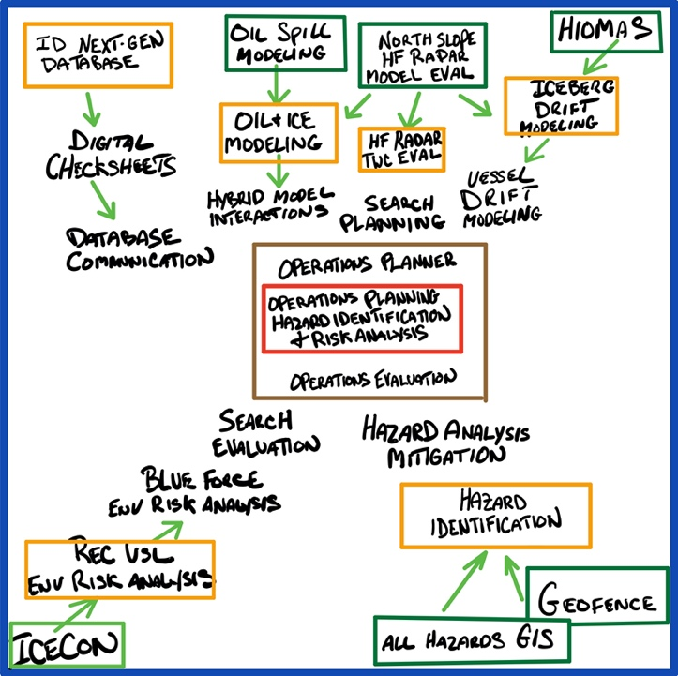
- Discussion: HIOMAS ice modeling and other ADAC related modeling research could be leveraged into iceberg drift modeling for use in the International Ice Patrol and future Arctic MTS management. Once Iceberg modeling has been established, vessel drift modeling could be explored, as both modeling programs would utilize many of the same datasets. Modern vessel drift modeling in a platform that can simultaneously display the output from all available models (similar to hurricane spaghetti models) would exceed the current capabilities of the USCG SAROPS program. Once ADAC is within range of developing a SAROPS alternative solution, innovative datasets can be incorporated into the program including sun direction and elevation as it relates to search object detection, the effects of wave/swell direction on search pattern effectiveness, and importing and evaluating GPS tracks for subsequent search planning.
Figure 15 Whiteboard of ADAC converging research: Green represents current projects and yellow represents near-term research opportunities. Ultimate goals are in the center.

- Research Evolution: Study and assess suitability of All Hazards GIS and Geofencing to Hazard ID to Hazard Analysis and Mitigation
- Discussion: As All Hazards GIS and Geofencing are integrated into a combined Domain Awareness platform, ADAC will have the opportunity to incorporate electronic and automated hazard area publishing. These hazard areas can be automatically populated based on severe weather forecast and observational data, safety and security zones, and search and rescue incidents. The ability to publish those geofence hazard areas to a Command Center GIS product would save time and provide increased visual awareness of hazards such as volcano eruption debris areas, tsunami warning areas, severe weather zones, gunnery exercises, and more; all while receiving Geofence generated notifications of which vessels and facilities are affected. Geofence-enhanced Hazard Area data could then be merged with vessel specific (ICECON developed) vessel hazard index information to graphically display a “risk of voyage” analysis on Command Center GIS systems. An example would be that smaller vessels transiting through a “Storm Warning” area would indicate higher risk-of-voyage and could then be easily identified. Following, graphically displayed risk-of-voyage would alert Command Center watch standers to unsafe operations that could then be investigated and more closely monitored.

- Research Evolution: Study and assess North Slope HF Radar to HF Radar Ocean Wave Evaluation to Validated Search Planning.
- Discussion: ADAC has recently entered into an agreement with Sandia National Labs to leverage HF Radar for tracking the ice edge off of the North Slope and validating HIOMAS models. Similar methodology has been successfully utilized to detect ocean waves/swells and validate ocean current models. This methodology presents ADAC with an opportunity to research shore side HF radar use for ocean current model evaluation in the Arctic. Use of this methodology could improve model validation techniques for the Arctic and inform model improvements. HF Radar ocean current validation could then be incorporated into a next-generation SAROPS replacement that leverages HF Radar ocean current observations to evaluate which ocean current models would be most effective for a particular incident. Semi-raw HF Radar ocean current data importation into SAROPS would provide a substantial time savings over traditional model validation methods (SLDMB) and would provide validation data over a larger area.
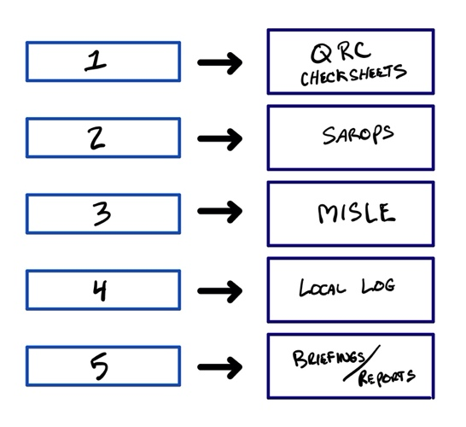
- Study and assess Current USCG command center IT solution shortfalls. These include the following topics and associated discussions:

- Topic: Investigate Stove piped IT development and Duplicate Data Entry.
- Discussion: The current suite of IT solutions employed in USCG Command Centers are not cross compatible causing five times higher than necessary duplication of data entry leading to a low task saturation threshold, a heightened potential for loss of operational focus, and an increased likelihood of errors. With 5 separate places to record updates and changes to an incident, errors or erroneous information can be difficult to deconflict as several separate databases often contain different information.
Figure 16 Stove piped IT and duplicated data entry

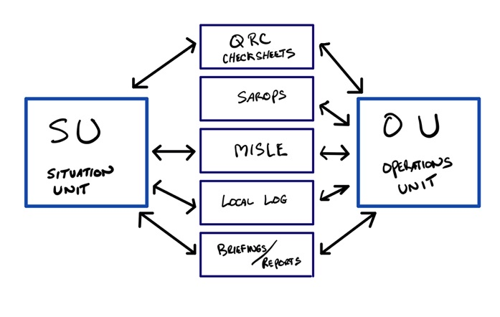
- Topic: IT solutions not aligned with watchstander roles.
- Discussion: Currently, multiple watch standers must jointly edit and utilize the same Five (or more) database solutions causing an overlap of roles and data entry. Routinely watch standers are overlapping tasks or waiting for one person to complete a task before they can start another in the same system. The Operations Unit watch position and the Situation Unit watch position currently both must simultaneously utilize the same isolated tools and verbally coordinate tasks in real time to avoid overlap and duplication of efforts.
Figure 17 IT solutions not aligned with Watch positions

- Topic: Uncoordinated GIS Solutions.
- Discussion: Study and assess current GIS products in use in Command Centers. ADAC understands USCG command centers typically involve a dozen or more websites and one-off GIS products, forcing watch standers to switch between multiple windows and programs increasing the potential for utilization of non-standardized environmental data. These practices make it difficult to coordinate with other units and partner agencies as all involved are looking at different GIS tools and products. The use of multiple resources also makes it difficult to standardize watch routines, to know what sites to check at what times, and have advanced knowledge of critical online resource outages.

- Topic: Study and assess elevated watchstander attrition rates.
- Discussion: The above described redundant recording and data entry procedures and cumbersome or outdated GIS technologies are substantial enough, to potentially impact employee retention. The USCG Operations Specialist Rate, 65-70% of which are Sector and District Command Center watch standers, has remained critically understaffed for the last 12 years and currently brings the Coast Guard’s highest reenlistment bonuses.

- Investigate and Develop Potential Solution Designs. These include the following topics and associated discussions:
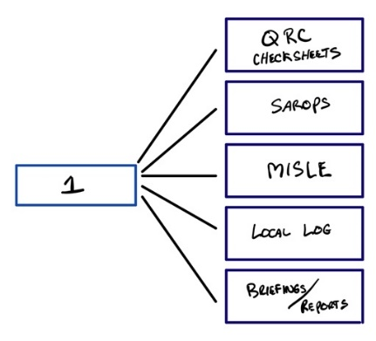
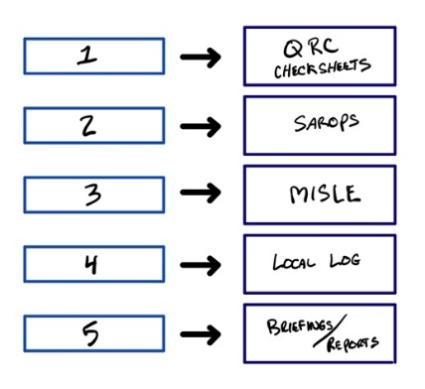

Figure 18 Future one data entry point that feeds other systems

Figure 19 Current stovepipe IT and duplicated data entry

- Topic: Coordinated mission planning.
- Discussion: Study and design coordinated mission planning and data solutions that eliminate redundancy by pulling from a singular database will increase time available for risk assessment and detailed mission planning during high op-tempo response operations. Storing and retrieving information from one place increases accuracy and eliminates the need for de-conflicting desperate information.

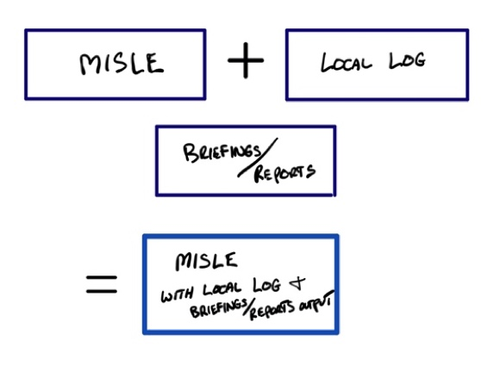
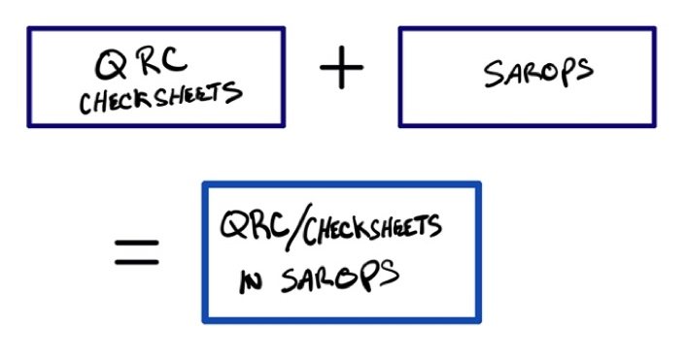

Figure 20 Future QRCs generated inside SAROPS
Figure 21 MISLE + Local Log + Auto-generated briefings/reports

- Topic: Study and assess suitability to Combine IT solutions.
- Discussion: Study and design new IT Solutions that minimize the need for multiple systems by combining and streamlining functionality. The new IT systems should be integrated and have the ability to push or pull database data as required to reduce data entry. The current 5 parallel documentation actions should be eliminated and brought together in two systems, the “Operations Planning Tool” and the “Command Center Database.”
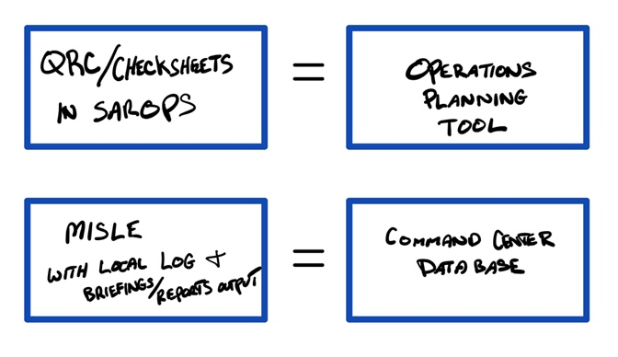

Figure 22 Future SAROPS becomes the Operations Planning Tool and MISLE becomes the Command Center Database

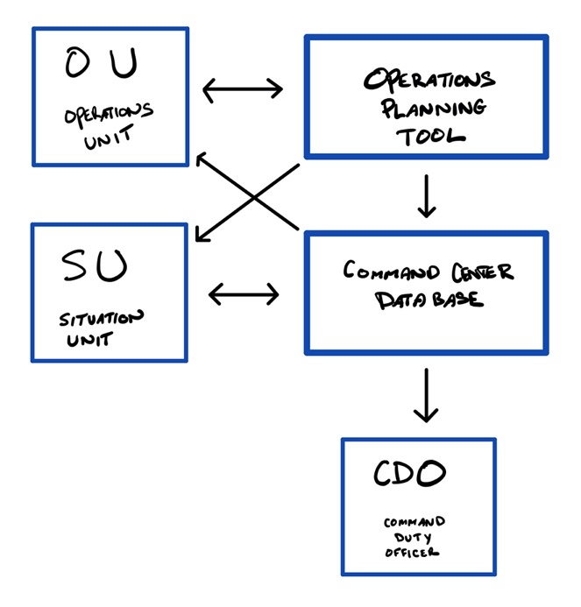
- Topic: Study and assess IT solutions to watchstander roles.
- Discussion: Study and design new IT Solutions that are designed around common watchstander tasks and provide logical information pathways and frameworks for efficient data exchange. In this example, The OU enters data through electronic QRC forms embedded into the Operations Planning Tool (OPT) during the initial stages of an incident. That data is used to quickly plan the initial response and also auto-populate data requirements in the Command Center Database (CCDB). The SU can then immediately begin case documentation tasks and complete information requirements while viewing information as it is entered by the OU as it auto-populates in the CCDB. The SU and CDO can then see what information has been gathered in real time and gather additional environmental data (SU) and conduct briefings (CDO) accordingly. The CDO can also immediately pull data fields populated by both the OU (through the OPT) and the SU into the CCDB. In this information model, no duplicate data entry exists and watch standers are not directly populating the same database as often.
Figure 23 Future How new tools would eliminate data entry overlap

- Topic: Study and design a Command Center IT system prototype.
- Discussion: Sector and District Command Center IT shortfalls appear to be largely the result of piecemeal and functionally aligned development, and ownership of those different systems rests with separate USCG systems organizations. As such, dissolving those silos would involve demonstrating the advantages and true potential of a new Command Center IT system approach to USCG Senior Leaders with the ability to direct coordination of such an endeavor, and begin a process that validates the requirements identified in the proposed Working Group.

In sum, identifying End-to-End (E2E) mission needs for Arctic focused USCG Sector and District Command Center IT Systems integration and modernization is the logical first-step in a system development process that has the potential to save lives, time, and money; for the USCG, for Federal, State, and local partners, and for the greater Maritime Community.

Student Participation:
Center leadership plans that available ADAC Fellows will support elements of studies project as part of professional development.

Key Milestones:

Identify requirements for coordinated mission planning and data solutions that eliminate redundancy by pulling from a singular database.

Identify requirements for IT Solutions that minimize the need for multiple systems by combining and streamlining functionality with the ability to push or pull database data as required to reduce data entry.

Identify requirements for IT Solutions that are designed around common watch stander tasks and provide logical information pathways and frameworks for efficient data exchange.

Develop a report detailing USCG Arctic Command Center requirements for next generation integrated Command Center systems suite design and development.

Key Stakeholder Engagement Plan:
If approved, the Co-investigators and ADAC leadership will work with the USCG Project Champion (recommended, CAPT (Ret) Hank Blaney, CG255 and the assigned USCG Project Support members to conduct approved scoping studies on a non-interference basis to USCG, in particular, USCG D17 Sector Anchorage.

Outcomes/Outputs:
The output of these scoping studies will be a knowledge product that provides baseline information, assessments, to include analysis of shortfalls and gaps, designs and relevant recommendations to support internal USCG decision making for command center improvements to meet USCG Arctic mission responsibilities.

Transitions:
Conclusion of scoping studies will be an ADAC provided knowledge product (an analytical research report) for onward USCG decision makers.
Potential programmatic risks to completion:
Research team assesses very low programmatic risk in completing the research/study. Principal concern is gaining adequate access to USCG D17 Sector Anchorage Command Center, albeit concern is mitigated by good working relations between the Center and Sector Anchorage.

THEME 6: Integrated Education

- Education Outreach and Workforce Development Overview;
- PROJECT: Minority Summer Intern (MSI) Program;
- PROJECT: Arctic Summer Internship Program (ASIP). ASIP is an integrated project with Minority Summer Intern (MSI) Program.

- Integrated Education Overview

Education outreach and workforce development is a core mission for ADAC. The intent of ADAC’s education program is to contribute to the next generation of Science, Technology, Engineering, and Mathematics (STEM) professionals for the Homeland Security Enterprise (HSE). ADAC’s geographic focus on the Arctic is unique in the DHS S&T OUP portfolio. The Arctic focused research led by ADAC offers ADAC fellows a variety of unique research and development opportunities to engage with research aimed specifically to respond to the challenges faced by the USCG and other DHS maritime missions operating in the High North. Upon graduation, ADAC fellows will be well suited to provide needed Arctic expertise as future members of the HSE.

The ADAC Fellows program is integral to the Center and associated research projects. During the academic year, ADAC fellows will participate in research and Center led activities, providing students with both technical and professional developmental experiences. ADAC Fellows participate in student research either in individual research projects, or in Center activities during the academic year. Additionally, ADAC fellows participate in two 10-week summer internships throughout the duration of their Fellowship.

In accordance with the DHS S&T OUP Cooperative Grant, the terms and conditions for applying and maintaining, “good standing” while associated with ADAC are rigorous and demanding. The reward for meeting these conditions are fiscal support for studies, professional and technical development through activities conducted as part of the ADAC Fellows program, and mentoring and improved access for graduates seeking a career within the HSE.

The ADAC Fellows program is open to undergraduate, graduate, and advanced graduate students. Currently, the ADAC Fellows program is comprised student research interns engaged in ADAC projects as Workforce Development fellows (WFD). The fellows are funded via the overall DHS S&T OUP Cooperative Grant to the Center. Additionally, ADAC will continue to seek appropriate institutional support funding to support the Center’s education activities in Year 7.

ADAC currently has established fellows at the University of Alaska Anchorage (UAA), University of Texas El Paso (UTEP), and the University of New Hampshire (UNH). In Program Year 7, ADAC will carry over all current ADAC fellows from Program Year 6 until either their two years of programmatic funding is complete, or they graduate from their respective academic program. With that said, all of ADAC’s fellows will graduate from the fellows program by the end of Program Year 7. ADAC’s student recruitment efforts will continue to seek to develop the ADAC Education Program into an ethnic and gender diverse group of student fellows.

Complementing the Fellows program, ADAC plans to host a minimum of two minority students in Program Year 7 to take part in a summer internship during the early spring/summer of 2021. Funding permitting, ADAC will integrate these two minority students with participating Center fellows for the Arctic Summer Intern Program (ASIP), which is discussed in more detail below.

Overall ADAC Fellows Program Schedule and Objectives. In this coming program year, ADAC seeks to continue advancing the Fellows program. Accordingly, the following are the key attributes for ADAC Fellows in Program Year 7. In sum, ADAC Fellows will:

- Participate in professional exchanges with USCG, in particular via the Arctic IoNS and MaLTE workshops, and any corresponding tabletop seminars.
- Accompany ADAC leadership to forums with U.S. Federal enterprises in the greater Anchorage area.
- Attend monthly Fellows meetings with Center leadership. These meetings will include professional mentoring, updates on the HSE and discussion about research efforts conducted by ADAC fellows in their respective ADAC projects and beyond. ADAC will continue to host meetings at UAA and use webinar technologies for students participating remotely. ADAC will invite speakers to provide leadership and career development perspectives oriented to science and technology careers, and/or careers across HSE, to these monthly meetings.

- In collaboration with Project PIs/lead(s) and ADAC Education and Administrative Manager, Fellows will develop individual student research work plans to map out their expected participation and contribution to ADAC’s research projects, or Center led activities. This includes the Arctic Incidence of National Significance (Arctic IoNS) Workshop, and the Medium and Long-Term Environment (MaLTE) Workshop (exact dates still TBD).

- Participate in significant maritime focused forums hosted in Anchorage Alaska. This includes the Arctic IoNS Workshop 2021 (exact dates still TBD), and the Alaska Marine Science Symposium 2021 (exact dates still TBD).

- Participate in an ADAC Summer Internship Program as an option to satisfy one of two required summer research internships. Included in the Summer Internship Program are visits to an array of Anchorage based federal, state, and local agencies associated with the HSE and supporting activities. Also included is a planned Arctic research program at Utqiaġvik (formally known as Barrow), Alaska.

- Integrate two Minority Summer Interns from Minority Serving (MSI) or Significant Minority Enrollment (SME) Institutions to ADAC’s Summer Internship Program.

- Participate (as a program graduate) as desired, in post-graduate mentoring and networking by Center leadership seeking entry into the HSE.

Additional Education Objectives beyond the Fellowship Program. In coordination with ADAC’s constituents at Alaskan Command (ALCOM) and the University of Alaska (UA), in Program Year 7, ADAC seeks to draft and implement an interdisciplinary Masters of Arts (MA) in Arctic Security. The foundation of the degree’s curriculum, where applicable, will be built upon current courses offered through the UA System’s three major universities, the University of Alaska Anchorage, Fairbanks, and Southeast. Drafting for the curriculum will begin during the second half of ADAC’s Program Year 6.

The Program’s curriculum will incorporate topics such as Alaska Native and Indigenous Studies, Arctic Policy and Governance, Arctic environmental sciences, communication, leadership and management, and Arctic operational strategies. ADAC seeks to divide the degree into several topic specific tracks in order to allow and attract a diverse array of students. As such, the degree’s target audience is broad, in that it seeks to attract current military personnel, working professionals, and full-time students. Furthermore, to increase the access and availability of the degree to a wide variety of students, the degree will be offered entirely online. In addition, in Program Year 7, ADAC will pursue the program accreditation process as established by the University of Alaska.

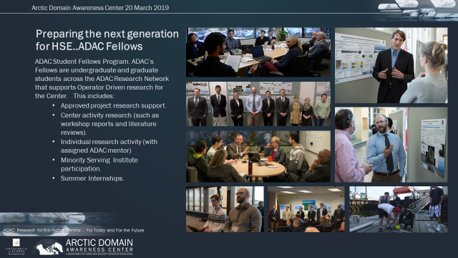
Figure 24 ADAC Fellows Program Overview
Quarterly coordination with DHS S&T UP. ADAC will conduct a program quarterly review with DHS S&T OUP ADAC Program Manager and DHS S&T UP Education Outreach and Workforce Development Program Manager. As discussed in Module 1, ADAC leadership will assess the Education Program in detail during ADAC Quarterly Reviews.

Compliance with DHS S&T UP Workforce development criteria. ADAC leadership (principally through the Center’s Education and Administration Manager) will ensure ADAC complies with the Homeland Security Act of 2002 to provide U.S. citizens training in homeland security-related science and engineering disciplines to maintain U.S. leadership in science and technology.

PROJECT: Minority Serving Institution (MSI) and Significant Minority Enrollment (SME) Summer Internship (MSI).

Project PI: ADAC Education and Administration Manager, Ellee Matthews

Lead Institution: University of Alaska Anchorage

Supporting Team:
- MSI Institutions: University of Texas El Paso (Hispanic)

SME Institutions:
- Texas A&M (Hispanic)
- University of Alaska Anchorage (Native American Indian)
- University of Alaska Fairbanks (Native American Indian)

Project Description:

Abstract: In Program Year 7, ADAC will recruit two student summer interns from under-represented classifications seeking to leverage established partnerships with designated MSI and SME institutions. The ADAC Minority Summer Internship will integrate these two summer interns along with additional participating ADAC fellows for a 2021 ADAC Arctic Summer Intern Program.

ADAC’s Arctic Summer Intern Program (ASIP) is a comprehensive internship conducted at the University of Alaska Anchorage. ADAC’s ASIP will provide students opportunity to visit across multiple U.S. federal agencies with offices in Anchorage, participate in ADAC research conducted at UAA, as well as with ADAC’s research network in Southcentral Alaska, and take part in fieldwork activities throughout the Southcentral region, with a visit to Alaska’s most northern village, Utqiaġvik (formally Barrow) Alaska.

Objective/Purpose: Provide an Arctic focused summer internship program as part of the overall ADAC Fellows program oriented for Minority Serving Institutions, under-represented classifications students and other ADAC Fellows as part of the student program’s overall workforce development to prepare undergraduate and graduate level students for entry into the Homeland Security Enterprise. The specifications in expectations for the project are included in the DHS - ADAC Terms and Conditions for Workforce Development Plan.
Baseline: As part of the ADAC student focus presented under the ADAC Fellows Program, the Center seeks to recruit student summer interns from under-represented classifications. ADAC will advertise the Minority Summer Internship opportunity across ADAC research network (in particular through existing networks with MSI or SMEs), DHS S&T OUP communications, U.S. Arctic Research Commission (USARC), Arctic Research Consortium of the U.S. (ARCUS), and Interagency Arctic Research Policy Committee (IARPC).

Funding permitting, the selected summer research interns will travel to UAA. ASIP will focus on providing students workforce development opportunities in operational capacities that will directly benefit the Department of Homeland Security and its components.

Relevance to DHS: Professionally developing students from under-represented classifications conforms to DHS diversity goals. Integrating visiting interns with ADAC fellows provides synergy and networking opportunities for all students. Visiting students may then seek to apply for a fellowship with ADAC, or seek similar opportunities with other DHS S&T OUP Center of Excellence due to their ASIP experience.

Research Method: Students from under-represented minorities who focus in science, technology, engineering and mathematics (STEM) fields are the most likely candidates to be interested in connecting with many of the projects the Center is pursuing and may be interested in seeking a career associated with the HSE.

Through an Arctic-focused, financially supported summer internship program, ADAC will recruit and connect with students from under-represented minorities. As described in project baseline, ADAC will recruit students via a comprehensive approach with ADAC’s network of MSI and SME institutions.

Visiting students from under-represented minorities participating in the MSI summer program will comply with DHS Approved Safety Plan as coordinated with the University of Alaska Anchorage procedures. In all cases, compliance with DHS approved safety procedures is mandatory for ADAC sponsored academic, government and industry institutions and will be applied in both field and laboratory conditions.

As described in the Education and Workforce Development segment, coaching and mentoring of students from under-represented minorities (and other ADAC fellows) is conducted to provide an overview and to orient these students to careers in government service across the DHS Enterprise .

The University of Alaska Anchorage plans to support the administration of the overall ADAC Fellows program, including the MSI summer internship program, and the overall ADAC Fellows program via institutional support resourcing.

Student Involvement: Program is focused on students from under-represented minorities.

Key Milestones: For Program Year 7, ADAC will conduct the following steps to reach intended goals of the Minority Summer Internships:

- Recruit two students from under-represented minorities to participate in ADAC’s Arctic Summer Intern Program and integrate the MSI students with participating ADAC fellows.
- Outline expectations and opportunities for recruited students by providing advance preparation information and associated materials.
- Recruited students will travel to Anchorage and participate in ADAC’s ASIP. Details of ASIP are available in the associated project segment.

Performance Metrics: Measures of meaningful performance for program success are as follows:

- Recruiting two students from under-represented minorities: Program is considered “Success” when full recruitment goal is achieved. , “Caution” is noted for the program when one student has been successfully recruited. The program will receive a “Failure” mark no students are successfully recruited.

- Visiting minority students who follow-on through a student relationship to a DHS CoE who then successfully graduate and enters into employment with the HSE. Program is considered “Success” when one student takes this path over the duration of the ADAC MSI program.

Outcomes/output: Coached, mentored and professionally developed students from under-represented minorities enter DHS enterprise workforce.

Key Stakeholder Engagement Plan: Students from under-represented minorities will be invited to join other ADAC fellows taking part in the summer internship program in a scheduled summer ADAC “Customer’s and Partner’s” Roundtable as a mentoring and professional development opportunity.

Project Champion: While not designated as Project Champion, DHS S&T UP Education POC reviews the progress of ADAC’s education program on an approximately quarterly basis.
MSI summer internship program progress will be included in ADAC’s quarterly reviews of the Center’s efforts in Education Outreach and Workforce Development with DHS S&T UP Education Outreach and Workforce Development program management.

Transition Plan: As students prepare to graduate, ADAC Education and Administrative Manager supports student career placement into the positions aligned to HSE. Transition plans will continue past lifecycle of grant for tracking and job initiatives.

Potential programmatic risks to completion: None.

PROJECT: ADAC Arctic Summer Intern Program (ASIP). An ADAC Fellow & Minority Student Integrated Summer Intern Program.

Project PI: ADAC Education and Administration Manager, Ellee Matthews
Lead Institution: University of Alaska Anchorage
Supporting Team: Dr. Craig Tweedie, UTEP, Utqiagvik (formerly Barrow) Field team and ADAC Executive Director, Randy Kee, (Exercise lead).
Project Description:
Abstract: In Program Year 7, ADAC will conduct its fourth Arctic Summer Intern Program (ASIP). ADAC’s ASIP will integrate visiting Minority Summer Interns with participating ADAC fellows in a comprehensive orientation and mission focused education experience. ASIP includes visits to U.S. federal agencies based in Anchorage that are concerned with Arctic issues, focused time with ADAC researchers at UAA, visiting time with ADAC’s network of Alaska-based Arctic researchers, field trips to local sites relevant to ADAC’s research mission and interests, individual research concept development to generate new approaches to addressing Science and Technology solutions to USCG Arctic mission needs, and fieldwork experience in Southcentral region of Alaska, as well as Utqiagvik.
The summer internship is focused on recruitment of students from underrepresented minorities. Project specifications of the Minority Student Internship are described in the associated, preceding project segment and included in the DHS - ADAC Terms and Conditions for Workforce Development Plan.

Objective/Purpose: Provide an Arctic focused summer internship program as part of the overall ADAC Fellows program oriented for Minority Serving Institutions, under-represented classifications students and other ADAC Fellows as part of the student program’s overall workforce development to prepare undergraduate and graduate level students for entry into the Homeland Security Enterprise. The specifications in expectations for the project are included in the DHS - ADAC Terms and Conditions for Workforce Development Plan.

Baseline: DHS S&T OUP Cooperative Grant Terms and Conditions require ADAC to develop and conduct two 10-week summer internships for all Center student fellows during their tenure of association with ADAC. Accordingly, ADAC created an innovative Summer Internship program for ADAC fellows and students from underrepresented minorities.
Additionally, the Center seeks to integrate minority students who are awarded paid internships from ADAC’s Minority Summer Intern program to ASIP. Specifically, ADAC has established a project to provide scholarships opportunity for two Minority interns recruited to gain an introduction to Arctic research and the Homeland Security Enterprise (HSE).

Anchorage, Alaska is home to a myriad of U.S. federal field offices focused on Alaska and Arctic Alaska. These field offices are staffed with federal professionals that are either directly or indirectly associated with the Homeland Security Enterprise. Anchorage is also home to many State of Alaska department offices and a number of Arctic-focused Native Alaskan Foundations and Arctic focused commercial enterprises, and a critical seaport, which offer opportunistic education and outreach experiences for ASIP interns. Anchorage’s Joint Base Elmendorf Richardson (JBER) is home to a U.S. Northern Command sub-Unified Command (Alaskan Command) and an array of U.S military forces oriented for the defense of Alaska and power projection into the Pacific region. JBER also hosts U.S. Coast Guard District 17, Sector Anchorage, Alaska’s Department of Military and Veterans Affairs (and the Alaska National Guard) and the Alaska District U.S. Army Corps of Engineers.

ADAC’s leadership team includes a retired USAF General Officer with extensive operational experience, including disaster response and humanitarian assistance missions, plus prior service as a Joint Exercise Director at a U.S. Unified Command. The team additionally includes a retired Coast Guard Petty Officer with twenty years of extensive operational and command center experience with the Center’s primary customer.

University of Alaska (UA) and University of Texas El Paso (UTEP) conduct considerable field research near Utqiagvik, (formerly Barrow) Alaska. Both universities support student activities in this field research. Based on existing logistics, the field teams are well suited to handling up to 5-8 ASIP interns in ADAC Year 7.

ADAC’s ASIP will leverage the attributes of the Anchorage area in a comprehensive introduction to the Arctic challenges faced by government agencies and commercial enterprises. ADAC will leverage the expertise of its staff based in Anchorage to conduct a meaningful guided seminar to facilitate student understandings of the challenges faced by USCG Arctic operators. ADAC will leverage the skills of UAA based researchers to guide students in understanding research oriented to support the Arctic operator. Lastly, ADAC will tap the unique experiences of expert field researchers and established locations at a critical Arctic location to provide students a safe developmental field research experience.

Methodology: ADAC leads planned activity guided by ADAC’s Education Manager that is overseen by the ADAC Executive Director for the Anchorage based portion of the internship program. UTEP and UA Supporting leaders will co-lead the field portion of the internship program and will contribute to an orientation of students at UAA prior to students departing for field activities. ADAC will screen and select a student leadership team to support detailed planning and execution of the program. ADAC will process visiting minority students and participating ADAC fellows into ASIP, and conduct and conclude the program as detailed in schedule and milestones.
Student Involvement: Program is focused on participating ADAC fellows and students from underrepresented minorities.
Key Milestones: For Program Year 7, ADAC will conduct the following for ASIP:
- Recruit two students from underrepresented minorities to participate in the Arctic Summer Intern Program that will also include the participation of other ADAC fellows.
- Outline expectations and opportunities for recruited students, providing advance preparation information and associated materials.
- Funding permitting, support student travel to Anchorage and participation in ADAC’s ASIP.
- Orient students in ADAC’s overall mission, the internship experience, expectations of the program, and safety briefs. Include professional mentoring of government careers in HSE and careers in Arctic-oriented science and technology.
  - The orientation is expected to incorporate 2 days of student activity.
- Engage University researchers associated with ADAC to participate and relay the breadth of Center research efforts and association with other university research enterprises.
  - ADAC Project leads/their designated representatives will present.
  - ADAC will gain overviews from other UA research entities such as UAA Institute of Social and Economic Research, the Institute for Circumpolar Health, UAF’s Matanuska Experimental Farm and Extension Center, the Applied Environmental Research Center, and business ventures such as UAA’s Business Enterprise Institute.
  - ADAC will introduce students to field research conducted in and around the Southcentral Alaska region, as well as sites of critical importance to the Arctic region.
  - The above activities should take approximately 10 days of student activities.
- Depart for ASIP Utqiagvik (Barrow) trip for field research. Team proceeds to Utqiagvik (Barrow) for a ~3-5 day of field-based research and returns to Anchorage.
  - Upon arrival, team participates in overview, safety briefings and orientation, supporting logistics and training on research tasks at hosted site.
  - Team participates in field-based research co-led by UTEP and UAF researchers.
  - Where possible, students will participate in field-based research that supports other ADAC projects. For example, field based testing of LRAUV, and affiliated research being conducted near Utqiagvik by ADAC researchers, including Dr. Tweedie’s storm surge monitoring and modeling project.
  - Total time allotted is approximately 5 days (~2 days for travel and ~3 in the field).
- ADAC UAA team conducts Anchorage area Arctic focused HSE and associated government visits.
  - This activity is 10 days of student activity.
- ASIP Intern Research White Paper development.
  - This activity is 9 days of student research and paper development.
  - Goal is to generate 2-3 Arctic research focused White Papers.
- Interns participate in ADAC Customer’s and Partner’s Roundtable.
- Complete out-process, obtain survey feedback and conclude Internship.

Logistics: ADAC provides funded support to students, and houses students from outside the Anchorage area at UAA student facilities. UTEP and UA Co-research leads will work with ADAC leadership to establish the field-based logistics required for the success of the field-based component of the program. Student workspace is located at ADAC’s office at 1901 Bragaw Street, Anchorage. ADAC does not provide transportation for students for personal matters, but will seek UAA transportation assets for local area visits.
Performance Metrics: Measures of meaningful performance for program success are as follows:
- Recruiting MSI metrics as previously described.

- Executing Outdoor leadership and Field research program 100% safely.

- Collecting feedback from ASIP participants accomplished at end of course survey.

Outcomes/Outputs: Coached, mentored and professionally developed students from both under-represented minorities and other enrolment categories participating in the ADAC Fellows Program enter DHS enterprise workforce enriched with their expertise gained by working through the ASIP experience.

Stakeholder Engagement: Students from under-represented minorities will be invited to join other ADAC fellows taking part in the summer internship program in a scheduled summer ADAC “Customer’s and Partner’s” Roundtable as a mentoring and professional development opportunity. ASIP progress will be included in ADAC’s quarterly reviews of the Center’s efforts in Education Outreach and Workforce Development with DHS S&T OUP Education Outreach and Workforce Development program management.

Transition Plan: As students prepare to graduate, ADAC Education and Administrative Manager supports student career placement into the positions aligned to HSE. Transition plans will continue past lifecycle of grant for tracking and job initiatives.

Potential programmatic risks to completion: Affordable housing at Point Barrow for ASIP. As risk mitigation, ADAC works with NOAA and Sandia National Labs to secure housing.

Appendix A: Acronyms
ACNFS  ADAC  ADCIRC51  AESC  AFP  AI  AIA | Arctic Cap Nowcast/Forecast System  Arctic Domain Awareness Center  Advanced Circulation Model  Arctic Executive Steering Committee  ADAC Fellows Program  Artificial Intelligence  Aleut International Association
AIS  AOOS  AOSC  ARN  ASRC FS  BOEM  BSSN  CAFF  CDG | Automatic Identification System  Alaska Ocean and Observation System  Arctic Oil Spill Calculator  ADAC Research Network  Arctic Slope Regional Corporation Federal Systems  Bureau of Ocean Energy Management  Bering Sea Sub-Network  Conservation of Arctic Flora and Fauna  Career Development Grant
CBP | Customs and Border Protection
C&ES AD  CIS  CFS  CMR | Communications and Educational Support Associate Director  Critical Indicators System  Climate Forecast System  Center for Maritime Research
COE  CONAS  COTS  CFS | Center of Excellence  Community Observing Network for Adaptation and Security  Commercial Off-the-Shelf  Climate Forecast System
DGPS  DHS  DHSEM  DHS S&T OUP  DIPP  DR  E2E | Differential Global Positioning System  Department of Homeland Security  Division of Homeland Security and Emergency Management (State of Alaska) Department of Homeland Security Science & Technology’s Office of University Prgms  Data Information Protection Plan  Disaster Response  End to End
ED  EO&WFDD  ERAU  EO&WFDD  ERMA  ET-Storm Surge | Executive Director  Education Outreach and Workforce Development Director  Embry Riddle Aeronautical University (ERAU)  Education Outreach and Workforce Development Director  Environmental Response Management Application  Extra Tropical Storm Surge
FEMA  FMI  FIST  FTD  FTIR  GoMRI  GNOME | Federal Emergency Management Agency  Finnish Meteorological Institute  Field Information Support Tool  Federal Tribal Designation  Fourier Transform Infrared Spectroscopy  Gulf of Mexico Research Initiative  General NOAA Operational Modeling Environment
HA  HFO  HIOMAS  HIPPA  HYCOM | Humanitarian Assistance  High Fidelity Observer  High-resolution Ice-Ocean Modeling and Assimilation System  Health Insurance Portability and Accountability Act  Hybrid Coordinate Ocean Model
IANA  IARPC  ICECON  IICWG | Indian and Northern Affairs  Interagency Arctic Research Policy Committee  Ice Conditions Index  International Ice Charting Working Group
IMO  InSAR  IONS  JTFN  KTG  LIDAR  LPBK  LRAUV  LWIR | International Maritime Organization  Interferometric Synthetic Aperture Radar  Incidents of National Significance  Joint Task Force North (Canada)  Kestrel Technology Group  Light Detection and Ranging  Local Placed Based Knowledge  Long Range Autonomous Underwater Vehicle  Longwave Infrared
MBARI  MIZMAS  MMA  MDA  MN  MOTR  MSI | Monterey Bay Aquarium Research Institute  Marginal Ice Zone Modeling and Assimilation System  Maine Maritime Academy  Maritime Domain Awareness  Member Node  Maritime Operational Threat Response  Minority Serving Institutions
MXAK | Marine Exchange of Alaska
NAIS  NASA  NCAR  NCEI  NCEP  ND | North American Ice Service  National Aeronautics and Space Administration  National Center for Atmospheric Research  National Centers for Environmental Information  National Center for Environmental Prediction  Nova Dine
NIC  NOAA | National Ice Center  National Oceanic and Atmospheric Administration
NSC  NSF  NWS  OODA  OGCWS  OSA  OUP  ORR  ONR | National Security Cutter  National Science Foundation  National Weather Service  Observe, Orient, Decide and Act  Open Geospatial Consortium Web Service  Open Systems Architecture  Office of University Programs  Office of Response and Restoration  Office of Naval Research
PI  PII  PIOMAS  PM  PMD  POA  PolSAR | Principal Investigator  Personally Identifiable Information  Pan-arctic Ice–Ocean Modeling and Assimilation System  Program Manager  Project Management Director  Port of Anchorage  Polarimetric Synthetic Aperture Radar
RD  RPA  SAR  S&T  SETS  SDI  SME  STCW  SWAN  TAMOC | Research Director  Remotely Piloted Aircraft  Search and Rescue  Science and Technology  Social-Ecological-Technological Systems  Spatial Data Infrastructure  Significant Minority Enrollment  Standards of Training, Certification, and Watchkeeping  Simulating Waves Near Shore  Texas A&M Oil Spill Calculator
TAMU  TRL | Texas A&M University  Technology Readiness Level
UAA | University of Alaska Anchorage
UAF  UAV  UDOP  UNM | University of Alaska Fairbanks  Unmanned Aircraft Vehicle  User-defined Operating Picture  University of New Mexico
UGV | Unmanned Ground Vehicle
USCG  USCG RDC  USGCRP  US MDA | United States Coast Guard  United States Coast Guard Research and Development Center  U.S. Global Change Research Program  United States Maritime Domain Awareness
USN  USNORTHCOM  USV  UTEP  UUV  UW  WHOI | United States Navy  United States Northern Command  Unmanned Surface Vehicle  University of Texas El Paso  Unmanned Underwater Vehicle  University of Washington  Woods Hole Oceanographic Institution

Appendix B. Budgetary Information.

ADAC Program Year 7 Financial Summary

https://coastguardnews.com/coast-guard-icebreaker-rescues-man-aboard-sailboat-trapped-in-arctic-ice/2014/07/13/
http://aosn.mbari.org/TethysDash/
http://aosn.mbari.org/TethysDash/data/daphne/realtime/sbdlogs/2012/201211/20121127T053258/

