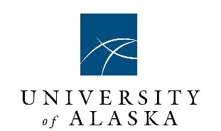

Arctic Domain Awareness Center (ADAC)
A Department of Homeland Security Science and Technology Office of University Programs,
Center for Maritime Research
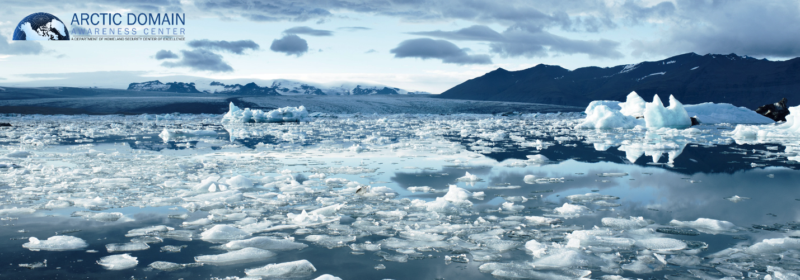
ADAC Mid-Year Performance Report for Program Year 6
1 July 2019–31 January 2020
As/of 31 Jan 2020

Douglas Causey, PhD, Principal Investigator, University of Alaska Anchorage (UAA)
Larry Hinzman, PhD, Research Director, University of Alaska Fairbanks
Randy Kee, Maj Gen (Ret) USAF, MS, Executive Director, UAA
Jason Roe, USCG (Ret), Assistant Director and Senior Research Professional, UAA
Heather Paulsen, MBA, Finance Director, UAA
LuAnn Piccard, MSE, PMP, Project Management Director, UAA
Elizabeth Matthews, MS, Education and Administrative Manager, UAA
Connor Keesecker, Communications and Research Associate, UAA

Table of Contents
I. Introduction: ADAC Program Year 6 Mid-Year Report 2
ADAC Center Activities: 2
II. ADAC Program Year 6 Mid-Year Project Accomplishments 2
Theme 1 – Maritime Risk, Threat Analysis, and Resilience 2
PROJECT: Mitigating the Damage to Arctic Copepods from Surface Oil Spills: When to Apply Dispersants 3
PROJECT: Photo-enhanced toxicity of dispersed and burned crude oil to Arctic mussels 8
PROJECT: Marine Induced Polarization Methods for the Detection and Mapping of Oil in an Arctic Marine Oil Spill; Including Investigation of Oil Within and Under Broken Ice Fields 13
PROJECT: Oil Spill Modeling for Improved Response to Arctic Maritime Spills: The Path Forward 15
Theme 2 – Maritime Domain Awareness 18
PROJECT: Ice Conditions (ICECON) for the Arctic (ARCTICE) 18
PROJECT: The Arctic All-Hazards GIS Platform 21
PROJECT: Arctic Vessel Monitoring Geofencing/Alert Awareness 23
THEME 3 – Maritime Technology Research: 25
PROJECT: Development of Propeller Driven Long Range Autonomous Underwater Vehicle (LRAUV) for Under-Ice Mapping of Oil Spills and Environmental Hazards 26
PROJECT: Arctic-related Incidents of National Significance (Arctic IoNS) Workshop 29
PROJECT: Arctic Medium and Long Term Environment (Arctic MaLTE) Workshop 30
THEME 4 – Integrated Education 32
III. Budget and Justification 35
Year Six Arctic Domain Awareness Center (ADAC) Financial Summary 35
Year Six Budget Analysis – Summary for Center 35

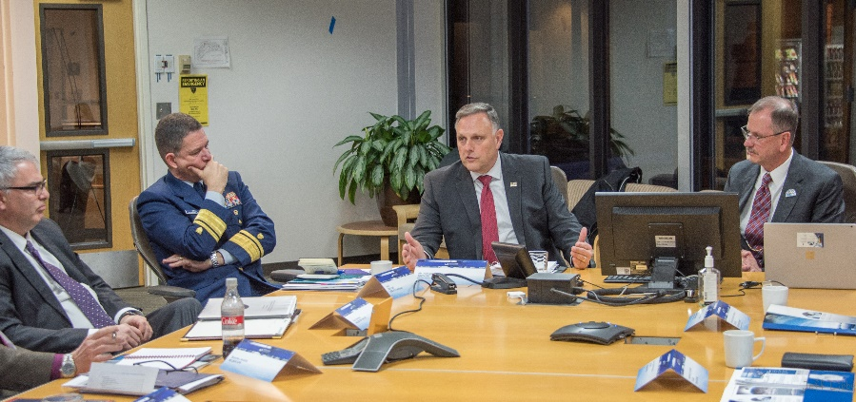
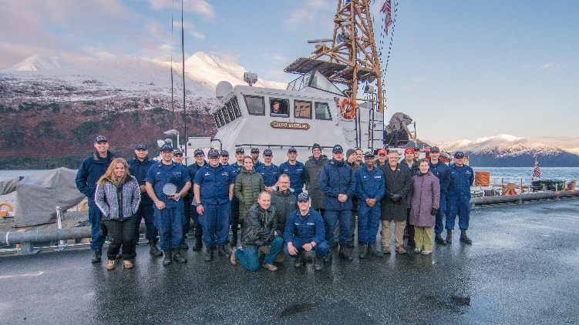
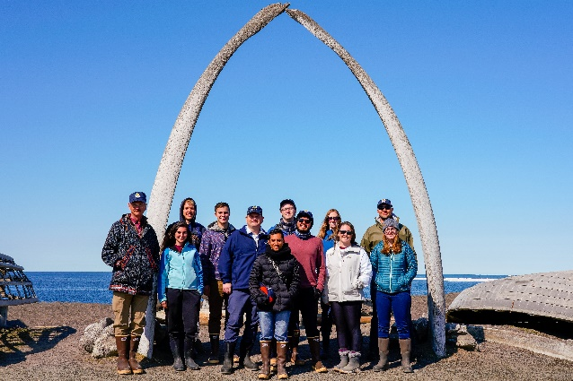
- Introduction: ADAC Program Year 6 Mid-Year Report
The Arctic Domain Awareness Center (ADAC) is a U.S. Department of Homeland Security Science and Technology (S&T) University Programs (DHS S&T UP) Center of Excellence in Maritime Research. In accordance with coordinated and approved DHS S&T UP workplans, ADAC provides relevant science and technology research, development, and support for the U.S. Coast Guard (USCG) as they conduct their statutorily assigned missions in the Arctic.

This following report describes the first portion of project work by ADAC conducted from 1 July 2019 to 31 January 2020. This report reflects overall program and individual projects approved by DHS S&T OUP in ADAC’s Program Year 6 Workplan. Specifically, this ADAC Program Year 6 mid-year report complies with terms and conditions of DHS S&T ADAC Cooperative Agreement to the University of Alaska Anchorage. Lastly, as/of 31 January 2020, ADAC is in coordination with DHS S&T UP Program Management to establish new research projects resulting from the Center’s “Arctic-focused Incidents of National Significance (Arctic IoNS) 2019 workshop and follow-on Request for Proposal (RFP).

Additionally:
- ADAC certifies no Patentable Inventions during the budget period from 1 July 2019 to 31 January 2020.
- ADAC continues to comply with existing Center’s Information Protection Plan and Researcher Safety Plan. ADAC offers no new updates to these existing documents.
ADAC Center Activities: ADAC has provided DHS S&T UP Program Management comprehensive Center updates via weekly meetings. ADAC will provide a full accounting of these activities in the Program Year 6 Annual report on 30 August 2020.

- ADAC Program Year 6 Mid-Year Project Accomplishments

Theme 1 – Maritime Risk, Threat Analysis, and Resilience
- Mitigating the Damage to Arctic Copepods from Surface Oil Spills: When to Apply Dispersants;
- Photo-enhanced toxicity of dispersed and burned crude oil to Arctic mussels;
- Marine Induced Polarization Methods for the Detection and Mapping of Oil in an Arctic Marine Oil Spill, including investigation of Oil within and Under broken ice fields;
- Oil Spill Modeling for Improved Response to Arctic Maritime Spills: The Path Forward;
- PLACEHOLDER TBD: Projects awarded and established responding to funded solicitation from “Stressing the system...managing a complex Arctic crisis” Arctic IoNS 2019 workshop.

PROJECT: Mitigating the Damage to Arctic Copepods from Surface Oil Spills: When to Apply Dispersants
Project Investigators:
Dr. Christoph Aeppli, Bigelow Laboratory for Ocean Sciences.
Dr. David Fields, Bigelow Laboratory for Ocean Sciences.
Project Champion:
CAPT Kirsten Trego, USCG.
Project supporting Investigators/team:
Maura Niemisto, Bigelow Laboratory for Ocean Sciences.
Phoebe Keyes, Bigelow Laboratory for Ocean Sciences.
Lead Institution:
Bigelow Laboratory for Ocean Sciences, East Boothbay, Maine.

Project Mid Program Year 6 status:
In the reporting period, progress was made according to the workplan in Phase I and Phase II.
Phase I: Oil Avoidance of Copepods
In the first phase of this project, we constructed our custom-made copepod observation towers and optimized the videography and water sampling systems (Task 1). The 2-m vertical water columns were equipped with video cameras to quantify the number copepods at three depths using infrared (IR) light. The use of IR light allows us to conduct experiments in the dark. This is essential since the vertical movement of copepods is triggered by visible light. Furthermore, the copepod towers were equipped with temperature and light sensors, as well as sampling ports at 5 horizons for water sampling and subsequent analysis of polycyclic aromatic hydrocarbons (PAHs). Our optimized analytical methods (solid phase microextraction, two-dimensional gas chromatography; SPME-GC×GC-TOF) only requires 20 mL of water sample for analysis of dissolved oil compounds.
After completion of the copepod towers, we first ran control (i.e., no-oil) experiments with wild-caught copepods (Task 2, first part). Copepods of the species Calanus finmarchicus were collected at approx. 100m depth in the Gulf of Maine during their seasonally non-dormant states, which is roughly between April through October. Once collected, these copepods can be kept in the laboratory for approximately one month. Within all control experiments, researchers maintained 85-100 copepods within view of the cameras throughout the experiments, indicating that there was not significant mortality within this time frame. Copepod distribution remained at a stable vertical distribution during control conditions (Task 3; Figure 1).
Researchers then conducted experiments with fresh oil and observed copepod behavior (Task 2, second part). After the addition of oil, the number of copepods in camera view immediately changed. The out-of-view copepods aggregated at the bottom of the water column or were trapped on the oil slick at the top of the column. After approx. 4 hours, the total number of copepods dropped to a relatively stable level of approx. 30% of what we counted before the addition of oil (Task 2). The decline in visible copepods results from of oil avoidance behavior or mortality; experiments in Phase II will determine the exact mechanism.
During each 24-h experiments, water samples sampled were from the five sampling ports at six time points. Chemical analysis was performed to determine the hydrocarbon movement through the water column over the course of experiment (Task 4). A transient PAH gradient established within approx. 2 hours with highest concentrations (total PAHs > 20 µg/L) close to the oil slick. We use this hydrocarbon gradient to study the short-term swimming response of copepods to hydrocarbons.
Overall, results from Tasks 2 to 4 indicate that the copepod towers are suitable to measure impacts of hydrocarbons on the swimming behavior of copepods, and that the presence of ppt-levels of PAHs (i.e., µg/L) of oil induce an immediate response on the vertical position of copepods (within less than an hour). Interestingly, a conventional experimental set-up to determine the mortality of C. finmarchicus copepods typically requires exposure copepods for 96h to a constant concentration of PAHs. Given researcher’s observations of the ability of copepods to vertically migrate, copepods are likely not exposed to such a constant concentration of PAHs in the environment.
Final conclusions and evaluation from Part I (Task 5) will be made after the complete dataset from experiments from Phase II is available (Milestone: June 2020).
Distribution of total copepods observed in each of the three filmed horizons (blue=top, orange=midpoint, gray=bottom) in the tower during a 24-hour control period with no oil present, and total copepods counted overall (yellow). Total abundance remained stable throughout the 24-hour control run.
Distribution of total copepods observed in each of the three filmed horizons (blue=top, orange=midpoint, gray=bottom) in the tower after oil is introduced to the tower (time=0 hr.), and total copepods counted overall (yellow). Total copepod abundance drops by 72% in the first 4 hours and then remains stable.
Phase II: Dispersants & Copepod Contact
Phase II focused on the effect of oil droplets present in the water column on the behavior of copepods. The bulk part of the biological experiments will be performed in April-June 2020, experiments conducted so far aimed to optimize the experimental system and chemically characterize it. Experiments analyzing the influence of dispersants on oil distribution in the water column are completed, and data analysis for this phase is ongoing (Task 6a and Task 7).
While the original experimental plan was to pre-mix oil/water without continued addition of mixing energy during the experiments, a review of preliminary results with our advisory group concluded that constant energy input is necessary. Adding an airstream to the water surface led to a constant concentration of droplets in the water column and a pronounced vertical gradient. This system is suitable to conduct the upcoming copepod experiments (Task 6b).
Phase III: Influence of Stratification:
Researchers made preparations for the experiment to test the influence oil/dispersants on copepods in a stratified water column. Investigators are currently refining a stratified system within the towers (First part of Task 9).
Researchers have equipped the towers with a circulating cooling plate fueled by a water chiller to cool the water column from below. An incandescent red light hangs just above the water surface to warm from the top. Seven hobo-loggers are distributed through the tower at 25cm intervals to collect continuous light and temperature data. Using this system, we have successfully established a stable temperature profile with a temperature difference of 7.8˚C from top to bottom. An established thermocline exists at a depth of around 1.3m. We will continue to refine the system to move the thermocline to shallower depths.

Key Milestones achieved:
As described above, work conducted so far focused on Phase I. Furthermore, the necessary preparations have been made to conduct the planned experiments with copepods in spring 2020 (once the copepods are no longer in a dormant state).

Milestone Completion Comment / Plan
- Phase I: Oil avoidance of copepods 78% in progress
  - Task 1: Copepod tower construction & optimization 100% completed
  - Presentation to Advisory group; decision to go forward 100% completed
  - Task 2: Three experiments with and without oil 100% completed
  - Task 3: Copepod data evaluation 100% completed
  - Task 4: Chemical analysis & data evaluation 90%
  - Task 5: Manuscript 1: Oil avoidance 0% Q2 2020

- Phase II: Dispersants and copepod contact
  - Task 6a: Experiments with dispersed oil (chemistry) 100% completed

- Phase III: Influence of Stratification
  - Task 9a: Exp. with stratification (chemistry) 20% Q1 2020

Key Milestones remaining:
The items below detail four deviations relative to the year-6 workplan necessitated by earlier-than-normal dormant copepods. The workplan changes and resultant extended timeline can be accommodated via a two-month no-cost extension applied to the project. The extension will allow time for spring copepod sampling to supply the active copepods required for these experiments. Proposed new end of research activities: October 2020 (original: August 2020).
- Researchers split Task 6 into two parts: 6a, focusing on the chemical characterization of the system without copepods, and Task 6b, which includes the experiments with the copepods. This change was necessary since in fall 2019 copepods went dormant sooner than expected. This prevented investigators from completing up Task 6 experiments. Accordingly, Task 6b will be completed in April-June 2020.

- In order to accommodate the changes related to Task 6, the corresponding research tasks are planned to be moved to Phase-III related milestones from April/May 2020 to August/September 2020.

- The project started with a two-month delay as originally envisioned. It is planned to add a two-month no-cost extension at the end of the project to make up for this delay (projected end: October 2020, rather than August 2020).

- The team originally planned to recruit summer undergraduate interns in summer 2019. This will now be done for summer 2020, as this will be more useful for the project.
The plan to fulfill the remaining Year-6 milestones is as follows:
- Phase I: oil without dispersants
  - Task 5: Synthesize data, write up manuscript (Milestone: June 2020)
- Phase II: oil with dispersant
  - Task 6b: Perform experiment with copepods (March-May 2020)
  - Task 7: Copepod data evaluation (May-June 2020)
  - Task 8: Chemical analysis and data evaluation (May-June 2020)
- Phase III: oil in a stratified water column
  - Task 9a: Experiments focusing on chemistry (Jan-March 2020)
- Task 9b: Experiments with copepods (May-August 2020)
- Other
  - Advisory group webinar (Spring 2020)
  - Start summer project (May 2020)

Performance Metrics achieved:
The progress on the Metrics outlined in Year-6 workplan is as follows;
- Successful performance review of Tasks 1a-1e from Year 5 by USCG Project Champion and Advisory Committee is required prior to starting Task 2.
  - Completed. The Advisory Group and Project Champion meeting took place, and a revised experimental plan – based on preliminary results – was decided on.
- Successfully perform 8 experiments: with and without oil (2 treatments) in 4 replicates, and record data.
  - 75% Completed. We performed 3 (instead of 4) replicates of each experiments. We plan to run the remaining replicates in April-June, along the experiments from Phase II (when copepods are no longer dormant).
- Evaluate and quality control 100% of the data recorded in Task 2: copepod behavior and chemical data, Prepare one manuscript for publication in a peer-reviewed scientific journal.
  - 75% completed. One replicate per treatment remains, as well as final evaluation and development of manuscript, now planned for April-June 2020.
- Successfully perform 6 experiments: with and without oil/dispersant mixture (2 treatments: control, oil/dispersant), in 3 replicates, and record data.
  - 50% completed. Task 6 was split into Task 6a (chemistry) and Task 6b (copepod). Task 6a was completed, Task 6b will be completed April-June 2020, when copepods are no longer dormant.
- Evaluate and quality control of 100% of data recorded in Task 6.
  - 50% completed. All data evaluation for Task 6a has been completed. Data evaluation of Task 6b will be possible once these experiments have been conducted (April-June 2020).
- Perform 9 experiments with a stratified water column; 3 treatments (control, oil, oil/dispersant), in 3 replicates.
  - 10% completed. Water column stratification optimization has been performed. The copepod experiments are planned for June – September 2020.
- Evaluate and quality control 100% of data recorded in Task 9.
  - Not yet completed. Will be completed once above (Task 9) is accomplished.
Performance Metrics remaining:
Research study species, Calanus finmarchicus, enters a diapause stage in the mid-winter months and cannot be sampled. This precludes investigators’ ability to measure copepod behavior within our system until they become available again in early spring (Tasks 6b and 9b). However, we are continuing to perform chemical analysis on how oil, with and without dispersants, moves through the water column without the presence of copepods (Task 6a). We are analyzing the collected data from experiments in November/December while we finalize our stratification design.
For February, researchers will refine their stratification technique and start oil experiments within this system (Task 9a). Investigator are on track to resume sampling of Calanus starting in early March, which will allow us to take on Task 6b in March/April, followed by analysis of these experiments in May/June (Tasks 7 & 8). Later in the summer, the team will undertake experiments within our stratification system on live copepods in July/August (Task 9b). Team also plans to have a manuscript for Phase I completed in June 2020, as indicated by the Year 6 workplan timeline.

PROJECT: Photo-enhanced toxicity of dispersed and burned crude oil to Arctic mussels
Project Investigator:
Patrick Tomco, PhD, University of Alaska Anchorage.
Project Champion:
LCDR John LaMorte, CG-MER-3.
Project supporting Investigators/team:
Colin McGill, PhD, University of Alaska Anchorage.
Katrina Counihan, PhD, Alaska Sea Life Center.
Phoebe Zito, PhD, University of New Orleans.
Lead Institution:
University of Alaska Anchorage.
Project Students:
Anastasia Hanson (MS in Biological Sciences), University of Alaska Anchorage.
Kevin Fitzpatrick (MS in Interdisciplinary Sciences), University of Alaska Anchorage.
Cameron Carlson (BS in Chemistry), University of Alaska Anchorage.
Project Mid Program Year 6 status:
This project assesses the impact burned vs dispersed crude oil has on marine life and if seasonal sunlight differences change the efficacy of either recovery method. This project began towards the end of Year 5 and is divided into five phases to accurately track the Milestones and Metrics. Currently, our group has completed performing static exposures, dissected all tissues, and is in the process of analyzing tissue and water samples.
Key Milestones achieved:
During program year 6, The following Milestones from Phase 1 were achieved:
- Team member Counihan (ASLC) constructed exposure chambers in Seward, AK
- Mussels were harvested from Resurrection Bay, AK
- Mussels were acclimated in exposure chambers for 1-2 weeks
- Mussels were dosed with oil, dispersed oil, and burned oil under light and dark conditions.
- Mussels were harvested at 0, 1, 4, and 7 days post-treatment
- Mussels were dissected and tissues archived for Phase 2 and 3
- Water samples were collected and mailed to Team member Zito (UNO).
Researchers have successfully executed Phase 1. Phase 2, 3, and 4 focus on the downstream analytical work and are still in-progress.
From Phase 2, data on hydrogen peroxide formation in hemolymph was collected at ASLC, while TBARS assay data was completed for the first round of samples.
Key Milestones remaining:
The following milestones remain, which focuses on the analytical work and data synthesis:
Milestones anticipated in ADAC Program Year 6:
- Phase 2: Physiological and Biochemical Assays
Team member Counihan (ASLC) will complete the following analyses:
- RNA:DNA ratio in mantle
- Cytochrome P450 in digestive gland
- Heat Shock Protein in gill
- Superoxide dismutase in digestive gland
- Micronuclei in gill
Team member McGill (UAA) will complete the following analyses:
- TBARS assay (last 2 rounds of samples)
- ATP/ADP ratio
- Caspase 3/7

      - Phase 3: Metabolomics
PI Tomco will complete the following:
- Metabolites will be extracted from tissues and archived
- NMR spectral data will be acquired at the University of Alaska Anchorage NMR facility
- Chemical constituencies that correspond to primary metabolites (polar and nonpolar) found in the Human Metabolome Database will be identified
- Concentrations of the identified metabolites will be determined
- Multivariate statistical analysis (PCA) will be performed on binned NMR spectra (i.e. unsupervised metabolomics)

        - Phase 4: Chemical Analyses.
Team member Zito will analyze the chemical composition of aqueous-phase hydrocarbons at the University of New Orleans.
- The dissolved organic carbon (DOC) content of each water sample will be calculated
- The three-dimensional fluorescence character of each water sample will be determined
- Water samples will be pre-concentrated for FT-ICR Mass Spectra collection
- FT-ICR MS data will be collected at the National High Field Magnetic Laboratory in Tallahassee FL
Performance Metrics achieved:
- Metrics achieved for Phase 1 (completed in full):
- Task A: Obtain approved State of Alaska Department of Fish and Game aquatic resource permit for hand collection of Mytillus trossulus in Resurrection Bay
- Task B: Obtain approved hazardous waste disposal and chemical safety approval.
- Task C: Construct 15 exposure chambers. Each capable is suitable for safely containing 50 mussels in 5L seawater and containing oil in the event of a spill.
- Task D: Collect >750 mussels from Resurrection Bay suitable for exposure assessment. Transport to exposure chambers.
- Task E: Successfully acclimate test organisms to exposure chambers. Record data on mortality. Ensure 50 mussels per exposure chamber are acclimated.
- Task F: Successfully collect burn residue from 3 small-scale controlled in-situ burns.
- Task G: Expose collected mussels to 5 conditions: seawater, dispersant, oil, dispersed oil, and burned oil) under 3 light regiments. Organisms are harvested on the defined time intervals and dissected with the tissues archived, masses recorded, and recordings of mortality rates.
        - TBARS Metrics achieved for Phase 2 (in-progress):
24 hour sunlight:
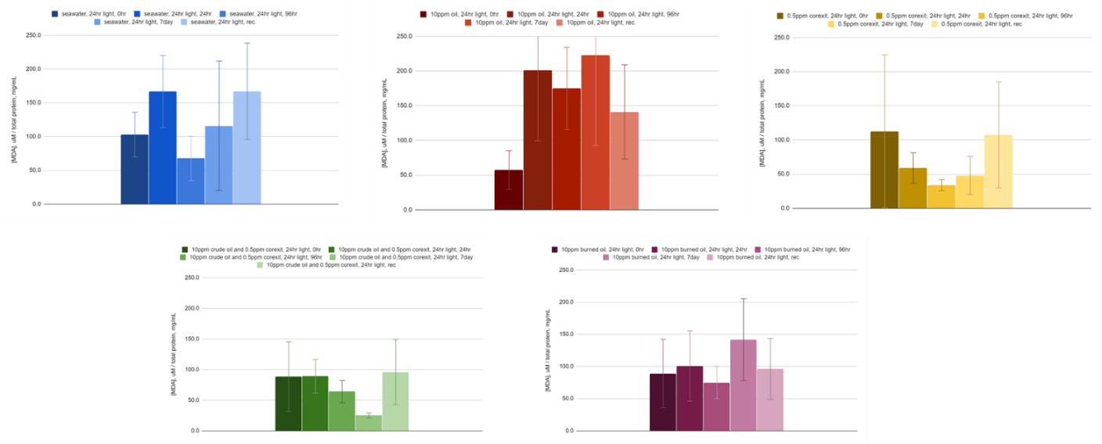
Continuous Dark:
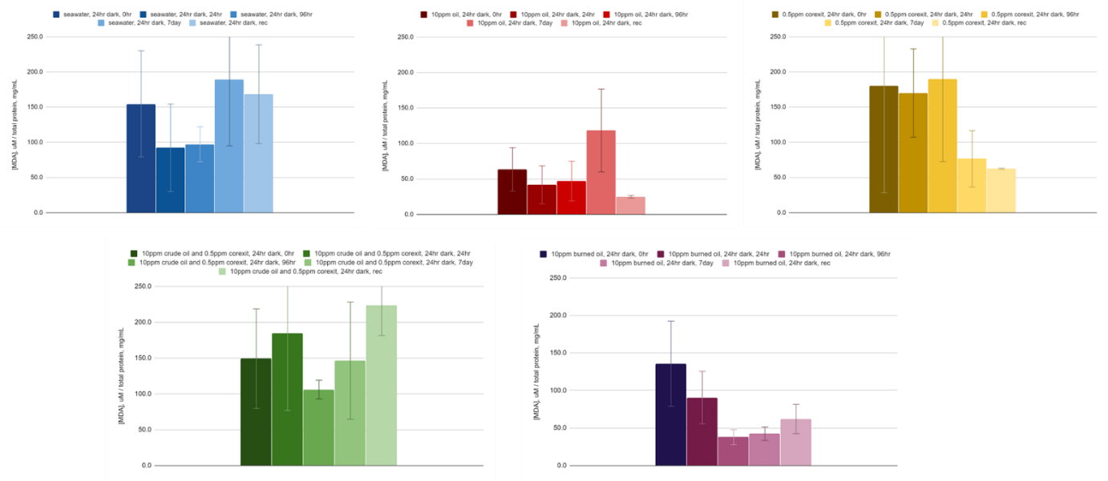
12 hour light/12 hour dark:
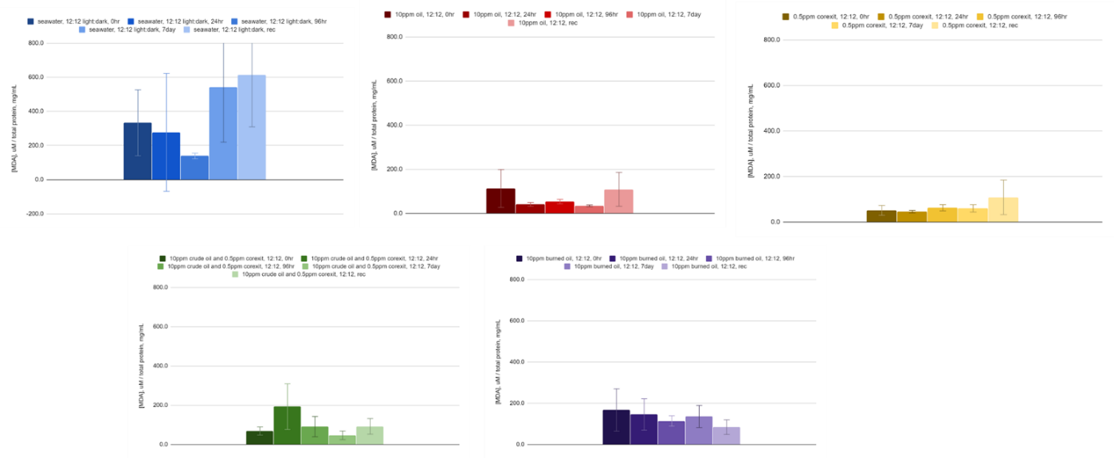
- From Phase 3, three tasks were assigned. Researchers have successfully completed two of them:
- Task A: Documentation of NMR spectra from tissue extracts.
- Task B: Using NMR spectra, identify small molecule metabolites present in tissues based on database matches.
Researchers have been able to document the metabolites relevant to exposure and baseline concentrations in mussel tissues using Nuclear Magnetic Resonance Spectroscopy (NMR):
- Phase 4: Chemical composition of water
Performance Metrics remaining:
The following performance metrics are remaining that researchers plan to accomplish in remaining Program Year 6:
- Phase 2: Biochemical and physiological readings
- Task A1: Documentation of 6 key physiological and biochemical measures of stress using archived tissues at ASLC: RNA: DNA ratio, Cytochrome P450, Heat Shock Protein, Superoxide dismutase, and Micronuclei.
- Task A2: Statistically compare key measures of physiological and biochemical changes between treatments, across time, and between individuals. Counihan to evaluate and quality control the data.
- Task B1: Documentation of 3 key physiological and biochemical measures of stress using archived tissues at UAA: TBARS, ATP/ADP ratio, and caspase 3/7.
- Task B2: Statistically compare key measures of physiological and biochemical changes between treatments, across time, and between individuals. McGill to evaluate and quality control the data.
      - Phase 3: Metabolomics
- Task C: Statistically compare differences in metabolite profiles between treatments, across time, and between individuals. Tomco to evaluate and quality control the data.
      - Phase 4: Team member Zito will analyze the chemical composition of aqueous-phase hydrocarbons at the University of New Orleans.
- Task A: Obtain necessary instrument time permissions for 180 FT-ICR MS samples at the National High Magnetic Field Laboratory.
- Task B: Document dissolved organic carbon concentrations in water samples
- Task C: Document spectrofluorescence and FT-ICR MS data from water samples.
- Task D: Statistically compare differences in DOC, spectrofluorescence and FT-ICR MS data between treatments, across time, and between replicates. Zito to evaluate and quality control the data.
        - Phase 5: Data Synthesis
- Prepare two manuscripts and submit to peer-reviewed journals relating to phase 2/3 and phase 4 of the project. Prepare technical report detailing the project.

PROJECT: Marine Induced Polarization Methods for the Detection and Mapping of Oil in an Arctic Marine Oil Spill; Including Investigation of Oil Within and Under Broken Ice Fields
Project Investigator:
Dr. Socolofsky, Texas A&M University.
Project Champion:
LT Matt Edes, USCG CG-MER.
Project supporting Investigators/team:
Dr. Jeff Wynn, USGS (Ret.).
Kevin Hand, IntelliSense Marine.
Kari Walker, IntelliSense Marine.
Nathan Lamie, Lead Engineer/Facility Operator, CRREL (U.S. Army Corps of Engineers).
Art Wright, Safety & Environmental Coordinator Williamson and Associates.
Mike Williamson, Chief Scientist, Williamson and Associates.
Max Schlereth, Technical Science, Field Lead, Williamson and Associates.
Tim Lewis, Marine Tech, Williamson and Associates.
Lead Institutions:
Texas A&M University.
IntelliSense Marine
CRREL (U.S. Army Corps of Engineers)

Project Mid Program Year 6 status:
The research project continues to make steady progress on Program Year 6 tasks and milestones, including the completion of key deliverables in Program Year Quarters 1 and 2 (Q1-2) which form the building blocks for the exciting ice tank and simulated Arctic environmental testing to follow in the second half of ADAC Program Year 6.
Completion of key milestones increased pace through Q2 which includes the construction, testing, and field trial of Marine IP Open Water cables, integration of transmitter/receivers and additional components into the Marine IP system, and design and testing of the Ice Cable for research to be conducted in Q3. Delivery of key milestones will increase in Q3 and Q4 as will analysis of data compiled throughout the program.
Overall, extensive test data is being compiled and positive conclusions are becoming established consistent with the anticipated research goals for deployment of Marine IP technology in an Arctic environment. Concurrently, a knowledge base of expanded lab data is being collected and analyzed regarding Marine IP’s ability to reliably detect hydrocarbons and operate reliably in ocean and ice-laden marine environments.
Key Milestones achieved:
- Design Ice Cable that can be successfully tested in a simulated ice environment: Complete
- Construct and beach test Open Water Cable: Complete
- Integrate Open Water Cable and transmitters/receivers into Marine IP control system: Complete
- Conduct post-cable integration beach tests: Complete
- Complete open water field tests for the detection of hydrocarbons in sediment: Complete.
- Construct and beach test Ice Cable: Complete
- Integrate Ice Cable and transmitters/receivers into Marine IP control system: Complete.
Key Milestones remaining:
Key Milestones remaining are on schedule as initiated prior to mid-year and are continuing in progress (e.g.: Marine IP spectral signatures); as well as those which are scheduled for completion in Q3 (mainly surrounding the ice tank baseline measurements and testing at CRREL); specifically as follows:
- Determine the spectral signature of selected target contaminants utilizing a Marine IP system: In Progress.
- Conduct preliminary tests at USACE Cold Regions Research Laboratory (CRREL) for tank baseline detection results: Scheduled 10-14 February 2020.
- Conduct ice tank testing of Marine IP in simulated ice conditions: Scheduled 2-6 March 2020.
- Complete preliminary engineering design for specification for Marine IP integration with ROV/AUV operations: Q4.
- Complete data analysis and reporting: Q4.
Performance Metrics achieved:
- Percentage of blind targets found with Marine IP: Q2, Open Water Test; Data processing in progress
- Percentage of known hydrocarbons found at designated test site vs. documented (mapped) contaminant extent: Q2, Open Water Test; Data processing in progress
- Percentage of uptime vs. total active survey time during open-water surveys: Q2, Open Water Test; Data processing in progress.
Performance Metrics remaining:
Metrics which remain to be established are on schedule consistent with the program tasks and milestones, with multiple metrics continuing in data analysis and compilation/reporting stages (e.g.: spectral signatures documentation and quantification of minimum detectible concentrations of polarizable materials).
Multiple metrics are scheduled to be compiled and analyzed with determinations during the ice tank testing phases at the CRREL facility, specifically as follows:
- Document spectral signatures of tested polarizable materials with reliable accuracy: Lab Testing in Progress.
- Quantify minimum detectable concentrations of specified polarizable materials: In Progress.
- Specify distances for minimum concentration detections: In Progress.
- Examine capability of Marine IP to concurrently detect other submerged materials during hydrocarbons surveys: Q3, Open Water Survey Data Processing.
- Determine the capability and effectiveness of detecting oil in broken ice: Q3-Q4, CRREL Testing.
- Determine what concentrations of ice formations (e.g. slush, broken, full ice sheet, etc.) allow effective hydrocarbon detection: Q3-Q4, CRREL.
- Determine the limit of detection in ice formations: Q3-Q4, CRREL.
- Determine size of interstitial space of ice in which petroleum is detectable: Q3-Q4, CRREL.
- Examine if ice formation or interstitial volume affects detectable concentrations: Q3-Q4, CRREL.
- Examine if different types of hydrocarbons affect the ability to detect in broken ice: Q3-Q4, CRREL.

PROJECT: Oil Spill Modeling for Improved Response to Arctic Maritime Spills: The Path Forward
Project Investigator:
Dr. Nancy E. Kinner, University of New Hampshire.
Project Champion:
CAPT Kirsten Trego, USCG.
Project supporting Investigators/team:
Lead Institution:
University of New Hampshire Coastal Response Research Center (CRRC), Center for Spills in the Environment (CSE).
Project Students:
Megan Verfaillie, University of New Hampshire.
Jessica Manning, University of New Hampshire.
Melissa Gloekler, University of New Hampshire.

Project Mid Program Year 6 status:
The objective of this project is to identify the: current state-of-the-art Arctic maritime oil spill response modeling, potential integration of these models, and specific needs to be addressed to obtain models that will be functional and effective in the response time scale to advance the FOSC’s decision making during an incident and improve the experience gained from exercises and drills. As of January 2020, Phases 1 through 3 have been completed and Phase 4 is in progress. Phase 4 includes the formation of Working Groups related to specific response model components/criteria determined during the three-day workshop that took place in Phase 3. The findings from these groups will be used to draft sections of the Knowledge Product that will be developed and integrated into the Knowledge Product in Phase 5 and 6.
The Phase 3 workshop on Arctic maritime spill response modeling included presentations from a variety of oil spill and ice modelers as well as responder perspectives from both the US Coast Guard and Alaska Department of Environmental Conservation. In addition, three breakout group sessions addressed potential Arctic spill scenarios (well blowout under ice, pipeline spill under landfast ice, and a large vessel spill of combinations of oil in the shoulder season) and answered questions related to: responder needs that can be addressed by modeling, limitations of ice in response modeling, observational gaps, and potential updates needed for existing algorithms and process understanding. Following the workshop, the Core Team and Workshop Organizing Committee identified potential topics for Working Groups including understanding of oil-in-ice interactions, new and existing technologies for filling data gaps for modeling, and how to improve visualization and uncertainty when communicating model results.

Key Milestones achieved:
- Phase 3 Milestones Completed/In Progress in Program Year 6:
- Project PI convenes Workshop Organizing Committee (OC) and provides charge to its members (Complete).
- Project PI conducts monthly meetings of OC to solidify workshop objectives, dates/location, & agenda, including speakers, breakout groups, and participants (Complete).
- Project PI leads planning of logistical support for workshop (e.g., venue selection, travel arrangements, audio/video supplies, room arrangements, lodging contracts, participant packet materials) in coordination with ADAC staff (Complete).
- Project PI leads execution of associated workshop in December 2019 (Complete).
- Project PI completes report from workshop including charge to follow-on Working Groups (reviewed and approved by Core Team and OC) (In progress).

      - Phase 4 Milestones Completed/In Progress in Program Year 6:
- Project PI leads formation of Working Groups following the Phase 3 workshop (In progress).
- Working Group Co-lead selection (one of the Co-leads from each group will be from governmental agency) (In progress).
Key Milestones remaining:
- Phase 4 Milestones Remaining:
- Project PI facilitates monthly meetings of the 3-4 Working Groups.
- Project PI facilitates Monthly meetings of Core Team and Working Group Co-leads for cross-coordination.
- Project PI conducts scheduled cross-team Working Group meetings.
- Project PI coordinates drafting of Working Group reports with onward edits provided by Co-leads, reviewed and approved by Working Group members.
Currently, there are no discrepancies with the workplan milestones. The project is progressing on time and on task. Weekly meetings with the Core Team and Workshop OC are scheduled through June 2020. 3-4 Working Group topics will be determined at the next meeting on January 22, 2020 and Working Group selection will begin following this meeting. Once these groups have been determined, monthly meetings will be scheduled and facilitated by the Project PI. These Working Groups will draft reports in time for the Phase 5 two-day workshop as part of Program Year 7.

Performance Metrics achieved:
Performance metrics for this project are all on track and include:
- Is the project on time, based on the schedule set forth in the detailed work plan established between ADAC, the Core Team, and Project PI?
- Are resources (e.g., references, workshop/Working Group participants) being gathered/recruited in sufficient numbers for the project tasks?
- Is the scope of the project adequate or does it need to change to meet unforeseen components that arise in the response modeling?
- Is the quality of the project products acceptable to the Project Champion/Core Team/ADAC? Are the products useful to responders and decision-makers in exercises and spills? Are they advancing the ability to model Arctic oil spills and inform decision-making by an FOSC?
- What actions need to be taken to continue the project/maintain quality/or improve quality?
In Program Year 6, Phase 3 was completed on time and on budget (metrics 1 and 2). Metric 3 is ongoing as suggested literature is compiled in Box and workshop materials are shared on the CRRC website (https://crrc.unh.edu/AMSM_Arctic_Modeling). No changes to scope (metric 4) are required at this time. Metric 5 is not applicable to this project as no products are being developed. No actions are required to satisfy metric 6.
Performance Metrics remaining:
There are no discrepancies with the workplan metrics listed. Metric 3 is ongoing as literature and workshop reports are found/produced. Metric 4 is not applicable to this project as no products are being developed so no planning is required to meet this metric. All reference materials produced have been shared with the Core Team, Workshop OC, and ADAC personnel.

Theme 2 – Maritime Domain Awareness
- Arctic Ice Conditions Index (ARCTICE);

- The Arctic All-Hazards GIS Platform;

- Arctic Vessel Monitoring Geofencing/Alert Awareness;

- PLACEHOLDER TBD: Projects awarded and established responding to funded solicitation from “Stressing the system...managing a complex Arctic crisis” Arctic IoNS 2019 workshop;

PROJECT: Ice Conditions (ICECON) for the Arctic (ARCTICE)
Project Investigator:
Dr. Jifeng Peng, University of Alaska Anchorage.
Project Champion:
CDR Christopher B. Tuckey, USCG.
Project supporting Investigators/team:
Dr. Shawn Butler, University of Alaska Anchorage.
Dr. Jinlun Zhang, University of Washington.
LT Ryan Huebner, U.S. Coast Guard Research & Development Center (RDC).
Kelsey Frazier, University of Alaska Anchorage.
Lead Institution:
University of Alaska Anchorage
Project Mid Program Year 6 status:
The project team has investigated the specifications of Polar Code, especially its Ice Class definitions and the Polar Operational Limit Assessment Risk Indexing System (POLARIS). The team has researched on the correlation between the Polar Class/Baltic Ice Class used by Polar Code, and the American Bureau of Shipping (ABS) Ice Class. A computer code to calculate the POLARIS index from High-resolution Ice-Ocean Modeling and Assimilation System (HIOMAS) has be established by the team. Additionally, researchers continue to advance Great Lakes ICECON per USCG Project Champion and USCG Project Champion Council of Experts, which includes participation of USCG District 9.
Key Milestones achieved:
- Provide and confirm the ARCTICE vessel classification index.
The Polar Code uses the International Association of Classification Society (IACS) Polar Class Unified Requirements and the Finnish-Swedish Ice Class Rules (Baltic Ice Class). The project team has identified the correlation between the Polar Class/Baltic Ice Class and the ABS Ice Class.

- Investigate other national models (in particular, Canadian programs).
The project team has investigated the Arctic Ice Regime Shipping System (AIRSS) as a regulatory standard for ice condition used by the Canadian authority. It is the basis of the POLARIS in the Polar Code and very similar to POLARIS.

- Determine suitable environmental factors.
Following Polar Code POLARIS, the project team used ice types and their area fractions (or partial concentrations) as the environmental parameters.

- Create, then optimize a forecast numeric Arctic ice condition index for Arctic waters.
This milestone is partially completed. A computer code has been developed to generate the POLARIS index for various Polar Class vessels. It still needs automation which the project team is advancing.

- In addition to the ARCTICE goals and objectives, the team is advancing research asks from Council of Experts for Great Lakes version, which includes operating ICECON from NOAA Affiliate AOOS/Axiom and publishing ICECON to USNIC.
  - In late January 2020, Great Lakes ICECON team just received long-awaited Great Lakes ice pressure for data from Canada. While continuing to publish ICECON without ice pressure variable, the team is commencing publishing ICECON data with the pressure variable, and will be able to conduct validation on the ice pressure variable in Project Year 7.
  - As part of transition support, and as requested by USNIC in late Program Year 5, ADAC is arranging UAA transition funds to support Axiom to establish an automated calculation protocol to publish ICECON via AOOS to USNIC, that includes incorporating the current environmental variables and will soon include the new ice pressure Canadian-provided ice pressure variable. This automation computation is planned to commence within the current ice season.
  - Establishing Axiom computed and AOOS published ICECON data utilizes a process similar to transition protocols established with several projects concluded by ADAC in Program Year 5.
  - Integration of the ICECON index to a visualization tool as an aid to vessel mariner planning and underway activities.

- Throughout Program Year 6, UAA researcher, Dr. Butler leading refinement of Apple and Android apps for ICECON and ARCTICE data capture based on D9 and D17 feedback and computational requirements.

Key Milestones remaining:
The reaming milestone for Program Year 6 is to “investigate suitable access” in which researchers will seek acceptable methods to transmit ARCTICE in Arctic conditions. The project team is researching the vessels in the Arctic, their communication capabilities and the challenges such as long distances between ports of call, communication shortfalls, etc. to ensure ease of access to ARCTICE for Arctic mariners;
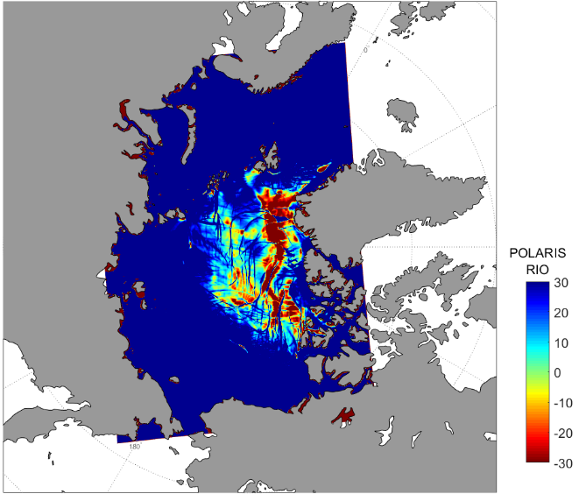

POLARIS index for the Arctic Ocean calculated from HIOMAS Model

Throughout remaining Program Year 6, the Project team will organize and plan 3 additional milestones which are scheduled for Program Year 7:
- Integrate the index to a visualization tool as an aid to vessel mariner planning and underway activities.
- Conduct validation.
- Transition the ARCTICE to an operational/operational support destination. This is likely to be the Axiom/AOOS transition approach to publish ARCTICE as currently in process for ICECON to USNIC. However, in current Program Year 6, ADAC is commencing discussions with Alaska Region National Weather Service (NWS) to also place ARCTICE within the NWS Alaska Region “Arctic Test Bed” for NWS experimentation for onward improvements.

The project team will work towards these milestones accordingly.

Performance Metrics achieved:
The project team is still working towards the 2 performance metrics listed in the project work plan.

Performance Metrics remaining:
      - ARCTICE algorithms provide comparable Bering, Chukchi and Beaufort Sea ice-conditions index accuracy to known accuracy of Canadian ice services within Canadian waters.
The project team is researching for Canadian AIRSS product to compare with the POLARIS product generated by the ADAC team.
      - The ARCTICE algorithms enable accurate Arctic ice condition predictions 65% of the time.
The metric will be evaluated project year 7 after model validation, according to the agreed work plan.

PROJECT: The Arctic All-Hazards GIS Platform
Project Investigator:
Marcus A. Boyd, PhD, University of Maryland.
Project Champion:
Mr. Hank Blaney, USCG.
Project supporting Investigators/team:
Sam Henkin, PhD, University of Maryland.
Joshua House.
Adam Martin.
Lead Institution:
University of Maryland, College Park, Maryland.
Project Students (note, these are not ADAC Fellows, but student assistants recruited via DHS S&T CoE START Emeritus Center):
Katarina Jerman, Penn State University.
Brett Kulka, University of Maryland.
Peter Lay, University of Maryland.
Alejandro Pugh, University of Maryland.
Hilary Sandborn, University of Maryland.
Project Mid Program Year 6 status:
The project is nearing completion based on the goals set forth in the statement of work. The application has been built within the Geospatial Management Office’s (DHS GMO) Geospatial Information Infrastructure (GII). The GII uses Homeland Security Information Network (HSIN) login credentials to allow for ease of access and application management. Only users who have both a HSIN account and have been given access to the Arctic All-Hazards Community of Interest (COI) are able to view the application. When the project is handed over to USCG D17, their watch-standers will have complete control over all aspects of the application including what data to include, what to archive, and who can have access. It is, in short, a geospatial solution that meets the initial needs of USCG D17 to control their own application and its environment.
Researchers took the information gleaned from our initial research into NOAA’s Arctic ERMA application and implemented them in our application. We have removed distracting colors and default to information that will be immediately relevant to the watch-stander.
Researchers continue to work with USCG to gain access to AIS data feeds. The team has access to, and have included, both Blue Force and Blue Force Partner data feeds, but have not been able to incorporate commercial AIS data into the application. The associated Project Champion is aware of this issue and is working within the USCG to determine what is creating the issue. The team has committed to ensuring that the AIS feed will be implemented at whatever point USCG is able to get the feed to us.
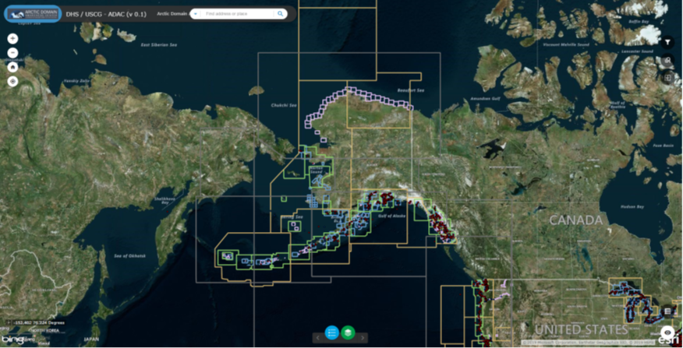
Arctic All-Hazards GIS Platform default screen for the web application
Key Milestones achieved:
- Phase 4 Beta Release: The research team incorporated suggestions and recommendations from the Alpha Release. We underwent load testing with multiple users, tested overall temporal stability with the application working for 12 hours continuously without incident. A full Beta Release has not happened due to the lack of commercial AIS data as noted above.
Key Milestones remaining:
Phase 5: Prep for Final Delivery:
Phase 5 is delayed until USCG is able to get the team access to commercial AIS data. We have been working on training documents and videos that will be used as a part of delivery of Phase 5, but as stated above, we are committed to getting the AIS data into the application before we go live.
Phase 6: Usability Study Report:
Researchers are planning to release submit the Usability Study Report for publication by 28 Feb. 2020.
Performance Metrics achieved:
Development of the User Guide is presently underway. Researchers have decided to include a written document and training videos to help new users better understand the functionality of the application, how to bring in new layers, and how to update the application as needed.
Performance Metrics remaining:
Researchers are awaiting delivery of AIS data from the USCG. Once this occurs we will be able to prep for final delivery. We expect delivery to go smoothly since the application is presently sitting on a U.S. Government server and USCG personnel already have access to the application.
Researcher’s last metric relates to submission of our usability report – adapted to a journal article for publication. We expect this to occur by 28 Feb. 2020. Researchers expect to submit the article to a journal focused on usability studies (e.g. Information Research, The Professional Geographer) or Human-Computer Interaction. Researchers also plan to submit, with USCG, ADAC, and OUP permission, an article to ArcNews a trade magazine published by ESRI Press detailing how ArcGIS and ESRI products have been used to solve government, industry, and/or policy problems.

PROJECT: Arctic Vessel Monitoring Geofencing/Alert Awareness
Project Investigators:
Dr. Shawn Butler, University of Alaska Anchorage.
Buddy Custard, CAPT, USCG (Ret).
Project Champion:
Mr. Hank Blaney, USCG.
Project supporting Investigators/team:
Aaron Poe, Alaska Conservation Foundation.
Ed Page, CAPT, USCG (Ret), Marine Exchange of Alaska.
Lead Institutions:
University of Alaska Anchorage
Alaska Maritime Prevention & Response Network (AMPRN)
Project Students:
Rachelle Lewis, University of Alaska Anchorage.
Raul Reutov, University of Alaska Anchorage.
Jack MacCaslin, University of Alaska Anchorage

Project Mid Program Year 6 status:
The first phase of this project is to gather the US Coast Guard’s geofencing requirements and develop an integration strategy with the All Hazards Web GIS (AHWG) application and CG One View. The project team has evaluated the All Hazards Web GIS application to determine how geofencing might be integrated with the AHWG application, and what additional development is necessary to have a functional geofencing capability. In addition, the team has developed geofencing requirements, and requested additional requirements from the CG One View program manager. In addition to the coast guard’s functional geofencing requirements, it is essential that we sufficiently understand the CG One View architecture and design requirements so that we can seamlessly integrate into CG One View when the project is complete. We are expecting that information shortly.
In addition to the technical specifications, we are in the process of forming an advisory committee that will provide valuable feedback on the specific operator requirements for the USCG D17 planners and operators and include the requirements for the US Coast Guard overall.
As related, while the original plan was to establish Geofence within PACTRACS that supports USCG D17 and Alaska/Arctic mariners, Program Year 6 added the task to accomplish a duplicate process within USCG CG One View. As of mid-year Program Year 6, the PACTRACS edition is functional, while the USCG CG One View edition is in development with HQ USCG CG One View program manager, supported by the HQ USCG Project Champion. Current accomplishments include:
- Alaska Marine Exchange successfully monitoring PACTRACS Geofence around Pribilof and St. Paul Islands.
- Continued testing and evaluation of PACTRACS dynamic Geofence (which is underway) by Alaska Marine Exchange.
- Project team working to refine PACTRACS alerts process to include visual alerts in addition to Email alerts.
- Dr. Butler coordinating with USCG Sector Anchorage Command Center for updated Geofencing requirements and potential uses for CG One View.

Key Milestones achieved:
- Developed Ozone Widget framework to develop basic geofencing capability.
- Conducted test notification and alerts with agencies and coastal communities.
- Created geofence tools and transitioned within PACTRACS.
- Evaluated the All Hazards Web GIS application for potential integration opportunities and shortfalls.
- Started development of geofencing requirements geofencing/vessel tracking enhancement requirements from USCG stakeholders and Arctic All-Hazards GIS Platform.
- Initiated development of an advisory committee to guide project requirements within CG One View (N/A for PACTRACS edition).
Key Milestones remaining:
Researchers are slightly behind original plan for CG One View edition, due to the difficulties in coordinating with organizations outside of ADAC. Lead times to establish a coordination meeting or responding to email queries to gain and/or confirm USCG desires and/or requirements for CG One View can take several weeks. HQ USCG Project Champion has been invaluable in supporting these coordination requests. Researchers anticipate that once we get most of the information that we need, we will be able to work more efficiently and make better progress on these remaining key milestones:
- Establish a complete set of geofencing requirements; advisory committee approved.
- Develop a geofencing architectural and interface design that will integrate with CG One View.
- Begin development of the CG One View with geofencing capability integrated.
Performance Metrics achieved:
- Engaged stakeholders for inputs to PACTRACS edition.
- Conduct design and documentation of system architecture, use cases, and test cases (for PACTRACS edition).
- Established features and use cases for PACTRACS edition.
- Conducted synthetic test cases (simulated vessel movements or other automated tests) for PACTRACS edition.
Performance Metrics remaining:
- Stakeholders that accept requirements specifications.
- Successful customer acceptance tests.
- Archival ability of created Geofences to support routine use-cases.
- Number and impact of peer-reviewed publications/presentations.
- Geofencing application that can be easily integrated with CG One View.

THEME 3 – Maritime Technology Research:
- Propeller Driven Long Range Autonomous Underwater Vehicle (LRAUV) for Under-Ice Mapping of Oil Spills and Environmental Hazards (Continuation Project);
- Arctic-related Incidents of National Significance (Arctic IoNS) Workshop;
- Arctic Medium and Long Term Environment (Arctic MaLTE) Workshop;
- PLACEHOLDER TBD: Projects awarded and established responding to funded solicitation from “Stressing the system...managing a complex Arctic crisis” Arctic IoNS 2019 workshop.

PROJECT: Development of Propeller Driven Long Range Autonomous Underwater Vehicle (LRAUV) for Under-Ice Mapping of Oil Spills and Environmental Hazards
Project Investigators:
Dr. James Bellingham, Woods Hole Oceanographic Institution (WHOI).
Amy Kukulya, Woods Hole Oceanographic Institution (WHOI).
Brett Hobson, Monterey Bay Aquarium Research Institution (MBARI).
Project Champion:
CAPT Kirsten Trego, USCG.
Project supporting Investigators/team:
Brian Kieft, Monterey Bay Aquarium Research Institution (MBARI).
Sean Whelan, Woods Hole Oceanographic Institution (WHOI).
Daniel Gomez-Ibanez, Woods Hole Oceanographic Institution (WHOI).
Noa Yoder, Woods Hole Oceanographic Institution (WHOI).
Amanda Besaw, Woods Hole Oceanographic Institution (WHOI).
Manyu Belani, Woods Hole Oceanographic Institution (WHOI).
Lead Institutions:
Woods Hole Oceanographic Institution (WHOI).
Monterey Bay Aquarium Research Institution (MBARI)

Project Mid Program Year 6 status:
During the summer, the WHOI/MBARI team followed up our June 2019 oil seeps experiment with a second field exercise in Santa Barbara. The exercise was a collaborate exercise to simulate raid response to an oil spill and included a team from EPA, NOAA, USCG participating aboard the USCG buoy tender, George Cobb. LRAUV’s role in the collaborative exercise was to use its long-term operational capability to map the seeps area to quickly and efficiently detect areas of high and low oil concentrations using its onboard mapping software and SeaOwl sensor. LRAUV Polaris was deployed from a pier and conducted around the clock surveys for six days operating around the clock informing the team aboard the Cobb and shore side where to survey each day during their response exercise. The following list gives a more details of our testing objectives and results:
- During this test, researchers deployed LRAUV from shore, without a vessel using a pier fish crane. Using an IPAD, researchers sent the vehicle on a preliminary search mission to map out areas known to be near source points. The goal was to do a broad search of the area by conducting yo-yo’s from 1 meter to 35 meters looking for elevated detections from the SeaOwl while creating an apriority map. Meanwhile, the team readied the two REMUS AUV’s and loaded out the USCG George Cobb each day for field operations. LRAUV was monitored from shore and data was passed via either a web-based portal or via cellphone. The team aboard the Cobb, deployed the Arctic Gateway Buoy which was to be used as the data relay for LRAUV back to command control (shore-side). During these tests, the team was not going to use the buoy as a dock, nor would a second buoy with a transponder be deployed due to prioritizing tasks and limited time on site.
- The SB seeps-2 exercise was not a planned mission as part of the DHS LRAUV project, but merely an opportunity to further test the oil plume tracking algorithms, data relay from the buoy, the ability to send commands to and from the buoy to both the LRAUV and command control, as well as showing the utility of LRAUV to swim around the clock with minimal support and no need for a ship.
- LRAUV was able to reliably test its systems while informing command and first responders of where oil was and was not therefore saving people, ship and vehicle time while deploying other oil spill response kit and freeing the ship up.
The researcher team also has been conducting a full system evaluation, inclusive of auxiliary gear and buoys, in order to review low cost manufacturing and design improvements for Build-2 and future builds. The team has implemented PDM tools consisting of Autodesk Vault and WHOI Roundabout for tracking current and future inventory and allowing time and cost savings for Build-2 ordering and manufacturing. Autodesk Vault enables revision control on drawings and documentation related to the build. With these tools in place, WHOI researchers have all mechanical drawings as well as ordering information for the entire LRAUV platform. Build instructions will be created to augment what MBARI currently has available.
Key Milestones achieved:
- The team conducted a review of the LRAUV mechanical build and is currently reviewing electrical systems for updates and improvements with an emphasis on performance and cost savings. The team reviewed design materials and acquisition of materials in accordance with revalidated LRAUV bill of materials.
- The team achieved successful underwater docking and undocking to a transponder.
- The team developed add on- second dock capability.
- The team conducted rapid response oil exercise at SB Seeps (August, 2019).
- Researchers modified one of three buoys for optimal docking and have a kit to change buoys frequencies between high and low depending on mission objectives
- Researchers performed offshore testing of vehicle docking and simulated under-ice behaviors.
- Developed firmware for buoys for subsurface capabilities (USBL, ACOMMS)
- Conducted further evaluation COTS sensor packages (split beam, multi-beam, methane, optics); (This was conducted at WHOI) Purchased new sensors
- Developed PDM tools and procedures for LRAUV Build-2 using Vault and WHOI Roundabout. Released all mechanical drawings except those identified to be candidates for low cost manufacturing
- Evaluated end of life parts and LRAUV system for improvements and manufacturing. Internal battery charger system will be redesigned to be more efficient and will also increase battery capacity.
- The team held a transition meeting with the ADAC Executive team and Brian Dolph from USCG RDC in October 2019 in Woods Hole MA
- Planned logistics for New England region under-ice test in an ice covered lake in Northern Maine to be conducted approximately 6-12 February 2020.
- Planned logistics for under-ice testing of Polaris in Lake Superior in late March (dates pending at 20 March- 3 April 2020) hosted by the Great Lakes Research Center
- Designed a davit LARS for our low-cost WHOI vessel for launch and recover of LRAUV and integrated a center lifting bail for launch and recovery versatility
- Developed WHOI operational DASH for operating LRAUV from inside WHOI https://lrauv.whoi.edu/#/
Key Milestones remaining:
- Provide reduced cost design where applicable, which is currently in progress.
- Project team will initiate subcomponent assembly and fabrication of LRAUV (to be concluded in Program Year 7). Project team will conclude approximately 50 percent of fabrication by 30 June.
- Complete development of long-base-line navigation for LRAUV to be able to map the seafloor with sonar/cameras.
- Prepare for Pt Barrow Summer Tests (conducted in July 2020).
- Conduct three more transition meetings remain with USCG.
- Participate in North Slope table top exercise, in March 2020.
- Prepare shipment to Barrow for summer 2020 operations.
- Procure sonar and design/build new payload for platform.
Performance Metrics achieved:
- Modification of Tethys platform in mechanical and electrical engineering to integrate separate oil sensor package to accomplish detection level of oil: measured in terms of minimum sensitivity Target: < 80 ppb.
- Modification and design improvements for Tethys platform to meet specified AUV range and endurance: Target: 300 km on secondary batteries, twice that on primary.
- Modification and design improvements for Tethys platform to integrate mapping algorithm for adaptive sampling performance- mapping of spill extent: Target: Area coverage 1000 km2 per vehicle deployment.
- Each Arctic buoy will be able to communicate position data via acoustics up </= 5 Km distance per buoy to undersea vehicle (please note two buoys navigation solutions are needed for a valid fix).
- Position updates from the LRAUV will be pushed to the Arctic buoys and then relayed back to command control (topside laptop anywhere in the world).
- LRAUV will be able to line capture or dock to a fixed beacon with its USBL and capture nose assembly. Target=50% success

PROJECT: Arctic-related Incidents of National Significance (Arctic IoNS) Workshop
Project Investigator:
ADAC Executive Director, Randy “Church” Kee, Maj Gen, USAF, (Ret), UAA
Project Champions (for Arctic IoNS 2020):
CDR Meredith Gillman, USCG D17
Phil Thorne, CAPT, USCG (ret), USCG D17
Project supporting Investigators/team:
ADAC Assistant Director & Senior Research Professional, Jason “Olaf” Roe, USCG (Ret), UAA
ADAC Finance Director, Heather Paulsen, MBA, UAA.
ADAC Education and Administration Manager, Elizabeth Matthews, MAS, UAA.
Lead Institution:
University of Alaska Anchorage
Project Students:
ADAC Fellows provide preparation and administrative support.

Project Mid Program Year 6 status:
ADAC planning one Arctic-related Incidents of National Significance (IoNS) workshop for this program year in close coordination with USCG District 17. The workshop shall consist of a tabletop exercise response to two separate commercial-aircraft mishaps involving long-range multiagency coordination in remote Alaskan environments. One scenario involves an in-flight emergency that requires a large commercial aircraft to conduct an emergency landing at a remote Aleutian airstrip. The aircraft lands, but skids off the runway, severely damaging the aircraft and injuring crew and passengers. The other scenario involves an In-flight emergency requiring a large commercial aircraft to make a forced landing on the Polar ice cap 400 nautical miles (NM) north of the Alaska coastline. The aircraft is destroyed, but there were survivors who require rescue, as well as fatalities.
Key Milestones achieved:
- Worked closely with DHS, USCG and Canadian counterparts on the workshop scenario.
- Conducted research to identify the universe of SMEs (international, domestic, in/out government, etc.); conduct research to determine what research is underway to address the likely challenges posed by the scenario and those challenges most relevant to USCG.
- Organized workshop via securing facility, developing agenda.
Key Milestones remaining:
- Organize via inviting participants.
- Complete workshop participants’ selection;
- Complete workshop participants’ invitations;
- Complete logistics arrangements;
- Complete workshop announcement;
- Complete workshop program.
- Make a determination to identify appropriate SME speakers to discuss relevant research activities across disciplines that likely address USCG challenges relevant to the scenario.
- Design exercise cells and guided simulation to support a USCG-led unified command response to address the simulated crisis.
- Execute workshop.
- Develop report/proceedings and study proposal representing the workshop discussions and submitted to DHS S&T UP and USCG for review
- Publish Rapporteur’s report/proceedings and submit follow-on study proposal to DHS S&T UP and USCG.
Performance Metrics met:
- N/A
Performance Metrics outstanding:
- Planned and conducted workshops that meets USCG D17 Commander Expectations.

PROJECT: Arctic Medium and Long Term Environment (Arctic MaLTE) Workshop
Project Investigator:
ADAC Executive Director, Randy “Church” Kee, Maj Gen, USAF, (Ret), UAA
Project Champion:
Mr. Shannon Jenkins, HQ USCG 5PW Senior Arctic Policy Advisor to the Commandant (SAPA) (for Arctic MaLTE workshop planned for ADAC Program Year 6)
Project supporting Investigators/team:
ADAC Assistant Director & Senior Research Professional, Jason “Olaf” Roe, USCG (Ret), UAA
ADAC Finance Director, Heather Paulsen, MBA, UAA.
ADAC Education and Administration Manager, Elizabeth Matthews, MAS, UAA.
Lead Institution:
University of Alaska Anchorage
Project Students:
ADAC Fellows provide preparation and administrative support.

Project Mid Program Year 6 status:
ADAC Project team is in work with HQ USCG SAPA to create Arctic MaLTE 2020 assessment/workshop (which is tentatively named “Arctic Maritime Horizons”) with planned execution in Mid-May 2020 at University of Alaska Anchorage. This workshop is in development to address of concern in accomplishing strategy, high level goals, policy and planning associated with the Maritime Transportation System of the Bering, Chukchi and Beaufort Sea regions of the U.S. Arctic Extended Economic Zone (EEZ). ADAC has developed an initial plan, conducted coordination meetings with HQ USCG SAPA and HQ USCG Director of Maritime Transportation Systems, and has preserved long lead logistics and is currently awaiting HQ USCG Statement of Work. ADAC plans to extend invitations to a team of researchers, operators and government officials assemble to analyze the preparatory materials to investigate scenarios and plenary discussions to determine needed policy, governance, and science & technology to realize DHS and USCG strategic goals and objectives, corresponding to advancing Arctic Maritime Transportation opportunities within the U.S. Arctic EEZ. ADAC will then publish the findings of the research in a comprehensive report.

Key Milestones achieved:
- N/A (awaiting HQ USCG Statement of Work)
Key Milestones remaining:
- Conducted research to identify the universe of SMEs (international, domestic, in/out government, etc.); conduct research to determine what research is underway to address the likely challenges posed by the scenario and those challenges most relevant to USCG.
- Work closely with DHS, USCG and Canadian counterparts on the workshop scenario (In process).
- Organize workshop (via securing facility, inviting participants, developing agenda etc.).
- Complete workshop participants’ selection;
- Complete workshop participants’ invitations;
- Complete logistics arrangements;
- Complete workshop announcement;
- Complete workshop program.
- Make a determination to identify appropriate SME speakers to discuss relevant research activities across disciplines that likely address USCG challenges relevant to the scenario.
- Design exercise cells and guided simulation to support a USCG-led unified command response to address the simulated crisis.
- Execute workshop.
- Develop report/proceedings and study proposal representing the workshop discussions and submitted to DHS S&T UP and USCG for review.
- Publish Rapporteur’s report/proceedings and submit follow-on study proposal to DHS S&T UP and USCG.
Performance Metrics met:
- N/A
Performance Metrics outstanding:
- Planned and conducted workshops that meets HQ USCG Senior Arctic Policy Advisor to the Commandant.

THEME 4 – Integrated Education
- Education Outreach and Workforce Development Overview;
- PROJECT: Minority Summer Intern (MSI) Program;
- PROJECT: Arctic Summer Internship Program (ASIP). ASIP is an integrated project with Minority Summer Intern (MSI) Program.

PROJECT: ADAC Arctic Summer Intern Program (ASIP): An ADAC Fellow & Minority Student Integrated Summer Intern Program
Project Investigator:
ADAC Education and Administrative Manager, Elizabeth (Ellee) Matthews.
Project Champion:
N/A
Project supporting Investigators/team:
Dr. Craig Tweedie, University of Texas El Paso, Utqiagvik (formerly Barrow) Field team.
ADAC Executive Director, Randy “Church” Kee, Maj Gen, USAF, (Ret), UAA.
ADAC Assistant Director & Senior Research Professional, Jason “Olaf” Roe, USCG (Ret), UAA.
Lead Institution:
University of Alaska Anchorage.
Project Students:
To be finalized for late Program Year 6.
Project Mid Program Year 6 status:
The initial planning has begun for the 2020 Arctic Summer Internship. Currently, the program has tentative dates of June 1-19, with the first orientation week spent in Anchorage, and the following two weeks spent in Utqiagvik (formerly Barrow), Alaska. The ASIP program anticipates 9-11 total students this Program Year: 2 MSI students from UTEP, 4-5 UAA students, 2 from the U.S. Naval Academy, and 1-2 from the U.S. Coast Guard Academy. Participating Staff members will include ADAC’s Executive Director, Church Kee, Education and Administrative Manager, Ellee Matthews, and the Center’s Senior Research Professional and Dr. Craig Tweedie from the University of Texas at El Paso. Accommodations, exact events, and transportation will be confirmed in the coming months.
Key Milestones achieved:
- ADAC has begun recruiting students, while correspondingly preparing recruited students with advanced associated materials and discussions of expectations and opportunities.
Key Milestones remaining:
- Recruit five students from underrepresented minorities to participate in the Arctic Summer Intern Program that will also include the participation of other ADAC fellows.
- Outline expectations and opportunities for recruited students, providing advance preparation information and associated materials.
- Funding permitting, support student travel to Anchorage and participation in ADAC’s ASIP.
- Orient students in ADAC’s overall mission, the internship experience, expectations of the program, safety briefs including both Anchorage and Utqiagvik (Barrow) portions. Include professional mentoring of government careers in HSE and careers in Arctic-oriented science and technology.
- Engage University researchers associated with ADAC to participate and relay the breadth of Center research efforts and association with other university research enterprises.
- Depart for ASIP Utqiagvik (Barrow) trip for field research. Team proceeds to Utqiagvik (Barrow) for a 12-14 day of field-based research and returns to Anchorage.
- ADAC UAA team conducts Anchorage area Arctic focused HSE and associated government visits.
- ASIP Intern Research White Paper development.
- Interns participate in ADAC Customer’s and Partner’s Roundtable.
- Complete out-process, obtain survey feedback and conclude Internship.
Performance Metrics achieved:
- ADAC has one confirmed undergraduate MSI student UTEP participating in ASIP, and is recruiting for additional students.
Performance Metrics remaining:
- Executing Outdoor leadership and Field research program 100% safely.
- Collecting feedback from ASIP participants accomplished at end of course survey.

PROJECT: Minority Serving Institution (MSI) and Significant Minority Enrollment (SME)
Project Investigator(s): ADAC’s Education and Administrative Manager, Elizabeth (Ellee) Matthews
Project Champion: N/A
Project supporting Investigators/team:
- MSI Institutions:
- University of Texas El Paso (Hispanic)
- SME Institutions:
- Texas A&M (Hispanic)
- University of Alaska Anchorage (Alaska Native, Native American Indian)
- University of Alaska Fairbanks (Alaska Native, Native American Indian)
Lead Institution:
University of Alaska Anchorage
Project Students:
This project is entirely student focused. The program currently has one MSI student from the University of Texas at El Paso, Undergraduate Biology student, Hector Dominquez (see additional comments in the following sections).
Project Mid Program Year 6 status:
Overall, in Program Year 6, ADAC has had two student fellows from the MSI Institution, the University of Texas at El Paso (UTEP). These students include Undergraduate Electrical Engineering Student, Daniel Cruz, and Undergraduate Biology Student, Hector Dominguez. Both students have been working with Dr. Craig Tweedie of UTEP on two different projects. Mr. Cruz has been working on a project called “Ruggedized time lapse imager for improved remote sensing of Arctic domain awareness.” On this project, Mr. Cruz has assisted with the development of a rugged custom time-lapse camera for deployment in the field, has developed hardware and software protocol to streamline data acquisition processes, assisted in the development of software and hardware updates, and has developed troubleshooting methods for changes in camera software and hardware. Conversely, Mr. Dominguez has been working on a project called “Validation of a sonar method to classify marine sublittoral habitats in a costal lagoon near Barrow, Alaska.” While on this project, Mr. Dominguez has been trained in GIS, data management, field data collection, sample preparation and analysis, and public presentations of scientific work. Mr. Dominguez has also processed topo-bathy data and generated map products for recent and historical bathymetric sampling of Elson Lagoon, while also exploring the relationship between sonar return signals and benthic biochemical composition.
Both students participated in ADAC’s Arctic Summer Internship Program in 2019, and continued their ADAC Fellowship into the academic year. At the end of the fall 2019 semester, Mr. Cruz graduated from UTEP with a Bachelor’s Degree in Electrical Engineering, and is now pursuing the idea of a Master’s Degree in Electrical Engineering. Mr. Dominguez continues his work with Dr. Tweedie, and may participate in ADAC’s 2020 ASIP as well.
ADAC EAM and ADAC Leadership are working with Dr. Tweedie regarding the potential to bring on an additional MSI student from UTEP, to begin the spring of 2020. This is still to be determined.
Key Milestones achieved:
- No project milestones have been fully completed yet, as Program Year 6’s ASIP remains in the planning stage, to take place during the tentative timeframe of June 1-19, 2020. ADAC EAM is currently working to recruit MSI students to participate in the upcoming internship program, and will outline expectations and opportunities when applicable.
Key Milestones remaining:
- Recruit five students from under-represented minorities to participate in ADAC’s Arctic Summer Internship Program, and integrate the MSI students with participating ADAC fellows.
- Outline expectations and opportunities for recruited students by providing advance preparation information and associated materials.
- Recruited students will travel to Anchorage and participate in ADAC’s ASIP. Details of ASIP are available in the associated project segment.
Performance Metrics achieved:
- Both of the MSI students recruited for ADAC’s Program Year 5 ASIP Program (Hector Dominguez and Daniel Cruz) continued on to participate as DHS CoE student fellows for ADAC throughout the following academic semester (Fall 2019).
Performance Metrics remaining:
- Recruiting five students from under-represented minorities for Program Year 6
- Visiting minority students who follow-on through a student relationship to a DHS CoE who then successfully graduate and enters into employment with the HSE.

- Budget and Justification

Year Six Arctic Domain Awareness Center (ADAC) Financial Summary

Year Six Budget Analysis – Summary for Center
This summary includes all sources of funding (carryforward from Year Five Request, Year Six Work Plan, Workshop, and Supplemental funding) from the Department of Homeland Security (DHS), Science and Technology Directorate (S&T), Office of University Programs (OUP). Projects awarded as a subaward are listed as a contractual object class in the roll up as they are a procurement action on the part of the University of Alaska (UA). The Other object class is noted as to how the money was utilized with an appropriate designee such as “(Reserved Funding)”. Additionally, because of the number of subawards and partners involved in the ADAC Center, the below presented financials are subject to change and noted as such in cases where they may change. This situation is caused because the invoices for the year Six mid-year report review of the budget are due after the December 31, 2019; therefore, in most subaward cases only one invoice is captured from the quarterly invoicing.

Budget Analysis by Object Class:

