 | ADAC Team Member Biography  ADAC PI/Project Lead:  Dr. James Bellingham, Woods Hole Oceanographic Institute | 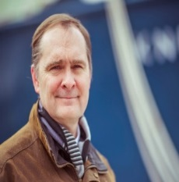
Dr. James G. Bellingham is the founding Director of the Center of Marine Robotics at the Woods Hole Oceanographic Institution (WHOI). He is the Principal Investigator/Project Lead of the Development of Propeller Driven Long Range Autonomous Underwater Vehicle (LRAUV) for under-ice mapping of oil spills and environmental hazards project of the Arctic Domain Awareness Center of Excellence Dr. Bellingham joined WHOI from the Monterey Bay Aquarium Research Institute (MBARI), where he was first Director of Engineering and then Chief Technologist. Prior to MBARI, Dr. Bellingham founded the Autonomous Underwater Vehicles Laboratory at MIT Sea Grant (1988) and co-founded Bluefin Robotics (1997). Bluefin is a Massachusetts-based company that develops, builds and operates autonomous underwater vehicles (AUVs) and was acquired by Battelle in 2005.
Dr. Bellingham’s research activities revolve around creation of autonomous marine robots and their use at sea. He pioneered the development of small, high performance Autonomous Underwater Vehicles (AUVs), resulting in a class of systems which are now widely used within the military, industry and scientific communities. He was instrumental in developing and demonstrating distributed system approaches to ocean observing, leading the Autonomous Ocean Sampling Network program which coupled fleets of AUVs to ocean models to observe and predict ocean conditions. Dr. Bellingham has spent considerable time at sea, leading over 20 AUV expeditions in locations such as the Antarctic, North Atlantic, Mediterranean, South Pacific, and the Arctic. He has served on numerous advisory committees and boards, including Chairing the Naval Research Advisory Committee and serving on several National Academies studies. His awards include the Lockheed Martin Award for Ocean Science and Engineering and the MIT Fourteenth Robert Bruce Wallace lecturer. Dr. Bellingham received an S.B., S.M., and Ph.D. in physics from the Massachusetts Institute of Technology.

 | ADAC Team Member Biography  ADAC PI/Project Lead:  Ms. Amy Kukulya, Woods Hole Oceanographic Institute | 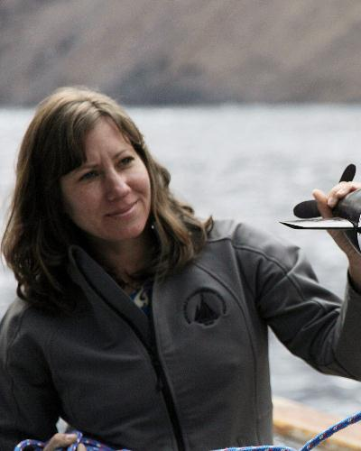
Ms. Amy Kukulya is a Research Engineer at the Woods Hole Oceanographic Institution (WHOI). She serves as the co-Project Lead of the Development of Propeller Driven Long Range Autonomous Underwater Vehicle (LRAUV) for under-ice mapping of oil spills and environmental hazards project of the Arctic Domain Awareness Center of Excellence She is a recognized authority in technical management and operations of autonomous underwater vehicle systems at WHOI. She has either led or participated in over 90 oceanographic expeditions since 2002 from the Arctic to Antarctica.
Her research interests are navigation, acoustic communications, underwater archaeology, three-dimensional tracking of marine animals and under-ice capabilities. Her work focuses on the development of science applications with underwater robots and several of her projects have been featured on Discovery Channel and PBS and in mainstream news. Most recently, Ms. Kukulya led a successful crowd funding campaign to study endangered sea turtles with an AUV and developed a new suction cup tag capability and holds a patent for tracking randomly moving targets. Amy is also passionate about education and outreach initiatives and has been named by the Governor's Office as a Science, Technology, Engineering and Math (STEM) role model in Massachusetts. She holds a B.S. from Rutgers University in Environmental Policy and International Relations and a Certificate in Technical Management from UCLA. Amy has also attended multiple leadership classes at the Harvard Kennedy School of Government.

 | ADAC Team Member Biography  ADAC Co-PI:  Brett Hobson, MBARI | 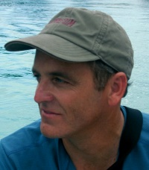

Brett Hobson is an Engineer at the Monterey Bay Aquarium Research Institute (MBARI) and serves as the co-PI of the Development of Propeller Driven Long Range Autonomous Underwater Vehicle (LRAUV) for under-ice mapping of oil spills and environmental hazards project of the Arctic Domain Awareness Center of Excellence. Brett began his ocean engineering career at Deep Ocean Engineering, developing remotely operated and manned submersibles. In 1992, he helped start and run Deep Sea Discoveries where he helped develop and operate deep towed sonar and camera systems offshore the US, Venezuela, Spain and the Philippians. In 1998, he joined Nekton Research in North Carolina to design and deploy bio-inspired underwater vehicles for Navy applications. After the sale of Nekton Research to iRobot in 2005, Hobson joined the Monterey Bay Aquarium Research Institute (MBARI) where he now leads the Long Range Autonomous Underwater Vehicle (LRAUV) program and oversees the development and science operations of six LRAUVs that have clocked over 11,000 hours at sea. Brett also helped develop MBARI’s long-endurance seafloor crawling Benthic Rover that has been working almost continuously for 5 years at a depth of 4km. Brett is currently also a Co-PI on a NSF funded project and has been Co-PI on other large projects funded by NSF, NASA, ONR and DARPA.

