- DHS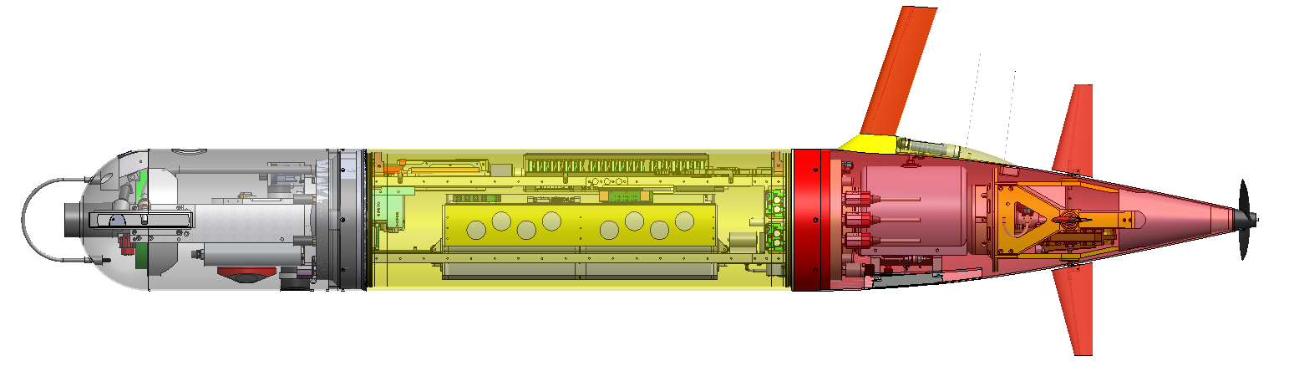
  - Load Control
    - C7 171-232-5 Sparton M2 Compass, Serial #070000270
    - C6 173-232-5 NBOSI CTD, #471 PCB, #390 sensor
    - C5 Open Expansion
    - C4 183-232-12 DUSBL Serial # 106319
    - C3 184-232-12 WET Labs SeaOwl, Serial # 019
    - C2 185-232-12 Aandera O2, Serial #651
    - C1 163-232-Batt-5A Camera/light, Share Port 6 with Optode
    - C0 49-0-0-A/D PAR Serial # 9381
    - B7 169-232-12-5A NALGPS/Iridium, J145GY, IMEI: 300234065452860
    - B6 177-Off-12 Cradlepoint WiFi/3G, Serial #MM170378300423, MAC: 003044268821, IMEI: 353547064362745
        - IP wired: 134.89.13.xx
        - IP cell: 134.89.95.xx
    - B5 161-232-Batt-5A DMON acoustic (future upgrade)
    - B4 SN 69947 3/5/12 Power Converter
    - B3 XXXX 24V Power Converter
    - B2 165-232-24-5A DVL down/ADCP, Serial # 1011, Tx #672910
    - B1 160-232-24-5A DVL up/ADCP, Serial # xxx, Tx #xxx
    - B0 228-0-0-A/D Keller PA-6ST, SN 114
    - A7 151-232-24-5A Micromodem SN (673)
    - A6 152-232-24-5A Line capture motors
    - A5 203-485-Batt-5A EzServo Mass
    - A4 204-485-Batt-5A EzServo Elevator, CSA #WHOI 1
    - A3 205-485-Batt-5A EzServo Rudder, CSA #WHOI 2
    - A2 206-485-Batt-5A EzServo Buoy (5A)
    - A1 207-485-Batt-5A EzServos Thruster (5A)
    - A0 Open Expansion
- Comms
  - Benthos transponder 26/29 kHz , Serial 73803 26/29 kHz
  - Telonics Argos/VHF, # 701359, ID standalone battery powered ,160.785 MHz,
- Notes: MB #69962, Seavent #05901T; 935g in tail, 2530g (2 drop weights) in the nose
Drawing package notes:
Sheet 100221216-08 (connector layout)
No change. I think we can use existing MCBH8F for DMON. On Keenan's
recommended wiring the shield goes up to the bulkhead but then he only
takes 8 wires thru the wet bulkhead-to-bulkhead cable. So I think we can
just order an Impulse MCIL-8-MP - to - 3L10 cable for the DMON.
BH: We can switch to the MKS3-10 on port 1 if required. I have a SST adaptor and am having it drilled and tapped for the 3/8-32 thread.
100221210 sheet 14 (Fwd Internal End Bell)
Corrected bulkhead connector part numbers - add titanium, used subconn
style BH8F part numbers not –FS
BH: Most of the connectors are Impulse, hence the FS (female socket)
Reallocated one spare pair for DMON shield. Labelled DMON pins on port 8.
Labelled pins on NBOSI port 1, match probe sequence.
Improved PAR and Sparton labels.
Improved LF ducer labels to match WHOI/AEL/Acomms/GTI transducer
numbering 1,2,3. Added transducer shield.
100221210 sheet 13 (Fwd section Connector)
Connected NBOSI shield to NBOSI. Rearranged NBOSI pins on 88-pin
connector to match board and probe sequence.
Routed Up-DVL to new LCB board.
Route Sparton to pins 42-45 (was on 79-80)
Route USBL (pins 37-40) to former CTD +12V LCB
route Whisker 24V and 232 to former "Payload" LCB. Make it 24V.
Route uModem xducer to power amp, coproc power
route umodem power and serial to former DAT LCB
Route modem USBL sync from modem to 88-pin connector
route DMON power, serial, transducer
BH: Pulled LCB and assigned serial numbers and updated pg 13i
BH: Fixed NBOSI CTD wiring, redundant and wrong set, changed to 5 pin depth + colors
BH: added a bunch of boxes around cable names to indicate a heat shrink label is required
BH: Removed PPP jumper to MB on ESP; Removed name to make it a generic spare
BH: Changed Whisker LCB power out to a 6 pin (24 v devices)
BH: Changed NBOSI CTD power out to 4 pin (5 v devices)

