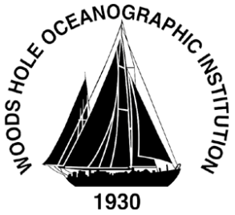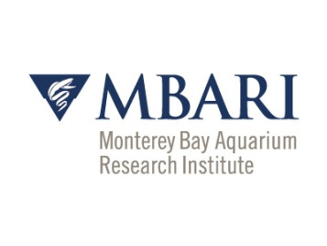

LRAUV Demo
Woods Hole Oceanographic Institution and Monterey Bay Aquarium Research Institute
Thursday, September 27, 2018 09:00-16:00

A G E N D A

09:00 Greeted by Amy Kukulya, Brett Hobson
Meet in MBARI Lobby

09:05 Convene in MBARI Conference Room for a brief on the vehicle water Demo
MBARI Conference Room

09:35 Walk down to the Pier and board the R/V Martin for an orientation, view LRAUV

10:00 Load out and transit 30 minutes to test site

10:30-11:30 Dye Mapping Mission underway, Launch UAV for aerial documentation

11:30 Steam back to MBARI

12:00:13:15 Working Lunch, Debrief in MBARI Conference room, data review, presentation led by Brett Hobson, Amy Kukulya, Jim Bellingham providing overview of vehicle specifications, instrumentation, mission planning, vehicle communications and current capability, vehicle future capability, transition plan, future work

13:15 Open discussion

14:00-15:30 Brett provides vehicle and lab tour, aborts vehicle and is brought back by MBARI's R/V Paragon. Data will be viewed to see if the Sea Owl sensed the dye and data will be plotted in the lab or conference room

16:00 Dismiss

