Long Range Autonomous Underwater Vehicle POLARIS
Deployment to Wreck 1487 Site - 20JAN22

As part of ongoing research for DHS Center of Excellence Arctic Domain Awareness Center (ADAC) to develop a helicopter deployable underwater vehicle that can track oil and other hazards under ice, the team offered Sector Southeastern New England (SENE) an opportunity to gain situational awareness on an oil spill associated with an offshore wreck.
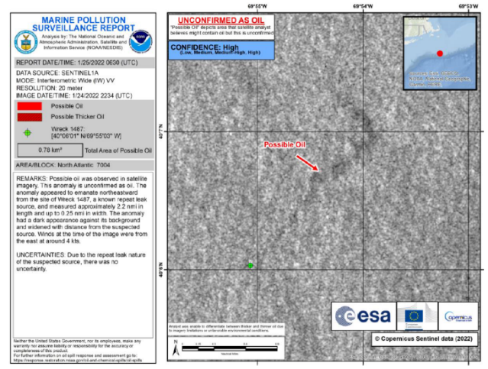
The wreck site, referred to as Wreck 1487, is perceived to be the bow portion of the Motor Vessel NORNESS, a vessel sunk during WWII that is identified as a high priority on NOAA’s Risk Assessment for Potentially Polluting Wrecks. Sector SENE receives approximately 60 marine pollution surveillance reports annually, which are directly connected to the wreck, from NOAA’s National Environmental Satellite, Data, and Information Service (NESDIS).
Figure 1: NOAA NESDIS Marine Pollution Surveillance Report received during the LRAUV survey mission.
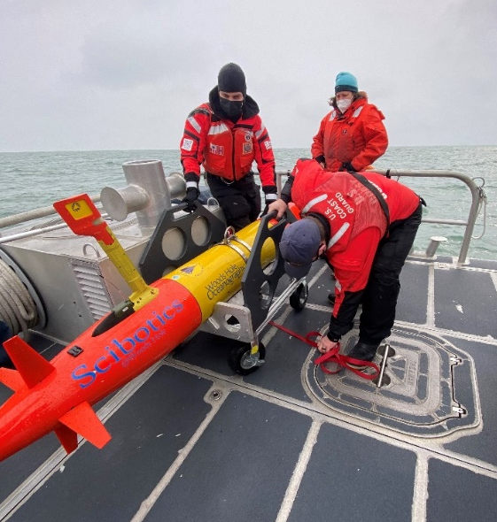
Through Regional Response Team-1, the First Coast Guard District and Sector Southeastern New England partnered with Woods Hole Oceanographic Institution (WHOI), Monterey Aquarium Research Institute (MBARI) and NOAA to utilize a MBARI LRAUV named POLARIS to conduct a 12-day, cost-free survey of opportunity of the wreck. The vehicle’s long range endurance allowed it to transit to the wreck site, located 100nm south of Cape Cod, MA and stay on-scene 5 days collecting data. Outfitted with an oil sensing package, it was able to identify and characterize dissolved hydrocarbons and environmental anomalies, informing decision-making by the FOSC.
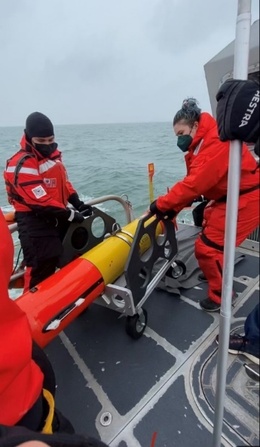
Figure 2: Sector SENE IMD, CG STA Woods Hole, & WHOI preparing POLARIS for deployment from a CG 45-ft RB-M near Cuttyhunk Island.
These efforts were supported by both a NOAA Scientific Support Coordinator (Dr. Willie Whitmore) and NESDIS satellite analysts (Ellen Ramirez and Juan Velasco) who provided real-time weather data and satellite imagery. Leveraging the vehicle’s operational controls, the team was able to quickly adapt the mission based on the areas NOAA identified as high interest for POLARIS to survey.
Figure 3: Sector SENE IMD, STA Woods Hole & WHOI deploying POLARIS.
Sector SENE looks to partner with WHOI during future missions to conduct follow-on site assessments of Wreck 1487 with additional payload instruments, to include imaging systems, to positively identify the wreck as the M/V NORNESS, pinpoint leak sources, and continue to environmentally map the spill site.

