Arctic Domain Awareness Center (ADAC)
A Department of Homeland Security Science and Technology Office of University Programs, Center for Maritime Research
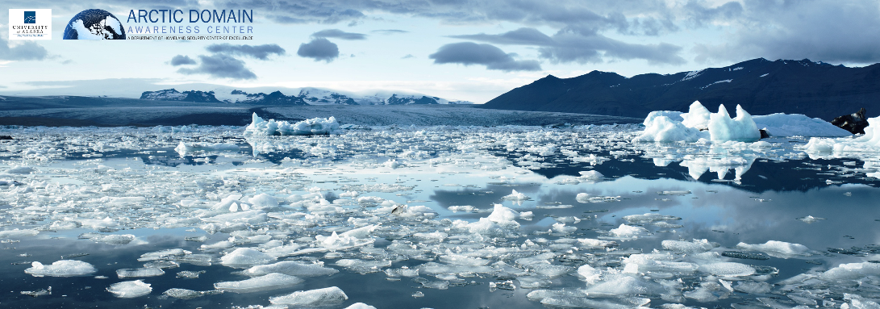
ADAC MBARI and WHOI Concepts of Applications for
The Propeller Driven Long Range Autonomous Underwater Vehicle (LRAUV) System

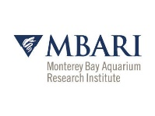
Current Draft As/of 3 April 2020
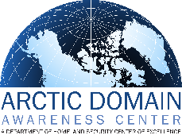

ADAC Leadership and management
Douglas Causey, PhD, Principal Investigator, University of Alaska Anchorage (UAA)
Larry Hinzman, PhD, Research Director, University of Alaska Fairbanks
Randy Kee, Maj Gen (Ret) USAF, MS, Executive Director, UAA
Jason Roe, USCG (Ret), Assistant Director and Senior Research Professional, UAA
Heather Paulsen, MBA, Finance Director, UAA
LuAnn Piccard, MSE, PMP, Project Management Director, UAA
Elizabeth Matthews, MS, Education and Administrative Manager, UAA
Connor Keesecker, MA, Communications and Research Associate, UAA

Project Investigators: Dr. James Bellingham (WHOI), Amy Kukulya (WHOI) and Brett Hobson (MBARI)
Lead Institutions: Woods Hole Oceanographic Institution (WHOI) and Monterey Bay Aquarium Research Institution (MBARI)
LRAUV System Supporting Team:
Brian Kieft, Monterey Bay Aquarium Research Institution (MBARI).
Sean Whelan, Woods Hole Oceanographic Institution (WHOI).
Daniel Gomez-Ibanez, Woods Hole Oceanographic Institution (WHOI).
Noa Yoder, Woods Hole Oceanographic Institution (WHOI).
Amanda Besaw, Woods Hole Oceanographic Institution (WHOI).
Ben Yair Raanan, Monterey Bay Aquarium Research Institution (MBARI)
Overview:
The Arctic Domain Awareness Center (ADAC) is a U.S. Department of Homeland Security, (DHS) Science and Technology (S&T) Directorate’s University Programs, center of excellence in maritime research hosted by the University of Alaska. ADAC was founded in July 2014, underwent reorganization in January 2016 and comprises a research and scientific investigative network across the U.S., with extensive collaboration in Canada and further research connections across the Nordic region.
The U.S. Coast Guard (USCG) is ADAC’s principal customer. ADAC research also supports departments and agencies who support USCG in Federal on-scene response in Arctic maritime regions. As part of DHS S&T UP’s mandate, ADAC is also charged to support the Public Good in an Arctic context. ADAC’s current research collaboration network includes fellow universities, National Research Laboratories and research institutes. In addition to S&T research, ADAC has earned recognized expertise in organizing and convening impactful Arctic focused workshops and symposia, plus innovative education and workforce development at the undergraduate and graduate levels.
Monterey Bay Aquarium Research Institution (MBARI) and Woods Hole Oceanographic Institution (WHOI) are world class centers of marine science and technology. MBARI and WHOI have each contributed considerable technological achievements to create the Propeller Driven Long Range Autonomous Underwater Vehicle (LRAUV) System.

PI Dr. Bellingham’s prior laboratories at MBARI originally created the Tethys platform specifically to carry biological and chemical payloads for long distances and extended durations. The vehicle is small, about 30 cm (12 inches) in diameter, and requires no special handling equipment. Prior deployments ranged from a few days to over three weeks, and conducted without the direct supervision of surface escort vehicles. The longest-range mission to date was over 1,800 km at a speed of 1 meter/second (m/s) off the coast of Moss Landing, California. The vehicle operated as far as 500 km from shore independent of any escort. However, achieving ranges two to three times greater is possible. The vehicle is typically shore-launched and recovered. A small boat can readily be used to tow the vehicle. The Tethys is also helicopter transportable to remote areas, and subsequently hand launched and recovered without special handling equipment.

The Tethys system occupies the design space intermediate between underwater ocean gliders and the current generation of propeller-driven AUVs. Existing ocean gliders such as the Teledyne Webb Slocum, the Scripps Spray, and Kongsberg Seaglider have a sufficient operational range to achieve the desired range goals needed by USCG. However, they do not have the payload capacity or power to carry the chemical and biological sensors that are required, and cannot operate at higher speeds without redesign. Typical gliders operate at speeds of about 0.3 m/s, and utilize a power source equivalent to 1W of energy with minimal power consumption.
In contrast, existing propeller-driven AUVs such as those manufactured by Hydroid, Bluefin, OceanServer, and Teledyne Gavia consume more power, resulting in a shorter endurance. These commercial propeller-driven systems can operate for a period typically up to 24 hours at speed of 1.5 m/s, and providing ranges of less than 130 km. As a result, Tethys is uniquely capable in its combination of payload capacity, range, and endurance for remote under-ice oil detection.
Mission-level control of the Tethys is achieved by using an architecture called ‘state-configured layered-control'. This is an improved variant of the layered control architecture developed by Dr. Bellingham (1991) and implemented on vehicles ranging from Webb gliders to the Dorado AUVs. State-configured layered control supports autonomous adaptive operations for long periods. The software building blocks of the system are behaviors, or control laws, that can be combined to accomplish tasks.
Operators interact with the vehicle via an Iridium satellite link by recovering data snippets in near real-time and sending new mission commands to the vehicle as desired. Communication with the vehicle is possible when it surfaces, and interpreted at operator-determined intervals.
In sum, the research team has developed an under-ice capable, oil detection and mapping payload for MBARI’s Long Range AUV. While we are working to refine the manufacturing process and lower the core platform cost, all of our development effort is going into adapting this platform for the specific application of searching and mapping oil under ice covered seas. While MBARI is considered the inventing agency of Tethys, the high latitude, under-ice, ice buoy, and oil detection capabilities have been funded by DHS S&T through ADAC. WHOI has been critical to the development through leveraging developments of their REMUS AUV, to include docking and onboard systems such as ACOMS as well. Through the skilled interaction of MBARI and WHOI, the LRAUV System project has rapidly accomplished much through leveraging the products of other funded projects and the engineering talent of both organizations.
Purpose:
The following paragraphs provide a series of potential use cases for suitable for the Propeller Driven Long Range Autonomous Underwater Vehicle (LRAUV) System employment by U.S. Coast Guard, in support of U.S. Coast Guard through deployment by non USCG entities and employment of LRAUV System capabilities in Arctic missions that are important and useful to USCG’s statutory missions. LRAUV System was developed through ADAC’s S&T research program via sub award of the associated DHS S&T UP Cooperative Agreement to world class science and technology developers at Monterey Bay Aquarium Research Institute (MBARI) and Woods Hole Oceanographic Institution (WHOI). LRAUV System’s primary purpose is intended to conduct multi-week Under-Ice Mapping of Oil Spills and Environmental Hazards. In addition to the primary purpose, LRAUV System is adaptable and is potentially suitable to conduct an array of additional tasks/missions.
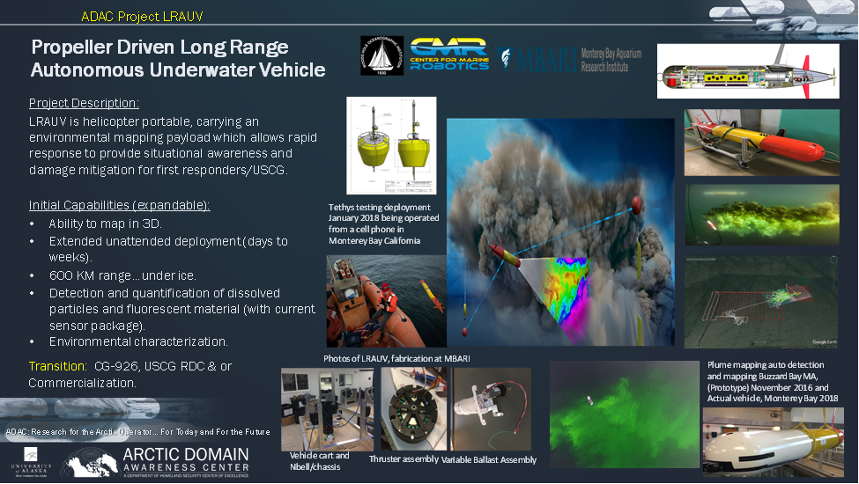
The Rapid response LRAUV System is now in its sixth year of development. Currently the first platform and three Arctic-capable gateway and communication (which is capable to support docking of LRAUV under ice) buoys and all associated software, firmware and training simulation aspects have been fabricated, with a second platform now in development. In addition to the original sensor (SeaOWL ecopuck) specifically oriented to detect dissolved hydrocarbons/oil and other chemical spills, the project team is underway in selecting and integrating a highly capable multibeam sonar for three-dimensional mapping. The project team is also evaluating the Simrad EK-80 Echosounder as yet an additional and highly useful sensor technology for integration to the LRAUV Platform for program Year 7. Details on LRAUV System development can be found in reviewing the associated system reports located at: https://arcticdomainawarenesscenter.org/Library
At the end of ADAC Program Year 7, LRAUV System is scheduled to deliver two platforms (each with SeaOWL Sensor), one multi-beam sonar (capable to be fitted aboard either platform), three Arctic communications buoys capable to dock the LRAUV platform under the ice and allow for an underwater/ice communication relay to command control, a comprehensive series of documented tests, and all associated software, firmware and training and other knowledge products regarding system details. LRAUV System Intellectual Property (IP) remains jointly held by University of Alaska Anchorage, MBARI and WHOI (in accordance with DHS S&T UP-University of Alaska Anchorage ADAC Cooperative Agreement, which has flow down to MBARI and WHOI). DHS and USCG are entitled full access to this IP, free of royalties. To date, there have been no decisions made to commercialize the IP, but the completed system will be suitable for such commercialization.
A key to LRAUV System is the ability for ready deployment without special handling equipment. The platform can be transported by ships, aircraft (fixed or rotary wing), zodiacs, or simply driven to the beach and deployed via the beach or pier. Operating on ice usually requires a simply gantry placed over an access hole, with associated rudimentary block and tackle for ease of getting the platform to and from the ice.
Studies are underway for low cost platform fabrication, and a series of successful tests have been conducted to include initial sea dye tests simulating an oil spill environment, (September 2018) a battery of tests conducted on real world oil seeps in California, (June and August 2019) and under ice tests conducted in a fresh water lake in Northern Maine (February 2020). Due to the unusual low level of lake ice at Lake Superior (and complicated due to the Coronavirus (COVID-19) pandemic) of winter 2020, LRAUV System was unable to conduct large body under ice tests designed to stress navigation and operation systems. In response to COVID-19 and associated State of Alaska and University of Alaska travel within the State of Alaska restrictions, summer Arctic tests planned for Utqiagvik are now on hold until further notice. Following the cessation of travel restrictions, ADAC and LRAUV System researchers will pursue follow-up testing options for Great Lakes and High Latitudes for ADAC Program Year 7.
In general terms (from a planning vantage), LRAUV System is approx. 9 feet in length, 12 inches in diameter and weighs approx. 255 lbs. The vessel speed is approximately 1m/second, can operate in a little as 2 meters water depth and as deep as 300 meters. An approximate endurance is 15 days and an approximate operating range is 600 KM, (preserving ability to then operate in an objective area) and is capable of both propeller driven and wave glider movement “yo-yo profiles (which provides for considerably extended range). Without a mission payload, the LRAUV platform can extend the range by approximately 30%. A set of consumable primary lithium batteries can be used to double the range, at a cost of $16k/deployment.
The platform can communicate with the vehicle agnostic gateway buoys placed on the ice surface, moored to seafloor or adrift in open ocean, with surface antenna to communicate to shore side command and control and subsurface cables/with integrated antennas protruding through the ice to acoustically communicate with the platform. The approximate effective range from communications buoy to platform is approximately 10KM per buoy (based on ocean conditions). Low frequency hydrophone arrays will enable extreme long ranges (400 KM) of vehicle communications leveraging work done by WHOI in the deep water sound channel in the high Arctic.
Two battery types (hi-endurance Lithium and medium endurance non-Lithium) provide power for the platform. In order to achieve maximum operating capability, hi endurance Lithium batteries are preferable, LRAUV’s rechargeable Li-Ion and consumable Lithium primary have aircraft restrictions as identified in International Air Transport Association (IATA),
The LRAUV System platform is capable of communicating directly to the buoy and conduct data transfer in addition to physically docking to the buoy cable. LRAUV System platform has integrated communication capability, Global Positioning System and magnetic compass system Note, in the current configuration, LRAUV System platform does not have integrated inertial navigation system (INS), principally as current technology INUs requires considerable power, correspondingly reducing the platform’s operating range.
If an integrated INS was needed as an alternate configuration for LRAUV, the platform is likely adaptable for such configuration. GPS reception in the Arctic is achievable, but there are challenges with may complicate precision navigation. A brief on-line article in the foot note provides an introductory explanation of the challenges of GPS navigation in the high latitudes (particularly for precision navigation). Note, non-precision navigation capability is generally sufficient in characterizing a spill environment, meaning the on-board capability of LRAUV platform is operationally sufficient for spill response characterization in high latitudes.
In sum, whether or not an INS is placed aboard the LRAUV platform is a matter of offsets and mission needs. If precision navigation is required, then the offset is reduced endurance and range.
Following the discussion of the range of potential use cases/missions that are potentially feasible, suitable and acceptable to DHS and USCG, (and potentially other users) this document contains LRAUV System project description as written in recent ADAC’s associated workplans and reports as a reference annex.

Employment Scenarios:
The following are scenarios of tasks/missions potentially feasible, suitable and acceptable for LRAUV System in both day to day and crisis employment. Note, these scenarios are not yet all-inclusive and will be added to as further deliberation and planning are conducted by ADAC and LRAUV System project personnel in consultation with USCG and other ADAC Customers and Partners.
Overall, an LRAUV System package provides USCG a response package with two platforms, two integrated SeaOWL sensors, an additional/exchangeable multibeam sonar, a planned Echo-sounder and three multi-communication capable Arctic buoys that aid underwater communications, command and control, plus navigation updates to augment autonomous mission tasking. Through leveraging two platforms and three distributed Arctic buoys, LRAUV System can task one platform for wide area marine environmental characterization (using the SeaOWL sensor) while the other platform can focus on fine scale characterization in a specific area with an alternate sensor (such as the multibeam sonar). Data provided by LRAUV system characterizes the marine environment in multiple ways: chemical analytics and mapping of hydrocarbons, (and other chemicals as tuned by the on-board sensors), sampling of ocean environment (such as salinity and temperature) acoustic monitoring using hydrophone arrays (such as marine mammal sounds or other items of acoustic interest like weather events), and mapping of chemicals under ice or mapping of the physical sea bed via multibeam sonar.
In sum, LRAUV System provides USCG led Federal On-Scene Command (FOSC) the ability to characterize the marine environment as a result of marine pollution, while also providing maritime monitoring communities the ability of long range/endurance autonomous to map the ocean floor environment (a chronic need across the Arctic), monitoring of marine life and potentially human activities. LRAUV System’s on-board sensors can be adjusted to mission specific needs. For example, following a characterization of oil spill, if/as dispersing agents where employed, LRAUV System can characterize distribution/spread of such agents and provide monitoring of marine life following use of chemical agents. While capable for an Arctic/ice laden region, LRAUV is suitably and acceptably employable in other regions.
Here is an array of potential use cases for consideration by USCG LRAUV System Project Champion and USCG LRAUV stakeholders.
- Leaking vessel petroleum in Arctic waters. LRAUV System tasked to characterize petroleum product and potentially other chemicals leaking from a disabled ship in ice-laden waters. LRAUV System deployed in survey of oil and chemical leak in the vicinity of a grounded ship or vessel partially/fully disabled (to include operating in ice-laden waters) as a result of striking a foreign object resulting in a compromised hull, where petroleum/petroleum products are leaking into the environment.
Due to LRAUV System’s extended range capability, deployment can be made from helicopter low hover near the stricken vessel or deployment can be simply made at the nearest shore side location and LRAUV transit (on surface or subsurface) to objective location, and characterize the spill emanating from the vessel and can track/characterize the chemical plume as it drifts away from the vessel.
LRAUV System’s on-board SeaOWL sensor is capable to tune to different petroleum/petroleum products. While normally an autonomous platform, LRAUV is capable to have incorporate the WHOI optical modem and operated remotely to survey the damaged vessel hull at suitable distance. While operating at the surface, LRAUV can transmit data back to command and control via on-board communications systems as described in the CONOPS Annex.
In a situation where oil collects under ice, LRAUV System’s planned multibeam sensor is capable of characterizing the volume of oil/petroleum product entrapped under the ice. For optimal configuration, a multibeam/echosounder and camera system is the ideal search, map and classify sensor package
This can prove critically important for USCG led FOSC in oil recovery decisions.
Note, as conducted in the LRAUV System summer 2019 tests in Santa Barbara CA, employing LRAUV platform with another AUV (such as WHOI’s REMUS) or by deployment of both completed LRAUV platforms simultaneously to characterize the marine spill environment, through employing either the same or alternative sensors provides the responding decision makers expanded options. Rapid response from multiple units ultimately saves hours to days of FOSC mitigation decisions
Note: An expanded discussion of this scenario can be located at the ADAC Arctic-focused Incidents of National Significance (Arctic IoNS) October 2017 workshop, “Coping with the Unthinkable...an Arctic Maritime Oil Spill.” Associated report is located at https://arcticdomainawarenesscenter.org/Arctic_IoNS
- Capsized and sank fuel oil barge in Arctic waters. LRAUV System deployed to conduct long term of characterization of a large petroleum product spill as a result of a large fuel oil barge (many of which replenish associated fuel reservoirs in rural Arctic/sub-Arctic locations) caught in a late season Bering Sea storm, capsized, sunk, with the hold partially breaching upon striking the sea floor.
Due to LRAUV System’s long endurance and range, the platform can readily monitor leaking petroleum product from the vessel and track movement of the plume from the sea bed through the water column with onboard SeaOWL sensor. If product enters under ice, LRAUV will need sensors other than SeaOWL to characterize product. If environmental responders needed to characterize product floating under ice, employing LRAUV with multibeam sonar is suitable to characterize petroleum floating under ice.
Note: significant portions of existing transportation routes across the Bering, Chukchi and Beaufort Sea regions are relatively shallow, many areas are less than 300 meters in depth. Accordingly, depending on clarity, LRAUV platform fitted with sensors suited to the environment (in particular the water clarity) from MBARI and WHOI camera can potentially deploy to conduct initial surveillance (such as acquiring the location) of the vessel resting on the sea bed. In-depth analysis of the shipwreck would be better suited to remotely operated or hovering AUVs (but these are notably short-range platforms).
Spill characterization data from LRAUV System can be leveraged by USCG FOSC personnel in organizing spill containment and recovery activities.
- Characterizing a remote shore-based leak. LRAUV System deployed to conduct spill characterization in a shore-based reservoir leak or failure. Such an event occurred into protected waters approximately 50 miles north of City of Kodiak (on Kodiak Island), Alaska in February 2018.

An approximately 3000 gallon fuel bladder housed in an abandoned building built over the water’s edge, which collapsed (as a result of a severe winter storm), ruptured the bladder to leak contents into pristine waters surrounding Kodiak Island. USCG District 17 Sector Anchorage and State of Alaska Department of Environmental Conservation chartered members of Alaska-based Oil Spill Response Organizations (OSROs) deployed to contain the leak once discovered.

USCG District 17 Sector Anchorage has conducted a series of inspections of petroleum reservoirs across southwestern and western Alaska, highlighting numerous problems and risks to freshwater and marine environments remain for potential future petroleum leaks due to substandard and poorly maintained infrastructure. Please see the Arctic IoNS Workshop 2019 report for additional details.
The portability of LRAUV system coupled with ease of handling for entry and exit allow for rapid deployment and long loiter (15 days) allow autonomous characterizing of hard to detect dissolved hydrocarbons in the water column, providing important concentration and location data to Federal On-Scene Responders and OSROs attempting to contain the spill.
- Conducting survey of sea/lake bed pipeline rupture. Such as monitoring leaking and characterizing associated rupture plume. As an example, characterizing a rupture in the “Line 5” pipeline in the Straits of Mackinac and resultant pollution in open water and under ice in upper Lake Michigan and Lake Huron.
Once again the ease of deployment of LRAUV can result of quick airlift to arrive on-scene within the first 24 hours of the incident to detect and classify oil, natural gas, and other pollutants in the water column and evaluate initial actions of the Responsible Party (RP) in successfully securing the source of the pollution, therefore mitigating damages. LRAUV System utilizing a combination of oil detection sensors, cameras, and multibeam sonar to take measurements and confirm the status of the pipeline.
If such a rupture occurred in winter, LRAUV is capable ofconducting searches under ice to detect oil deposits collecting in and under ice features and provides responders with positions where large amounts of oil can be accessed from the surface by drilling holes through the ice and collecting oil with vacuum equipment.
As part of the spill characterization, LRAUV System provides the critical information for the most effective use of suction-based oil removal equipment through holes drilled in the ice.
If/as dispersants are applied, LRAUV System is capable to execute a “parallel search” monitoring pattern periodically collecting samples to determine the efficacy of dispersant use and inform subsequent treatments with dispersants. LRAUV System developers have the ability to utilize water gulpers with the platform to support sampling to inform treatments.
LRAUV leverages its endurance to subsequently cover the previously defined area (adjusted for currents) multiple times. The data collected further informs chemical dispersant use during the incident and informs future research.
LRAUV uses other sensors to monitor aquatic biological activity as it reacts to dispersants.
- Conducting extended routine bathymetry survey in remote regions, ice free or under ice. Improved waterways management and associated marine safety can be advanced via improved ocean mapping of shipping corridors’ and known marine traffic routes.

The project team is currently engineering an integrated multi-beam sonar aboard LRAUV Platform. While the current configuration and specifications not highly specialized for long endurance and large area ocean floor bathymetry survey, the developing capability is capable to conduct small scale, but persistent survey of ocean floors, and can operate such surveys under ice, with good precision via communication with Arctic Buoy System.
Project team estimates LRAUV system will be capable be able to map a 5 km square patch of seafloor using LBL navigation between three Arctic Buoy boys. Larger surveys will require placing an onboard INS to the LRAUV platform.

Currently, as reported by NOAA, much of the Arctic (including within the U.S. EEZ) remains in need of modern charting.

Arctic tourism is anticipated to rise. As reported in ADAC’s Arctic IoNS 2016 preparatory workshop Literature Review, Arctic tourism’s rise in response to an increasingly accessible Arctic due to diminishing extant and volume of sea ice is being realized. As related in ADAC’s Feasibility study of Alaskan North Slope Liquefied Natural Gas (LNG) the potential of vessel conveyed LNG tanking is increasing.

ADAC conducted and conducted research of Alaskan and U.S. Arctic region maritime ship routing via the Automated Information Systems (AIS) Prioritized for Arctic Charting (PAC) project. AIS-PAC created products to improve maritime domain awareness and support decision-making concerning vessel traffic and vessel safety in a rapidly changing Arctic environment.

For example, AIS-PAC can identify marine vessel risk areas, such as those with outdated bathymetry or insufficient coastal detail for safe passage of vessel traffic. Methods to reduce execution times required for a handling and analyzing exceptionally large collections of Automated Information System (AIS) vessel tracking data were developed, which enabled the investigating team to develop AIS-derived data products. AIS-PAC has transitioned from research to operations support and is currently hosted by the Alaska Ocean Observing System. In sum, AIS-PAC provides ocean floor mappers geographic areas of concentration, oriented to location and routing of vessel traffic.

Accordingly, with the anticipated incremental to moderate rise in maritime traffic with U.S. Arctic waters, the need to quicken the pace of bathymetric survey also is a challenge and decision point in which to contend.

Bathymetric survey/charting, is a NOAA, not a USCG mission. However, accurate charting of U.S. maritime regions contributes to Marine safety...which is a USCG statutory mission.

As currently planned for ADAC Program Year 7 delivery, LRAUV System will be multi-mission capable and suitable to conduct bathymetric survey on a less than broad and enduring scale. The platform as configured will be suitable to conduct small scale bathymetric mapping and leverage associated system buoys in order to conduct fine scale mapping.

- Conducting crisis response bathymetry survey following an earthquake in areas of concern along transportation routes or port regions. Following a large earthquake on the Kenai Peninsula, the Seward Port Director fears the approach to the port may not permit large cruise vessels from safely arriving to the port.
From Attu Island the Aleutians to Ketchikan, southwest through southeast Alaska is highly significant seismic zone. In addition to active faults, the Aleutian Islands, Alaska Peninsula, and Cook Inlet regions have numerous volcanos.
As a result of individual or in aggregate, the total of earthquakes and volcanic activity across this region can create tremendous changes in the seafloor bathymetry, which if such changes are located within shipping corridors, approaches to ports and other areas of known traffic, poses a potential hazard.
In the given scenario, USCG and FOSC can readily lift LRAUV System for employment at the City of Seward and conduct port and incrementally longer route surveys throughout Resurrection Bay and out into Gulf of Alaska if needed to ensure safe shipping channels.

- Conducting long endurance marine environmental monitoring. LRAUV assigned to conduct long endurance and or long-range acoustic monitoring of either marine mammals, weather events, vessel traffic,or potentially both along U.S. EEZ near sensitive marine mammal sanctuaries (such as St. Lawrence Island in the Northern Bering Sea) or monitoring for illegal fishing activities in areas difficult for USCG patrol.
Ocean going Buoyancy driven AUVs/gliders are used for a variety of long endurance ocean monitoring through designed parameters which change the platform buoyancy to achieve “yo-yo” diving down and up through the water column.
This includes missions such as ocean acidification and marine mammal acoustics.. Current Buoyancy driven AUVs/gliders tasks are generally oriented to NOAA, Environmental Protection Agency and U.S. Fish & Wildlife Service. Many Buoyancy driven AUVs/gliders dive to approximately 200 Meters and are swept by ocean currents.
Similar to current Buoyancy driven AUVs/gliders, LRAUV has the ability to conduct long endurance ocean monitoring by going into a glider mode. Further the LRAUV platform has the ability to move under vessel power to travel to needed locations via using the propeller driven capabilities and use this ability to either maintain a given station or circuit or enter a drift pattern and the return to a designated station point.

While onboard sensors can conduct monitoring of the chemistry of the ocean environment, configuration changes are readily achieved to also conduct monitoring of ocean acoustics (such as observing marine mammal voice transmissions). Specific passive ocean acoustics monitoring can be tailored to the sound waves of interest. The passive acoustics that monitor marine mammals can be re-tuned to listen to human manufactured mechanisms.

Importantly, LRAUV can conduct these operations in either open water, or an ice laden environment. With current battery life, these endurance activities can be 15 days of autonomous operations and download data via surfacing, or remain submerged and communicate to the Arctic buoys. Note, if deployed in open water, the buoys will drift in the direction of winds, current or both. Conversely, they can be anchored.

In sum, LRAUV has the ability to conduct long endurance and range monitoring of important areas, and do so with far greater control than existing Buoyancy driven AUVs/gliders in order to autonomously extend the range of USCG security missions and/or support other federal agencies (such as NOAA) for unity of effort.

Conclusion:
The Propeller Driven Long Range Autonomous Underwater Vehicle (LRAUV) System provides the Department of Homeland Security, the U.S. Coast Guard and supporting departments and agencies a remarkably versatile capability. The LRAUV System is well on the developmental path to be a world-class petroleum spill characterization system, (and this remains a principal focus to the developmental team). However, the uniqueness in versatility of LRAUV is provided by the platform itself. LRAUV’s basic Tethys platform ability to fit readily in the back of a helicopter, be deployed by three people by hand, operate for 15 days endurance autonomously, and employ a variety of sensors, on a number of distinct missions, opens a new horizon for USCG and other FOSC operators in responding to disaster and conducting day to day missions.
What perhaps is the most important set of decisions for DHS, USCG, and supporting FOSC departments and agencies to determine are the number of needed day to day systems and missions that LRAUV System should support, that can be safely paused for what would be a higher priority crisis mission.
What LRAUV System should not become...is “shelf ware” waiting for the crisis, which will hopefully never come. Only by using the technology, will the response community learn how to best employ and exploit the capabilities. ADAC respectfully acknowledges the LRAUV developmental team are fit for purpose to serve USCG in a long-term technical support role to operate and showcase the platform in accordance with USCG needs and direction.

Annex

Development of Propeller Driven Long Range Autonomous Underwater Vehicle (LRAUV) System for Under-Ice Mapping of Oil Spills and Environmental Hazards
Project Investigators: Dr. James Bellingham (WHOI), Amy Kukulya (WHOI) and Brett Hobson (MBARI)
Lead Institutions: Woods Hole Oceanographic Institution (WHOI) and Monterey Bay Aquarium Research Institution (MBARI)
Supporting Team:
Brian Kieft, Monterey Bay Aquarium Research Institution (MBARI).
Sean Whelan, Woods Hole Oceanographic Institution (WHOI).
Daniel Gomez-Ibanez, Woods Hole Oceanographic Institution (WHOI).
Noa Yoder, Woods Hole Oceanographic Institution (WHOI).
Amanda Besaw, Woods Hole Oceanographic Institution (WHOI).
Ben Yair Raanan, Monterey Bay Aquarium Research Institution (MBARI)

Abstract:
Increasing level of commercial marine activity in high latitudes creates an ever-growing risk of oil spills. Characterizing oil spills in remote and austere Arctic locations is a daunting challenge to the U.S. Coast Guard. Through 5 years of focused research and engineering, the LRAUV team at WHOI and MBARI have taken the original baseline Tethys Autonomous Underwater Vehicle (AUV), created by LRAUV Project Investigator Dr. Jim Bellingham, to design, develop and fabricate a specialized easily portable long-range Arctic-capable Tethys platform equipped with oil sensors, new software and navigation systems. In addition to creating (1) LRAUV, the project team has (2) provided demonstrations of the LRAUV survey capability, (3) created a simulator for establishing Standard Operating Procedures (SOP) related to AUV oil spill deployments, (4) designed and created three communications and navigation agnostic Arctic buoys, (5) designed and fabricated exchangeable nose sections with communications and homing capabilities and a mechanical retrieval and docking capability for ease of shipborne handling and recovery, and (6) complete a review of a reduced cost design for USCG leveraging additive manufacturing. In the coming program year, the LRAUV team will initiate and advance the fabrication of a second vehicle, procure, design and commence integration of a side beam sonar sensing capability and conduct extensive testing, to include under ice evaluations.
The LRAUV is designed as a helicopter-portable platform, which will be multi-mission capable system. Through designing, fabricating and testing two platforms, two sets of sensing capabilities and three communication and navigation buoys, the LRAUV project team will provide a suitable deployment package to support USCG-led Arctic oil spill response. In sum, the ADAC LRAUV project, led by WHOI and MBARI, creates a rapid response solution to incidents occurring in the maritime environment, and increases situational awareness by characterizing the undersea and under ice conditions of ocean surroundings, autonomously, and capable at great distances from first responders in an Arctic maritime crisis.

Objective/Purpose:
Advance LRAUV capability for DHS S&T UP and USCG through additional research and engineering program to (1) advance the technical competency of USCG RDC in operating and testing the platform, (2) seek to further reduced cost fabrication by constructing an additional LRAUV (spanned over Program Year 6 and 7), (3) conduct Arctic tests in partnership with USCG RDC, (4) design and fabricate an additional sensor capability to LRAUV in order to create a multi-mission capable LRAUV, and (5) create a knowledge product outlining various scenarios and approaches to conduct an LRAUV deployment.

Baseline:
PI Dr. Bellingham’s prior laboratories at MBARI originally created the Tethys platform specifically to carry biological and chemical payloads for long distances and extended durations. The vehicle is small, about 30 cm (12 inches) in diameter, and requires no special handling equipment. Prior deployments ranged from a few days to over three weeks, and were conducted without the direct supervision of surface escort vehicles. The longest-range mission to date was over 1,800 km at a speed of 1 meter/second (m/s) off the coast of Moss Landing, California. The vehicle operated as far as 500 km from shore independent of any escort. However, achieving ranges two to three times greater is possible. Maximizing the vehicle range is achievable by operating at a speed of 0.5 m/s, using the buoyancy engine, shifting internal weight, trimming the vehicle to neutral buoyancy, and drifting at zero propeller speed while using minimal sensors.
The vehicle is suitable to shore-launch (whether on land or on ice pack) and recovered. A small boat is readily used to tow the vehicle between the harbor entrance and a boat launch ramp. LRAUV is also helicopter transportable to remote areas. The fabricated vehicle is approximately 230 lbs. and is possible to be carried by 2-3 personnel for short distances. LRAUV can operate in shallow (2 meters) to medium range depths (300 Meters).
The baseline Tethys system occupies the design space intermediate between underwater ocean gliders and the current generation of propeller-driven AUVs. Existing ocean gliders such as the Teledyne Webb Slocum, the Scripps Spray, and Kongsberg Seaglider have a sufficient operational range to achieve the desired range goals needed by USCG. However, they do not have the payload capacity or power to carry the chemical and biological sensors that are required, and cannot operate at higher speeds without redesign. Typical gliders operate at speeds of about 0.3 m/s, and utilize a power source equivalent to 1W of energy with minimal power consumption.
In contrast, existing propeller-driven AUVs such as those manufactured by Hydroid, Bluefin, OceanServer, and Teledyne Gavia consume more power, resulting in a shorter endurance. These commercial propeller-driven systems can operate for a period typically up to 24 hours at speed of 1.5 m/s, and providing ranges of less than 130 km. As a result, LRAUV is uniquely capable in its combination of payload capacity, range, and endurance for remote under-ice oil detection.
Mission-level control of the LRAUV is achieved by using an architecture called ‘state-configured layered-control'. This is an improved variant of the layered control architecture developed by Dr. Bellingham (1991) and implemented on vehicles ranging from Webb gliders to the Dorado AUVs (the first asset deployed during Deep Water Horizon). State-configured layered control supports autonomous adaptive operations for long periods. The software building blocks of the system are behaviors, or control laws, that can be combined to accomplish tasks. These control laws are conditionally connected to the AUV to complete missions that are more complex or respond to certain contingencies. For example, vehicle software is able to detect faults in critical components and respond appropriately, greatly improving the reliability of the AUV. In some cases, through configuration changes, the Tethys may continue a mission after a component failure. For example, depth control of the submersible is a redundant system. If the elevator actuator fails, the vehicle can continue to control depth by shifting internal weight.
Operators interact with the vehicle via an Iridium satellite link in remote areas or via WiFi in near shore zones by recovering data snippets in near real-time and sending new mission commands to the vehicle as desired. Communication with the vehicle is possible when it surfaces, and interpreted at operator-determined intervals.
Over ten years of operations via a web-based operator portal for the LRAUV has been developed, which includes a display of science and engineering data. On a secure portion of the site users can access a command interface and a variety of utilities, such as an alert page that operators can configure to send mission data via email or mobile phones based upon certain criteria. Prior research has established a design, created operating and navigation software, investigated the range of capabilities associated with critical components, implemented a systems integration plan, and conducted successful field-tests to validate research.
Completed research to date provided a suitable design for platform fabricators to construct an LRAUV platform to meet stated parameters in navigation, mission performance, and operator ease of use. Subsequent activities resulted in full fabrication of the LRAUV engineered design.
In addition to a completed fabrication and integration of the Arctic/oil science payload, project team has provided a completed augmented AUV simulator and test scenarios addressing high-risk elements, including navigation and sensing systems, demonstrating oil-spill following capabilities in Alaskan waters. The completed LRAUV operator simulator (with sea ice geographically situated in Alaska’s Cook Inlet), integrates software-modelling code from ADAC’s Arctic Oil Spill model (to include oil plume modeling). This simulator fulfills a research and development task to support orientation, training and mission rehearsal for LRAUV operators.
LRAUV has undergone ocean field trials to verify that top-level systems, as well as science sensors contained in the platform nose section: (SeaOWL Ecopuck, CTD (Conductivity, Temperature & Depth), PAR (Photosynthetically Active Radiation (Light)), Optode (optical measurement), and ADCP’s (Acoustic Doppler Current Profiler)), and have been found fully functioning in accordance within planned parameters. LRAUV now has two nose sections. The small nose contains all of the sensors listed above. The second ‘large’ nose contains the same sensors but with the added DUSBL (homing array) and dynamic docking (whisker box) system.
AUV navigation crucial system usefulness to USCG led decisions. LRAUV multiple modes of navigation to mitigate complex environmental conditions and changing scenarios to include:
- A GPS system built into the Tethys antenna will routinely obtain GPS fixes when the vehicle surfaces. If surfacing is not possible Arctic buoys can provide ground-truthing via acoustics;
- The vehicle will dead-reckon using a Doppler sonar to measure velocity relative to the bottom, and a compass for heading;
- An Ultra-Short-Base-Line (USBL) acoustic system will measure range and direction to a transponder/buoy acoustically, marking interesting sites for revisit by the vehicle.
- LBL navigation with two or more buoy transponder systems for aided navigation allowing for triangulated fixes.
Prior to start of Program Year 6, LRAUV Project team successfully tested completed LRAUV system and Arctic buoys in open water in order to evaluate systems with actual oil from seeps.
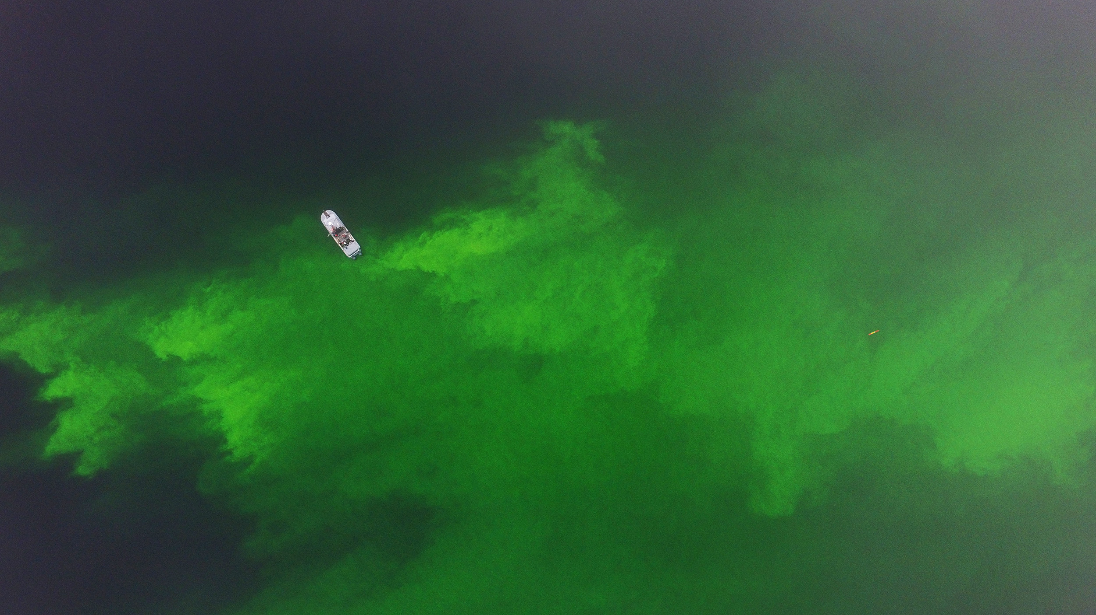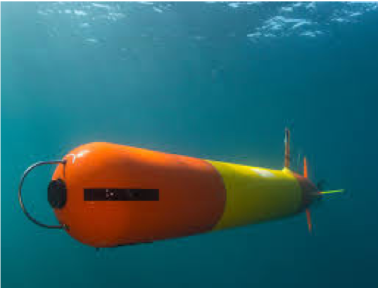
Drone footage of dye demo 27 September 2018 with LRAUV pictured
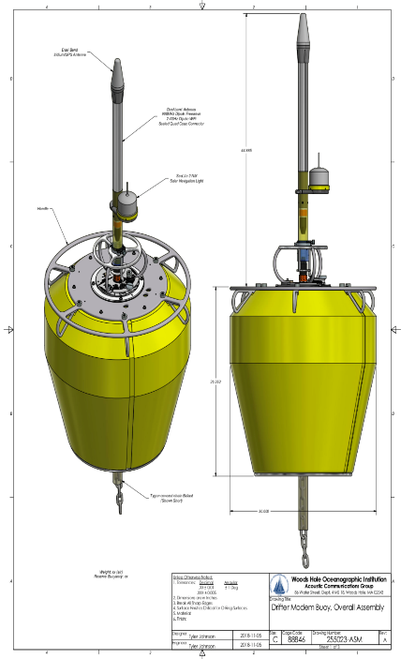
In order to complete an Arctic capable oil spill deployment package, project team designed and constructed Arctic Communication buoys, oriented to an “agnostic” communications design. These communication buoys include long baseline (LBL) and ultrashort baseline (USBL) systems, ACOMMS, Wi-Fi, RF, Iridium, and thermistor capability. LBL allows for long range (up to 10 Km per buoy), while USBL allows for short range (<500 meters) homing and docking for recovery under ice or in open water. The buoy system will also allow for data transfer from the LRAUV back to Command Control Center via Iridium. In order to transfer data in a format that can be visualized by the receiving party, a software compression is included in the buoy development. These buoys are critical to enable LRAUV to operate as a “system” to effect characterization and communication of an Arctic oil spill, under sea ice, to USCG led unified command.
Arctic buoy design.
Arctic Buoy design
Advancing LRAUV further, project team designed, implemented and conducted initial testing of a platform “Umodem” to include advanced navigation capabilities inclusive of LBL and USBL systems.
The Umodem team at WHOI is working on new firmware to allow the buoys to be used as transponders (a new development, set for May completion). In sum, Umodem, USBL and whisker box are new hardware and software capabilities provided to LRAUV to assist with under ice navigation and docking.
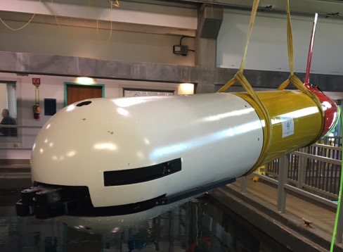
WHOI/MBARI/ADAC LRAUV with whisker box nose undergoing pool tests.
Additionally, when Autonomous Underwater Vehicles (AUVs) are strategically equipped with multiple sensor technologies, including cameras and sonar, they are capable of remote detection and analysis of oil under sea ice.
Test data illustrates that AUV's remain the most mature tool for the search, chart, and classification procedures routinely performed in seafloor analysis and similar methodology can be effectively applied to under-ice anomaly detection. Beyond the need for rapid detection of oil and gas in the Arctic, based on discussions and conclusions from several Center-led workshops, ADAC and the LRAUV project team notes the important utility for small AUV platforms with a variable endurance range of hours to weeks capable of mapping the seafloor for the purpose of bathymetric surveys and anomaly detection to include leaking pipelines and infrastructure.
The project team’s investigations have determined, multibeam sonars are capable of providing a high-resolution swath map with precise readings of hard structure as well as water column oil and gas detections (see figures below). Multibeams are well suited in first return systems for mapping the seafloor or underside ice. Accordingly, in order to create a multi-mission capability to LRAUV, the project team PI's, will research, procure and integrate a multibeam sonar system for use on portable AUV platforms.
The MBARI/WHOI team combined the best AUV technologies from two successful AUV systems to make a custom Arctic capable platform. Below are combined Program Year 5 and Mid-Year Program Year 6 Summary Outcomes/accomplishments:
- Built an operational Arctic-capable LRAUV with an environmental sampling payload allowing for detection and mapping of dissolved hydrocarbons as well as physical measurements like temperature, salinity, water currents, dissolved oxygen and turbidity; the WHOI-DHS vehicle has a homing docking nose that allows it to find an ice hole for recovery purposes. LRAUV can also be configured with additional payloads depending on mission requirements.
- Presented and published two IEEE papers on our research along with ~10 project talks; (WHOI)
  - Built collaborations with EPA, NOAA, UNH and BSEE whom have funded further AUV behavior and sensor development as well as field testing; These collaborations allow for more rapid transition of new technology to DHS.
  - Integrated arctic/oil science payload on LRAUV; and field tested in a real-world oil seeps environment in Santa Barbara, CA.
  - Conducted open water testing and plume mapping exercise at MBARI
- Developed LRAUV mission simulations with Chukchi Sea (Burger site) current data;
- Designed and built three* Arctic buoys (LBL, USBL, ACOMMS, Wi-Fi, RF, Iridium);
- Performed extensive further offshore testing of vehicle docking;
- Implemented and tested Umodem and USBL (docking) functionality;
- Developed firmware for buoys for three subsurface capabilities (LBL, USBL, ACOMMS);
- Evaluated COTS sensor packages (split beam, multi-beam, methane, optics);
- Conducted successful field trials in a real-world oil spill at the Santa Barbara seeps (June 2019); LRAUV ran continuously from 1 June through 13 June 2019 with on ship-less recovery in order for the team to check the onboard camera for successful docking attempts as well as for data evaluation.
  - The mission objectives were as follows: Exercise plume tracking algorithm and ability to detect and map out oil from the seeps; Send ACOMMS modem packets on a duty cycle of two minutes via the buoy/”Freewave” to command control at UCSB;
  - Test homing and latching to the highflier mooring;
  - Test single command through buoy to vehicle (example: abort, restart, get GPS fix) Deploy Arctic buoys and run a large scale oil detection mission;
  - Determine the extent of where the oil is and where the signal drops off;
  - Keep vehicle underwater for 3-4 days to simulate an overhead ice environment and inform first responders to where oil was and was not in order assist in other asset deployments and mission planning.
  - Data from the LRAUV was sent via Iridium, cell, or Freewave initially and then received on the MBARI established Data Dash web portal found at Tethys Dash accessible from anywhere: https://okeanids.mbari.org/dash3/#/data. A field report inclusive of the YR5 June Seeps-1 experiment and the August seeps-2 experiment will be complete in December.
- Conducted multi-vehicle operations, real-time data transmission from the vehicle to buoy to command control, sent first ever acoustic data packets from LRAUV, and mapped out several seep locations using adaptive sampling capabilities
- Water tested Arctic buoys and successfully relayed data packets and vehicle information without the LRAUV surfacing therefore simulating an under-ice field exercise with oil as a proxy. The team was able to send messages from the vehicle to command control via the buoy network.
- The team conducted a review of the LRAUV mechanical build and is currently reviewing electrical systems for updates and improvements with an emphasis on performance and cost savings. The team reviewed design materials and acquisition of materials in accordance with revalidated LRAUV bill of materials.
- The team achieved successful underwater docking and undocking to a transponder.
- The team developed add on- second dock capability.
- The team conducted rapid response oil exercise at SB Seeps (August, 2019).
- Researchers modified one of three buoys for optimal docking and have a kit to change buoys frequencies between high and low depending on mission objectives
- Researchers performed offshore testing of vehicle docking and simulated under-ice behaviors.
- Developed firmware for buoys for subsurface capabilities (USBL, ACOMMS)
- Conducted further evaluation COTS sensor packages (split beam, multi-beam, methane, optics); (This was conducted at WHOI) Purchased new sensors
- Developed PDM tools and procedures for LRAUV Build-2 using Vault and WHOI Roundabout. Released all mechanical drawings except those identified to be candidates for low cost manufacturing
- Evaluated end of life parts and LRAUV system for improvements and manufacturing. Internal battery charger system will be redesigned to be more efficient and will also increase battery capacity.
- The team held a transition meeting with the ADAC Executive team and Brian Dolph from USCG RDC in October 2019 in Woods Hole MA
- Planned logistics for New England region under-ice test in an ice covered lake in Northern Maine to be conducted approximately 6-12 February 2020.
- Planned logistics for under-ice testing of Polaris in Lake Superior in late March (dates pending at 20 March- 3 April 2020) hosted by the Great Lakes Research Center
- Designed a davit LARS for our low-cost WHOI vessel for launch and recover of LRAUV and integrated a center lifting bail for launch and recovery versatility
- Developed WHOI operational DASH for operating LRAUV from inside WHOI https://lrauv.whoi.edu/#/
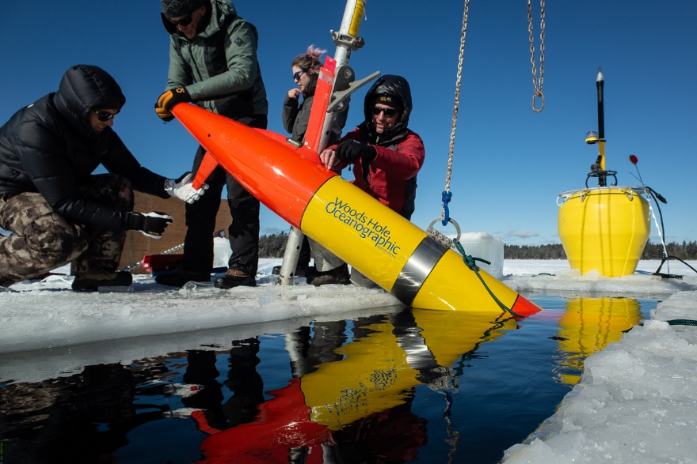

https://www.allaboutcircuits.com/news/navigating-the-arctic-why-gps-might-fail-you/
Based-upon the highly successful Sea-Bird Scientific ECO sensor, Sea-Bird Scientific has developed an industry-leading oil-detection technology with 5X optical resolution improvement over its predecessor. SeaOWL-UV-A™ measures crude oil-in-water using the same UV-A excitation and blue emission wavelengths (370 nm EX, 460 nm EM) currently used in the ECO FDOM fluorometer. The SeaOWL UV-A™ improves the resolution and range of the ECO with a greater depth of field, optimized electronics and dynamic gain stage modulation. The new dynamic gain provides industry-leading sensitivity across a large detection range, making saturation unlikely in even the most heavily impacted environments. The compact SeaOWL UV-A™ design also includes chlorophyll fluorescence and 700 nm backscattering measurements to discriminate crude oil from phytoplankton and other natural sources of FDOM.
https://www.adn.com/alaska-news/environment/2018/03/04/after-weather-delays-kodiak-island-fuel-oil-spill-cleanup-underway/
https://content.govdelivery.com/accounts/USDHSCG/bulletins/1df97a9
https://arcticdomainawarenesscenter.org/Arctic_IoNS
https://www.noaa.gov/explainers/arctic-charting-mapping-new-frontier
https://arcticdomainawarenesscenter.org/Arctic_IoNS
https://arcticdomainawarenesscenter.org/Library
https://pac.portal.aoos.org/
The need for precision navigation through a technique called Terrain Relative Navigation (TRN). In areas that have previously been mapped, and are not featureless, the AUV can use the old map to navigate. Using TRN makes it possible to detect changes in the original map. This is not currently a LRAUV System capability, but if resourced, is feasible and suitable to establish in LRAUV.
https://www.pmel.noaa.gov/arctic/news-story/longest-ocean-acidification-glider-mission
Ibid
Drifting is a ‘parking’ capability that minimizes power consumption at the cost of being carried by the current. So provided currents are not high, one might have the vehicle drift at depth for a few hours, surface to get a GPS update, then motor back to the desired parking spot.
http://aosn.mbari.org/TethysDash/
http://aosn.mbari.org/TethysDash/data/daphne/realtime/sbdlogs/2012/201211/20121127T053258/

