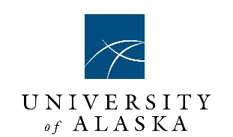

Arctic Domain Awareness Center (ADAC)
A Department of Homeland Security Science and Technology Office of University Programs,
Center for Maritime Research
ADAC Annual Performance Report for Program Year 6
1 July 2019–30 June 2020
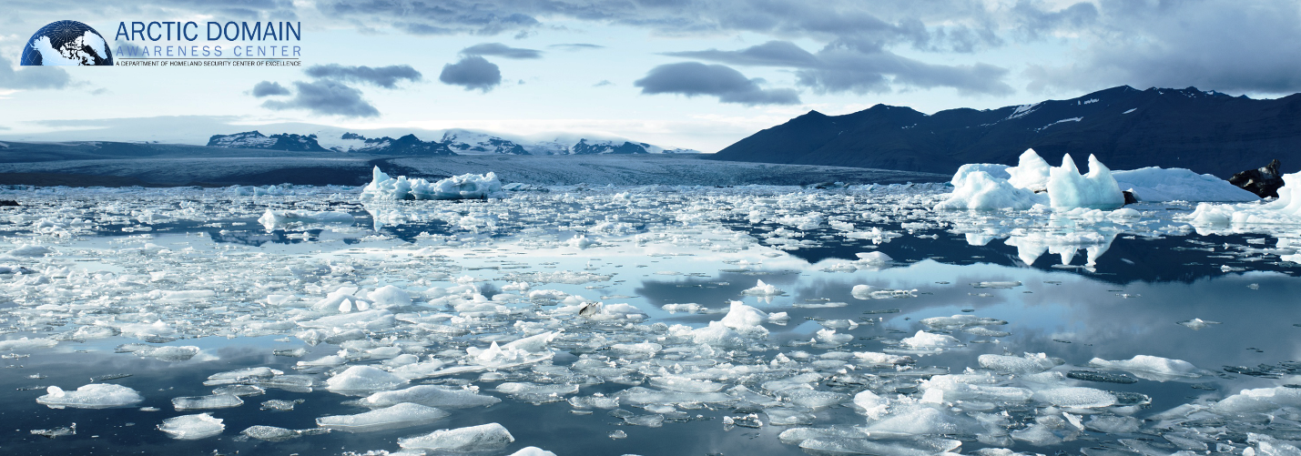
Submitted by ADAC Leadership Team to DHS S&T OUP
31 August 2020

Douglas Causey, PhD, Principal Investigator, University of Alaska Anchorage (UAA)
Nettie Labelle-Hamer, PhD, Research Director, University of Alaska Fairbanks (UAF)
Randy Kee, Maj Gen (Ret) USAF, MS, Executive Director, UAA
Jason Roe, USCG (Ret), Associate Director and Senior Research Professional, UAA
Heather Paulsen, MBA, Finance Director, UAA
LuAnn Piccard, MSE, PMP, Project Management Director, UAA
Elizabeth Matthews, MS, Education and Administrative Manager, UAA
Connor Keesecker, MA, Communications and Research Associate, UAA
Kelsey Frazier, MS, Research Associate, UAA

Table of Contents
Table of Contents 1
List of Figures 2
List of Tables 4
I. Summary Report on ADAC’s Strategic Vision and Activities 5
ADAC’s new research activities notification for Program Year 6: 7
ADAC’s partner academic and research institutions. 7
Industry partners. 7
Collaborative organizations. 8
A Summary of ADAC Program Year 6 Activities: 9
II. Summary of Center Management Efforts 28
ADAC Program Year 6 Strategy implementation: 31
ADAC Executive Counselors 33
ADAC Affiliated Researchers. 34
ADAC Student Fellows. 34
Summary of Center Research Management Process. 35
Summary of ADAC’s Communication’s Efforts. 37
III. ADAC Program Year 6 Project Descriptions Aligned to DHS CMR FOA Themes: 40
THEME 1: Maritime Risk, Threat Analysis, and Resilience Research Projects: 40
PROJECT: Mitigating the Damage to Arctic Copepods from Surface Oil Spills: When to Apply Dispersants 40
PROJECT: Photo-enhanced toxicity of dispersed and burned crude oil to Arctic mussels 50
PROJECT: Marine Induced Polarization Methods for the Detection and Mapping of Oil in an Arctic Marine Oil Spill; Including Investigation of Oil Within and Under Broken Ice Fields 57
PROJECT: Oil Spill Modeling for Improved Response to Arctic Maritime Spills: The Path Forward 84
THEME 2: Maritime Domain Awareness (MDA) Research 97
PROJECT: Ice Conditions (ICECON) for the Arctic (ARCTICE) 97
PROJECT: The Arctic All-Hazards GIS Platform 111
PROJECT: Arctic Vessel Monitoring Geofencing/Alert Awareness 118
THEME 3: Maritime Technology Research: 127
PROJECT: Development of Propeller Driven Long Range Autonomous Underwater Vehicle (LRAUV) for Under-Ice Mapping of Oil Spills and Environmental Hazards 127
PROJECT: Arctic-related Incidents of National Significance (Arctic IoNS) Workshop 145
PROJECT: Arctic Medium and Long Term Environment (Arctic MaLTE) Workshop 148
THEME 4: Integration of Science and Engineering with Maritime Security Governance and Policy Research 152
THEME 5: End-to-End (E2E) 152
THEME 6: Integrated Education 152
Education Outreach and Workforce Development Overview 152
PROJECT: ADAC Arctic Summer Intern Program (ASIP). ASIP is an ADAC Fellow & Minority Student Integrated Summer Intern Program. 161
IV. Budget and Justification 169
Year Six Arctic Domain Awareness Center (ADAC) Financial Summary 169
Year Six Budget Analysis – Summary for Center 169

List of Figures
Figure 1: Arctic Symposium 2019 Group Photo 16
Figure 2 ADAC's Personnel (as of August 2020) 33
Figure 3 ADAC's Executive Counselor Team (as of June 2020) 34
Figure 4 Front Page of ADAC's Website 39
Figure 5: Distribution of total copepods observed in each of the three filmed horizons (blue=top, orange=midpoint, gray=bottom) 43
Figure 6: An example of PAH concentrations (ug/L) over depth (in), 0 hr, 2 hr, 6 hr, and 24 hr after introduction of fresh crude oil (ANS). 43
Figure 7: Photograph of the copepod tower with oil/dispersant mixture and constant mixing energy added 44
Figure 8: Temperature profile in stratified tower over 4020 minutes (67 hours) (a), over depth (b). 45
Figure 9: Diagram of the Marine IP Ice Cable design 60
Figure 10: Marine IP Diagram of OWC (TO)P, Marine IP Cable (Bottom Left), and bulk Power/Signal 4026 cable (Bottom Right) 61
Figure 11: Marine IP system electronics and receiver box 62
Figure 12: Marine IP Beach testing 63
Figure 13: Marine IP Open Water testing 63
Figure 14: Marine IP Open Water test transect locations 64
Figure 15: Marine IP cable figure eight on deck 65
Figure 16: Marine IP transmit electrodes 65
Figure 17: Marine IP beach testing equipment 66
Figure 18: CRREL Labs testing 68
Figure 19: Marine IP CRREL testing Scenario Diagram 69
Figure 20: Illustration of CRREL testing Methodology 69
Figure 21: Images of Marine IP CRREL testing 69
Figure 22: Image of Marine IP CRREL testing (underwater view) 70
Figure 23: Marine IP CRREL test Scenario ice types 71
Figure 24: Marine IP CRREL ice conditions 72
Figure 25: Marine IP CRREL test team group photo 75
Figure 26: ARCTICE Polar class and Baltic class considerations 99
Figure 28: May 2020 Polar Class 5 (PC 5) voyage area output chart 103
Figure 27: May 2020 Polar Class 1 (PC1) voyage area output chart 103
Figure 29: May 2020 Polar Class 7 (PC 7) voyage area output chart 104
Figure 30: A sample plot of the GL ICECON index. 109
Figure 31: Interface of the iOS mobile app (top) and the android version (bottom) for ship-based observation data collection. 110
Figure 32: Arctic All-Hazards GIS Platform: Front-end of the application at Beta release 113
Figure 33: Polaris at Goleta Pier during the Santa Barbara Seeps experiment. Figure 2. Polaris being deployed in a frozen lake in Northfield, Maine during February 2020 testing. 127
Figure 34: Detections of petroleum hydrocarbons from the SeaOwl onboard the LRAUV are displayed on the dashboard. 131
Figure 35: LRAUV route during Santa Barbara seeps testing 131
Figure 36: Near real-time data as seen from the web portal that the LRAUV sends data to which is accessible from the Dash website. 132
Figure 37: LRAUV Docked to a 3/8 line! The plot of the vehicle's acoustic ranges to the dock show it making a few passes before finally docking. 132
Figure 38: Weathered oil is common on the surface in Santa Barbara and is not indicative to where submerged oil was found. Oil and methane bubbles (right) escape from underground reservoirs. 133
Figure 39: LRAUV ice camp as seen from a UAV. Shown is a 3x9 foot hole with a simple gantry used to hoist the LRAUV in and out of the water. 134
Figure 40: LRAUV is docked under ice to the Arctic buoy cable and awaits its next mission command. 134

List of Tables
Table 1. Tasks and associated metrics for direction and management of established projects. 28
Table 2. Tasks and associated metrics for continuation of Year 4 and 5 research initiatives. 29
Table 3. Tasks and associated metrics for conducting outreach, engagement, and communications. 30
Table 4. Tasks and associated metrics for conducting education, outreach, and workforce development efforts. 31
Table 5. Copepods project progress against each milestone. 46
Table 6. Copepods project progress against each metric. 47
Table 7: Arctic Mussels Year 6 milestones. 55
Table 8: Arctic Mussels Year 6 metrics. 56
Table 9: Marine IP Open Water test transect lines 64
Table 10: Marine IP CRREL testing table 71
Table 11: Marine IP Year 6 Milestones 76
Table 12: Marine IP Year 6 Metrics 78
Table 13: Oil Spill Modeling student activities 86
Table 14: Oil Spill Modeling Year 6 Milestones Phase 1: Formation of Project Core Advisory Team 92
Table 15: Oil Spill Modeling Year 6 Milestones Phase 2: Define needs/questions addressed by response models 93
Table 16: Oil Spill Modeling Year 6 Milestones Phase 3: 2 Day Workshop on Arctic Maritime Spill Response Modeling 93
Table 17: Oil Spill Modeling Year 6 Milestones Phase 4: Develop working groups 94
Table 18: Oil Spill Modeling Year 6 Metrics 95
Table 19: IMO Polar Class and Ice description 99
Table 20: Breakdown of Arctic Vessel traffic 100
Table 21: Ice Class and Ice condition risk matrix 101
Table 22: ARCTICE Year 6 Milestones 105
Table 23: ARCTICE Year 6 Metrics 105
Table 24: ICECON algorithm accuracy. 109
Table 25: Arctic All-Hazards GIS Platform Year 6 Milestones 115
Table 26: Arctic All-Hazards GIS Platform Year 6 Metrics 115
Table 27: Arctic Vessel Geofencing; Progress against Milestones 123
Table 28: Arctic Vessel Geofencing; progress against each Metric 124
Table 29: Project progress against each milestone 137
Table 30 Project progress against each metric 139
Table 31: Arctic Domain Awareness Center Fellows - Program Year 6 154
Table 32: ADAC Fellows support to Year 6 Research projects. 156
Table 33: ADAC Fellows Year 6 Milestones. 158
Table 34: ADAC Fellows Year 6 Metrics. 159
Table 35: ASIP Year 6 Milestones. 166
Table 36: ASIP Year 6 Metrics. 167

ADAC respectfully submits the report below to the U.S. Department of Homeland Security, Science and Technology Directorate, Office of University Programs. This ADAC Program Year 6 report complies with terms and conditions of the ADAC Cooperative Agreement to the University of Alaska Anchorage. Additionally:
- ADAC certifies no patentable inventions during the budget period.
- ADAC has reviewed the existing Center’s Information Protection Plan and Researcher Safety Plan. ADAC offers no new updates to these existing documents.
- Summary Report on ADAC’s Strategic Vision and Activities
ADAC Program Year 6 in summary: The Arctic Domain Awareness Center achieved greater maturation and technological readiness of multi-year research projects, launched exciting new operationally relevant research initiatives, produced several knowledge products, and expanded the Center’s network of international and local partners while developing the next generation workforce to advance the homeland security in the Arctic.

When the United States became an Arctic nation in 1867, the US became responsible for facilitating domestic security and sovereignty for a significant portion of the Arctic. In the century and half since the Alaska purchase, the national security challenges within the Arctic have radically changed. As seasonal sea ice continues to diminish, the opening of the Arctic region to natural resource development, maritime trade, and tourism have transformed the security landscape of the high latitude north. New international actors now look above the Arctic Circle for opportunity, while existing Arctic nations have begun to realize its economic potential. In the midst of this evolving dynamic, it falls to the U.S. Department of Homeland Security (DHS) and the United States Coast Guard (USCG) to serve as the United States’ visible sovereign presence within the region to safeguard American territory and national interest the Arctic.
As the changing Arctic presents new economic and geopolitical opportunities, environmental change poses a significant threat to traditional social and economic systems of the Arctic. Melting permafrost is eroding the land that served as the foundation for coastal Arctic communities. With less sea ice cover, weather systems have become more volatile, allowing for stronger storm systems that further exacerbate coastal erosion through storm surges and high winds. Warmer seas have also caused traditional fisheries to move north, dislocating traditional food sources for Arctic people and marine mammals. This poses a significant threat to existing infrastructure within the region and the traditional lives of Arctic people.
While traditional subsistence activities have been disrupted, reductions in sea ice have invited in more economic activity. The vast hydrocarbon deposits within the region have become more accessible, allowing for Arctic nation-states like the Russian Federation to expand resource extraction efforts. Sea lanes are opening, allowing reduced global maritime trade to take advantage of shorter trade routes between the markets in East Asia and Europe. The economic potential of the Northern Sea Route, and the possibility of a Transpolar route within this century have incentivized the People’s Republic of China to see the Arctic as vital to its global ambitions. All of this activity places increased pressure on the limited infrastructure for search and rescue operations, environmental security, and transportation in the region.
To prepare for these emerging challenges, the United States Coast Guard released the USCG Arctic Strategic Outlook from 2019 describes three “complementary lines of effort” to protect national interests: 1. Enhance Capability to Operate Effectively in the Dynamic Arctic. 2. Strengthen Rules-Based Order. 3. Innovate and Adapt to Promote Resilience and Prosperity. As a DHS S&T University Program with the USCG as the primary “customer,” ADAC promotes each line of effort daily through the development of ADAC research projects.
As a DHS Science and Technology Office of University Programs (DHS S&T OUP) Center of Excellence in Maritime Research, the Arctic Domain Awareness Center (ADAC), hosted by the University of Alaska Anchorage, continues to provide relevant science and technology research and support for the USCG as they conduct and enhance their statutorily assigned missions in the Arctic.
As ADAC’s principal customer is the USCG, ADAC investigates operational shortfalls and gaps for the USCG mission needs in the Arctic. Through this effort, ADAC supports the primary USCG missions in the Arctic of search and rescue, environmental protection, disaster response, and coastal security. As University hosted Center, ADAC promotes education through the Center’s Fellows program which engages and prepares students for careers within the Homeland Security Enterprise (HSE). Through these core functions, ADAC supports the USCG and other DHS Maritime mission needs throughout the Arctic. While focused on the USCG, ADAC continues to seek and gain success in research and associated interaction with the community of U.S. Departments and Agencies concerned about the Arctic. This includes Department of Defense, Department of Commerce (in particular, National Oceanic and Atmospheric Administration), Environmental Protection Agency, and Department of Interior (namely Bureau of Ocean and Energy Management and Bureau of Safety and Environmental Enforcement). ADAC’s “partner and customer’s” base has grown quite robust which includes more than 920 individuals from across U.S. Federal, State of Alaska, Tribal Alaskan, Canadian Government and academics and Nordic collaborators.
With this report, ADAC reflects upon the 6th year of providing science and technology research in support of DHS and the USCG. In Program Year 6, ADAC continued to mature existing investigations and prepared technology developed through the center for the transition to real-world application. ADAC continued advanced Arctic knowledge and domain awareness through numerous ADAC and partner-led workshops, conferences, and symposia, which resulted in knowledge products that inform DHS and USCG policy and strategy in the Arctic.
This report describes Year 6 project work completed by ADAC from 1 July 2019 to 30 June 2020. In addition to updates on the ADAC supported research, the report provides an overview of the Center’s activities within this period. The report reflects the results and accomplishments performed in accordance with the DHS S&T OUP approved Program Year 6 Workplan of ADAC.
ADAC’s approved vision, mission, and strategy remain:
Vision: The DHS Center of Excellence provides networked and mission-focused support to the USCG Operator in the High North. ADAC continues to strive to become a National Center of Arctic maritime research.
Mission: ADAC’s mission is to develop and transition technology solutions, innovative products, and educational programs to improve situational awareness and crisis response capabilities related to maritime challenges posed by the dynamic Arctic environment. ADAC seeks to accomplish this mission through an inclusive approach.
Strategy: In Program Year 6, ADAC continued the Center’s existing strategy and conducted a parallel effort over five lines of a major collaboration principally focused on DHS S&T OUP and USCG in order to:
- Investigate, develop, resource, and initiate new research.
- Execute approved research work plans that are appropriately detailed and resourced.
- Successfully integrate university student Fellows into the Homeland Security Enterprise workforce.
- Transition sufficiently mature research to meet customer acquisition needs and commercialize as appropriate.
- Adapt Center activities, management, and communications to continue to learn and collaborate with an array of Center partners and continue to suitably expand the reach of ADAC across U.S. and Canada to include Arctic government, military, and security operators, researchers, and industry partners.

ADAC’s new research activities notification for Program Year 6:
ADAC launched Program Year 6 on 1 July 2019 with DHS S&T OUP approval. During Program Year 6, the Center received further project notification of accepted proposal for the following research project on 29 May 2020:
- Remote Unmanned Aircraft System (UAS) Inspection and Response Team Development in the Bering Strait Region.

ADAC’s partner academic and research institutions.
The following universities or research institutions collaborated with ADAC during individual research projects in Program Year 6:
- Alaska Ocean Observation System (AOOS), Anchorage, Alaska.
- Bigelow Laboratory for Ocean Sciences, East Boothbay, Maine.
- Texas A&M University, College Station, Texas.
- Monterey Bay Research Aquarium Institute (MBARI), Monterey Bay, California.
- University of Alaska Anchorage, (UAA) Anchorage, Alaska.
- University of Alaska Fairbanks, (UAF) Fairbanks, Alaska.
- University of New Hampshire (UNH) Coastal Response Research Center (CRRC) Center for
- Spills in the Environment (CSE), Durham, New Hampshire.
- University of Maryland, (UMD) College Park, Maryland.
- University of Texas El Paso, (UTEP) El Paso, Texas.
- University of Washington Applied Physics Laboratory, Seattle, Washington.
- Ukpeagvik Inupiat Corporation (UIC)-Science, Utqiagvik, Alaska.
- Woods Hole Oceanographic Institution, Woods Hole, Massachusetts.
- US Army Cold Regions Research and Engineering Laboratory, Hanover, New Hampshire.

Industry partners.
The following industry or business enterprises contributed to ADAC’s Center efforts or individual research projects in Program Year 6:
- Alaska Marine Exchange, Juneau, Alaska.
- Axiom Data Science, Anchorage, Alaska.
- IntelliSense Marine, LLC, Seattle, Washington.
- Induced Polarization Associates, LLC, Seattle, WA.
- Williamson and Associates, Seattle, WA.

Collaborative organizations.
The following organizations provided research input, collaborations, or contributed in ADAC activities (such as workshops and/or educational activities):
- Alaska Maritime Prevention and Response Network, Anchorage, Alaska.
- Alaska Department of Public Safety, Anchorage, Alaska.
- Bering Sea Elders, Nome and Anchorage, Alaska.
- Bering Straits Native Corporation, Nome, Alaska.
- Canadian Department of National Defense, Ottawa, Ontario, Canada.
- National Research Council, Canada, Ottawa, Ontario, Canada.
- City and Port of Anchorage, Alaska.
- DHS S&T OUP Centers of Excellence at George Mason University, Rutgers University, Northeastern University, Stevens Institute of Technology, and University of Houston.
- Kawerak Incorporated, Nome, Alaska.
- National Oceanic and Atmospheric Administration (NOAA)and National Weather Service, Anchorage, Alaska; Seattle, Washington; and Washington, D.C.
- North American and Arctic Defense and Security Network, Trent University, Peterborough Ontario, Canada.
- North Slope Borough, Utqiaġvik, Alaska.
- Pacific Northwest National Laboratories, Hanover, Washington.
- Sandia National Laboratories, Albuquerque, New Mexico.
- Sitnasuak Native Corporation, Nome, Alaska.
- U.S. Arctic Research Commission, Washington, D.C.
- U.S. Coast Guard Academy and their Center for Arctic Study and Policy (CASP), New London, Connecticut.
- USCG Headquarters, USCG Pacific Area, USCG Research and Development Center, and Districts 9 and 17.
- U.S. National Ice Center, Suitland, Maryland.
- United States Naval Academy, Annapolis, Maryland.
- University of Alaska Northwest Campus, Nome, Alaska.
- Aleutian and Bering Sea Islands Land Conservation Council, Anchorage, Alaska.

A Summary of ADAC Program Year 6 Activities:
The timeline below provides a list of major Center activities conducted throughout Program Year 6. The majority of these activities follow ADAC’s long-range schedule, established in the Center’s DHS S&T OUP approved Program Year 6 Workplan. This summary highlights ADAC’s management strategy to engage and iterate research initiatives with the Center’s principal customer, the U.S. Coast Guard, as well as other members of the U.S. Federal, State, and international government officials. The Center also collaborated with the community of Arctic maritime research to prepare and conduct activities expected of DHS S&T UP, while accomplishing planned research and developing students to serve in the Homeland Security Enterprise.
While the advent of the Coronavirus 2019 (COVID-19) pandemic forced ADAC to postpone in-person gatherings or transition to “virtual” activities starting on 17 March 2020, ADAC was still able to foster Arctic innovation and collaboration through effective workshops, conference presentations, stakeholder meetings, customers partners and roundtables, and the Virtual ADAC Annual Meeting. ADAC leadership respectfully extend sincere thanks our research teams, external partners and collaborators and to DHS S&T OUP and Arctic minded USCG leadership, and staff for their resourcefulness and flexibility in these challenging times.
ADAC’s Program Year 6 was marked by significant service in advancing research and research collaboration to the Arctic, including the following activities:


8 July 2019: ADAC Leadership conducted meeting with State of Alaska Deputy Commissioner for Public Safety and DHS Intel Director. Deputy Commissioner for Public Safety Michael Duxbury welcomed ADAC ED and SRP to an informative discussion on current and near-term future threats to public safety in Arctic and Rural communities. This discussion highlighted the importance of sustained community engagement and robust domain awareness capabilities.
16 July 2019: ADAC released 1st Quarter Newsletter.

ADAC’s first newsletter of Program Year 6 covered the activities of the Center since July 2019. The newsletter featured articles on HIOMAS transitioning to AOOS and Axiom Data Science and the 2019 Nome and Anchorage Arctic-related Incidents of National Significant (Arctic IoNS) workshops. Please see: https://arcticdomainawarenesscenter.org/Publications
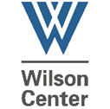
16-18 July 2019: ADAC Co-Sponsored the July 8th Symposium on the Impacts of an Ice-Diminishing Arctic on Naval and Maritime Operations. The biennial event, hosted by the US Arctic Research Commission, US National Ice Center, and Wilson Center’s Polar Institute in Washington DC, featured a variety of speakers and panels discussing a wide range of issues related to the changing Arctic. Panels covered a variety of issues related to maritime, geopolitical, environmental, and economic security. The ADAC Executive Director served on a panel on Arctic Science and moderated panels on Alaska Operations and the US Military perspective Arctic Security. The event featured prominent guest speakers including Senator Angus King of Maine, Senator Lisa Murkowski of Alaska, Senator Dan Sullivan of Alaska, Admiral Charles W. Ray, Vice Commandant, USCG, Deputy Secretary of U.S. Department of Energy Dan Brouillette, and Wayne Westlake, President and CEO of NANA Regional Corporation.
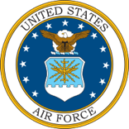
22-26 July 2019: ADAC Senior Research Professional (SRP) presented during Air Force Chief Scientist Group Visit to JBER Alaska. ADAC SRP conducted a presentation on ADAC Arctic research to USAF Chief Scientist Dr. Richard J. Joseph during his visit to Alaska. The meeting was attended by Dr. Joseph, representatives from ALCOM, and congressional staffers. The presentation and follow-on discussions included overviews of ADAC projects, workshops, and partnerships.

23 July 2019: FBI Orientation for ADAC and Arctic Research
ADAC ED hosted visiting Federal Bureau of Investigation agents from various locations in the Continental U.S. to an orientation on Arctic security challenges and to an overview of “operator driven” Arctic research.
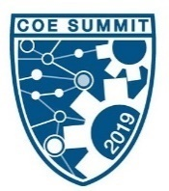
30 July-1 August 2019: ADAC Participates in DHS COE S&T OUP Summit 2019.
The 2019 DHS Centers of Excellence Summit was co-organized and hosted by the Criminal Investigations and Network Analysis (CINA) on July 31 and August 1 at Mason’s Arlington Virginia Campus. The event served as an important opportunity for ADAC staff and leadership to collaborate and engage with fellow Centers of Excellence and the DHS enterprise. ADAC led collaboration to secure the Canadian Embassy to the United States as a host site a symposium welcoming ice breaker. The 2019 Summit was organized around two central themes: gray zone threats, and homeland security challenges in a highly networked world. ADAC supported the DHS S&T CoE network in hosting one of 2 tracks of expert presentations, that involved organizing and securing participation of distinguished speakers from DoD, FBI and Washington D.C. based think tanks, to include leadership from Center of Strategic and International Studies (CSIS).
ADAC student Fellows had the opportunity to present posters at the Summit and join with other student teams from across the COE network to participate in the Student Grand Challenge. ADAC Fellow Tristian Goers received a 1st place Grand Challenge Award in the challenge in which students were tasked with developing strategies for countering unmanned aerial systems.
DHS S&T OUP Funds were utilized to support this event.

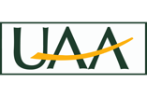
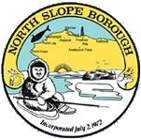
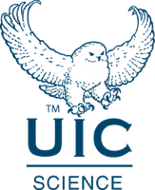
2 August 2019: ADAC Fellows Completed the Arctic Summer Internship Project 2019.
ADAC Fellows finished their respective courses of workforce development associated with the Arctic Summer Intern Project (ASIP). As described in detail later in the report ASIP summer 2019 entailed spending 10 weeks between Anchorage, Alaska and Utqiagvik, Alaska. ADAC ASIP Fellows learned a great deal about the changing Arctic, Alaskan research into the Arctic, and several important facets of the changing Arctic upon rural Alaskan villages. ASIP 2019 leveraged DHS S&T OUP Funds to support this event.

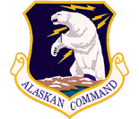
8 August 2019: ALCOM Arctic Symposium Planners Kick-off Meeting.
ADAC met with Alaska Command (ALCOM) Commander, Lt Gen Tom Bussiere and his staff to form the initial plan for the ALCOM Arctic Symposium.

9 August 2019: ADAC conducted Monthly Fellows Meeting.
Monthly meeting with ADAC Student Fellows took place both in person and via video conference. ADAC Education and Administrative Manager conducted the monthly ADAC Fellows meeting, which included remote participation via Zoom for geographically dispersed Fellows. Fellows received administrative updates on their respective research assistance-ships, discussed current Arctic issues, and planned future activities. More details about ADAC student fellow programs can be found at https://arcticdomainawarenesscenter.org/Education.html
12 August 2019: ADAC Leadership Met with UAA Chancellor and ALCOM Commander.
ADAC ED coordinated, prepared and supported UAA Chancellor Cathy Sandeen for her initial meeting with ALCOM Commander and staff.

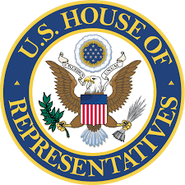
12 August 2019: ADAC Leadership Met with staff from U.S. Representative Don Young.
ADAC Executive Director and fellow Center leaders hosted staff members from Representative Don Young (R-Alaska) in providing an orientation to center research in support of DHS and USCG.

14 August 2019: DHS S&T CoE Directors Meeting.
ADAC Leadership participated in the monthly DHS S&T OUP Directors meeting.

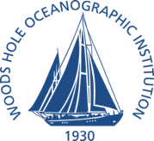
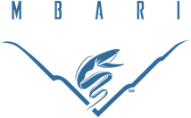
25-30 August 2019: LRAUV Research Team performs Oil Seeps Test in Santa Barbara Channel.
The LRAUV project team participated in field exercise in Santa Barbara that consisted of the TETHYS LRAUV and two REMUS AUVs. The exercise was a collaborate exercise to simulate rapid response to an oil spill and included a team from EPA, NOAA, USCG participating aboard the USCG buoy tender, USCGC GEORGE COBB. LRAUV’s role in the collaborative exercise was to use its long-term operational capability to map the seeps area to detect areas of high and low oil concentrations using its onboard mapping software quickly and efficiently and SeaOwl sensor.
26 August 2019: ADAC launched updated website.
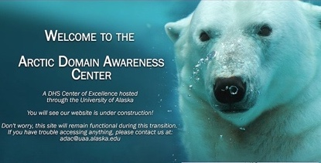
After transiting support from Dubay Business Service at the end of Program Year 5, ADAC debuted the Center’s new website. The website developed by staff at the Business Enterprise Institute at UAA with support from ADAC’s summer internship. Built from the ground up, the website offers greater customization options, allowing ADAC and BEI staff to tailor ADAC’s web presence to align with the center’s objectives and activities.
31 August 2019: ADAC Submitted Final Year 5 Program Report to DHS S&T OUP.
ADAC submitted the Center’s Program Year 4 Annual Report, which summarized the Center’s progress and activities from 1 July 2018 – 30 June 2019.
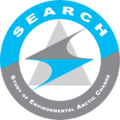
4-6 September 2019: ADAC Leadership Participated in Arctic 2050 Conference.
ADAC’s Executive Director participated in a table-top exercise on Inclusive Planning at the Arctic 2050 Conference in Washington DC. The event is hosted by the Study of Environmental Arctic Change (SEARCH) and brings together a diverse set of scientists, indigenous leaders, and government leaders together to discuss the future of Arctic. The table-top exercise provided a demonstration on how science, indigenous, and policy communities can work together to develop emergency response strategies in Arctic.

4 September 2019: ADAC provided briefing for Dr. Kelvin K. Droegemeier, Director of White House Office of Science and Technology Policy (OSTP).
ADAC Executive Director provided a briefing on the efforts of the Arctic Domain Awareness Center to Dr. Kelvin Droegemeier in Washington D.C. Dr. Droegemeier serves as Science advisor for the President of the United States and leads OSTP efforts to coordinate science and technology initiatives within the Federal Government.
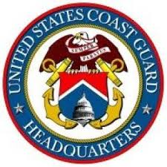
8 -12 September 2019: Hosting and support to HQ USCG Director of Maritime Systems and HQ Senior Arctic Policy Advisor (SAPA) visits to Anchorage, Juneau and Utqiagvik Alaska.
ADAC Executive Director and ADAC Senior Research Professional and Assistant Director hosted HQQ USCG Director of Maritime Systems and HQ Senior Arctic Policy Advisor (SAPA) to meetings at ADAC in Anchorage as well as supported meetings with USCG District 17 leadership at Juneau in addition to organizing and supported a series of meetings in Utqiagvik on Alaska’s North Slope.
DHS S&T OUP Funds were utilized to support travel for this event.
13 September 2019: ADAC conducted Monthly Fellows Meeting.
Monthly meeting with ADAC Student Fellows took place both in person and via video conference. ADAC Education and Administrative Manager conducted the monthly ADAC Fellows meeting, which included remote participation via Zoom for geographically dispersed Fellows. Fellows received administrative updates on their respective research assistance-ships, discussed current Arctic issues, and planned future activities. More details about ADAC student fellow programs can be found at https://arcticdomainawarenesscenter.org/Education.html
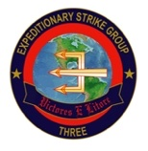
19 September 2019: ADAC hosted 3rd Expeditionary Strike Group (3 ESC) Commander, RDML Cedric Pringle.
RDML Pringle visited the ADAC offices to learn about Maritime Operational Research and to discuss the US Navy’s expanding role in the Arctic Region. Growing Naval Maritime Domain Awareness and expanding infrastructure requirements are significant drivers for increased interest in Arctic research.
19 September 2019: ADAC conducted 1st Quarterly Review of Program Year 6.
In accordance with the approved Program Year 6 work plan, ADAC conducted its first Program Year 6 Quarterly Review. This review served to ensure projects in program year were compliant with the Center’s project management criteria, while also serving as a preparation forum for ADAC’s Year 6 Annual Meeting

25-26 September 2019: ADAC Leadership and Researchers participated in the Center for Maritime Robotics Annual Meeting in Woods Hole, MA.
ADAC ED and AD/SRP joined with researchers associated with the Propeller-driven Long Range Autonomous Underwater Vehicle System (LRAUV System) for the WHOI the Center for Maritime Robotics’ Annual members meeting at the National Academies of Science in Woods Hole, MA. LRAUV team members participating in the CMR Annual Meeting included Dr. Jim Bellingham (WHOI), and members of the LRAUV System team. The CMR Annual Meeting highlighted current trends in UAV research and development for Department of Defense, NOAA, USCG, and commercial applications.
DHS S&T OUP Funds were utilized to support travel for this event.
26 September 2019: ADAC Leadership, LRAUV, and USCG RDC Joint Transition Meeting:
ADAC Leadership conducted a transition meeting for the LRAUV Project in concert with the Center Maritime Robotics Annual Meeting. The transition meeting included Amy Kukulya (WHOI), Dr. Jim Bellingham (WHOI), and Dr. Brett Hobson (MBARI), Mr. Brian Dolph (USCG RDC), ADAC ED, ADAC SRP, and ADAC FD. The transition meeting participants discussed new sensors including multibeam sonar, and established a crawl, walk, run concept for program year 6 under-ice operational testing.
DHS S&T OUP Funds were utilized to support travel for this event.
30 September 2019: ADAC conducted Geofence Project Advisory Committee Meeting.
As coordinated by Project Investigators and ADAC Central Leadership, a comprehensive update on ADAC’s project for Arctic Vessel Monitoring Geofencing/Alert Awareness was provided to HQ USCG Project Champion and associated Advisory Committee to review both the current version associated with general maritime operation

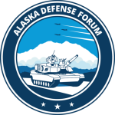
3-4 October 2019: ADAC participated in the Alaska Defense Forum in Fairbanks, Alaska. ADAC’s Executive Director gave a presentation the Alaska Defense Forum, hosted by the Fairbanks North Star Borough. The event brings together leaders from the Department of Defense, Alaska defense communities, State of Alaska, and industry to explore issues and local partnership with communities in Alaska.
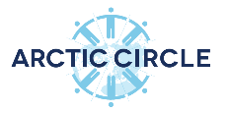
10-12 October 2019: ADAC Leadership attended the 2019 Arctic Circle Assembly in Reykjavik, Iceland.
ADAC’s Executive Director, Senior Research Professional & Assistant Director, and Research Director attended and participated in the Arctic Circle Assembly. The event held annually in Reykjavik, Iceland, is one of the largest gatherings on the Arctic and draws a variety of government officials, business leaders, indigenous leaders, and activists from across the region and the globe. ADAC Research Director Dr. Larry Hinzman moderated the keynote presentation of Dr. France A. Córdova, Director of the National Science Foundation, who serves at the driving force behind the Navigating the New Arctic initiative. Dr. Hinzman also hosted a panel on strengthening collaboration between the U.S. Department of Energy National Laboratories and the University of Alaska Fairbanks. ADAC Executive Director participated in multi-national panel on Arctic Security with research professionals from Canada, United Kingdom and Greenland.
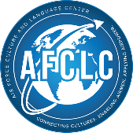
15 October 2019: ADAC meeting with Dr. Susan Steen from the Air Force Culture and Language and Language Center.
ADAC received a visit from Dr. Susan Steen with AFCLC Culture/Region Division. Dr. Steen serves as Assistant Professor of Cross-Culture Communication at the AFCLC.
17 October 2019: ADAC conducted 1st Quarter Customers and Partners Roundtable.
The first ADAC Year 6 C&P RT teleconference was conducted virtually in accordance with the Year 6 workplan. The meeting commenced with a review of the center’s efforts and accomplishments in the first quarter of Program Year 6. Each active and transiting research project provided a brief technical summary of their project and answered questions from federal customers and interested parties.

17-19 October 2019: ADAC participated in the Annual Alaska Federation of Natives (AFN) Convention. ADAC’s Executive Director attended and moderated a panel of military leaders at the Alaska Federation of Natives 2019 Convention in Fairbanks, Alaska. The AFN is largest annual gathering of the Alaskan Natives and serves as an important opportunity to engage with indigenous leaders and community members from rural Alaska. The theme of the 2019 convention was “Good Government, Alaskan Driven.”
24 October and 1 November 2019: ADAC conducted Executive Counselors Meetings.
In accordance with the ADAC Year 6 workplan, ADAC Executive Director hosted two meetings with the Center’s Executive Counselors (a primary and a back-up) to strategically review plans, challenges and opportunities for Program Year 6.
25 October 2019: ADAC conducted Monthly Fellows Meeting.
Monthly meeting with ADAC Student Fellows took place both in person and via video conference. ADAC Education and Administrative Manager conducted the monthly ADAC Fellows meeting, which included remote participation via Zoom for geographically dispersed Fellows. Fellows received administrative updates on their respective research assistance-ships, discussed current Arctic issues, and planned future activities. More details about ADAC student fellow programs can be found at https://arcticdomainawarenesscenter.org/Education.html
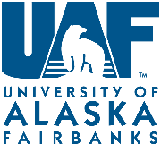
29-30 October 2019: ADAC attended US High Arctic Research Center (HARC) Executive Planning Committee.
ADAC Executive Director and Senior Research Professional attended a two-day planning committee workshop for the formulation of a proposal to establish a High Arctic Research Center on the North Slope of Alaska. The workshop was held at the University of Fairbanks and was attended by a range of Alaskan Arctic Stakeholders.
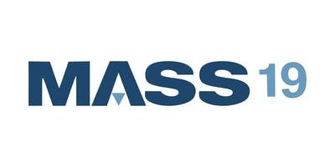
5-7 November 2019: ADAC SRP Presented at Maritime & Arctic Security & Safety Conference.
ADAC Senior Research Professional presented on ADAC Maritime Research in support of USCG Arctic Operations at the Maritime & Arctic Security & Safety Conference. The sixth installment of the conference, the event was hosted in Newfoundland Canada by the Atlantic Canada Aerospace and Defense Association.
8 November 2019: ADAC conducted Monthly Fellows Meeting.
Monthly meeting with ADAC Student Fellows took place both in person and via video conference. ADAC Education and Administrative Manager conducted the monthly ADAC Fellows meeting, which included remote participation via Zoom for geographically dispersed Fellows. Fellows received administrative updates on their respective research assistance-ships, discussed current Arctic issues, and planned future activities. More details about ADAC student fellow programs can be found at https://arcticdomainawarenesscenter.org/Education.html
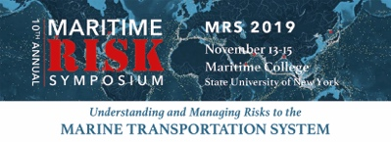
13- 15 November 2019: ADAC SRP participated in the 10th Annual Maritime Risk Symposium. Hosted by the Maritime College of State University of New York, (SUNY) Bronx, the conference pulls together government, academia, and industry to examine risk to the United States Marine Transportation System. ADAC SRP attended Maritime Risk Symposium presentations, represented ADAC at the initial MRS 2020 planning session, and participated in the student poster competition as a judge.
DHS S&T OUP Funds were utilized to support travel for this event.
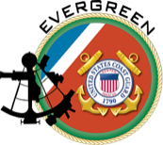
14 November 2019: ADAC SRP Participated at USCG “Evergreen Project.”
ADAC Senior Research Professional participated at HQ USCG DCO-X hosted “Evergreen Project” as a breakout group participant per HQ USCG request, in the afternoon of day 2 MRS 2019, SUNY NY.
DHS S&T OUP Funds were utilized to support travel for this event.

13-15 November 2019: Alaskan Command Arctic Symposium 2019 (AAS19).
In support of U.S. Northern Command (USNORTHCOM), Alaskan Command (ALCOM) hosted the ALCOM Arctic Symposium (AAS19) from 13-15 November 2019 at the University of Alaska Fairbanks. The overarching goal of the symposium was to support USNORTHCOM’s Arctic mission, through convening of a wide array of Arctic leaders and experts.
The theme of AAS19 was “Advancing Strategic Partners in Securing American and Allied Arctic Interests.” In short, the principal goal of the symposium was to improve and strengthen the understanding of the challenges associated with the complicated risk environment that describes the new Circumpolar North. The symposium sought to create a set of thoughtful and collaborative discussions amongst Arctic experts in order to explore the potential solutions associated with safety, security, and defense risks in the region.
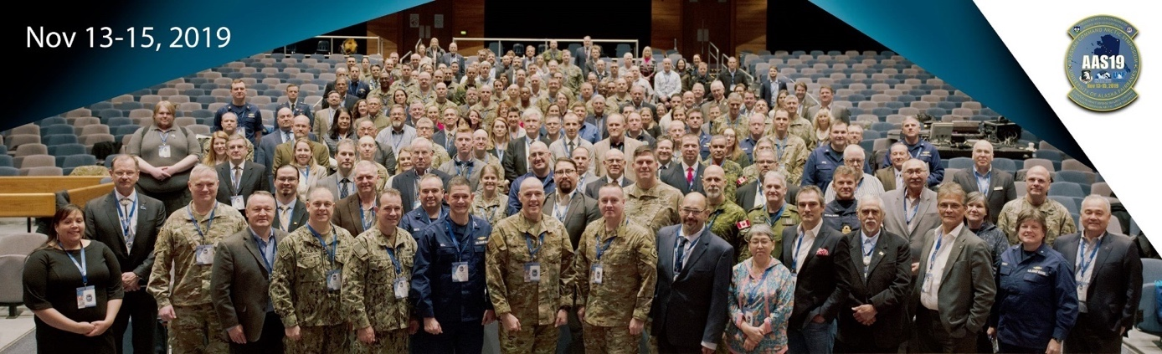
Figure 1: Arctic Symposium 2019 Group Photo
Symposium attendees included military leaders and personnel, academia, industry members and leaders, congressional leaders, tribal leaders, and international defense officials. The event was supported by moderators from the University of Alaska Fairbanks Homeland Security and Emergency Management program, the Polar Institute of the Woodrow Wilson Center, Trent University, and Alaska Federation of Natives. The changing environmental and strategic conditions throughout the Arctic region require us to seek increased Arctic awareness, enhanced Arctic operations, and a strengthened rules-based order in the Arctic. This symposium was meant to shape the way forward in ensuring the Arctic remains a secure and stable region.
Note, HQ USCG SAPA, USCG Pacific Area and USCG District 17 Commanders were active and engaged participants of the ALCOM Arctic Symposium.
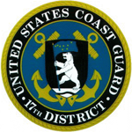
19-20 November 2019: IoNS 2020 Exercise (Arctic Air 2020) Initial Planning Meeting. ADAC Executive Director and Senior Research Professional hosted USCG D17 Contingency Planning Branch Chief CDR Meredith Gillman, D17 Arctic Planner CAPT (Ret) Phil Thorne, and D17 SAR specialist Paul Webb in facilitating the Initial Planning Meeting for IoNS 2020. The meeting was supported by representatives from USAF AKRCC, Alaska National Guard Joint Emergency Operations Center, and the Commercial Airline Industry.

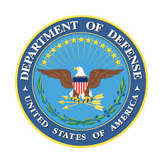
21 November 2019: Meeting with DASD EUR-NATO, Mr. Michael C. Ryan
ADAC Executive Director met with the Deputy Assistant Secretary of Defense for Europe and North Atlantic Treaty Organization (EUR-NATO) for the secretary’s orientation to Arctic security and research associated with supporting Arctic maritime operations at the Pentagon, Washington D.C.
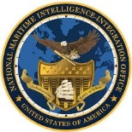
21 November 2019: NGA/NMIO Maritime Community of Practice Conference on the Arctic.
ADAC Executive Director participated in the National Geospatial Intelligence Agency (NGA) and National Maritime Intelligence Office (NMIO) Arctic Community of Practice meetings held at Springfield VA.

26 November 2019: ADAC released 2nd Quarter Newsletter.
ADAC’s second newsletter of Program Year 6 covered the activities of the Center since July 2019. The newsletter featured articles on marine environmental research, ADAC’s experience at the Arctic Circle Assembly, and profiles of ADAC Senior Research Professional Jason Roe and Fellow Daniel Cruz. Please see: https://arcticdomainawarenesscenter.org/Publications
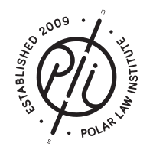
2 December 2019: ADAC participated in the 12th Annual Polar Law Symposium in Hobart, Tasmania, Australia.
ADAC Executive Director attended and participated in this international conference hosted by Institute for Marine and Antarctic Studies (IMAS), the Polar Law Institute, the Northern Institute for Environmental and Minority Law, and the University of the Arctic. The symposium was held at the IMAS campus in the capital city of the state of Tasmania, and featured academics, students, and practitioners in polar law from around the word.

3-5 December 2019: ADAC Hosted Arctic Maritime Spill Modeling (AMSM) Conference.
The Center for Spills and Environmental Hazards (CSE) and Arctic Domain Awareness Center (ADAC) hosted this workshop at the University of Alaska in Anchorage, AK. The workshop was facilitated by Dr. Nancy Kinner with CSE with the objective of identifying key topics that needed to be resolved to improve oil spill response modeling. The Conference resulted in 4 Working Groups: Oil and Ice Interactions (at the meter scale), Oil and Ice Interactions (at the kilometer scale), New and Existing Technologies for Observing Ice and Informing Models, and Visualization and Uncertainty in oil spill modeling data. These working groups will conclude with a conference to be held in November 2020 to integrate feedback into a knowledge product.
DHS S&T OUP Funds were utilized to support travel for this event

4 December 2019: ADAC participated in The Scope for the Greater Five Eyes Cooperation for the Arctic and Antarctic Presentation.
ADAC Executive Director served as a panel member for a discussion covering to what extent the Five Eyes nations should increase their role within the Arctic. The presentation was hosted by the Australian Institute of International Affairs – Victoria and featured panelist from Trent University, the Royal Military College of Canada, Arctic Circle, Polar Research and Policy Initiative, and the Morris J. Wosk Centre for Dialogue at Simon Fraser University.
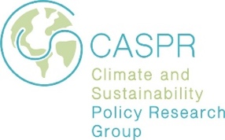
5-6 December 2019: ADAC Participated in Geostrategic Futures in the Southern Ocean and Antarctica Workshop.
ADAC Executive Director participated in a workshop hosted by the Climate and Sustainability Policy Research Group at Flinders University in Canberra, Australia. The Geostrategic Futures brought together thought leaders and stakeholders from both Poles to address strategic challenges within Antarctic and the Southern Ocean. ADAC’s Executive Director served as a panelist discussing New and emerging security challenges and threat vectors: Environmental security and domain awareness. ADAC’s Principal Investigator participated remotely.
6 December 2019: conducted ADAC “NSF-style Science Review” Panel in response to Arctic IoNS 2019 Proposals.
ADAC Principal Investigator finalized the Science Review Panel, which was conducted in support of Arctic IoNS 2019. This was subsequently provided to DHS S&T UP Program Leadership in support of overall evaluation of the 9 proposals responding to the Arctic IoNS 2019 funded solicitation.
11 December 2019: ADAC participated in DHS S&T CoE Directors Meeting. Via Electronic Communications.
ADAC Leadership participated in the monthly DHS S&T OUP Directors meeting.

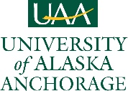
13 December 2019: End of the University of Alaska Fall 2019 Semester.
Student-related fall semester activities were completed, and the Academic components of the university entered winter break.

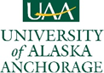
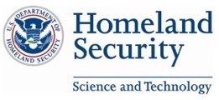
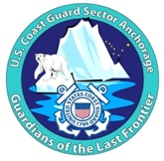
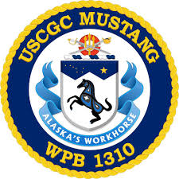
16-19 December: DHS Senior Official Performing the Duties of the Undersecretary of Science and Technology (SOPDUSST) visit to ADAC and University of Alaska Anchorage. ADAC facilitated the visit by the SOPDUSST through a series of gatherings, meetings, and visits with local ADAC staff, students, and researchers, as well as with ADAC’s broad network of local academic and Federal partners. During Day 1 of the visit, ADAC facilitated an overview and roundtable regarding COE endeavors in Arctic research & innovation, education, and convening activities in support of USCG Arctic mission. The meetings showcased USCG and the community of Arctic operators within Alaska, across the U.S., and internationally across the Circumpolar Arctic and included roundtables regarding COE endeavors in Arctic research & innovation, education, and convening activities in support of USCG Arctic missions. They were conducted with representatives from DHS S&T OUP, The University of Alaska system, USCG District 17 (D17), and ADAC Executive Counselors. Day 1 Lunch included representatives from DHS S&T OUP, USCG D17, and USCG Sector Anchorage. After Lunch ADAC Leadership facilitated a tour of USCG D17 Sector Anchorage, received a Command Overview, and conducted a roundtable with USCG D17 and Sector Anchorage Command Center personnel, specifically focused on USCG Arctic Mission, mission challenges, and current efforts by ADAC to address shortfalls in the Arctic. Following the tour of Sector Anchorage, ADAC Leadership convened a DHS, USCG, and ADAC Federal and State Partner Alaska-based Roundtable focused on Arctic safety, security, and response. This Roundtable was attended by Senior Leadership from NORAD, ALCOM, USCG, Alaska National Guard; and regional representatives from DHS S&T, FBI, NOAA, CBP, BOEM, National Labs, University of Alaska, Canada’s Department of National Defence Research and Development Center, Alaska Federation of Natives, among others. Day 2 consisted of travel to Port of Alaska in Anchorage for a discussion on the Port of Alaska and associated infrastructure and supply chain vulnerabilities. This discussion was attended by DHS S&T OUP, the Mayor of Anchorage, and Director of External Affairs for the Port of Alaska. From the Port of Alaska, the group traveled by car to Whittier, Alaska and toured the USCGC MUSTANG. The USCGC MUSTANG tour provided the SOPPDUST, DHS S&T, HQ USCG and other Federal representatives a unique operational perspective on Arctic and Alaskan maritime operations.
19 December 2019: ADAC conducted 2nd Quarterly Review.
In accordance with the approved Program Year 6 work plan, ADAC conducted its second Program Year 6 Quarterly Review. This review served to ensure projects in program year were compliant with the Center’s project management criteria, while also serving as a preparation forum for ADAC’s Year 6 Annual Meeting.
20 December 2019: ADAC conducted Monthly Fellows Meeting.
Monthly meeting with ADAC Student Fellows took place both in person and via video conference. ADAC Education and Administrative Manager conducted the monthly ADAC Fellows meeting, which included remote participation via Zoom for geographically dispersed Fellows. Fellows received administrative updates on their respective research assistance-ships, discussed current Arctic issues, and planned future activities. More details about ADAC student fellow programs can be found at https://arcticdomainawarenesscenter.org/Education.html

6-10 January 2020: ADAC Executive Director participated in Sandia NL and UTEP Research Coordination Meetings.
ADAC Executive Director met in a series of discussions with leadership and staff focused on Arctic science and research at Sandia National Laboratories, Albuquerque New Mexico to foster pathways to practically implement the Sandia-ADAC Cooperative Research and Development Agreement (CRADA) approved in 2019. Following Sandia meetings, ADAC ED met with University President and Research leadership at University of Texas El Paso to advance existing ADAC-UTEP collaboration in educational activities.
8 January 2020: ADAC participated in DHS SRT CoE Directors Meeting
ADAC Leadership participated in the monthly DHS S&T OUP Directors meeting

13 January 2020: ADAC facilitated Arctic Environmental Security Class Begins at UAA. ADAC Executive Director and Principal Investigator began instruction for BIOL 490/690 “Arctic Environmental Security” course at UAA, the 3rd Spring Semester the course has been instructed.

15 January 2020: ADAC Team Met with Jodie Anderson, Director of the Matanuska Experiment Farm and Extension Center.
Ms. Anderson visited ADAC office to meet with ADAC leadership to discuss collaboration opportunities centered around food production and security in the High North Latitudes.
16 January 2020: ADAC conducted 2nd Quarter Customers’ and Partner’s Roundtable.
The second ADAC Year 6 C&P RT teleconference was conducted virtually in accordance with the Year 6 workplan. The meeting commenced with a review of the center’s efforts and accomplishments in the second quarter of Program Year 6. Each active and transiting research project provided a brief technical summary of their project and answered questions from federal customers and interested parties.
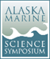
28-30 January 2020: ADAC participated in Alaska Marine Science Symposium. Anchorage Alaska ADAC leadership and researchers participated at this annual event in downtown Anchorage. ADAC Fellows participated in the conference with posters and presentations. UAA ADAC Fellow Kelly Ireland was awarded Best Student Poster at the Symposium.

29-30 January 2020: ADAC participated in Alaska Day 2020. Washington D.C.
ADAC Executive Director served as a moderator for Alaska Day(s) 2020, a gathering of federal government officials and Alaskan Native leaders hosted by the Alaska Federation of Natives in Washington DC. Key attendance included Alaska Command leadership, Alaska Congressional Delegation and Federal Departments from Justice, Defense and Interior.
31 January 2020: ADAC conducted Mid-Year Quarterly Review with ADAC Executive Counselors (via teleconference and in person meeting Washington D.C.).
In accordance with the approved Program Year 6 work plan, ADAC conducted its Mid-Year Program Year 6 Quarterly Review. This review served to ensure projects in program year were compliant with the Center’s project management criteria, while also serving as a preparation forum for ADAC’s Year 6 Annual Meeting.
10 February 2020: Marine IP Research Team conducted Ice Tests at CRREL.
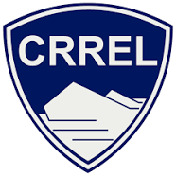
The ADAC Marine Induced Polarization (Marine IP) research team coordinated with the CRREL for use of their ice generating lab at the CRREL facilities at Hanover NH. The Marine IP team tested induced polarization methodology under ice and collected data representative of differing ice environments.
28 February 2020: ADAC Assistant Director met with Alaska Lt Gov Kevin Meyer.
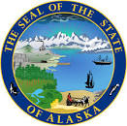
University of Alaska Arctic Researchers met with Alaska Lt Gov Kevin Meyer at the University of Fairbanks to promote the many benefits of University Research and illustrate the value of University of Alaska research to the State of Alaska.
28 February 2020: ADAC conducted Monthly Fellows meeting.
Monthly meeting with ADAC Student Fellows took place both in person and via video conference. ADAC Education and Administrative Manager conducted the monthly ADAC Fellows meeting, which included remote participation via Zoom for geographically dispersed Fellows. Fellows received administrative updates on their respective research assistance-ships, discussed current Arctic issues, and planned future activities. More details about ADAC student fellow programs can be found at https://arcticdomainawarenesscenter.org/Education.html

2 March 2020: ADAC Leadership and Researcher observed KupEx 2020 Oil Spill Response Exercise.
ADAC Assistant Director and Senior Research Professional joined the Long Range Autonomous Underwater Vehicle (LRAUV) Co-PI Amy Kukulya to observe an oil spill response exercise at Kuparuk Oil Field on Alaska’s North Slope. The exercise included responders and on-scene coordinators from the USCG, EPA, The Alaska Department of Conservation (ADEC), the North Slope Borough, Alaska Clean Seas, and ConocoPhillips. As the exercise progressed, several stakeholders expressed interest in the capabilities of LRAUV which could serve as an important tool in oil spill response planning.
DHS S&T OUP Funds were utilized to support travel for this event
5 March 2019: ADAC released 3rd Quarter Newsletter.
ADAC’s third newsletter of Program Year 6 covered the activities of the Center since July 2019. The newsletter featured articles on the KupEX 2020 Oil Spill Response Exercise and a Fellow Spotlight on ADAC Fellow Kelly Ireland. Please see: https://arcticdomainawarenesscenter.org/Publications
10-11 March 2020: ADAC Conducted Arctic IoNS 2020 Arctic Air Final Planning Meeting.
ADAC Leadership, including Executive Director and Assistant Director, conducted a final planning meeting in anticipation of the Arctic Air 2020 tabletop Exercise originally planned to be held in March 2020. Due to concerns related to COVID-19, the team made the determination to postpone the event to 26-27 August 2020. The event has been further postponed for an in-person meeting in Spring 2021.
17 March 2020: ADAC began remote operations in response to COVID-19.
ADAC transitioned to remote operations in anticipation of forthcoming guidance from the UA President and the UAA Chancellor. The ADAC Center office was subsequently closed, and staff transitioned to “telework status” in compliance with signed telework agreements between staff members and the UAA administration.
2 April 2020: ADAC Executive Director Co-Hosted State of Alaska Civil Armed Services Team (ACAST) 1st Quarter 2020 Meeting.
ADAC ED co-hosted a meeting to support a number of new initiatives to advance needed support to U.S. military, to include USCG concerns in Alaska. Meeting minutes and draft memo for State of Alaska Governor drafted and provided to Alaska Adjutant General.
3 April 2020: Submitted LRAUV USCG Concept of Applications to HQ USCG Project Champion, DHS S&T, and USCG Customers. The purpose of this Concept of Applications was to provide a series of potential use cases suitable for the Propeller Driven Long Range Autonomous Underwater Vehicle (LRAUV) System employment by U.S. Coast Guard, in support of U.S. Coast Guard through deployment by non USCG entities and employment of LRAUV System capabilities in Arctic missions that are important and useful to USCG’s statutory missions. This Concept of Applications can help inform LRAUV transition planning and future industry involvement.
7 April 2020: ADAC submitted ADAC Year 6 Program Carry Forward requests to DHS S&T OUP.
ADAC Executive Director, in coordination with ADAC Financial Director, submitted the ADAC Program Year 6 carry forward request to DHS S&T OUP Program Manager.
9-10 April 2020: ADAC conducted 3rd Quarterly Review of Program Year 6.
In accordance with the approved Program Year 6 work plan, ADAC conducted the Center’s third Program Year 6 Quarterly Review. This review served to ensure projects in program year were compliant with the Center’s project management criteria, while also serving as a preparation forum for ADAC’s Year 6 Annual Meeting
10 April 2020. ADAC leadership met with UAA Provost regarding a Proposed Masters in Arctic Security.
Over the preceding months, ADAC initiated a University of Alaska-wide multi-track and disciplined Masters in Arctic Security, providing advance copies to DHS S&T OUP, HQ USCG, USCG D17 and Alaska Command as well as UAA leadership. The meeting resulted in an agreement by the UAA Provost to initiate a formal review and integration process to academically review the master’s program for incorporation as an approved UA/UAA credentialled master’s program.
10 April 2020: ADAC conducted Monthly Fellows Meeting.
Monthly meeting with ADAC Student Fellows took place via video conference. ADAC Education and Administrative Manager conducted the monthly ADAC Fellows meeting, which included remote participation via Zoom. Fellows received administrative updates on their respective research assistance-ships, discussed current Arctic issues, and planned future activities. More details about ADAC student fellow programs can be found at https://arcticdomainawarenesscenter.org/Education.html
28 April 2020: ADAC submitted ADAC Program Year 7 Initial Draft Workplan (Version 1.1).
ADAC leadership submitted the first draft of the Year 7 Workplan to DHS S&T OUP.

1 May 2020: ADAC conducted ICE-PPR Situational Awareness Working Group Meeting – US Only. This meeting centered around introducing US officials with the ICE-PPR, in which ADAC Executive Director as named by the Chief of Naval Research to serve as the U.S. lead for the Situational Awareness Working Group (USSAWG), as a U.S. ICE-PPR Principal.
8 May 2020: ADAC conducted Fellows Review/End of Academic Year Meeting.
Each ADAC fellow conducted virtual presentations for their research projects for their cohorts and the ADAC leadership team. Projects included research on ADAC's supported projects, as well as graduate thesis work where applicable. As of 11 May 2020, all ADAC fellows completed their spring 2020 semesters and participated in the ASIP Virtual Summer Internship which commenced on 1 June.
7 May 2020: ADAC supported ICE-PPR Situational Awareness Working Group Meeting. This meeting of the ICE-PPR Situational Awareness working group followed several meetings with ONR ICE-PPR lead (LCDR John Woods), Danish lead for ICE-PPR and multi-national team for Situational Awareness Working Group following receipt of Memo from Chief of Naval Research.
11 May 2020: Conclusion of Arctic Environmental Security Course and UAA Spring 2020 Semester.
Executive Director and Principal Investigator completed instruction for BIOL 490/690 “Arctic Environmental Security” course at UAA.

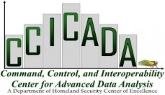
12 May 2020: ADAC participated in DHS S&T Meeting Regarding “COVID-19 Supply Issues.” ADAC leadership participated in the meeting led by Dr. Fred Roberts from fellow DHS Center of Excellence CCICADA in advancing possible areas of research addressing COVID19 impacts to supply chains across the United States.

12 – 14 May 2020: ADAC participated in Department of Defense’s “Transatlantic Security Jam: Securing the Post-COVID Future.”
ADAC leadership and staff participated in the “Transatlantic Security Jam,” a virtual conference hosted by AFCEA and PfP Consortium with technical support from IBM. The exclusively online event took place over 50 hours with members of the transatlantic security and defense community coming together for an international brainstorm to discuss the security landscape of the post-COVID 19 future. ADAC leadership took part in facilitating discussions on the security of implications of COVID-19 in the Arctic and ADAC staff provided comments to expand existing security conversations to include the Arctic region. Overall, the use of the innovative IBM platform used to facilitate event helped to inform further conversations on how ADAC can best adapt upcoming workshops and events to a virtual model that encourages robust participation and produces useful knowledge products.

14 May 2020: ADAC conducted Annual Meeting.
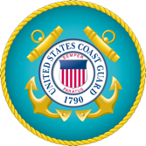
ADAC leadership project Principal Investigators, DHS S&T OUP, HQ USCG ADAC Project Champions, and other customers and partners participated ADAC’s Year 6 Annual Meeting. The Annual Meeting was held virtually via Cisco WebEx as COVID-19 prevented an in-person gathering in Washington D.C. as in previous program years. The meeting was well attended drawing a total of 202 registrations for the 7-hour virtual event with a peak of 157 participants.
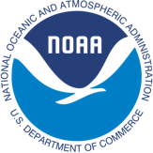
The session featured guest speakers including UAA Chancellor Dr. Cathy Sandeen, a DHS and NOAA S&T "fireside chat" by the DHS Senior Official Performing the Duties of the Undersecretary of Science & Technology, Mr. Bill Bryan and the Deputy NOAA Administrator, Dr. Tim Gallaudet, RDML, USN (Ret) along with key insights Director of the DHS S&T Office of Innovation and Collaboration, Mr. Bob Burns. The Commandant of the USCG, Admiral Karl Schultz provided keynote reflections.
ADAC Leadership provided an overview of Center efforts (which included on-going Center activity to bring new research online and transition strategies), followed by current project presentations. ADAC Principal Investigator, Research Director, Executive Director, Finance Director, and Education and Administrative Manager presented details of their participation in the Center and associated efforts. Each project investigator or designated team member presented on current project research, schedule & milestones, metrics and transition. The meeting was followed by virtual roundtable on 15 May 2020 where Annual Meeting participants had the opportunity to ask to follow up questions regarding ADAC’s Year 6 efforts and the research projects.
20 May 2020: ADAC conducted Call with New ALCOM Commander, Lt. Gen. Krumm. ADAC leadership met with Lt. Gen. Krumm and was informed that ADAC would receive a new 5-year contract from Pacific Air Forces to conduct Arctic Symposiums and Arctic Senior Leader Summits in the summer 2020.

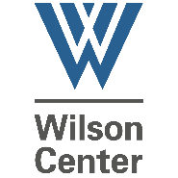
21 May 2020: ADAC PI Participated in “COVID-19 Impacts in the Arctic” Event. ADAC PI support USARC as panel moderator for the event hosted by the Wilson Center and U.S. Arctic Research Commission. ADAC Center Leadership and staff also participated and attended sessions of the event.

22 May 2020: ADAC conducted/Led a ONR ICE-PPR U.S. Situational Awareness Working Group Meeting.
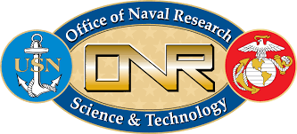
ADAC Executive Director, led the first Situational Awareness Working Group (ICE-PPR USSAWG) meeting. ADAC’s lead of the USSAWG includes multiple USCG and Department of Defense agencies. USCG participants include HQ USCG CG5PW, CG926, USCG R&D Center and USCG Pac Area. Overall ICE-PPR SAWG lead is provided by the Danish Armed Forces.
26 May 2020: Dr. Nettie Labelle-Hamer joined ADAC team as Research Director.
Following the departure of Dr. Larry Hinzman from his position of UAF Vice Chancellor of Research (VCR), the incoming Interim VCR, Dr. Nettie Labelle-Hamer, joined ADAC Leadership as the Center’s Research Director. ADAC staff provided a virtual meet and greet and orientation following her appointment
27 May 2020: ADAC conducted Spring 2020 Executive Counselors Meeting.
ADAC Executive Director hosted the Spring 2020 meeting with Center Executive Counselors via video conference. Executive Counselors Dr. John Farrell, Rudy Peschel RADM USCG (Ret.), Michael Duxbury, and Dr. Paul Hubbard all participated in the meeting. Individual consultations with absent Executive Counselors were scheduled following the meeting. ADAC Executive Director provided an update on the status of the Year 7 Workplan as well as the progress of current ADAC projects and facilitated discussions regarding the possible replacements for a departing Executive Counselor. ADAC Executive Counselors are the Center’s board of advisors who serve in a pro-bono capacity to guide and advocate for ADAC with the communities in which these advisors intersect.
29 May 2020: DHS S&T OUP and HQ USCG Accepted Arctic IoNS 2019 Proposal: "Remote Unmanned Aircraft System (UAS) Inspection and Response Team Development in the Bering Strait Region".
DHS and USCG provided formal notification of the “accepted proposal” of “"Remote Unmanned Aircraft System (UAS) Inspection and Response Team Development in the Bering Strait Region,” an ADAC Arctic Incidents of National Significance 2019 proposal. The project team is led by Jessica Garron of UAF and supported by researchers with the Alaska Center of Unmanned Aerial System Integration (ACUASI) and researchers based in Unalakleet and the Pacific Northwest. The team prepared a workplan and budget for review in anticipation of the project’s start date of 1 July 2020.
2 June 2020: ADAC conducted Orientation and First Day of ADAC Virtual Arctic Summer Internship. ADAC Education and Administrative Manager commenced the first day of ADAC’s Virtual Arctic Summer Internship. Students were provided with an overview of the internship’s structure as well as introductory remarks from ADAC leadership.
3 June 2019: ADAC released 4th Quarter Newsletter.
ADAC’s fourth newsletter of Program Year 6 covered the activities of the Center since July 2019. The newsletter featured articles on the Virtual ASIP program plus a welcome to our new Research Director Nettie La Belle-Hamer and a farewell to outgoing Research Director Larry Hinzman.

4 June 2020: ADAC developed Draft Article for USCG Proceedings.
ADAC provided draft USCG Proceedings Article on 4 June 2020 and follow-up on 5 June regarding options in developing a final article based on the ADAC DHS S&T Program Manager’s suggestions.
8 June 2020: Arctic Circle Secretariat accepted ADAC Proposals for Arctic Circle Assembly 2020. Two ADAC panel submissions were accepted for the 2020 Arctic Circle Assembly in Reykjavik, Iceland. ADAC proposed two panels: “Governance, Environmental Security & the Arctic Maritime Transportation System” and “Stability and Resilience in the Arctic: An Interdisciplinary Security Approach" The forum is the largest international gathering in the Arctic and hosts a wide range of attendees including government officials, scientists, business leaders, activists, and indigenous representatives from across the Arctic Circle. Due to concerns related to COVID-19, the Arctic Circle 2020 session was postponed to 2021. ADAC will have the opportunity to host the aforementioned panels should the event proceed as planned in 2021.
17 June 2020: ADAC participated in the Alaska Defense Industry Resiliency Group.

ADAC Leadership participated in a group meeting for the Alaska Defense Industry Resiliency Initiative, an effort by the UAA’s Center for Economic Development. Participation informed the first phase of the Initiative, centered around developing a series of reports to lay a foundation for economic development strategies centered around the State of Alaska’s large and historically important defense sector.
18 June 2020: ADAC conducted Final Program Year 6 Quarterly Review.
In accordance with the Year 6 Workplan, ADAC completed the final Quarterly Review of Program Year 6.
24 June 2020: ADAC Executive Director Co-Hosted State of Alaska Civil Armed Services Team (ACAST) 2nd Quarter Meeting.
ADAC ED co-hosted a meeting to support a number of new initiatives to advance needed support to U.S. military, to include USCG concerns in Alaska. Meeting minutes and updated draft memo for State of Alaska Governor drafted and provided to Alaska Adjutant General.
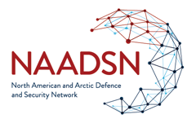
24 June 2020: ADAC Executive Director participated in the Northern American and Arctic Defense Security Network Workshop “North American Arctic Security in a Geopolitically Contested World.
ADAC Executive Director, who serves in a pro-bono capacity to NAADSN, jointed NAADSN hosted discussions on the Arctic, which featured USAF’s Iris Ferguson as a principal speaker.
25 June 2020: ADAC conducted Final Program Year 6 Customers and Partners Roundtable.
The final ADAC Year 6 C&P RT teleconference was conducted virtually in accordance with the Year 6 workplan. The meeting commenced with a review of the center’s efforts and accomplishments in the final quarter of Program Year 6. Each active and transiting research project provided a brief technical summary of their project and answered questions from federal customers and interested parties.
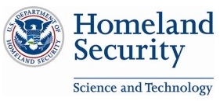
30 June 2020: DHS S&T OUP approved ADAC’s Program Year 7 Workplan and Close of ADAC Program Year 6.
DHS S&T OUP provided official approval of ADAC’s Program Year 7 Workplan with the exception, Marine IP, and ARCTICE which were awarded approval later in early ADAC Program Year 7.
30 June 2019: Close of ADAC Program Year 6.
The remainder of this report maps ADAC’s results for the period of performance from 1 July 2019 through 30 June 2019 in accordance with the Center’s Program Year 6 workplan approved by DHS S&T OUP. This report addresses the following
- Center management efforts.
- Performance reports on each project, including:
  - Explanations of changes from the associated ADAC Year 6 approved Workplan.
  - Progress against milestones with explanations.
  - Unanticipated problems and obstacles and how they were overcome.

- Summary of Center Management Efforts
The overall effort of the Center’s leadership, staff, and research team was to achieve the deliverables and meet the metrics outlined by the Program Year 6 Workplan. The Workplan serves as an overall strategy to drive Center efforts, allowing leadership to effectively divide responsibility to accomplish multiple tasks and efforts simultaneously. The follow describes the strategic implementation of the plan and results of Center management activities.
USCG and other DHS maritime Arctic operators remain the key end users propelling research for the Center. Throughout Program Year 6, the Center continued to explore both fundamental and applied research in the Arctic.
ADAC’s leadership delineated the execution of the Program Year 6 Work Plan accordingly:
- Direct and manage the research of established projects, which includes extensive research transition coordination between Project teams, USCG Project Champions, HQ USCG Acquisition and DHS S&T OUP. This entailed 60% of the ADAC management focus. Specific tasks and associated measurements include:
Table 1. Tasks and associated metrics for direction and management of established projects.
Task | Associated Metric | Met task and associated metric?
Conduct weekly teleconferences with ADAC Project leads and research teams. | Informed ADAC leadership and research team. | Yes
Participate in weekly teleconference with DHS S&T UP Program Manager. | Informed DHS S&T UP Program Manager. | Yes
Conduct monthly project invoice review. | Fiscal understanding of each project performance on monthly basis. | Yes
Conduct a Quarterly Review with ADAC Project Leads and research teams for DHS S&T UP Approved workplans that includes specific project transition planning. | Comprehensive review of project performance by ADAC leadership team, enabling oversight on a scheduled basis. | Yes
Conduct one Quarterly Review with ADAC Project Leads and research teams, with the Executive Counselors. | Comprehensive review as with regular reviews, with added recommendations from ADAC’s Executive Counselors. | Yes
Prepare Center and project Work plan for any approved research activities that extend beyond Year 6 (30 June 2020). | Approved plans and activities by DHS S&T UP PM. | Yes
Establish new projects from Spring 2019 Arctic IoNS workshop. This includes concluding proposal reviews, notification, development of workplans and establishing HQ USCG Project Champions. | Projects approved by DHS S&T OUP PM. | Yes
Subrecipient monitoring via ADAC leadership in-person visits at each subrecipient of the DHS S&T OUP Cooperative Grant location (university or business). | Successfully concluded subrecipient monitoring. ADAC leadership plans to conduct a minimum of one subrecipient monitoring visit at each location at least once per two-year program period. | Yes
Prepare Annual Report reporting on Center activities and Project Research | Approved report by DHS S&T O  UP PM. | Yes
Participate in detailed effort for project transition, including collaboration with HQ USCG CG-9 ADAC point of contact and USCG Project Champions. | Established transition pathway for ADAC research to meet USCG acquisition needs. | Yes
Investigate commercial opportunities for research transition, including patent and licensing. | Approved patents and/or licensing from submitted proposals. | No

- Continue research development Initiative started in Program Year 4 and extended through Year 6. This entails 10% of ADAC leadership focus. This effort entails collaborating with DHS S&T OUP and USCG for workshops that generate research questions, conducting and processing calls for research. Specific tasks and associated measurements include:
Table 2. Tasks and associated metrics for continuation of Year 4 and 5 research initiatives.
Task | Associated Metric | Met task and associated metric?
Plan and conduct Arctic IoNS workshop, with topic determined by USCG (in particular, USCG D17 Commander). | Successfully concluded workshop that provides workshop Rapporteurs report and USCG approved research questions. Research questions may result in ADAC funded solicitation, simply intended for mission agencies to consider sponsoring research, which addresses priority shortfalls identified at the workshop. | No
Coordinate and conduct Arctic Medium and Long-Term Environment (Arctic MaLTE) workshop focused on HQ USCG security and safety concerns | Conducted workshop addressing HQ USCG security and safety concerns. | No

- Conduct outreach, engagement and communications with customers, partners and collaborators, including potential new partners, to inform of center initiatives and research project details, while advancing ADAC’s research networks. This encompassed 10% of ADAC leadership focus. Specific tasks and associated measurements include:
Table 3. Tasks and associated metrics for conducting outreach, engagement, and communications.
Task | Associated Metric | Met task and associated metric?
Prepare and conduct Annual meeting in Washington D.C. (preferably at HQ USCG). | Successfully presented meeting, informing DHS, USCG and invited participants of ADAC research and transition planning. | Yes (Conducted Virtually due to COVID-19 Travel Restrictions)
Conduct approximately quarterly Customers and Partners Roundtables via teleconference/webinar. | Successful completion of roundtables, and publishing of associated minutes. | Yes
Conduct semi-annual USCG focused ADAC “Principal Customer’s” research project teleconference. | Successful completion of teleconference. | Yes
Participate in Alaska Marine Science Symposium (January 2020). | ADAC completing a planned presentation. | Yes
Conduct an Anchorage Arctic Research Day, highlighting ADAC activities and research (in partnership with fellow UAA researchers). | ADAC participates, presents and contributes to Anchorage Arctic Research day. | No. Cancelled due to COVID19
Develop center and project motion graphics presentations in support of outreach. | Completed and posted motion graphics that describe ADAC efforts. | Yes
Prepare and release quarterly newsletters. | Published newsletters to established ADAC mailing list and posted to Center website. | Yes
Prepare brief noteworthy activities and project vignettes for DHS S&T UP communications staff. | Providing DHS S&T UP, communications needed information of ADAC activities and project research. | Yes
Update ADAC website, Facebook and Twitter of Center activities and noteworthy events. | Informing public of ADAC activities and research. | Yes
Publish specific ADAC events and activities to Interagency Arctic Research Policy Committee (IARPC). | Informing community of Arctic researchers about ADAC activities. | Yes

- Continue conducting education, outreach, and workforce development efforts consisting of a variety of activities that include both ADAC Fellows and minority students. ADAC anticipated this effort requires 10% of Center leadership focus.

Table 4. Tasks and associated metrics for conducting education, outreach, and workforce development efforts.
Task | Associated Metric | Met task and associated metric?
Recruit student interns (ADAC Fellows) for available research. | Achieve 100% fill for ADAC Fellow available slots. | Yes
Assign projects and develop workplans to ADAC Fellows. | Students fully assigned to projects with associated workplans. | Yes
Conduct monthly ADAC Fellows meetings. | Accomplish planned meeting schedule. | Yes
Conduct an ADAC Student research Symposium. | Completed symposium highlighting student research efforts via virtual means. | Yes
Support ADAC Fellows entry into suitable 10- week summer internship; | All ADAC Fellows conclude a 10-week summer internship. | Yes
Support post-graduate student placement with Homeland Security Enterprise (HSE). | All graduated ADAC Fellows complete one year minimum service in an HSE related position or alternatives as described in the DHS OUP Terms and Conditions. | Yes
Recruit and conduct an abbreviated Minority Serving Institute (MSI) Arctic Summer Intern Project (ASIP) for June 2020. | Successful completion of an On-line (vs in person, due to COVID19) MSI ASIP in June 2020. | Yes

ADAC Program Year 6 Strategy implementation:
As established in Program Year 3, ADAC leadership continued practices, which formed a comprehensive “implementation plan” to deliver on the Center’s Program Year 6 strategy. The following summarizes results from this strategy implementation plan:
- Success in ADAC’s efforts to investigate, develop approaches, and resource and initiate new research.
- Solid execution of approved research work plans, which were appropriately resourced and detailed.
- Graduated and placed ADAC student Fellows into the homeland security enterprise.
- Matured and readied research for transition in accordance with U.S. Coast Guard Project Champion direction to meet acquisition and/or commercialize needs.
- Continued progress to adapt Center activities, learn and collaborate with an array of ADAC partners, and expand the reach of the Center across the U.S. and Canadian public officials, operators, researchers, and industry partners.
The following paragraphs outline associated personnel, management, and communications summaries, providing additional details in support of overall ADAC management efforts.

Center Personnel:
ADAC’s Center staff and leadership experience both transition and continuity in Program Year 6. Center staff who joined in Year 5, Senior Research Professional Jason Roe and Education and Administrative Manager, Ellee Matthews continued their vital service for the Center’s efforts. ADAC’s Research and Communications Associate Seth Campbell departed to pursue opportunities in the engineer field. In December 2019, ADAC Fellow Kelsey Frazier joined the center as Research Associate and Connor Keesecker was hired to serve as the Research and Communications Associate.
ADAC continued to receive communications assistance from personnel assigned to UAA Business Enterprise Institute (BEI) and BEI’s Applied Environmental Research Center.
As of the end of Program year 6, ADAC accredited leadership comprised of the following:
- Douglas Causey, PhD, Principal Investigator, University of Alaska Anchorage (UAA).
- Nettie Labelle-Hamer, PhD, Research Director, University of Alaska Fairbanks (UAF)
- Randy Kee, Maj Gen (Ret) USAF, MS, Executive Director, UAA.
- Jason Roe, USCG (Ret.), Associate Director and Senior Research Professional, UAA.
- Heather Paulsen, MBA, Finance Director, UAA.
- LuAnn Piccard, MSE, PMP, Project Management Director, UAA.
- Elizabeth Matthews, MS, Education and Administrative Manager, UAA.
- Connor Keesecker, BA, Research and Communications Associate, UAA.
- Kelsey Frazier, MS, EIT, Research Associate, UAA
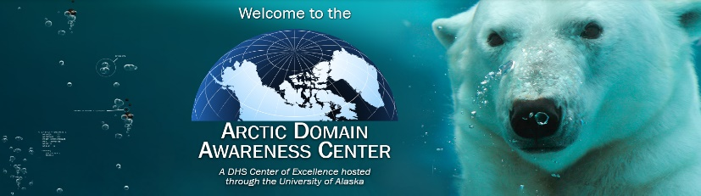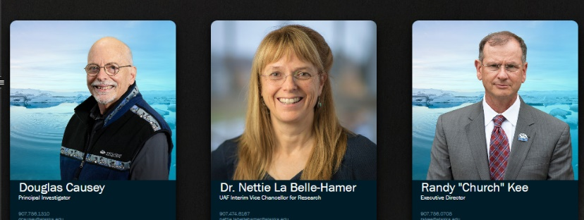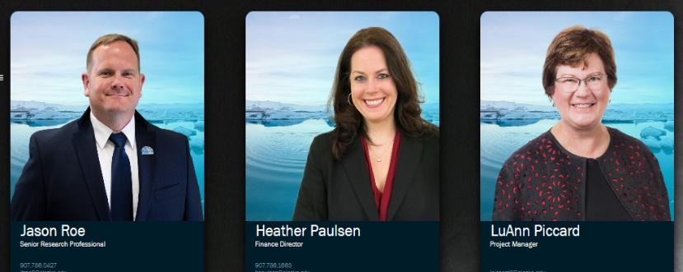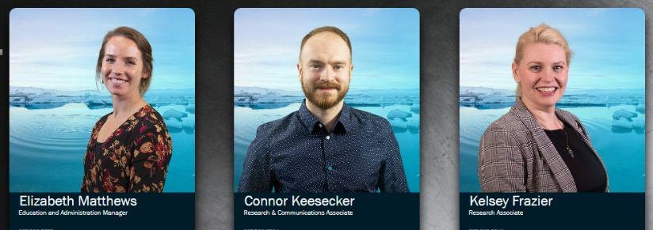
Figure 2 ADAC's Personnel (as of August 2020)

ADAC Executive Counselors
ADAC continued to receive excellent support from the Center’s team of advisors, the Executive Counselors team. ADAC’s Executive Counselors continued to provide unfunded/pro-bono support by participating in teleconferences and other engagement opportunities. The Counselors advise ADAC leadership on overall strategy of Center efforts and connect ADAC to greater research collaboration with international, federal, and Alaskan partners.
ADAC’s Executive Counselors in Program Year 6 continued to meet either individually or collectively with Center leadership and conducted three strategic meetings with ADAC leadership via a dedicated forum.
The following are ADAC’s Executive Counselors who participated in the Center’s Program Year 6 efforts:
- Tom Barrett, VADM (Ret), USCG, President, Alyeska Corporation, Anchorage, Alaska. Admiral Barrett is a former USCG Vice Commandant and District 17 Commander.
- Paul Hubbard, PhD, Canada Department of National Defense, Ottawa, Canada.
- John Farrell, PhD, Executive Director, U.S. Arctic Research Commission, Washington, D.C.
- Heather Quilenderino, CDR, USN, Director, National Ice Center, Suitland, Maryland.
- Ukallaysaaq Okleasik, Vice President of External Affairs, Sitnasuak Native Corporation, Nome, Alaska. Note, concluded his service at end of Program Year 6.
- Tom Case, Chancellor Emeritus, University of Alaska Anchorage, and Lt. Gen, USAF (Ret).
- Rudy Peschel, RADM USCG (Ret), Fellow, Center of Arctic Study and Policy (CASP) U.S. Coast Guard Academy
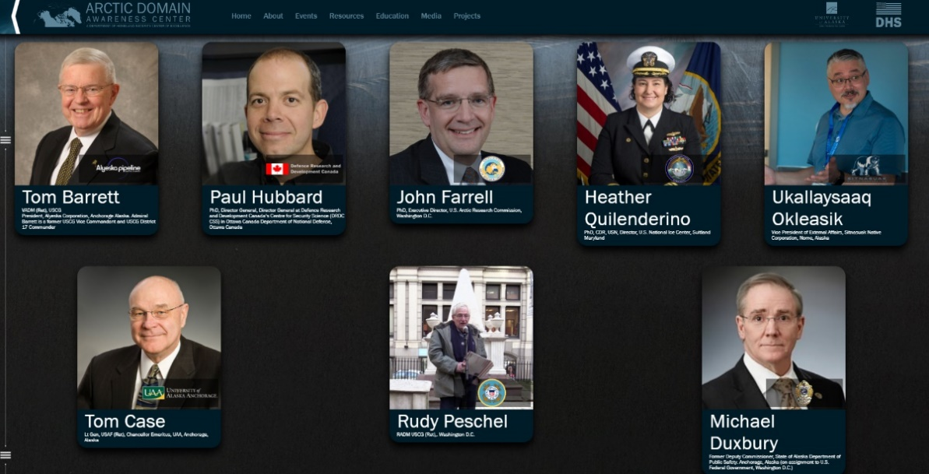

Figure 3 ADAC's Executive Counselor Team (as of June 2020)

ADAC Affiliated Researchers.
ADAC continued to maintain affiliated researchers on pro-bono, non-compensated basis due to their professional interests and support to the Center. At the close of Program Year 6 Ms. Nicole Kinsman, NOAA, Mr. Scott Blough, Tiffin University, and Ms. Brenda Dunkle, Booz-Allen-Hamilton (BAH), as Ms. Dunkle is pursuing a PhD with a strong Arctic operations nexus.

ADAC Student Fellows.
The events and progress of the Workforce Development (WFD) Fellowship Program are more comprehensively covered in the ADAC Student Activities section of this report. To summarize, ADAC Fellows perform a variety of support functions for the center while gaining valuable professional skills to succeed in a career within the Homeland Security Enterprise (HSE) and beyond. Fellows have the opportunity to participate in almost every aspect of the Center’s activities: from performing critical technical support for project research teams to participating ADAC hosted or affiliated events. ADAC’s student fellows aided with a number of ADAC supported or hosted events including the July/August 2019 COE Summit at George Mason University in Fairfax, VA, the Arctic Oil Spill Response Modeling Workshop in December 2019, the January 2020 Alaska Marine Science Symposium, and ADAC’s 2020 Program Year 6 Annual Meeting.
The program was made possible by two distinct funding streams: a small number funded via DHS S&T OUP Supplemental Career Development Grant (CDG) and a larger number resourced via Education Outreach and Workforce Development, as part of the overall ADAC Award. ADAC Fellows participated in projects associated with ADAC DHS S&T OUP approved Program Year 6 Workplan or directed studies managed via Center leadership. Upon graduation, ADAC Fellows seek employment within the Homeland Security Enterprise (HSE).
While COVID-19 limited the opportunities for students to present their research to the public, ADAC included Fellows in virtual activities after March 2020. ADAC students continued to remain engaged and all current ADAC Fellows participated in a Virtual Arctic Summer Internship (ASIP) in Summer of 2020. To prevent due to travel restrictions imposed by the novel coronavirus, ADAC staff cancelled the sessions of the ASIP program previously held in Anchorage and Utqiagvik. Instead, ADAC Fellows participated in a 10-week summer program where students participated in three virtual sessions a week featuring presentations and Q&A opportunities with a variety of Arctic residents, operators, research professionals, ADAC staff, and government officials.
In total, four students graduated from the ADAC Fellows program during Program Year 6: three fellows graduated following the Fall 2019 Semester and one graduated in May of 2020. Three graduates will be pursuing higher level education opportunities at the University of Alaska Anchorage and one will be continuing a master’s program at the University of Texas El Paso (UTEP). One student joined ADAC’s staff as a Research Associate and will pursue a PhD at UAA in Program Year 7. ADAC’s Fellows program closed with the aforementioned 10-week summer internship program.

Summary of Center Research Management Process.
Quarterly Reviews. Center Leadership continued to provide oversight and accountability for the ADAC’s research projects through Quarterly Reviews. These forums were scheduled to provide an opportunity for research teams to share results, milestones, and challenges encountered in each Quarter of the Program Year. The Center’s research projects, and Executive Counselors participated in a Mid-Year Review on 31 January 2020. ADAC originally established this mid-year review to help ADAC prepare for its first Bi-Annual review in March 2016. These Reviews occurred on 19 September 2019, 19 December 2019, 9-10 April 2020, 18 June 2020.
Transition Planning. A critical function of ADAC’s activities is to prepare technology and research developed through the Center for real-world, end-user applications. A principal focus of Year 6 was to prepare research teams for the transition of mature research to industry, HQ USCG CG-7 (Assistant Commandant for Capabilities), and HQ USCG CG-9 (Assistant Commandant for Acquisitions) through the adoption of ADAC’s “Research-to-Capabilities Process” (RTCP). The Quarterly Review process provided dedicated time between Center Leadership and research teams to coordinate transition planning activities. Additionally, Center leadership and respective research teams prepared teams for the RTCP process by engaging with USCG Project champions and planned destination “end-users” via meetings or electronic communications to ensure research was progressing in a manner to meet the ends of the planned end user and USCG “Customer.”
The following is a summary of planned research destinations that ADAC funded investigations whichresulted in transition to end users during Program Year 6 of ADAC:
- High-resolution Ice-Ocean Modeling and Assimilation System (HIOMAS). Planned destination: Axiom Data Sciences. HIOMAS was originally planned to transition to the U.S. Navy meteorological community to create a suite of Arctic Ocean current and sea-ice models. At ADAC’s Program Year 3 Annual Meeting, USN announced that HIOMAS did not meet its requirements process. As a result, ADAC found an alternative pathway whereby HIOMAS could transition to Axiom Data Science (an AOOS computational center) to operate and publish HIOMAS to provide useful sea ice data modeling to support U.S. National Ice Center and National Weather Service. In Program Year 5, HIOMAS was transitioned to Alaska Ocean Observation System (AOOS), an accredited NOAA affiliate and its associated Data Center, Axiom Data Science and now generates operational data via 7 day hindcast and 30 day forecast of ocean current, sea ice presence, thickness, movement and ridging to a fine scale of 2 KM resolution for the Circumpolar North on a bi-weekly basis for NOAA, NWS and USNIC, to include the NWS Alaska ice desk and NOAA’s Arctic Environmental Response Management Application (ERMA).

- Arctic Oil Spill Modeling (AOSM). Planned destination: NOAA’s General NOAA Operational Modeling Environment (GNOME). At the close of Program Year 5, AOSM transitioned to PyGNOME as part of NOAA’s GNOME suite and was in the process of final transition to web-GNOME. Prior to AOSM, GNOME had no Arctic capability, but the addition of AOSM alleviates that shortfall. In Program Year 5, AOSM received a no-cost extension to conclude transition of AOSM to web-GNOME, which concluded prior to the end of ADAC Program Year 6. All GNOME related transitions were completed by the end of ADAC Program Year 6.

- Using Vessel Tracking Data to Prioritize Bathymetric Surveying in a Rapidly Changing Arctic (AIS-PAC). Planned destination: NOAA-OCS Hydrographic Health Model (final data products); AOOS (raw data); AOOS data system, DHS S&T HSUP and USCG websites (visualization tool). By the end of the project in Program Year 5, the project team transferred final data products in the form of geo-spatial density files to NOAA-OCS for application in their Hydrographic Health Model and to any other applications as discovered through interactions with assigned USCG Project Champion(s) and project advocates, including the project stakeholder steering committee. The Alaska Ocean Observing System (AOOS) being a regional association of the NOAA funded Integrated Ocean Observing System (IOOS) serves as the transition target for the raw data. All data and data products generated as part of this effort, including the 5-year vetted AIS data and the web-based user tool, are now publicly available on the AOOS data system portal. The visualization tool is also accessible and can be made available through links posted on the DHS S&T HSUP and USCG websites and other interested party websites. At the end of ADAC Program Year 6, onward efforts to incorporate an additional year of data to continue to keep AIS-PAC updated were underway between ADAC and NOAA/NWS.
Reporting. ADAC Center leaders achieved the necessary engagement and reporting requirements of DHS S&T OUP through close coordination between Center’s leadership and research teams, to include routinely scheduled weekly meetings between DHS S&T OUP Program Manager and ADAC leadership. Comprehensive, project by project reporting was accomplished via the ADAC Virtual Annual Meeting in May 2020, Program Year 7 Workplan, approved in July 2020, and the Year 6 Annual Report. For ADAC Annual meeting details, please see https://arcticdomainawarenesscenter.org/AnnualMeetings

Summary of ADAC’s Communication’s Efforts.
ADAC has continued to remain engaged with strategic partners and the broader public through the Center’s Communications efforts throughout Program Year 6. ADAC conducted high level of direct engagement with the Center’s Federal partners at DHS, USCG, and other Federal departments and agencies. ADAC has also continued to have a broad reach of engagement with academic institutions, commercial enterprises, tribal organizations, and local communities within Alaska, the United States, Canada and the pan-Arctic Region.
Customers’ and Partners’ Roundtables. ADAC’s Customers’ and Partners’ Roundtable teleconferences continue to serve as important point of engagement for ADAC’s Leadership and Researchers with a wide range of interested partners. ADAC continues to find these teleconferences especially useful for inform the development of research at the Center and to inform potential use-cases of ADAC produced technology. Conducted quarterly, ADAC Customers and Partner’s Roundtables serve as an exchange opportunity with:
- Arctic-focused community of USCG operators (seen by ADAC as the Center’s “customers”).
- Federal government research entities.
- State of Alaska, primarily, environmental response agencies.
- Academic Institutions engaged with Arctic Research.
- Industry and Commercial enterprises focused on the Arctic.
- International research collaborators.
As these forums were conducted virtually in previous program years, these tele-conferences have remained relatively unaffected by COVID-19. In Program Year 6, ADAC conducted these teleconferences on 17 October 2019, 16 January 2020, 25 June 2020. ADAC conducted an equivalent session after the 14 May 2020 Annual meeting on 15 May 2020 which served the same function as a Customers’ and Partners’ Roundtable.
Beyond the structures of these forums, ADAC also conducts other leadership and researcher engagement activities through both in-person and virtual meetings, workshops, symposiums, and affiliated events. ADAC also produces high-quality content to educate interested parties in research achievements, staff accomplishments, and other center activities on a consistent basis. In these efforts, ADAC strives to relate to importance of the investing in science and technology that advances domain awareness in the strategically vital region of the Arctic to a variety of audiences. The following illustrates ADAC’s comprehensive communications efforts.
ADAC Video Shorts. ADAC has continued to produce and release video shorts to highlight the Center’s activities, research, and people. These videos are published online through the website and are available to wider audience on YouTube. In total, ADAC personnel have published 18 video shorts on YouTube within the past year covering a variety of topics from updates on research projects to ADAC hosted events. These videos are an essential tool engage both federal customers and a wider audience in importance of ADAC’s work and mission. These videos have helped to expose ADAC’s work to previously unreached audiences within the Arctic including Alaskan Native and Rural communities as well as international researchers. URL: https://arcticdomainawarenesscenter.org/Media.html.
Social Media. ADAC has continued to advance its messaging around Center Activities through Facebook and other social media platforms in Program Year 6. Updates include not only center activities but highlight important and interesting events happening the Arctic, facilitating greater interest in the geostrategic importance of the Arctic. These updates serve as an important point of engagement for University students, aiding with the recruitment of Center fellows. URL: https://www.facebook.com/ADACAlaska/
IARPC Collaborative Network. In March 2017, Center leadership established an ADAC research network at the U.S. Interagency Arctic Research Policy Committee (IARPC) interactive collaborative portal. This collaborative network serves to assist the Center in disseminating information about current and future activities and opportunities. Achieving an IARPC Collaborative Network strongly connects ADAC research to the U.S. Arctic scientific community, enabling the Center to reach more comprehensive audiences. Throughout ADAC Program Year 6, the Center has leveraged the Arctic Domain Awareness Center’s vast Network on several IARPC Collaborations. Such access is important to further research idea generation and to widely advertise ADAC activities and opportunities, thereby cementing the Center as a universally recognized Arctic institution.
Quarterly Newsletters. ADAC has continued the Center’s practice of publishing Quarterly Newsletters throughout Program Year 6. Traditionally, these publications featured significant Center activity by highlighting various research projects, interaction with key ADAC customers and partners, and showcasing ADAC student Fellows and their contributions to the Center. ADAC’s Quarterly Newsletters provide a platform to update and inform of recent Center activities, ongoing research, and upcoming events to ADAC’s customers, transition partners, and research collaborators. In Program Year 6, Center staff expanded the scope of these Newsletters to include more Arctic content featuring topics outside of ADAC’s research projects and activities. ADAC published Newsletters in July 2019, November 2019, March 2020, and June 2020. URL: https://arcticdomainawarenesscenter.org/Publications
Updates and improvements to ADAC’s webpage. ADAC’s webpage serves as an accessible point for the public and partners to learn about ADAC’s objectives, activities, and history. The webpage functions in part as a repository of Center activities, reports, workplans, specific research, current and prior newsletters, student events, and other items of interest. This product is now a source containing the Center’s significant research documents and associated research materials. The Webpage serves to provide details about ADAC to Center customers, transition partners, and collaborators, including prior and current endeavors.
In August 2019, ADAC debuted the center’s new website. The website created in partnership with staff at the Business Enterprise Institute at UAA and with the support of an ADAC Fellow who joined the Center team as an Intern in Summer 2019. ADAC’s new website has been well received by the center’s partners, drawing compliments for both its aesthetic quality and functionality.
Figure 4 Front Page of ADAC's Website
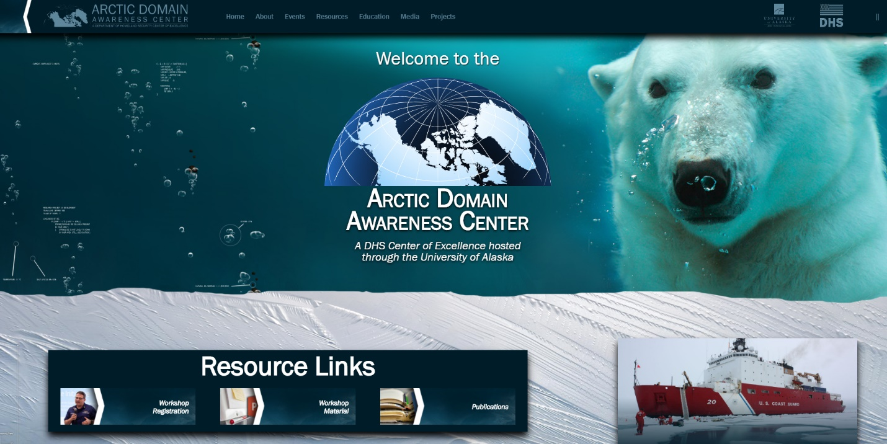
The new webpage is a significant advancement from the previous domain supported by Dubay Business Service, allowing more agile web communications and greater customization options to tailor ADAC’s web product to the Center’s mission needs. The website has continued to advance through Program Year 6 as Center and BEI staff learn new web development techniques. Overall, the new website allows Center and BEI staff to be more flexible and reactive in responding to technical issues. Significantly, greater customization has afforded Center staff with more tools to integrate ADAC’s website into the Center’s events and activities. This has been particularly useful as most activities and events have gone ‘virtual’ with the advent of COVID-19.

- ADAC Program Year 6 Project Descriptions Aligned to DHS CMR FOA Themes:

THEME 1: Maritime Risk, Threat Analysis, and Resilience Research Projects:
- Mitigating the Damage to Arctic Copepods from Surface Oil Spills: When to Apply Dispersants.
- Photo-enhanced toxicity of dispersed and burned crude oil to Arctic mussels.
- Marine Induced Polarization Methods for the Detection and Mapping of Oil in an Arctic Marine Oil Spill, including investigation of Oil within and Under broken ice fields.
- Oil Spill Modeling for Improved Response to Arctic Maritime Spills: The Path Forward.

PROJECT: Mitigating the Damage to Arctic Copepods from Surface Oil Spills: When to Apply Dispersants
Project Investigators: Dr. Christoph Aeppli, Dr. David Fields.
Lead Institution: Bigelow Laboratory for Ocean Sciences, East Boothbay, Maine.
Supporting Team: Erin Beirne and Maura Niemisto, Bigelow Laboratory for Ocean Sciences.
Project Champion: CAPT Kirsten R. Trego (USCG) HQ USCG MER
Project Description:

Abstract:
While dispersants are a highly efficient and proven tool for oil spill response in sub-Arctic and Arctic environments, there is concern about negative impacts on Calanus spp. copepods, which are critical zoo planktonic organisms in the overall Arctic food chain. Current risk assessment of oil toxicity towards copepods do not account for their vertical movement, potentially leading to a significant spatial separation between toxic compounds and animals, even in the presence of dispersants. This ADAC research project advanced and applied a novel and more environmentally realistic system to measure the impacts of dispersed oil towards Arctic copepods. A new research method using seawater towers (2-m vertical mesocosms) that allow chemical introduction to Calanoid copepods in a vertical regime allow researchers to test the main hypothesis of this project: in the ocean, Calanoid copepods can spatially separate themselves from surface oil spills during portions of their developmental cycle. Therefore, they might be exposed to much lower concentrations and for much less time than has been assumed based on currently used laboratory studies.

Objective/Purpose:
This project worked to address two key research questions: (i) what is the impact of an oil spill, with and without dispersant, on copepods that are able to move vertically in the water column, thereby potentially avoiding the oil? (ii) Are there times in the year (stratification of the water column) when the impact of dispersant application on copepods is minimal? In order to address these questions, the research plan was focused on addressing three objectives:
- What is the impact of an oil spill, with and without dispersant, on copepods that are able to move vertically in the water column, thereby potentially avoiding the oil?
- Are there times in the year (associated with stratification of the water column) when the impact of dispersant application on copepods is minimal?
In order to address these questions, this project had the following three objectives:
- Objective 1: Determine whether C. finmarchicus copepods actively and effectively avoid oil or dispersants in mesocosm experiments (Phase I of this project).
- Objective 2: Investigate how dispersants influence the exposure of subsurface animals to oil products (Project Phase II).
- Objective 3: Determine how water column stratification influences the contact between copepods and oil (with and without dispersants) (Phase III).
In order to achieve these objectives, researchers investigated this migration behavior in a novel mesocosm system, which allowed us to determine the effects of dispersants and oil in a more environmentally-relevant condition than the traditionally-used systems using a water-accommodated fraction (WAF) or chemically enhanced WAF (CEWAF; i.e., oil with dispersants). Specifically, investigators performed experiments using 2-m vertical mesocosms in which copepods could move vertically in the water column. Furthermore, this system allowed us to investigate the effects of water column stratification on the distribution of oil and copepods. Researchers used C. finmarchicus as a model Calanus species to test associated project hypothesis. These results, once finalized, will fill critical knowledge gaps about the toxicity of oil and dispersants on Calanus spp. copepods, which are essential organisms for the Arctic food web as well as for commercial fishery. This knowledge is useful to support USCG led federal on-scene response of an Arctic maritime oil spill.

Methodology:
The project’s research method was a sequenced set of scientific laboratory experiments conducted by a select and qualified team of marine biologists. The research team is underway in investigating the effect of dispersed oil and vertically migrating copepods.
In Project Year 6, experiments with 100-L mesocosms (“Copepod towers”; constructed in Year-5) were conducted. These mesocosm systems allowed for measurable vertical migration of copepods (Calanus finmarchicus) as well as for oil/dispersant concentration gradients along the depth of the mesocosms. Test protocols were developed where 5 mL of pre-evaporated Alaskan North Slope (ANS) crude oil per column was added, leading to a 100-um thick oil sheen. For the dispersed oil treatment, Corexit EC9500 (NALCO Environmental Solutions LLC), was mixed with crude oil at the recommended 1:20 dispersant-to-oil ratio and added on top of the copepod towers. The dispersion was formed by adding wind energy through an air pump that directs an air stream on top of the water surface.
During the experiments, the copepod behavior was observed using video observations of free-swimming copepods, and hydrocarbon concentration (total particulate oil and aqueous concentration of individual PAHs) are measured. The resulting data sets were used to determine:
- If copepods avoid the oil actively (by swimming), passively (by being immobilized and sinking) or not at all.
- How a stratified water column affects this behavior.
Note: as this project was investigating invertebrates, Institutional Animal Care and Use Committee (IACUC) protocols have not been required.

Student Involvement:
Two students participated in remote summer research internships during Year 6 (June 2020). The internships consisted of student involvement in analysis of data captured during Copepod experiments. Students reviewed video and imagery of Copepod behaviors when exposed to oil and dispersants and annotated results.

2019-2020 Key Accomplishments:
Phase I: Oil Avoidance of Copepods
In the first phase of this project, we constructed our custom-made copepod observation towers and optimized the videography and water sampling systems (Task 1). The 2-m vertical water columns were equipped with video cameras to quantify the number copepods at three depths using infrared (IR) light. The use of IR light allows us to conduct experiments in the dark. This is essential since the vertical movement of copepods is triggered by visible light. Furthermore, the copepod towers were equipped with temperature and light sensors, as well as sampling ports at 5 horizons for water sampling and subsequent analysis of polycyclic aromatic hydrocarbons (PAHs). Our optimized analytical methods (solid phase microextraction, two-dimensional gas chromatography; SPME-GC×GC-TOF) only requires 20 mL of water sample for analysis of dissolved oil compounds.
After completion of the copepod towers, we first ran control (i.e., no-oil) experiments with wild-caught copepods. Copepods of the species Calanus finmarchicus were collected at approx. 100m depth in the Gulf of Maine during their non-dormant states, which are roughly between April through October 2019. Once collected, these copepods can be kept in the laboratory for about a month. Within all control experiments, we maintained 85-100 copepods within view of the cameras throughout the experiments, indicating that there was not significant mortality within this time frame. Copepod distribution remained at a stable vertical distribution during control conditions (Task 3).
We then ran experiments with un-dispersed oil and observed copepod behavior. After the addition of oil, the number of copepods in camera view immediately changed. The out-of-view copepods aggregated at the bottom of the water column or were trapped on the oil slick at the top of the column. After approx. 4 hours, the total number of copepods dropped to a relatively stable level of approx. 30% of what we counted before the addition of oil (Figure 5). The decline in visible copepods results from of oil avoidance behavior or mortality.
Figure 5: Distribution of total copepods observed in each of the three filmed horizons (blue=top, orange=midpoint, gray=bottom)
During each 24-h experiments, water samples sampled were from the five sampling ports at six time points. Chemical analysis was performed to determine the hydrocarbon movement through the water column over the course of experiment. A transient PAH gradient established within approx. 2 hours with highest concentrations (total PAHs > 20 µg/L) close to the oil slick (Figure 6). We use this hydrocarbon gradient to study the short-term swimming response of copepods to hydrocarbons.
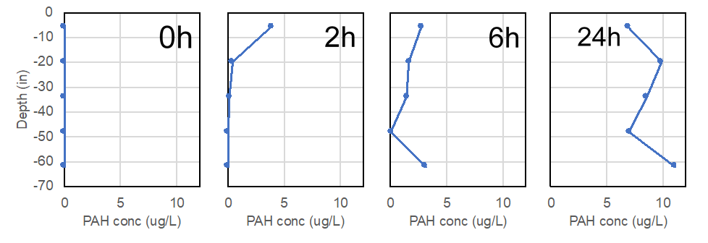
Figure 6: An example of PAH concentrations (ug/L) over depth (in), 0 hr., 2 hr., 6 hr., and 24 hr. after introduction of fresh crude oil (ANS).
Overall, results from Phase I indicate that the copepod towers are suitable to measure impacts of hydrocarbons on the response of copepods, and that the presence of ppt-levels of PAHs (i.e., µg/L) of oil induce an immediate response on the vertical position of copepods (within less than an hour).
Final conclusions and evaluation from Phase I will be made after the complete dataset from experiments from Phase II is available.
Phase II: Dispersants & Copepod Contact
.
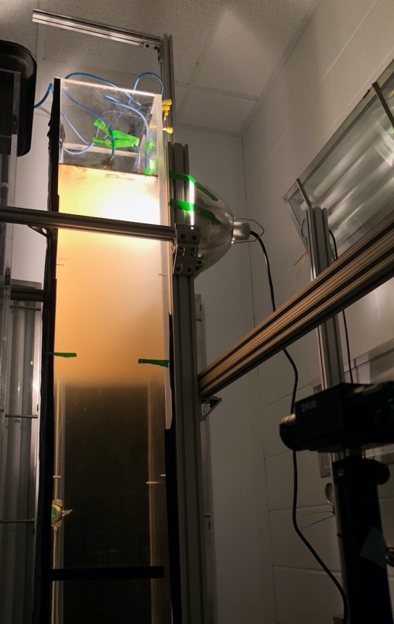
Phase II focused on the effect of oil droplets present in the water column on the behavior or copepods. In contrast to Phase I, that added oil contained dispersant (Corexit 9500, 1:20 ratio), and the added wind energy led to a cloud of dispersed oil that traveled down the column during the 24-hour experiments (Figure 7). Five replicates of control and oil/dispersant treatments (10 experiments) were conducted.
While final evaluation of copepod and chemistry data is still pending, researchers generally observed a magnified response of copepods to this dissolved and particulate oil present in the water column. This suggests that the particulate oil as well as the dissolved oil constituents in the water column impact copepods. Final conclusions will be drawn one the complete dataset is available. The milky color in the top 1/3rd of the column is a well-defined area with the presence oil droplets, whereas no significant amounts of droplets are found below.

Figure 7: Photograph of the copepod tower with oil/dispersant mixture and constant mixing energy added
Phase III: Influence of Stratification:
Researchers prepared for the experiment to test the influence oil/dispersants on copepods in a stratified water column. Investigators refined a stratified system within the towers.
Researchers equipped the towers with a circulating cooling plate fueled by a water chiller to cool the water column from below. An incandescent red light hangs just above the water surface to warm from the top. Seven hobo-loggers are distributed through the tower at 25cm intervals to collect continuous light and temperature data. Using this system, investigators successfully established a stable temperature profile (Figure 8) with a temperature difference of 7.8˚C from top to bottom. An established thermocline exists at a depth of around 1.3m. We will continue to refine the system to move the thermocline to shallower depths.
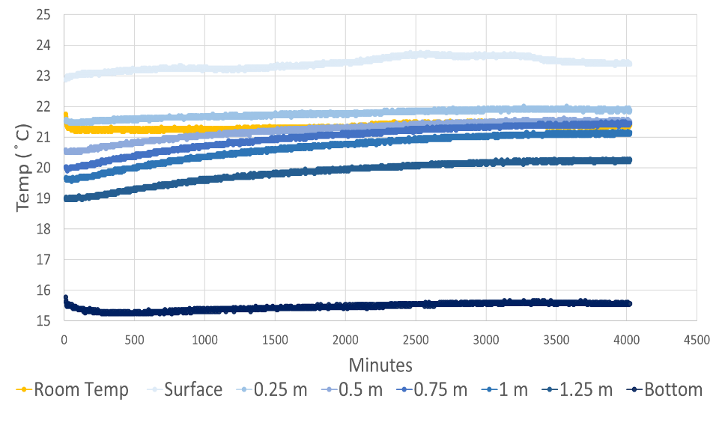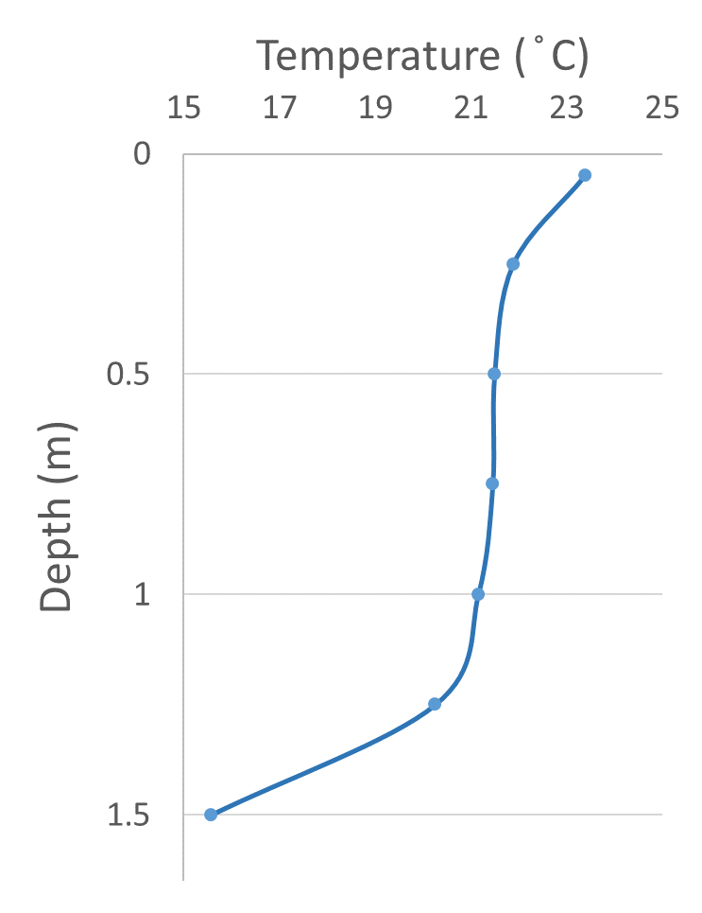
Figure 8: Temperature profile in stratified tower over 4020 minutes (67 hours) (a), over depth (b).

Key Stakeholder Engagement:
Project team participated in four ADAC Customers and Partners Roundtables. During the Customers and Partners Roundtable, the project team provided a brief technical summary of their project and answered questions from federal customers and interested parties including representatives from the US Coast Guard and National Oceanic and Atmospheric Administration.

Key Publications (peer reviewed):
No publications were developed in ADAC Program Year 6. In accordance with Year 7 plans, research team will develop a manuscript for peer review in addition to a final knowledge product.

Key Presentations:
The Project team presented at ADAC Program Year 6 Annual Meeting. The Annual Meeting was held virtually via Cisco WebEx as COVID-19 prevented an in-person gathering in Washington D.C. as in previous program years. The meeting was well attended drawing a total of 202 registrations for the 7-hour virtual event with a peak of 157 participants. DHS S&T OUP, HQ USCG ADAC Project Champions, NOAA leadership, ADAC Executive Counselors, and many other customers and partners participated ADAC’s Year 6 Annual Meeting.

Changes from initially approved Workplan:
- After approval of the workplan, it was realized that the planned Phase I experiments could be executed without loss of data quality with three copepod towers. Therefore, the team decided initially built three towers (rather than originally proposed nine) for the tests in Phase I with the intent to build the remaining towers as necessary for execution of Phase II and III experiments. This was a necessary to allow the project team to focus on collecting specimens in the Gulf of Maine before their capture would be infeasible as the suitable concentration of Calanus finmarchicus would become more difficult and costly as concentrations move away from littoral areas and towards open ocean. Additionally, modifications can be to subsequent towers based on results from Phase I. This change in the plan was briefed to ADAC leadership who made a priority decision to support a timely collection of Calanus finmarchicus before this collection would be delayed for potentially several months.

Project progress against each milestone:
Table 5. Copepods project progress milestones completed.
MILESTONE | COMPLETED | WHY NOT REACHED? (IF APPLICABLE)
Phase I: Oil avoidance of copepods
Task 1: Copepod tower construction & optimization; Presentation to Advisory group; decision to go forward | 100%
Task 2: Three experiments with and without oil | 100%
Task 3: Copepod data evaluation | 100%
Task 4: Chemical analysis & data evaluation | 100%
Task 5: Manuscript 1: Oil avoidance | 0% | Postponed to Year-7 workplan due to COVID-19 related restrictions in laboratory access.
Phase II: Dispersants and copepod contact
Task 6: Experiments with dispersed oil (with copepods) | 100%
Task 7: Copepod data evaluation | 25% | Delay due to COVID-19 related restriction to lab access. Will be finished in early-mid Year 7.
Task 8: Chemical analysis and data evaluation | 25% | Delay due to COVID-19 related restriction to lab access. Will be finished in early-mid Year 7.
Phase III: Influence of Stratification
Task 9a: Optimization of the experiments with stratification (chemistry and temperature characterization) | 100% | Task 9 from the Year-6 workplan was divided up into 9a and 9b
Task 9b: Stratified water column: Experiments with copepods | 0% | Postponed to early-mid of Year 7 due to COVID-19 related delays.
Task 10: Copepod data evaluation | 0% | Can be completed after Task 9 is done.
Task 11: Chemistry analysis & data evaluation | 0% | Can be completed after Task 9 is done.
Other
Presentation at 4 quarterly reviews, 4 quarterly customers & partners roundtables, and the annual meeting | 100% completed
Summer Research Internships for two students | 100% completed | Due to COVID-19, remote internship (rather than in-person) where designed and conducted.

Project metrics:
Table 6. Copepods project metrics to evaluate scientific progress.
METRIC | PROGRESS | WHY NOT REACHED? (IF APPLICABLE)
Metric 1: Successful performance review of Tasks 1a-1e from Year 5 by USCG Project Champion and Advisory Committee is required prior to starting Task 2. | Completed. The Advisory Group and Project Champion meeting took place, and a revised experimental plan – based on preliminary results – was decided on.
Task 2: Successfully perform 8 experiments: with and without oil (2 treatments) in 4 replicates, and record data. | 100% Completed.
Task 3-5: Evaluate and quality control 100% of the data recorded in Task 2: copepod behavior and chemical data, Prepare one manuscript for publication in a peer-reviewed scientific journal. | 66% completion (100% completion for Task 3 and 4; O% completion for Task 5.) | Task 5: Postponed to Year-7 workplan due to COVID-19 related restrictions in laboratory access
Task 6: Successfully perform 6 experiments: with and without oil/dispersant mixture (2 treatments: control, oil/dispersant), in 3 replicates, and record data | 100% completed.
Task 7-8: Evaluate and quality control of 100% of data recorded in Task 6. | 25% completion | Delay due to COVID-19 related restriction to lab access. Will be finished in early-mid Year 7.
Task 9: Perform 9 experiments with a stratified water column; 3 treatments (control, oil, oil/dispersant), in 3 replicates. | 10% completed only water column stratification optimization without copepods has been performed. Experiments with copepods have been postponed to Aug-Oct of Year 7. | Postponed to early-mid Year 7 due to COVID-19
Tasks 10-11: Evaluate and quality control 100% of data recorded in Task 9. | Not completed. Will be completed once Task 9 will be done. | Can be performed after completion of Task 9.

Outcomes/output and TRLs:
As with all ADAC products, research team and center leadership will ensure dissemination of all suitable data. In sum, all data produced during this project will be made publicly available.
Outputs:
Technical Report: Creating a report with all the results of this research for USCG and DHS S&T OUP.
Write Peer-Reviewed Publications: Researchers plan to produce three peer-reviewed scientific publications from this project, where all the results from this project will be described and discussed: (i) Do copepod avoid oil? (ii) The toxicity of surface oil and dispersed oil on vertically mobile copepod. (iii) The distribution of oil and dispersed oil in a stratified and un-stratified water column.
All data produced during this project will be made publicly available. Researchers will use the Knowledge Network for Bio-complexity (KNB) data repository (knb.ecoinformatics.org). KNB accepts open environmental and ecological data and metadata, assigns DOIs, and replicates data to other DataONE member repositories for redundancy and secure long-term preservation.
ADAC will post all data and reports to the Center’s website.
Outcomes
The described knowledge products will inform oil spill response. Adding dispersants to the oil spill may redistribute the oil deeper into the water column reaching copepods well below the surface. Our data will help to provide seasonal and time of day protocols to minimize harm to copepod populations.
Establishing an environmentally relevant testing system. The toxicity of oil to copepods is well known. However previous studies have exposed the copepods to homogeneous
Technology Readiness Level (TRL):
This project is fundamental research and will achieve TRL 1-3, which tests the Hypotheses 1: Subarctic copepods and dispersants are spatially separated in a stratified ocean, and Hypothesis 2: Subarctic copepods can actively avoid hydrocarbons, in a mesocosm setting.

Unanticipated problems and plans for addressing them:
Two issues led to a delay of certain milestones and metrics: First, research study species, Calanus finmarchicus, typically enters a diapause stage in the mid-winter months and cannot be sampled. In Fall 2019, this diapause state started earlier than researchers anticipated, and subsequently had to postpone some experiments into spring 2020. Second, once the copepods awakened from their diapause state in early spring 2020 and were accessible for sampling, however, the COVID-19 pandemic led to laboratory restrictions of three months. This led to a slow-down in research plan accomplishment. To address these delays, researchers had to postpone some experiment from Year-6 to ADAC Program Year 7.

Transition Activities:
Transition plans and progress made: Principal transition plan is to create research knowledge products to support USCG led Federal On-Scene Maritime Environmental Response in an Arctic context.

PROJECT: Photo-enhanced toxicity of dispersed and burned crude oil to Arctic mussels
Project Investigator: Patrick Tomco, PhD
Lead Institution: University of Alaska Anchorage
Supporting Team: Colin McGill, UAA Chemistry Department, Katrina Counihan, Alaska Sea Life Center, Phoebe Zito, University of New Orleans
Project Champion: LCDR John LaMorte, USCG, HQ USCG MER
Project Description:

Abstract:
This project studied the direct effects of oil, dispersants, and in-situ burning, along with photo-enhanced effects, on several physiological, biochemical, and metabolic aspects of a cold-water species of mussel (Mytilus trossulus). Sunlight-exposed oil is potentially more toxic to aquatic organisms than non-weathered oil, yet there remains little information on what effects (if any) dispersants and in-situ burning have on bay mussels in the arctic environment when exposed to sunlight, which in the summer months is continuous. This study sought to determine if dispersed oil or herded/burned oil are more toxic to bay mussels than oil alone and if these effects are more pronounced during periods of long sun exposure. Researchers also sought to determine the changes in chemical composition of Alaska North Slope (ANS) crude oil as it is exposed in each of these scenarios. Since these concentrations that marine life would be exposed to during an oil spill are realistic, these results are applicable to management decisions on the use of recovery methods.

Objective/Purpose:
The goal of this project was to understand which response method (dispersants vs in-situ burning) has a greater effect on Arctic mussel toxicity and whether the extreme seasonal differences in sunlight can affect acute sublethal response. Accordingly, this project sought to address the following objectives:
- Objective 1: Conduct static exposure tests with bay mussels in seawater with oil, Corexit 9500, oil dispersed with Corexit 9500, and oil subjected to in-situ burn with three different photoperiods.
- Objective 2: Assess physiological and biochemical responses of bay mussels to the oil, dispersant, and in-situ burned oil in the exposure tests at different time points.
- Objective 3: Evaluate metabolic health of mussels in the exposure tests using metabolomics.
- Objective 4: Profile the chemical constituencies of oil, dispersed oil, and burned oil treatments used in the mussel exposures and how each treatment chemically weathers throughout the experiment.

Methodology:
Project method was a laboratory-based exposure study coordinated through three entities (Alaska Sealife Center, UAA, and UNO) designed to generate a substantial, scientific research derived knowledge product.
Note: as this project was investigating invertebrates, Institutional Animal Care and Use Committee (IACUC) protocols have not been required.

A principal question this research addresses in support of U.S. Coast Guard decision makers leading Unified Command in an Arctic maritime is: Disperse or Burn? Is one strategy more toxic at different times of year due to sunlight? Despite some of the benefits dispersants and in-situ burning appear to have in oil spill mitigation, opinions on the utilization of these strategies are polarized, and the issue required careful consideration and study. The presence of continuous sunlight in the summer months potentially confounds our knowledge of the seasonal toxic effects that these treatment strategies pose in comparison to no action.
The goal of this project was to understand which response method (dispersants vs in-situ burning) has a greater effect on Arctic mussel toxicity and whether the extreme seasonal differences in sunlight cause each response strategy to be more toxic in the summer than in the winter.

In order to achieve this goal, the research team had methodology to proceed in five phases:
- Phase 1: Construct exposure apparatus, collect mussels, and conduct laboratory-based exposures
- Phase 2: Conduct physiological and biochemical assays
- Phase 3: Perform metabolomics analysis
- Phase 4: Profile chemical constituencies of water-accommodated petroleum and photo-degraded petroleum
- Phase 5: Synthesize data and prepare knowledge products

Student Involvement:
Two graduate students and one undergraduate student have received training and been involved in this project. Anastasia Hanson and Kevin Fitzpatrick (ADAC graduate fellow) and Cameron Carlson (ADAC undergraduate fellow) have been involved with and received training on appropriate methods for sample collections, experiment design, instrument analysis, and data curation.

Key Accomplishments:
Program Year 6 completed activities include:
Phase 1 (complete):
- Mussel Collection Permits obtained at Alaska Sea Life Center
  - Engagement with Project Champion LCDR LaMorte
  - Exposure chamber build-out
  - Mussel harvest
  - Exposures conducted
  - Tissues dissected
  - Samples distributed
  - Constructed exposure apparatus. Research team constructed and configured an apparatus in order to safely conduct mussel exposure to oil and dispersant in a controlled laboratory environment.

- Collection: Researchers collected Mytilus trossulus from Resurrection Bay (Southcentral Alaska) one week prior to the experiment for acclimation in the lab. Mussels that are of similar size were collected to ensure the same age class is tested.

- Conducted laboratory-based exposure: Research team used conservative estimates of concentrations of oil and dispersant. The 10 parts per million (ppm) concentration of ANS crude oil that used in the experiments were selected because that concentration of oil has been measured in dispersed oil field trials and after the Sea Empress spill (Lewis, et al., 1998; Lunel, 1998). The dispersant concentration was selected based on usage recommendations for the products and levels that were measured during field trials (Ross, 1998; Trudel, 1998). Bench-scale burning of oil residues followed the procedures outlined in Bullock et al. (2017)

- Further laboratory exposure details: Five treatments were prepared: seawater control, 10ppm Alaskan North Slope (ANS) crude oil, 0.5 ppm Corexit 9500, 10ppm ANS crude oil dispersed with 0.5 ppm Corexit 9500, and 10ppm ANS burned crude oil. Each treatment had three beakers each consisting of 5L of solution, 17 mussels and be maintained at 4°C. One set of beakers from each treatment were exposed to 24h darkness, one set to 24h light (using a custom-built fixed overhead-simulated sunlight irradiation fixture) and the third set exposed to 12h light: 12h dark. The test was a 7-day static exposure with no water renewals. Mussels were fed Isochrysis galbana algae during the experiment. Mortality was monitored. The pH, dissolved oxygen and temperature of the water were tested. Mussels were sampled after 0h, 24h, 96h and 7d for assays. After exposure, a subset of surviving mussels were transferred to clean water and sampled after 96 hours to assess recovery. The experiment was repeated monthly for a total of three replicate experiments.

- Conducted Mussel Dissections. The anterior end of each mussel was opened using a scalpel, inverted and gently shaken to remove excess seawater from inside the shell. A tuberculin needle was inserted into the posterior adductor muscle and all the hemolymph aspirated. The posterior adductor muscle, gill, digestive gland, mantle, and excess visceral mass were excised. Tissues were stored at -80 °C to preserve the materials until later analysis.

Phase 2 (complete):
- Measure Hydrogen Peroxide Production. Hemocyte hydrogen peroxide production was measured by diluting a hemolymph sample 1:1 with TBS. The sample was tested in triplicate by pipetting the 1:1 hemolymph: TBS solution into a 96-well plate. After incubating the plate in the dark for 1 hour, phenol red solution (phosphate buffered saline pH 7.4, 5.5 mM dextrose, 0.56 mM phenol red, 8.5 U ml⁻¹ horseradish peroxidase, type II) was added to each well and incubated for another 30 minutes in the dark. The reaction was stopped by adding 1 N NaOH, and the plate will be read on a Molecular Devices SpectraMax Plus microplate reader (Sunnyvale, CA) at 620 nm (Akaishi, et al., 2007).

- Measure RNA to DNA Ratio. The RNA to DNA ratio was measured by homogenizing the muscle portion of the mantle with a mortar and pestle. A volume of 1% sarcosyl tris-EDTA (STEB) was added to the homogenate. The mixture was vortexed for a maximum of 60 minutes at a medium speed until the tissue completely dissolves. Each sample had TE buffer added and mixed. The sample was centrifuged 15 minutes at 14,000 x g at room temperature and the supernatant saved for testing. The samples were diluted 1:20 and each sample were added to a 96-well plate in duplicate. Genomic, unsheared DNA from calf thymus was used to prepare a DNA standard curve (Sigma-Aldrich, St. Louis, MO). RNA from bovine pancreas was used for an RNA standard curve (Sigma-Aldrich). The stock solutions of DNA and RNA were diluted in 0.1% STEB to the appropriate concentrations. The wells had ethidium bromide solution (2 µg ml⁻¹) added to them and the microplate were shaken for 5 minutes. The plate was read in a SpectraMax Gemini EM fluorescent microplate reader (Molecular Devices) with 525 nm excitation, 600 nm emission to determine if the readings are in range. Each well had RNase solution (20 U ml⁻¹) added to it and the plate was shaken for 20 minutes and read on the microplate reader again with the same settings. The second reading was the DNA only reading. The RNA content was determined by subtracting the second reading from the first (Caldarone, et al., 2001).

- Conduct TBARS assay. TBARS was measured via fluorescent detection of an MDA-TBA adduct (Cayman Chemical TBARS kit). 25 mg tissue was homogenized via sonication over ice in 250 µL RIPA buffer, centrifuged, and the supernatant removed for analysis. 100 µL samples were combined with 100 µL SDS and 4 mL color reagent, mixed, and heated at 100 C for 1 hour. Reactant products were cooled on ice, centrifuged, and the supernatant evaluated in triplicate versus a linear standard curve. Samples were excited at 530 nm and emission evaluated at 550 nm. Signal was normalized to total protein.

Key Stakeholder Engagement:
The PI and the team in program year 6 have worked with the USCG in close coordination with ADAC leadership and the HQ USCG Project Champion and other stakeholders to ensure that the project is useful for USCG knowledge needs. We have discussed with the relevant USCG personnel, foremost the Project Champion during the Kickoff Meeting and throughout the experiment and received input on relatability of experiment outcomes.

Project Champion: During program year 6, the project team engaged LCDR John LaMorte, CG-MER-3 on a frequency basis as determined by LCDR LaMorte, including mostly email and teleconference communication. Critical coordination has occurred between team members, the PI, and project champion.

Throughout the research, the project team has remained in close coordination with ADAC leadership and USCG mission users. Investigation team has been represented at the following ADAC events:

- Coordination with Project Champion LCDR John Lamorte.
- Weekly All Hands meeting (Normally Thursdays, 1130-1230 Alaska Time via teleconference).
- Quarterly Reviews
- Quarterly Customer’s and Partner’s Roundtables.
- ADAC Annual meeting

Key Publications (peer reviewed):
N/A for Program Year 6. In accordance with Year 7 plans, research team will develop two manuscripts for peer review in addition to program knowledge product.

Key Presentations:
Project team presented at ADAC Program Year 6 Annual Meeting. The Annual Meeting was held virtually via Cisco WebEx as COVID-19 prevented an in-person gathering in Washington D.C. as in previous program years. The meeting was well attended drawing a total of 202 registrations for the 7-hour virtual event with a peak of 157 participants. DHS S&T OUP, HQ USCG ADAC Project Champions, NOAA leadership, ADAC Executive Counselors, and many other customers and partners participated ADAC’s Year 6 Annual Meeting.

Changes from initially approved Workplan:
Following are summaries of how investigators (in coordination with ADAC leadership) made changes from the originally approved workplan:
- Exposures consisted of three replicate experiments, each with less sample replicates over three months instead of one large experiment with more replicates conducted over one month.
- Water sample data was collected at a different analytical facility than originally proposed by contract staff instead of project team members, due to travel restrictions. While these will complete in program year 7, Researchers have been conducting sample preparations in year 6. Project team members are fully vested in data curation.
- A no-cost extension has been approved into program year 7 that would allow this project to complete by 31 December 2020.
- Expected number of peer-review journal article submissions on this modified timeline have been adjusted to one manuscript from the originally scoped two manuscripts.

Project progress against each milestone:
Table 7: Arctic Mussels Year 6 milestones.
MILESTONE | PROGRESS | WHY NOT REACHED? (IF APPLICABLE)
1. Mussels will be harvested from Resurrection Bay, AK  2. Mussels will be acclimated in exposure chambers for 1-2 weeks  3. Mussels will be dosed with oil, dispersed oil, and burned oil under light and dark conditions.  4. Mussels will be harvested at 0, 1, 4, and 7 days post-treatment  5. Mussels will be dissected, and tissues archived for Phase 2 and 3  6. Water samples will be collected and mailed to Team member Zito (UNO). | Completed | N/A

Project progress against each metric:
The following metrics were scoped for ADAC Program Year 6:
Table 8: Arctic Mussels Year 6 metrics.
METRIC | PROGRESS | WHY NOT REACHED? (IF APPLICABLE)
Student Training: Two graduate students and two undergraduate students are recruited, and their projects are started.  Collect >750 mussels from Resurrection Bay suitable for exposure assessment. Transport to exposure chambers.  Successfully acclimate test organisms to exposure chambers. Record data on mortality. Ensure 50 mussels per exposure chamber are acclimated.  Successfully collected burn residue from 3 small-scale controlled in-situ burns.  Expose collected mussels to 5 conditions: seawater, dispersant, oil, dispersed oil, and burned oil) under 3 light regiments. Organisms are harvested on the defined time intervals and dissected with the tissues archived, masses recorded, and recordings of mortality rates. | Completed | N/A

Outcomes/output and TRLs:
As with all ADAC products, research team and center leadership will ensure dissemination of all suitable data. In sum, all data produced during this project will be made publicly available.
Outputs:
Technical Report: Creating a report with all the results of this research for USCG and DHS S&T UP.
Ensure Publicly Available Data: All data produced during this project will be made publicly available. Researchers and ADAC will coordinate submission of associated data to use the Knowledge Network for Bio-complexity (KNB) data repository (knb.ecoinformatics.org). KNB accepts open environmental and ecological data and metadata, assigns DOIs, and replicates data to other DataONE member repositories for redundancy and secure long-term preservation.
The published works will include peer-reviewed scientific articles. This project will conclude in program year 7.
ADAC will also post all data and reports to the Center’s website.
Outcomes
The described knowledge products will inform USCG led Arctic region oil spill response.
Technology Readiness Level (TRL):
This project is fundamental research and will achieve TRL 1-3, creating a knowledge product to inform USCG Federal On-scene Coordination in Arctic region oil spill response.

Unanticipated problems and plans for addressing them:
Team member Counihan’s investigative tasks were postponed due to maternity leave. This delayed the start of the exposures by several months, commencing in September 2019 and completing in November 2019.
The COVID-19 situation temporarily suspended access to research laboratories and prevented presentation at conferences. Researchers plan to complete in program year 7.
The National High Magnetic Field Laboratory suspended user facility work due to COVID-19. We identified a different facility (Michigan Tech) capable of performing similar water chemistry analysis and plan to complete this work in program year 7.

Transition Activities:
Transition plans and progress made: The major scope of this project is to develop knowledge products to advance our broad understanding of the environmental toxicology of petroleum, chemically treated petroleum, and weathered chemically treated petroleum exposure. This is classified TRL 1-3 (fundamental research), which will conclude in ADAC Program Year 7.

PROJECT: Marine Induced Polarization Methods for the Detection and Mapping of Oil in an Arctic Marine Oil Spill; Including Investigation of Oil Within and Under Broken Ice Fields
Project Investigator: Dr. Scott Socolofsky, Texas A&M University
Lead Institution: Academic: Texas A&M University, College Station Texas; Industry: Induced Polarization Associates, Seattle, Washington
Supporting Team: Ms. Kari Walker and Mr. Kevin Hand, IntelliSense Marine LLC, Mr. Nathan Lamie, Lead Engineer/Facility Operator, CRREL (U.S. Army Corps of Engineers), Dr. Jeff Wynn, USGS (Ret), Key Induced Polarization Associates Project Team Members: Mr. Art Wright, Mr. Mike Williamson, Mr. Jay Radler, and Mr. Todd Stedman.
Project Champion: LCDR Clifton Graham, USCG, HQ USCG-MER
Project Description:

Abstract:
Federal on-scene oil spill responders benefit from remote sensing tools to detect and map oil in the open-Arctic ocean, broken ice fields, and oil under and in ice. This research effort worked to test and evaluate performance of the Marine Induced Polarization technology (Marine IP), to locate and assesses very low percentage polarizable mineral and particle distributions, such as hydrocarbons, in water, ice, and in sediment. Marine IP has demonstrated consistent potential to detect hydrocarbons in fresh, brackish, and seawater sediments, and current research is underway assessing the performance for Marine IP’s suitability in Arctic environmental conditions. The research approach was to conduct a 5-phase investigation: design ice tests, fabricate ice-tank test equipment, conduct ice-tank testing, fabricate equipment for open water tests and conduct open water testing. The outcome of this research is a series of knowledge products (a technical report and supporting data) to demonstrate that Marine IP technology can be effectively utilized in the Arctic environment.

Objective/Purpose:
The objective of this project was to validate Marine IP as a valuable tool in detecting and potentially characterizing contamination of hydrocarbons in Arctic waters, investigate the potential of Marine IP to detect oil in partial ice formations as well as under pack ice, and identify preferred deployment mechanisms (such as ROVs or AUVs) for characterization. Further, the researchers worked to investigate and determine Marine IP’s effectiveness to accurately detect the extent of contaminated areas (as well as identifying areas absent of oil) in order to apply spill response efforts most effectively.

Additionally, researchers planned for concurrent testing to confirm the validity of results in submerged sediments in fresh and saltwater environments for the purposes of contaminant delineation. Accordingly, research worked to determine Marine IP’s ability to enhance planning for deployment of spill cleanup resources, in-situ burning, and use of dispersants and to aid application of other spill response methodologies. Lastly, research worked to determine the suitability of Marine IP to detect and delineate contamination of seafloor sediments (which has high potential in the relatively shallow water depth as is common throughout U.S. Arctic waters).

Strategically, this research may expand the USCG’s and the oil spill response community’s capability to perform wide area assessments – cost-effectively and rapidly – for the presence of oil in Arctic waters. Accordingly, a key objective was to provide reliable insight into a catastrophic problem where a solution currently does not exist: the ability to detect oil in broken ice and under ice formations. In sum, this research investigation investigated whether or not Marine IP will provide the USCG and DHS with a reliable method in providing situational awareness of an oil spill’s extent, migration, and potential areas of contamination in various (and probable) Arctic situations.

The project work plan represented a five-phase research effort. Phases 1 and 2 were initiated in the final two months of ADAC Program Year 5 and focused on the important ability to detect oil (including non-floating oil) in open waters and sediment using Marine IP’s 10-meter measurement swath. Phases 3, 4 and 5 followed in ADAC Program Year 6, and focused on the investigation of the IP signatures of selected oils, Marine IP’s ability to detect oil under and encapsulated within ice, and on the determination of initial design engineering parameters for ROV/AUV applications of Marine IP.

Methodology:
The project research method was a sequenced series of laboratory experiments oriented to a test plan examining Marine IP hardware design and engineering and investigating signatures of target contaminants simulating Arctic and open water conditions. Since much of the research tasks were conducted by the commercial team which has previously advanced Marine IP in coordination with U.S. Geological Survey (USGS), the project team was led by a Principal Investigator who objectively assessed the research from an academic vantage (Dr. Socolofsky, Texas A&M University).
Investigators examined Marine IP as a potentially useful approach to reliably survey, detect, and categorize oil in Arctic and open waters, as well as to investigate the potential to detect oil in partial ice conditions and under solid sea ice. The research team challenged the original hypothesis that Marine IP has the potential to perform wide-area surveys with highly efficient detection and characterization of contaminants and to significantly improve situational awareness of an oil spill’s extent, area of impact and migration.

In ADAC Program Year 6, the following tasks were completed: designed the ice-capable Marine IP system (the Ice Cable), constructed and beach tested the Open Water Cable, integrated the Open Water Cable into the Marine IP control system, conducted post-cable integration beach tests, completed the open water field tests from a small vessel for the detection of hydrocarbons in sediment, constructed and beach tested the Ice Cable, integrated the Ice Cable into the Marine IP control system, conducted preliminary tests at CRREL for tank baseline anomaly detection results, conducted ice tank testing of Marine IP in simulated ice conditions, and completed preliminary engineering design for specification for Marine IP integration with ROV/AUV operations. Work in ongoing to determine the spectral signature of selected target contaminants utilizing a Marine IP system and complete data processing and reporting, pending completion of the laboratory work that was delayed due to COVID-19.

ADAC Program Year 6 Details:
Research Task 3. Designed a Marine IP cable for investigation of oil in simulated ice conditions – the Ice Cable. The new design of the Ice Cables differs from the standard Marine IP cables in that they are much shorter, the electrodes are significantly closer together, and the electrode pods and protective casings have been shortened to allow the desired electrode spacing. The cable, electrode pods, and electrode casings were designed to accommodate these requirements. Special considerations were also made to account for working in extreme cold-weather environments. Researchers examined and selected cable and electrode components conducive to subfreezing temperatures to minimize common issues such as brittleness, inflexibility, and in some cases, signal degradation. The Marine IP Ice Cable Design is summarized in the figure below and has been provided in more detail in a separate document (Ref: ADAC Marine IP_ICE_Cable Design).
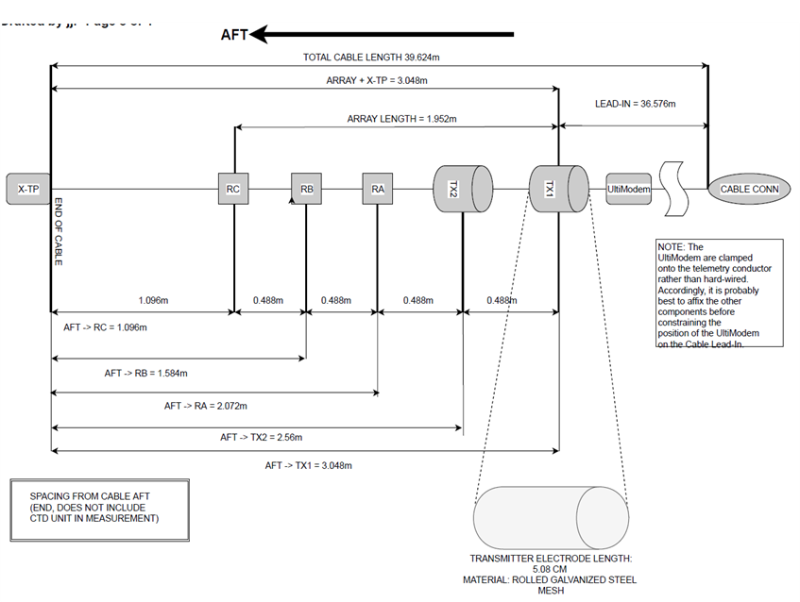
Figure 9: Diagram of the Marine IP Ice Cable design

Illustration: Diagram of the Marine IP Ice Cable design, showing two transmit electrodes and three receiver electrodes, each spaced by approximately 0.5m. Total length of the measurement end of the Ice Cable is 3m.
Phase 2: Construct, integrate and test Marine IP Open Water Cables. (Note, Phases were re-ordered from the original proposal and previous workplans, due to later than planned project start date, and delays in availability and shipping of cable components).
Research Task 4. Constructed and tested a primary and spare cable for investigation of oil in water depths from 1 to 35m in open water conditions – the Open Water Cable. The design swath width of survey area for this cable was targeted to be 20 meters and the minimum depth resolution was targeted to be one-half a meter. The Open Water Cables were each constructed at a length of 180 m, and the measurement portion of this length is 52 m. Each Open Water Cable has two transmitter electrodes and six receiver electrodes, as seen in the diagram below.
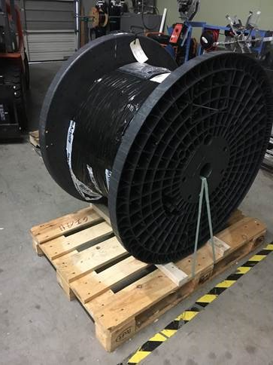
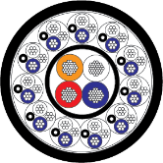
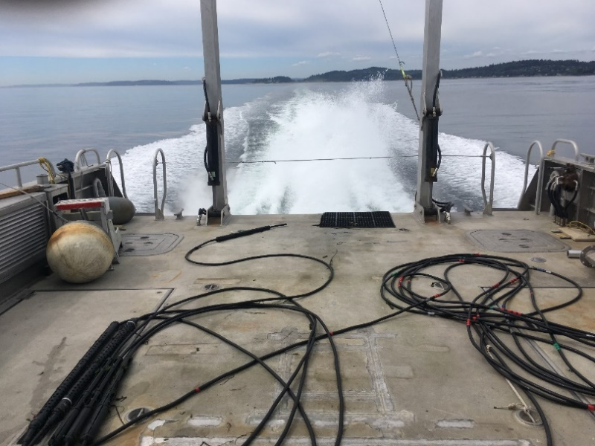
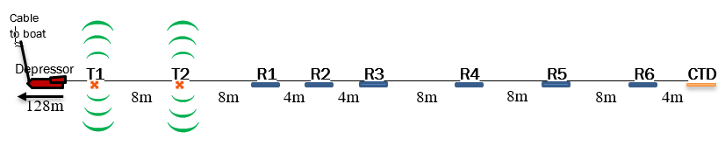
Two types of cable were used to construct the Open Water Cables in order to test for the optimal cable to be used for future cable builds. Long lengths of multiconductor cable are long-lead-time items to order, and some delays were experienced in the availability and shipping of the cable materials. Open Water Cable #1 (OWC #1) was constructed from Power/Signal 4206 multiconductor cable (sourced from MacArtney Inc. in Houston, TX), and was completed 29 July 2019. Open Water Cable #2 (OWC #2) was constructed from custom Power/Signal multiconductor cable (sourced from Mercury Wire Products, Inc. in Spencer, MA), and the construction of the cable was completed 5 December 2019. The Marine IP Open Water Cable Design is summarized in the figure below and has been provided in more detail in a separate document (Ref: ADAC Marine IP_Open Water Cable)

Figure 10: Marine IP Diagram of OWC (TO)P, Marine IP Cable (Bottom Left), and bulk Power/Signal 4026 cable (Bottom Right)
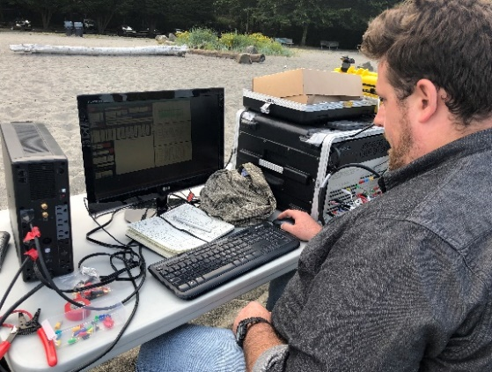
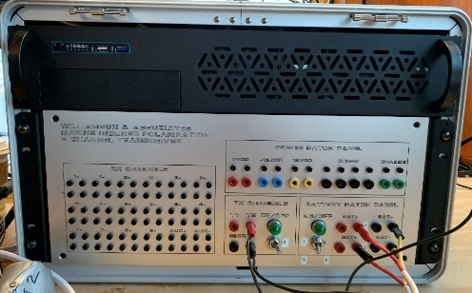
Research Task 5. Integrated the Open Water Cable into the researcher-developed control system. The Marine IP topside system consists of a Topside Control Box, Universal Power Supply connected to either ship AC mains or a portable generator, two 12v DC sulfur glass-mat batteries, a signal routing wire harness interfacing the Topside Control Box with the cable. The Topside Box components include a transmission (TX) waveform generator powered by the 12V batteries, an external battery patch panel, isolated receiver analog front end and a computer-controlled Data Acquisition System (DAS) synchronized by the onboard computer. Operator control and is provided via standard computing peripherals (keyboard and mouse or other pointing device) and a monitor displaying a Graphical User Interface tailored for visualizing Marine IP data.
Figure 11: Marine IP system electronics and receiver box
(Left) Marine IP system. (Right) Marine IP receiver box with Open Water Cable plugged in.
Research Task 6. Conducted Open Water Cable beach tests at Seattle Golden Gardens Park on Puget Sound, Washington to verify proper operation of the transmit/receive electrodes of both cables in a marine environment. OWC #1 was beach tested on 9 August 2019 and OWC #2 was beach tested on 5 December 2019.
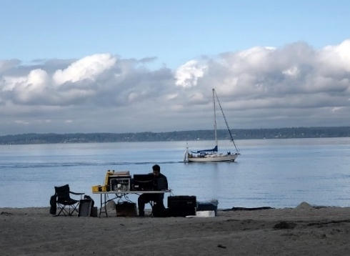
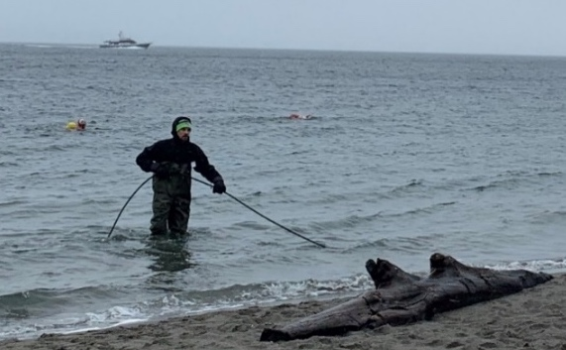
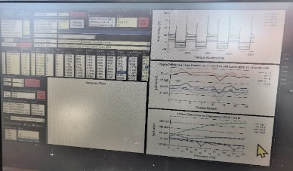
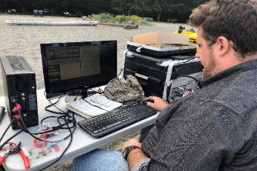
During this field experiment, researchers manually deployed the cable from the beach to approximately 1-meter depth. Investigators then deployed known targets at planned locations along the cable to test and validate the signal received from the cables. The control system and associated topside electronics were also tested during these trials for proper operation. During this field experiment, the test targets were clean materials that did not contribute contaminants to the environment. Standard Marine IP beach test targets were deployed in the vicinity of the cable: a metal pipe, anodized steel bolts, decommissioned brass ammunition casings, and a bag of sand containing gold particles. All materials were retrieved at the conclusion of the data collection run for each target material.
Figure 12: Marine IP Beach testing
Clean signal from all receivers

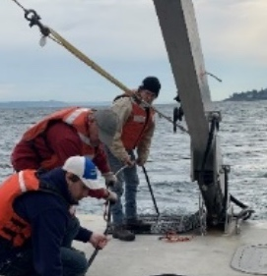
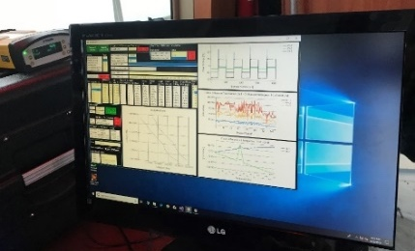
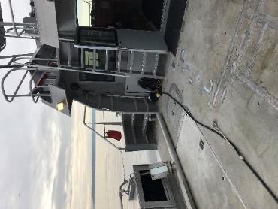
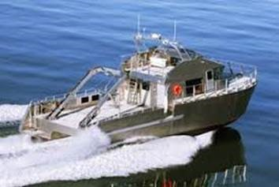
Phase 3: Conducted open water testing.
Figure 13: Marine IP Open Water testing
Kvichak Defender 4

Research Task 7. Conducted field tests in Puget Sound to test and demonstrate system mobilization, baselining procedures and deployment from a 54-ft vessel of opportunity. On 15 October 2019, a survey was performed to test the deployment of the Open Water Cable. OWC #1 was used for this testing. To increase the sensitivity and dynamic range of the Marine IP system, four baselines (i.e., ambient background) measurements were performed before and after data collection at the Eagle Harbor survey transects.
The first baseline was a “calibration dangle” where the cable characteristics in saltwater are collected with the cable suspended in deep water with the vessel at station keeping. Second, a towed baseline measurement was taken in shallower water outside the Survey zone and compared with the deep water “dangle” to ensure the cable was operating correctly. Finally, two additional baseline measurements were taken, in the same areas as the pre-survey baseline measurements, after completing operations at the survey site.
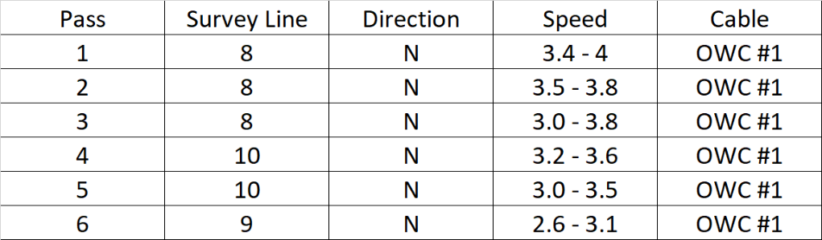
Field testing confirmed reliable operational performance of all Open Water Cable components and interface with the Topside Control Box, showing expected electrode connections, signal reception from each receiver electrode pair (i.e., a “channel”), no grounding faults within the system, and minimal electromagnetic interference from the ambient environment.
Table 9: Marine IP Open Water test transect lines

Once the topside Data Acquisition System was fully operational, the vessel transited to Eagle Harbor, WA. Six Marine IP transect lines were run, and details are listed in the table below. The table can be read as follows: ‘Pass’ shows the order the lines were run, ‘Survey Line’ refers to the planned survey lines shown in the figure below, ‘Direction’ indicates the direction the boat traveled, ‘Speed’ is in knots, and ‘Cable’ indicates which cable was used for the survey line. For each transect, the cable was powered by two 12V gel cell batteries and a square wave was transmitted at 4 Hz. The cable was deployed by hand, data was collected along the line, and the cable was recovered by hand. Of the total active survey time during this open-water survey, uptime was 100%.
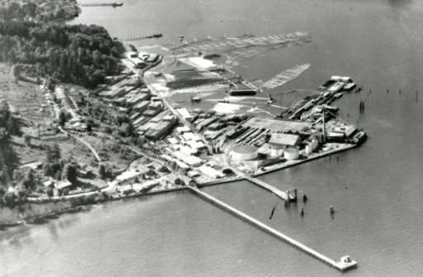
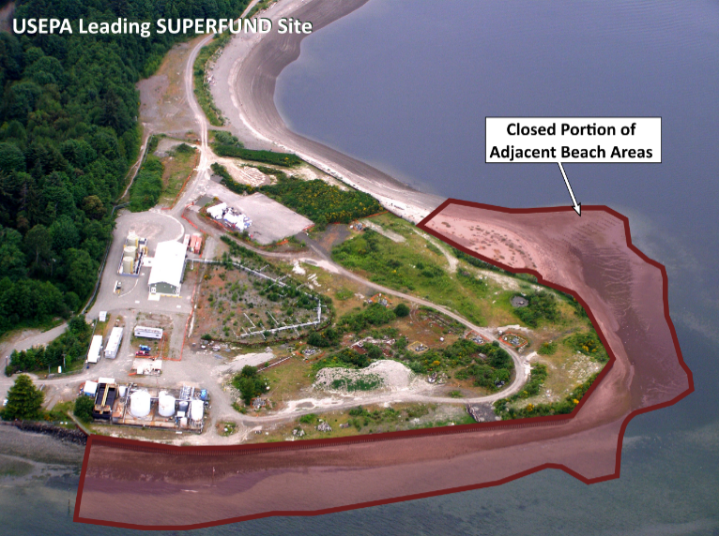
Figure 14: Marine IP Open Water test transect locations
Wyckoff: historical aerial photo
Photo from Bainbridge Island Historical Museum
East Beach
Wyckoff: 2019
Line 7
Line 8
Line 9
Line 10
https:/apps.ecology.wa.gov/gsp/Sitepage.aspx?csid=2683

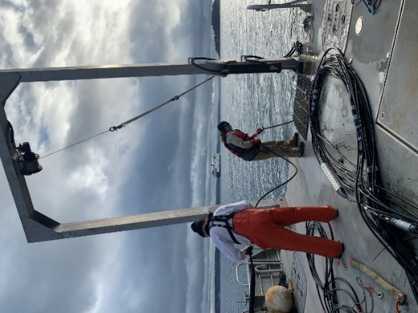
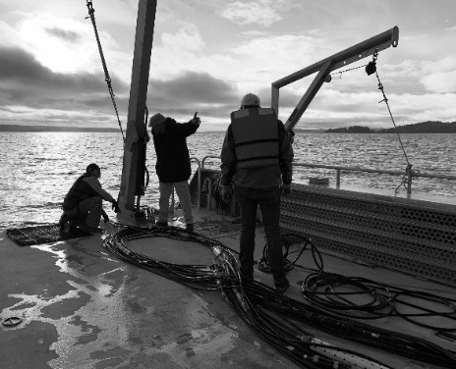
Research Task 8. The team conducted field trial to demonstrate performance of wide-area assessments identifying presence/absence of hydrocarbons. The field trial was conducted on 13 December 2019 at Eagle Harbor, WA, aboard a vessel of opportunity, the Kvichak 54’ catamaran Defender 4. OWC #2 was used for this field trial. During this survey, all aspects of system performance were tracked and associated metrics for navigation and data were recorded. Marine IP data were recorded for post-analysis to characterize the target area and for comparison against known targets. The sediment in the area was a mix of sand and gravel, salinity was 28 practical salinity units (PSU) and water temperature was 9.9°C (49.8°F). Survey lines were run off Eagle Harbor, East Beach. All data collected and associated results are in process for integration into the final data report. Implementation costs were monitored for cost and performance comparisons. For baseline comparative purposes, an area known to be absent of pollutants was included in the survey.
Figure 15: Marine IP cable figure eight on deck
The same survey lines that were run during the October 15th test were repeated during this field trial: lines 8, 9, and 10, east of East Beach, run from south to north as shown in the image on the previous page. For each run, approximately 70 m of the 180 m cable was streamed behind the vessel with 110 m of cable remaining on deck during each run. Of the total active survey time during this open-water survey, uptime was 100%.
Phase 4: Constructed, integrated, and tested Marine IP Ice Cables; investigated target signatures
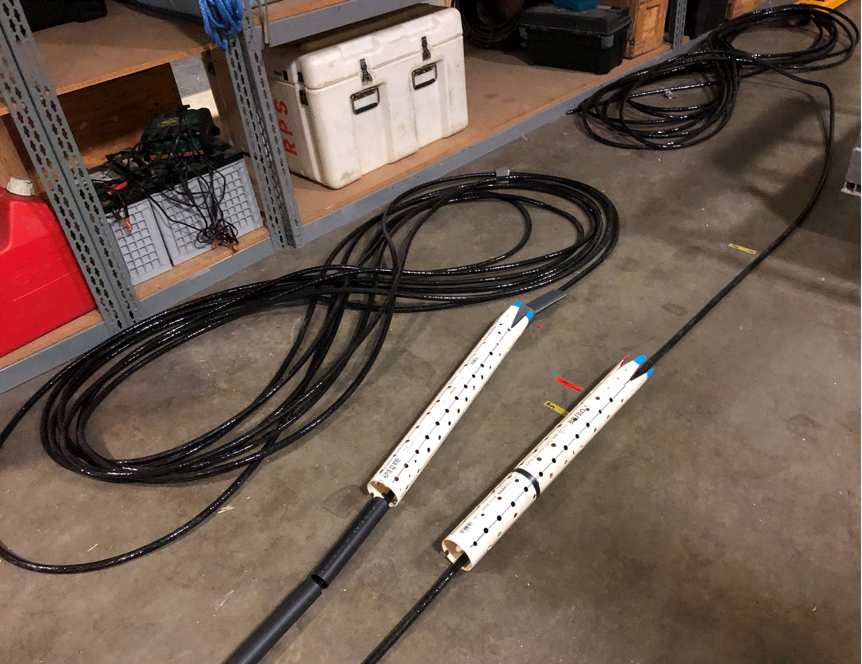
Research Task 9. Constructed and tested a primary and a spare cable for investigation of oil in simulated ice conditions. To study the capabilities of Marine IP for mapping oil contaminants under and within ice, researchers constructed the Ice Cable designed during Research Task 3, optimized for the dimensions and environment of the CRREL GRF Concrete Basin. The CRREL GRF measures 60 ft long, 20 ft wide, and 7 ft deep, and therefore the Ice Cables needed to have a tight field of measurement to avoid signal interference with the sides of the concrete basin. The measurement end of the Marine IP Ice Cable has a total length of 3 m, including the two transmit (TX) electrodes and three receive (RX) electrodes. The TX and RX electrodes are spaced linearly 1.6 ft (0.5 m) apart (Design detail is provided in a separate document (Ref: ADAC Marine IP_ICE_Cable Design).
Figure 16: Marine IP transmit electrodes
Research Task 10. Integrated the Ice Cable into the researcher developed Topside Control system. The Marine IP topside system consists of a Topside Control Box, Universal Power Supply connected to either ship AC mains or a portable generator, two 12v DC sulfur glass-mat batteries, and a signal routing wire harness interfacing the Topside Control Box with the cable. The Topside Box components include a transmission (TX) waveform generator powered by the 12V batteries, an external battery patch panel, isolated receiver analog front end and a computer-controlled Data Acquisition System (DAS) synchronized by the onboard computer. Operator control is provided via standard computing peripherals (keyboard and mouse or other pointing device) and a monitor displaying a Graphical User Interface tailored for visualizing Marine IP data.
Researchers also took some of the lessons from the field deployments in Research Tasks 7 and 8 by constructing hardened, more portable cases for the computer peripherals. The previously used mouse was replaced with a trackball mouse to provide more control and precise movement on a pitching vessel deck during field operations. A monitor and keyboard were integrated into a field-case for faster deployment.
Most crucially for rapid deployment and setup, a signal routing box with interchangeable channel routes and universal connectors with standardized pinouts was constructed. The OWC #2 and both ICE Cables were designed and constructed to adhere to this standard conductor pinout to enable quick changes of the cables during tests without risk of damaging the cable interface wiring harness. This relieved mechanical strain on the wiring harness connecting the cable interface to the Topside Control Box.
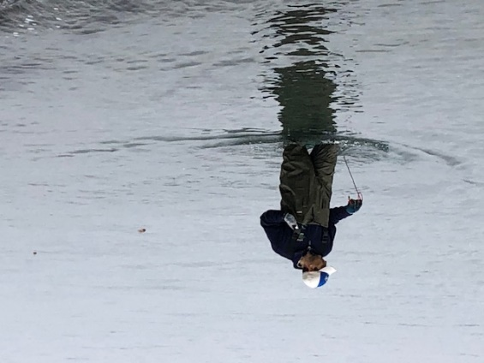
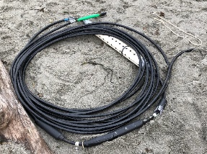
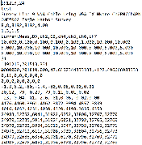
Research Task 11. Conducted Ice Cable beach tests at Seattle Golden Gardens Park on Puget Sound, Washington to verify the integrity of the cable jacketing and potting and ensure proper operation of the transmit/receive electrodes of both cables in a marine environment.
Figure 17: Marine IP beach testing equipment
The Ice Cables produced clean Marine IP signals
During this field experiment, researchers manually deployed the cable from the beach to approximately 1-meter depth. Investigators then placed known targets at planned locations along the cable to test and validate the signal received from the cables. During this field experiment, targets tested were clean materials that did not contribute contaminants to the environment, including metal pipes, bolts, and other polarizable materials. The Topside Control Box, cable interface routing box, battery systems, and associated revisions to the topside interface electronics were also tested for operational integrity.
Research Task 12. Researchers are still conducting ongoing investigations of IP signatures for targeted petroleum following the signature study plan defined in the Test Plan for Marine IP Target Petroleum Signatures for IP signature investigation. Pursuant to accomplishing this task, the lab testing environment was iteratively optimized, and a systematic series of tests were designed to characterize the effects of changing ambient conditions on marine IP signatures for specified oils. While carrying out this task, the team uncovered some key differences between the electrical properties in field measurement environments and those found in the implemented laboratory test apparatus for characterizing spectral signatures of materials.

The research team (and other workers with this technology) have found indications that the average power density of the transmitted waveforms has a more profound effect on the behavior of the transmitter electrodes in small (relative to open water environments) containment vessels than was previously understood. Particularly, it was noted that overvoltage of the transmitter electrodes causes vigorous cavitation at the electrode-electrolyte interface and subsequent rapid corrosion of the galvanized steel electrodes in the laboratory simulated saltwater environment. This has been found to cause deleterious effects on Marine IP signals in the laboratory and represents a hurdle to high-resolution laboratory characterization of spectral signatures for petroleum.

Interestingly, the average transmitted waveform power levels in open water (i.e., field) environments are substantially higher – nearly tenfold greater than laboratory power levels – without encountering this overvoltage and resulting interference problem during field measurements. It was noted that the impedance to Earth ground of a field environment is close to zero – that is, there is a nearly infinite capacity of the open water connected directly to Earth to sink the current transmitted by the Marine IP array. In contrast, the laboratory system implements a floating ground scheme and routes the grounding through the transceiver device or power supply for the test, representing a substantial increase in ground impedance – in essence an additional barrier between the charge pumped into the test tank and the Earth ground. This realization led the team to hypothesize that the grounding scheme in the laboratory is insufficient to tolerate the increased transmitter power necessary for matching the complex impedance (Marine IP) spectral features of known petroleum contaminant targets with field studies to laboratory tests.

Additional studies using the field-deployable version of the transceiver in the lab through a resistive signal power attenuation network were performed during the last week of February using samples of the crude oil provided by the team at CRREL. Testing was started on the petroleum used at the CRREL GRF according to the signature study plan; the team also investigated additional petroleum and petroleum products, which vary in characteristics but match Arctic target categories, (e.g. Alaska North Slope crude and marine bunker oil). The data using the signal power attenuation system without enhanced grounding in the laboratory test tanks exhibited a high level of noise and harmonic distortion. As we finish program year 6, the team is currently still implementing postprocessing methods capable of detecting low-intensity Marine IP signatures in noisy data and will apply these methods to the results of these and future lab tests once they are able to be conducted in program year 7. The laboratory noise level coupled with harmonic distortion in the transmitted waveforms led the team to conclude that a redesign of the laboratory apparatus – focusing on as closely replicating the electrical and current-sinking properties of an open water environment -- is required to attain the resolution and data quality necessary for characterizing effects of salinity and temperature on Marine IP spectral signatures.

Modifications to the laboratory test apparatus were designed to address these issues in February, however the team has not yet had the opportunity to fabricate or implement the new laboratory system design due to the ongoing COVID-19 pandemic. The COVID-19 pandemic forced stay-at-home orders on Washington State residents and businesses approximately one week after the team returned from completing Task 16 at CRREL. As a result, the Induced Polarization Associates research team was barred from accessing their laboratory space, test and fabrication equipment, target samples (including petroleum samples from CRREL), test tanks, electrical, IT and computing infrastructure. Extremely limited access was granted in early July to pick up various pieces of computing and test equipment.

Subsequently, in mid-July 2019 the Marine IP team was informed of the termination of their workspace rental agreement with Nytec, as Nytec had been acquired early in 2020 by Accenture. As program year 6 ended, the team seeked alternate workspace facilities that meet requirements for safety, ventilation, social distancing, electrical, IT and waste disposal infrastructure to continue laboratory work. One such available candidate facility was an outdoor concrete pad in a residential, private area. The pad provides cover from weather, proper ventilation, and access to electrical infrastructure. The Marine IP team plans to secure suitable lab space by 15 August 2020 to resume laboratory testing and data processing.

Phase 5: Conduct ice tank testing at CRREL.
Research Task 13. Conducted baseline measurements at the CRREL facility. For the CRREL simulated ice tests, a baseline configuration was established, and measurements recorded in advance of introducing petroleum to the CRREL GRF. The baseline measurements characterized the effects of inductive responses due to the physical properties of the CRREL GRF, as well as any signal artifacts, noise, or distortion due to the boundary conditions imposed by the presence of the solid ice and other ice-water interactions. The specifics of the setup design at the GRF for the baseline measurements were as follows:
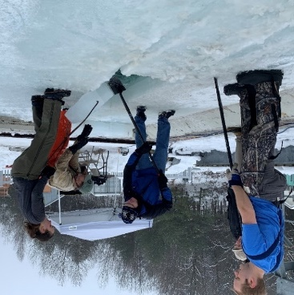
A long section was cut out of the ice on each end of the GRF to act as the access areas for the Ice Cabe to enter the tank and six 1m x 1m cutouts were made in the ice, designed to be at least 2m apart, as seen in the Scenario Diagram below. The cutouts were prepared in advance of the Marine IP team arriving at CRREL so that the lowest extent of each of the 1m x 1m Sites would be at least six inches thinner than the rest of the ice sheet. This implementation of design was to ensure that once oil was added to the Sites, the Ice Cable being pulled under the ice would not come in contact with the oil and therefore cause the oil to spread and cross-contaminate other areas of the tank. For the baseline measurements, no oil was added to the tank and the scenarios measured were 1) solid ice, 2) broken ice, 3) broken ice that has refrozen to create a rough bottom and 4) open ice.
Figure 18: CRREL Labs testing
The research team systematically moved the Marine IP Ice Cable longitudinally (i.e., along the long axis of the array) through the tank in each direction (northward and southward) and under each set of cutout sites (Lanes A, B and C), as seen in the illustrations below.
Figure 19: Marine IP CRREL testing Scenario Diagram

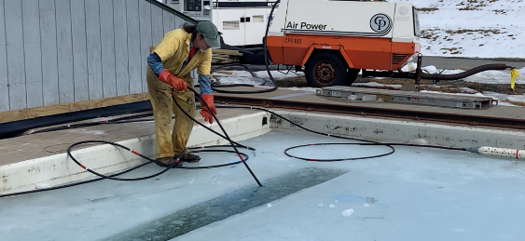
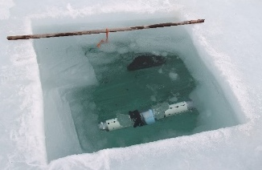
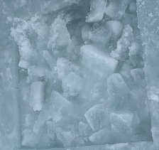
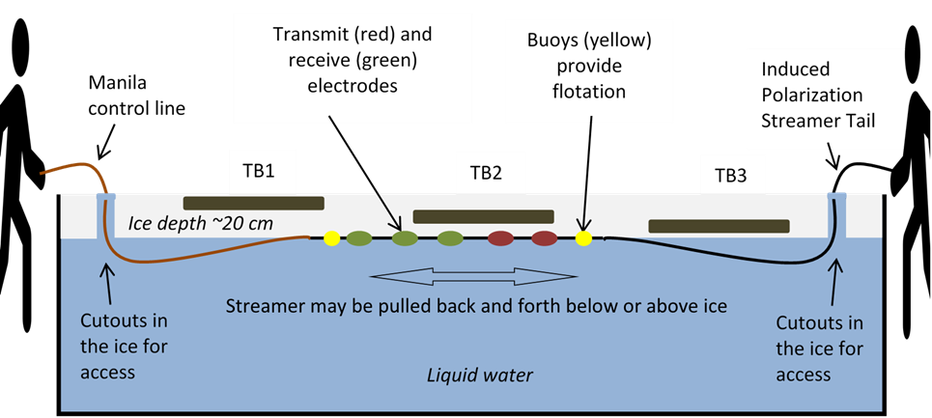
Figure 20: Illustration of CRREL testing Methodology
Illustration of how the Marine IP cable will be manipulated through the CRREL ice tank.
To accomplish this step, the team used two cutouts in the ice, one at each side of the tank, in through which taglines were threaded. Small buoys were placed along the cable to keep it close to the ice. Personnel took positions at each end of the tank and manipulated the position of the cable using the tagline at one end of the tank and the non-active part of the cable at the other end of the tank (please see Illustration below).
Figure 21: Images of Marine IP CRREL testing
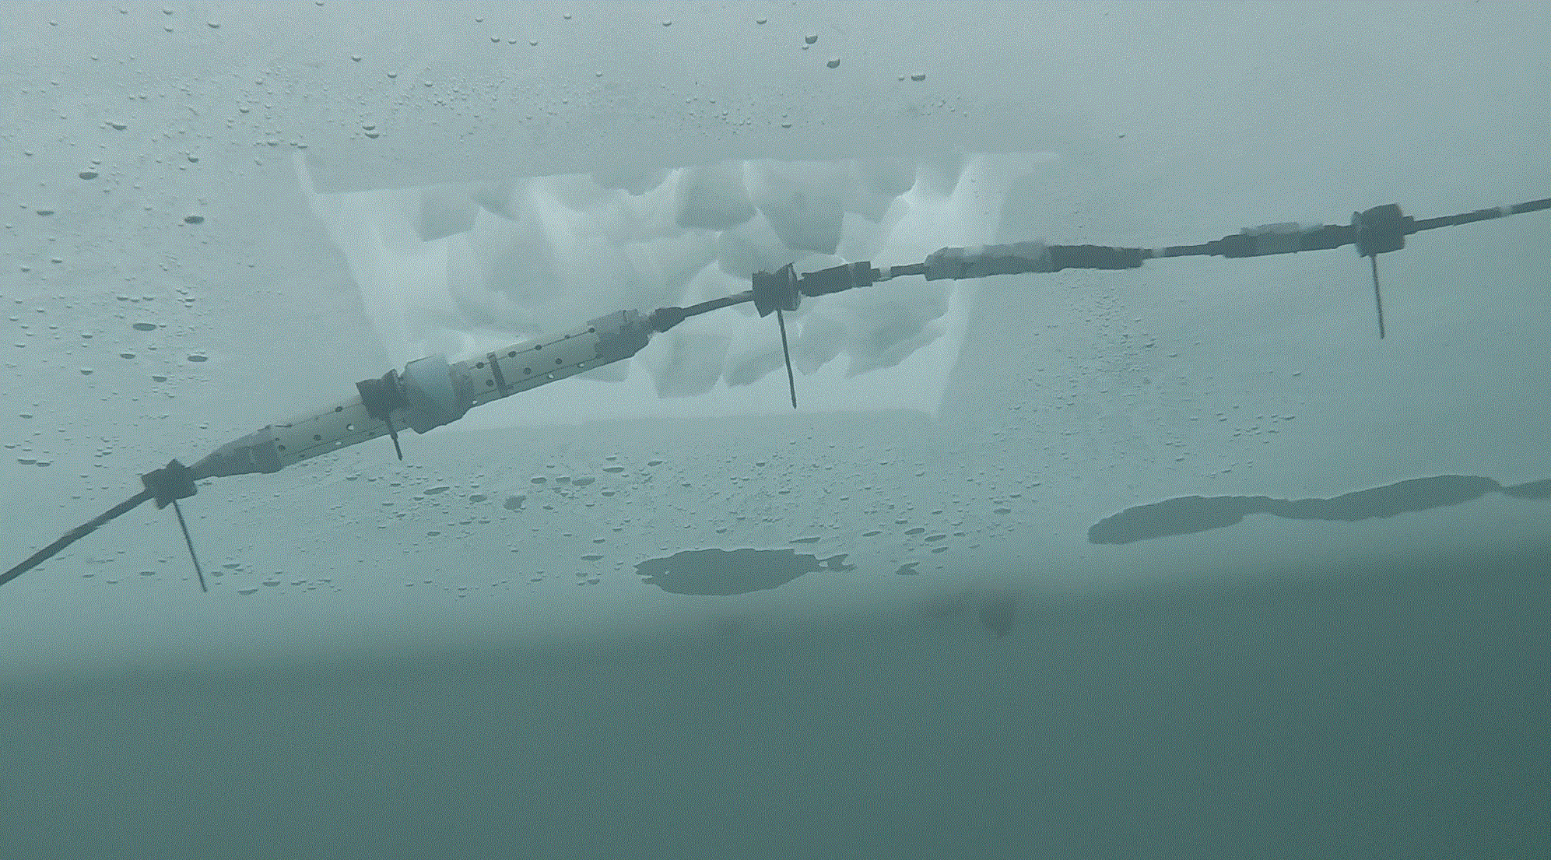
An underwater camera was periodically deployed beneath the ice to visualize the positioning and operation of the cable under the ice as the study is conducted. The camera was not operated during data collection cycles to avoid introducing additional electrical interference or damaging the camera equipment.
Figure 22: Image of Marine IP CRREL testing (underwater view)
Following the experiments, research is ongoing with respect to both analyzing the collected data as well as implementing better data analysis techniques to provide a better understanding of the effects of temperature and salinity on the Marine IP anomaly signal. Efforts are also underway to characterize changes to the Marine IP response that might occur due to proximity of the array to the ice, and to understand any effects of the GRF construction rebar and other materials found in the GRF tank may have on the signal, awaiting the completion of the laboratory work.
As of June 30th, the Research team has reached a preliminary conclusion that the inductive effects of metal in the GRF tank do not negatively impact the appearance and relative intensity of capacitive anomaly (Marine IP) signals provided appropriate countermeasures are taken to remove ground-loops in the cable and transceiver hardware through careful placement of the Earth ground for the system. Moreover, there is no discernible anomaly from mechanical stress placed on the cable. Therefore, capacitive anomalies observed by the array can be confidently attributed to the presence of polarizable, capacitive materials such as crude oil within the measurement radius of the Marine IP array in saltwater.
It is known, however, that the intensity and power spectral density of Marine IP signals can be affected by temperature and salinity differences in the water. However, while this data was collected at CRREL, the Research team intends to, but has not yet been able to, implement postprocessing algorithms to map a correlation (if any) between the temperature and salinity dependent variables and the Marine IP anomaly signal frequency bands and intensity values.
The researchers coordinated closely with the CRREL personnel to design an effective layout for the test regions within the GRF tank, the test scenarios that would be created. The chronological order in which the oil targets were added to designated test regions after the clean ice control measurements were collected was also established in coordination with CRREL laboratory personnel and are shown below in the Scenario Descriptions.
Research Task 14. Conducted final testing at the CRREL facility. The research objective of this portion of the field program was to gain an understanding of both the capabilities and limitations of Marine IP for detecting and mapping oil under and encapsulated within the ice. Oil was introduced into the ice tank environment in coordination with CRREL test procedures and in accordance with the agreed research test plan shown in Research Task 13. The study design included six test regions and seven
scenarios within the CRREL GRF. The specific scenarios tested are listed in the table below and can be seen in the illustrated diagram below the table:

Site 1A: Solid ice, encapsulated oil and  Oil under solid ice | Site 2C: CONTROL: Solid ice - NO OIL
Site 3A: Broken ice with oil to surface | Site 4C: CONTROL: Broken ice - NO OIL
Site 5A: Broken ice, oil to surface,  encapsulated oil | Site 6C: Broken ice, rough bottom, encapsulated oil
Figure 23: Marine IP CRREL test Scenario ice types

Table 10: Marine IP CRREL testing table
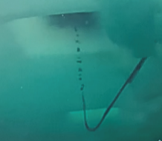
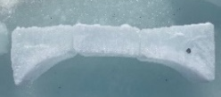
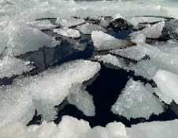
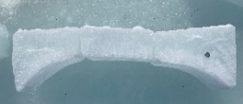
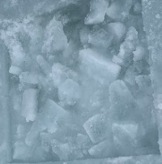
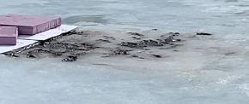
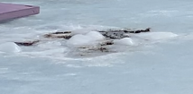
1st site scenario,
oil encapsulated
in solid ice
CONTROL: Broken ice

NO OIL
Broken ice, rough bottom

encapsulated oil
Broken ice, oil to surface

encapsulated oil
Oil in broken ice

direct contact with oil

Solid ice

Encapsulated oil +
direct contact with oil

CONTROL: Solid ice

NO OIL
2nd site scenario, oil under solid ice
Figure 24: Marine IP CRREL ice conditions
The Marine IP cable was systematically moved longitudinally through the tank in each direction and under each set of test sites that represent the scenarios shown previously.
The oil detection test deployment methodology followed a similar workflow to that of the baseline measurement. While taking the oil testing measurements, the team used two cutouts in the ice, one at each (longitudinal) end of the tank, through which a tagline was placed. The team placed small buoys along the cable to keep it close to the ice prior to baseline and measurement of clean ice areas at the start of the test day. Researchers then connected the tagline to the cable at one end and the cable was manually pulled at a rate of approximately 0.3 m/s along specified lanes beneath the ice. During testing, researchers collected simultaneous measurements of water temperature and again employed an underwater camera in between Marine IP data collection cycles.
The safety and health of all team members and environmental protection was of paramount importance throughout all phases of this research program. As related, Research team was following all aspects of the approved ADAC Safety Plan. In accordance with the plan, all team members and others involved wore requisite personal protective equipment (PPE) as laboratory and field conditions warranted during the pandemic.
Research Task 15. Research team conducted data analysis, interpretation, and developed preliminary results. Prior to the extensive system testing in the laboratory and the field both in Seattle and at CRREL, it was hypothesized that, in addition to the known role of providing a baseline dataset for comparison to the oil under ice measurements, an along-line system baseline could also be subtracted from the oil under ice measurements in order to increase the resolution and sensitivity of the Marine IP system. However, it has been determined that a baseline subtraction is not feasible in postprocessing due to artifacts in the signal, and so the baseline measurements will continue to serve their known purpose of comparison analysis.
In advance of completing the laboratory work, the team developed a statistical and machine-learning powered methodology for postprocessing that shows great promise. This development required a substantial retooling of the system’s existing postprocessing software. This has provided an opportunity for the Marine IP team to modularize and upgrade the postprocessing software suite – bringing it to a form that is platform-agnostic and running from a Relational Database Management System (RDBMS) that enables enhanced data and result persistence.
The team collected several gigabytes of data during their 2020 field deployments of the Marine IP system. Data analysis is ongoing since returning from CRREL in early March of 2020. Initial attempts at analyzing the data using automated techniques were met with several challenges early in the analysis process, prompting substantial rework of the Marine IP postprocessing software systems. Several unforeseen and uncontrollable factors led to the emergence of these challenges.
Damage incurred to the Marine IP system during transport from Seattle, WA to CRREL in New Hampshire urged the field-repair and substantial changes to the architecture of the transmitter circuitry. Additional damage to the analog receiver frontend was discovered during repairs to the transmitter circuitry. These repairs were conducted in the field in New Hampshire during the first two days of our CRREL tests. The extent of the damage was such that our existing digital signal postprocessing and analysis methods were insufficient to resolve the Marine IP signals from system noise. The postprocessing calculation algorithms needed redesign to accommodate the new signal characteristics before automatic postprocessing could occur. Specifically, the lack of capability to synchronize receiver measurements with the function generator waveform cycles caused substantial artifacts in the spectra produced from the receiver signals in postprocessing.
The redesigned postprocessing algorithms addressed this problem by implementing waveform cross-correlation statistics and linear optimization techniques to minimize the time-domain offsets of the measured waveforms relative to the transmitted waveforms. Additional postprocessing algorithms have been identified and implemented for locating patterns in the phase shift (complex impedance) and apparent (real) impedance response spectra. Particularly, a K-nearest Neighbors algorithm has been implemented in MATLAB to mitigate the effects of the timing-offsets in the measured waveforms and locate clusters of probable phase anomalies (i.e., Marine IP Signals).
Attempts have been made to manually process the data collected at CRREL concurrently with analysis automation algorithm development to better characterize the data and organize it for deeper analyses and presentation. Some of the data has already been successfully processed using this manual workflow. However, several gigabytes of data collected in the laboratory and at CRREL remain to be processed as of June 30th. The sheer volume of raw data collected is challenging to process with limited personnel working remotely due to the ongoing COVID-19 pandemic.
The sudden shift to fully remote work has made management and transfer of several gigabytes of data over residential Internet systems challenging, requiring some workarounds. Problems with data and database synchronization and versioning were addressed through the construction and deployment of Amazon Web Services (AWS) Elastic Cloud Computing (EC2) and Relational Database Server (RDS) instances by the team. Existing manual postprocessing methodologies are labor and time-intensive, leading to the redevelopment of various automation tools and data management techniques. Automated data parsing and tabulation with Python, MATLAB, and MySQL Database structures were developed concurrently to address this problem.
Marine IP data sets are highly multidimensional so much effort was required to distill the relevant information from the data sets and present it in a clear tabular and visual form for reporting. Several representation methods for displaying the Marine IP data were investigated by the team. Visualization techniques for highlighting the various indicators of Marine IP signals as combinations of simultaneous changes in the signal were investigated in detail. Prototype visualizations were constructed and presented by researchers.
Research Task 16. Determine and document preliminary engineering design specifications for integration of Marine IP with AUV operations using information and lessons learned during Phases 2 and 3. The research team drafted a preliminary integration analysis for the Marine IP system deployed as a payload module aboard an AUV or ROV. This analysis is based on a set of high-level requirements identified by the team during field operations in 2020 as well as additional research into the current state-of-the-art in AUV instrumentation packages and modules. The report for this research is included as a separate document (Ref: ADAC Marine IP Preliminary Specifications for AUV Integration).

Student Involvement:
N/A

Key Accomplishments:
- Produced the Marine IP Ice Cable Design Document.
- Constructed and beach tested the Open Water Cable.
- Integrated the Open Water Cables and transmitters/receivers into the Marine IP control system.
- Conducted post-cable integration beach tests.
- Completed open water field tests from a small vessel for the detection of hydrocarbons in sediment.
- Constructed and beach tested the Ice Cable.
- Integrated the Ice Cable and transmitters/receivers into Marine IP control system.
- Started work on the determination of the spectral signature of selected target contaminants utilizing a Marine IP system. Preliminary measurements were collected of Alaska North Slope crude oil, and additional measurements will be collected and analyzed during the carry forward in Year 7.
- Conducted baseline measurements at CRREL February 11-13, 2020.
- Conducted ice tank testing of Marine IP in simulated ice conditions at CRREL March 3-5, 2020.
- Preliminary engineering design for specification for Marine IP integration with ROV/AUV operations was produced.
- Data analysis and reporting is in progress and will be completed during the carry forward in Year 7.

Key Stakeholder Engagement:
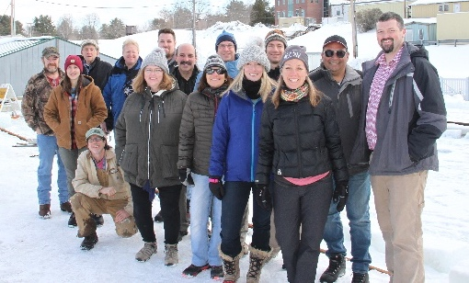
Conducted a project update meeting on 12 November 2019, including Project Champion LT Matthew Edes (USCG), Alexander Balsley (USCG), LT Omar Borges (USCG), Brandon Booker (CRREL), and the Marine IP research team. Three project planning meetings were conducted with Nathan Lamie (CRREL), Brandon Booker (CRREL), and the Marine IP research team in advance of CRREL research.
Figure 25: Marine IP CRREL test team group photo
On 12 February 2020, while at the CRREL facility, the Marine IP team met with and discussed the Marine IP technology with Dana Tulis (USCG), Karin Messenger (USCG), Alexander Balsley (USCG R&D), Lisa DiPinto (NOAA), Paul Panetta (Chief Scientist, Ohmsett), and Oscar Garcia-Pineda (Geoscientist/Oil Spill Researcher and Responder).
On 16 July 2020, discussed the Marine IP technology in a presentation to ADAC’s Arctic Summer Intern Program (ASIP), a group of students learning about oil spill response techniques and technology. The Marine IP team participated in ADAC Quarterly Reporting presentations and Round Table meetings, as well as the ADAC Annual Meeting. All tasks associated with program contracting, accounting and personnel were completed in close coordination with ADAC leadership and supporting staff.
All cables have been designed, built and tested and the field work has been completed, data processing ongoing.

Key Publications (peer reviewed):
In work during Program Year 6 due to delays in completing analysis by laboratory closures mandated by COVID19.

Key Presentations:
Project team presented at ADAC Program Year 6 Annual Meeting. The Annual Meeting was held virtually via Cisco WebEx as COVID-19 prevented an in-person gathering in Washington D.C. as in previous program years. The meeting was well attended drawing a total of 202 registrations for the 7-hour virtual event with a peak of 157 participants. DHS S&T OUP, HQ USCG ADAC Project Champions, NOAA leadership, ADAC Executive Counselors, and many other customers and partners participated ADAC’s Year 6 Annual Meeting.
Due to laboratory measurement and data processing delays caused by interrupted access to facilities due to COVID-19, no presentations have been given outside of the ADAC community to date. The Marine IP team has presented on the technology and ADAC project updates through ADAC Quarterly Reports, the Annual Meeting, and the ADAC ASIP activity.

Changes from initially approved Workplan:
No changes from approved overall Workplan. However, due to delays caused by COVID-19, some tasks will be completed in ADAC Program Year 7, to be conducted alongside the Year 7 workplan.

Project progress against each milestone:
Project progress toward milestones is summarized in the table below.
Table 11: Marine IP Year 6 Milestones
MILESTONE | PROGRESS | WHY NOT REACHED? (IF APPLICABLE)
Design an ice-capable Marine IP system (Ice Cable) that can withstand the temperature exposure and can be successfully tested in a simulated ice environment (carry forward from Year 5) | Completed
Construct and beach test Open Water Cable (carry forward from Year 5) | Completed
Integrate Open Water Cable and transmitters/receivers into Marine IP control system (carry forward from Year 5) | Completed
Conduct post-cable integration beach tests (carry forward from Year 5) | Completed
Complete open water field tests from a small vessel for the detection of hydrocarbons in sediment | Completed
Construct and beach test Ice Cable | Completed
Integrate Ice Cable and transmitters/receivers into Marine IP control system | Completed
Determine the spectral signature of selected target contaminants utilizing a Marine IP system | Incomplete | Due to interrupted access to laboratory facilities immediately following the work at CRREL, the team was not able to complete the lab measurements needed for this analysis. The team will secure space to complete the lab measurements by approximately 1 October 2020. The team will then set up the lab equipment (estimated to require two weeks), continue the measurement program (estimated to require two weeks), and complete the analysis (estimated to require three weeks).
Conduct preliminary tests at CRREL for tank baseline anomaly detection results | Completed
Conduct ice tank testing of Marine IP in simulated ice conditions | Completed
Complete preliminary engineering design for specification for Marine IP integration with ROV/AUV operations | Completed
Complete data analysis and reporting | Incomplete | Due to the interruptions caused by COVID-19, the team was not able to complete all of the laboratory measurements. Once the team secures space and is able to complete the lab measurements, the data processing, analysis and reporting can be completed. The team will secure space to complete the lab measurements by approximately 1 October 2020. The team will then set up the lab equipment (estimated to require two weeks), continue the measurement program (estimated to require two weeks), and complete the analysis (estimated to require three weeks).

Project progress against each metric:
Project progress toward each metric is summarized in the table below.
Table 12: Marine IP Year 6 Metrics
METRIC | PROGRESS | WHY NOT REACHED? (IF APPLICABLE)
Multiple metrics are delayed due to restricted laboratory facility access caused by COVID-19. All tasks are to be completed in ADAC Program Year 7.
Document spectral signatures of tested polarizable materials with reliable accuracy | Delayed, | Target Petroleum Signatures Laboratory Work Plan completed. Laboratory work delayed due to COVID-19 restricted access to laboratory space from 9 March 2020 - present. The team will secure space to complete the lab measurements by approximately 1 October 2020. The team will then set up the lab equipment (estimated to require two weeks), continue the measurement program (estimated to require two weeks), and complete the data analysis (estimated to require three weeks).
Quantify minimum detectable concentration of specified polarizable materials | Incomplete | Target Petroleum Signatures Laboratory Work Plan completed. Laboratory work delayed due to COVID-19 restricted access to laboratory space from 9 March 2020 - present. The team will secure space to complete the lab measurements by approximately 1 October 2020. The team will then set up the lab equipment (estimated to require two weeks), continue the measurement program (estimated to require two weeks), and complete the data analysis (estimated to require three weeks).
Specify distances for minimum concentration detections | Incomplete | Laboratory work delayed due to COVID-19 restricted access to laboratory space from 9 March 2020 - present. The team will secure space to complete the lab measurements by approximately 1 October 2020. The team will then set up the lab equipment (estimated to require two weeks), continue the measurement program (estimated to require two weeks), and complete the data analysis (estimated to require three weeks).
Percentage of blind targets found with the Marine IP cable | Incomplete | Open Water Cable testing is complete. The completion of the data analysis is dependent on the completion of laboratory work. Laboratory work was delayed due to COVID-19 restricted access to laboratory space from 9 March 2020 - present. The team will secure space to complete the lab measurements by approximately 1 October 2020. The team will then set up the lab equipment (estimated to require two weeks), continue the measurement program (estimated to require two weeks), and complete the data analysis (estimated to require three weeks).
Percentage of known petroleum fluids found at designated test site compared to previously documented (mapped) contaminant extent | Incomplete | Open Water Cable testing is complete. The completion of the data analysis is dependent on the completion of laboratory work. Laboratory work was delayed due to COVID-19 restricted access to laboratory space from 9 March 2020 - present. The team will secure space to complete the lab measurements by approximately 1 October 2020. The team will then set up the lab equipment (estimated to require two weeks), continue the measurement program (estimated to require two weeks), and complete the data analysis (estimated to require three weeks).
Percentage of uptime vs. total active survey time during open-water surveys | Complete
Examine capability of Marine IP survey to concurrently detect other submerged materials, debris, or infrastructure (e.g., cables, pipelines, or shipwrecks) during surveys primarily targeting hydrocarbons. | Incomplete | Open Water Cable testing is complete. The completion of the data analysis is dependent on the completion of laboratory work. Laboratory work was delayed due to COVID-19 restricted access to laboratory space from 9 March 2020 - present. The team will secure space to complete the lab measurements by approximately 1 October 2020. The team will then set up the lab equipment (estimated to require two weeks), continue the measurement program (estimated to require two weeks), and complete the data analysis (estimated to require three weeks).
Determine the capability and effectiveness of detecting oil in broken ice using a submerged IP cable | Incomplete | Oil under ice testing at CRREL is complete. The completion of the data analysis is dependent on the completion of laboratory work. Laboratory work was delayed due to COVID-19 restricted access to laboratory space from 9 March 2020 - present. The team will secure space to complete the lab measurements by approximately 1 October 2020. The team will then set up the lab equipment (estimated to require two weeks), continue the measurement program (estimated to require two weeks), and complete the data analysis (estimated to require three weeks).
Determine what concentrations of ice formations (e.g. slush, broken, full ice sheet, etc., as determined by the test plan) allow effective hydrocarbon detection | Incomplete | Oil under ice testing at CRREL is complete. The completion of the data analysis is dependent on the completion of laboratory work. Laboratory work was delayed due to COVID-19 restricted access to laboratory space from 9 March 2020 - present. The team will secure space to complete the lab measurements by approximately 1 October 2020. The team will then set up the lab equipment (estimated to require two weeks), continue the measurement program (estimated to require two weeks), and complete the data analysis (estimated to require three weeks).
Determine the limit of detection in ice formations (if any). | Incomplete | Oil under ice testing at CRREL is complete. The completion of the data analysis is dependent on the completion of laboratory work. Laboratory work was delayed due to COVID-19 restricted access to laboratory space from 9 March 2020 - present. The team will secure space to complete the lab measurements by approximately 1 October 2020. The team will then set up the lab equipment (estimated to require two weeks), continue the measurement program (estimated to require two weeks), and complete the data analysis (estimated to require three weeks).
Determine size of interstitial space in ice in which target petroleum is detectable | Incomplete | Oil under ice testing at CRREL is complete. The completion of the data analysis is dependent on the completion of laboratory work. Laboratory work was delayed due to COVID-19 restricted access to laboratory space from 0 March 2020 - present. The team will secure space to complete the lab measurements by approximately 1 October 2020. The team will then set up the lab equipment (estimated to require two weeks), continue the measurement program (estimated to require two weeks), and complete the data analysis (estimated to require three weeks).
Examine if ice formation, or interstitial volume, affects detectable concentrations | Incomplete | Oil under ice testing at CRREL is complete. The completion of the data analysis is dependent on the completion of laboratory work. Laboratory work was delayed due to COVID-19 restricted access to laboratory space from 9 March 2020 - present. The team will secure space to complete the lab measurements by approximately 1 October 2020. The team will then set up the lab equipment (estimated to require two weeks), continue the measurement program (estimated to require two weeks), and complete the data analysis (estimated to require three weeks).
Examine if different types of hydrocarbons affect the ability to detect in broken ice, i.e. are some hydrocarbons easier to detect than others? (e.g.: Alaska North Slope Crude (exploration spill) v. bunker oil (from a shipwreck). | Incomplete | Oil under ice testing at CRREL is complete. Due to practical limitations, it was only possible to use one type of oil during testing, Alaska North Slope Crude. The completion of the data analysis for that oil type is dependent on the completion of laboratory work. Laboratory work was delayed due to COVID-19 restricted access to laboratory space from 9 March 2020 - present. The team will secure space to complete the lab measurements by approximately 1 October 2020. The team will then set up the lab equipment (estimated to require two weeks), continue the measurement program (estimated to require two weeks), and complete the data analysis (estimated to require three weeks).
Outcomes/output and TRLs:
As with all ADAC products, research team and center leadership will ensure dissemination of all suitable data. In sum, all data produced during this project will be made publicly available.
Outputs:
Technical Report: Creating a report with all the results of this research for USCG and DHS S&T UP. The published works will include peer-reviewed scientific article(s). This will conclude in program year 7. ADAC will also post all data and reports to the Center’s website
During ADAC Program Year 6 performance period the research team has successfully completed the following:
- Integrate Open Water Cable and transmitters/receivers into Marine IP control system.
- Design an ice-capable Marine IP system (Ice Cable) that can withstand the temperature exposure and can be successfully tested in a simulated ice environment.
- Construct and beach test Ice Cable.
- Integrate Ice Cable and transmitters/receivers into Marine IP control system.
- Provide preliminary engineering specifications for integrating a Marine IP system onto an AUV/UAV system for potential deployment in sea ice conditions.
Outcomes:
The described knowledge products will inform oil spill response.
Technology Readiness Level (TRL):
This project is fundamental research and upon completion, provides DHS S&T OUP and USCG a research knowledge product associated with TRL 1-3.

Unanticipated problems and plans for addressing them:
The project included tasks that require the acquisition of some long-lead time materials (specialized cable), which pushed back the date by which the cables could be built and tested. This pushed the completion of the laboratory testing to after field testing in open water and oil-in-ice simulated conditions was completed, by 6 March 2020. COVID-19 restrictions went into place on 9 March 2020 in Seattle, WA, which prevented the team from accessing their laboratory facilities as well all of the Marine IP equipment located in the lab. The team will secure space to complete the lab measurements by approximately 1 October 2020. The team will then set up the lab equipment (estimated to require two weeks), continue the measurement program (estimated to require two weeks), and complete the data analysis (estimated to require three weeks). Upon completion of all laboratory data collection and analysis, the research team will accomplish the following in ADAC Program Year 7 carry forward:
- Provide test results for Open Water Cable.
- Provide preliminary tests in open water environment.
- Provide boat-based Marine IP test results in open water environment.
- Provide test results for Open Water Cable.
- Provide the spectral signature information of selected target contaminants utilizing a Marine IP system.
- Provide preliminary CRREL tank baseline detection tests results.
- Provide oil-in-ice simulated test results from CRREL tank facility for detection of hydrocarbons under and encapsulated within ice, in line with compatible ice tank conditions.

Transition Activities:
Transition plans and progress made: N/A.

PROJECT: Oil Spill Modeling for Improved Response to Arctic Maritime Spills: The Path Forward
Project Investigator: Dr. Nancy E. Kinner
Lead Institution: University of New Hampshire Coastal Response Research Center (CRRC), Center for Spills and Environmental Hazards (CSE).
Supporting Team: NOAA OR&R and USCG PACAREA and USCG D17
Program Year 6 Project Champion: CAPT Kirsten Trego, USCG, HQ USCG MER
Project Description:

Abstract:
As examined during an ADAC 2017 maritime oil spill response workshop, the Arctic region is projected to realize more maritime shipping and natural resource development. Accordingly, the probability of more and larger spills, particularly of petroleum, is increasing the need for response-relevant computer modeling. The National Oceanic & Atmospheric Administration (NOAA) Office of Response & Restoration (ORR) provides scientific support to the U.S. Coast Guard (USCG) Federal On-Scene Coordinator (FOSC) during oil spill response. One principal product NOAA ORR supplies is decision support models that include: predicting the path and future location of the spilled oil; characterizing the habitats and species at risk (including humans) and the extent to which they must be protected; and analyzing the potential performance of various clean-up alternatives.
NOAA ORR has access to multiple environmental models useful to characterize an Arctic spill response, including several specifically for ice conditions (such as ADAC’s Arctic Oil Spill Modeling). The rising risk of an Arctic oil spill increases the urgency to identify the current state-of-the-art models and the potential for integration across current and emerging environmental models. Accordingly, this research investigation will create a knowledge project, as guided by a Project Core Team, Workshops and expert Working Groups, to assist future USCG-led spill response communities in strategizing new investment in model development and associated integration.
Accordingly, the Oil Spill Modeling for Improved Response to Arctic Maritime Spills, the Path Forward project provides a structured approach to solicit expert advice to develop such a strategy as driven by USCG FOSC core needs in an Arctic oil spill response. The project began with the formation of a project “Core Team” (membership consists of ADAC center representative, University of New Hampshire Coastal Response Research Center, Center for Spills in the Environment, Headquarters USCG Maritime Environmental Response (HQ USCG MER), USCG Pacific Area (PACAREA) USCG District 17 (USCG D17), Alaska Department of Environmental Conservation (ADEC) and NOAA ORR). This core team developed a list of needs/questions that Arctic response models should address. These served as guideposts to focus all of the project’s efforts. Subsequently, the project developed and executed a workshop and established 4 expert Working Groups to produce stakeholder consensus on approaches to Arctic response modeling that yield more accurate results with clear uncertainty bounds in response timeframes. Working Group topics include Oil and Ice Interactions at the Meter/Sub Grid Scale, Oil and Ice Interactions at the Kilometer + Scale, New and Existing Technologies for Observing Ice and Informing Models, and Visualization/Uncertainty. Another workshop will be held to compile the information gathered from these Working groups. The final knowledge product will recommend what new components/sub-models should be developed and validated and how best to coordinate further modeling efforts to aid a USCG-led FOSC in an Arctic maritime oil spill response.

Objective/Purpose:
The objective of this project is to create and publish a knowledge product (a comprehensive report) that details:
- Specific needs to be addressed to obtain models that will be functional and effective in the response time scale to advance FOSC decision making during an incident as well as improve the experience gained from exercises and drills.
- Current state-of-the-art Arctic maritime oil spill response models.
- Potential integration of these models and components from recent research efforts (integration of ice models with oil spill models).
- Gaps in current models that need to be addressed by future research.
In addition, the knowledge product clearly delineates the characteristics of oil spill response that makes some models inappropriate for the timescales required to inform daily response planning and decision-making.
Finally, the knowledge product will recommend specific new components/sub-models that should be developed, if any, and validated so that Arctic maritime spill response models may better inform an FOSC’s crisis decision-making. As part of the investigation conclusions, the Project Team may recommend which new components/sub-models are most suitable to coordinate further model development in Arctic oil spill response modeling. It is likely that such model development will need to consider the special requirements of the U.S. Federal incident command system where the USCG FOSC receives scientific support from NOAA’s Office of Response and Restoration (ORR).

Methodology:
The objective of this project identifies the following: current state-of-the-art Arctic maritime oil spill response modeling, potential integration of these models, and specific needs to be addressed to obtain models that will be functional and effective in the response time scale to advance the FOSC’s decision making during an incident and improve the experience gained from exercises and drills. The focus will be on making models that consider the complications unique to the Arctic (e.g., ice, adverse weather, international waters, and lack of response equipment) that make response modeling particularly challenging. ADAC Program Year 6 consisted of 2 phases:
- Phase 3: A Three-Day Workshop on Arctic Maritime Spill Response Modeling.
- Phase 4: Working Groups on Specific Response Model Components/Criteria (Draft of Knowledge Product Sections).

Student Involvement:
Two ADAC Fellows were selected to work on this project: Megan Verfaillie, whose UNH Civil
Engineering master’s thesis will be the focus of this project and Jessica Manning, a UNH
Environmental Engineering Undergraduate, who is assisting Megan and the team in all
tasks and will be attending both workshops.

In late Program Year 5, ADAC and the Project investigator successfully integrated Megan and Jessica into the ADAC Fellows Program. These Fellows helped write the Project Year 5 Annual Report and Year 6 Workplan and will help with subsequent reports and the final knowledge product. During Program Year 6, they participated in conference calls and workshop participation and attendance, notetaking, database maintenance, and report writing. These students met key people in the field of oil spill response, assessment, restoration and research. This includes meeting with USCG experts and operators. Consistent with all ADAC undergraduate and graduate student fellows, once they graduate, ADAC supports and advocates for these student fellows for career placement in the Homeland Security Enterprise.
The students participating in the program, who are ADAC Fellows, are shown in the table below.
Table 13: Oil Spill Modeling student activities
Name | University | Year | Duties | Benefit
Megan Verfaillie | University of New Hampshire | M.S. | Note taking, report writing, literature search, database maintenance | Exposure to and understanding of state-of-the-art Arctic and non-Arctic oil spill modeling
Jessica Manning | University of New Hampshire | Senior Undergraduate | Note taking, database maintenance | Exposure to and understanding of state-of-the-art Arctic and non-Arctic oil spill modeling.

The ADAC Fellows completed the following activities in Program Year 6:
- Participated in Core Team, Workshop Organizing Committee, and Working Group meetings as recorders and organizers
- Attended Arctic Maritime Spill Response Modeling (AMSM 2019) Workshop
- Attended additional CRRC/CSE Workshops on Related Topics:
  - Response Oil Assay Workshop (2019)
  - Coordinating Recent Advances in Estimating and Measuring Oil Slick Thickness (CAMPRI) (2019)
  - NOAA Regional Preparedness Training (NRPT) Scoping Workshop (2020)
  - Hurricane Summit (2020, Remote)
- ADAC Fellow Jessica Manning:
  - Participating in ADAC Arctic Summer Intern Program 2020 (Remote)
  - Learning about various aspects of the Arctic through online lectures, assignments, and independent study
  - Conducting independent research on available and desired ice characteristics (e.g., ice distribution and thickness, under ice storage capacity) to improve oil spill models in the Arctic
    - Includes review of accepted file formats and time required to integrate data during a response
  - Continuing usual organizational and note taking tasks for Project Core Team and Working Groups
- ADAC Fellow Megan Verfaillie:
  - Conducting independent research at UNH (Remote)
  - Working on section of the final knowledge product that will define specific characteristics (subsurface releases, surface spreading) of each oil spill model
    - Will include tabulated list of modeler responses
  - Will attend ASIP lectures and CRRC/CSE meetings (schedule permitting)
  - Continuing usual organizational and note taking tasks for Project Core Team and Working Groups as well as drafting documents and presentations as needed

Key Accomplishments:
Phase 3: Three Day Workshop on Arctic Maritime Spill Response Modeling (AMSM): Once the list of needs/questions guideposts created in Phase 2 was completed and accepted by the Core Team, (including Project Champion Trego and ADAC leadership), the Project PI began developing a 3 day comprehensive workshop, organized via a Workshop Organizing Committee (OC). The Project PI coordinated with the Arctic Maritime Spill Response Modeling Three-Day Workshop OC in consultation with the Project Core Team. The Project PI, with guidance from the Core Team and Workshop OC, determined potential workshop OC members and conducted coordinating conference calls. The OC worked with the Project PI to establish the agenda and select participants, plenary speakers, and breakout group leads for the workshop. The Project PI and OC met approximately five times via conference call prior to the workshop (meetings every 2-4 weeks).
The Project Team conducted the Arctic Maritime Spill Response Modeling workshop in Anchorage, AK on 3-5 December 2019. There were 49 attendees from both the U.S. and internationally. The workshop included a mix of presentations on the different models available for oil spill response in the Arctic and included a range of oil spill modeling and ice modeling experts. In addition to presentations, three different breakout group scenarios were discussed including: a well blowout under ice, a pipeline spill under land fast ice, and a large vessel spill of combinations of oil in the shoulder season (during fall as ice is developing).
All workshop discussions were mindful of the ultimate goal of having useful oil spill response modeling for the Arctic that will inform decision-making during spills and will be conducted considering the guidepost needs/questions developed in Project Phase 2. The outcome of the workshop resulted in the formation of 4 Working Groups based on final plenary discussions and key topics that need to be resolved to improve oil spill response modeling (Project Phase 4). All workshop notes, modeler presentations, and breakout group discussions are included in the detailed workshop report found online at: https://arcticdomainawarenesscenter.org/P25_AMSM.
Phase 4: Formation and Onward Investigation via Arctic Maritime Spill Response Modeling Workshop Working Groups: Following the 3-Day spill response modelling workshop, the Project PI facilitated the formation of Working Groups with help from the project Core Team and Workshop OC. The Project PI designated a NOAA ORR co-group lead for each Working Group. The Co-Working Group Leads work with the Project PI to ensure that the Working Groups are making good progress and are on task. The Working Groups meet every three weeks via Google Meets conference calls. The Project PI provides administrative coordination for all Working Groups, including maintaining records and files for documents and relevant materials. Working Group meetings began in March 2020 and will meet approximately 11 times for 1 hour each leading up to the two-day workshop in mid-October (Project Phase 5). Detailed meeting notes are available to the group online through Google Drive. The Project PI and Co-Working Group Leads will coordinate and document group outcomes in a spreadsheet and a five-page white paper summarizing the group’s findings, their relevance to response modeling, resolution of issues and detailed research needs. The Project PI and Working Group Co-leads will complete all associated documents no later than one year after the Phase 3 Three-Day Workshop.
Working Groups include the following topics:
- Oil and Ice Interactions (Meter/Sub Grid Scale)
- Oil and Ice Interactions (Approximately Kilometer + Scale)
- New and Existing Technologies for Observing Ice and Informing Models
- Visualization/Uncertainty
Individual Working Group Objectives:
Oil and Ice Interactions (Meter/Sub Grid Scale):
Objectives: Determine outputs from sub ice models including what they are and how could they be used to better understand sub models and used in oil spill models to define when oil is going to show up on the ice surface vs. encapsulation vs. enter water under ice
- Who does this kind of sub modeling and what are their sub models? (e.g., sub ice and ice forecasting models, data sets)
- How can oil be included in the existing ice sub models; how do we use output from existing ice sub models to predict the behavior of the ice.
- Discuss how models may mesh with oil spill modelers (e.g., inform high resolution coupled simulations that can feed into larger scale models)
- List dynamic feedback from oil to sub ice models: how does oil affect what ice is doing?
- How do different types/characteristics of ice affect oil behavior?
- How do we recognize/incorporate the value in including traditional knowledge with specialty in small scale ice interactions?
  - When responders in the field are walking out on the ice it’s important to be able to identify ice integrity, what might the end result of this be for response modeling? How to bridge this gap. What are the key timescales for the information and processes (near-term vs long-term)?
- Presentations were provided to this group on related topics by (with a brief description):
  - Icepack: Developed by Los Alamos National Laboratory (LANL). Icepack software represents sea ice processes including thermodynamics, ridging, biogeochemistry, and associated area and thickness changes.
  - CICE: Originally developed by LANL, CICE is a computer model that simulates the growth, melt and movement of sea ice. It has been integrated into coupled climate system models as well as global ocean and weather forecasting models.
  - HIOMAS: High Resolution Ice-Ocean Modeling and Assimilation System. HIOMAS was completed through ADAC and the University of Washington Applied Physics Laboratory/Polar Science Center. HIOMAS transitioned to NOAA’s Affiliated Alaska Ocean Observation Systems (AOOS) and AOOS accredited Computational Center, Axiom Data Science.
  - Integrated Modeling/Unified Forecasting Systems: NOAA NWS. A new approach of collaborating across the Weather Enterprise to improve NOAA models using the Unified Forecast Systems (UFS) approach to sharing developmental activities. UFS approach to sharing developmental code should better enable academic and industry researchers supporting NOAA to be faster and more productive.
  - SINTEF’s SINMOD: SINMOD is a numerical ocean model system which has been under continuous development at SINTEF for over 25 years. The model system connects and simulates physical and biological processes in the ocean.
Oil and Ice Interactions (Approximately Kilometer + Scale):
Objectives: What is the current state of the art ice modeling, revisit oil and ice modified fate and transport algorithms for what improvements can be made?
- Review widely adopted algorithms include minimum/maximum default thresholds for ice coverage (spreading, evaporation, entrainment into the water including with or without chemical dispersant…) and degradation (biodegradation, photo effects).
  - The group had concluded that having more elaborate models/algorithms will not be beneficial without more accurate descriptions of ice characteristics.
  - The group is currently reviewing degradation.
- Propose algorithms for: Under ice storage capacity, effect of roughness, other aspects of oil in ice that we can already use to improve the model without new data (e.g., using ice velocity from coupled ice ocean model is better than previous rules of thumb, temporal component) oil thickness between ice floes, pumping of oil over and under ice floes
  - How does the type of oil affect the algorithms used (e.g., higher pour point for crude oils, thermal effects from blowouts in shallow water that cause melting ice)?
  - Effect of storms and storm surges on ice breaking
  - Effect of storms and storm surges on remobilizing land fast ice
  - Eulerian/Lagrangian
New and Existing Technologies for Observing Ice and Informing Models:
Objectives: What new and existing ice and environmental monitoring technologies exist and could be operationalized as inputs to models
- Include Alaska IOOS to determine what data is already being collected (e.g., HF Radar data) that might be useful
- What new technologies might be available (e.g., induced polarization, satellite remote sensing, LRAUV – US and Canadian)?
- How long does it take to deploy certain sensors (e.g. Buoys)?
- Summarizing information on what technologies/sensors are available, how accessible are they, network between resources within ice modeling and oil spill modeling (e.g., suitable formats to ensure compatibility)
- How would we take what we learn and move it into oil and ice interactions at meter and km+ scale working groups? (Will be done during Phase 4 working group period)
- Deliverables:
  - Composing spreadsheet that summarizes information on what technologies/sensors are available, how accessible they are, network between resources within ice modeling and oil spill modeling (e.g., suitable formats to ensure compatibility). Technologies are divided into the following categories:
    - Satellite.
    - Airborne.
    - On Ice.
    - Under Ice (Water Column).
    - Seafloor Mounted.
Visualization/Uncertainty:
Objectives: How uncertainty is shown and the extent to which it is demonstrated in existing oil and ice forecasts?
- What would responders want to know that they aren’t getting now? Especially specific to oil in ice/Arctic.
- Circular error of probability, thickness estimates?
- Which aspects of current model outputs are preferred/do you like?
- How will model outputs be presented into visualization systems used by NOAA (e.g., ERMA) or USCG (e.g., CG1View, Homeland Security Information Network (HSIN), Automated information services…AIS)?
- Are standard trajectory products an effective communication strategy (if not, what needs to be done (i.e., response community, public))?
- How should this product evolve to suit modern needs in the Arctic (e.g., show where the ice is)?
- How to visualize/convey uncertainty? How are these things currently conveyed by oil and ice models?
- How can model outputs and field data be compared (e.g. not just visually)?
- Do the models accurately predict what actually happens and how can models be adjusted in real time to make predictions better?
- USCG representatives and NOAA Modelers composed document on defining needs for uncertainty visualization in model outputs.
- Presentations were provided to this group on related topics by:
  - Department of Energy’s National Energy Technology Lab (NETL) Blow Out and Spill Occurrence Model (BLOSOM).
  - DHI (corporation) Oil Spill Model.
  - RPS Group (corporation) OILMAP.
  - NOAA General NOAA Operational Modeling Environment (GNOME).
  - Bentley Systems (corporation) MOHID modeling system.
  - Texas A&M University Texas A&M Oil spill Calculator (TAMOC) and ADAC Arctic Oil Spill Modeling (AOSM).
  - TetraTech Oil and Contaminant Spill SPILLCALC Model.
  - National Research Council (NRC) Canada Oil Spill Model.
  - Meteorological (MET) Canada COSMoS (environmental modeling).

Key Stakeholder Engagement:
Key Stakeholder participation in the December 2019 workshop.
Regular Core Team meetings and Working Group Meetings held monthly.
Project team participated in four ADAC Customers and Partners Roundtables. During the Customers and Partners Roundtable, the project team provided a brief technical summary of their project and answered questions from federal customers and interested parties including representatives from the U.S. Coast Guard and National Oceanic and Atmospheric Administration.
The Core Team is composed of the primary stakeholders for this project including NOAA ORR and USCG PACAREA and D17. As a result, there is frequent stakeholder engagement inherent in this project. In addition to regular Core Team Meetings, individual meetings have been held with NOAA ORR modelers in Seattle, WA (both virtually and in person) to discuss Working Group topics, project status, and the path forward. As part of regular Working Group progress, supplemental meetings have been held with USCG FOSC representatives and NOAA SSC Catherine Berg to discuss related topics.

Key Publications (peer reviewed):
N/A.

Key Presentations:
Project team presented at ADAC Program Year 6 Annual Meeting. The Annual Meeting was held virtually via Cisco WebEx as COVID-19 prevented an in-person gathering in Washington D.C. as in previous program years. The meeting was well attended drawing a total of 202 registrations for the 7-hour virtual event with a peak of 157 participants. DHS S&T OUP, HQ USCG ADAC Project Champions, NOAA leadership, ADAC Executive Counselors, and many other customers and partners participated ADAC’s Year 6 Annual Meeting.

Changes from initially approved Workplan:
N/A

Project progress against each milestone:
Table 14: Oil Spill Modeling Year 6 Milestones Phase 1: Formation of Project Core Advisory Team
MILESTONE | PROGRESS | WHY NOT REACHED? (IF APPLICABLE)
Selection of Core Team members in coordination with Project Champion. | Complete | N/A
Project PI providing invitations to Core Team members with project description/schedule and explanations of Core Team duties. | Complete | N/A
Project PI conducts kickoff meeting with Project Champion and rest of Core Team organizing meeting via Zoom to review work plan, milestones, and schedule of monthly meetings. | Complete | N/A
Continue monthly Core Team meetings throughout project. | In Progress | Project still ongoing, monthly meetings have continued as scheduled.

Table 15: Oil Spill Modeling Year 6 Milestones Phase 2: Define needs/questions addressed by response models
MILESTONE | PROGRESS | WHY NOT REACHED? (IF APPLICABLE)
Core Team review of final Project Timeline and Scientific Project Goals. | Complete | N/A
Planning of Agenda for Modeling Needs/Questions meeting. | Complete | N/A
Phase 2 meeting in conjunction with Arctic IoNS meeting in Anchorage May 2019. | Complete | N/A
Report with list of modeling needs/questions with 1-2 paragraph explanations of each one. | Incomplete | Core Team decided to group questions under specific categories and include a bullet list of relevant explanatory information instead of using 1-2 paragraph explanations.

Table 16: Oil Spill Modeling Year 6 Milestones Phase 3: 2 Day Workshop on Arctic Maritime Spill Response Modeling
MILESTONE | PROGRESS | WHY NOT REACHED? (IF APPLICABLE)
Project PI leads selection of workshop Organizing Committee (OC) in coordination with Core Team. | Complete | N/A
Project PI convenes OC and provides charge to its members. | Complete | N/A
Project PI conducts monthly meetings of OC to solidify workshop objectives, dates/location, and agenda, including speakers, breakout groups, and participants. | Complete | N/A
Project PI completes report form workshop including charge to follow-on Working Groups (reviewed and approved by Core Team and OC). | Complete | N/A
.
Table 17: Oil Spill Modeling Year 6 Milestones Phase 4: Develop working groups
MILESTONE | PROGRESS | WHY NOT REACHED? (IF APPLICABLE)
Project PI leads formation of Working Groups following the Phase 3 workshop. | Complete | N/A
Working Group co-lead selection. | Complete | N/A
Project PI facilitates monthly meetings of the 4 Working Groups. | In Progress | Meetings ongoing now through mid-October.
Project PI facilitates monthly meetings of Core Team and Working Group co-leads for cross coordination. | In Progress | Meetings ongoing monthly.
Project PI conducts scheduled cross-team Working Group meetings. | In Progress | Meter/sub grid scale and km+ scale groups both participate in ice modeling discussions/presentations.
Project PI coordinates drafting of Working Group reports with onward edits provided by co-leads, reviewed and approved by Working Group members. | Incomplete | Will occur during/following Working Group meetings.

Project progress against each metric:
Table 18: Oil Spill Modeling Year 6 Metrics
METRIC | PROGRESS | WHY NOT REACHED? (IF APPLICABLE)
Is the project on time, based on the schedule set forth in the detailed work plan established between ADAC, the Core Team, and the Project PI? | Completed for Phases 1, 2, and 3. | N/A
Is the project at, or under, cost based on the budget established by ADAC and Project PI? | Completed for Phases 1, 2, and 3. | N/A
Are resources (e.g., references, workshop/working group participants) being gathered/recruited in sufficient numbers for the project tasks? | Incomplete | N/A, database will be updated throughout the project. Questions are completed, literature database in progress.
Is the scope of the project adequate or does it need to change to meet unforeseen components that arise in response modeling? | Complete | Completed during reporting period. However, this will need to be continuously evaluated during the project.
Is the quality of the project products acceptable to the Project Champion/Core Team/ADAC? Are the products useful to responders and decision-makers in exercises and spills? Are they advancing the ability to model Arctic oil spills and inform decision making by an FOSC? | Workshop 1 report completed, reviewed, and accepted by Core Team. | Will be continuously evaluated by Core Team and Project Champion.
What actions need to be taken to continue the project/maintain quality/or improve quality? | Incomplete | Activities are proceeding according to schedule and cost, stay the course.

Outcomes/output and TRLs:

Outcomes.

Output:

Technology Readiness Level (TRL):

Unanticipated problems and plans for addressing them:
COVID-19 has affected University of New Hampshire in-person operations due to the closing of campus buildings and facilities. Due to project progress commencing during routine virtual conferences, there have been minimal impacts to this project due to these closures. In order to accommodate altered schedules due to closing of business or sickness, many meetings are recorded and shared with those in each group who are unable to attend. The planned ADAC Program Year 7 two-day Workshop may be transitioned to remote participation in order to accommodate travel restrictions.

Transition Activities:
Transition plans and progress made: None undertaken
Not applicable to reports during Project Year 6 because the project will not conclude until Year 7. Principal transition plan is to create a research knowledge product to support USCG led Federal On-Scene Maritime Environmental Response in an Arctic context.

THEME 2: Maritime Domain Awareness (MDA) Research
- Arctic Ice Conditions Index (ARCTICE).
- The Arctic All-Hazards GIS Platform.
- Arctic Vessel Monitoring Geofencing/Alert Awareness.

PROJECT: Ice Conditions (ICECON) for the Arctic (ARCTICE)
Project Investigator: Dr. Jifeng Peng, University of Alaska Anchorage.
Lead Institution: University of Alaska, Anchorage
Supporting Team: Dr. Shawn Butler, University of Alaska Anchorage; Dr. Jinlun Zhang, University of Washington; Kelsey Frazier, University of Alaska Anchorage. Sam Cheung, U.S. Coast Guard Research & Development Center (RDC). U.S. Coast Guard RDC and Canadian Ice Services.
Project Champion: CDR Christopher B. Tuckey, HQ USCG CG-WWM.
Project Description:

Abstract:
In collaboration with USCG and other government agencies, the project team is developing an Arctic ice condition index (ARCTICE) for the Arctic region, initially focused on the ice laden waters of the Bering, Chukchi and Beaufort Seas. Building on the successful Ice Conditions Index for the Great Lakes Region, ADAC’s Arctic Ice Conditions Index, or “ARCTICE,” produces an easy-to-understand numeral to communicate ice conditions that are relevant to the capabilities of an individual vessel. This index will be available for current and future ice conditions, providing forecasts from 72 hours up to 1 month in advance. Based on Great Lakes ICECON investigations, proposed research will result in providing marine operators a transition destination ready access to this information (in particular the U.S. National Ice Center and the Alaska Ocean Observation System) supporting vessel captains and officers in route planning and in determining associated risk with traveling through a particular region in the Arctic Waters.
Similar to ICECON for the Great Lakes region, ARCTICE research, guided by the USCG-led “council of experts” creates a visualized decision support product, a numeric index that combines marine vessel size, gross tonnage and hull strength to contrast against current and forecast ice of the planned route of sail, to provide USCG and shipmasters improved safe passage insight in Arctic ice laden waters. In order to achieve improved usefulness, ARCTICE includes an inclusive and iterative process principally with meteorological, marine traffic, and safety experts. Accordingly, project researchers conduct coordination activities (using distant technologies as appropriate) in coordination with USCG D17 to collaborate with ice and maritime transportation experts. These experts are from a range of organizations including (but not exclusive to): NOAA, the U.S. National Ice Center, the US Army Corps of Engineers Cold Regions Research and Engineering Laboratory (CRREL), USCG RDC, USCG D17, Transport Canada, the Canadian Ice Service, the Finish Meteorological Institute, and the University of Alaska. Transitioned ARCTICE will publish to U.S. National Ice Center and will be readily to USCG D17 and Arctic mariners.

Objective/Purpose:
In combination with experience from Great Lakes ICECON, extensive research, and customer input, ARCTICE advanced a mariner decision support tool for vessels principally operating in the U.S. EEZ, specifically the Bering, Chukchi, and Beaufort Sea regions, and secondarily operating in the waters of the North American Arctic. These research investigations leverage guidance from a USCG led Council of Experts and utilize environmental models for sources of ocean currents, sea ice presence, movement, thickness, and ridging. In line with metrics associated with Great Lakes ICECON, researchers leverage ice indices as available on a current and forecast basis and can utilize hindcast data as well.
In Program Year 6, ARCTICE advanced research for a mariner support tool to be concluded in Program Year 7 to operational destinations as determined and coordinated via the planned USCG led, Council of Experts (to include USNIC products and NOAA’s Arctic Environmental Response Management Application (Arctic ERMA).

Methodology:
The ARCTICE team created a specialized team of engineers, sea-ice geophysics, sea ice modelers and computer architecture experts, guided by a USCG-led council of experts to accomplish a series of research tasks. These research tasks included: (a) The refinement of as ARCTICE vessel classification index, (b) Investigation of ice models, in particular, High-resolution Ice-Ocean Modeling and Assimilation System (HIOMAS) model developed at ADAC, and Canadian Pressured ICE Model, (c) Determining suitable environmental factors, (4) Investigating suitable access, and (5) Creating, then optimizing a forecast numeric Arctic ice condition index for Arctic waters.
Accordingly, the research team investigated five specific outcomes:
- Providing and confirming (via Project Champion) the ARCTICE vessel classification index for U.S. Arctic Waters,
- Researched and determined the best ice forecast model for use for ice conditions for Arctic Regions,
- Determined suitable environmental factors necessary to calculate risk indices,
- Investigated the process by which a forecast numeric Arctic ice condition index for Arctic waters could be automated,
- Advanced methods for integrating the index to a visualization tool as an aid to vessel mariner planning and underway activities,

Student Involvement:
One graduate student, Kelsey Frazier, at UAA was involved in this project. She supported the development of the project in meetings with USCG D17 and technical expertise until her graduation in December of 2019. Following graduation, Ms. Frazier transitioned to ADAC management as a research associate (and has remained on the project).

Key Accomplishments:
- Provide and confirm (via Project Champion) the ARCTICE vessel classification index. The research team, under suggestion from USCG D17, investigated the types of vessel classification systems likely to be used by Arctic mariners. Three systems, the American Bureau of Shipping (ABS), the Finnish-Swedish system (Baltic), and the International Maritime Organization (IMO) comprise the three primary systems used by vessels in the US EEZ. Careful review was also given to the Russian Maritime Register of Shipping (RS), the China Classification Society (CCS), and the Nippon Kaiji Kyokai (NK), as there are vessels from these nations passing through the Bering Strait.
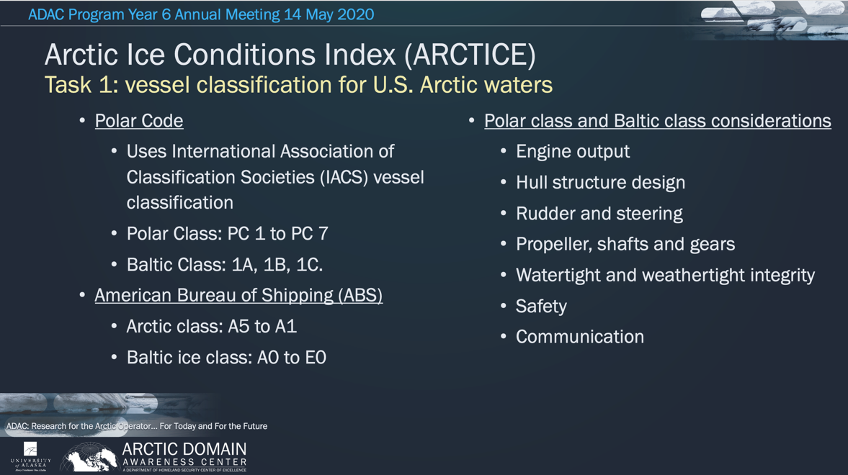
- Based on discussion with D17, the research team decided to focus on vessel classification methods by the IMO, and the team determined how current ABS and Baltic classes matched up to IMO classes.
Figure 26: ARCTICE Polar class and Baltic class considerations
Table 19: IMO Polar Class and Ice description
- Output from the ARCTICE algorithm is produced using the IMO vessel classification system of Polar Class and the Baltic Class.
The ARCTICE team also surveyed the AIS data available in the Bering, Beaufort, and Chukchi seas. Unique MMSI IDs were pulled for vessel information, allowing the team to better understand the current state of Arctic and sub-Arctic shipping.

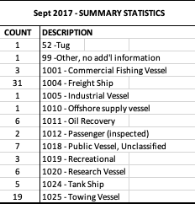
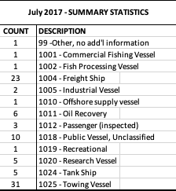
Looking specifically at July and September of 2017, the team found an overwhelming majority of the vessel traffic had been freight and towing vessels. Curiously, there were multiple instances of Russian and Chinese icebreakers passing through the Chukchi.
Table 20: Breakdown of Arctic Vessel traffic
- Investigate other national models (in particular, Canadian programs).
- The research team did a review of other national ice charts from Canada and Finland as they were related to vessel navigation through ice. Output from these nations follows the IMO’s guidance in the Polaris amendment of the POLAR code. The team was satisfied that following the Polaris amendment would offer a high degree of interoperability for Arctic mariners and that this was a prudent path to follow in the development of ARCTICE. Determine suitable environmental factors. Based on other Arctic nation’s models, and the guidance from the Polaris amendment, suitable environmental parameters were determined. Polaris quantifies the ice condition numeral by a “Risk Index Outcome” method, or RIO. The RIO is calculated using the following equation:
$$RIO= C_{1}{RV}_{1}+C_{2}{RV}_{2}+…+C_{n}{RV}_{n}$$
- Those RIO values, depending on vessel ice class, indicate the likely risk of a significant vessel/ice interaction during transit. Mariners looking to limit potential catastrophic events, would choose a path where the RIO falls into an acceptable range for their vessel. Acceptable RIO values are summarized in the table below.
- Risk associate with ice interaction is illustrated in another way in the chart above. Polar class is listed on the vertical axis, and increasing risk due to increasing ice stage, is on the horizontal axis. Mariners should seek to stay in the green and potentially the yellow. Red areas are to be avoided. Note: The RIO calculation only uses partial concntration of various ices, as expressed in the RIO equation.
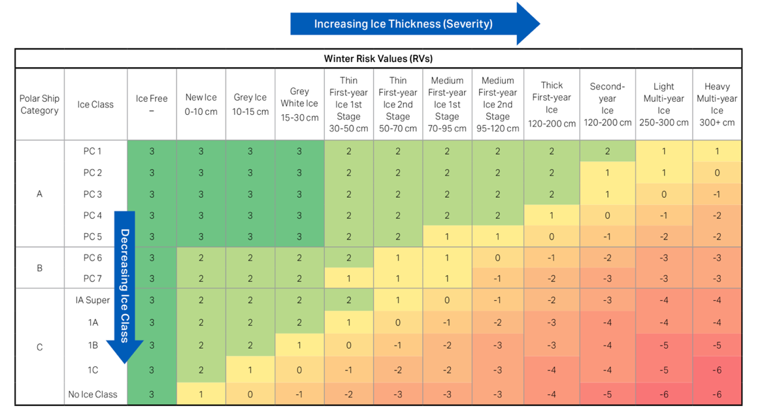
- The research team investigated available environmental models from which to collect the necessary inputs to apply the POLARIS index. These models included the High-resolution Ice-Ocean Modeling and Assimilation System (HIOMAS), the Global Navy Coastal Ocean Model (NCOM), the Pressurized Ice Model by the National Research Council Canada and the Department of Energy “CICE” model. Due to access restrictions the NRC model was excluded from selection. Further, due to the necessity of sea ice partial concentrations
Table 21: Ice Class and Ice condition risk matrix

from a potential model, and the desire for a high resolution of 1km, HIOMAS was selected as the best option. Unlike other models which only provide the average ice thickness and the overall ice concentration, HIOMAS provides partial concentrations for 8 categories of ice based on the ice thickness, which are used to interpolate into the partial concentrations of the various ice types required to calculate the POLARIS index.
- Investigate suitable access.
- Researchers spent time discussing the type and size of files accessible when vessels are underway. Based on anecdotal evidence from the district experts, there are significant connectivity challenges for commercial entities above 65 degrees N, where satellite communications start to diminish. Above 70 degrees N, data sources are extremely limited. Very few commercial communications satellites are available in the Arctic. It was suggested that if a vessel had a satellite link, there would be the possibility of receiving ARCTICE output if the file size were very small. When the vessel was at port, size of file is less of a concern.
- Therefore, the research team has determined that the ARCTICE output will come in two formats. Namely, .png files to accommodate low bandwidth access users, with smaller file sizes, enough for vessels to identify whether significant changes to the ice pack have occurred, and whether they need to adjust course.
- For vessels with a higher bandwidth availability, larger-size Geotiff output files will be provided for integration with ArcGIS and other software.
- The team is currently discussing the transition of ARCTICE. They identified the need for a partner who could publish the RIO charts, and offer a subscription service. Currently, the team believes Axiom Data Science will be the best home for ARCTICE.
- Create, then optimize a forecast numeric Arctic ice condition index for Arctic waters.
- At the onset of the project, the team included the idea that the forecast would need to be optimized to marry observable ice conditions with the modeled conditions. This was an important learning from the Great Lakes ICECON project. As the team discovered, optimization is not a necessary component. This is due to the methodology employed by the project team. Using the Polaris amendment meant that the process by which the RIO is calculated was vetted by international experts in the area of Arctic vessel/ice interactions. Therefore, the team feels optimization is not a necessary component for this project. Further, the team feels that year 7 tasks, namely the validation of the project output, will prove that the model is accurate and effective in their claims.
- After careful investigation, the research team created an experimental ARCTICE algorithm using a software program called MATLAB. The algorithm pulls environmental data, as defined above, from HIOMAS, calculates the RIO for a region, and generates the color maps illustrating RIO values for a given vessel polar class.
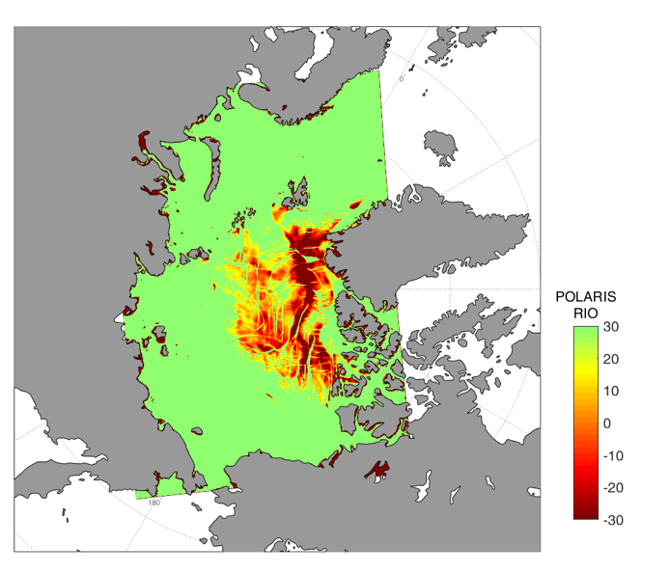
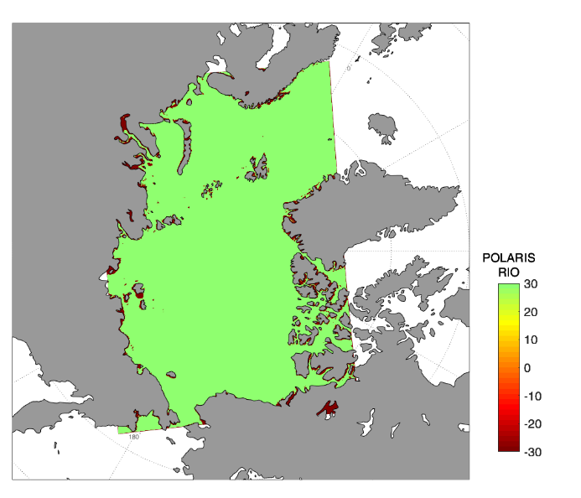
- While the creation of ARCTICE visualizations is a year 7 task (Task 7 in the workplan), the team felt it necessary to graphically output the RIO values. To that end, the team was able to start working ahead on their tasks. There is still much to accomplish, per the workplan, however important strides have been made in this area. Examples of the output charts can be seen below for vessels with polar classes PC 1, PC 5, and PC 7. These charts were created in May of 2020.
PC 5
PC 1
Figure 28: May 2020 Polar Class 5 (PC 5) voyage area output chart
Figure 27: May 2020 Polar Class 1 (PC1) voyage area output chart

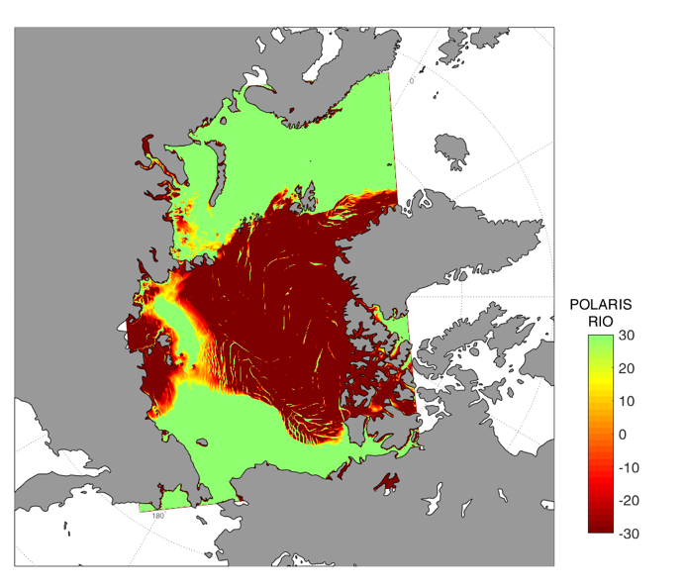
PC 7
Figure 29: May 2020 Polar Class 7 (PC 7) voyage area output chart

Key Stakeholder Engagement:
Project team participated in four ADAC Customers and Partners Roundtables. During the Customers and Partners Roundtable, the project team provided a brief technical summary of their project and answered questions from federal customers and interested parties including representatives from the U.S. Coast Guard and National Oceanic and Atmospheric Administration.
Teleconferences with USCG D17 were conducted in September and December 2019.
A Council of experts meeting with USCG WWM, RDC, D17 and USNIC occurred in January 2020.

Key Publications (peer reviewed):
No publications were drafted or published during the reporting period. In accordance with Year 7 plans, research team will develop manuscript for peer review in addition to program knowledge product.

Key Presentations:
Project team presented at ADAC Program Year 6 Annual Meeting. The Annual Meeting was held virtually via Cisco WebEx as COVID-19 prevented an in-person gathering in Washington D.C. as in previous program years. The meeting was well attended drawing a total of 202 registrations for the 7-hour virtual event with a peak of 157 participants. DHS S&T OUP, HQ USCG ADAC Project Champions, NOAA leadership, ADAC Executive Counselors, and many other customers and partners participated ADAC’s Year 6 Annual Meeting.

Changes from initially approved Workplan:
N/A

Project progress against each milestone:
Table 22: ARCTICE Year 6 Milestones
MILESTONE | PROGRESS | WHY NOT REACHED? (IF APPLICABLE)
Provide and confirm (via Project Champion) the ARCTICE vessel classification index | Completed
Investigate other national models (in particular, Canadian programs). | Completed
Determine suitable environmental factors. | Completed
Investigate suitable access. | Completed
Create, then optimize a forecast numeric Arctic ice condition index for Arctic waters. | Completed

Project progress against each metric:
Table 23: ARCTICE Year 6 Metrics
METRIC | PROGRESS | WHY NOT REACHED? (IF APPLICABLE)
The ARCTICE algorithms enable accurate Arctic ice condition predictions 65% of the time. | Not started | Year 7 task under the current workplan
ARCTICE algorithms provide comparable Bering, Chukchi and Beaufort Sea ice-conditions index accuracy to known accuracy of Canadian ice services within Canadian waters. | Not started | Year 7 task under the current workplan

Outcomes/output and TRLs:

Outcomes.

Outputs:
      - Technical Report: Creating a report with all the results of this research for USCG and DHS S&T OUP.

      - Mariner Decision Support Tool oriented to U.S. Arctic EEZ to transition to either USNIC or National Weather Service (depending on USCG Project Champion, USNIC and NWS decisions.
- As planned via ADAC Year 6, researchers developed a finalized set of ARCTICE algorithms for U.S. Arctic waters in the Bering, Chukchi and Beaufort Sea. The current algorithm produces charts for these regions, and researchers continue to advance with automation.
- The team has finalized vessel a classification system for U.S. waters in the Bering, Chukchi and Beaufort Sea. Namely, we investigated the relationship between IMO, ABS, and Baltic systems, and can offer guidance on how those systems are related. ARCTICE charts will display IMO classes. Further discussion will take place in year 7 as to how ABS and/or Baltic classes will be used/displayed.
- During the end of ADAC Program Year 6, researchers engaged in discussions with both USNIC & or National Weather Service in determining which organization is better suited to operate ARCTICE for U.S. waters in the Bering, Chukchi and Beaufort Sea. Further discussions are planned for year 7.
Technology Readiness Level (TRL):

- Final product development is on track and anticipated to conclude at TRL 7.

Unanticipated problems and plans for addressing them:
No problems developed.
Transition plans and progress made:
The research team has been working with the project partner AOOS and Axiom Data Science to transition ARCTICE following the conclusion of the research for computational support of ARCTICE using the existing pathways already leveraged via Great Lakes Ice Conditions Index. The infrastructure would include python scripts that automatically parses the input data, calculates the RIO index, and also generates plots in PNG and GEOTIFF formats. An email subscription server would also been set up for daily distribution of the product.
The ARCTICE team, working with ADAC leadership, has been developing the necessary relationships with the National Weather Service (NWS) as an alternative to AOOS & Axiom for the potential transition of the completed project to their hands. Specifically, during the reporting period the team has discussing with NWS Alaska (in Anchorage) to leverage the NWS Alaska “Arctic Test Bed and Proving Ground” as a proof-of-concept test in the final stages of ARCTICE development. Discussions toward final transition will continue with AOOS, Axiom Data Science, NWS and USNIC and conclude in ADAC Program Year 7.
- The ARCTICE team during the reporting period actively developed relationships with commercial parties interested in using ARCTICE. The team has discussed the scalability of the output for Indigenous walrus hunters and smaller vessels excluded from the polar classes. They have also introduced the project to the Alaska Conservation Foundation, Kawerak Inc., the International Arctic Research Center at the University of Alaska Fairbanks, and the National Snow and Ice Data Center. Effort to reach out to these partners was initiated to develop the most robust and user-friendly output possible. The team also considered that user groups might have ideas about additional features/uses the team hadn’t thought of. Input from these agencies and individuals has been incredibly useful for the next phase of the project.
- In late ADAC Program Year 6, Qilak Liquefied Natural Gas (LNG), a resource development company, reached out to ADAC to discuss the feasibility of shipping LNG from Point Tomson, Alaska in the Beaufort Sea, to markets in East Asia. The team was suitably interested in ARCTICE. They reiterated the need for hindcast RIO charts, (which is part of the workplan). The team plans to keep Qilak LNG apprised of their progress. Qilak LNG has expressed interest in data from the project as it informs their current feasibility study. This development has been of significant value to the ARCTICE team as it better helps them understand how the output could be used, and who is interested industry collaborator.
- Lastly, the team has started developing information and presentations for outreach to marine insurers and underwriters. Based on experience, discussion with user groups and district council, it was determined that Hull and P&I insurers act as gatekeepers to future arctic shipping development. The team feels it is prudent to bring these entities onboard early and get their feedback on the product. This will allow any tweaking of the charts that the team and the council of experts feels is necessary, based on this commercial input.
Annex 1: Great Lakes ICECON
In ADAC Program Year 6, the ADAC team also continued to work on the Great Lakes Ice Conditions Index (Great Lakes ICECON) project. While Great Lakes ICECON completed most investigations at the end of Program Year 5, (and transitioned to AOOS and Axiom for ICECON reports for the 2019-2020 winter season) the Project Champion and Council of Advisors wanted to further changes addressed as related to the environmental factors. These updates are provided below:
            - Switched from GLCFS to WCPS as GL ICECON environmental input.
- The prior version of ICECON used Great Lakes Coastal Forecast System (GLCFS) from NOAA’s Great Lakes Environmental Research Laboratory (GLERL) as input. However, because the GLCFS model is still experimental, the ADAC team, USCG, and USNIC agreed in June 2019 to switch to a more reliable operational ice model. USNIC recommended using Water Cycle Prediction System (WCPS) from Environment and Climate Change Canada (ECCC) as the ICECON input. WCPS is an operational model with 72-hour forecast at 2km spatial resolution. It includes all parameters required for the ICECON calculation, including ice pressure. The Beta version of WCPS became available in December 2019 and final product became available on Datamart in February 2020.

- After WCPS data became available in January 2020, the ADAC team revised the ICECON algorithm using the WCPS data with the 2019-20 ship based ICECON observation data from D9. Because WCPS only has data from January 2020 forward so the ship-based ice data from the previous ice seasons were not usable for the calibration.

- Of the ship-based ice observation data collected by D9, some were of incomplete information lacking location coordinates or timestamps. Many more entries were located in the locks and narrows straits where there is no data from WCPS (WCPS only provides data for the lakes, not for the connecting waterways), probably because the ice-breakers didn’t travel much into the lakes due to the light-ice season. In total, there were 103 complete ice data entries from D9, which were used to calibrate the ICECON algorithm.

- The below table listed the accuracy of the ICECON algorithm. The overall concurrent rate (the same ICECON level from the algorithm and from USCG District 9 data) is 70%, which is a significant improvement compared with about 50% concurrent rate using the initial NIC scoring table. The concurrent rates were also calculated for each ICECON level. There is no ICECON 5 data from D9’s data, because of the light ice season.

ICECON | Concurrent rate (the same ICECON level from the algorithm and from D9 data)
1 | 67%
2 | 65%
3 | 70%
4 | 72%
5 | No data
Table 24: ICECON algorithm accuracy.

2. Completed the transition of GL ICECON to operational
- The ADAC team and project partner Axiom Data Science established a new python script for automatic calculation and performed sanity check of the manual product.

- An ICECON operational infrastructure has been established in which the daily WCPS data is downloaded, the raw data is then parsed, and additional information added to the processed netCDF files to track the forecast run date/time and relative forecast hour.

- The ICECON calculation then reads the processed WCPS data and forecasts the ICECON index for 1, 6, 12, 24, 48, and 72 hours. Plots of ICECON forecasts are generated in png and geotiff formats. An email subscription has also been established to distribute the ICECON plots to users. All tasks are performed in automation by scripts on a computer server with minimal manual maintenance required.

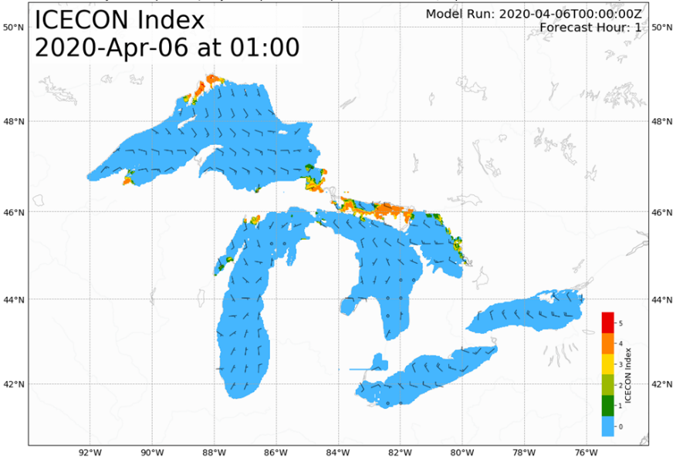
Figure 30: A sample plot of the GL ICECON index.
      - Created a New version of the mobile app for USCG District 9
- The ADAC team had previously developed an android app for D9 for ship-based observation data collection, which has been in use.

- A sailor on a ship can simply open the app and make a data entry based on observation. Upon connection to internet during or after sailing, all data entry recorded during the sailing are delivered to a specified computer server for data storage. Based on the feedback from USCG District 9, the application was upgraded and made in both IOS and android version, provided by the research team to USCG District 9 for onward use.
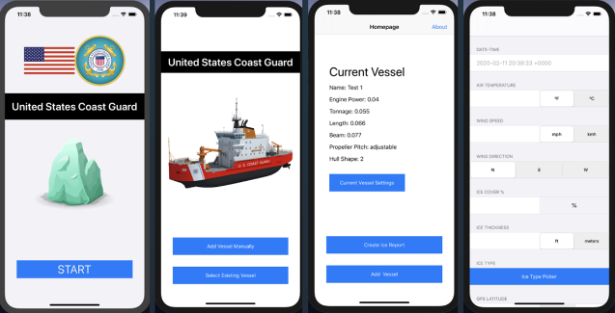
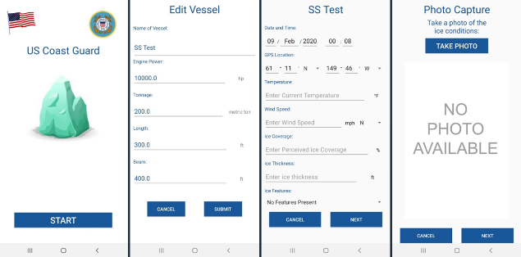
Figure 31: Interface of the iOS mobile app (top) and the android version (bottom) for ship-based observation data collection.

PROJECT: The Arctic All-Hazards GIS Platform
Project Investigator: Marcus A. Boyd, PhD
Lead Institution: University of Maryland, College Park
Supporting Team: Joshua House and Matthew Brady, University of Maryland
Program Year 6 Project Champion: CAPT (Ret) Hank Blaney, HQ USCG CG-255
Project Description:

Abstract:
The National Oceanic and Atmospheric Administration (NOAA) Arctic Environmental Response Management Application (ERMA) serves an important function for improving U.S. Coast Guard (USCG) Arctic domain awareness. However, increased activity in the Arctic (particularly the U.S. Arctic Extended Economic Zone (EEZ) demonstrates the need for an all-hazards approach centered on a next-generation geospatial platform capable of displaying, informing, and disseminating data to users from various communities (e.g., the public, non-governmental, state, local, tribal, and federal). This project seeks to provide a web application that matches the state-of-the-art in commercial geovisualization. The project team worked with stakeholders to design, develop, and implement a web-based geospatial tool in an ArcGIS Online format.
The research goal was to minimize redundancy by providing an accessible application that meets stakeholder needs. The project team tested presently available options (e.g., ERMA) for user experience, interface, and design. Through creating Alpha and Beta versions, and testing with project stakeholders, the research team discovered areas of needed improvement in coding, display, and usability. The project resulted in an Arctic web GIS application and that is driven by HQ and operational level USCG mission needs and requirements.
This project blends basic research into cartographic design with the applied research of implementing a WebGIS application that uses state-of-the-art technologies and methods and will be compliant with the DHS S&T prototype Integrated Maritime Domain Enterprise (IMDE). The application was built within the Geospatial Information Infrastructure (GII) under the Geospatial Management Office (GMO) and the Homeland Security Information Network (HSIN) infrastructure and aligns with existing requirements within HSIN and the GMO.

Objective/Purpose:
The research goal of this project was to create and transition a web-hosted Geographic Information System (GIS) application for USCG decision makers, oriented to Arctic operations. Accordingly, this WebGIS application improves Arctic Domain Awareness for USCG operational and tactical centers, useful for USCG watch standers at Pacific Area (USCG Pac Area), USCG District 17 and District 17’s Sector Juneau and Sector Anchorage. Investigator’s purpose was to work hand-in-hand with Arctic stakeholders to provide recommendations for a geospatial web application that accommodates an all-hazards approach and to better inform the various communities of interest. Researchers conducted a review of present web GIS tools and capabilities, and then provided recommendations for a full-scale approach in design and implementation. The final product provides a geospatial web platform flexible enough to meet the needs of various types of users with differing degrees of skill level.

Methodology:
Project method was a comprehensive geospatial WebGIS, based technology research and development, which integrated project research into an existing government, sponsored and supported data and geo-spatial knowledge platform. The goal of this project was to create a web tool, via specific research that advanced user interface and associated capabilities of an existing system architecture to better meet the needs and requirements of the Arctic Domain stakeholder community. In order to achieve this goal, the research team followed a six-phase process. Phases 1 through 3 were completed during project year 5.
Activities conducted in ADAC Program Year 6
- Phase 4: Releasing advanced (beta) versions.
  - Load testing for stability of application
- Phase 5 will transition the application to government stakeholders.
  - Development of the training guide
  - Demonstration of capabilities at Annual Meeting and Customers and Partners Roundtables
- Phase 6: verification and validation of the new web application.
  - Worked with USCG, GMO, and ADAC staff to ensure the application’s stability and prep for long-term integration with DHS mission
Phases 5 and 6 were substantially delayed due to issues with gaining access to the AIS data feed from U.S. Coast Guard to DHS Geospatial Management Office. In year 7, the project team will continue to work with the project champion and GMO to finalize in the AIS data feed to ensure transition to the end user. The application is housed on DHS servers and USCG project champion Hank Blaney is the owner-of-record of the application.

Student Involvement:
N/A

Key Accomplishments:
- Beta Release – The project team demonstrated the long-term stability of the application through a 14-hour test run of continuous use. This occurred concurrently with an application demonstration to District 17 watch standers and demonstrated capabilities during briefing with USCG District 17 commander.
  - The project team continued application development including adding new data sources, securing the application by restricting access to only authorized users, and adding Blue Force and Blue Force Partner AIS data.
  - Beta release identified typical user: Typical users of the application (e.g., USCG watch standers) normally do not have extensive experience with geographic information systems and will be most familiar with a web mapping application no more complex than Google Maps. This necessitates an easy-to-use format that is user friendly for general users and allows for robust analysis for specialized “power users.”
  - The project team worked with the ADAC Geofencing team to investigate using Environmental Systems Research Institute (ESRI)’s GeoEvents Server to add geofencing capabilities into the application. The project team also examined further development possibilities for the application, including the addition of field reporting, field data collection, inclusion of sensor data, and analyzing patterns in the available data feeds. These findings were outlined during Customers and Partners Roundtable discussions, the Annual Meeting, and in the associated usability report.
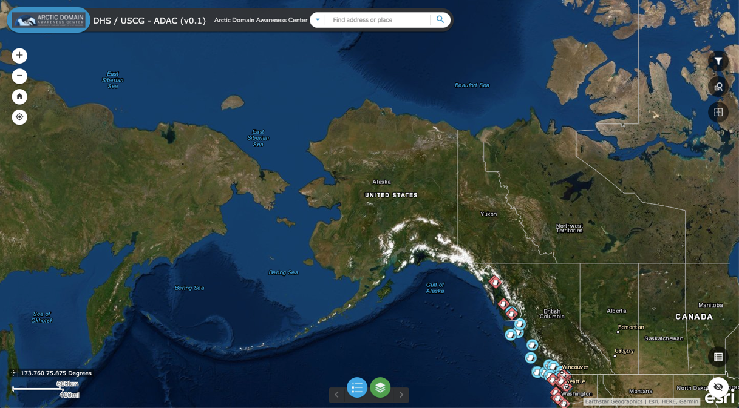
Figure 32: Arctic All-Hazards GIS Platform: Front-end of the application at Beta release
- User Guide – The project team developed a draft and refined a user guide for the operation of the web application including adding/removing data, general maintenance, and visualization. The user guide details how to manage the application, how to update and remove data, and how to work with DHS information technologies (IT) to troubleshoot potential issues.
  - Provided recommendations for best practices in using the application: Through building on lessons learned from ADAC Program Year 5, the project team developed a series of best practices for the user guide and are further outlined in the final report. In summary, a web mapping application needs to be developed to be understandable to the widest range of audiences and visualizations, widgets, and add-ons must not distract from the main goal/mission of the application.
- Prep for “Go Live” – The project investigator continued discussions with stakeholders regarding Automated Information Systems (AIS) vessel tracking data. The project team produced a test AIS feed for demonstration purposes that debuted at ADAC’s annual meeting. The project team has continued to work with the project champion, DHS GMO, USCG Information Technology personnel, and USCG contractors (namely ESRI) to direct an AIS feed to the DHS Geospatial Information Infrastructure (GII) for use in this application and to prep for future applications.
  - In an attempt to circumnavigate AIS data feed issues, the research team explored numerous options, including open source, commercial closed source, and with the Maritime Exchange of Alaska. The research team discovered that there are no open source solutions to this issue. Access to AIS data is only available via closed sources. Secondly, AIS data is delivered in a variety of formats, but are not natively available in a WebGIS (geojson, WFS, REST Service) format. This results in requiring preprocessing of the AIS data either from the vender or within the GII.
  - The project team investigated options for including other ADAC projects in as either visualizations or by incorporating underlying data into the Arctic All-Hazards platform. The GII platform is robust and capable of incorporating any form of spatial data and can visual dynamic data use the GeoEvent Server if required/desired. The results of this investigation were shared at a weekly all-hands meeting.
- Usability Study Report – The research team completed a complete usability report detailing the overall scope of the project, including detailing work that occurred in Year 5 and Year 6. The report details design decisions, why those design decisions were made, and explains how the application functions within the GII environment. This report serves as the final project report and will be updated to reflect additional work to be completed in year 7, principally the inclusion of an AIS feed into the application and hand-off to USCG. The report also outlines potential improvements to the application to increase its utility.

Key Stakeholder Engagement:
Project team participated in ADAC “Customers and Partners” Roundtables, in order to inform and receive feedback on project progress. The PI and the team worked with the USCG, (in close coordination with ADAC leadership and the HQ USCG Project Champion), HSIN, the GMO, and other stakeholders to ensure that the platform is useful to USCG needs and requirements.
Project Champion: Hank Blaney, CAPT (Ret), USCG. Personnel engaged (as coordinated with Project Champion) included staff members from HQ USCG CG926, USCG PAC Area, USCG D17 and USCG R&D Center. The primary operational customer for this product is the 17th U.S. Coast Guard District, and the tactical customer is U.S. Coast Guard District 17 Sector Anchorage. Lew Summers and Marigny Boyd served as points of contact from the GMO and HSIN, respectively.
The project investigator engaged regularly with CAPT (Ret) Hank Blaney. The project investigator also worked closely with GMO staff, USCG IT, and USCG contract performers to troubleshoot issues related to AIS data.
The project investigator participated in the quarterly Customers and Partners Roundtable and the virtual ADAC Annual Meeting conducted via WebEx.

Key Publications (peer reviewed):
During the program, theproject investigator initiated the development of a draft peer-reviewjournal article outlining key lessons learned from the development of the Arctic All Hazards GIS Platform, following completion of the last portion of the project.

Key Presentations:
Project team presented at ADAC Program Year 6 Annual Meeting. The Annual Meeting was held virtually via Cisco WebEx as COVID-19 prevented an in-person gathering in Washington D.C. as in previous program years. The meeting was well attended drawing a total of 202 registrations for the 7-hour virtual event with a peak of 157 participants. DHS S&T OUP, HQ USCG ADAC Project Champions, NOAA leadership, ADAC Executive Counselors, and many other customers and partners participated ADAC’s Year 6 Annual Meeting.

Changes from initially approved Workplan:
N/A

Project progress against each milestone:
Table 25: Arctic All-Hazards GIS Platform Year 6 Milestones
MILESTONE | PROGRESS | WHY NOT REACHED? (IF APPLICABLE)
Beta Release | Complete
Analysis of Beta Release Feedback | Complete
Prep for Final Delivery | Incomplete | Awaiting AIS feed via USCG.
Final Report | Complete

Project progress against each metric:
Table 26: Arctic All-Hazards GIS Platform Year 6 Metrics
METRIC | PROGRESS | WHY NOT REACHED? (IF APPLICABLE)
Beta Release Developer Testing | Complete
Beta Release | Complete
Analysis of Beta Release Feedback | Complete
Prep for Final Delivery | Incomplete | Awaiting AIS feed via USCG.

Outcomes/output and TRLs:

Outcomes.
The alpha release was provided constructive feedback, which enabled a successful beta release, which demonstrated the stability of the system. The major challenge regarding the application continues to be lack of AIS integration which is ongoing (see prior discussions).
Output:
- Developed best practices for WebGIS applications
- Developed the Arctic All-Hazards WebGIS application
- Identified a project transition pathway that incorporates DHS IT infrastructure to cut down on risk of transition failure or maladaptation.
- Identified a DHS knowledge gap – specifically, DHS IT were unaware of AIS data and its utility for applications including the NOC COP.
- Identified data assets internal and external to DHS and NOAA that are useful for USCG operations in the Arctic, including identifying data layers produced and released publicly by operational partners.
- Developed a space (GII) where researchers can access AIS data for DHS S&T COE-funded projects.
Technology Readiness Level (TRL):
In Program Year 6, the Arctic All-Hazards GIS Platform achieved a TRL 7. Integrating AIS data will allow the application to achieve TRL 8/9.

Unanticipated problems and plans for addressing them:
Continued lack of access to AIS data has been more challenging than originally anticipated. During the reporting period, the project team worked with USCG-HQ and expects to gain access to AIS data. The project investigator was regularly in contact with USCG staff, the project champion, GMO, and USCG contractors to gain permanent access to an AIS data feed and incorporate it into the application in order to overcome this challenge.

Transition Activities:
Transition plans and progress made:
The web application is presently housed within the DHS Geospatial Management Office Geospatial Information Infrastructure. The Project Champion is the “community owner,” as such, the project team expects transition of the application to be complete when development is finished. Presently, the application can only be accessed if a user has a HSIN account and has been given access to the proper GII Group. Access to join the GII Group is controlled by the project champion, development staff, and GMO. When the project is complete, the project team will divest from the application and ensure that a core of users is properly trained on how to authorize access to new users. Once the project is completed and transitioned, the project team will work with ADAC staff to develop activities that could serve to publicize the application throughout the ADAC community.
The application is presently ready to incorporate additional functionality and capabilities depending on funding. The project team recommends adding remote data collection, at a minimum, to increase the overall utility of the application and because ESRI’s ArcGIS Online environment that the GII is built on is designed to ingest field collection. ESRI offers two products – Collector and Survey123 – that allow for field data collection.
These two mobile applications feed directly into the ESRI ArcGIS Online/Portal environment. It would be possible for field personnel to use Collector and/or Survey123 to respond to queries from headquarters. Collector and Survey123 both geotag the user’s location, store data, and then feed responses directly to the application. To make this a reality, the GMO will need to enable the connections between Arctic All-Hazards and the mobile applications. USCG D17 would then need to build the questionnaires and push those out to mobile devices for field personnel. Survey123 and Collector are presently being used by emergency and rescue personnel, police, and utility providers throughout the United States for various purposes from cataloging signage, resource allocation, and planning for large public events.
As previously mentioned, ESRI offers the GeoEvent Server which is a part of the larger cloud architecture. The GeoEvent Server is designed to integrate seamlessly with applications like Arctic All-Hazards WebGIS. The GeoEvent Server offers many real-time monitoring capabilities including geofencing. Integrating the GeoEvent Server into Arctic All-Hazards will offer real-time tracking of all assets overseen by USCG D17. It would also allow for seamless integration of geofencing. Users would simply designate a given data feed (e.g. NAIS) and construct a geofence around a given area. GeoEvent Server gives users various options for how to filer or process mobile and stationary assets depending on the user’s specifications.
For example, USCG D17 could institute a geofence around a sensitive ecological area where vessels cannot exceed a certain speed. A user could build a process in GeoEvent Server that would detect a vessel speeding and then send an automated email to the vessel’s owner or to USCG D17 watch standers. A more serious example would involve area denial. A user would use the GeoEvent Server in a similar fashion as mentioned above, but in the case of area denial, if a vessel crossed the geofence, an automated encrypted message could be pushed to designated personnel for immediate response. Overall, GeoEvent Server’s integration into the Arctic All-Hazards WebGIS would create numerous exciting outcomes.
Lastly, The USCG’s Search and Rescue Optimal Planning System (SAROPS) is a desktop based ESRI ArcGIS application for modeling maritime search areas. Using a Monte Carlo simulation, the tool outputs probable search areas. As this is a desktop tool, it requires users to use a traditional desktop – or laptop – computer. The results from the model runs could, however, be displayed in the Arctic All-Hazards WebGIS application and these data could be stored and compared with locations of actual findings to aid in evaluating error rates, but more importantly, to increase the dissemination of search areas if needed. The variables needed for SAROPS can also be displayed and housed in the Arctic All-Hazards WebGIS system allowing for a single repository.
While none of the above suggested improvements to the application are presently required for adoption by USCG D17, the research team recommends that, by including these capabilities and functionalities, adoption and retention of the application is likely to increase and proliferate. The application itself can be easily replicated now that it is complete. This will allow other USCG Districts to implement their own version of the Arctic All-Hazards WebGIS application. Conversely, as CG One View (CG1V) is also designed around the ESRI ArcGIS Online platform, the application could be ported to CG1V without issue if USCG desired to have complete control over the application.

PROJECT: Arctic Vessel Monitoring Geofencing/Alert Awareness
Project Investigators: Buddy Custard CAPT, USCG (Ret) and Dr. Shawn Butler
Lead Institutions: Alaska Maritime Prevention & Response Network (AMPRN – a 501c6 organization) and University of Alaska Anchorage (UAA)
Supporting Team: Aaron Poe, Alaska Conservation Foundation
Program Year 6 Project Champion: CAPT (Ret) Hank Blaney, HQ USCG CG-255
Project Description:

Abstract:
The Geofencing/Alert Awareness project in year 6 focused on two parallel tracks – 1) completing the objectives of the initial project in creating and displaying geofences and alerts when vessels crossed the virtual fence developed for the Marine Exchange of Alaska unclassified commercial “PACTRACS” system; and 2) initiating the extended research project by leveraging the geofencing and alert notification technology developed for the PACTRACS system for CG OneView (CG1V) version 3.0, the US Coast Guard’s designated common operating picture. U.S. Coast Guard users can now define and display static and dynamic geofences and receive electronic alerts via email and text on several unclassified electronic devices through the enhancements made to PACTRACS. Accordingly, the initial objectives of the research project were met in year 6. Building upon the technology and processes developed in meeting the requirements for the initial project, the research team was asked to extend the Arctic Vessel Monitoring Geofencing/Alert Awareness project associated with ADAC Program Years 5 and 6 by providing enhanced geofencing command and control features to the USCG CG1V common operating picture. As CG1V 3.0 now displays both terrestrial and satellite AIS data, there is a need for a geofencing/alert awareness application that supports Coast Guard planning and command and control decision making tasks which easily integrates into CG1V.

In addition, new geofencing capabilities associated with the research outcomes developed in the Arctic Domain Awareness Center’s project Arctic all-Hazards GIS Platform (AAH WebGIS) were investigated for incorporation. In the PACTRACS systems, users can define and display geofences and receive electronic alerts via text or email.

The objectives of the extended project are: 1) to use the CG OneView application architecture, leveraging the associated PACTRACS success, to design a geofence capability that meets the needs of Coast Guard command and control operators; and 2) to design the application such that it readily integrates into the CG1V system architecture and AAH WebGIS. The outcome of ADAC Program Year 6, (in support of these two objectives) was to produce a set of requirements that extend those developed for the PACTRACS system and an application design that relies on the CG1V system architecture. The extended project research team developed additional geofencing requirements working with Coast Guard District 17 Anchorage Sector operators and planners. To accomplish the second objective, the team worked with the CG1V program office and technical development team to explore the human computer interface (HCI) features that facilitate efficient geofence creation, reuse, modification, deletion, and alert notification, which can be especially challenging in an information overloaded environment.

Objective/Purpose:
- The objectives of this initial project were to develop:
  - Geofences and push notification alerts that can be customized by the end-user to meet agency requirements within PACTRACS.
  - Geofencing and alert files that can be shared among users of vessel tracking display systems.
  - Geofences that can have multiple filters and GIS overlays to better discriminate vessel type and activities.
  - Geofences that can be developed around moving vessels.
  - Alerts and push notifications with visual reference points that can be received on multiple unclassified platform devices by government agencies and vetted stakeholders.
  - Geofence and alert notifications that can be sent via email and text message for other Federal and State agencies, and Arctic stakeholders.
- The objectives of the extended project were to develop:
  - A set of functional requirements that extended the PACTRACS geofencing capabilities based on Coast Guard operational and planning needs into CG OneView 3.0 and Homeland Security Information Network (HSIN).
  - An application design and development process that allows for continuous integration into CG OneView, the Arctic Domain All-Hazards WebGIS display, and the initial ADAC geofence/alert notification project to include better geofence management and improved alert notification, as well as explore additional data sources that can improve monitoring vessels and special areas of interest.

Methodology:
In accomplishing the initial objectives and in meeting the requirements posed by the project advisory committee in Year 5, the project team built upon existing and emerging geofencing techniques to develop enhanced processes, protocols, and Automatic Identification System (AIS) geofencing and alert software. The team developed software changes to an existing vessel tracking and monitoring unclassified system (PACTRACS) used by U.S. Coast Guard and commercial marine monitoring centers within the U.S. Arctic EEZ. The project team employed task-oriented objectives to develop its software geofencing and push notification enhancements via AIS transmitters or other communications. The overall methodology was to leverage Machine to Machine (M2M) and Internet of Things (IoT) software engineering, while understanding the mechanical and electrical AIS limitations to refine the trigger alerts across multiple unclassified platform devices. These objectives are aligned with the International Maritime Organization’s e-navigation objectives. Upon developing the software, the team tested the software against the project objectives and made modifications accordingly.
For the extended objectives, working with USCG stakeholders in Alaska, the team analyzed the geofencing features of CG OneView 3.0, the PACTRACS geofencing application, and the Arctic Domain All-Hazards WebGIS project to determine the set of extended features that will best improve Coast Guard planning and operational awareness efficiencies.
- To accomplish extended objective 2.a, the team developed additional geofencing requirements working with Coast Guard District 17, Anchorage Sector operators and planners. Representatives for each functional area in the Anchorage Sector collectively met with the team to identify their specific geofencing requirements. In addition, as the geofencing capability in PACTRACS was undergoing testing, the team was able to identify additional requirements that resulted from using the PACTRACS based application.
- To accomplish extended objective 2.b, the team worked with the CG OneView program office and the CG OneView technical development team. Discussions with the program office and technical team allowed us to develop a geofencing design that should be consistent with the CG OneView system architecture and leverage existing CG OneView components. In addition, we discussed a software development process that will allow us to ensure that the geofencing application will be coherent with the existing architecture when our project is finished. Thus, transition efforts into CG OneView should be minimal.
Over time, the number of geofences created for planning and operational requirements will grow. Coast Guard users will need a mechanism to find existing geofences, perhaps modify some of the geofence attributes, and reuse or create altered copies. In addition, they will likely need to delete no longer needed geofences.
Some geofences will be created that need to follow the shoreline. Users should be able to create a geofence that can be defined by existing a defined number of meters/kilometers from the shoreline. ArcGIS is known to have tools that can identify the coastline which may be used to identify geofence boundaries. This will give the Coast Guard more accurate information when vessels cross geofences.
Identifying and implementing additional features that may help improve planning tasks and operational response to vessels crossing geofences is of further importance. For example, detect vessels that are approaching (i.e., likely to cross if the vessel doesn’t change heading), but have not yet crossed a geofence. The system can apply colors to show when a vessel is approaching (yellow)/or crossing a geofence (red) so that operators of the geofences can instantly see the geofence and vessel that is approaching or crossing. This will allow less clutter on the CG1V operational picture.
Although the extended project will focus on Arctic maritime operations, research explores additional data sources for tracking vessels and monitoring areas of interest. The results achieved to date enhance geofencing capabilities in PACTRACS, CG1V, and AAH WebGIS platform.

Student Involvement:
Four ADAC fellows, Jack McCaslin, Rachelle Lewis, Raul Reutov, and Kris Carroll supported this project. All participated in the development of Coast Guard requirements: Jack McCaslin developed skills that allowed other fellows to integrate the Ozone Widget Layer application with the ARCGIS Web Map. Rachelle Lewis, Raul Reutov, and Kris Carroll developed a prototype Ozone Widget application that could interact with the ARCGIS Web Map. ARCGIS Web Map and Ozone Widget software tools are also used in CG OneView.

Key Accomplishments:
- Developed new PACTRAC geofencing and push notification alerts per the initial project objectives.
- Identified established environmentally protected areas where application of the geofencing tools should be pre-populated in the software.
- Developed web accessible tool to request AIS generated alerts or reports for agencies and other authorized stakeholders. The tool is located on a newly created public website at www.alaskageofence.org.
- Investigator discussions with stakeholders highlighted the need for a communications tool to explain how the geofence tool works. Accordingly, we developed a stop-motion graphic animation to explain functionality and important applications in Alaska marine waters that can be found at https://vimeo.com/418261996. The educational video is posted on the www.alaskageofence.org website.
- Developed more than 120 functional geofencing requirements for CG OneView per the extended objectives. Most of the functional requirement will result in 3-4 additional sub-requirements once development begins.
- Coordinated with the CG OneView program office to obtain the technical information necessary to develop an application that can integrate with CG OneView. As CG OneView was designed to allow third-party developers to contribute applications, geofencing will be the first application attempting to do so.

Key Stakeholder Engagement:
In program year 6, the resulting capabilities from the initial project were presented during three different forums with the aim of securing agency managers and coastal communities’ interest in testing the software, providing feedback to the development team, and otherwise increasing stakeholder domain awareness through its application.
Engagements with coastal stakeholders lead to a successful pilot effort of an array of geofences around the community of St. Paul and the broader geography of the Pribilof Islands in the Bering Seas. Summary observations from July-December 2019 from these geofences were compiled by the Marine Exchange; staff from the Aleut Community of St. Paul shared these results with the Tribal Council to inform a broader discussion about potential impacts on northern fur seals.
The tool was also successfully piloted in September 2019 by the Alaska Department of Fish and Game in the area of Togiak Bay with an array of geofences placed over key walrus haul outs and foraging areas.
The web-based tool was also shared via webinar meetings with two different groups of managers and scientists from the U.S. Fish and Wildlife Service. On March 2nd, 2020 discussions focused on improving domain awareness for the Alaska Maritime National Wildlife Refuge, and on June 25th, 2020 potential future applications of the tool for research and management by the Fisheries and Ecological Services and Migratory Bird Programs in Alaska.
The project team further met with D17 Command Center personnel in providing training on the PACTRACS software’s enhanced capabilities.
The enhanced project team met with Coast Guard officials at Sector Anchorage Sector and separately with the CG OneView program office and technical developers obtaining requirements for CG OneView geofencing and alert push notification.

Key Publications (peer reviewed):
The project investigators drafted a peer-review journal article outlining key lessons learned from the development of the PACTRACS effort as well as the CG1V edition.

Key Presentations:
Alaska Forum on the Environment in Anchorage, AK, February 13, 2020. Presented on and demonstrated the www.AlaskaGeofence.org web-based tool in requesting a geofence by federal, state, and community resource trustees.
Project team presented at ADAC Program Year 6 Annual Meeting. The Annual Meeting was held virtually via Cisco WebEx as COVID-19 prevented an in-person gathering in Washington D.C. as in previous program years. The meeting was well attended drawing a total of 202 registrations for the 7-hour virtual event with a peak of 157 participants. DHS S&T OUP, HQ USCG ADAC Project Champions, NOAA leadership, ADAC Executive Counselors, and many other customers and partners participated ADAC’s Year 6 Annual Meeting.

Changes from initially approved Workplan:
As follow-up to inputs received from USCG D17, ADAC added an additional task to investigate and plan to deliver a parallel version hosted to CG1View/HSIN.

Project progress against each milestone:
Table 27: Arctic Vessel Geofencing; Progress against Milestones
MILESTONE | PROGRESS | WHY NOT REACHED? (IF APPLICABLE)
Develop AIS geofencing & alert push notification software modification for PACTRACS. | Completed  Dynamic zone based on a vessel’s Mobile Service Identities (MMSI)
Develop web-based geofence and notification request portal for resource trustees. | Completed  Working with the Alaska Conservation Foundation, US Fish & Wildlife Service, NOAA, the Alaska Department of Fish & Game, developed the request portal (www.alaskageofence.org).
Test push notification and alerts with agencies and relevant stakeholders | Completed  Established six concentric geofence rings around fur seal colony; 8 alerts sent to 3 different email addresses – over 24,600 emails received.  Several dynamics zone established around lightering tankers operating in Western Alaska; received alert notifications for each during test period in the software app and via emails.
Finalize software and complete transition into PACTRACS | Completed
Ozone Widget Framework to develop basic geofencing capability | Completed. All ADAC fellows are able to use the Ozone Widget framework to develop the geofencing application.
Develop geofencing/vessel tracking enhancement requirements from USCG stakeholders and Arctic All-Hazards GIS Platform project 1 Mar 2020. | - Completed initial set of functional requirements.  - Coordinated with the Arctic All-Hazards GIS platform project to ensure that the both applications can be integrated.  - Application design and development process estimated at 85% complete | Functional requirements will significantly expand as the development process reveals additional details for each of the existing functional requirements collected during this phase. This is normal during the agile software development process.  Identification and coordination among many stakeholders take a significant amount of time, and documentation of CG OneView has not been completed since it is still in development.

Project progress against each metric:
Table 28: Arctic Vessel Geofencing; progress against each Metric
METRIC | PROGRESS | WHY NOT REACHED? (IF APPLICABLE)
Number of stakeholders engaged and generation of requirements. | Initial functional requirements completed. All functions within Anchorage Sector were represented during requirements elicitation.  System requirements identified
Suitable application within CG1View/HSIN. | Incomplete, however, until development process begins, it is difficult to confirm. | We lack specific system and interface documentation with respect to CG OneView. As part of the development process and coordination with technical leads, we expect to ensure geofencing can transition to CG OneView.

Outcomes/output and TRLs:

Outcomes:
During year 6, Arctic vessel geofencing was completed as planned to provide a vessel geofencing capability within the PACTRACS system housed at the Alaska Marine Exchange, to support USCG D17 (and external collaborator to the Marine Exchange) and the mariner community of Alaska.
The CG1V edition of the project advanced planning and coordination with HQ USCG in Program Year 6 to integrate a useful geofencing prototype within CG1V that leverages work accomplished within PACTRACS.
Outputs:
The PACTRACS edition provides a functioning vessel Geofencing capability accessible to USCG D17 and subordinate units via coordination to Alaska Marine Exchange. This same capability was delivered and is now available to the Alaska mariner community, fish and wildlife managers, tribal entities and more.

Technology Readiness Level (TRL):
- In Program Year 6, the Vessel Geofencing PACTRACS edition provides a functioning vessel Geofencing capability at TRL 5.
- The project team anticipates a Technology Readiness Level 3 status (as a working prototype) upon completion of the Year 7 portion for the extended project’s planned outputs for CG1V.

Unanticipated problems and plans for addressing them:
This effort is the first project to work with CG1V as an external developer. Therefore, progress has slowed in obtaining the necessary coordination, information and testing to ensure that the application is consistent with the architecture of CG1V. This places an additional burden on the CG1V technical leads. However, the end result will be better documentation and application programming interfaces (API’s) that will only serve to improve the capabilities and maintainability of CG OneView. Researchers continue to mitigate risk of these potential delays is to ensure that we have a development process that allows as much “continuous integration” as possible. Continuous integration means that we will develop functionality in small steps, testing whether each small step works with the overall system at each step. This process ensures that we find incompatibilities or issues early in the development process so that our application is as compatible as possible with CG1V when finished. The team will rely on the operational customer for developing requirements and validating whether the enhanced features are likely to improve District planning and operational tasks. In specific:
- ArcGIS and Ozone Widget technologies may limit what is possible. For example, there may be a limit to precisely identifying coast lines. The team will leverage any existing add on modules that improve coastline identification.
- Open source software is often not as intuitive to use as the contributor’s claim, which may delay our ability to set up the development environment. Researchers will continue to coordinate with the Arctic All-Hazards GIS Platform project, which has already worked with the ArcGIS Web version. In addition, project team will consult with other ADAC researchers who have particular expertise using ArcGIS. Researchers may also need to consult with the CG OneView project office as they have particular expertise using the Ozone Widget Framework.

Transition Activities:
For the initial project, the primary output was new software, which was incorporated into the existing unclassified AIS PACTRACS tracking and monitoring system used by the Coast Guard, State of Alaska, and the maritime industry for MDA&M within the U.S. Arctic EEZ.
The unclassified PACTRACS enhanced software is hosted on Marine Exchange servers rather than require installation on end-user or client computers. By hosting a version of software on the Marine Exchange servers and making it web/Internet accessible, the technology transition for stakeholders is simplified by removing the need for stakeholders to set up and install their own servers or software systems. Additionally, by hosting the enhanced unclassified software on the Marine Exchange servers, data transport and access to vessel data stored on the same servers is more efficient than if the new software were hosted elsewhere.
MXAK servers and computers have been used to receive, process, and display AIS information used by the Coast Guard for over 10 years. All Arctic terrestrial AIS data accessed by the Coast Guard is provided by MXAK AIS receivers, servers and software; therefore, the cost to develop this geofence system is based on the ability to use the existing software and hardware owned and operated by the MXAK as well as accessing MXAK AIS data from the 130 AIS sites the organization established and operates in Alaska. The AIS data provided to the Coast Guard by MXAK servers can ultimately reside on Coast Guard servers (as directed by HQ USCG Project Champion).
The project team provided training to stakeholders on how to use the new software to D17 command center personnel. As the initial and primary stakeholder, the team intend to continue in working with the USCG across the deployment lifecycle and expect additional input from the USCG through periodic engagements.
For the extended project, since transition is one of the objectives, these activities are integrated into the development process, such as continuous integration and coordination with the CG OneView technical leads.

THEME 3: Maritime Technology Research:
- Propeller Driven Long Range Autonomous Underwater Vehicle (LRAUV) for Under-Ice Mapping of Oil Spills and Environmental Hazards (Continuation Project).
- Arctic-related Incidents of National Significance (Arctic IoNS) Workshop.
- Arctic Medium-and-Long Term Environment (Arctic MaLTE) Workshop.

PROJECT: Development of Propeller Driven Long Range Autonomous Underwater Vehicle (LRAUV) for Under-Ice Mapping of Oil Spills and Environmental Hazards
Project Investigators: Dr. Jim Bellingham (WHOI), Amy Kukulya, Dr. Brett Hobson (MBARI)
Lead Institutions: Woods Hole Oceanographic Institution (WHOI) and Monterey Bay Aquarium Research Institution (MBARI)
Supporting Team: Brian Kieft, Ben Raanan (MBARI), Sean Whelan, Daniel Gomez-Ibanez, Noa Yoder, Amanda Besaw, Ryan Govostes (WHOI),
Project Champion: CAPT Kirsten Trego, HQ USCG MER

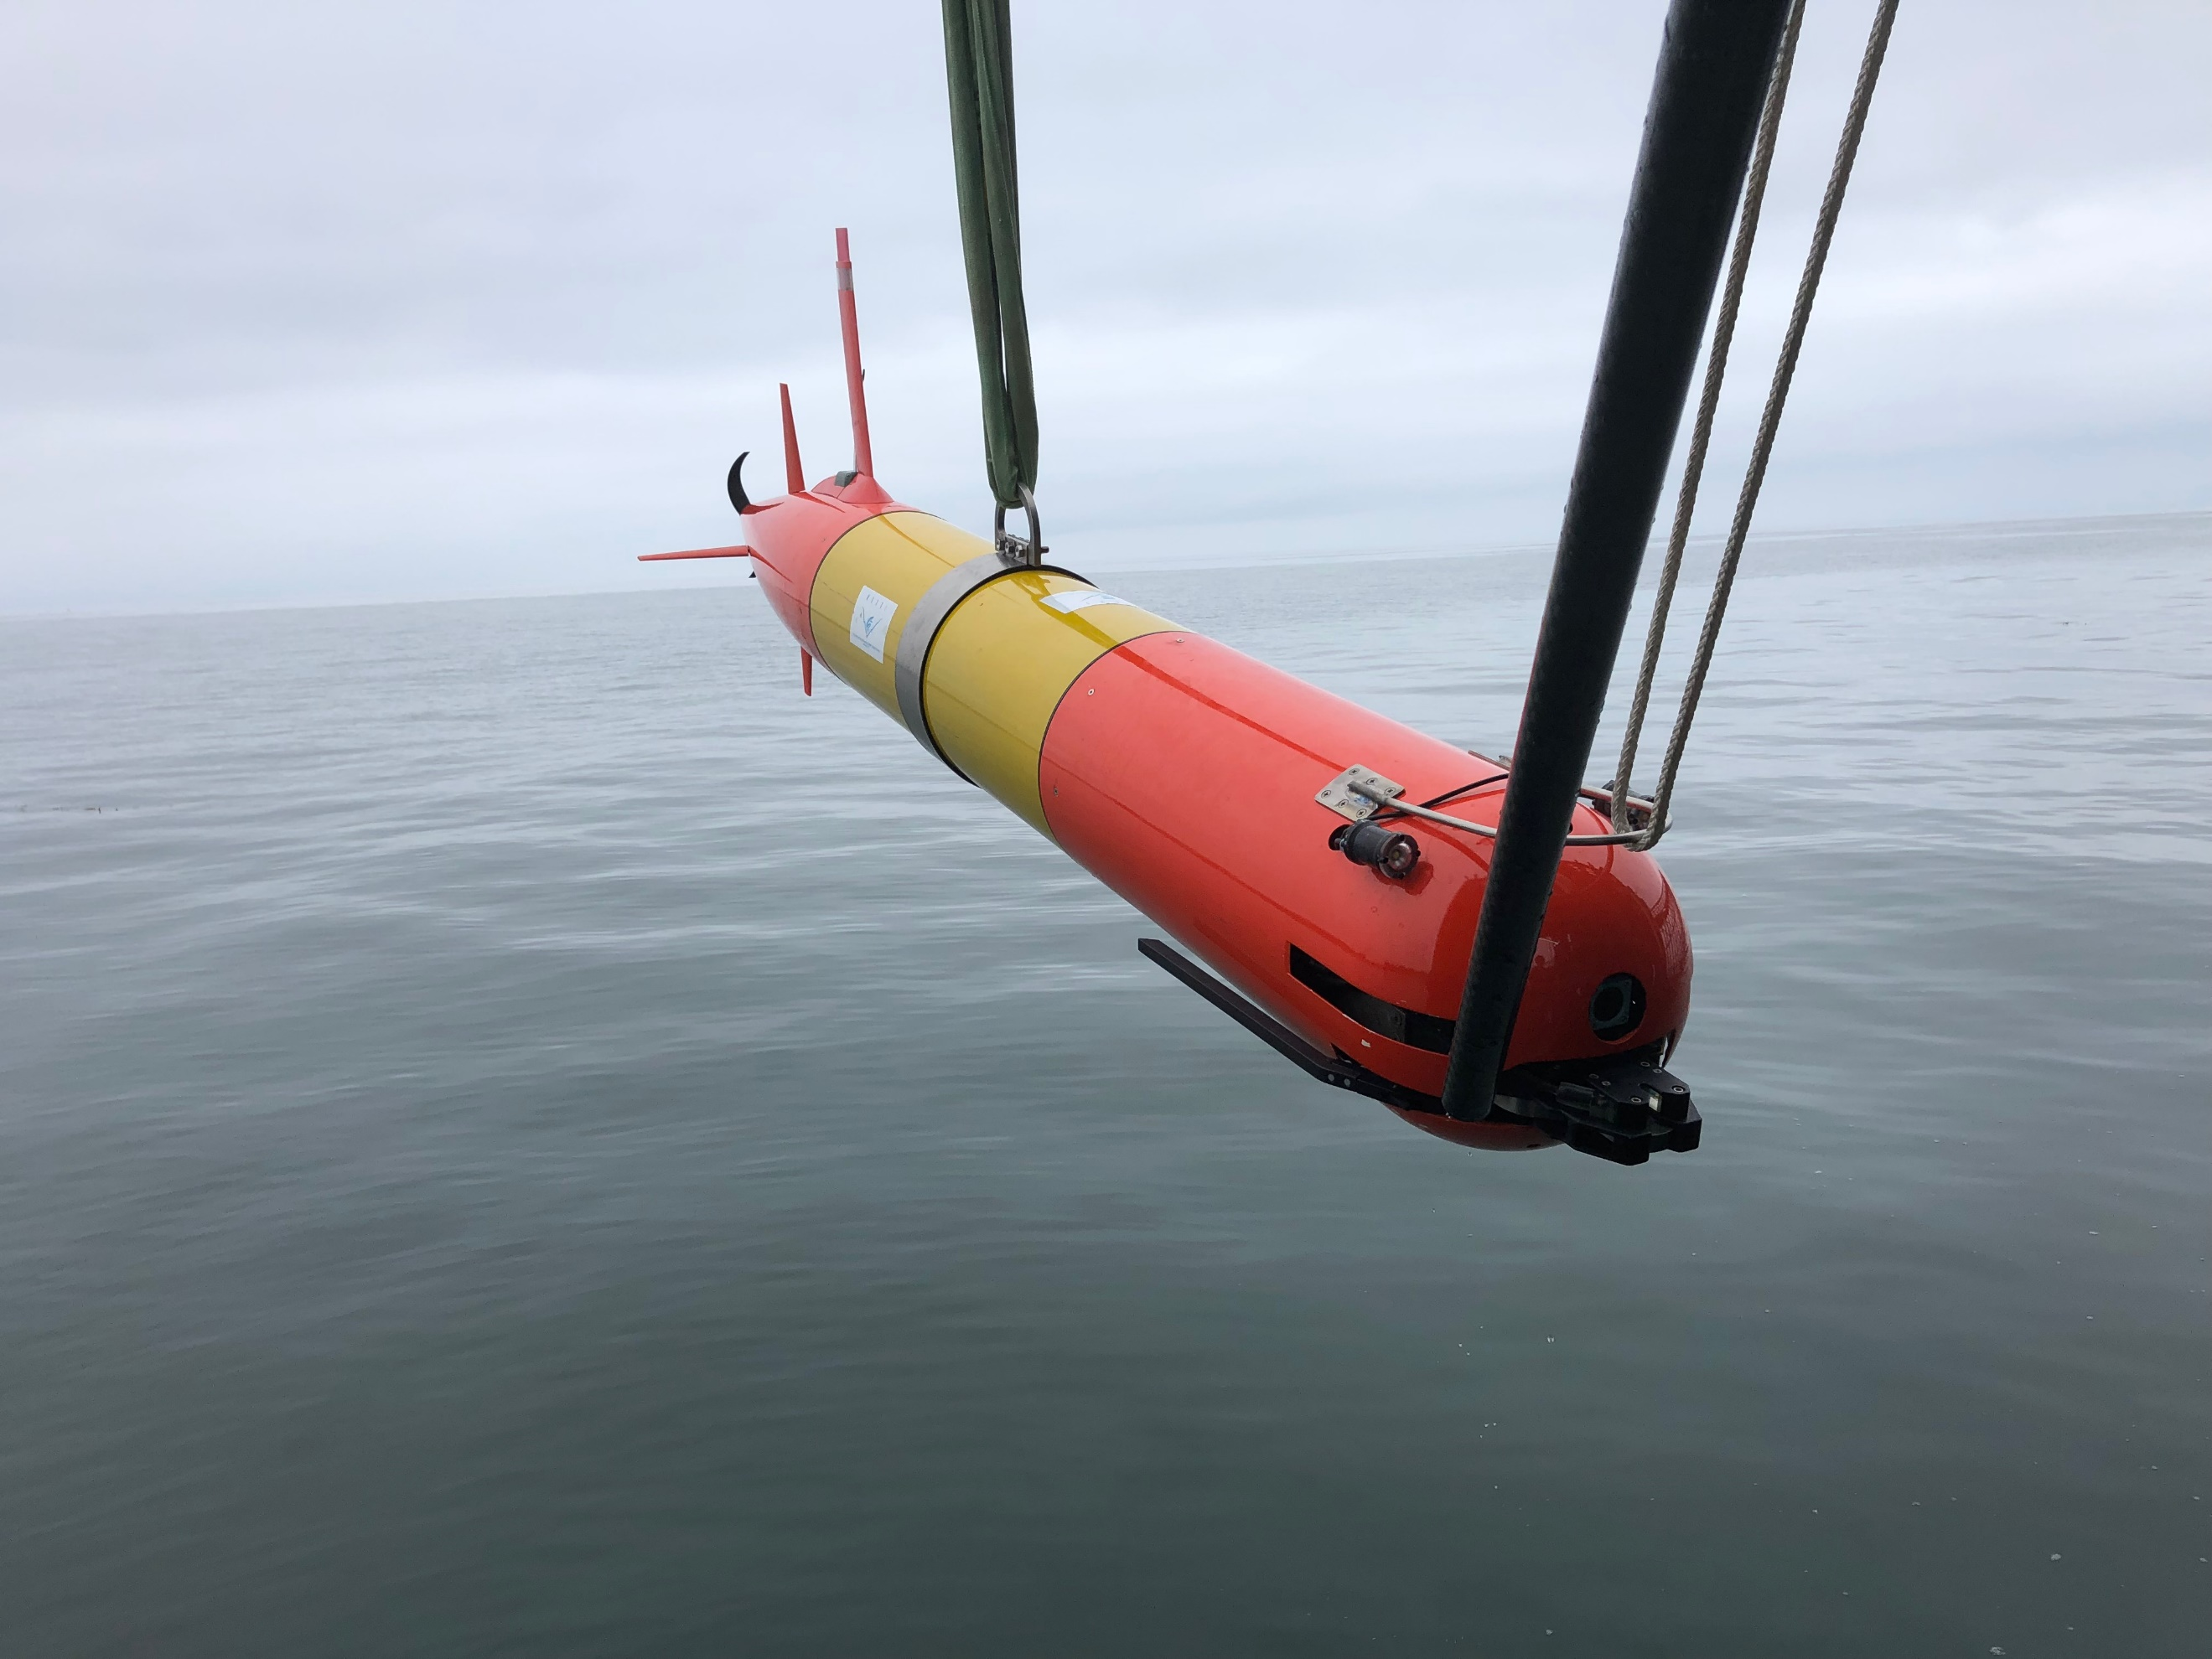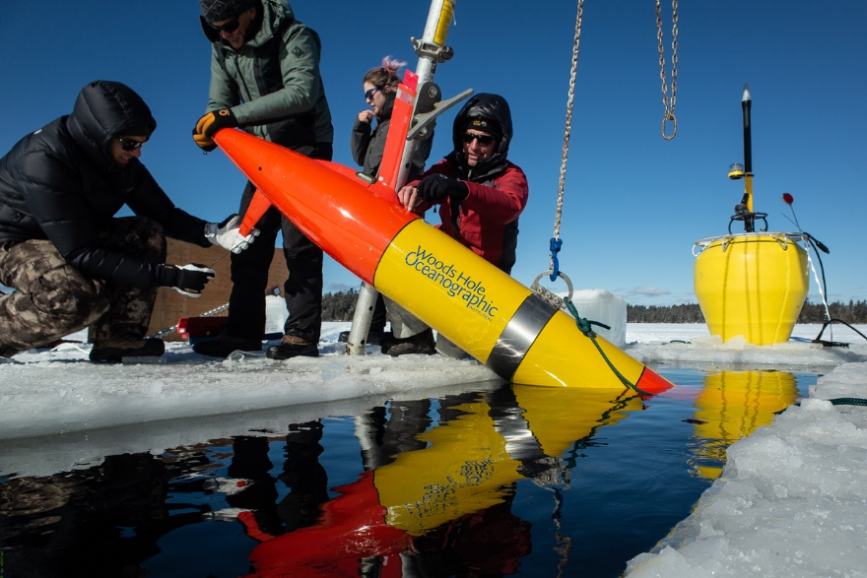

Figure 33: Polaris at Goleta Pier during the Santa Barbara Seeps experiment. Figure 2. Polaris being deployed in a frozen lake in Northfield, Maine during February 2020 testing.

Project Description

Abstract:
Increasing level of commercial marine activity in high latitudes creates an ever-growing risk of oil spills. Characterizing oil spills in remote and austere Arctic locations is a daunting challenge to the U.S. Coast Guard. Led by the LRAUV project PI, Dr. Bellingham, the laboratories at Monterey Bay Aquarium Research Institute (MBARI) developed a small long-range system called the Tethys Autonomous Underwater Vehicle (AUV). The Tethys AUV is a helicopter-portable system that functions as a rapid response solution to incidents occurring in the maritime environment and aims to increase the situational awareness of first responders. Outcomes of this project will be: (1) construction of two small long-range AUV (LRAUV) based on a modified Tethys platform equipped with oil sensors and navigation systems, (2) demonstrations of LRAUV survey and under-ice capabilities, (3) development of a mapping capability, and it further evaluates (4) a review of a reduced cost design for USCG and broader ADAC use (5) integration of onboard Inertial Navigation System and Multi-beam Sonar capability interchangeable between either platform to create a more sophisticated platform as a complement to the baseline platform. LRAUV and the expertise of the project team provide an autonomous underwater capability to survey oil spills at long range, high latitudes, and under ice. This project answers an unmet need for DHS and the USCG and offers an interagency, collaborative pathway to environmental anomaly detection and classification using the latest proven oceanographic technology.

Objective/Purpose:
The research team’s objective was to develop a Long Range Autonomous Underwater Vehicle (AUV) system, which included adapting, testing and orienting USCG mission operators and stakeholders to a Tethys AUV platform specifically modified for long range under ice operations capabilities to observe and sample dynamic processes in the Arctic Ocean. In addition to the platform, researchers have designed and developed a deployable communication buoy system that supports near real time transmission of oil spills via data such as heat maps and other environmental hazards under ice as characterized by LRAUV. Further, in order to support additional capability for Arctic maritime environmental response, investigators advanced developmental activities that create greater precision in characterizing environmental responses via integration of multi-beam sonar and INS.

Methodology:
The overall objectives of project year six for LRAUV were to advance WHOI and USCG competency in AUV oil response and mission capabilities for long range AUV platforms. By project year conclusion, the team has completed successful testing and training of LRAUV during three expeditions in addition to delivery of platform #1, Polaris, to WHOI from MBARI. Transition of LRAUV to WHOI, with project funding from ADAC, allows us to build the technical competency of the platform for under-ice capabilities, while enabling the team to lead operations and train USCG operators and first responders/scientists to access cutting edge technology in a time of crisis, as well as for multi-mission environmental response capabilities by completing the following: building a second platform; developing new behaviors and sensor capabilities for oil research and mapping objectives; develop an efficient manufacturing workflow for follow-on platforms; conduct open ocean and under-ice testing for mission development, reliability, training and transition.
This report details the in water and under-ice testing conducted on Polaris and the Arctic buoy system as well as the development of a second platform and its new capabilities.

Student Involvement:
N/A

Key Accomplishments:
Field Exercises: August 2019 “Santa Barbara Seeps-2” exercises. During summer 2019, the WHOI/MBARI team followed up our June oil seeps experiment with a second field exercise in Santa Barbara involving Polaris and two REMUS AUVs. The exercise was a collaborate exercise to simulate rapid response to an oil spill and included a team from EPA, NOAA, USCG participating aboard the USCG buoy tender, George Cobb. LRAUV’s role in the collaborative exercise was to use its long-term operational capability to map the seeps area to detect areas of high and low oil concentrations using its onboard mapping software quickly and efficiently and SeaOwl sensor. LRAUV Polaris was deployed from a pier and conducted surveys for six days operating around the clock informing the team both aboard the Cobb and shoreside where to survey each day during their response exercise. LRAUV provided hotspot snapshots allowing the team to make informed decisions where to operate their vessel and other sensing platforms inclusive of UAVs, over-the-side sampling techniques and AUVs carrying larger payloads with shorter duration capabilities. The following list provides an overview of our testing objectives and results:
- During this test, we deployed LRAUV from shore, without a vessel using a pier fish crane highlighting the versatility in LRAUV launch and recovery. Using an IPAD connected to a hotspot on the LRAUV, we sent the vehicle on a preliminary search mission to map out areas known to be near source points. The goal was to do a broad search of the area by conducting yo-yos from 1 meter to 35 meters looking for elevated detections from the SeaOwl while creating an apriority map. Meanwhile, the team readied the two REMUS AUV’s and loaded out the USCG George Cobb each day for field operations. LRAUV was monitored from shore and data was passed via either a web-based portal (command control) or via cellphone. The team aboard the Cobb, deployed the Arctic gateway buoy which was to be used as the data relay for LRAUV back to command control (shoreside). During these tests, the team was not going to use the buoy as a dock, nor would a second buoy with a transponder be deployed due to prioritizing tasks and limited time on site.
- The team was able to use this exercise to test two-way communications from LRAUV to the buoy to the Dash and back which further develops the under-ice behavior for navigation and communication by not surfacing unless commanded to do so.
- The SB seeps-2 exercise was an opportunity to further test the oil plume tracking algorithms, data relay from the buoy, the ability to send commands to and from the buoy to both the LRAUV and command control, as well as showing the utility of LRAUV to swim around the clock with minimal support and no need for a ship.
- LRAUV was able to reliably test its systems while informing command and first responders of where oil was and was not therefore saving people, ship and vehicle time while deploying other oil spill response kit and freeing the ship up to do other things.
The August Santa Barbara Seeps-2 deployment demonstrated the value of the LRAUV in a multi-vehicle and private/governmental partnership in oil response operations. The LRAUV’s unique ability to run around-the-clock over multiple days, allowed for consistent data collection that informed the operators of where to deploy the REMUS-100 and REMUS-600 in order to maximize their utility. The LRAUV was sent on a broad search of the area, in order to find areas of elevated SeaOWL detections and create apriority map for the other two vehicles. The LRAUV was reprogrammed to minimize its yo-yo depths when oil was not detected in shallow or deeper depths demonstrating the value of LRAUV sending near-real time data packages in the form of heat maps without having to recover the platform.
The team aboard USCGC GEORGE COBB deployed the Arctic gateway buoy, providing another opportunity to test the Arctic buoy communication system in an open ocean environment while allowing for the opportunity for WHOI to work closely with the crew of a USCG vessel. Polaris continued to successfully send data back to shore through both communication methods, via radio and acoustically through the gateway buoy. The data was automatically unpacked and plotted on the MBARI dashboard, providing heat maps of the dissolved petroleum hydrocarbons detected by the SeaOwl. Further details of these tests are provided in the LRAUV Seeps Field Report.
Detections of petroleum hydrocarbons from the SeaOwl onboard the LRAUV are displayed on the dashboard, informing operators on the location of oil hot spots. The dashboard shows the heat map of dissolved petroleum hydrocarbons with the LRAUV depth over time (top), which is georeferenced to the vehicle path (bottom), providing specific coordinates.
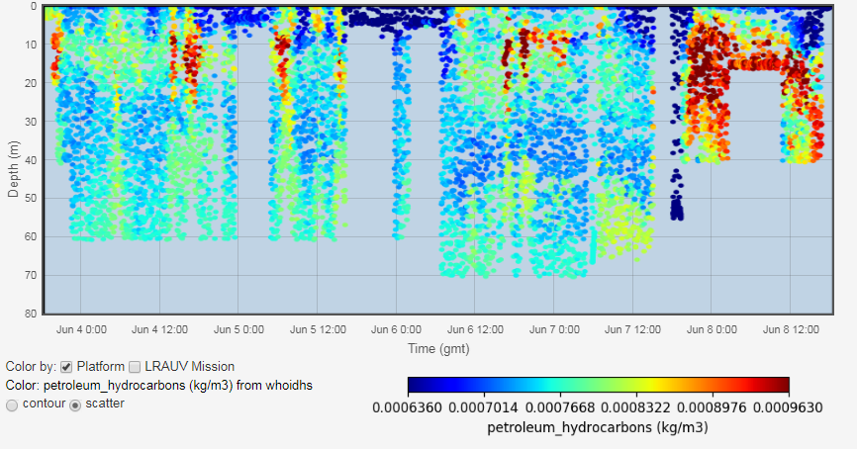
Figure 34: Detections of petroleum hydrocarbons from the SeaOwl onboard the LRAUV are displayed on the dashboard.
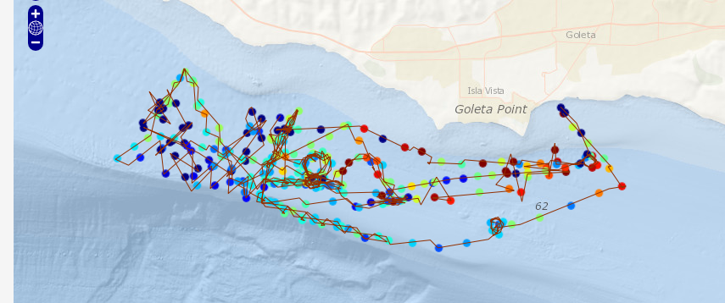
Figure 35: LRAUV route during Santa Barbara seeps testing

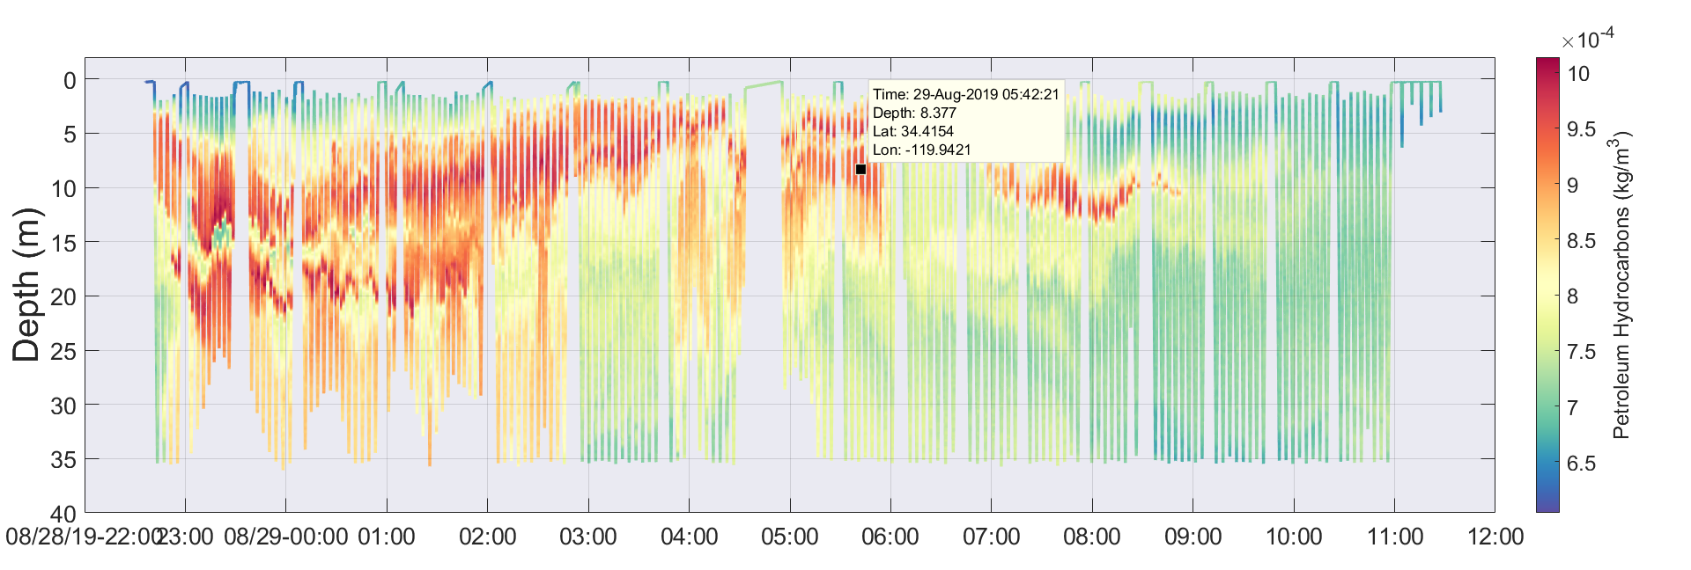
Figure 36: Near real-time data as seen from the web portal that the LRAUV sends data to which is accessible from the Dash website.

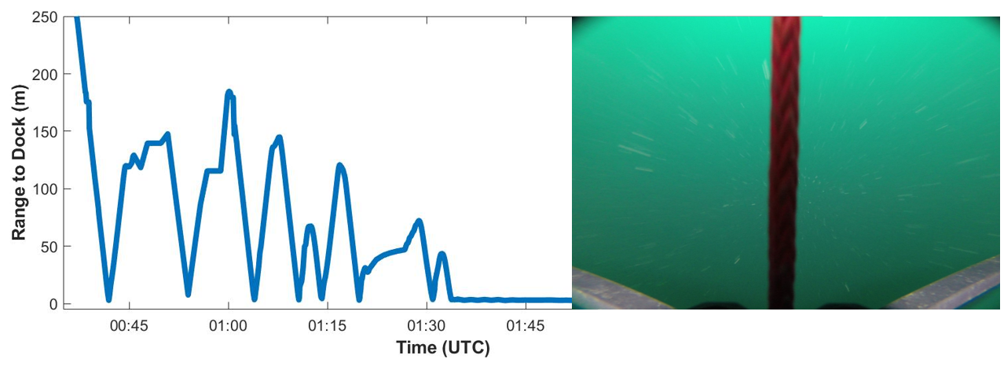
Figure 37: LRAUV Docked to a 3/8 line! The plot of the vehicle's acoustic ranges to the dock show it making a few passes before finally docking.

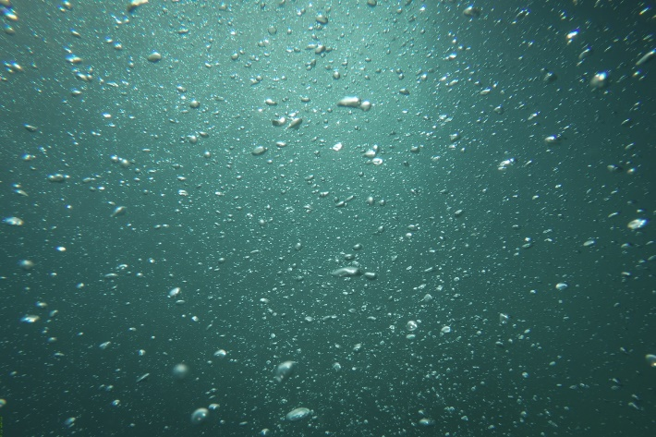
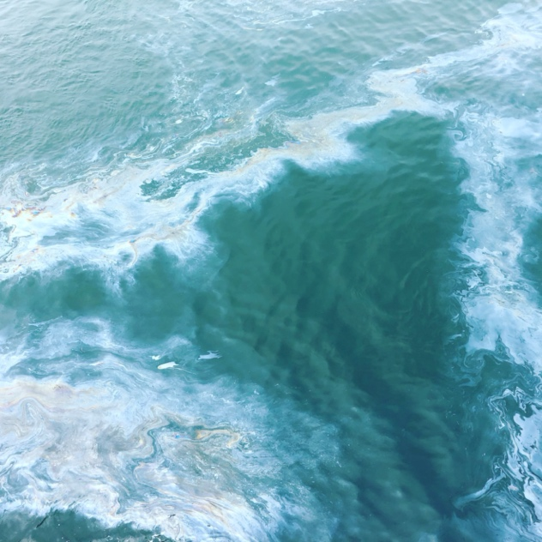
Figure 38: Weathered oil is common on the surface in Santa Barbara and is not indicative to where submerged oil was found. Oil and methane bubbles (right) escape from underground reservoirs.

Field Exercises February 2020, Under-ice expedition at Bog Lake Maine. After WHOI received Polaris in early February, the team worked around the clock in the lab to troubleshoot and test the micromodem and docking capability to support under ice operations. Researchers were able to implement and test vehicle code in Buzzard’s Bay and ran tests that concluded that docking was working as intended and we were ready to deploy under-ice.
The under-ice tests in Bog Lake with MBARI and WHOI were the first time LRAUV was ever operated under-ice. These tests were a dry run of what to expect from the unexpected and expose any challenges and performance issues that were not identified in open water or simulation.
Researchers were testing under-ice homing, docking, undocking, remote comms and operations on an ice sheet as well as all logistics involving cutting holes, testing emergency backup beacons and locating a lost vehicle under-ice. Operator training was also a priority.
Overall, this was a successful test and provided the needed data sets to help evaluate current behaviors and changes that may be needed including how the vehicle undocks in a low water current environment. Further details on the Woods Hole testing and under-ice expedition are available in the Final Report Under-ice Bog Lake 2020.

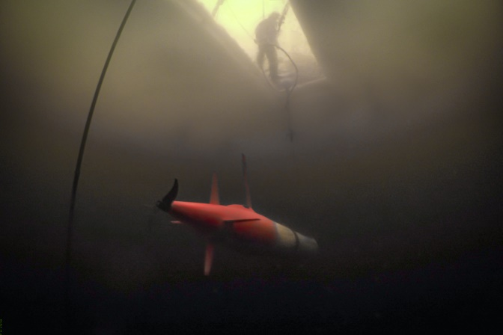
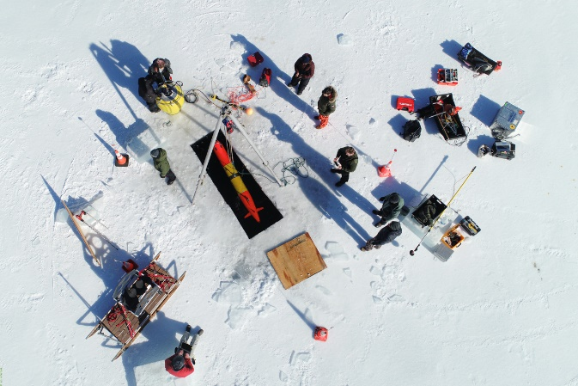
Figure 39: LRAUV ice camp as seen from a UAV. Shown is a 3x9 foot hole with a simple gantry used to hoist the LRAUV in and out of the water.
Figure 40: LRAUV is docked under ice to the Arctic buoy cable and awaits its next mission command.

System Evaluation and Fabrication: Creating LRAUV Platform #2: Stella. The WHOI/MBARI team also has been conducting a full system evaluation, inclusive of auxiliary gear and buoys, in order to review low cost manufacturing and design improvements for Build-2 and future builds. The team has implemented PDM tools consisting of Autodesk Vault, Basecamp, Slack and WHOI Roundabout for tracking current and future inventory and allowing time and cost savings for Build-2 ordering and manufacturing. Autodesk Vault enables revision control on drawings and documentation related to the build. With these tools in place, WHOI has all mechanical drawings as well as ordering information for the entire LRAUV platform in a secure and controlled environment. Build instructions were drafted in year 6 and that effort will continue into YR7 to make manufacturing of LRAUV a more efficient and economical endeavor.
All mechanical parts have been designed and or ordered and received in YR6. Given major hurdles in the spring of YR6 activities due to Covid-19, including shop and services shutting down, this is a huge success and will limit more delays in build-2 related to the core vehicle build. All mechanical parts and most electrical components have been organized at the WHOI lab in bins labeled per assembly. Next steps (Year 7) include figuring out how to build up the assemblies as we work diligently to document with photos, diagrams, drawings and notes/instructions. This documentation package will be a deliverable goal for program year 7 that may be pushed into YR8 depending on the further impacts by Covid-19 delays and any other unforeseen hurdles.
Updating the electrical drawing package is an ongoing effort that will continue throughout program year 7. This effort is achieved by hands on evaluation of the current vehicle and a learn as you go effort in order to update project materials provided by MBARI. We are also working to make the vehicle more modular so we can move around payloads such as the sonar more efficiently.
Low Cost Vehicle Evaluation: Low cost evaluation was conducted on the LRAUV build to identify what items can be 3D printed versus machined. In theory, 3D printing provides quicker and less expensive fabrication. In Program YR6, parts were identified that are currently machined, but could possibly be 3D printed without redesign, based on the following criteria:
- Currently made in plastic
- No sealing features
- Not strength-limited
If printed, these parts may cost as little as a quarter of their current cost, which would represent a roughly 3% reduction of the core vehicle cost (not inclusive auxiliary equipment, sensors, etc. costs).
In contrast, there is a single machined part that was designed to protect the ends of the pressure hull when not installed on the vehicle, shown as “Tube Protectors” on the diagram. Just eliminating this part and taping a cardboard or rubber mat over the end of the tube would save $1000 per vehicle.
Fasteners: The total cost of fasteners for one vehicle is less than $800. MBARI quoted out every fastener with a distributor, Olander, who made individual kits for the build of each vehicle. It is possible that there was some cost savings associated with eliminating excess inventory and not paying the “McMaster-Carr” tax, but for these items the marginal gain is very small, and the time associated with quoting all of the vehicle’s fasteners in a batch may actually outweigh the cost savings.
Mechanical re-design: The largest single body of cost is in the custom machined parts that MBARI designed. These parts could be re-designed with cost-savings in mind, but a concerted engineering effort would be necessary to realize those gains, and the cost of re-engineering may be greater than the savings for even a multiple-vehicle build. This is a larger effort that exceeds the scope of this project. Future efforts should be evaluated by an outside firm with input by WHOI/MBARI if DHS S&T OUP, USCG or ADAC seeks commercialization of LRAUV System.
Accomplishments
- The team conducted a review of the LRAUV mechanical and electrical builds reviewing electrical systems for updates and improvements with an emphasis on performance and cost savings. The team reviewed design materials and acquisition of materials in accordance with revalidated LRAUV bill of materials. Upon evaluation of LRAUV design drawings, extensive work was done to update, correct and detail the drawing package in order for a second party to efficiently procure/build platforms. This activity was more intensive than previously estimated and is still ongoing with the electrical drawings.

- The team achieved successful underwater docking and undocking to a transponder during testing in Woods Hole as well as the first ever successful docking under-ice by LRAUV using the Arctic buoy and micromodem system.
- The team developed an add on- second dock capability which is pending in water testing in YR7 (WHOI/MBARI)
- The team conducted a rapid response oil exercise at Santa Barbara Seeps (August 2019)
- We modified one of three buoys for optimal docking and have a kit to change buoys frequencies between high and low depending on mission objectives
- MBARI delivered the Polaris LRAUV to WHOI on 4 February 2020
- Developed and tested firmware for buoys for subsurface capabilities (USBL, ACOMMS)
- Conducted further evaluation of COTS sensor packages (split beam, multibeam, methane, optics); (WHOI)
- Developed PDM tools and procedures for LRAUV Build-2 using Vault, Basecamp and WHOI Roundabout. Released all mechanical drawings except those identified to be candidates for low cost manufacturing. The team determined that the cost savings (~3%) was not justifiable to test new manufacturing methods for one additional build given the resources and time constraints within project year 6.
- Evaluated end of life parts and LRAUV system for improvements and manufacturing. Internal battery charger system will be redesigned to be more efficient and will also increase battery capacity. A new, more robust antenna design is underway and will be built in YR7.
- The team held a transition meeting with the ADAC Executive team and Brian Dolph from USCG RDC in late September 2019 in Woods Hole, MA.
- Planned logistics for a New England under-ice test in a frozen lake in Maine conducted between 6-12 Feb 2020.
- Planned logistics for under-ice testing of Polaris in Lake Superior in late March hosted by the Great Lakes Research Center. This operation was canceled due to lack of ice and would have been eventually canceled due to Covid-19 shutdowns. Research team quickly pivoted and found a suitable location in Northfield, Maine for LRAUV’s first under-ice tests.
- Designed a davit LARS for our low-cost WHOI vessel for launch and recovery of LRAUV and integrated a center lifting bail for launch and recovery versatility from other platforms
- Developed WHOI operational DASH for operating LRAUV from inside WHOI https://lrauv.whoi.edu/#/
- Conducted first ever under-ice mission of LRAUV and successfully tested docking to one buoy and two-way comms between the vehicle, buoy and Dash.
- Completed ordering of all year six funded build-2 mechanicals and sensors. Researchers also were able to receive all outstanding parts despite major shutdowns and delays of shops and services affected by COVID19. This was due to the perseverance and organization of the WHOI team to work with WHOI’s extensive network of suppliers and machine shops. The value of the researchers’ time and commitment to project management was a huge payoff to the success of ADAC Program Year 6 fabrication progress.
- Identified and procured a low-cost and low power multibeam system (Norbit WMBS) for seafloor mapping, in water detection of particles and potentially oil submerged under-ice. Further testing is needed to evaluate all three applications. Further work will need to be expanded beyond Year 7’s workplan.
- A concept of operations was developed by the ADAC team for vehicle scenarios and outputs.
- Project team completed evaluation of data and provided mission reports for Santa Barbara and Bog Lake experiments.
- Low cost vehicle evaluation was completed.
- Participated in North Slope tabletop exercise, Feb 2020.
- Created Test Plans/Conops for project team for field exercises.
- Began testing of a 360-docking array for improved docking resolution.

Key Stakeholder Engagement:
Project team participated in four ADAC Customers and Partners Roundtables. During the Customers and Partners Roundtable, the project team provided a brief technical summary of their project and answered questions from federal customers and interested parties including representatives from the US Coast Guard and National Oceanic and Atmospheric Administration.

Key Publications (peer reviewed):
within year 6 project investigators started drafting a suitable peer-review journal article outlining key lessons learned from the development of LRAUV System and Field Testing (leveraging field reports from summer 2019 and winter 2020).
Key Presentations:
- LRAUV Seeps Field Report, 2020, Kukulya, et al.
- REMUS (with LRAUV) Seeps Field Report, 2019, Kukulya, et al.
- Field Report Under-ice LRAUV, 2020, Kukulya, et al
- Participation in ADAC Quarterly Reviews, Kukulya
- Presentation, ADAC Annual meeting 2020, Kukulya
- LRAUV Under-Ice Test Plan, 2020, Kukulya
- Conops Seeps Experiment, 2019, Kukulya
Project team presented at ADAC Program Year 6 Annual Meeting. The Annual Meeting was held virtually via Cisco WebEx as COVID-19 prevented an in-person gathering in Washington D.C. as in previous program years. The meeting was well attended drawing a total of 202 registrations for the 7-hour virtual event with a peak of 157 participants. DHS S&T OUP, HQ USCG ADAC Project Champions, NOAA leadership, ADAC Executive Counselors, and many other customers and partners participated ADAC’s Year 6 Annual Meeting.

Changes from initially approved Workplan:
None
Project progress against each milestone
Table 29: Project progress against each milestone
MILESTONE | PROGRESS | WHY NOT REACHED? (IF APPLICABLE)
Project team will procure a 3D Norbit multibeam system | Completed
Finish design and integration planning for Norbit multibeam system by 15 Dec 2019. | Completed
Project team will advance the technical competency of USCG RDC in operating and testing the platform. Project team, led by WHOI investigators at Woods Hole, MA, will conduct up to two training sessions. Project team will complete this task via two sessions, the first by 1 Feb 2020 and the second by 30 June 2020. | Incomplete | ADAC and LRAUV Systems team met with USCG RDC PoC (Mr. Brian Dolph) at Woods Hole in Sep 2019 to initiate technical competency plan.  COVID19 prevented suitable meetings to conduct follow-up meetings to advance technical competency. ADAC and LRAUV Systems leadership at WHOI and MBARI created a comprehensive LRAUV Systems Concept of Applications to advance technical competency and conducted one Video teleconference in May 2020 with USCG Project Champion and assembled USCG program advocates to draft Year 7 workplans and needed competency requirements for USCG.
Initiate fabrication of an additional sensor capability to LRAUV (focused on multi-beam sonar), completing sub assembly construction by 1 Feb 2020. | Incomplete | Fabrication efforts underway, but priority had to shift to focus on under ice testing in Winter 2020. Further delays due to COVID 19 impact on supply chain for needed parts. By end of Program Year 6, initial Platform #2 subassembly construction was underway at WHOI.
Conclude science evaluations of late Program Year 5 and early Program Year 6 tests in Santa Barbara Channel to inform further Arctic tests. Project team will deliver science evaluations by 1 March 2020. | Completed | Delayed, but completed in program year.

Associated discussion.
The WHOI team invested ample time in reviewing vehicle build details including bill of materials and drawings that were provided by MBARI. A larger effort was needed in order to work with MBARI to complete and update drawings so they could be sent out to shops for quotes. Associated iteration was time consuming. The impacts of COVID-19 slowed the process of getting quotes back from multiple shops to meet quote estimates and budgetary constraints. Purchasing the sonar was completed however completion of the sonar module was held back for carryforward to be completed in program year 7 so efforts could remain focused on the core vehicle build. Completion of the second LRAUV platform, Stella, is a principal Year 7 task.
Progress on local testing of Polaris and the three-buoy system was also delayed due to cancelation of all onsite activities for 3+ months due to COVID19. Efforts were refocused to get a jump start on a new antenna design since two of three had been broken in the field (one before arriving to Woods Hole). The antenna was evaluated to not be viable in an under-ice environment and will be shortened and made to be thicker in its next revision being completed at WHOI.
The third antenna was damaged during evaluation in the lab. A spare antenna will be loaned to WHOI by MBARI and is pending a ship date. While the vehicle is in the lab, efforts are being made to redesign the nose to fit the new CTD and DO sensor and make room for the new sonar head. Bracketry and cables are out for quote and are expected in Early Year 7. Effectively, these delays collectively have delayed key planned LRAUV system tests for multi-buoy operations, docking, undocking behaviors and LBL testing approximately 3 months behind original schedules.

Project progress against each metric:
Table 30 Project progress against each metric
METRIC | PROGRESS | WHY NOT REACHED? (IF APPLICABLE)
Navigation performance:  Conduct design improvements for Tethys platform to achieve the following drift rate: percentage of distance traveled. Target: < 1.0% with LBL aided navigation.  Conduct design improvements for Tethys platform to achieve the following error bounding of navigation drift by ranging from a fixed beacon. | Incomplete | Testing delays in Program Year 6 due to COVID 19 delayed measurements to confirm navigation performance.
Modification of Tethys platform in mechanical and electrical engineering to integrate separate oil sensor package to accomplish detection level of oil: measured in terms of minimum sensitivity. Target: < 80 ppb. | Incomplete | Testing delays in Program Year 6 due to COVID 19 delayed measurements to confirm oil sensor sensitivity.
Modification and design improvements for Tethys platform to meet specified AUV range and endurance. Target: 300 km on secondary batteries, twice that on primary | Incomplete | Long Range evaluations conducted to date, indicate this parameter is achieved, but more tests are required to confirm.
Modification and design improvements for Tethys platform to integrate mapping algorithm for adaptive sampling performance- mapping of spill extent. Target: Area coverage 1000 km 2 per vehicle deployment. | Incomplete | Evaluations will be accomplished once 2nd platform is fabricated.
Each Arctic buoy will be able to communicate position data via acoustics up </= 5 Km distance per buoy to undersea vehicle (please note two buoys navigation solutions are needed for a valid fix). | Incomplete | One buoy was tested to exceed 5 Km. A long range three buoy test has not yet been completed.
Position updates from the LRAUV will be pushed to the Arctic buoys and then relayed back to command control (topside laptop anywhere in the world) | Incomplete. | Tests accomplished to date with Arctic buoys indicate this measure is readily achieved, but tests in Program Year 7 should confirm.
LRAUV will be able to line capture or dock to a fixed beacon with its USBL and capture nose assembly. Target=50% success. | Incomplete | Tests so far indicate measure has been accomplished. More work is needed to improve from 50% which research team believes is possible.
Logistical footprint: number of operators required on site, number of kilograms to transport. Target: 2-3 adult operators and < 600kg | Complete
Ease of mission configuration: design time to specify grid survey. Target: < 1 hour | Incomplete | Software will be evaluated in early Program Year 7 tests.
Ease of remote interaction: design modifications to allow training time required for operators: Training: < 1 week | Complete | This is achieved as long as an expert is available or on call to assist with more obscure questions/advice until operators have had more significant time experiencing things not going according to plan
Low cost system evaluation:  End bell of PV complex and long lead: Can additive manufacturing be used to build integrated end bells rapidly?  Wet volume for sensors: This space is inefficiently used. Can additive manufacturing allow more efficient integration of actuators/propulsion system/sensors?  BoM = 1000 parts for LRAUV: How much does 3d printing allow us to reduce this?  Wiring harness: How much can the wiring harness complexity (wire number, connector count) be reduced?  Connectors: Can connector count be reduced?  Customization: Can 3d printing be used to enable faster turnaround on custom sensor suites?  Software reliability: Can integration of mechanical/electrical/software system engineering documentation be used to enable auto-configuration of I/O software?  Cumulatively how much cost can be extracted from the build, and how much lead-time is removed? In addition, does this enable smaller, low cost vehicles (e.g. could they be expendable)? | Complete | 3D printing cost savings were evaluated. Please see details starting on page 134

Unanticipated problems and plans for addressing them:
The metrics discrepancies are attributed to impacts of COVID19 as well as the larger than anticipated effort to evaluate the LRAUV design for the current build as well as extensive efforts needed outside the scope of this project to effectively evaluate LRAUV for additive manufacturing and significant low-cost design analysis. The vehicle has over 1000 components and research team focused on evaluating parts that could be 3D printed and what cost savings that would provide. Further refinement was needed on existing electrical and mechanical schematics which was an unplanned refocus time and efforts from the research team. Due to competing priorities, advancing development of LRAUV’s Long Base Line (LBL) capability was deemed a lower priority for ADAC Program Year 6 and associated efforts were re-allocated to ADAC Program Year 7by WHOI and LRAUV software contractor Intuaware. Full multibeam Sonar integration was also moved to Program Year 7 and is anticipated be integrated into Polaris for local testing.

Outcomes/output and TRLs:
Outcomes:
The goal of this project remains to create an operational system prototype that the USCG can use for characterizing spills in ice-covered ocean environments. ADAC, WHOI, and MBARI focus in advancing LRAUV System will provide and demonstrate a prototype system consisting of two advanced platforms and three Arctic Buoys feasible and suitable for production. Outcomes of effort will provide a commercially available off-the-shelf sensor package that is AUV ready, and turnkey for Arctic seafloor and under-ice mapping. Predicting and monitoring environmental hazards in the Arctic remains an outstanding challenge for under-ice surveys. Our approach builds on proven AUV technology and expands its capability by adding the latest COTS sensor technology for creating 3D maps. The power of this technology for investigation of oil spills in open water or under ice remains largely unexplored, but sample data shows strong potential for oil mapping and detection capabilities in the future.
Outputs:
The team conducted a review of the LRAUV mechanical and electrical builds reviewing electrical systems for updates and improvements with an emphasis on performance and cost savings. The team achieved successful underwater docking and undocking to a transponder during testing in Woods Hole as well as the first ever successful docking under-ice by LRAUV using the Arctic buoy and micromodem system. The team conducted a rapid response oil exercise at Santa Barbara Seeps, modified one of three buoys for optimal docking and have are created agile buoys frequencies between high and low depending on mission objectives. The team developed and tested firmware for buoys for subsurface capabilities, conducted further evaluation of COTS sensor packages, developed tools and procedures for LRAUV Build-2, conducted low cost manufacturing evaluation and evaluated end of life parts and LRAUV system for improvements and manufacturing. The team successfully conducted under ice tests, designed a davit LARS for launch and recovery of LRAUV and integrated a center lifting bail for launch and recovery versatility from other platforms. The team completed ordering of all year six funded build-2 mechanicals and sensors. Researchers also were able to receive all outstanding parts despite major shutdowns and delays of shops and services affected by COVID19. The team also identified and procured a low-cost and low power multibeam system for seafloor mapping, in water detection of particles and potentially oil submerged under-ice. A concept of operations was developed by the ADAC team for vehicle scenarios and outputs. The team also began testing of a 360-docking array for improved docking resolution.

Technology Readiness Levels (TRLs):
As of close of the close of the year 6 program, the system is at TRL 6. Following the LRAUV’s testing plan, and completion of data relay devices, the overall system will be TRL 7/8 and ready for production.

Transition Activities:
The ADAC and LRAUV project team continue to seek an integrated approach with USCG RDC and HQ USCG to acquire and develop additional LRAUVs commensurate with USCG mission needs. In accordance with DHS S&T OUP-ADAC Grant Terms and Conditions, LRAUV Intellectual Property (IP) rights developed under this project remain jointly held between ADAC, WHOI, and MBARI. According to the DHS S&T Terms and Conditions, DHS and USCG may leverage this IP royalty free to acquire and construct additional LRAUVs to USCG and other DHS maritime mission needs. During LRAUV testing, ADAC, WHOI, and MBARI recommend HQ USCG Project Champion, HQ USCG CG5-R, CG7, CG-9 as well as USCG RDC participation. Project team notes that NOAA, BSEE, and EPA remain interested in LRAUV System capabilities.
During program year 6, the LRAUV Team, in collaboration with ADAC and the USCG Research and Development Center, coordinated several transition-related meetings, events, documents, and activities. Those events include the Transition plan development meeting with USCG R&D Center in Woods Hole, MA, LRAUV Co-PI Participation in the March 2020 KupEX 2020 Conoco Phillips Oil Spill Exercise at Kuparuk, AK, and the development of an LRAUV Concept of Applications, submitted to the HQ USCG and key USCG stakeholders on 3 April 2020.

PROJECT: Arctic-related Incidents of National Significance (Arctic IoNS) Workshop
Project Investigator: ADAC Executive Director Randy Kee
Lead Institution: University of Alaska Anchorage
Supporting Team: USCG District 17 Staff officers for Arctic IoNS. Note: ADAC Fellows provide preparation and administrative support.
Project Champion: None designated, but ADAC coordinated closely with USCG D17 Arctic Planner, Mr. Phil Thorne to design and plan the workshop.
Project Description:

Abstract:
ADAC planned to conduct one Arctic-related Incidents of National Significance (IoNS) workshop for program year 6. ADAC planned the Arctic IoNS workshop in close coordination with USCG District 17. Based on identified operator concerns, Arctic IoNS workshops assemble expert academic and industry research professionals to work with select Canada and U.S. Coast Guard Arctic operators, along with U.S. and Canadian government security officials in a structured workshop to understand gaps and shortfalls in science and technology and to provide corresponding research questions to address. ADAC publishes a corresponding workshop Rapporteurs report addressing research challenges and specific areas of focused future research. The Arctic IoNS event in Program Year 6 was planned to utilize a guided decision table-top venue based on a crisis response scenario coordinated by USCG D17. Following the workshop and development of the workshop Rapporteur’s report, ADAC planned to coordinate with DHS S&T and designated USCG officials to conduct a follow-on directed study, with designated workplan approved by DHS S&T UP and research team assembled and directed by ADAC center leadership. This project has been significantly impacted by COVID-19 and is now postponed until 2021. The project team will conduct the follow-on directed study in ADAC Program Years 7 and 8 and deliver a comprehensive knowledge product to DHS S&T UP and USCG by the close of Program Year 8 (30 June 2022).

Objective/Purpose:
Conduct focused workshop, provide post workshop Rapporteur’s report with select researchers/paired with USCG and other suitable operators to discern USCG shortfalls as established by Commander, USCG D17. Following completion of workshop, ADAC plans a sponsored study as coordinated by USCG and approved by DHS S&T UP.

Methodology:
ADAC planned its next Arctic IoNS workshop for April 2020. The workshop initially planned the scenario of an Arctic region, crisis response scenario associated with a major transportation accident that results in loss of life, significant injury and a maritime environmental response. The workshop method planned to employ a significantly modified version of the “wargame” exercise scenario routinely used by the U.S. Joint Staff J-8 Wargaming Division. Final scenario determination and workshop development was coordinated by ADAC to USCG D17, USCG CG926 and DHS S&T UP.
Arctic IoNS development began with the Arctic operators providing specified areas of concern to investigate. ADAC sought to conduct a scenario-based seminar in Program Year 6 with USCG D17 and USCG Canadian counterparts to identify areas of crisis response concern in an Arctic maritime response scenario, however the IoNS exercise was postponed due to COVID-19 restrictions on travel and large public gatherings.
ADAC planned a comprehensive literature review through Center Fellows to establish a baseline of published experts and corresponding baseline capabilities associated with the crisis response. Guided by the review, ADAC solicited to assemble a framework of various response groups, corresponding to real-world crisis response decision-makers (oriented to Federal On-scene Unified Response). ADAC then invited operators and government officials from U.S. (at Federal, State, Local and tribal organizations to compose crisis teams, and complement with relevant academic and industry leaders to form the response cells associated with USCG-led crisis response. ADAC will also invite Canadian response counterparts to join the proceedings.
Through a structured and sequenced plenary, guided exercise and breakout workshop, participants would gain understanding of knowledge gaps and shortfalls in crisis response. Equipped with this understanding, participants would develop research areas of focus for onward study and research. ADAC will then create a Rapporteurs report, to establish a framework and needed details for a research study proposal for USCG and DHS S&T deliberation and approval considerations. The output of Arctic IoNS workshop would have included workshop proceedings, and a proposal for relevant directed study and subsequent knowledge product to advance and support USCG mission needs.

Student Involvement:
ADAC Fellows aided preparation and provided administrative support during the Initial Planning Meeting as professional development and opportunity for networking.

Key Accomplishments:
The ADAC project team, consisting of ADAC Executive Director and ADAC Senior Research Professional facilitated, co-organized, and co-planned the IoNS 2020 Exercise Initial Planning Meeting, in collaboration with USCG District 17. The initial Planning Meeting took place over two days, 19-20 November, and was held in the UAA Business Enterprise Institute training room.

Key Stakeholder Engagement in Program Year 6:
Through a series of prior research and coordinating meetings, established a network of Canada and U.S. operators, researchers and government official tailored to address each individual workshop. ADAC Project leads worked with DHS S&T UP, HQ USCG CG926, and USCG D17 to design and plan the execution of the workshop.

Key Publications (peer reviewed):
N/A

Key Presentations:
N/A

Changes from initially approved Workplan:
This projecttimeline had been significantly impacted by COVID-19 and the exercise is now postponed until 2021. The project team will conduct the follow-on study in ADAC Program Years 7 and 8 and deliver a comprehensive public knowledge product to DHS S&T UP and USCG by the close of Program Year 8 (30 June 2022).

Project progress against each milestone:
MILESTONE | PROGRESS | WHY NOT REACHED? (IF APPLICABLE)
Work closely with DHS, USCG, and Canadian counterparts on the workshop scenario. | Completed | N/A
Conduct research to identify the universe of SMEs (international, domestic, in/out government, etc.); conduct research to determine what research is underway to address the likely challenges posed by the scenario and those challenges most relevant to USCG. | Completed | N/A
Organize workshop (securing facility, inviting participants, developing agenda etc.)  1. Completed workshop participants’ selection.  2. Completed workshop participants’ invitations.  3. Completed logistics arrangements.  4. Completed workshop announcement; and  5. Completed workshop program. | Completed | N/A
Decide to identify appropriate SME speakers to discuss relevant research activities across disciplines that likely address USCG challenges relevant to the scenario. | Completed | N/A
Complete panel selection and invitations. | Completed | N/A
Execute workshop – Research Questions developed and provided to USCG. | Incomplete | Postponed due to COVID19
Complete report/proceedings and slides deck representing the workshop discussions and submitted to USCG for review. | Incomplete | Postponed due to COVID19
Publish rapporteurs’ report/proceedings, including list of participants and slides deck will be publicly posted (website) with the ADAC RFP. | Incomplete | Postponed due to COVID19
Conduct funded study based on findings of Rapporteurs report | Incomplete | Postponed due to COVID19

Unanticipated problems and plans for addressing them:
Workshop postponed due to COVID19.

Transition Activities:
ADAC’s goal of the next Arctic IoNS workshop is to ultimately transition discovered crisis response gaps and shortfalls into a relevant follow-on study.

PROJECT: Arctic Medium- and Long-Term Environment (Arctic MaLTE) Workshop
Project Investigator: ADAC Executive Director Randy Kee
Lead Institution: University of Alaska Anchorage
Supporting Team: ADAC Fellows
Project Champion: HQ USCG 5PW (Senior Arctic Policy Advisor...SAPA).
Project Description:

Abstract:
ADAC planned to conduct one Arctic focused Medium- and Long-Term Environment (MaLTE) workshop to understand and address the medium and long-term strategy, policy and planning needs specific to the USCG Arctic mission. The Arctic MaLTE format is planned as a structured workshop involving select academics, industry researchers, and government officials, who explore longer, range challenges comprehensively, from policy, governance, and science & technology vantages. The outcome of the MaLTE workshop is a comprehensive knowledge product which includes workshop analysis and recommendations.

Objective/Purpose:
Conduct focused workshops to meet medium and long-term strategy, planning and policy problems as determined by HQ USCG (specifically, HQ USCG Senior Arctic Policy Advisor to the Commandant.

Methodology:
As a strategy, planning and policy-oriented workshop, Arctic MaLTE events convene subject matter experts, Government Officials in both the U.S. and Canada, academic researchers, and respected leaders of the Arctic, to include Arctic residents from indigenous communities and organizations. The workshop structure is framed as a series of focused briefings, highlighting issues, concerns and recommendations, followed by roundtable discussions and breakout sessions using Delphi prioritized solutions that if taken for action through policy decisions, provide pathways to improved governance, safety and security for U.S. interests in the Arctic. ADAC will conduct a comprehensive literature review through Center Fellows to establish a baseline of published experts to support the workshop. In creating the workshop, ADAC solicits and assembles an appropriate panel of select researchers from the baseline to present to invited operators and government officials in Canada and the U.S. (at Federal, State, Local, and Tribal) to form cross-section expertise resulting in comprehensive discussions. After the plenary, ADAC divides participants across facilitated breakout workshops to discover pathways towards improved unified action.
While focused on strategy, policy and planning, through this structured plenary and breakout workshop, participants will also likely gain understanding of knowledge gaps and shortfalls in science and technology. In order to capture the discussions in plenary, roundtables and breakout groups, ADAC will create a Rapporteurs report, with prioritized recommendations and conclusions.
ADAC planned at least one Arctic MaLTE workshop.
Scenario based literature review will present a baseline of understanding by futurist researchers in terms of economic, security and physical environment of the future Arctic. Guided by the Literature Review, expert opinion of selected and polled researchers, and the strategy documents.
The Program Year 6 Arctic MaLTE workshop will establish areas of concern in accomplishing strategy, high level goals, policy and planning. ADAC plans to extend invitations to a team of researchers, operators and government officials assemble to analyze the preparatory materials to investigate scenarios and plenary discussions to determine needed policy, governance, and science & technology to realize DHS and USCG strategic goals and objectives, corresponding to Arctic Maritime shipping within the U.S. Extended Economic Zone. ADAC will then publish the findings of the research in a comprehensive report.

Student Involvement in Year 6:
Center leadership planned to have ADAC Fellows aide in preparation and administrative support as part of professional development and opportunity for networking.

Key Accomplishments in Program Year 6:
N/A. Planned workshop for May 2019 was postponed due to COVID 19.

Key Stakeholder Engagement in Program Year 6:
Through a series of prior research and coordinating meetings, establish a network of Canada and U.S. operators, researchers and government official tailored to address each individual workshop.
1) Worked closely with DHS, USCG and Canadian counterparts on the workshop scenario.
2) Conducted research to identify suitable SMEs (international, domestic, in/out government, etc.); conduct research to determine what research is underway to address the likely challenges posed by the scenario and those challenges most relevant to USCG.
3) Organizedworkshop (via securing facility, inviting participants, developing agenda etc.).
  - Completed workshop participants’ selection.
  - Completed workshop participants’ invitations.
  - Completed logistics arrangements.
  - Completed workshop announcement.
  - Completed workshop program.
- Decidedd to identify appropriate SME speakers to discuss relevant research activities across disciplines that likely address USCG challenges relevant to the scenario.

- Complete panel selection and invitations.

Key Publications (peer reviewed):
None

Key Presentations:
None

Changes from initially approved Workplan:
This project has been significantly impacted by COVID-19 and the workshop is now postponed until December 2020. The project team will conduct the follow-on directed study in ADAC Program Years 7 and 8 and deliver a comprehensive knowledge product to DHS S&T UP and USCG by the close of Program Year 8 (30 June 2022).

Project progress against each milestone:
N/A

Project progress against each metric:
N/A

Performance Metrics:
Planned and conducted workshops that meets HQ USCG Senior Arctic Policy Advisor to the Commandant.

Outcomes/output and TRL:

Unanticipated problems and plans for addressing them:
COVID19 caused a delay in finalizing and conducting the planned workshop.

Transition Activities:

THEME 4: Integration of Science and Engineering with Maritime Security Governance and Policy Research

THEME 5: End-to-End (E2E)

THEME 6: Integrated Education
1. Education Outreach and Workforce Development Overview.
2. PROJECT: Minority Summer Intern (MSI) Program.
3. PROJECT: Arctic Summer Internship Program (ASIP). ASIP is an integrated project with Minority Summer Intern (MSI) Program.

Education Outreach and Workforce Development Overview

Project Investigator: Elizabeth (“Ellee”) Matthews
Supporting Team: Randy Kee, Maj Gen (Ret) USAF, MS, Executive Director, UAA
Jason Roe, USCG (Ret), Associate Director and Senior Research Professional, UAA
Lead Institution: The University of Alaska Anchorage (UAA)
Program Year 6 Project Champion(s): N/A
Project Description:

Abstract:
ADAC’s Workforce Development (WFD) Fellowship Program aims to foster the next generation of scientists and engineers devoted to the discovery, development, and improvement of technologies and applications for Arctic maritime domain awareness, response, and resilience. Participation in the program provides student fellows with both valuable research experience and professional development opportunities, as well as access to DHS and other federal professional forums and networks. Furthermore, the funded fellowship provides students with monthly stipend and tuition support at respective education levels. Fellows are selected to the program based upon a set of criteria established by the DHS S&T OUP Award Terms and Conditions, which include U.S. citizenship, a GPA of 3.3 or higher on a scale of 4.0, the ability to pass a background check, a major in a science, technology, engineering, or math discipline (STEM), and a commitment to seek and gain employment within the HSE or a related discipline for at least one year following graduation. ADAC leadership manages these requirements to ensure compliance and continues to mentor and develop opportunities for each student fellow throughout the duration of their fellowship.
Furthermore, ADAC’s WFD Fellowship program’s mission seeks to recruit and incorporate minority students, as well as those from underrepresented classifications, in addition to non-minority students.

Objective/Purpose:
The objectives of this project were to provide scholarship and professional development opportunities to both undergraduate and graduate students in order to facilitate fulfilling future careers in the Homeland Security Enterprise, or related disciplines. These activities are not only aimed to contribute to the growth of a highly skilled federal workforce, but also to contribute to the capability of the U.S. Coast Guard operator in support of USCG missions in the Arctic. The specifications and expectations for the project are included in the DHS - ADAC Terms and Conditions for Workforce Development Plan.

Methodology:
Students were recruited to the ADAC WFD Fellowship program using ADAC’s Fellowship webpage, as well as through ADAC’s project principle investigators upon recognition of outstanding performance in an academic setting. In order to apply, students first completed the application on ADAC’s website. Applications were then screened and evaluated by ADAC’s leadership team using the same criteria required for ADAC’s fellowship program (as discussed in the “Abstract” section). Upon acceptance into the program, students were placed either with a project principle investigator, or incorporated as a primary ADAC team member to assist with Center-related activities, such as event and workshop planning, technical report writing, feasibility analyses, literatures reviews, etc.
In order to track and evaluate the progress of each student, a fellowship “Work Plan” was developed, and/or modified at the start of each semester (Spring/Summer/Fall). The progress of each student was then evaluated with each student’s respective PI (if applicable), as well as ADAC’s Education and Administrative Manager. Each fellow also provided a monthly progress report to the Education and Administrative Manager throughout the academic year. In addition, student fellows attended monthly gatherings with ADAC leadership at the ADAC office, as well as virtually (due to COVID-19). These meetings included regular Center-related updates, mentoring opportunities, and occasional guest presentations.
Throughout their fellowship, students were provided continuous mentoring, coaching, and professional development. This came in the form of participating in research, attending and assisting with the education of ADAC’s workshops and events, as well as assistance with placement into a 10-week summer internship program, such as ASIP (discussed in the following section).
Upon completion of the fellowship program, career assistance and guidance were provided to each student as they either sought employment within the HSE or related discipline. In addition, in many cases, assistance with placement into graduate school programs is also offered1.

Student Involvement in Program Year 6:
ADAC’s WFD Fellowship program is entirely focused on student involvement. Below is a table illustrating the number of students that participated in ADAC’s Fellowship Program during Program Year 6:
Table 31: Arctic Domain Awareness Center Fellows - Program Year 6
Arctic Domain Awareness Center Fellows – Program Year 6
University | Undergraduates | Graduates | Total | Total Overall Fellows
University of Alaska Anchorage (UAA) | 7 | 6 | 13 | 17
University of Texas at El Paso (UTEP) | 2 | 0 | 2 | 17
University of New Hampshire (UNH) | 1 | 1 | 2 | 17

Key Accomplishments in Program Year 6:
ADAC’s Program Year 6 WFD Fellowship Program achieved key accomplishments as categorized by the following subjects: outreach and exchange activities, research participation, and summer internship placement. The key accomplishments are listed for each category below:
- Outreach & Exchange Activities
  - July 2019 – Three ADAC Fellows, Tristan Goers (graduate), Sarah Gering (graduate) and Max Zaki (undergraduate), traveled with the ADAC Leadership team to participate in the 2019 COE Summit at George Mason University in Fairfax, Virginia. Each student participated in both the Event’s “Hackathon” activity, as well as the student poster competition. One of the student fellows, Tristan Goers, achieved the second-place winning team for the “Hackathon.”
  - November 2019 – Two of ADAC’s graduate fellows, Tristan Goers and Kelly Ireland, traveled to and participated in the 2019 Arctic Alaska Command Symposium held in Fairbanks, Alaska. Both students assisted with the overall execution of the event, while also helped in the completion of the event’s follow-on report.
  - December 2019 – Three student fellows were involved in the Arctic Oil Spill Response Modeling Workshop held in Anchorage, Alaska. Two students, Jessica Manning (undergraduate) and Megan Verfaillie (graduate) assisted with the overall execution of the event, while one of ADAC’s graduate students, Kelsey Frazier, presented her work on ice modeling.
  - December 2019 – Four of ADAC’s fellows participated in the visit made by the Senior Official Performing the Duties of the Undersecretary for Science and Technology (SOPDUSST) to Alaska, Max Zaki (undergraduate), Kelsey Frazier (graduate), Sarah Gering (graduate), and Leif Hammes (former graduate).
  - January 2020 – Two ADAC fellows participated in the Arctic Marine Science Symposium hosted in Anchorage, Alaska, Kelly Ireland (graduate) and Hector Dominguez (undergraduate). Kelly won the award for the best graduate student poster for the event’s student poster competition.
  - May 2020 – Three ADAC fellows participated in the Center’s virtual Program Year 6 Annual Meeting. UNH students, Megan Verfaillie (graduate) and Jess Manning (undergraduate) presented for ADAC’s Education Programs, as well as for the Center’s Arctic Oil Spill Modeling Project. Recently graduated ADAC Fellow, Kelsey Frazier (graduate), presented on her involvement in the center’s ARCTICE project.
  - All ADAC fellows participated in monthly meetings with ADAC leadership throughout the academic year, with the exception of March-April 2020, in which students were transitioning from in-person to online programs due to COVID-19.
- Research Participation
  - Throughout the academic year, the majority of ADAC fellows participated in Center-supported research projects. The following table illustrates which students were involved in which research related activities through the Center.
Table 32: ADAC Fellows support to Year 6 Research projects.
Project Name | Fellow(s) on Project | University
Arctic Vessel Monitoring/Geofencing: | Undergraduate Fellows Raul Reutov, Kristopher Carroll, Rachel Lewis, and Jack McCaslin | UAA
Arctic Oil Spill Modeling Strategies | Undergraduate Fellow, Jessica Manning & Graduate Fellow, Megan Verfaillie | UNH
Arctic Mussels | Undergraduate Fellow Cameron Carlson, and Graduate Fellows, Stacey Hanson and Kevin Fitzpatrick | UAA
ICECON for the Great Lakes | Undergraduate Fellow Rachel Lewis and Jack McCaslin | UAA
ARCTICE | Undergraduate Fellow Kristopher Carroll, and graduated Fellow Kelsey Frazier | UAA
Assisting USCG Sector Anchorage with the Arctic and Western Alaska Area Committee | Graduate Fellows Kelly Ireland and Tristan Goers | UAA
UTEP Bathymetric Survey Project | Undergraduate Fellow Hector Dominguez | UTEP

- Summer Internship Placement
  - As a requirement of the DHS S&T OUP Workforce Development Terms & Conditions, each ADAC Fellow is required to obtain two ten-week summer internships throughout their duration as ADAC Fellows. The following are a list of the summer internship placements obtained by ADAC’s 2020 student fellows:
    - 11 ADAC Fellows – Virtual Integrated MSI/ASIP Internship (this program is further explained in the following education project section).
    - 1 ADAC Fellow – Virtual Internship with Bigelow Laboratories for Ocean Sciences.
    - 1 ADAC Fellow – Virtual Woods Hole Partnership Educational Program.
    - 1 ADAC Fellow – Virtual Internship at UAA on Dr. Caixia Wang’s Machine Learning Project.
    - 1 ADAC Fellow – Virtual Internship at UAA on Dr. Kathryn Milligan-Myhre Crude Oil Bioremediation Project.
    - 1 ADAC Fellow – Continued virtual work on ADAC’s Arctic Oils Spill Modeling Project with Dr. Nancy Kinner.

Key Stakeholder Engagement in Program Year 6:
ADAC fellows participated in numerous events and workshops during Program Year 6 that involved stakeholder engagement. Please see the section on “Key Accomplishments” for a full list of engagement opportunities that took place during Program Year 6.

Key Publications (peer reviewed):
None

Key Presentations:
ADAC Fellows presented their research at the following events during Program Year 6:
- July/August 2019 COE Summit in Fairfax, VA
- December 2019 Arctic Oil Spill Response Modeling Workshop
- January 2020 Alaska Marine Science Symposium
- May 2020 ADAC’s Annual Meeting
- May 2020 ADAC’s final Fellows meeting with center leadership

Changes from initially approved Workplan:
There were no programmatic changes to ADAC’s Workforce Development Program during Program Year 6. However, in an effort to streamline and improve clarity in the Program Year 6 Annual Report, all summer internship activities are reported in their own project section for the Arctic Summer Internship Program. As such, only the milestones and metrics applicable to the ADAC Fellowship program have been included in the corresponding tables below.

Project progress against each milestone:
Table 33: ADAC Fellows Year 6 Milestones.
MILESTONE | PROGRESS | WHY NOT REACHED? (IF APPLICABLE)
Fellows will conduct tailored research work during the academic year with schedules mutually determined by the Fellow and assigned mentor with appropriate Center leadership oversight (normally conducted by Education and Administration Manager). | Completed | N/A
ADAC Fellows will participate in two, ten-week summer internships with ADAC or industry hosted research (one per summer). | Completed | N/A
ADAC Fellows will join ADAC Customers and Partners Roundtables in order to gain insights to operator driven research requirements. | Completed | N/A
ADAC Fellows will participate in coaching and mentoring sessions hosted by ADAC Education and Administration Manager. | Completed | N/A
ADAC Fellows will participate in planning, execution and follow-up administration of ADAC sponsored research Arctic IoNS and MaLTE workshops. | Incomplete | Due to COVID-19, ADAC’s Program Year 6 Arctic IoNS and MaLTE workshops were postponed, which did not allow for student participating in Program Year 6.
Two ADAC Fellows, who have not previously participated, will join the ADAC Annual meeting in Washington, D.C. | Complete | Due to COVID-19, the ADAC Annual Meeting in Washington D.C. was transitioned to a virtual event. Two ADAC Fellows participated in the virtual Annual Meeting in May 2020.
ADAC Fellows will participate in ADAC planned outreach activities. | Completed | N/A
ADAC Fellows will participate in end of academic year recognition event. | Completed | N/A

Project progress against each metric:

Table 34: ADAC Fellows Year 6 Metrics.
METRIC | PROGRESS | WHY NOT REACHED? (IF APPLICABLE)
Comparing student’s grade point average (GPA) with DHS required minimum (3.3 on a 4.0 scale). Program is considered a “Success” when 100% of students are above the required 3.3 GPA. “Caution” is noted for the program when two students are performing below expectation. The program will receive a “Failure” mark if three or more students are not being able to maintain the required GPA; | Completed – success | N/A
Comparing ADAC Fellows completion of required 10-week summer internships with DHS required minimum of two summer internships prior to graduation. Program is considered a “Success” when 100% of students complete two internships prior to graduation. “Caution” is noted for the program when two students are completing only one internship before graduation. The program will receive a “Failure” mark if three students complete only one internship or if two students fail to complete at least one summer internship prior to graduation. | Completed – success | N/A
Comparing graduated ADAC Fellows accredited to DHS enterprise careers with program graduates who are unable to gain employment in HSE. Program is considered a “Success” when all graduated fellows are able to gain employment for 1 (or more) year(s) within the HSE. “Caution” is noted for the program when two ADAC graduates are unable to complete a minimum of one year of HSE service. The program will receive a “Failure” mark if three or more ADAC graduates are unable to obtain employment for a minimum of one year of in the HSE. | In work | All ADAC Fellows who graduated from the Fellowship Program during Program Year 6 chose to either defer their employment with the HSE in order to pursue further education, or they are students of veteran status who have already completed their commitment.

Outcomes/output and TRLs:
A total of four students had graduated from the ADAC Fellowship program during Program Year 6. Below is a summary of each of these students, and their current successes following graduation:
- Max Zaki – Mr. Zaki completed his fellowship with ADAC in December of 2019. Following the completion of the fellowship, Mr. Zaki continued to complete his dual bachelor’s degree in Electrical and Mechanical Engineering through UAA. Mr. Zaki also simultaneously began his M.S. in Mechanical Engineering at UAA during the summer of 2020.
- Kelsey Frazier – Ms. Frazier completed her dual bachelor’s and master’s degrees in Mechanical Engineering at UAA in December 2019. Ms. Frazier is now a Research Associate with ADAC on the ARCTICE Project and has plans to pursue a PhD in Engineering through the University of Alaska within the next year.
- Daniel Cruz – Mr. Cruz graduated with his bachelor’s degree in Mechanical Engineering at UTEP in December 2019. Mr. Cruz is now pursuing an M.S. in Computer Science at UTEP.
- Kristopher Carroll – Mr. Carroll completed his B.S. in Computer Science at UAA in May of 2020. Mr. Carroll received a full scholarship research assistantship at UAA to purse an M.S. in Geospatial Data Science beginning in the fall of 2020.

Unanticipated problems and plans for addressing them:
N/A
Due to the threats of COVID-19, all ADAC Fellowship activities were transitioned to a virtual platform in March of 2020. While this limited student participation in several events that were correspondingly postponed, the transition to virtual learning was smooth overall.

Transition Activities:
Transition plans and progress made:
As students prepare to graduate, ADAC Education and Administrative Manager supports Student career placement into the positions aligned to HSE. Transition plans continue past lifecycle of grant for tracking and job initiatives.

PROJECT: ADAC Arctic Summer Intern Program (ASIP). ASIP is an ADAC Fellow & Minority Student Integrated Summer Intern Program.
Project Investigators: ADAC Education and Administration Manager, Elizabeth (“Ellee”) Matthews
Lead Institution: University of Alaska Anchorage (UAA)
Supporting Team: Dr. Craig Tweedie, University of Texas El Paso (UTEP), Primary Instructor; Randy Kee, ADAC Executive Director, PI Support and Program Instructor; Jason Roe, ADAC Associate Director and Senior Research Professional, PI Support and Program Instructor; University of Texas El Paso, MSI, (Hispanic); University of Alaska Anchorage, SME, (Native American Indian)
Program Year 6 Project Champion: N/A
Project Description:

Abstract:
In Program Year 6, ADAC conducted its third Arctic Summer Intern Program (ASIP). ADAC’s ASIP mission included the integration of both minority and non-minority students into a comprehensive Arctic-focused education experience. This year’s ASIP was planned to follow the template set forth by prior years, which included an orientation week in Anchorage, Alaska, followed by two weeks of Arctic field-work experience in Utqiaġvik, Alaska. Each location included planned visits to U.S. federal agencies specifically concerned with Arctic issues, focused time with ADAC researchers, and individual research concept development to generate new approaches to addressing Science and Technology solutions to USCG Arctic mission needs. However, due to the risks associated with COVID-19, the in-person program was cancelled, and replaced with a comprehensive 10-week virtual internship. In line with the overall mission of the program, the virtual ASIP utilized an interdisciplinary and holistic approach to teach students of the interconnected nature of the Arctic domain, covering topics ranging from the Arctic biophysical environment, to international geopolitics. The program included a comprehensive and esteemed series of guest presenters, Arctic-specific lectures by the program’s primary instructor, Dr. Craig Tweedie (UTEP), independent research projects, group projects, and weekly mentorship round table discussions.

Objective/Purpose:
To provide an Arctic focused summer internship program as part of the ADAC’s overall workforce development initiatives. In particular, the ASIP program is oriented for Minority Serving Institutions, under-represented classification students, and other ADAC fellows in preparation for entry into the Homeland Security Enterprise. The specifications in expectations for the project are included in the DHS - ADAC Terms and Conditions for Workforce Development Plan.

Methodology:
The ASIP/MSI program is oriented towards students majoring in science, technology, engineering, and mathematics (STEM) fields, as these disciplines are inextricably connected with ADAC’s mission and vision. As such, participating students gained exposure to science and technology research oriented towards future careers associated with the Homeland Security Enterprise and similar disciplines.
Through an Arctic-focused, financially supported summer internship program, ADAC recruited and connected with students from both underrepresented minorities as well as non-minority students. Students were recruited to the program through ADAC’s fellowship program, ADAC’s project principle investigators housed at a variety of institutions nationwide, as well as ADAC’s ASIP application website. Once students were recruited, they applied to the program using ADAC’s online application, and were screened and evaluated by ADAC’s leadership team using the same criteria required for ADAC’s fellowship program (discussed in the previous project section). These criteria include U.S. citizenship, the ability to pass a background check, a major in a STEM discipline, a GPA of 3.3 on a scale of 4.0, and the commitment to fulfill one year of employment within the HSE or related disciplines for at least one year following graduation.
Virtual program topics were selected based on the academic expertise of the program’s supporting leadership, with substantial collaboration amongst Dr. Craig Tweedie (UTEP), Church Kee (UAA/ADAC), Dr. Douglas Causey (UAA/ADAC), Ellee Matthews (ADAC), and Jason Roe (ADAC). Guest presenters were further solicited from ADAC’s comprehensive network of Arctic academics, leaders, and operators.
Similar to ADAC’s WFD Fellowship Program, coaching and mentoring of all participating ASIP students was conducted during the program’s first orientation week, as well as intermittently throughout the program in order to orient students to careers in government service across the DHS Enterprise.
The University of Alaska Anchorage supported the administration of the overall ADAC Education Program, including the MSI summer internship program, and the overall ADAC Fellowship Program via institutional support resourcing.

Student Involvement in Program Year 6:
Spanning nearly all time zones of the United States, ADAC’s 2020 ASIP includes 11 students originating from a total of 6 universities, including the University of Alaska Anchorage (UAA), the University of Texas at El Paso (UTEP), the University of New Orleans (UNO), the University of North Carolina Wilmington (UNCW), the United States Naval Academy (USNA), and the University of New Hampshire (UNH). This year’s students included:
- Brenda Almanza, Undergraduate, Environmental Science, UTEP
- Cameron Carlson, Undergraduate, Biology and Chemistry, UAA
- Jack McCaslin, Undergraduate, Mechanical Engineering, UAA
- Jessica Manning, Undergraduate, Environmental Engineering, UNH
- Katherine Humpal, Graduate, Biochemistry, UNO
- Kevin Fitzpatrick, Graduate, Interdisciplinary Analytical Chemistry, UAA
- Rachel Lewis, Undergraduate, Computer Science, UAA
- Raul Reutov, Undergraduate, Computer Science, UAA
- Sam McNeely, Undergraduate, Marine Biology, UNCW
- Sara Vianco, Undergraduate, Oceanography, USNA
- Anastasia Hanson, Graduate, Biology, UAA

Key Accomplishments in Program Year 6:
As mentioned previously in this project’s description, due to the risks associated with the COVID-19 crisis, ADAC had to cancel its traditional in-person Arctic Summer Internship Program. In its place, the ADAC Team transitioned ASIP into an entirely virtual 10-week summer internship. With the leadership of the program’s Principle Investigator, Dr. Craig Tweedie from the University of Texas at El Paso (UTEP), and program development coordination by ADAC’s Education & Administrative Manager, Ellee Matthews, ADAC’s new online internship program began on June 2nd, 2020.
In recognition of the dynamic and complex challenges presented by the Arctic region, the 2020 ASIP program took an interdisciplinary approach to teaching students about the Arctic. In particular, the program emphasized that the Arctic’s challenges are multidimensional, as they are impacted by the current ever-changing characteristics of the Arctic, while also rooted in the region's vibrant historical, political, and cultural complexities. As such, the ASIP program covered a compilation of critical topics, ranging from Alaska Native studies to biology. Below is a list of the lectures provided throughout the program:
- Introduction to the Arctic Biophysical Environment
- Introduction to Arctic Change
- Introduction to Data Archives
- Introduction to Arctic Security
- Introduction to U.S. Arctic Agencies and Entities
- Diary of an Expedition
- An Arctic Operators Perspective
The program was further comprised of a comprehensive series of guest presenters, including:
- Randy “Church” Kee, ADAC Executive Director
- Jason Roe, ADAC Associate Director & Senior Research Professional
- Kaare Erickson, Ukpeaġvik Iñupiat Corporation (UIC) Science Support
- Dr. Shawn Butler, UAA and ADAC PI
- USCG (Ret.) CAPT. Buddy Custard, President and CEO of the Alaska Maritime Prevention and Response Network
- Dr. Douglas Causey, ADAC’s Principle Investigator and Professor of Biology at UAA
- Mr. Gilber Castellanos, the U.S. Representative for the Arctic Council’s Conservation of Arctic Flora and Fauna (CAFF) Working Group
- Dr. John Farrell, Executive Director of the U.S. Arctic Research Commission
- Mr. Delbert Rexford, President and CEO of Ukpeaġvik Iñupiat Corporation (UIC)
- Dr. Paul Berkman, Director of the Science Diplomacy Center at the Fletcher School of Law and Diplomacy at Tufts University
- Sarah Thomas, Community Organizer, Native Movement
- Justin Mitchak Gatten, North Slope Borough, Risk Department
- Mr. Chris Hall, the Planning and Development Manager of Alaska Clean Seas
- Ms. Kelsey Frazier, Research Associate at ADAC
- Mr. Craig Fleener, the Executive Director of the Alaska Ocean Cluster
- Dr. Nancy Kinner, Professor of Civil and Environmental Engineering at the University of New Hampshire, and the Director of both the Coastal Response Research Center and Center for Spills in the Environment
Throughout the program’s 10-week duration, students tackled a wide variety of assignments and activities, such as an independent research project, a group disaster-oriented project, bi-monthly Ignite-style presentations, networking weekly with ADAC’s constituent base, and exposure to numerous skills-based lectures oriented towards both academic and professional development.
The major learning objectives of this compilation of activities include:
- To learn and apply knowledge of the Arctic biophysical and sociopolitical environment to regional problem solving.
- To gain public speaking and presentation skills.
- To gain a thorough understanding of the research process, from idea conceptualization to the start of research execution (depending on the level of the student).
- To gain critical thinking and analytical skills.
- To practice and develop networking skills, and to learn how to take advantage of connections.
- To develop innovative and well researched options for incidence of national significance in the Arctic.
- Experience a team-working environment influenced by various stressors in the development of planning contingencies.
- Develop experience and appreciation for how science, engineering, and other approaches can be applied to improve adaptive responses to natural and other disasters in the Arctic.
- To be exposed to the federal, state, local, and non-profit agencies and organization oriented towards the Arctic domain.

Key Stakeholder Engagement:
All internship students participated in guest presentations conducted by members of ADAC’s constituent base, including members from the U.S. Arctic Research Commission, the Ukpeaġvik Iñupiat Corporation, the U.S. Coast Guard, the Arctic Council, the U.S. Coast Guard, as well as the ADAC team, instructors and professors from multiple universities, and Indigenous leaders. These activities provided both mentoring and professional development opportunities, as well as valuable networking opportunities. ASIP progress was additionally included in ADAC’s quarterly reviews of the Center’s efforts in Education Outreach and Workforce Development with DHS S&T OUP Education Outreach and Workforce Development program management.

Key Publications (peer reviewed): N/A

Key Presentations: N/A

Changes from initially approved Workplan:
As explained in the preceding sections, due to COVID-19, the in-person program was cancelled and transitioned to an entirely online 10-week internship.

Project progress against each milestone:
Table 35: ASIP Year 6 Milestones.
MILESTONE | PROGRESS | WHY NOT REACHED? (IF APPLICABLE)
Recruit five students from under-represented minorities to participate in ADAC’s Arctic Summer Intern Program and integrate the MSI students with participating ADAC fellows. | Completed - Five students from under-represented minorities and classifications were recruited to the ASIP 2020 program. | N/A
Outline expectations and opportunities for recruited students by providing advance preparation information and associated materials. | Complete | N/A
Funding permitting, support student travel to Anchorage and participation in ADAC’s ASIP. | Modified | Due to the cancellation of the in-person program, all funds originally allocated to fund student travel to Alaska were transitioned to fund student stipends in order to fund more students to join the program virtually.
Orient students in ADAC’s overall mission, the internship experience, expectations of the program, safety briefs including both Anchorage and Utqiaġvik (Barrow) portions. Include professional mentoring of government careers in HSE and careers in Arctic-oriented science and technology. | Modified | All components of this milestone are complete, with the exception of the safety briefs for both Anchorage and Utqiaġvik, as the in-person program was cancelled.
Engage University researchers associated with ADAC to participate and relay the breadth of Center research efforts and association with other university research enterprises. | Complete | N/A
Depart for ASIP Utqiaġvik (Barrow) trip for field research. Team proceeds to Utqiaġvik (Barrow) for a 12-14 day of field-based research and returns to Anchorage. | Incomplete | The in-person program was cancelled, as such, no travel was involved.
ADAC UAA team conducts Anchorage area Arctic focused HSE and associated government visits. | Modified | The ADAC UAA team conducted Anchorage area and Arctic focused HSE visits virtually.
ASIP Intern Research White Paper development. | In work | To be completed when program ends on August 6th.
Interns participate in ADAC Customer’s and Partner’s Roundtable. | Complete | N/A
Complete out-process, obtain survey feedback and conclude Internship. | In work | To be completed when program ends on August 6th.

Project progress against each metric:
Table 36: ASIP Year 6 Metrics.
METRIC | PROGRESS | WHY NOT REACHED? (IF APPLICABLE)
Recruiting five students from under-represented minorities: Program is considered “Success” when full recruitment goal is achieved. “Caution” is noted for the program when four students have been successfully recruited. The program will receive a “Failure” mark if only three or less students are successfully recruited. | Success | N/A
Executing Outdoor leadership and Field research program 100% safely. | Incomplete | Due to the cancellation of the in-person program, ASIP leadership was unable to conduct outdoor field research.
Collecting feedback from ASIP participants accomplished at end of course survey. | In work | Feedback for the virtual program will be collected upon program completion on August 6th.

Outcomes/output and TRLs:
Coached, mentored and professionally developed students who complete the ASIP program are enriched with a unique experience to advance their success in future endeavors, whether it be continued education or direct entrance into the HSE workforce or related disciplines.
Given that the duration of the ASIP program spans the transition of ADAC’s program years, the outcomes and successes of ASIP Program Year 6’s participants will be reported in the Program Year 7 Annual Report. As such, the following ASIP Program Year 5 students have transitioned on to pursue further education or career placements:
- ASIP Program Year 5:
  - Sarah Gering, UAA, M.S. Biology - Graduating with her M.S. at the end of summer 2020; to begin a PhD at the University of CO, Boulder in Ecology and Evolutionary Biology; NSF Graduate Fellowship Award recipient.
  - Luka Cota, USNA, B.S. Oceanography - Graduated from the USNA in May of 2020; to begin flight school in October 2020 to become a Navy Pilot.
  - Grace Santella. USNA, B.S. Oceanography - Completing her B.S. degree, with plans to become a Commissioned Naval Officer in 2021.
  - Andrew Segalla, USCGA, B.S. Political Science – Graduated from the USCGA in May of 2020, to begin flight school in Pensacola, CA in the fall of 2020.
  - Daniel Cruz, UTEP, B.S. Mechanical Engineering – Graduated in December 2019 with his B.S. and is now an M.S. student at UTEP in Computer Science.
  - Hector Dominguez, UTEP, B.S. Biology – Completing his B.S. degree, with plans to pursue a master’s degree in the fall of 2021.
  - Jessica Manning, UNH, B.S. Environmental Engineering – Completing her B.S. degree, with plans to pursue her master’s degree in the fall of 2021.
  - Megan Verfaillie, UNH, M.S. Environmental Engineering – Completing her M.S. degree, with potential plans to pursue her PhD in the fall of 2021.
  - Cameron Carlson, UAA, B.S. Biology & Chemistry – Completing his dual bachelor’s degree, with plans to pursue his master’s degree in the fall of 2021.
  - Jack McCaslin, UAA, B.S. in Mechanical Engineering – Completing his bachelor’s degree, with plans to enter a career in the oil, gas, or mining industries in 2023.

Unanticipated problems and plans for addressing them:
As explained in the preceding sections, due to COVID-19, the in-person program was cancelled, and transitioned to an entirely online 10-week internship.

Transition Activities:
As students prepare to graduate, ADAC Education and Administrative Manager supports student career placement into the positions aligned to HSE. Transition plans will continue past lifecycle of grant for tracking and job initiatives.

- Budget and Justification

Year Six Arctic Domain Awareness Center (ADAC) Financial Summary

Year Six Budget Analysis – Summary for Center

Students may defer their employment commitment in order to pursue higher education. In addition, students with veteran status do not need to fulfill the HSE employment commitment.

