PROJECT: Propeller Driven Long Range Autonomous Underwater Vehicle (LRAUV) for Under-Ice Mapping of Oil Spills and Environmental Hazards (Continuation Project)

Final Report
Project Investigator(s): Amy Kukulya (WHOI) and Brett Hobson (MBARI)
Project Champion: Kirsten Trego, HQ USCG MER
Project supporting Investigators/team: Daniel Gomez-Ibanez, Noa Yoder, Amanda Besaw, Kaitlyn Tradd, Robert Petitt, Ryan Govostes, Steven Seeberger(WHOI) and Brian Kieft, Ben Raanan (MBARI)
Lead Institution: Woods Hole Oceanographic Institution
Project Student(s): Two co-ops participated on the LRAUV project, Adarsh Salagame (Northeastern University), and Nathan Un (Rensselaer Polytechnic Institute). No students at MBARI.

Introduction
The Long Range Autonomous Underwater Vehicle (LRAUV, was developed by MBARI and customized for this project with partners at the Woods Hole Oceanographic Institute (WHOI) and the Arctic Domain Center of Awareness (ADAC) to provide rapid response detection and mapping of oil spills in Arctic environments. Several new payloads were developed for the MBARI LRAUV under this project to support the detection of oil in water and work under-ice using WHOI acoustic/RF gateway buoys and WHOI’s line-capture recovery device. A multibeam mapping payload with Inertial Navigation System (INS) was also developed to map the seafloor and detect oil at the ice/water boundary under floating ice. Two MBARI LRAUVs were built to support this effort and field trials were conducted at Monterey Bay, Santa Barbara, Offshore Woods Hole MA, Bog Lake Maine, and Barrow AK. During these field trials the team demonstrated:
- WHOI can build MBARI LRAUVs on their own, at WHOI.
- These AUVs can be delivered to a remote site of interest using a USCG helicopter.
- These AUVs can be operated from anywhere in the world using satellite communication.
- These AUVs can navigate underwater at high latitudes.
- These AUVs can operate trouble-free for weeks at a time.
- The project’s AUV Polaris can use the WHOI acoustic/RF gateway buoys to operate under ice at a range of up to 10 km and can home and dock to a recovery line below the Gateway buoy.
- Polaris can detect oil in water, and can autonomously map patches of water containing oil and oil residue and find the 3-D position of peak signal.

These points demonstrate a base competency equivalent to solid TRL-7 through low TRL-8. 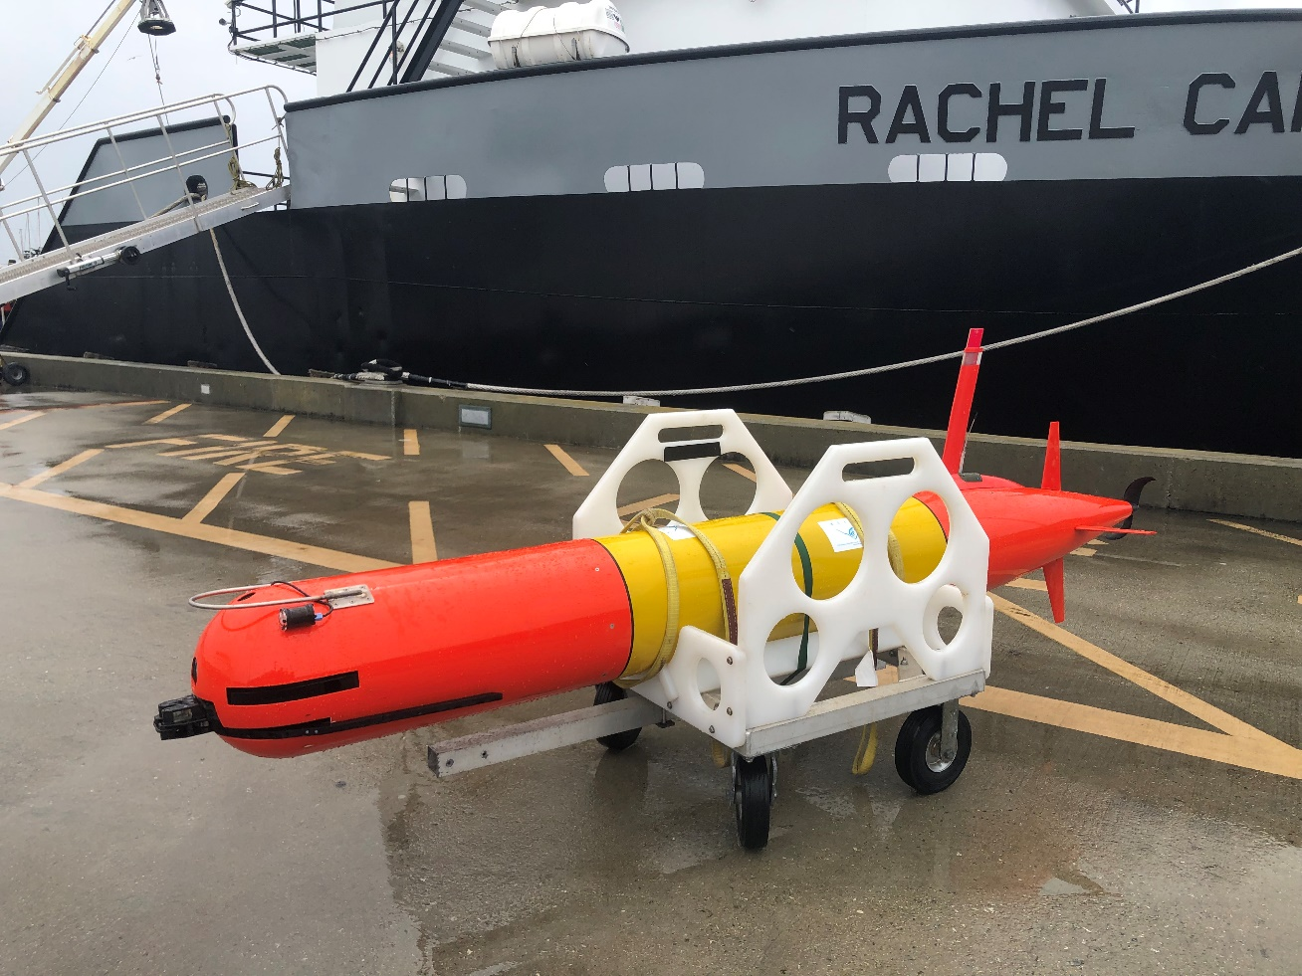
Figure 1:WHOI/ MBARI LRAUV Polaris

Discussion
The project leveraged 10 years of investment by the Packard Foundation to develop the MBARI LRAUV. This unique platform fills a nitch between small, task specific, long endurance buoyancy gliders and larger, multi-mission AUVs that operate for about one day. The MBARI LRAUV has a range of over 1,000 km and has sufficient payload and a power/computer architecture to support sophisticated and high-power payloads and has over 36,000 hours offshore to provide reliable operations.
This effort developed new payloads and vehicle behaviors to find and track oil in water and work under-ice, then demonstrate this valuable new capability to the US Coast Guard and arctic oil spill stakeholders.

The first step was to export the core vehicle design and manufacturing know-how from MBARI to WHOI. A team from WHOI cam to MBARI to work for several weeks to build the project’s first vehicle, LRAUV Polaris.
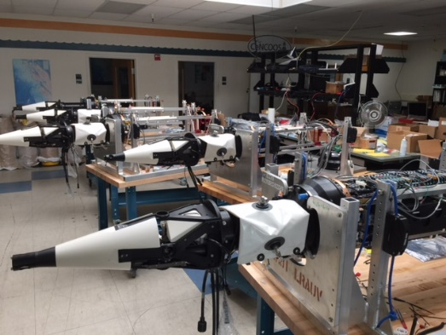
Figure 2: MBARI LRAUV vehicle assembly line with Polaris in the front.
All of the design drawings, solid-models, schematics, Bill of Materials (BOMs) and assembly procedures were shared with WHOI. During year 7 and 8 of the project WHOI build the second vehicle LRAUV Stella at WHOI with support from MBARI. A new nose-mounted payload was developed to carry the oil-in-water sensor, the SeaOWL, WHOI’s acoustic micro modem, Digital Ultra Short Base Line Array (DUSBL) and DDM line capture box, along with a CTD, PAR, compass and a new, custom upward and downward-looking Doppler Velocity Log (DVL). 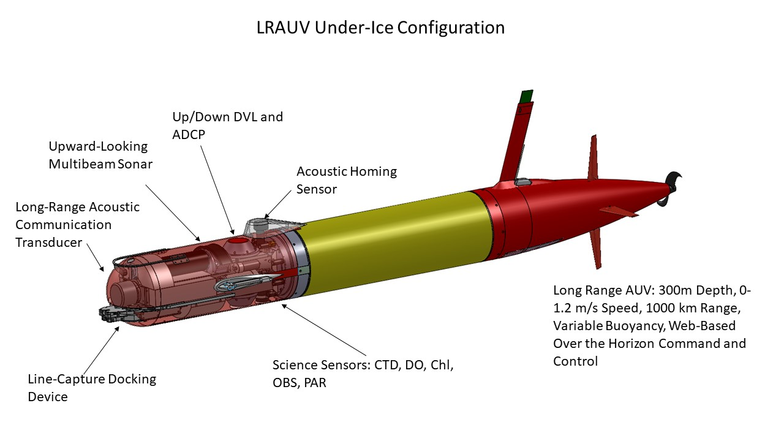
The new vehicle was extensively tested in Monterey Bay before our first field trial within the oil seeps off Santa Barbara CA in 2019. The WHOI acoustic/RF gateway buoy was anchored offshore Coal Oil point and the Polaris was launched from the Goleta pier and controlled remotely from shore. The vehicle ran a series of search missions to find and map the extents of oil in the water which are shown in Figures 3 and 4 below.
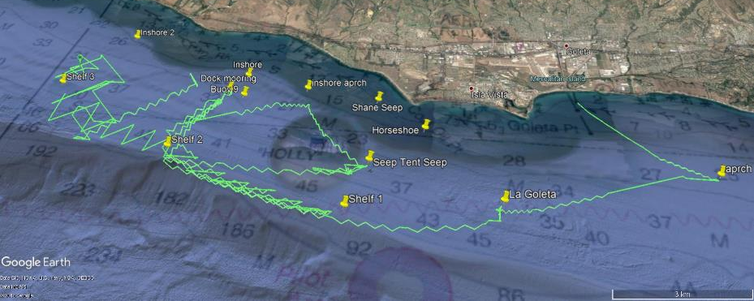
Figure 3: Polaris track lines off Santa Barbara
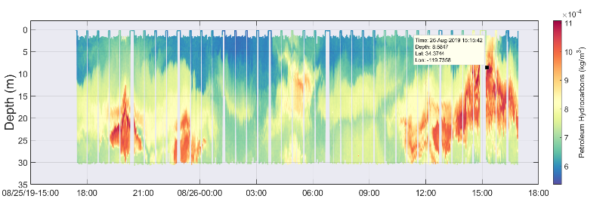
Figure 4: Oil in water sensor detections as a function of time and depth offshore Santa Barbara
The team found the oil in the water column was highly mixed in the nearshore environment and therefor difficult to identify and track discrete “spills”. Nonetheless, it was a very successful experiment in a real-world oil-in-water environment. Shortly after the Santa Barbara experiment Polaris was shipped back to WHOI for East Coast operations by the WHOI operations team.

Under-Ice Experiments
After a series of test deployments in Buzzards Bay MA, the team brought Polaris, a Gateway Buoy and ton of gear to a frozen lake (Bog Lake) in Maine in early 2020. WHOI’s experience with ice operations were on display as a large hole was cut in the ice and a crane erected to swing Polaris into the frigid water. A series of minor problems, many of which were cold and ice related, slowed progress, but eventually a series of free-swimming missions were conducted. One of the many developments required to operate under ice are changes to the AUV’s software fault response. In the open ocean missions start on the surface and if a problem occurs the vehicle tries hard to get back to the relative safety of the ocean’s surface. When operating under ice the missions are started while submerged and if there are any problems, the vehicle must return to the ice hole. Software to handle these new conditions were refined and tested and eventually proven to be working well. At one point the AUV ran into shallow water and became trapped between the ice and lake floor mud and was unable to return to the dock and hole in the ice. Polaris was located with an avalanche beacon that was added by WHOI and a new hole was cut to extract Polaris. These under-ice operations demonstrated the open ocean antenna mast was not nearly tough enough, nor was such a long antenna mast required. WHOI designed and fabricated a new antenna mast that could be used under-ice, or be extended for open water operations.

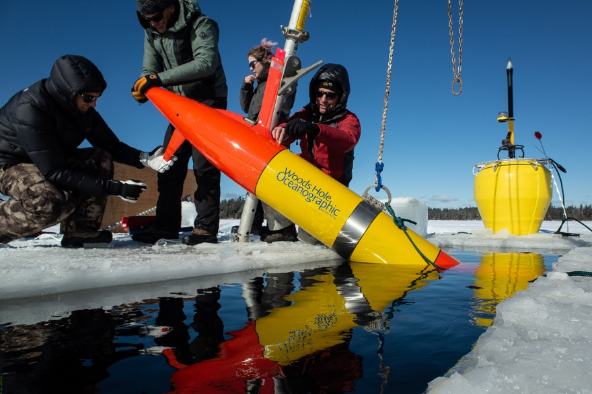
Figure 5: LRAUV Polaris being deployed through the ice.
A second set of under-ice experiments were planned for the Great Lakes in the spring of 2021 but a funding shortfall and complications with the COVID pandemic caused that trip to be canceled.

More Testing and Vehicle Construction
The key to reliable offshore operations is lots of testing. The team returned to WHOI and continued testing in Buzzards Bay. For one series of tests a Coast Guard helicopter was arranged to deploy the AUV as it would in a real Arctic oil spill deployment.
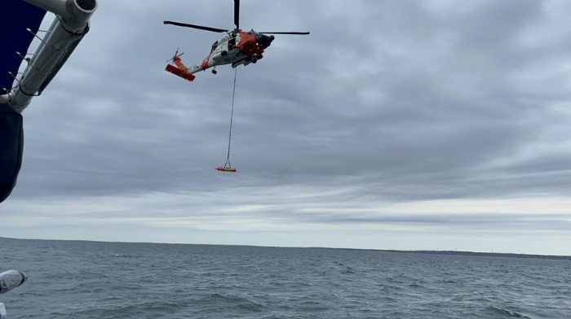
Figure 6: LRAUV Polaris being deployed for testing using a USCG Jayhawk helicopter.

If the AUV cannot find its way back to the hole in the ice, and dock to the riser, it is very difficult or impossible to recover so lots of additional homing and docking trials were conducted in Buzzards Bay during 2021 and early 2022. Back in the WHOI shop the new mapping payload and second LRAUV Stella were assembled and tested. The multibeam mapping sonar and INS are very difficult instruments to integrate so lots of time was spent working on those tasks.

High Latitude Testing
There were lingering doubts among the Coast Guard and future users that the LRAUV could navigate accurately at high latitudes so in July of 2022 LRAUV Polaris and a ton of gear were shipped to Barrow (Utqiagvik) Alaska for some offshore testing. Barrow may be one of the easiest places to work on the north slope in arctic waters, but it still proved quite difficult to get all of our gear delivered on time. Shipping delays used up about ½ of our planned operation days but we were able to deploy the Arctic Gateway buoy and LRAUV Polaris. The work plan was to run the oil spill simulator onboard Polaris and run the oil spill mapping behavior to map the spill while staying submerged and communicating through the Gateway Buoy. We discovered there is a very strong current (>AUV speed) offshore Barrow so we had to limit our operations area to a small portion of the “spill”. The simulated spill is 4-D , which is position plus time, so it evolves and grows in time. The core data for this simulation was derived from the Burger Oil spill and digitized for ADAC by Dr. Tom Ravens and Dr. Michael Ulmgren at University of Alaska Anchorage and then built into the oil spill simulator that runs on-board the AUV as a kind of “look-up” table in space and time that can feed simulated sensor data to the AUV so it thinks it is detected oil and the appropriate place and time. Off Barrow Polaris was able to detect oil, and send data through the gateway buoy but the reduced operations area, strong current, bad weather and short operations time limited how thoroughly we could test. In an actual event offshore in the arctic the oil or other hazard that need to be mapped will be moving with the ambient current so the AUV will not be forced to work against a strong current. The important objectives for this experiment are listed below, and all of them were achieved:
- Accurate navigation at high latitudes
- Demonstrate radio to acoustic relay by the Gateway Buoy
- Detect oil and send a notice of this detection to shore while submerged
- Safe recovery of all of the equipment

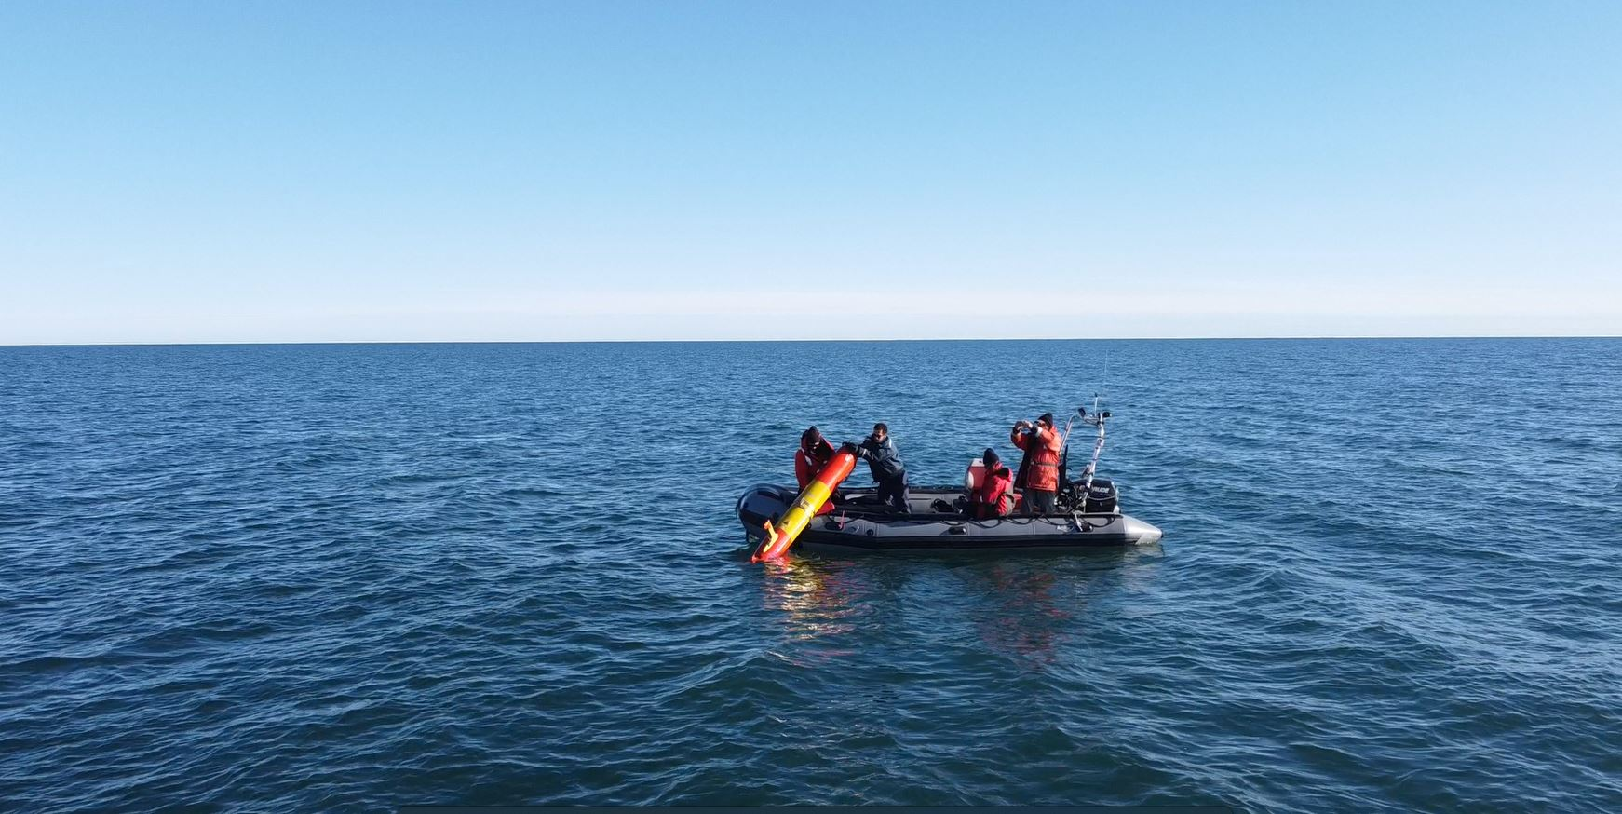
Figure 7: LRAUV Polaris being deployed from an inflatable off Barrow
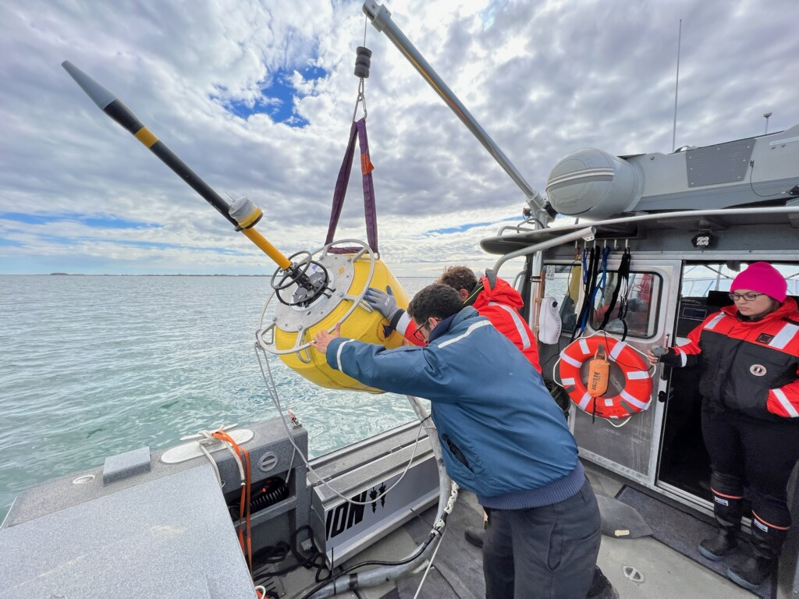
Figure 8: Arctic Gateway Buoy being deployed from the 10m vessel
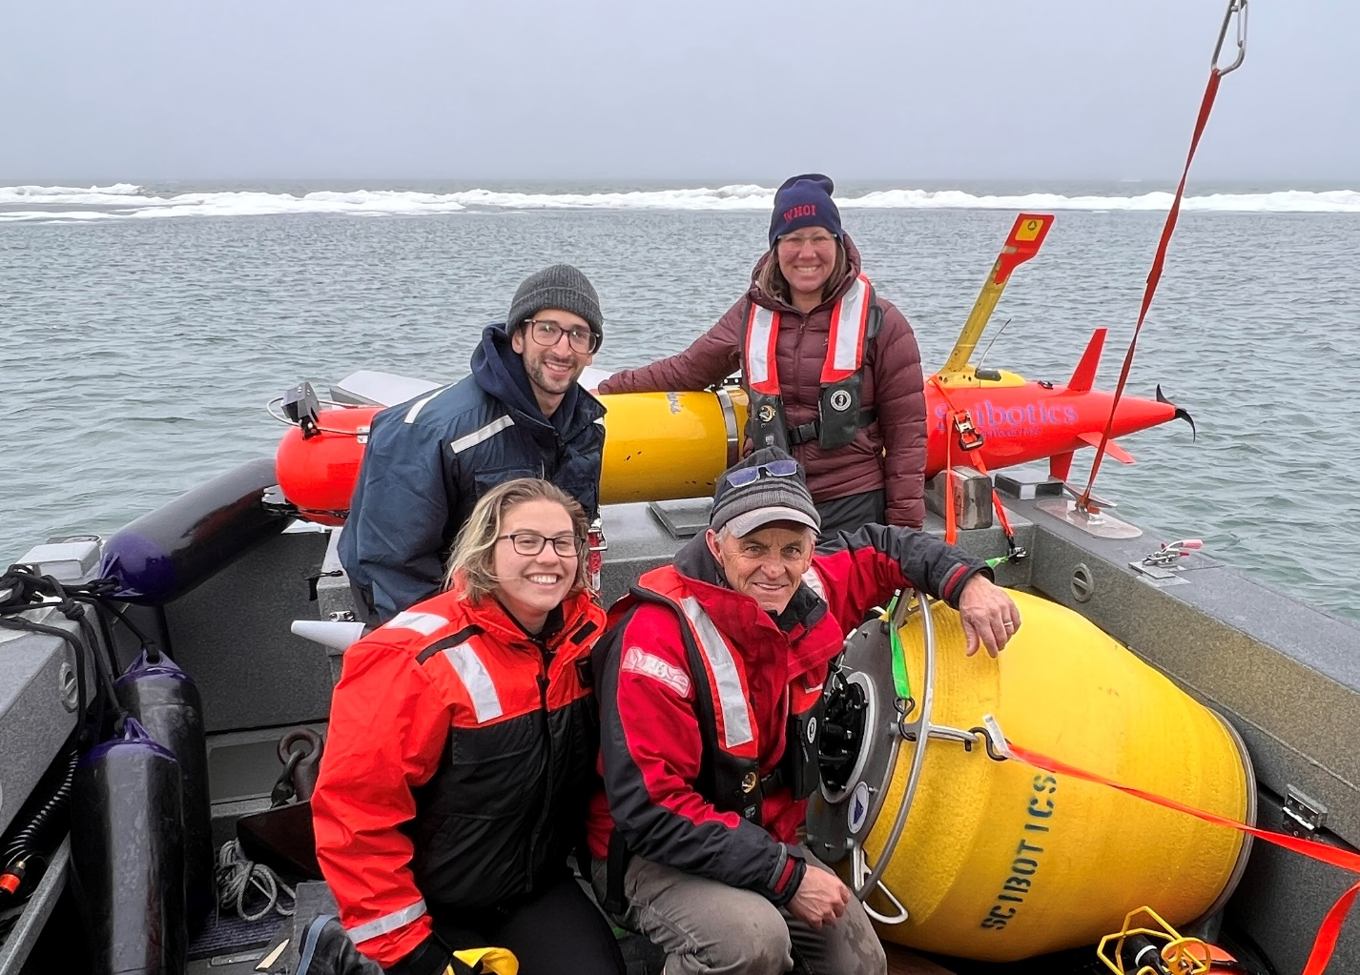
Figure 9: A happy Barrow field operations team after recovery of Polaris and the Gateway Buoy.
Next Steps
This is the final report, from MBARI, for this effort. The team is extremely proud of our accomplishments and are ready to assist WHOI when and if this system is requested for an actual hazard or spill in Arctic water. However follow-on work should be performed to refine the system and keep it operational. We need additional experience working under ice and new stand-off oil sensing capabilities like those proposed with the multibeam sonar should be developed. We were never able to get the stakeholders to agree what sort of group should host this level of technology. It is our opinion systems of this complexity need to operated routinely, by experts. If this system is parked on a shelf somewhere and expected to be run by people who are unfamiliar with it, they system will fail. Hopefully we are successful at finding follow-on funding to continue the development and keep a team of experts and the equipment exercised so it will be ready if needed.

Project progress against each milestone:
Table 23. LRAUV Project Milestones for MBARI
MILESTONE | COMPLETED | WHY NOT REACHED? (IF APPLICABLE)
Write a final report | Completed | N/A
Participate in high latitude testing at Barrow AK | Completed | N/A
Support testing and training at WHOI | Completed | N/A
Develop and test an on-board oil simulation model to exercise patch tracking algorithm. | Completed | N/A
Participate in under-ice field experiment in the Great Lakes |  | Experiment was cancelled due to funding and COVID
Participate in under-ice field experiment in Maine | Completed | N/A
Conduct field test experiments at Santa Barbara to test the complete system. | Completed | N/A
Modify MBARI’s adaptive search algorithm to use the oil in water sensor (SeaOWL) signal. | Completed | N/A
Assist with the selection of an appropriate multi-beam sonar and INS. Design the parts and schematics for integration. | Completed | N/A
Support WHOI while they build a second vehicle and maintain and operate the project LRAUVs | Completed | N/A
Conduct field trials in Monterey Bay to test the new LRAUV and custom payload | Completed | N/A
Design custom nose payloads that include the WHOI docking module, micromodem+DUSBL, SeaOWL oil detection instrument and a custom up/down DVL. | Completed | N/A
Build the project LRAUV (Polaris) while training WHOI to how to build the vehicles (Stella). | Completed | N/A
Provide Drawings, solid models, BOMs, construction notes and part vendors of MBARI’s LRAUV. | Completed | N/A

