PROJECT: Propeller Driven Long Range Autonomous Underwater Vehicle (LRAUV) for Under-Ice Mapping of Oil Spills and Environmental Hazards (Continuation Project)

Year-8 Mid-Year Report
Project Investigator(s): Amy Kukulya (WHOI) and Brett Hobson (MBARI)
Project Champion: Kirsten Trego, HQ USCG MER
Project supporting Investigators/team: Daniel Gomez-Ibanez, Noa Yoder, Amanda Besaw, Kaitlyn Tradd, Robert Petitt, Ryan Govostes, Steven Seeberger(WHOI) and Brian Kieft, Ben Raanan (MBARI)
Lead Institution: Woods Hole Oceanographic Institution
Project Student(s): Two co-ops participated on the LRAUV project, Adarsh Salagame (Northeastern University), and Nathan Un (Rensselaer Polytechnic Institute)
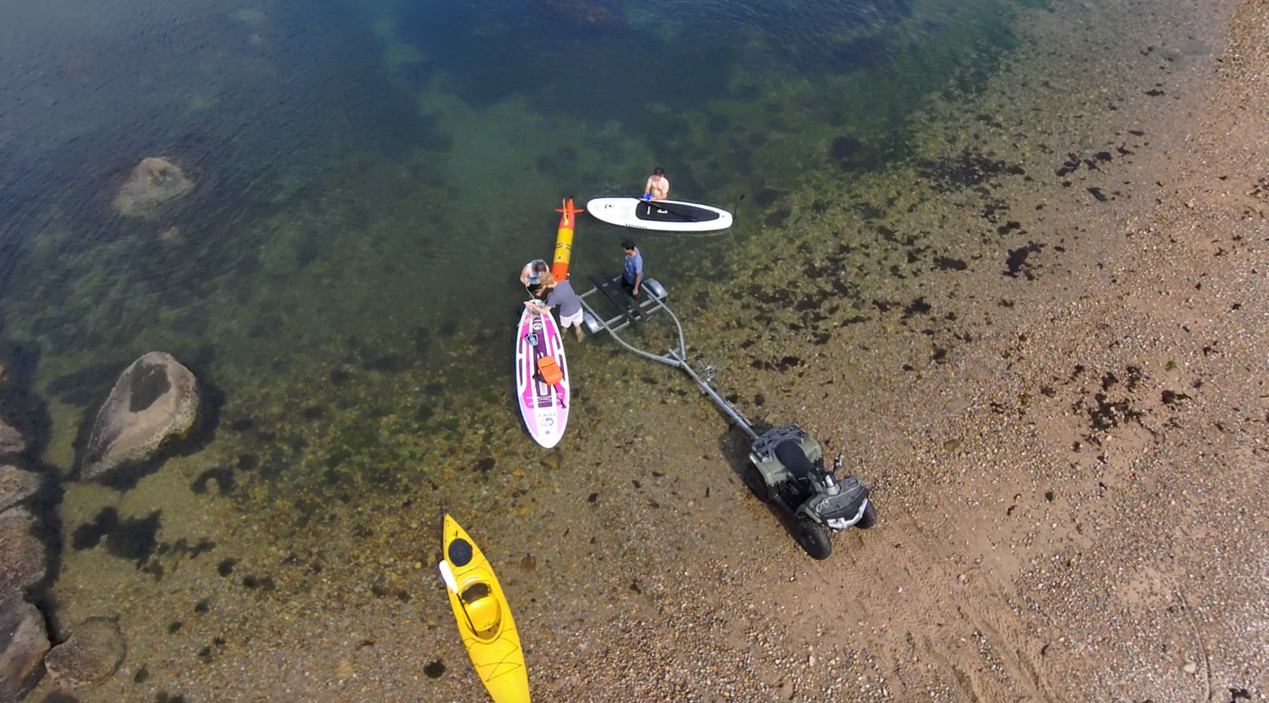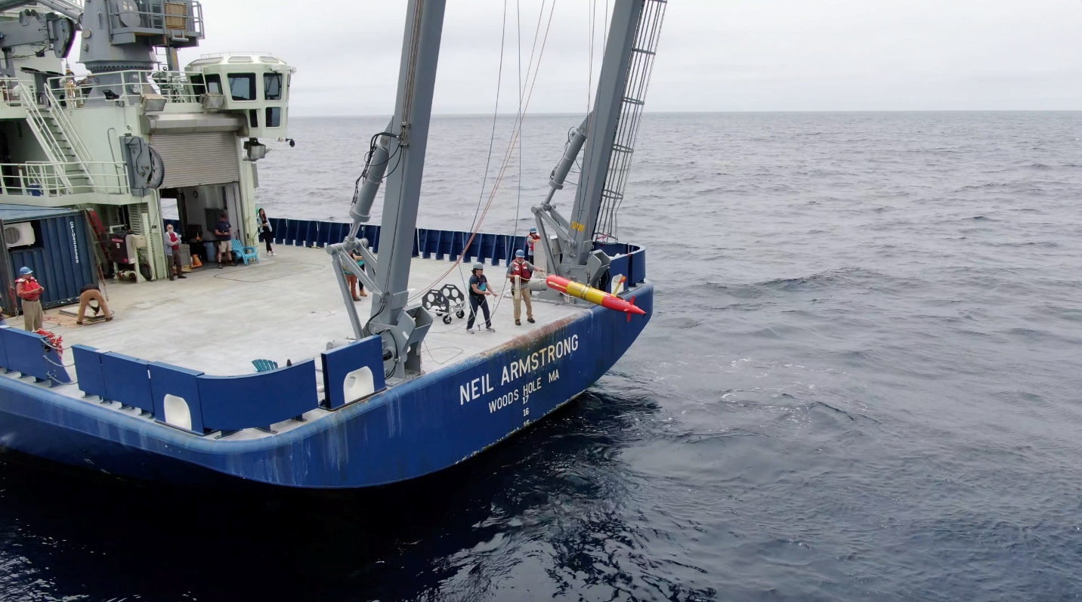

Project Mid Program Year 8 status: Key elements and progress of the LRAUV project are in line with the YR8 workplan. Major accomplishments include:
- Developed backseat- wireless joystick driving (Co-op project)
- Developed backseat- Sidecar Action Manager development, allowing sensors and behaviors to be developed in a vehicle agnostic way so capabilities can be leveraged across platforms (i.e. REMUS to LRAUV, etc.)
- Completed LRAUV backseat computer system health monitor ROS node
- LRAUV Software Simulation is running. This allows us to simulate missions in 3D space at 100x.
    - The SIM hardware in the loop can test things like oil spill simulations
    - We are currently set up with Burger Oil field Simulation which will run in January
- Polaris ran three over-the-horizon missions covering more than 450 km each time
- We conducted a total of nine missions to date in Program Y8
- Developed, integrated and tested LBL including filtering
- Building Stella and systems – Stella is 80% built and is in the component testing phase
- Refined docking and successfully tested and implemented (extreme cold tolerant gearbox installed and successfully tested)
- Developing onboard SIM mission for plume tracking tests
- Updating plume tracking algorithm (WHOI to test in January on Polaris at sea)
- Building second docking nose (for Stella), to be completed in March.
- Have hardware and integration plan for GPS, timing (1 PPS), for IMU and sonar, new PIC board to be implemented on Stella’s INS in January
- All updated wiring for new sensors and config complete
- Built vehicle in a box, Proxima (for rapid testing)

Key Milestones:
Specific schedule and associated milestones are as follows:
- Complete water testing and documentation of LRAUV vehicle and systems, 15 Jun 2022.
  - Polaris has had nine deployments to date in YR8. Testing included finishing up a 2D front sampling test using the SeaOwl sensor and updated anomaly detection algorithm. Four docking tests and there LBL tests were conducting. Final results from docking tests produced a 44% success rate which is within our targeted metric. LBL tests conducting in early December were also successful. Navigation error using LBL is still being calculated with the current data set. Those results will determine whether another round of tests are needed in early January. At this point, we now how LBL as a capability and future work for developing new vehicle behaviors can be sought.
- Process the data and tune navigation algorithms from the LBL testing missions, 30 Jan 2022.
  - This task is in progress and results from the previous tests are expected on 17 Dec.
- Plan mapping mission using sonar, 15 Feb 2022.
  - Not started. Integration will begin in mid-Jan on Stella.
- Complete fabrication of second LRAUV platform, 1 Nov 2021.
  - Stella’s base vehicle was competed on 15 Dec. Next steps for Stella are to individually test all the load control boards and components before firing up the entire system. This task is anticipated to be completed by 7 Jan. Once complete, integration and testing of the INS and multibeam will begin.
- Design and initiate fabrication of an additional sensor capability to LRAUV in order to create a multi-mission capable LRAUV, completing the task in Program Year 8 (multibeam).
- Complete software development of LRAUV data for near real-time visualization 15 Jun 2021.
  - How to’s for using the DataViz software for LRAUV are underway
- Evaluate data, make software and hardware adjustments. Perform training to USCG; 30 Jun 2022.
  - This task is underway and proceeds each deployment. The first training to USCG stakeholders will take place in mid-January followed by a second training in Mid-March.
- Build second capture/USBL docking nose system (30 July 2021).
  - We are awaiting one circuit board which has a 72-week lead time. We expect this board by early March and completion of the whisker box will take one week.
- Develop backseat autonomy (WHOI) and SIM capability (MBARI), 30 Mar 2022.
  - Backseat capability is complete and the MBARI SIM is in progress. The SIM is currently capable of running and testing missions at 100x.
- Project team will advance the technical competency of HQ USCG Project Champion USCG designated follow-on recipient of LRAUV System. Project team, led by WHOI investigators at Woods Hole, MA, will conduct up to two training sessions. Project team will complete this task via two sessions, the first by 30 Sep 2021 and the second by 30 Jun 2022.
  - Trainings are planned for Jan and March 2022.
- Create and provide the comprehensive report no later than 30 Jun 2022.

Key Milestones remaining:
- Arctic readiness testing to include under-ice missions
  - Cold-weather testing in Buzzard’s Bay and local waters will give us more data on cold weather performance. Under-ice testing is not planned in YR8
- Plan adaptive mapping mission using sonar 15 Feb 2021;
  - This task will be a full system Stella water test where we collect multibeam and can view it post mission with all the needed navigation and auxiliary date needed for map making. We currently do not have a mapping mission development task that is funded.
- Software development and compression of LRAUV data for near real-time visualization 15 Jun 2020;
  - We will be optimizing the online MBARI data viz tool for plotting unserialized LRAUV sensor data. This will be part of the stakeholder training to take place in 2022.
- Build second capture/USBL docking nose system
  - Once the optical sensor board arrives, we win assemble and test the docking nose. Estimated to be early March.
- Plan for Barrow Summer tests
Summary:
Polaris had been a workhorse over the past 1.5 years and has been a reliable vehicle for both R&D testing and science applications. We anticipate all major components and capabilities on Polaris to be completed by 31 March. Stella’s build has made significant progress and the base vehicle will be complete by end of January. Integration and testing of the PHINS INS and multibeam will be an intensive task with some risk associated with scope creep beyond March 31 due to the rapid iteration of bench to sea testing trials. We look forward to future collaborations and follow-on funding that to keep these important efforts moving forward.

